ASSIGNMENT 2

Community engagement

Desislava Hristova

ID:1813113

Tutor: Navami Leena

Module code: LCBB4002

Table of Constance

Introduction………………………………………………………………………………3
Reflective practice with reference to Gibbs reflective cycle…………………………….3
Description……………………………………………………………………………….3
Feelings…………………………………………………………………………………...3
Evaluation…………………………………………………………………………………3
Analysis……………………………………………………………………………………3
Conclusion and action plan……………………………………………………………….4
Reflection on personal experience throughout the activity………………………………...4
Relationship between relevant theory and the experience…………………………………4
Examples of key issues encountered during the role play activities……………………….4
A signed completion form from the peer’s ‘supervisor’ providing the role play experiences…………………………………………………………………………………6
Conclusion…………………………………………………………………………………9
References…………………………………………………………………………………10

Introduction:
In this term we had the opportunity to learn how to act in real situation involving taking decision in order to solve a problem inside the company. The company that I have been choose is Apple. My position was Vice-president and I should take action in order to solve issue inside the company. To learn more from this situation we use reflective practice extract all the facts and wrote down my individual weakness and strengths. Reflective practice helped me to develop new skills and improve my existing ones.
Reflective practice with reference to Gibbs reflective cycle:
1Description
In this role-play my role was as a Vice-president of Apple. One of my responsibilities is to look after my employees. I found out that the manager of the company was selling information about producing the new iPhone to competitive company. I called her to my office to discuss the situation and try to understand the reasons for this betrayal. I started the conversation friendly, trying to predispose her. after not willingly to acknowledge the mistake, I decided to inform her that I was aware of the theft of information and I also know she was behind it. When I asked her why she did it, she said she needed money and she saw a good chance, but she did not think about the consequences. She started crying and begging me to be tolerant, promising that this would not happen again, but in such a situation the decision was only one: the dismissal and payment of compensation to the company.
2Feelings
During the conversation with my manager I was initially angry because of the betrayal but after she started crying, I felt uncomfortable and sorry for her. I think the other person was sorry for what she has done and felt very bed because of the situation. Perhaps she was not aware of the consequences of her actions.
3Evaluation
The positive thing about this situation was that the thief was caught and measures were taken The negative thing is that the other person started crying and put me in a very awkward situation.My contribution was that I caught the robber before it is too late.
4Analysis
I believe things went well because the thief is no longer in the company and the problem was solved. What didn’t go well is that the manager was upset and that put me in stressful situation. I believe that one of the reasons that bring as in that situation is that I trusted blindly to my employees. That is one of the areas I would like to improve in future.

5conclusion and action plan
There are some things I would do differently and some areas I would like to develop in future, such as:
- secondary controls to be in place, in order to avoid potential information leaks/loss/espionage
- root cause analyses to be performed
- improve the relationship between the employee and the management, increase engagement, work to improve the dedication
(Gibbs reflective cycle)

Reflection on personal experience throughout the activity:
The role-play activity was new experience for me from which I learned how to solve problems occurring at the workplace.From the situation I came across, I found it extremely important to keep your emotions under control and predispose the other side to get the necessary information. The experience I gained was extremely useful for my future development in the company. The situation was unpleasant, but I managed to solve the problem.
Relationship between relevant theory and the experience:
In theory, problems are solved easily, and there is always a plan, but in practice when one more person is involved everything changes. While you are studying the problem theoretically, you are in a relaxed and safe environment. But in fact, at the moment of the problem there are involved our own feelings and the feelings of somebody else. We cannot theoretically assume how a person would react when you caught him in an offense or treason and what his actions would be when you fired him.
Examples of key issues encountered during the role play activities
Тhe positive situation in the role play is that the thief was caught and measures were taken to avoid repeating it. Тhe negative situation was the employee's cry and that put me in an awkward situation and I was not sure how to react.
I gained a research to see how other people solve problem like mine.
From this research, I found examples of corporate espionage and how they did in a situation similar to mine.
Two robbers committed corporate espionage in two companies in China.One of the companies is Avago. Avago is a leading designer of analogy, digital and mixed signal and optoelectronics components and subsystems in the semiconductor space. Their products are used in many cells’ phones globally.
The other company was Skyworks Solutions-innovator of high-performance analogy semiconductors. The insiders applied a low and slow technique of data exfiltration, sluggishly take out data over the course of numerous years. This method is often seen in spying style cases. It depends on control avoidance through a systematic and planned approach, regularly testing and checking control points for warnings and activates before attempting exfiltration.
The Good from the situation:
Education and awareness training was in place annually
Standard deterrent procedures such as login banners and NDA’s had been put in place to gain a legal standing and to warn users from considering a malicious act
Physical security controls seem adequate for the size organizations
Access control at a file and folder level seem to have been consider with a “least restrictive” security mindset and separation of duty for approvals
The Bad from the situation:
Lack of tools or poor application of tools. DLP is a foundational insider threat prevention and detection mechanism that when in place and configured correctly could have potentially identified hostile or malicious email communications with external entities
No signs of correlation of data into a centralized means for analysis, each control point was being uniquely being monitored but not collectively analyzed
Lack of audit reviews for file and folder access patterns
No peer review of access rights and behavioral baselines (Securonix,2015)

A signed completion form from the peer’s ‘supervisor’ providing the role play experiences:
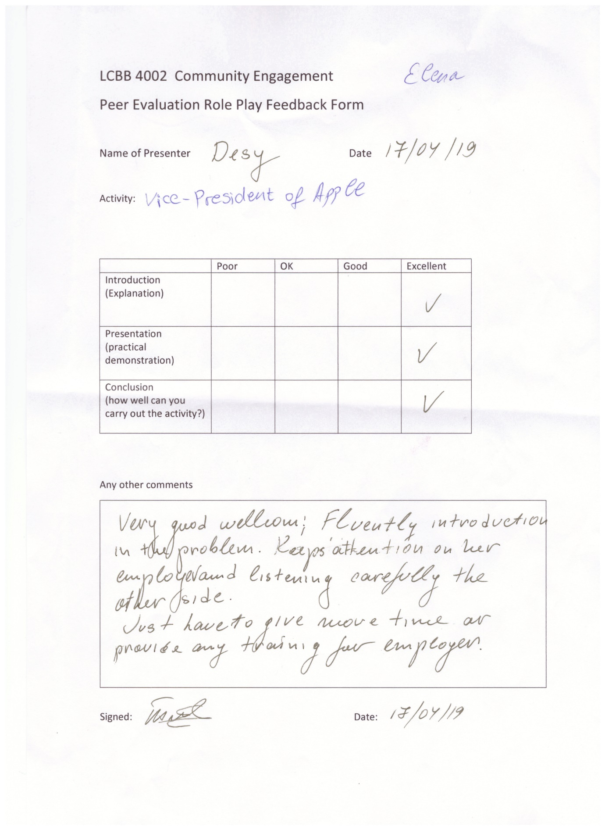
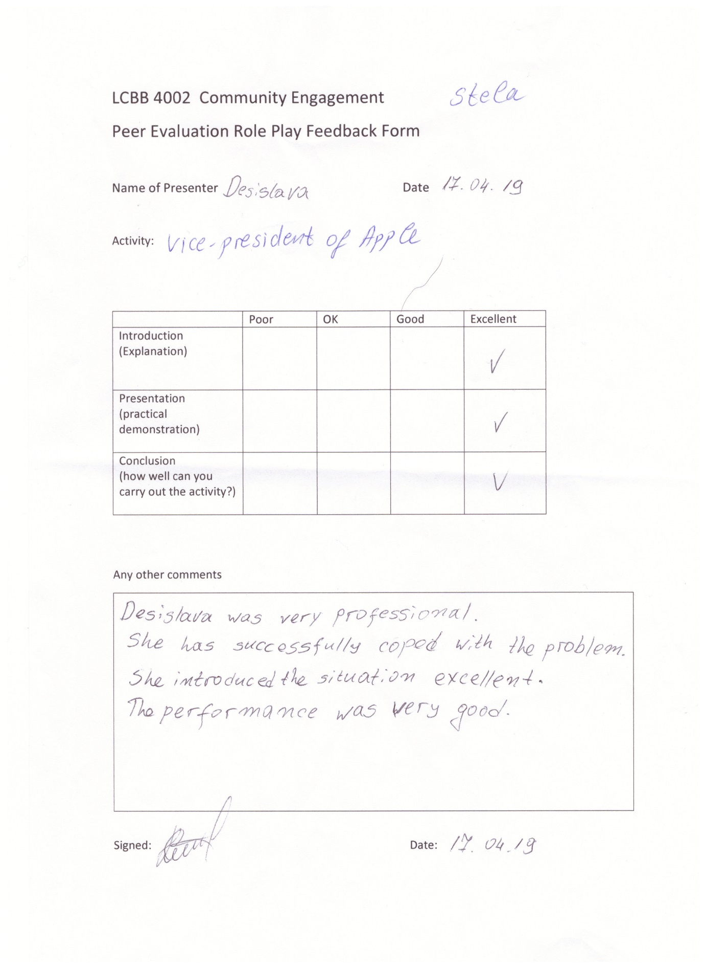
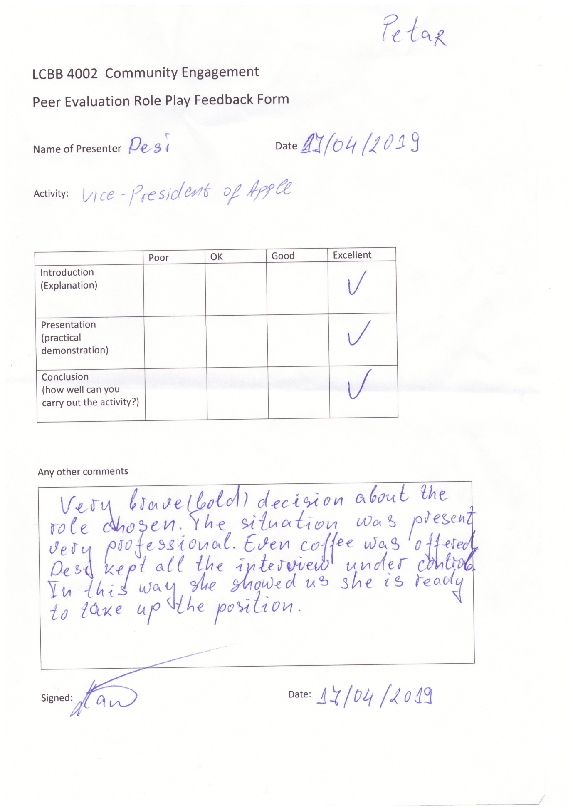

Conclusion
The role play was a new experience for me that gave me and the other students different view about a situation on the workplace. It is very important to see what other people think about your skills and abilities. After study models of reflection is easy to improve yourself and to reach great results in everything. Reflection practice give as ability to grow better communication and administration skills. Another advantage to reflection is the opportunity to correct issues that can obstruct presentation. To improve the person, demonstration courage and effective determination

References
Anon., 2015. securonix. [Online]
Available at: https://www.securonix.com/a-case-of-corporate-espionage/
[Accessed 01 05 2019].
Anon., 2019. Gibbs reflective cycle. [Online]
Available at: https://www.mindtools.com/pages/article/reflective-cycle.htm
[Accessed 28 04 2019].

