Module Code: BMSK5004
Title: MANAGING PROJECTS IN THE ORGANISATION

Student: Gyurses Sadak

ID: 1605758

Date: 07/05/2019

Table of Contents
Managing Projects in an organisation 3
Introduction 3
Assessment of the usefulness of project management tools and techniques 3
Plan the implementation of a project within the workplace 6
Communication of the project plan 9
Implementation of the project plan 10
Evaluation of the ability to manage a project 11
Self-development plan 14
Conclusion 15
References 16

Managing Projects in an organisation

Introduction
Project management refers to activities which are performed to achieve the desired goals. In the corporate world, many businesses have adopted project management as a way or reducing risks and increasing the likelihood of projects succeeding. Since the development of project management as a discipline, the field has been characterised by a common sense approach and its practicality. Also, it has been designed in a way that thinking is uniform, and a wide range of tools and techniques are used in the process to enhance it. With this regard, this assignment will present a report which assesses the usefulness of various project management techniques and tools, plans the implementation of a project in an organisation, communicates the project plans and implements the plan. Additionally, the report will evaluate their own ability to plan and implement a project stating the strengths and weaknesses and as well present a self-development plan to improve performance in project management.

Assessment of the usefulness of project management tools and techniques
Project management is a process with various activities being performed to achieve the goals. The activities and responsibilities in the process are challenging and complex which at times cannot be completed through thinking (Watson, 2002.)). The use of tools and techniques help in the accomplishment of tasks and execution of responsibilities. Discussed below are the tools and techniques and their usefulness in the management of projects within an organisation.
Brainstorming. This is the first technique a project manager thinks of when it comes to managing projects. Brainstorming is ideally a random technique which involves free- thinking. In this technique, divergent thinking is used to generate ideas whereas convergent thinking is used to focus on selecting the evaluated options. This technique is so natural thus simpler and easier to use. However, it can be under-utilized or be overlooked as it is not a natural approach for project managers whose strengths lie in the processes and systems. Even so, brainstorming is used in the project planning phase and helps project managers to think randomly yet creatively. In an organisation, projects are carried out in teams and brainstorming helps people to come up with ideas which are evaluated to settle on a single idea about a particular project (Berkun, 2008).
Fishbone diagram. This model is helpful in project management planning and task management. Specifically, the model is useful in detecting faults in quality management and process improvement during production. Often, fishbone diagrams are used when obtaining factors which are critical in project planning. This tool is useful in the identification of hidden factors which are crucial in enabling other larger activities and other resource areas. However, this tool is not efficient in scheduling and showing critical time factors which are interdependent.
This tool is called fishbone because when drawn, it takes the shape of a fish. The diagram is drawn with a spine which has built factors that contribute to the outcome of the result. The diagram below illustrates a project’s main factors as identified.
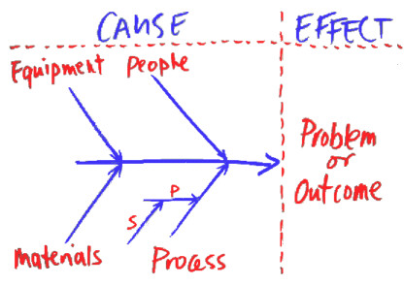
When using this tool, project managers need to be keen so that the diagram makes sense of the project. They also need to choose the right structure as organisations and problems vary. Though simple, fishbone diagram is a very important tool in planning as it helps in mapping. In its drawing, the effect is shown as an aim or the result.
Gantt chart. This is a chart that is drawn to help in planning the sequence of activities if a project in various ways of completion while determining the timeline and the resources which are needed (Buttrick, 2009). Gantt charts are commonly used by project managers and are very useful when correctly adapted. In the organisation, Gantt charts are helpful in scheduling and budgeting, reporting and presenting project plans and communication of the progress. This tool is often preferred because they are easy to use and are quick in the accomplishment of the stated functions such as reporting.
Gantt charts can be produced using an Excel spreadsheet or a word table. However, they are more powerful when generated using tailored software, for example, Microsoft Project. In the organisation, Gantt charts are produced using the software. The advantage of using this software is that it enables the linking of tasks. For instance, task 2 cannot start unless task 1 is completed. This linking aspect enables project managers to identify the extent to which the project is likely to overrun. It also allows them to identify different possibilities as earlier as from the planning stage and this is essential for organisations. In the bidding stage, Gantt charts help in the generation of a visual presentation of the project.
Nonetheless, the software-generated Gantt chart helps in identification of critical tasks. These are those tasks which highly determine completion of the whole project. This means that if they are late in completion, the project will also be completed late. In this case, the Gantt chart is useful in those tasks identification as they need more careful management. Generally, Gantt charts help in planning and for periodic updates. However, updating needs to be done more often. Below is an example of how a Gantt chart is drawn to aid in project management.
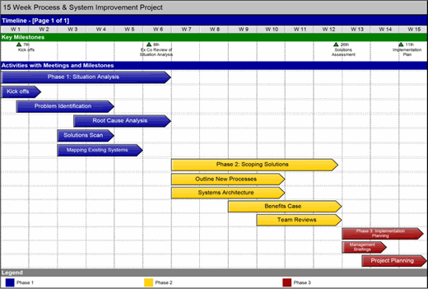

Program Evaluation Review Technique (PERT). This too is used to compute the amount of time a project is likely to take to completion. In my organisation, this tool is used to calculate the time for individual activities and the project as a whole. This enables team building and enhances an organisation’s effectiveness. PERT allows project managers to estimate the shortest time a task is likely to take, the longest amount of time a task can be able to take and the most likely time. PERT is useful in warning an organisation about the task dependencies. The tool helps in a case when the project is complex with many tasks depending on each other. Generally, PERT helps in visualisation of tasks and their interdependencies.
Critical Path Method. This tool shows the minimum amount of time that can be taken to complete a project. It also reveals the activities which are critical in project completion on time. Critical path method shows the real-time, available time and the slack time. Real-time is the time estimate required to complete the project; available time is the amount of time in schedule required for the project to be complete whereas the slack time is the difference between the real-time and the available time. In my organisation, we use critical path method in the prioritisation of various activities and tasks (Meredith & Mantel, 2009).
Risk analysis. This is an essential technique that is employed by every project manager. Risk analysis helps in the definition of a consequence and a probability. Probability is the likelihood that something is going to happen whereas a consequence defines how serious something is if it happens. In effective risk analysis, the two are separated so that they are managed differently. In an organisation, managers manage the risks of losing employees by securing their jobs. The consequence is managed by ensuring their work is documented and that they obtain training in their key areas of work.
Stakeholder analysis. This is a tool or technique that is used in identification and understanding of the needs and expectations of the primary interests within and outside the project environment. Interrelationships, attributes and interfaces among stakeholders help in strategic planning of a project. This is so as there are always project risks and viability which need to be retained and obtained. Incorporation of various stakeholders in a project is important as their skills are integrated to ensure projects are completed successfully. Often, stakeholder analysis is considered a technique which is considered in the first step of a project which is project planning. The image below shows some of the stakeholders in an organisation.
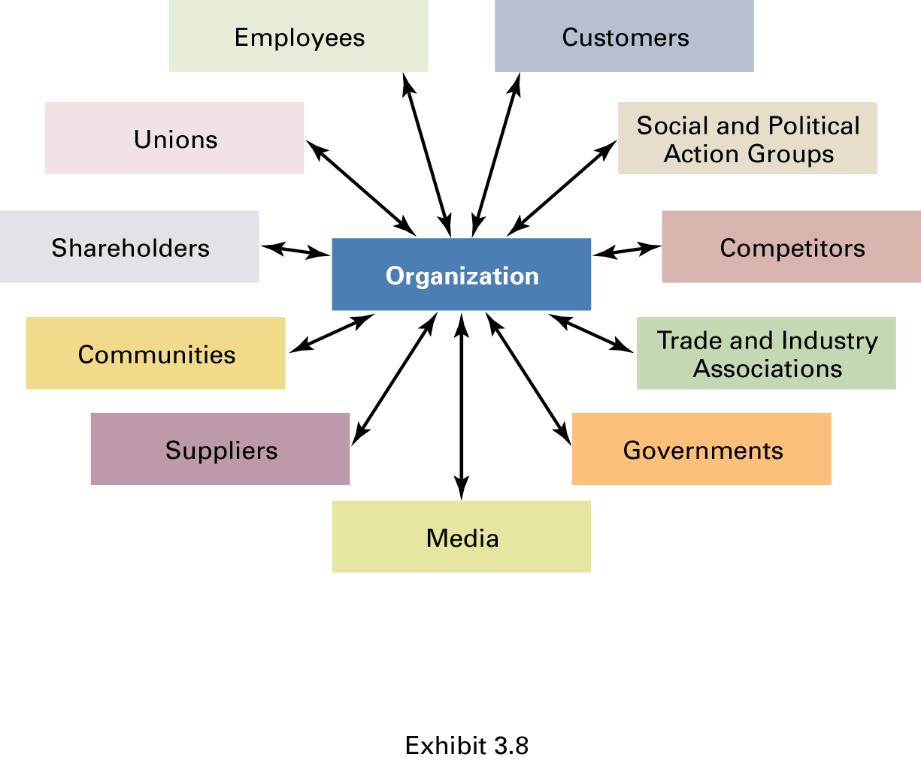

Plan the implementation of a project within the workplace
In the Little Bay Kilburn restaurant in the UK, there is a plan to renovate the kitchen to upgrade the design. This project has been proposed to enable an increase of food supply in the organisation to meet customer demands. As a volunteer at the organisation, I took the role of a project manager whereby I had to set out all the aspects regarding the success of the project. Discussed below is the plan within the workplace.
Scope description
To successfully renovate the restaurant kitchen while ensuring compliance of various standards and regulations. The management of the restaurant prefer an industrialised design which will accommodate ore equipment and chefs for the purpose of more food production. The goal of this project is to be complete within the stipulated budget, be completed within 7 weeks and use energy-saving appliances and equipment.
Objectives
The objectives of the project plan of renovating the kitchen include;
To makeover the kitchen to make it look appealing and have a fresh look.
To change the kitchen layout. This will involve better positioning of the fixtures, appliances and other objects to make the design look stylish and organised.
To increase the kitchen space.
Key staff
The stakeholders who will be involved in the kitchen renovation project include the general contractor, the designer, subcontractors, city inspector.
Stakeholder analysis
General contractor- tracking of the budget and schedule.
Designer- designing an efficient kitchen which can accommodate more chefs and equipment to enable more food production.
Subcontractor-to completes the contracted work as per the agreement.
City inspector-to ensure construction of the renovated kitchen meets all the city and state codes.

Work breakdown structure
This structure shows how work has been broken down into smaller tasks (Gray & Larson, 2014). There are six main activities which have been breaking down into other sub-levels. They have been shown below.
- Planning and design
- Research the design styles
- Development of the preliminary design
- Establishment of the funds
- Selection of the sub-contractors
- Research about the subcontractors
- Acquisition of the sub-contractors
- Package designing
- Demolition
- Architecture specification
- Appliances
- Cabinetry
- Flooring
- Electricity
- Painting
- City permissions and inspection
- Review and approval of the drawings
- Roughed in inspection
- Finished product inspection
Cost estimation
The total budget for the kitchen renovation project is anticipated to be $50,000. Every process is the level of activity has been allocated funds as specified below.
- Planning and design- $10000
- 2. Demolition - $1,000
- 3. Construction - $30,000
- 4. Test and Commission - $3000
- 5. Clean-up - $1,000
- Turnover - $5000
Time estimation for completion of every phase of the project

ACTIVITY | TIME ESTIMATE(in weeks)
Design | 1
Demolition | 1
New material and equipment installation | 2
Removal and disposal of excess material | 1
Equipment testing to ensure they are functioning correctly. | 1
Project complete and signed over to the organisation | 1

Analysis of potential risk
A high risk anticipated in this case is overspending which may indicate a higher amount than the one set in the budget.

Communication of the project plan
INFORMATION | KEY STAKEHOLDERS | FREQUENCY | DISSEMINATION METHOD | INFORMATION PROVIDER
Initial consultation | contractor | At the start of the project | meeting | Project office
Design consultation | designer | After consultation | meeting | Design office
General Contractor | General contractor | After completion of the initial design | Meeting | Project office
Designer | designer | Twice a week | Email | Design office
General Contractor, Designer | General contractor | After the final design | meeting | Project office
Project Office | designer | Every week | Email | General contractor
Sub-contractor | General contractor | Every week | Email | Sub-contractor
Project Office | Project office | Every week | Email | General contractor
Project Office | Project office | anytime | Online cloud | Project office

Implementation of the project plan
The project plan was implemented successfully as the specified objectives were met. All the tasks as outlined were also performed which led to the deliverables of the project. The project was implemented using the Gantt chart which helped in planning and keeping track of the project. Below is a Gantt chart which was used in implementation and monitoring of the project.

Activity | Time in weeks
Design
Demolition
New material and equipment installation
Removal and disposal of excess material
Equipment testing
Project completion

Most of the activities went as specified in the plan. For instance, the budget was as proposed as the spending was exact $50,000. Also, the work breakdown was organised as earlier indicated in the plan. However, the time estimates did not go right. There was a delay in between the activities which made the project to take ten weeks in contrary to the specification of seven weeks.
I ensured collaboration and team work to keep things on track. Based on the fact that the project team had a lot of stakeholders, there was a challenge in ensuring that skills were merged together to complete the project. I took the initiative of explaining the importance of working in a team thus this helped me in running the project well till completion.
Despite the efforts I made to have the project successful, there were various constraints. For instance, the project team could sometimes lack commitment an instance which could lead to time wastage. Also, some of the subcontractors obtained were not very skilled thus as a project manager I had to ensure better subcontractors were obtained for the success of the project. Nonetheless, communication was not so good between the project office and other stakeholders. However, I made efforts to ensure communication was flowing properly and this enabled completion of the project successfully.

Evaluation of the ability to manage a project
From the accorded role of a project manager, I was not sure if I could complete the project based on the fact that I have little experience. However, I have been able to draw a plan and follow on it till when the project was successfully completed. Also, colleagues had different opinions over the fact that I was the one to carry out the project management role. After the project completion, I have been able to obtain feedback from them on how I carried out the project. I devised a questionnaire which had specific questions they were to answer. Below is a discussion on what my thoughts are concerning the project and some of the feedback received from employees in the organisation.
Most employees feel that managed the development of the project plan better than anyone else could do. From their opinions, I was honest with myself and everyone that I could not try to hide a lack of knowledge and uncertainty. I was open to observe what was happening, curious to ask questions whenever I felt like I needed someone’s help and patient as I could not jump into conclusions. From these qualities and skills, I can ascertain that I did my best in the development and implementation of the project plan.
In my thoughts, I feel like I kept everyone who was associated with the project was adequately informed. However, from the feedback received, I tried to keep the people posted, but I did not sufficiently inform them. This feedback was received with an argument that I could delay in relaying the information and sometimes I could inform some people while some could not be informed. Also, I could communicate some information which was not thoroughly thought about thereby causing inconveniences. For instance, some employees stated that I could not bring out the situation of the project properly. This was so as situation analysis could not be done properly or as expected.
I did communication well but time constraint was a problem. As stated by some of the interviewees, I could complete a step and move to the next one before informing them about the progress. This means that I had a problem merging communication and the appropriate time thus bringing out the problem of poor time management (Wysocki et al., 2000).
Project implementation was done in a better way an aspect which led to the project’s success. However, the timing was not done well, and this aspect explains the problem of time management in the entire project plan development. Even so, implementation was done well, and this led to the success of the plan.
Based on the feedback, I have a major problem with poor time management skills. And as a project manager, this is an important skill that I need to possess and empress as it can have a major impact on the final deliverable. Therefore, I need to do all it takes to improve on this particular skill. An example of the ways of improving is drawing of time schedules to familiarise myself of what I need to do, so that time allocation is appropriately done. I also need to discipline myself so that I can follow the schedules and take the stated time to avoid inconveniencing myself as well as other people who may be following up on the project.
In budget planning, my approximations were perfect. I anticipated the cost of the project to be $50,000 which was the case. Most of the people affected by the plan were happy that I minimally allocated funds for the tasks and the allocation and project were done as planned.
From the feedback obtained in the development of a project plan, I have been able to identify my strengths as well as weaknesses that I need to work on to increase my competencies. Below is a discussion of those strengths and weaknesses.
Strengths
Good communication skills. Communication is essential in ensuring team effectiveness and successful relationships whereby people work towards a common goal. As a project manager, I can communicate with other stakeholders in a better and an appropriate way. I possess this skill as I always evaluate what I need to talk and prepare before communicating with others. For instance, when conveying information about the progress of the project plan, I would tailor my speech on the said agenda and ensure I stick to it to avoid miscommunication.
Honest and open-minded. I am honest with myself and everyone. I discovered I possess this strength from my colleagues who gave feedback about their opinions on how to manage the project plan. In cases where I had no idea of what was expect or what I needed to do, I could air it out to want to know. I was honest with myself in that I could not hide a lack of knowledge. Also, I was honest with others as I could always tell them the truth regardless of whether the information was positive or negative. On the other hand, I am open-minded to understand that I cannot be all knowing, but I need to strongly believe in myself.
Good research skills. To avoid most mistakes and problems, research needs to be done (Maylor, 2005). In the plan of renovating the kitchen, I did proper research on what was required and expected. The thorough investigation enabled me to approximate the resources, capital and skills required in the renovation plan. This skill has been better expressed on the fact that I researched the requirements and approximated the costings which turned out to be exactly as anticipated.
Collaboration and team building. In an organisation, employees have to work together towards meeting the organisations’ objective. In the project plan, I had to work with others to ensure the project succeeded closely. Due to my better skill of collaborating and team building, I was able to work with other stakeholders who helped me succeed in the plan. I could encourage us to work closely with each other because when together, we could share opinions, ideas and thoughts which led to better performance.
Weaknesses
Poor time management skills. Time management is an essential skill that each needs to possess regardless of the role or position (Roberts, 2011). Time management not only affects an individual but also affects those close or are connected in one way or the other. For instance, in my project management, I had a problem managing time and this affected other employees as well. I could get late communicating the progress of the project, and this could make others lag in their roles as the project affected them directly or indirectly. Therefore, poor time management is a weakness that I need to battle with to ensure I do not inconvenience myself as well as others.
Poor analytical skills. In any setting, the analysis is required to obtain summarises information about the current situation. However, my skills in analytics are poor which makes it difficult for me to communicate the exact state and progress of a project. For instance, I was supposed to present a report on the situation and progress of the project. However, due to my poor analytical skills, I could not communicate properly, and this made my colleagues realise that my skills in this area were poor.
Curious and nervous. Because I had not worked on a project as a manager, I was nervous and at the same time curious to know what the outcome of the project could be. This is a weakness as I risked eagerly waiting for the outcome yet not keenly concentrating on the procedures and activities involved.

Self-development plan
From the above-discussed strengths and weaknesses, I have been able to identify areas that I need to perfect, improve or work on to increase my competence. The table below shows my current proficiency and what I will do to perfect the skills.
competency | Current proficiency(on a scale of 1-5) | What to do to improve on the area
Time management skills | 2 | I will ensure I make time plans and schedules which I would follow.
Analytical skills | 2 | I will ensure I actively read as this will expand my mind and allow it to think in new ways and also observe things keenly.
Budget planning | 5 | I will ensure I maintain good research skills before I set the budget.
Communication skills | 4 | I always learn better ways of communication to improve the skill.
Project planning | 3 | I will ensure I always work hand in hand with others towards the same objective.
Report writing | 4 | I will always research on how to write good reports to ensure I improve the skill.
Research skills | 4 | I will ensure that I always research to improve my skill.
Progress monitoring | 3 | I will use the right tools and techniques to evaluate and monitor project progress.
Collaboration and team-building | 5 | I will ensure to always work in teams for better results

Conclusion
In conclusion, project management is a crucial aspect which should be treated with a keenness to alleviate problems in organisations. This report has tackled various tools and techniques which can be used in project management to ensure the objectives are met within the stipulated time. Some of the techniques and tools used include the Gantt chart, critical path method, Program evaluation review technique, risk analysis and brainstorming. The report has further documented a project plan of renovating the kitchen in the Little Bay Kilburn restaurant. In the project plan, implementation and communication have been done. Furthermore, the work has documented a reflective summary stating some of the strengths and weaknesses of the project manager as depicted from the project plan. Some of the strengths depicted include good communication, honesty, research skill and team-building whereas the weaknesses include curiosity and anxiety and poor time management. Therefore, it is recommendable that project managers should often evaluate their skills to identify areas of weaknesses so that they may work on them to perfect the project plans.

References
Berkun, S (2008) Making Things Happen: Mastering Project Management
Buttrick, R. (2009). The Project Workout: The Ultimate Handbook of Project and Programme Management. 4th ed. Harlow, England: Financial Times/Prentice Hall.
Gray, C. F., & Larson, E. W. (2014). Project management: The managerial process (6th ed.). New York, NY: McGraw-Hill Education.
Maylor, H. (2005). Project Management. 3rd ed. Harlow, England: FT Prentice Hall.
Meredith, J. & Mantel, S. (2009) Project Management: A Managerial Approach, Asia: John Wiley & Sons
Roberts, P. (2011). Effective project management. London, UK Philadelphia, PA: Kogan Page.
Watson, M. (2002.) Managing Smaller Projects: a practical guide, Hook: Project Manager Today Publications.
Wysocki, R. K. et al. (2000). Effective Project Management, New York: Wiley.

