Module Code and Title
BMIH 4002 – Food and Beverage Operations

Project Title
Assignment 2 Menu Engineering (Practical Task)

Student Name: Ana Maria Stoica
Student ID: 2245028
Module Leader: Antoinette Milne
Academic Year/Group: Level 4 2023

Table of Contents
Part One – Restaurant Concept 3
Primary Concept of Restaurant 3
Target Audience of the Restaurant 3
Reasons for Designing Menu of Restaurant 4
Part Two – Menu Design 5
Menu Design 7
Reference 8

Part One – Restaurant Concept

Primary Concept of Restaurant
A restaurant concept is presented in this project by connecting with Hotel Trinity Chain. "Delicious Food" has been selected as the title to provide the restaurant concept within this project (Filimonau et al., 2017). The main mission of this restaurant is to provide maximum fresh and healthy food to the customers. The management of the restaurant will provide some food and dishes that are at the top of the customer's choice.

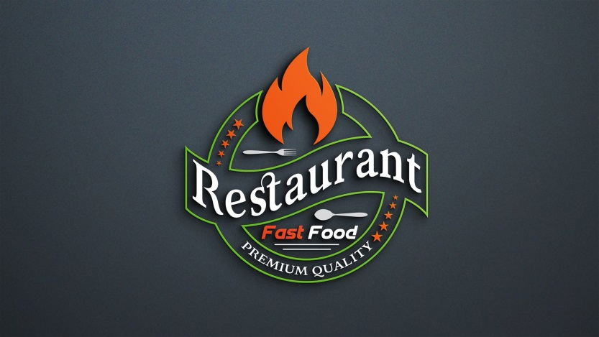
Figure 1 https://graphicsfamily.com/downloads/restaurant-logo-design/

The cooking department of this restaurant must take care of the quality of the food and the freshness of the raw materials (Nguyen et al., 2018). The entrepreneur will build this restaurant in such a way that customers can have lunch and dinner in a pleasant environment. Birthday parties, anniversary parties, and all other types of programs will be organized in this restaurant. The interior environment of this restaurant will be illuminated by lighting to attract customers.

Target Audience of the Restaurant
Every business organization has potential customers around whom all activities are conducted. Restaurants also have specific types of customers. "Delicious Food" restaurants also have a target audience whose preferences will be analyzed to guide all activities (Zhang et al., 2018). The main target audience of "Delicious Food" is those people who are used to eating at restaurants all the time.

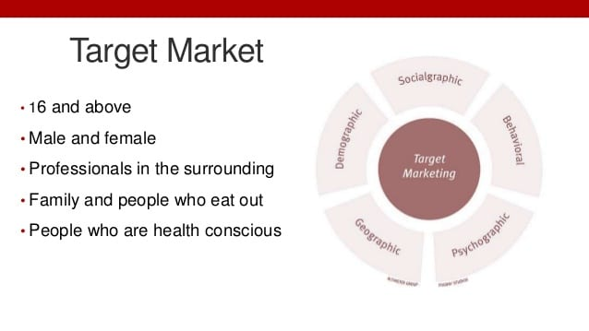
Figure 2 https://business.getonbloc.com/restaurant-marketing-plan/

The main target audience for this restaurant is likely to be between the ages of 15 to 65. Customers from almost all kinds of backgrounds fall into the target audience of this restaurant. Tourists, businessmen, cricketers, footballers, actors, and politicians are the target audience of this restaurant (Baiomy et al., 2019). People who are used to celebrating birthdays and anniversaries day every year are also potential customers of "Delicious Food" restaurants. There are many working people who are used to having lunch mostly in restaurants, they are also the target audience of this restaurant.

Reasons for designing Menu for Restaurant
The menu conveys the idea of a restaurant's food information, service quality, food standards, and branding. Each restaurant has its menu designed in which all the information is included (Bacon & Krapan, 2018). All the information and prices of the food that a restaurant provides are mentioned in the menu. Adequate information about the restaurant's service quality and product reviews is presented within the menu.

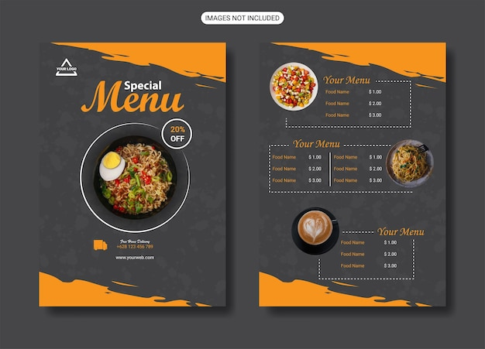
Figure 3 https://www.freepik.com/free-photos-vectors/menu-design

The menu also provides information to the guests about the restaurant's service quality, world image, customer satisfaction, and brand value. Customers get an idea about the tradition and service quality of a particular restaurant from the menu design. In addition, customers select which food to consume by looking at the menu design (Peters et al., 2020). That is, the menu is a mandatory requirement of a restaurant which conveys to the customers their brand value, tradition, and service quality. Customers cannot order food without a menu. So it can be clearly said that menu designing is an important activity for every restaurant.

Part Two – Menu Design
Menu designing is a mandatory task for every restaurant without which customers cannot get an idea about food description, pricing, and service quality. Designing the menu is also a mandatory responsibility for the management of Delicious Food restaurant. There are several things to keep in mind while designing the menu which are discussed below.

Menu Design
First of all, designing a menu should focus on designing. Designing refers to a menu's color, attractiveness, language, and structure. Colors should be selected to design the menu which can attract people. Color and design should be done in such a way that can attract the guests. The menu should use straightforward language that can be understood by all types of customers (Jawabreh et al., 2018). The authority of Delicious Food Restaurants should not use difficult language that is not understandable to common customers. Restaurant management must follow a straightforward structure to design the menu so that customers of almost all backgrounds can use it.

Menu Items
Restaurant management should select popular food and dish items according to customer demand. The menu design gives an idea of the food and prices of each restaurant. The restaurant authorities have to select the items according to the needs of the customers of the particular region. The type of food and dish that customers are used to having should be included in the menu items. Among the menu items, the food selection must target vegetarians and non-vegetarians. While selecting menu items, care must be taken to incorporate almost all types of food.

Standard and Nutrition Requirements of Food
The management of Delicious Food The important responsibility of the restaurant is to pay attention to the standard, nutrition, and healthiness of the food while selecting the food items. No food shall be included in the menu items that are harmful to the health of the customers (Lo et al., 2017).
Restaurant management must give preference to dishes that are standard, quality, and tasty. Restaurant authorities should give priority to dishes that are in tune with the traditions of the local area and are loved by the people.

Pricing Strategy
One of the most important aspects of the menu is to mention the price of the food. The authority of Delicious Food Restaurant should determine the price of food by doing a competitive pricing strategy and customer demand analysis.


Figure 4 https://www.price2spy.com/blog/pricing/

The customer's budget must be kept in mind when mentioning the food prices on the menu. Food prices must be in line with competing restaurants. Food prices cannot be set in ways that exceed the budgets of competing organizations and customers. Customers don't order food when they notice on the menu that the price of the food is out of their budget. So while deciding the price of each food one must keep in mind the customer and the customer's capacity.

Menu Design

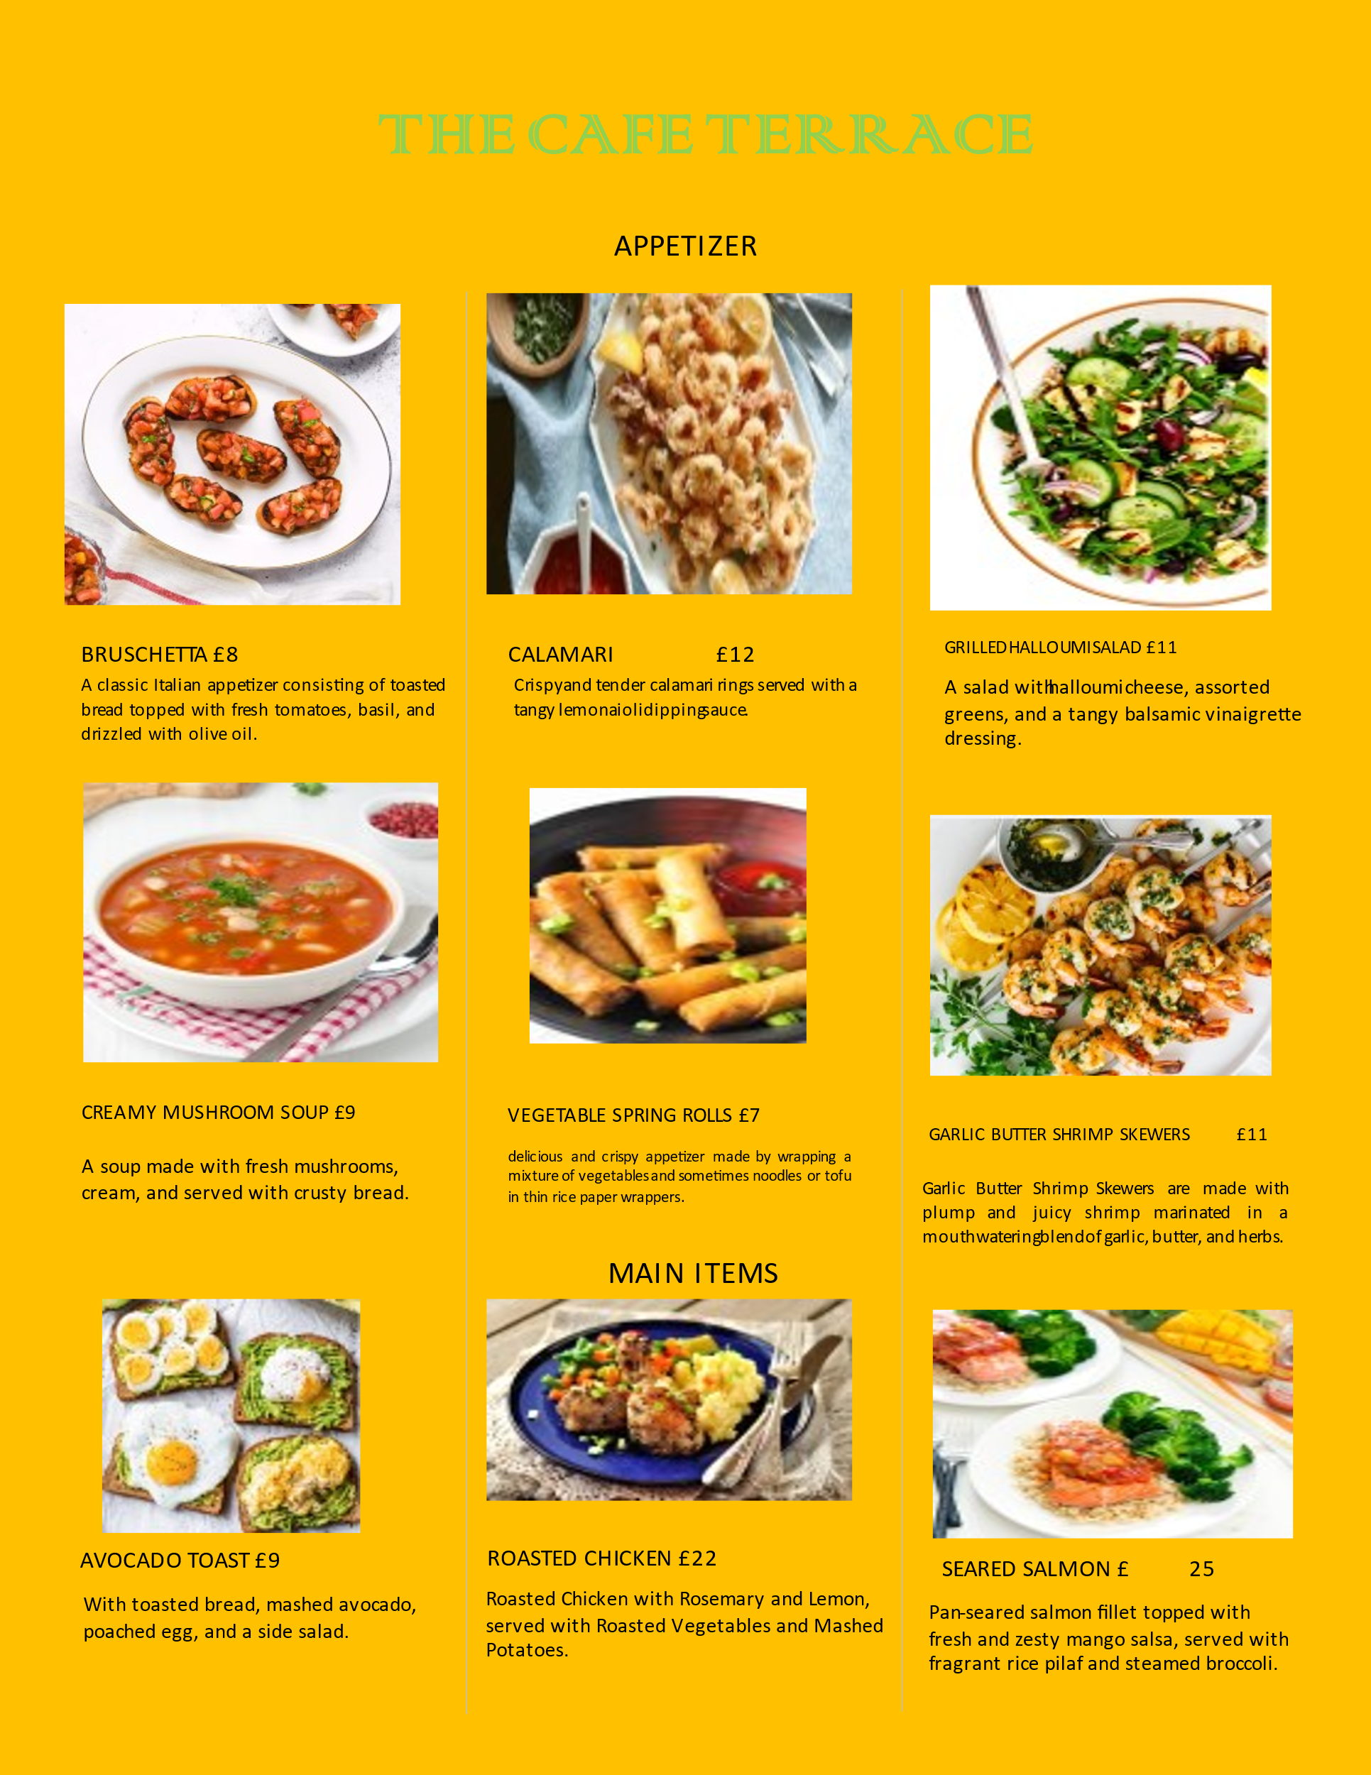

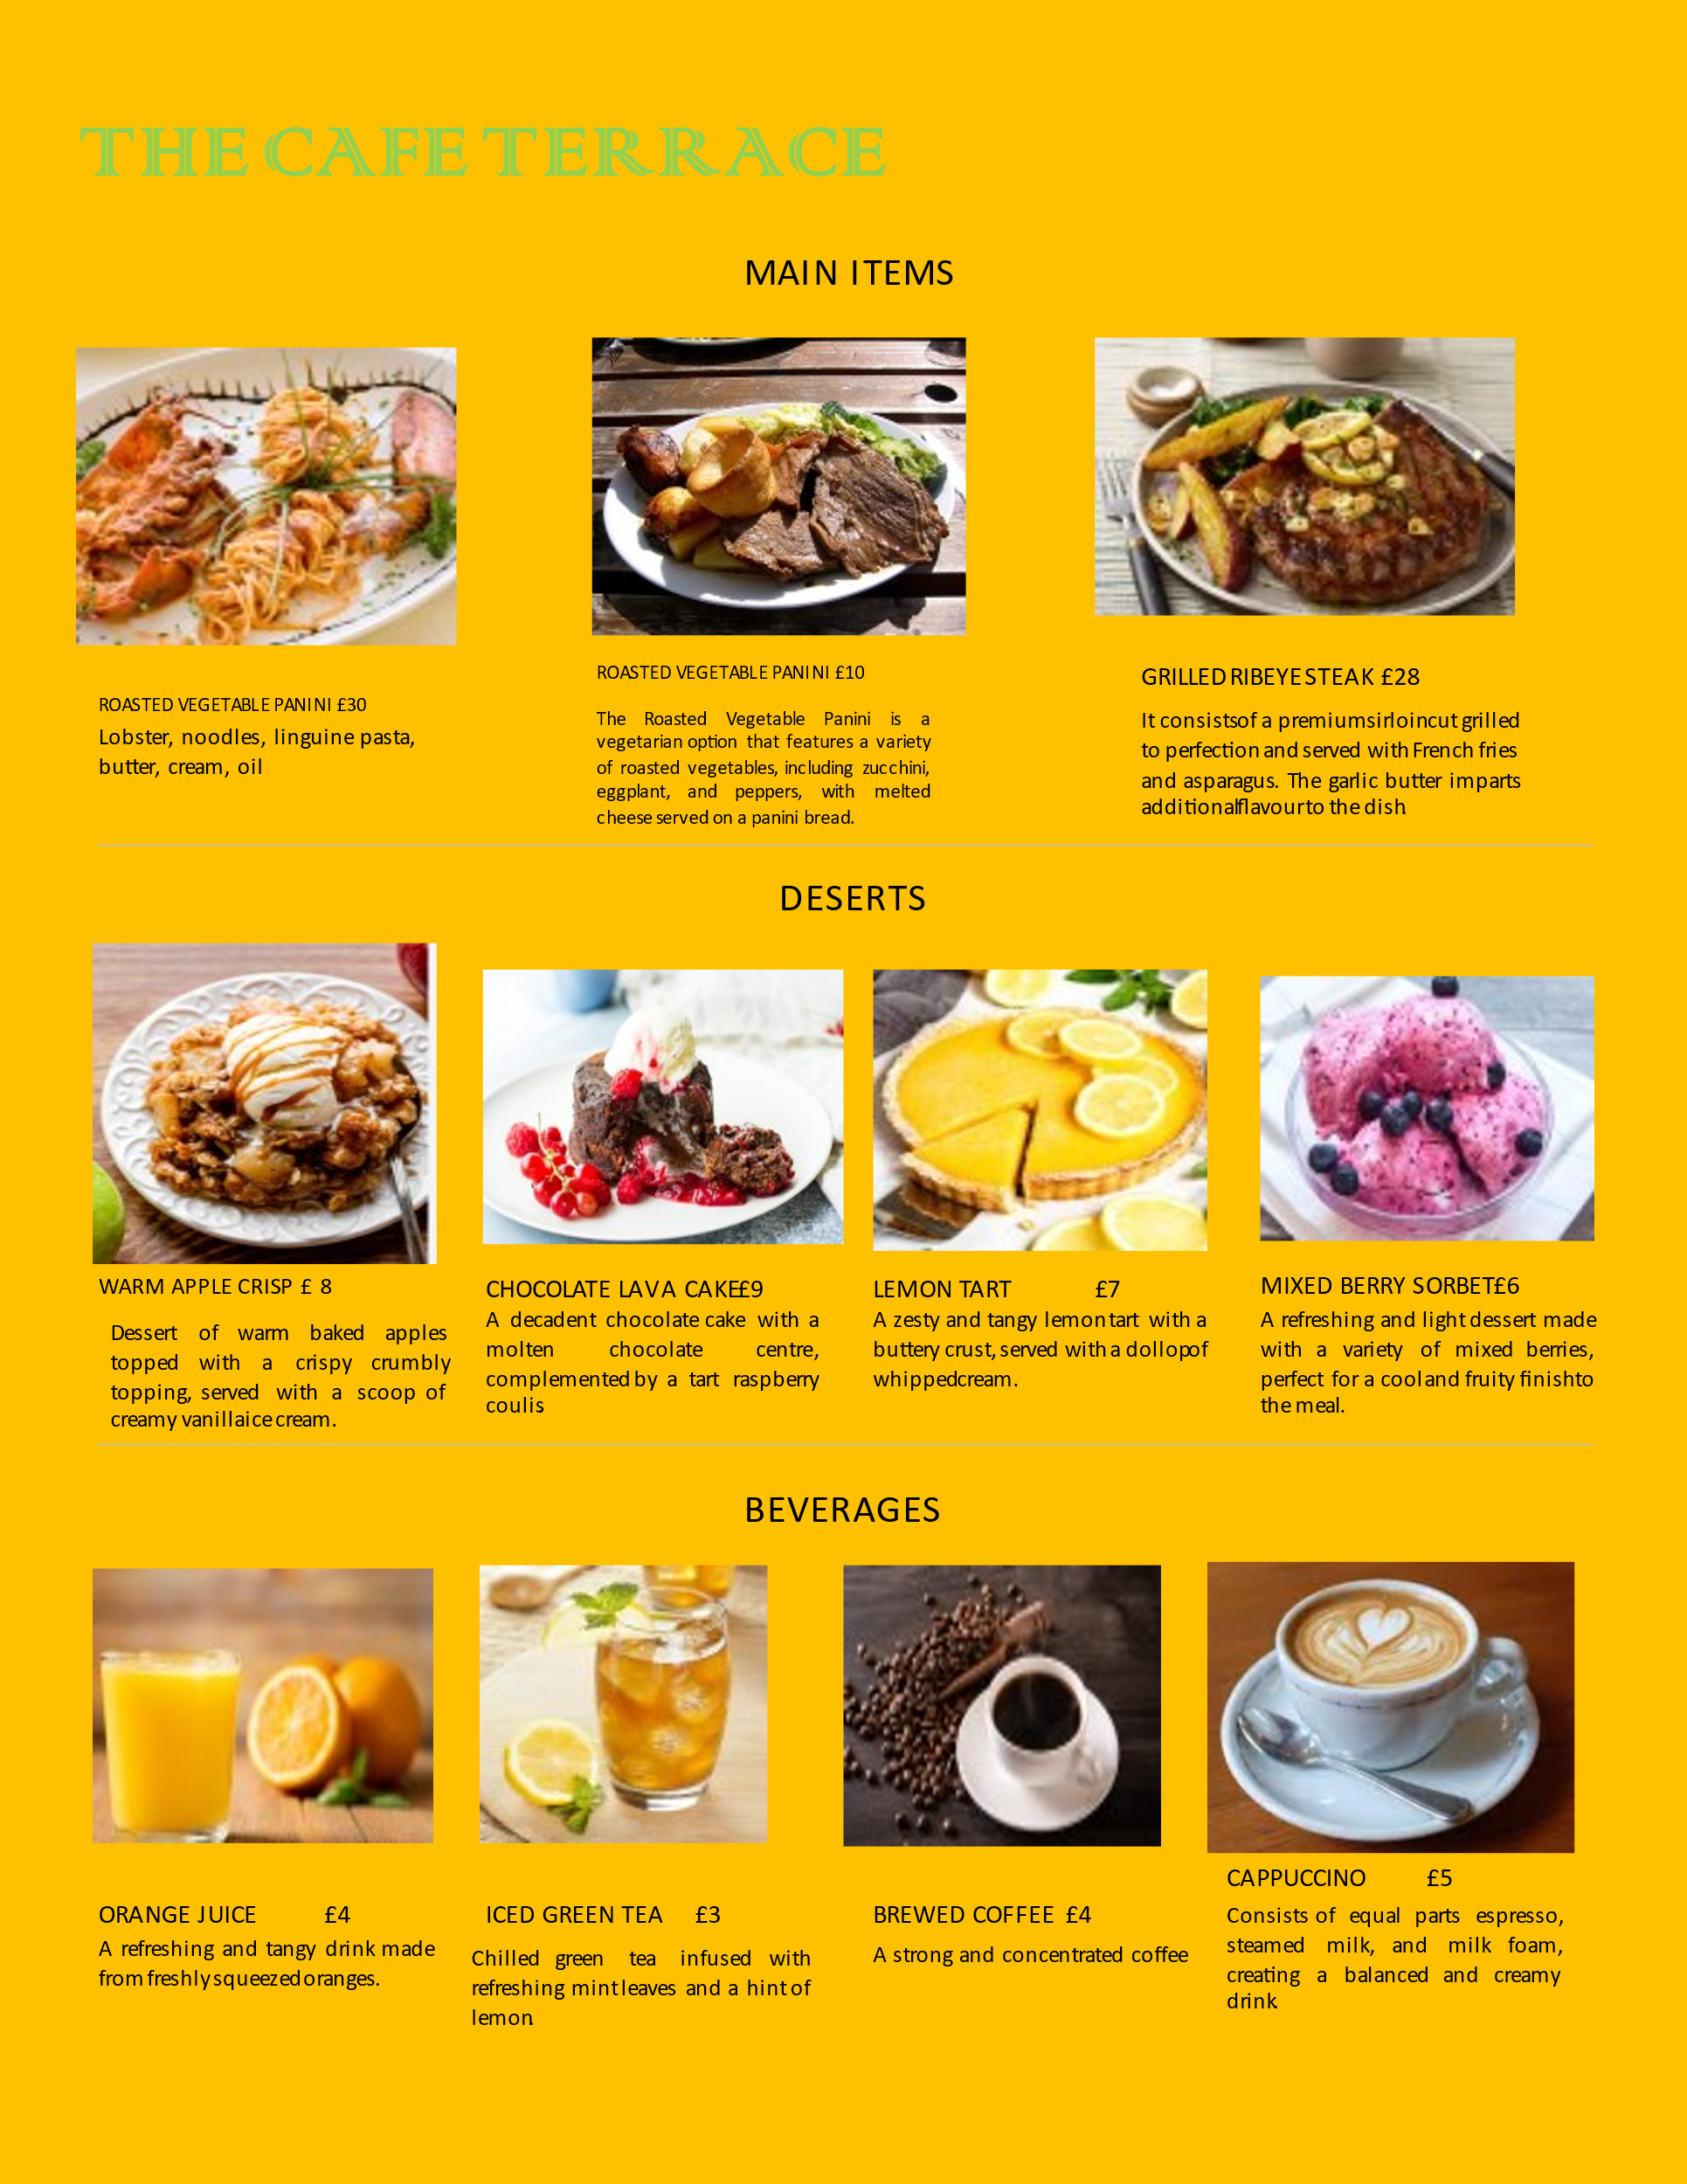

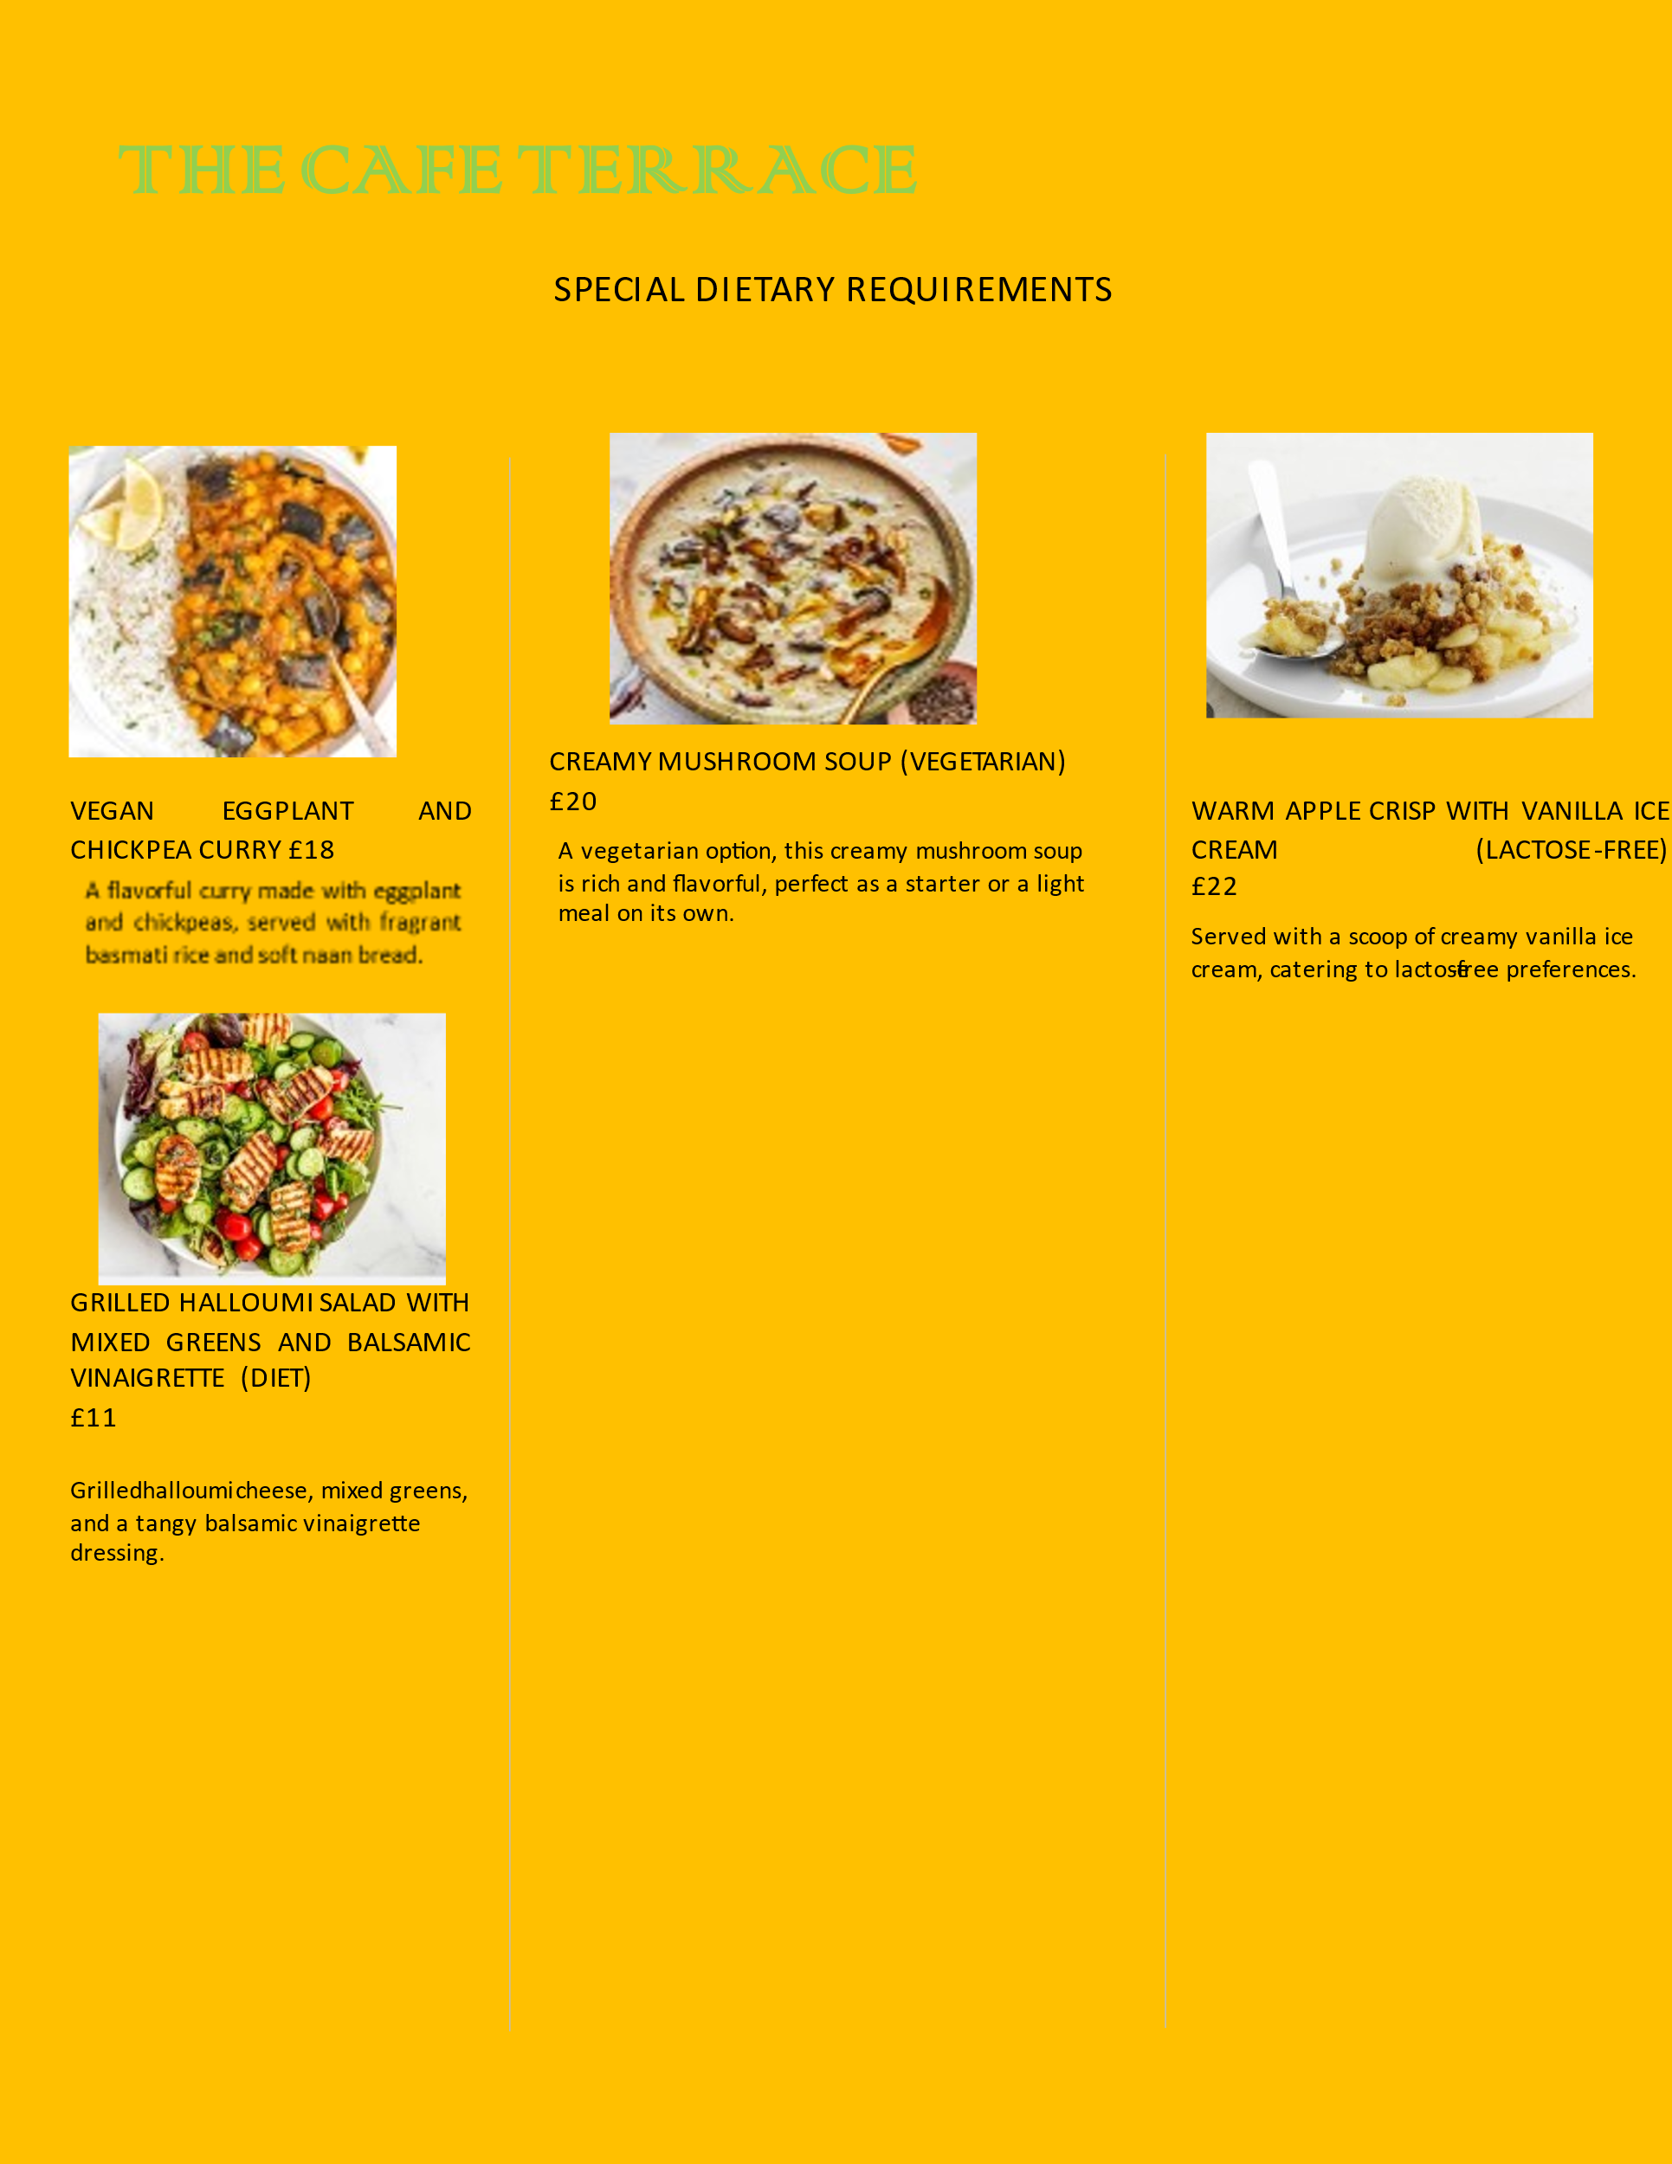

Thank you.

Reference
Bacon, L. and Krpan, D., (2018). (Not) Eating for the environment: The impact of restaurant menu design on vegetarian food choice. Appetite, 125, pp.190-200.
Baiomy, A.E., Jones, E. and Goode, M.M., (2019). The influence of menu design, menu item descriptions, and menu variety on customer satisfaction. A case study of Egypt. Tourism and Hospitality Research, 19(2), pp.213-224.
Filimonau, V., Lemmer, C., Marshall, D. and Bejjani, G., (2017). ‘Nudging’as an architect of more responsible consumer choice in food service provision: The role of restaurant menu design. Journal of cleaner production, 144, pp.161-170.
Jawabreh, O., Al Jaffal, T., Abdelrazaq, H. and Mahmoud, R., (2018). The impact of menus on customer satisfaction in restaurants classified in the Aqaba Special Economic Zone Authority (ASEZA). Journal of Tourism, Hospitality and Sports, 33, pp.29-39.
Lo, A., King, B. and Mackenzie, M., (2017). Restaurant customers’ attitude toward sustainability and nutritional menu labels. Journal of Hospitality Marketing & Management, 26(8), pp.846-867.
Nguyen, Q., Nisar, T.M., Knox, D. and Prabhakar, G.P., (2018). Understanding customer satisfaction in the UK quick service restaurant industry: The influence of the tangible attributes of perceived service quality. British Food Journal, 120(6), pp.1207-1222.
Peters, K. and Remaud, P.H., (2020). Factors influencing consumer menu-item selection in a restaurant context. Food Quality and Preference, 82, p.103887.
Zhang, C., Zhang, H. and Wang, J., (2018). Personalized restaurant recommendation method combining group correlations and customer preferences. Information Sciences, 454, pp.128-143.

