
Applied Leadership and Management in the Workplace
Module Assignment Submission
Student Name: | Leanne Thomas
Student Number: | 2318789
Module No: | BMSK5013
Module Title: | Knowledge and Information Management Skills for the Workplace

Statement of Confirmation of Authenticity
By the act of making this submission, the student declares that this is the work of the student named above. The work has not, in whole or in part, been knowingly presented elsewhere for assessment, or where assessment has been built on a previous assessment, this has been identified. Where materials have been used from other sources it has been properly acknowledged. If this statement is untrue, the student acknowledges that an assessment offence has been committed.
Attention is drawn to the plagiarism and unfair practice policies of both the University and of ILM.

Index
Introduction…………………………………………………………………………………………………….3
1.0 Evaluation of the Concept and Importance of Knowledge Management……………4
1.1 Relationship Between Data, Information and Knowledge………………………………..5
1.2 Relationship Between Individual and Organisational Knowledge………………………6
2.0 Framework for a Knowledge Management Culture………………………………………….7
2.1 Business Case for the Collection and Distribution of Knowledge……………………….9
2.2 Creating, Storing and Implementing Knowledge…………………………………………..10
2.3 Current Systems for Storage of Information…………………………………………………11
2.4 Key Performance Indications in the Workplace…………………………………………….13
1. Information Required by the Business………………….………………………………………15
2. Systems to Protect Confidentiality, Integrity and Availability of Information….….15
Conclusion……………………………………………………………………………………………………..16
References…………………………………………………………………………………………………….17
Appendix A – SECI Model…….………………………………………………………………………….20
Appendix B - Tactic and Explicit……………………………………………………………………….20
Appendix C – CIA Model………………………………………………………………………………….21
Appendix D – DIKW Model………..……….……………………………………………………………21
Appendix E – Intellectual Property and Organisational Knowledge……………………….22
Appendix F– implémentation cycle……………………………………………………………………22
Appendix G– DGPR…………………………………………………………………………………………23
Appendix H- Knowledge Management Process………………………………………………….23

Introduction
Knowledge management (KM) is the structured process through which organisations create, capture, store, share, and apply knowledge to ensure safe, consistent, and continuously improving practice. Davenport and Prusak (1998) define KM as “capturing, distributing and effectively using knowledge,” while Alavi and Leidner (2001) highlight how accessible, usable information strengthens organisational decision making. In a mental health residential home within Accomplish / Keys Group, KM underpins safeguarding, staff competence, regulatory compliance, and person-centred outcomes, making it essential to high-quality care.
Residential services depend on both explicit knowledge—policies, support plans, risk assessments, training records—and tacit knowledge such as staff intuition, experience, and relational understanding. Polanyi’s (2009) view that people “know more than they can tell” is particularly relevant in mental health care, where experienced staff recognise subtle behavioural or emotional changes before they appear in documentation. When tacit knowledge remains individual, inconsistency can arise during handovers, absence, or turnover; effective KM converts these insights into shared organisational knowledge, strengthening continuity and reducing risk.
This structured approach aligns with Care Inspectorate Wales (2024), which requires robust systems that support governance, transparency, learning, and accountability, and with the Social Services and Well-being (Wales) Act 2014, which mandates accurate information sharing, early intervention, and person-centred practice. KM supports these duties by ensuring support plans, risk assessments, incident learning, and professional guidance remain current, accessible, and consistently applied.
KM is also central to organisational learning. Senge (2006) describes learning organisations as those that improve through reflection, while Nonaka and Takeuchi’s (1995) SECI model shows how knowledge is continually created, shared, and internalised. These perspectives reinforce that KM is not simply document management but a dynamic cultural process involving systems, communication, reflection, and leadership.
Overall, KM provides the foundation for safe, person-centred, and well-governed care. It ensures staff have the right knowledge at the right time, supports consistent decision making, protects organisational knowledge assets, and embeds learning into everyday practice. This assignment will evaluate KM principles, explore the relationship between individual and organisational knowledge, examine systems for creating, storing, and sharing knowledge, and consider the importance of information governance, data protection, intellectual property, and organisational learning in delivering high-quality residential care.
1.0 Evaluation of the Concept and Importance of Knowledge Management
Knowledge Management (KM) is essential because it treats knowledge as a strategic organisational asset rather than informal information held by individuals. Dalkir (2017) argues that effective KM reduces duplication, strengthens learning, and improves organisational performance. In a mental health residential home, this is not only an efficiency issue but a safety, safeguarding, and ethical requirement, as staff decisions directly influence wellbeing, emotional regulation, medication safety, and risk management. When knowledge is inaccurate, inaccessible, or poorly shared, staff responses become inconsistent, increasing anxiety, distress, and potential harm to the individual in our care.
KM also underpins organisational learning and continuous improvement. Senge (2006) describes learning organisations as those that reflect on experience and embed learning into daily practice. This is highly relevant to Accomplish / Keys Group, where incidents, compliments, complaints, audits, and daily observations generate learning opportunities. Argote and Miron-Spektor (2011) emphasise that experience only becomes organisational learning when it is retained, transferred, and applied, and KM provides the structure that turns isolated insights into improved practice.
However, KM has limitations. Wilson (2002) argues that organisations often confuse KM with document management, assuming that storing information equates to managing knowledge. This is particularly relevant in residential care, where high-quality support depends on judgement, empathy, relational skill, and tacit understanding, not just written plans. Firestone and McElroy (2003) similarly highlight that knowledge is dynamic and socially constructed, meaning KM must integrate systems with culture, communication, and reflective practice.
Therefore, KM in care must be understood as both a technical and human process. It requires accurate records, strong information governance, and secure systems, but also open communication, reflective supervision, psychological safety, and effective leadership. This aligns with Care Inspectorate Wales (2024), which expects robust governance, quality assurance, transparency, and continuous improvement. Effective KM ensures that support plans, risk assessments, PBS strategies, incident learning, and professional advice are understood, shared, and consistently implemented.
In summary, KM strengthens safety, consistency, organisational memory, and staff competence. It prevents knowledge loss during turnover or absence and ensures predictable, therapeutic, person-centred care. KM is therefore a core component of high-quality residential practice, not an optional administrative task.

1,1 Relationship Between Data, Information and Knowledge
The relationship between individual and organisational knowledge is fundamental to how residential services learn and improve. Individual knowledge includes staff skills, experience, intuition and tacit understanding of people supported. Polanyi (2009) argues that “we know more than we can tell,” reflected in staff recognising emotional triggers, communication preferences and early signs of distress.
Organisational knowledge is the explicit knowledge embedded in policies, procedures, training and shared practices (Alavi & Leidner, 2001). Hislop (2013) states that it develops when individual insights are formalised. Nonaka and Takeuchi’s (1995) SECI model explains how tacit knowledge becomes organisational learning through socialisation, externalisation, combination and internalisation. Within Accomplish / Keys Group, this occurs through handovers, meetings, logs and support plan updates, supporting Senge’s (2006) concept of a learning organisation. Please see Appendix A SECI Model and Appendix B Tactic and Explicit.
This relationship directly affects wellbeing. Poor knowledge sharing can lead to inconsistent staff responses, increasing anxiety and dysregulation. In contrast, strong organisational knowledge supports predictable, therapeutic and person-centred care. Rycroft-Malone (2004) argues that effective knowledge sharing strengthens evidence-based practice. As Deputy Manager, I ensure valuable tacit knowledge is captured and embedded into organisational systems.
However, limitations exist. Polanyi (2009) and Tsoukas (2005) argue that tacit knowledge cannot be fully articulated, while Eraut (2000) notes that professional knowledge is often informal and embedded in practice. Newell et al. (2009) warn that over-reliance on formal systems can create gaps when experienced staff are absent.
Developing a strong knowledge management (KM) culture is therefore essential. Davenport and Prusak (1998) argue that knowledge only creates value when organised and applied, while Care Inspectorate Wales (2024) emphasises robust governance. Leaders must promote learning, reflective practice and effective communication (Hislop, 2013).
Knowledge should be created, stored and shared through handovers, supervision, meetings, incident reviews, support plans, risk assessments and digital systems such as Nourish and Radar. These systems should follow the confidentiality, integrity and availability (CIA) model (Stallings, 1995). Knowledge sharing through Multidisciplinary Team (MDT) meetings, reflective sessions and lessons learned reviews promotes consistent practice. Please see Appendix C CIA Model.
While Firestone and McElroy (2003) criticise linear knowledge models and Ackoff’s (1988) DIKW hierarchy overlooks relational aspects of care, both emphasise the importance of applying knowledge effectively. Leadership remains central in creating a culture of psychological safety, continuous learning and knowledge sharing. See Appendix D DIKW.
Overall, the interaction between tacit and explicit knowledge is essential for safe, consistent, person-centred care. Effective KM systems improve staff competence, reduce distress and enhance outcomes, supporting Rycroft-Malone’s (2004) view that strong knowledge management improves care quality.
1.2 Relationship Between Individual and Organisational Knowledge
Individual knowledge refers to the skills, experience, intuition, values, and tacit understanding held by staff. In residential mental health care, this includes recognising how a person communicates distress, what helps them feel safe, which routines reduce anxiety, and which relational approaches increase engagement. Polanyi (2009) and Tsoukas (2005) emphasise that tacit knowledge is difficult to articulate, yet it forms the foundation of high-quality care because staff develop subtle professional judgement through time, trust, and consistent interaction.
Organisational knowledge, by contrast, is the shared knowledge embedded in policies, procedures, training, digital systems, and workplace culture. Hislop (2013) explains that organisational knowledge emerges when individual insights are captured and formalised. Nonaka and Takeuchi’s (1995) SECI model illustrates this process: socialisation through observing colleagues; externalisation through handovers, supervision, and reflective discussions; combination through integrating insights into support plans, risk assessments, PBS plans, and training; and internalisation as staff apply updated knowledge until it becomes routine practice.
This relationship directly affects outcomes. When individual knowledge is not shared, people may receive inconsistent responses, leading to confusion, emotional dysregulation, or increased risk. When knowledge is embedded into organisational systems, staff responses become predictable, therapeutic, and person-centred. Rycroft-Malone (2004) notes that effective knowledge use depends on evidence, context, and facilitation, meaning leaders must create conditions that support consistent knowledge sharing.
There are risks in over-relying on explicit knowledge. Newell et al. (2009) warn that organisations may assume written processes are sufficient, overlooking relational and intuitive aspects of care. A support plan may describe a communication preference, but not the tone, timing, or relational approach that helps someone feel safe. Benner’s (2001) novice-to-expert model reinforces that expertise develops gradually through exposure, reflection, and guided practice. KM should therefore support not replace professional judgement, enabling expertise to transfer through mentoring, shadowing, supervision, and communities of practice.
In summary, individual and organisational knowledge are interdependent. Individual knowledge provides depth, nuance, and relational understanding, while organisational knowledge ensures consistency, continuity, and accountability. Effective KM ensures valuable insights do not remain with individuals but become part of shared organisational memory, strengthening safety, quality, and the lived experience of the people supported.

2.0 Framework for a Knowledge Management Culture
A strong Knowledge Management (KM) culture positions knowledge creation, sharing and application as essential to safe, person-centred practice. Schein (2010) argues that organisational culture shapes what people notice and communicate; therefore, a KM culture must promote psychological safety, open communication and shared responsibility. In a mental health residential home, this means staff feel confident to report concerns, ask questions and acknowledge uncertainty without fear of blame.
Within Accomplish / Keys Group, KM culture is built around five components: purpose, creation, storage, sharing and application. Leaders must clearly communicate the purpose of KM so staff understand its role in safety, consistency, wellbeing, compliance and organisational learning. Knowledge is created continuously through observations, incidents, audits, MDT discussions and reflective practice. Wenger (1998) and Lave & Wenger (1991) emphasise that learning is socially situated, so leaders must create opportunities for reflection and collaborative learning.
Knowledge must then be stored securely and accessibly through systems such as Nourish, Radar, electronic risk assessments and organisational policies. Dalkir (2017) highlights that strong KM strengthens organisational memory and prevents duplication. Sharing knowledge through handovers, meetings, supervision and MDT communication ensures individual insights become organisational learning. Nonaka and Takeuchi’s (1995) SECI model explains how tacit knowledge becomes explicit and embedded through socialisation, externalisation, combination and internalisation.
Knowledge only improves outcomes when applied consistently. Updated support plans, risk assessments and PBS strategies must be read, understood and used. Rycroft-Malone (2004) argues that evidence-based practice requires facilitation, meaning leaders must support implementation through supervision, modelling and feedback. This aligns with Care Inspectorate Wales (2024) expectations for governance, quality assurance and continuous improvement.
Leadership is central to sustaining KM culture. Kotter (2012) notes that meaningful change requires clear direction, urgency and reinforcement. For a Deputy Manager, this includes setting expectations for accurate recording, reviewing documentation, promoting psychological safety, ensuring training compliance and using audits to drive improvement. When knowledge is shared and applied effectively, individuals experience predictable, consistent and therapeutic care, strengthening emotional security and improving outcomes.

2.1 Business Case for the Collection and Distribution of Knowledge
A strong business case for collecting and distributing knowledge is grounded in five organisational priorities: quality, safety, efficiency, compliance and workforce resilience. In residential mental health care, knowledge is a critical organisational asset because it directly shapes decision making, safeguarding, emotional wellbeing and the consistency of support. Grant (1996) notes that knowledge enables organisations to coordinate complex activities, which is essential where staff, the individual, families, MDT professionals, social workers and regulators all contribute to a person’s care.
Quality and safety depend on accurate knowledge collection. When essential information is not recorded, it remains held by individuals, increasing the risk of inconsistent or unsafe practice. For example, if a person becomes distressed by changes in routine but this is not documented, new or agency staff may unintentionally escalate risk. Dalkir (2017) highlights that effective knowledge storage protects organisational memory, ensuring learning remains available even when staff leave. Consistent distribution of knowledge also reduces repeated incidents by ensuring lessons learned are shared and embedded. This aligns with the Social Services and Well-being (Wales) Act 2014, which emphasises accurate information sharing and early intervention as foundations of safeguarding.
Efficiency improves when knowledge flows effectively across the team. Davenport and Prusak (1998) argue that knowledge only becomes valuable when it is used. When information is shared through handovers, meetings, supervision, digital systems and policy updates, staff spend less time searching for information or duplicating work. This strengthens workflow, reduces administrative burden and supports continuity during staff absence, turnover or emergencies.
Regulatory compliance and governance also rely on strong KM processes. Care Inspectorate Wales (2024) requires accurate record keeping, transparent decision making and continuous improvement. A structured KM approach provides evidence of how information is captured, reviewed, updated and communicated. It also supports compliance with information governance principles, confidentiality, integrity and availability, reinforced by the Trade Secrets (Enforcement) Regulations 2018 and GDPR expectations.
Workforce development and resilience are strengthened when staff have access to the insights, strategies and relational knowledge needed to support individuals safely. Clear induction, mentoring and shared understanding reduce reliance on a small number of experienced staff, improve confidence and support reflective practice, contributing to a more stable and capable workforce.
Ultimately, the strongest business case for KM is its impact on the lived experience of the individuals supported. When knowledge is shared effectively, staff can identify patterns earlier, respond consistently, adapt support plans quickly and provide predictable, therapeutic care. This reduces distress, strengthens emotional security and supports recovery-focused practice.
In summary, collecting and distributing knowledge prevents the loss of critical information, reduces repeated incidents, strengthens safeguarding, improves staff competence, enhances regulatory compliance, supports continuity during staff changes and improves person-centred outcomes. A structured KM approach is therefore essential for safe, high-quality and resilient mental health residential care.
2.2 Creating, Storing and Implementing Knowledge
Creating, storing and implementing knowledge requires practical systems, clear organisational processes, strong leadership and a supportive culture. Knowledge must be deliberately captured, structured, protected and applied to ensure safe, consistent, person-centred care. Wiig (1997) argues that organisations must intentionally manage knowledge to maintain performance, while Dalkir (2017) emphasises that KM preserves organisational memory and prevents learning from being lost.
Knowledge creation begins with systematically capturing learning from everyday practice, including observations, incidents, complaints, compliments, supervision, MDT input and audits. Jennex and Olfman (2005) describe this as building organisational memory, where information from multiple sources is collected and interpreted. Staff must identify patterns and meaning, reflecting Kolb’s (1984) experiential learning cycle. Psychological safety is essential; if staff feel unable to report concerns or share insights, tacit knowledge remains hidden. Leaders must therefore model openness, curiosity and reflective dialogue. See Appendix E experiential learning cycle.
Knowledge must then be stored in reliable, secure and accessible systems. Digital platforms such as Nourish, Radar, electronic risk assessments, PBS plans, training systems and secure communication tools support accessibility, audit trails and oversight. Turban et al. (2015) highlight that digital systems enhance decision making by providing timely, structured information. Paper-based systems MAR charts, emergency grab bags, visitor logs and policy read-and-sign sheets remain essential for high-risk tasks (Atkinson & Heritage, 2017). All storage must comply with confidentiality, integrity and availability principles outlined in ISO 27001 (ISO, 2013) and reinforced by the Trade Secrets Enforcement Regulations 2018, supported by role-based access, password protection, version control and regular audits.
Knowledge only becomes valuable when implemented consistently. Rycroft-Malone (2004) argues that evidence-based practice requires facilitation, meaning leaders must actively support staff to use knowledge rather than simply providing access. Implementation relies on staff reading and understanding updated support plans and risk assessments, reading read and signs, attending training, engaging in supervision and reflective practice, and receiving clear communication through handovers and team meetings. MDT involvement ensures specialist knowledge is applied appropriately. A simple implementation cycle capture knowledge current and aligned with individual needs while supporting managerial accountability. See Appendix F implementation cycle.
In summary, effective KM requires structured systems, clear processes, strong information governance, leadership oversight, a reflective culture and regular evaluation. When these elements work together, knowledge becomes a shared organisational asset that strengthens safety, consistency, compliance and person-centred care.
2.3 Current Systems for Storage of Information
Effective Knowledge Management (KM) relies on reliable, secure and accessible systems that support accuracy, continuity, safeguarding, compliance and timely decision making. In residential mental health care, this requires a combination of digital, paper-based and process-based systems that together form organisational memory and support consistent practice.
Digital Systems
Digital platforms form the core of knowledge storage because they provide accessibility, audit trails, trend analysis and management oversight. Key systems include Nourish (daily notes, health information, support plans), Radar (incident reporting and trend analysis), electronic risk assessments and PBS plans, online training platforms and secure digital communication. Alavi and Leidner (2001) argue that such systems strengthen organisational memory and support informed decision making, aligning with Care Inspectorate Wales (2024) expectations for governance and transparency. These systems must comply with confidentiality, integrity and availability principles outlined in ISO 27001 (ISO, 2013), supported by access controls, encryption and audit trails.
Paper-Based Systems
Paper documentation remains essential for high-risk or immediate-access tasks, including MAR charts, emergency grab bags, visitor logs, fire registers and policy read-and-sign sheets. Atkinson and Heritage (2017) note that paper systems provide legal assurance and redundancy. However, they must be tightly controlled to avoid version confusion, with outdated copies removed and clear identification of the “source of truth.”
Process-Based Systems
Some knowledge is stored through organisational routines and communication processes such as handovers, supervision, reflective practice, team and MDT meetings, audits and lessons-learned reviews. Nonaka and Takeuchi (1995) emphasise that knowledge is created through interaction between tacit and explicit knowledge; these processes ensure that documented information becomes shared understanding rather than static records.
Integration and Consistency
The main challenge is ensuring alignment across digital, paper and process-based systems. Inconsistent records increase risk, so services require regular audits, version control, clear communication during handovers and leadership oversight to maintain accuracy and coherence. Integrated systems ensure staff base decisions on up-to-date, approved information.
When aligned and well governed, these systems strengthen safety, continuity, compliance and organisational learning. Effective storage prevents knowledge from being lost or siloed and provides a reliable foundation for consistent, person-centred care.
Key Performance Indicators
Key Performance Indicators (KPIs) measure how effectively knowledge is created, stored, shared and implemented. They link directly to safety, consistency, organisational learning and CIW governance expectations, ensuring KM becomes measurable and accountable.
Knowledge Accuracy and Quality
Records must be factual, complete and timely, with 95% accuracy demonstrated through audits and spot checks. Support plans and risk assessments should be updated within 48 hours of significant change or MDT advice. Reductions in repeat incidents indicate effective learning, supported by Radar trend analysis and lessons-learned reviews.
Knowledge Sharing and Communication
Handovers must consistently include essential information risks, mood, medication concerns, appointments and required actions monitored through senior checklists. Team engagement should reach 90% attendance at meetings, reflective sessions or documented catch-ups. MDT information must be recorded and shared within 48 hours to ensure timely integration into practice.
Staff Competence and System Use
All staff must be trained and competent in using digital systems such as Nourish and Radar, and in confidentiality and recording standards. Compliance is evidenced through the training matrix and supervision notes. Policy compliance should reach 100%, with reflective practice documented monthly to show how learning is embedded.
Organisational Learning and Improvement
Learning from incidents, audits and MDT advice must lead to demonstrable changes in practice, evidenced through updated plans, audit follow-ups and staff feedback. Compliance with the knowledge-flow process record, share, act, review should reach 100%, supported by audit trails and senior oversight. Safeguarding information must meet high standards of chronology, clarity and documented outcomes.
Person-Centred Outcomes
Improved consistency should lead to reductions in anxiety, dysregulation and incidents linked to inconsistent approaches, evidenced through Radar trends, wellbeing records and MDT feedback. Improvements in engagement, routines, sleep, nutrition and emotional stability further demonstrate the impact of effective KM.
Summary, These KPIs ensure KM is measurable, accountable and directly linked to improved safety, compliance and wellbeing. They provide a clear framework for evaluating how effectively the service captures, shares and applies knowledge to deliver consistent, person-centred mental health support.
2.4 Key Performance Indications in the Workplace
Key Performance Indicators (KPIs) provide a structured way to measure how effectively knowledge is created, stored, shared and implemented. They link directly to safety, consistency, organisational learning and the governance expectations of Care Inspectorate Wales (CIW). Strong KPIs ensure KM becomes measurable, accountable behaviour rather than an abstract concept.
Knowledge Accuracy and Quality
- Records must be factual, complete and timely, with 95% accuracy demonstrated through weekly audits and senior spot checks.
- Support plans and risk assessments should be updated within 48 hours of significant change or MDT advice, evidenced through audits and version-control logs.
- Reductions in repeat incidents where missed information contributed to risk indicate effective learning, supported by Radar trend analysis and lessons-learned reviews.
Knowledge Sharing and Communication
- High-quality handovers must consistently include key information: risks, mood, medication concerns, appointments and required actions. Senior checklists and observations monitor this.
- Team engagement should reach 90% attendance at meetings, reflective sessions or documented catch-ups.
- MDT information must be recorded and shared within 48 hours, ensuring professional advice is integrated promptly into practice.
Staff Competence and System Use
- All staff must be trained and competent in using Nourish, Radar, and in confidentiality and recording standards, evidenced through the training matrix and supervision notes.
- Policy compliance should reach 100%, monitored through read-and-sign trackers.
- Monthly reflective practice should show clear actions and updates to support plans, demonstrating embedded learning.
Organisational Learning and Improvement
- Lessons from incidents, audits and MDT advice must lead to demonstrable changes in practice, evidenced through updated plans, audit follow-ups and staff feedback.
- Compliance with the knowledge-flow process - record → share → act → review should reach 100%, supported by audit trails and senior oversight. See Appendix G knowledge-flow process.
- Safeguarding information must show clear chronology, actions and outcomes, evidenced through safeguarding audits.
Person-Centred Outcomes
- Reductions in anxiety, dysregulation or incidents linked to inconsistent approaches indicate improved consistency, supported by Radar trends, wellbeing records and MDT feedback.
- Improvements in engagement, routines, sleep, nutrition or emotional stability following knowledge-based interventions further demonstrate effective KM, evidenced through Nourish data and support-plan reviews.
These KPIs ensure KM is measurable, accountable and directly linked to improved safety, compliance and wellbeing. They provide a clear framework for evaluating how effectively the service captures, shares and applies knowledge to deliver consistent, person-centred mental health support.
1. What Information Is Required by the Business
The business requires accurate, timely and comprehensive information to ensure safe, consistent and person-centred care. This includes daily observations, behaviour records, incident reports, post-incident analysis, complaints, compliments, supervision notes, reflective practice discussions, MDT recommendations, audit findings and regulatory feedback. Together, these sources form the organisation’s knowledge base and support effective decision making. Jennex and Olfman (2005) describe this as building organisational memory, where information from multiple inputs is collected and interpreted to guide practice. Staff must not only record events but also identify patterns, meaning and implications, reflecting Kolb’s (1984) experiential learning cycle in which experience is analysed and used to improve future outcomes.
The business also requires up-to-date support plans, risk assessments, PBS plans, health information, medication records, training compliance data and communication logs. These documents ensure that staff have the knowledge needed to support individuals safely and consistently. Wiig (1997) argues that organisations must intentionally manage knowledge to maintain performance, while Dalkir (2017) highlights that effective KM prevents learning from being lost when staff leave or when situations change. For a residential mental-health service, this information is essential for safeguarding, regulatory compliance, MDT coordination and maintaining continuity of care.
2. Systems to Protect Confidentiality, Integrity and Availability of Information
Protecting the confidentiality, integrity and availability of information requires secure, reliable and well-governed systems. Digital platforms such as Nourish, Radar, electronic risk assessments, PBS plans, online training systems and secure email provide accessible and auditable records. Turban et al. (2015) argue that digital systems improve decision-making through timely and accurate information. Paper-based systems, including MAR charts, emergency grab bags and visitor logs, remain important for high-risk tasks (Atkinson & Heritage, 2017).
Information governance frameworks ensure knowledge is protected and used appropriately. ISO 27001 (ISO, 2013) and the Trade Secrets (Enforcement) Regulations 2018 emphasise confidentiality, integrity and availability (CIA). These principles are maintained through role-based access controls, password protection, secure storage, version control and audits. Confidentiality limits access to authorised staff, integrity ensures records remain accurate, and availability guarantees access when needed. Together, these safeguards support safe practice and regulatory compliance.
Organisational knowledge assets may also be protected through the Copyright, Designs and Patents Act 1988, Trade Secrets Regulations 2018 and Registered Designs Act 1949. Knowledge management must additionally comply with the Data Protection Act 2018 and UK GDPR, requiring information to be processed lawfully, stored securely and accessed only by authorised personnel. Secure records, audit trails, role-based access and staff training support compliance (ICO, 2023).
This approach aligns with the Keys Group (2024) Governance and Quality Assurance Framework, which promotes accountability, audit and continuous improvement. Effective knowledge sharing is particularly important when supporting individuals who display behaviours of concern. NICE (2015) recommends that support strategies are consistently implemented and informed by accurate assessment and review, while NHS Digital (2022) highlights the importance of secure records and staff understanding of information governance responsibilities.
Accurate information collection and distribution are also essential for incident reporting and organisational learning. The Health and Safety Executive (2020) states that analysing incidents helps identify trends, reduce risks and improve safety outcomes.
Leadership is critical in embedding these practices. Collins (2010) argues that leaders create cultures where knowledge is valued and applied. Bouthillier and Shearer (2002) distinguish between information management, which organises information, and knowledge management, which ensures knowledge is interpreted, shared and used effectively. This distinction is particularly important in residential care, where access to information alone does not guarantee safe and consistent practice.
Conclusion
Knowledge Management is a fundamental component of safe, effective and person- centred practice within residential mental health services. This assignment has demonstrated that knowledge extends beyond information and documentation to include the experience, skills and professional judgement of staff. Effective management of both tacit and explicit knowledge supports safeguarding, consistency of care, organisational learning and regulatory compliance. By embedding robust knowledge management processes into everyday practice, residential services can improve decision making, reduce risk, maintain compliance and deliver consistent, high-quality care that reflects the principles of person-centred support. See Appendix H Knowledge Management Process.

References
Ackoff, R. L. (1988). From data to wisdom. Journal of Applied Systems Analysis, 15(1), 3–9.
Alavi, M., & Leidner, D. E. (2001). Review: Knowledge management and knowledge management systems. MIS Quarterly, 25(1), 107–136.
Argote, L., & Miron-Spektor, E. (2011). Organizational learning: From experience to knowledge. Organization Science, 22(5), 1123–1137.
Atkinson, P., & Heritage, J. (2017). Structures of social action: Studies in conversation analysis. Cambridge University Press.
Benner, P. (2001). From novice to expert: Excellence and power in clinical nursing practice. Prentice Hall.
Bouthillier, F., & Shearer, K. (2002). Understanding knowledge management and information management. Information Research, 8(1).
Care Inspectorate Wales. (2024). Regulatory framework and inspection standards. Welsh Government.
Collins, D. (2010). Knowledge management and leadership in organisations. Routledge.
Copyright, Designs and Patents Act 1988. UK Parliament.
Dalkir, K. (2017). Knowledge management in theory and practice (3rd ed.). MIT Press.
Davenport, T. H., & Prusak, T. (1998). Working knowledge: How organizations manage what they know. Harvard Business School Press.
Data Protection Act 2018. UK Government.
Eraut, M. (2000). Non-formal learning and tacit knowledge in professional work. British Journal of Educational Psychology, 70(1), 113–136.
Firestone, J. M., & McElroy, M. W. (2003). Key issues in the new knowledge management. Butterworth Heinemann.
General Data Protection Regulation (GDPR). Regulation (EU) 2016/679.
Grant, R. M. (1996). Toward a knowledge-based theory of the firm. Strategic Management Journal, 17(S2), 109–122.
Health and Safety Executive. (2020). Incident reporting and RIDDOR guidance.
Hislop, D. (2013). Knowledge management in organizations: A critical introduction (3rd ed.). Oxford University Press.
ICO. (2023). Guide to the UK GDPR. Information Commissioner’s Office.
International Organization for Standardization. (2013). ISO/IEC 27001: Information security management systems.
Jennex, M. E., & Olfman, L. (2005). Assessing knowledge management success. International Journal of Knowledge Management, 1(2), 33–49.
Keys Group. (2024). Governance and quality assurance framework.
Kolb, D. A. (1984). Experiential learning: Experience as the source of learning and development. Prentice Hall.
Kotter, J. P. (2012). Leading change. Harvard Business Review Press.
Lave, J., & Wenger, E. (1991). Situated learning: Legitimate peripheral participation. Cambridge University Press.
Newell, S., Robertson, M., Scarbrough, H., & Swan, J. (2009). Managing knowledge work and innovation (2nd ed.). Palgrave Macmillan.
NHS Digital. (2022). Data Security and Protection Toolkit.
NICE. (2015). Challenging behaviour and learning disabilities: Prevention and interventions.
Nonaka, I., & Takeuchi, H. (1995). The knowledge-creating company. Oxford University Press.
Polanyi, M. (2009). The tacit dimension. University of Chicago Press. (Original work published 1966)
Registered Designs Act 1949. UK Parliament.
Rowley, J. (2007). The wisdom hierarchy: Representations of the DIKW hierarchy. Journal of Information Science, 33(2), 163–180.
Rycroft-Malone, J. (2004). The PARIHS framework. Journal of Nursing Care Quality, 19(4), 297–304.
Schein, E. (2010). Organizational culture and leadership (4th ed.). Jossey-Bass.
Senge, P. M. (2006). The fifth discipline: The art and practice of the learning organization (Rev. ed.). Doubleday.
Skills for Care. (2022). Knowledge and skills framework for adult social care.
Social Services and Well-being (Wales) Act 2014. Welsh Government.
Stallings, W. (1995). Network and internetwork security: Principles and practice. Prentice Hall.
Trade Secrets (Enforcement, etc.) Regulations 2018. UK Government.
Tsoukas, H. (2005). Complex knowledge: Studies in organisational epistemology. Oxford University Press.
Turban, E., Sharda, R., & Delen, D. (2015). Decision support and business intelligence systems. Pearson.
UK Government. (2018). Trade Secrets Regulations explanatory notes.
UK Parliament. (1949). Registered Designs Act 1949.
Wales Audit Office. (2021). Governance and assurance in social care.
Welsh Government. (2023). Information Governance Framework for Social Care.
Welsh Safeguarding Procedures. (2022). National safeguarding guidance.
Wenger, E. (1998). Communities of practice: Learning, meaning and identity. Cambridge University Press.
Wiig, K. M. (1997). Knowledge management: An evolving concept. Knowledge and Process Management, 4(3), 139–154.
Wilson, T. D. (2002). The nonsense of knowledge management. Information Research, 8(1).
World Intellectual Property Organization. (2020). Geographical indications.
World Intellectual Property Organization. (2021). Understanding intellectual property.
World Intellectual Property Organization. (2022). Trade secrets and confidential business information.

Appendices

Appendix A – SECI Model
The SECI Model explains how knowledge is created and shared within an organisation by converting personal knowledge into organisational knowledge through four stages: Socialisation, Externalisation, Combination and Internalisation.
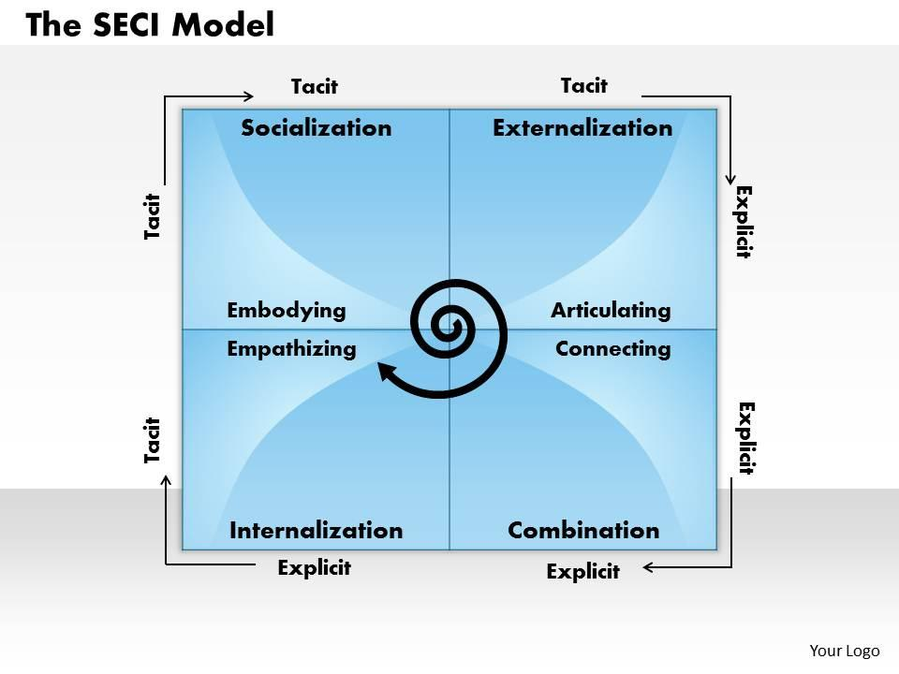 www.slideteam.net

Appendix B – Tactic and Explicit
Tacit knowledge is personal knowledge gained through experience and intuition, while explicit knowledge is documented information that can be easily shared. Both are important for supporting learning, consistency and effective care practice.
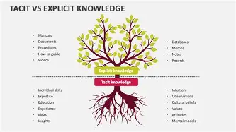 www.gaiinsights.substack.com

Appendix C – CIA Model
Confidentiality: Information is only accessed by authorised staff. Integrity: Information remains accurate and complete. Availability: Information is accessible when required to support safe care.

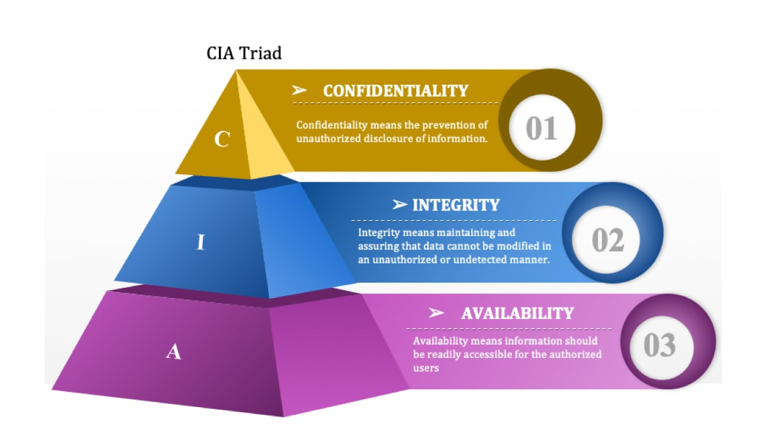www.torage.googleapis.com

Appendix D – DIKW Model
DIKW Model Explained (Data → Information → Knowledge → Wisdom) The DIKW model describes the four layers of understanding that build on each other.
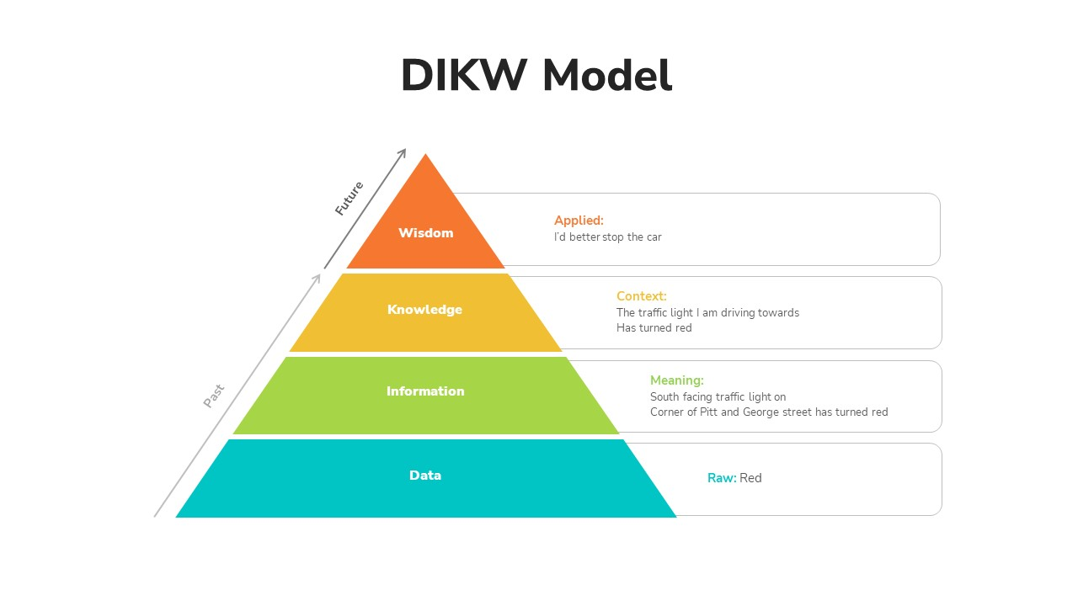www.slidebazaar.com

Appendix E – Intellectual Property and Organisational Knowledge
Policies, procedures, training materials and organisational systems are valuable knowledge assets protected through copyright, trade secret and related legislation.

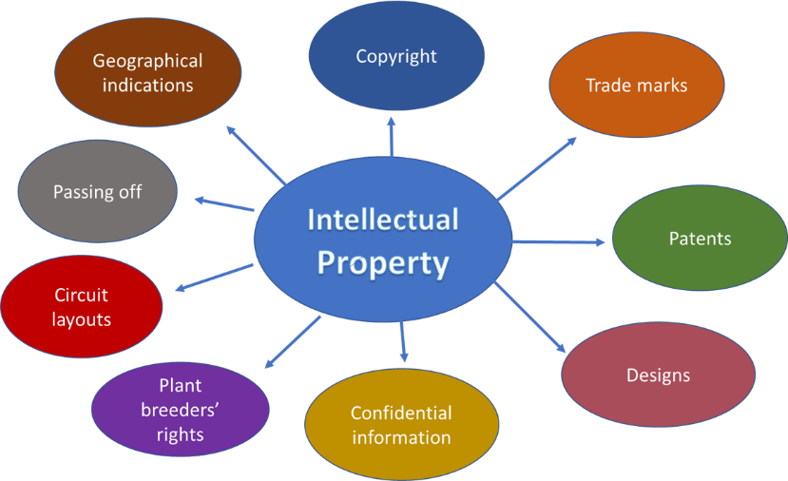www.linkedin.com Margaret Ryan

Appendix F – Implementation Cycle that fits seamlessly with the rest of your assignment and aligns with your KM framework (capture → check → store → share → apply → review → update).

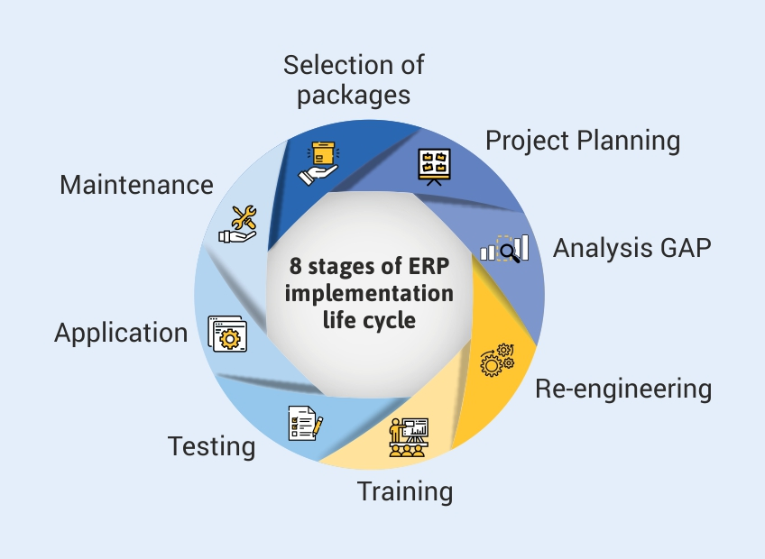 www.tallysolution.com

Appendix G – UK GDPR Principles
Lawfulness, Fairness and Transparency; Purpose Limitation; Data Minimisation; Accuracy; Storage Limitation; Integrity and Confidentiality; Accountability.

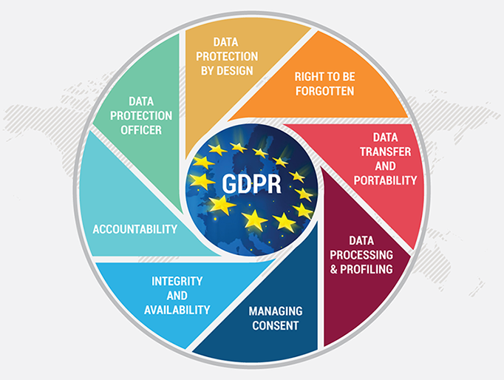 www.storage.googleapis.com

Appendix H – Knowledge Management Process
Knowledge Creation → Storage → Sharing → Application → Review and Continuous Improvement
.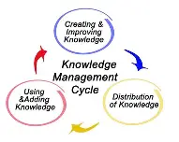www.storage.googleapiss.com

