Safiya Nanton (2114630)
04/05/2022
Lighting layout and sound index
ACBA4006

Material Science and Building Services

Table of Contents
Table of Figures 1
Task A: 2
Task B: 5
References 8

Table of Figures
Figure 1: Calculations for Room Index 2
Figure 2: Utilisation Factor Table 3
Figure 3: Calculations for Number of Lamps and S-value 3
Figure 4: Lighting Layout in Factory 5
Figure 5: Calculations for Light spacing 5
Figure 6: Calculations for Overall Sound Room Index 6

Task A:
Number 1:
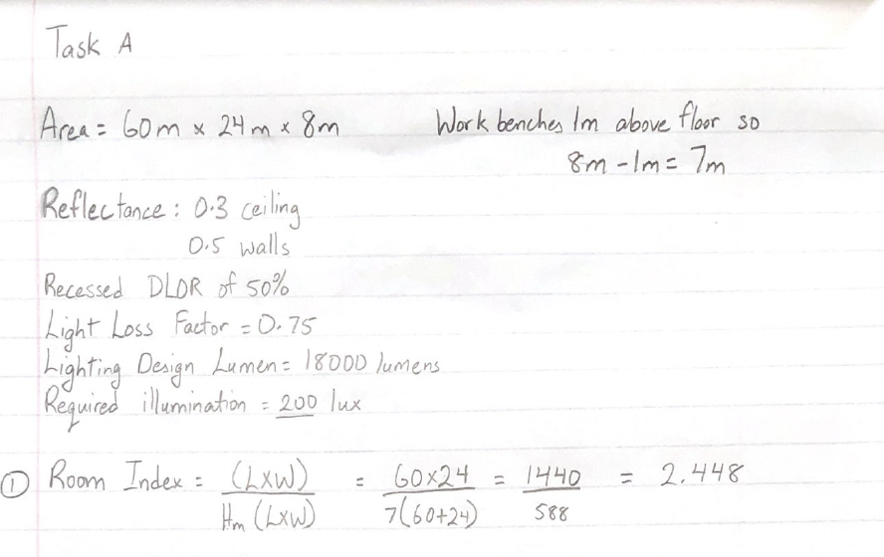
Figure 1: Calculations for Room Index

2. Utilisation Factor from the table below is 0.46
On the table the ceiling reflectance is 0.3, the wall reflectance is 0.5, the Basic DLOR% is 50% and the closest Room Index to my answer above is 2.5. The Light fitting described as well fitted the description from the question with it being a recessed louvre. They all indicate that the Utilisation factor is 0.46.
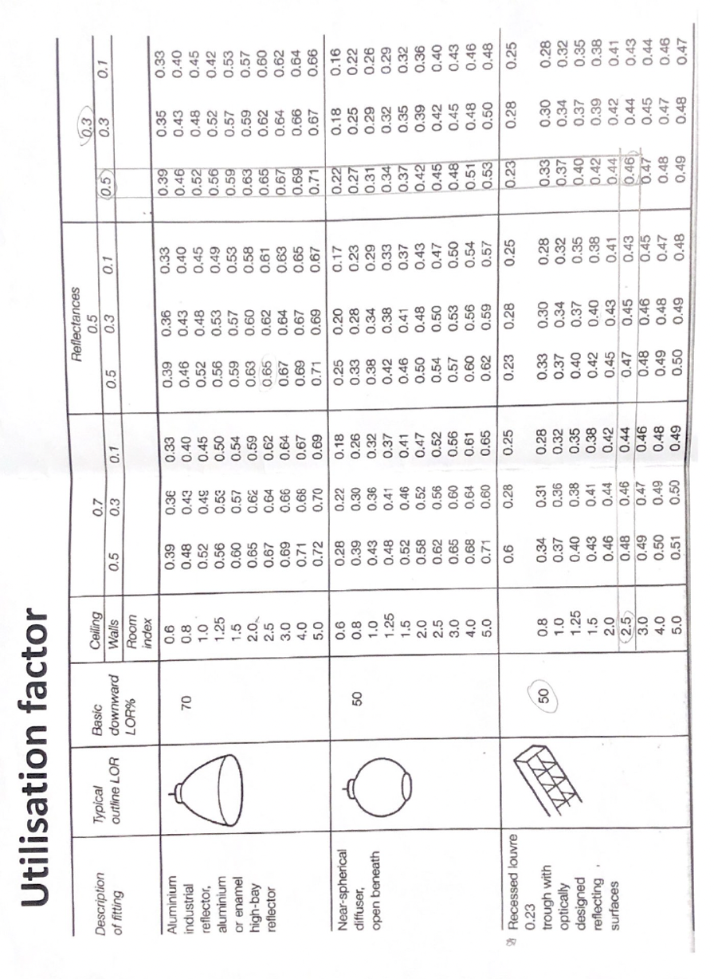
Figure 2: Utilisation Factor Table
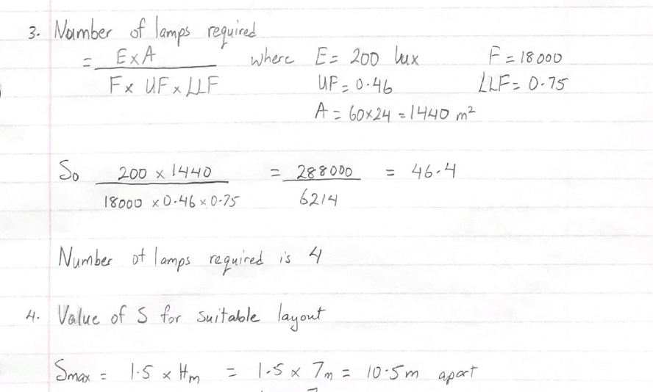
Figure 3: Calculations for Number of Lamps and S-value

Number 2: Lighting Layout

Figure 4: Lighting Layout in Factory
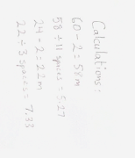
Figure 5: Calculations for Light spacing

Task B:
Number 1: Overall Sound Reduction Index
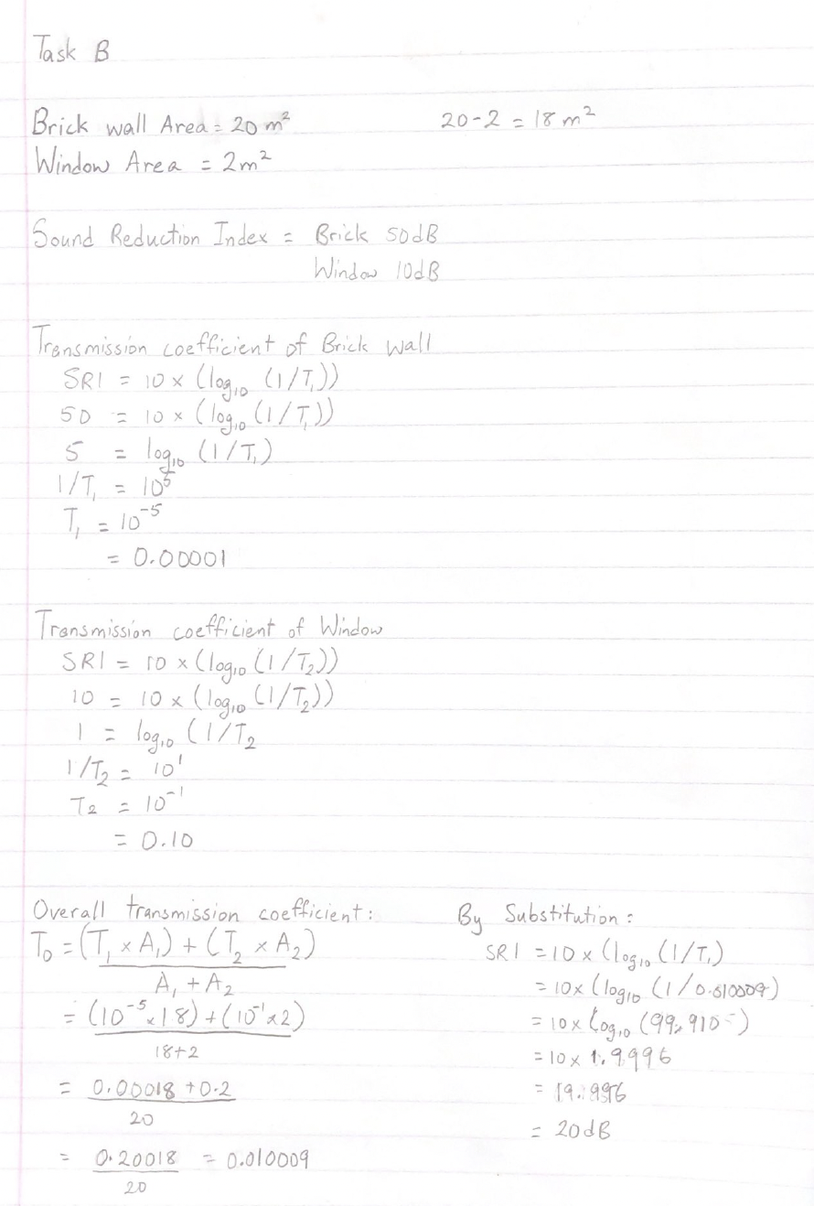
Figure 6: Calculations for Overall Sound Room Index
Number 2- Discuss the Implications of the factors of frequency and wavelength in:

Building fabric resonance
According to the Warwick Heath and Safety Services, any structure, surface, fixture, or fitting related internally or externally with a building is referred to as the fabric of the building (warwick.ac.uk, n.d.). Apart from architectural constraints, such as the quality of the structure's construction, an earthquake's unique resonance may demolish a small building while sparing the skyscraper. Resonance is the term used to describe the up-and-down or back-and-forth motion caused by a vibration. By estimating the natural frequencies of the building throughout the design phase, these motions may be kept within acceptable limits by wind and earthquakes. A structure's weight, rigidity, and height all contribute to its natural frequency. Structures that are heavy and rigid are less prone to shaking than those that are light and thin. Skyscrapers, which are tall and thin, have low integral frequencies and substantial electromagnetic field deflections. Individuals inside the building may feel sick if the structure sways over an extended period or if the movement is significantly accelerated. Exterior dampers may help prevent the structure from wobbling and allow it to recover to its original position more quickly (Eriksson, 2018). To lower the overall structure's resonance, a building's fabric can be built of heavy and sturdy materials.

Partition wall construction technique
There must be consideration for sound transmission between rooms throughout the design phase of a building to ensure that it meets acceptable reverberant standards. Noise should be kept to a minimum by designing and constructing structures in a manner that minimises sound transmission between and within structures. Small gaps in building partition components have a negative impact on sound attenuation, hence it is critical that floors and partitions be well sealed. When it comes to soundproofing walls and floors, it's best to choose rigid materials with greater bulk (BH Doors & Engineering Ltd, 2021).
In commercial structures, the layout of an office is critical for establishing divisions with varying degrees of functioning and isolation. Acoustic Products explains that in terms of sound insulation, it is thought that a partition will deal with airborne sound and minimise noise transmission from one room to the next. Regardless of the relative size of the lower rated product, the overall degree of sound attenuation will be less than that of the partition's highest rated component (Acoustic-products.co.uk, 2018).

The Insulation material choice
Materials such as insulation in the walls must be used to trap and absorb sound waves to prevent them from spreading. Blanket insulation is a form of material that may span the distance between studs in a wall, floor joists, and a ceiling beam. It's self-installing and doesn't need any more customization. Fiberglass is an excellent choice for insulation since it is both fire-resistant and long-lasting. Inorganic fibre glass insulation batts from Owen Corning are among the best on the market (Soundproof Living, 2019). Sound waves have a frequency that specifies how quickly pressure changes or cycles. When used between 500 and 2000 Hz, this insulator performs well. On the Contrary, A building's external walls can also use insulation that aids in sound absorption. They are the most common location for rigid insulation panels, although they may also be utilised inside. Because of their sturdy construction, they may be utilised for a wide range of applications. As an example, consider Rock wool can be used to insulate practically any aspect of a construction, including the walls, roof, and floors (Insulation-info.co.uk, n.d.). Rock wool may serve as a fire retardant and an acoustical barrier in addition to its thermal insulation capabilities. As a bonus, rock wool is made from mineral which makes it completely mould and rot resistant since it does not have an organic breeding ground.

References
Acoustic-products.co.uk. (2018). Acoustics In Buildings | Acoustic Products. [online] Available at: https://www.acoustic-products.co.uk/faq/acoustics-in-buildings/.
BH Doors & Engineering Ltd. (2021). A Guide To Acoustics In Buildings For Specifying Movable Wall Systems. [online] Available at: https://www.bhdoors.co.uk/a-guide-to-acoustics-in-buildings-for-specifying-movable-wall-systems/ [Accessed 3 May 2022].
Eriksson, J. (2018). HORIZONTAL NATURAL FREQUENCY IN A 10 STORY BUILDING. [online] Available at: https://www.diva-portal.org/smash/get/diva2:1251690/FULLTEXT01.pdf.
Insulation-info.co.uk. (n.d.). Rock wool insulation | Advantages, types and thicknesses. [online] Available at: https://www.insulation-info.co.uk/insulation-material/rock-wool.
Soundproof Living. (2019). Best Soundproofing Insulation for Walls & Ceilings in 2021. [online] Available at: https://soundproofliving.com/soundproof-insulation/.
warwick.ac.uk. (n.d.). Fabric of the Building - Pre-Work Guidance. [online] Available at: https://warwick.ac.uk/services/healthsafetywellbeing/guidance/asbestos/preworkguidance/ [Accessed 3 May 2022].
www.customaudiodirect.co.uk. (n.d.). Basic Room Acoustics. [online] Available at: https://www.customaudiodirect.co.uk/basic-room-acoustics [Accessed 3 May 2022].
www.sciencedirect.com. (n.d.). Leaf Partition - an overview | ScienceDirect Topics. [online] Available at: https://www.sciencedirect.com/topics/engineering/leaf-partition.
All Drawings and Calculations done by Safiya Nanton
Word Count: 611

