BMDS7003-CW

An overview of decision-support systems in secondary care phlebotomy workload management

Introduction
In secondary care inpatient settings in Wales, most pathology samples are taken by the phlebotomy department during daily ward rounds. Test requests are raised electronically, with sample labels printed by the requestor. In the laboratories, test samples are processed digitally using laboratory information management systems. Results are reported into electronic patient records through interoperable message flows.
The electronic test requesting and results process has been digitised to improve visibility and audit of test requests, improve the data quality and accuracy of testing, and increase the speed of results reporting. However, phlebotomy departments rely on paper labels and manual processes to manage and plan their daily workload and identify patient locations. Figure 1 highlights in red the parts of the system that require manual tasks rather than digital tools.

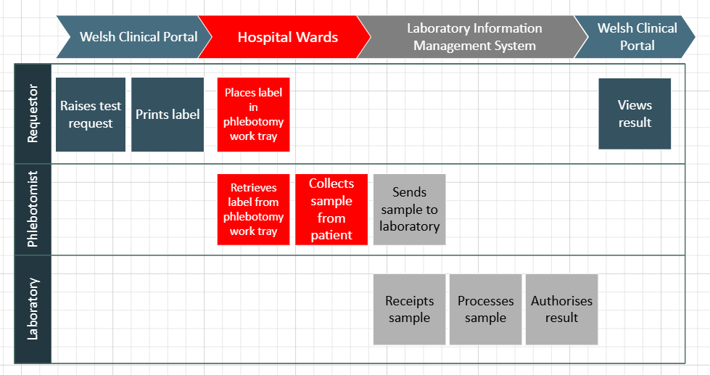
Figure 1: process map of “as is” secondary care inpatient phlebotomy workflow.
This essay will explore how the development and adoption of a clinical decision support system may enhance phlebotomy workload management. Through a systematic review, it will investigate the evidence base for digital phlebotomy worklists, including the effectiveness of such tools and potential implementation challenges. It aims to provide recommendations and considerations for decision makers, product teams, software designers and software developers. It concludes with a proposal on how build and implement a digital phlebotomy worklist that improves patient safety and streamlines phlebotomy round management.

Electronic test requesting
In NHS Wales, clinicians in primary and secondary care can request pathology tests electronically, either via Welsh Clinical Portal (WCP) or the GP test requesting system (Digital Health and Care Wales, no date b, no date a). This function is delivered through an electronic form that sits within the patient's digital record, which auto-populates with the patient demographics and allows the user to select single tests or test sets, and to record additional relevant information, such as whether the patient is fasting.
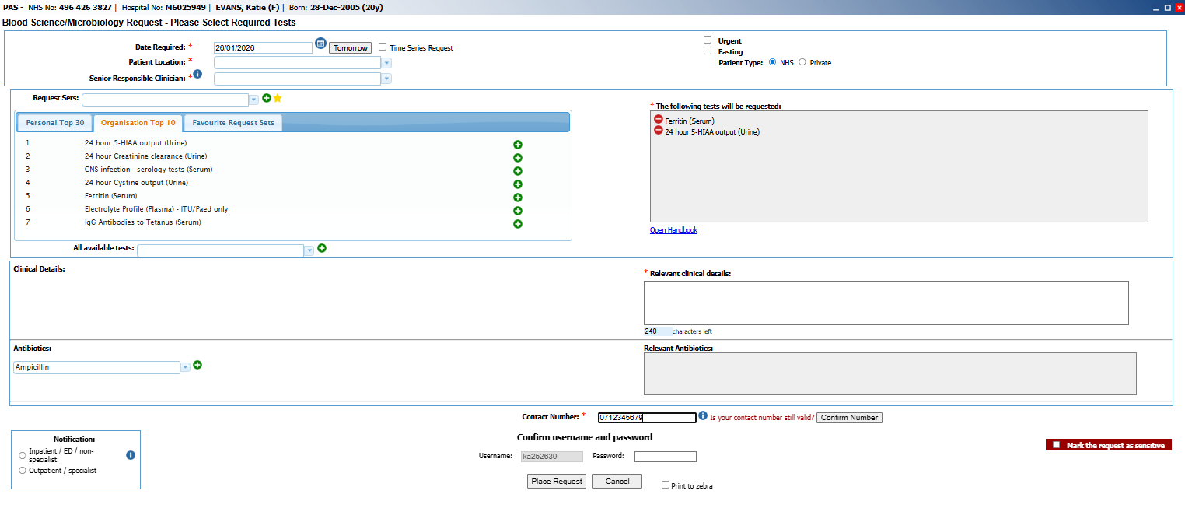
Figure 2: screenshot of secondary care pathology electronic test requesting form (from test environment).

When the user submits the request, the system generates a sample label for the user to print (Figure 3). When used in secondary care inpatient settings, the user can then either:
- Take the sample themselves and affix the label to the tube, or
- Add the label to the phlebotomist’s tray for the phlebotomist to take the sample during their rounds.

Secondary care phlebotomy
During ward rounds, the phlebotomist visits each ward in turn and collects the test request labels from their work tray. Using a bed management white board or the Patient Administration System on a desktop computer, the phlebotomists identifies where each patient is and plans their route around the ward. For each patient, the phlebotomist must check the identity matches the request details, take a blood sample and immediately affix the label to the tube, and then write the date and time on the label.
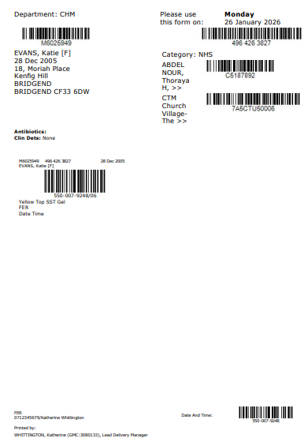
Figure 3: example pathology test request label (from test environment).

Once they have taken samples from each patient on the ward who requires a test, the phlebotomist moves onto the next ward. At the end of ward rounds, the samples are sent to the laboratory, where the barcode on the label is scanned into the laboratory information management system, which auto-populates with the test request details due to interoperability between the requesting system and the laboratory system.

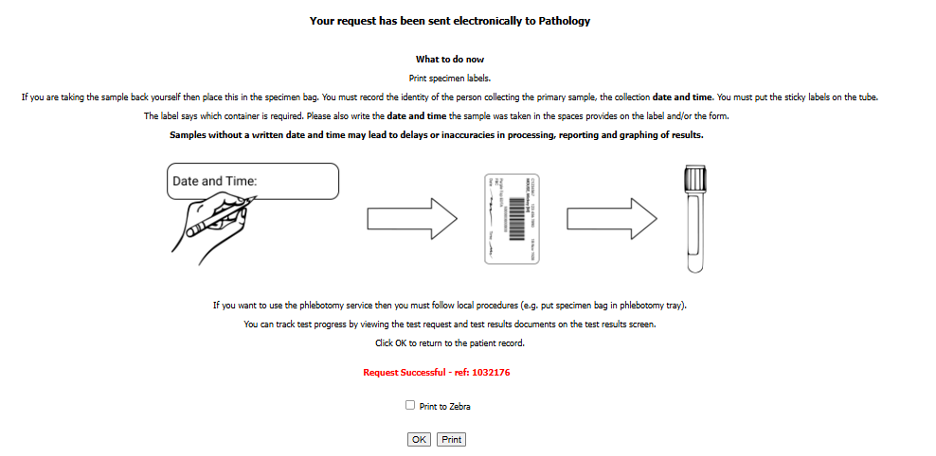
Figure 4: user instructions from WCP for pathology sample collection and labelling.

Rationale
The lack of digitisation in the phlebotomy process raises several issues.
Firstly, phlebotomy workload management deserves attention due to the scale of the service. In 2011 data from England, 800 million pathology tests are taken each year, at a cost of approximately £2.5 billion for the NHS (NHS Improvement, 2011), which is about 4% of total NHS expenditure (Lord Carter, 2006). In his review of pathology services, Lord Carter (2006) noted, “It is generally phlebotomists who collect samples from patients in hospital, and those attending outpatient clinics”.
Yet, despite the requesting and resulting workflow having been digitised, the phlebotomy process remains paper based. Therefore, the phlebotomy team cannot appropriately plan and prioritise their ward rounds. Instead, the phlebotomist attends one ward at a time and may not become aware of an urgent test request or busier than usual ward until they arrive. The phlebotomy department may not be utilising their resource as well as they could – one phlebotomist may be stuck on a busy ward whilst another is finished elsewhere, and lack of visibility of the team’s workload means colleagues cannot see where help is needed. This can also result delays for samples getting to the laboratory and urgent results being processed.
The current workflow in inpatient settings relies on quality and accurate information in the bed management or patient administration system. If the patient is moved or discharged and the system is not updated, the phlebotomist may waste time searching for the patient. Similarly, if the patient is away from their bed at the time of the ward round, the sample will not be taken, and the phlebotomist may waste time looking for them. Furthermore, the phlebotomy team may need to return to these wards later in the day to take samples from patients not available during ward rounds, further wasting phlebotomy resources.
If the clinician does not place the test label in the phlebotomist’s tray before the phlebotomist visits that ward, the patient may not be bled until a later ward round or until the following day, depending on the size of the hospital site. In some sites, the clinician may phone the phlebotomy department and ask the phlebotomist to return to the ward if the label was not in the tray when the phlebotomist attended. This results in additional workload for the phlebotomy department, as they may have to revisit wards.
Finally, paper labels may go missing. Once the label is printed, it must be placed in the phlebotomist tray, but if that label is lost, there is no audit or log of tests raised that need samples taken. Lack of visibility of the requests missed may result in a sample not being taken, which can delay diagnosis or discharge.

Clinical decision support systems
Sutton et al. (2020) state that clinical decision support systems (CDSS) are "intended to improve healthcare delivery by enhancing medical decisions with targeted clinical knowledge, patient information and other health information". They tend to combine clinical knowledge with computerised knowledge, to support prioritisation, resource management or diagnosis (Sutton et al., 2020), improve patient outcomes and reduce costs (Chen et al., 2023). The effectiveness of clinical decision support systems is impacted by the quality of the information used to build the system, the quality of the user interface (how the information or advice is presented to the user) and the behaviour of the user (Medlock et al., 2016).
CDSS vary in complexity, from AI-based systems that provide prescribing or diagnostic support, to natural language processing tools to ease administrative tasks, to wearables that support patient self-care through monitoring and alerts (Weiner and Biondich, 2006; Chen et al., 2023; Jung et al., 2025). This essay will explore the use of CDSS to support workload management, workflows and information availability.

Research question
Based on the context and rationale, this systematic review will seek out recommendations based on a literature search to ask the following questions:
- What are the advantages of adopting CDSS in secondary care inpatient phlebotomy departments?
- What are the considerations and challenges for designing and implementing CDSS in secondary care inpatient phlebotomy departments?

Evidence review

Source selection
The databases used for the article search were PubMed and Google Scholar. A search of grey literature was also undertaken, including the NHS website, the NHS Wales website and the Kings Fund, but no relevant materials were identified.
The databases selected utilise different search logic, so different search strings were used. The searches were conducted on 31/01/2026.
In PubMed, the following search string was used:
- ((phlebotomy) AND (decision support)) OR ((phlebotomy workflow) AND (decision support)) OR ((worklist) OR (workflow)) AND ((phlebotomy) OR (phlebotomist))
In Google Scholar, the following search criteria was used:
- "phlebotomy" AND "Decision support" AND "workflow"
- exclude citations
Database searches resulted in 932 results to be screened. With duplicates removed, 925 were screened. Of these, 887 items were excluded based on the title or abstract. 38 articles were then sought for retrieval, but 8 could not be retrieved. Then, 30 articles were assessed for eligibility, and 21 were excluded. A total of 9 articles were therefore included in the review. Figure xx represents the flow of identifying relevant sources to include.
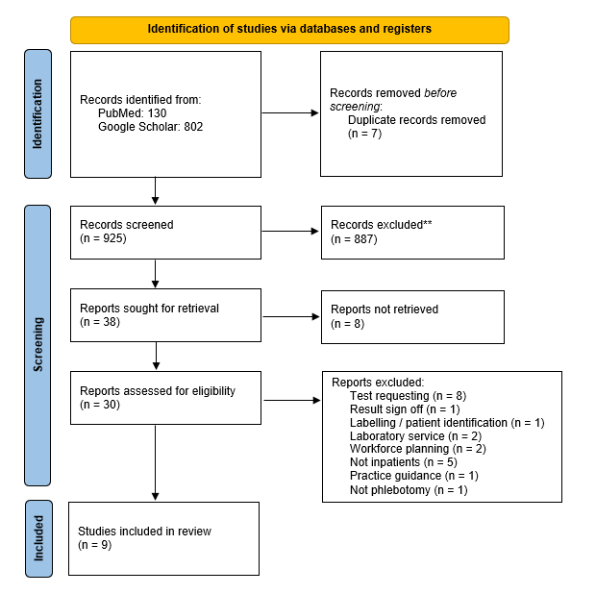
Figure 4: PRISMA flowchart showing source selection process.

Exclusion criteria
QUESTON FOR ED: if I talk about exclusion criteria, do I need to reference those that were excluded?
The most common reason for exclusion was that articles addressed alternative elements of the pathology process. Table 1 shows the number of articles that did not focus on the phlebotomy flow.
Table 1: justification for articles excluded because they were not relevant to the phlebotomy service.
Stage in pathology process | Number of articles
Test requesting | 8
Labelling / patient identification | 1
Result sign off | 1
Laboratory service | 2
Total | 12

Although these sources reflect the wide breadth and multidisciplinary nature of pathology services, and in some cases included the application of CDSS, they either focused on the requestor / clinician activities such as requesting and result sign off, or on laboratory investigation or information management.
Five articles did focus on the phlebotomy service, but in different settings: four explored outpatient phlebotomy clinics, and one was about primary care phlebotomy. Careful consideration was given to whether these cases were an analogous evidence base for inpatient secondary care phlebotomy. However, these studies focused on improving the patient experience and managing waiting times by introducing patient ticketing / sign-in systems. Thus, it was judged they could not be applied to secondary care inpatient settings, where the phlebotomist comes to the patient, rather than the patient coming to the phlebotomist.
Two of the articles explored how workforce planning and resource allocation could enhance the phlebotomy service, but there was no discussion of workflow or process changes or clinical decision support tooling.
Of the remaining articles excluded, one was practical guidance for laboratory staff, and another was a systematic review of clinical decision support tools with no focus on pathology or phlebotomy services.

NOTE FOR ED: everything after this is bullet points or notes for what I will do next.

Articles included
Describe the properties of the articles included – year of publication, research methods (qual or quan), key themes/trends

Critical appraisal / synthesis
Grade the evidence of effectiveness, identify any gaps in the existing evidence base and compare your selected digital decision aid to other types of decision support. Synthesise what remains, and explain what is not yet known, identify gaps, explore whether other domains could be used as an evidence base.
To assess the quality of the studies included in this review, a custom tool was created for the critical appraisal, utilising the PRISMA 2020 checklist (Page et al., 2021).

Challenges in implementation
Discuss the risks and constraints associated with application of decision support in the specified business area and what methods you propose to manage these factors.
Consider replicating a table like Sutton et al: Table 1 Benefits of clinical decision support systems (CDSS), possible harms, and evidence-based mitigation strategies.

Advantage | Explanation
Patient safety | Reduction of unnecessary duplication of testing by improving visibility of existing test requests and improve phlebotomy workflow to identify and bleed patients.  Reducing potential of missed phlebotomy due to better visibility of who needs a blood test.  Barcode scanning to ensure the right patient is being bled for the right test.
Clinical management | Improved legibility and completion of mandatory fields; easier to see patients due a blood test and follow up non-attendees / missed bleeds, e.g., patient not in bed; providing information in real time, at the time it is needed
Cost containment | Reduction of duplication of tests due to lost paperwork or lack of visibility of test requests and results.  Increase speed of phlebotomy rounds due to visibility of worklist.
Admin functions | Auto population of patient demographics from MPI database; creation of test sets; standardised data sets for fields, e.g., patient location; providing information in real time, at the time it is needed
Patient experience | Potential to improve discharge times and reduce duplication of tests by enabling phlebotomists to more easily identify patients and speed up test request and processing times.  In community settings, less reliance on patient to remember test paperwork; potential to increase availability or visibility of available appointments.
Documentation and audit | Visibility of existing test requests and status of test; standardised data set for test requests; improved legibility and completion of mandatory fields.
Workflow improvement | Visibility of test requests so phlebotomy team can better plan their workload, evidence their workload, identify patient location, identify priority test requests, etc.  In community settings, ability to see patients due phleb so they can be followed up if not attending.
Discharge timelines and bed management | Potential to ease bed management and improve discharge times by enabling phlebotomists to more easily identify patients and speed up test request and processing times.

Disadvantage / Risk | Middleton’s challenges | Explanation | Mitigation / solution
Financial costs | Implementation and integration | Cost of initial purchase and ongoing maintenance of devices | Cost/benefit analysis from outset.  Research potential maintenance / replacement costs and plan long-term budget.  Utilise usage management data to show ongoing benefits of costs incurred in purchase of devices.
Battery life | Architecture and technology | Mobile devices reliant on users remembering to charge them up ready for next user. | Creation of new workflow with users to include processes for charging devices.  Consider purchase of mobile charging tools for back up.
Interoperability | Architecture and technology | Dependency on interoperability with LIMS system – potential operational support implications.  Dependency on PAS / bed management system for patient location. | Assess and predict long term operational support costs from start.  Consider adoption of Cloud data – more flexible, open architecture.
Information / data accuracy | Data | if the bed location is inaccurate, the phlebotomists waste time finding the patient | User training.  Patient RFID – scan the patient when they leave the ward or move beds to speed up the updates in the PAS.
Changes to workflow or clinical guidance | Users | May require software development changes in future. | Plan for long-term operational support costs.  Transition to product management to ensure longer term software development and continuous improvement is planned in.  Work with test requestors and phlebotomists on workflow to ensure user satisfaction.
Variation in workflow or environment | Users | Intended national solution but may not work for different settings, e.g., community phlebotomy | Need for extensive workflow analysis before adoption.  Design for flexibility and personalisation in different settings.
Data standardisation – national agreement | Data | Similar to above. | National standards to be agreed with clinical input and national data standards team.
Expanded use - national | Implementation and integration | Potential data storage requirements may increase when usage increases | Consider adoption of Cloud data storage – more flexible, open architecture. Need to consider security of cloud.
Security | Implementation and integration / Users | Use of mobile tablets or devices open to higher security risk | User training in device management including locking devices when not in use.
Impact on user skill / user digital literacy | Users | Limited impact – this tool is simply an admin tool for managing workflow and workload.  Potential for users to create workarounds?  Success is dependent on user training and digital literacy. | Assessment of user digital literacy and offer training if required.  Work with users to ensure that the tool meets user needs and allows for flexibility and different user scenarios or environments.  Ongoing evaluation of user experience and skill, beyond initial implementation.
Patient experience | Implementation and integration | Some patients have negative associations of clinicians using digital devices | User training to ensure continued face to face time and engagement.  Patient engagement to explain why digital devices are being used.

Recommendation
Describe the proposed digital solution
[Insert screenshots from phleb module/ App Presentation.pptx

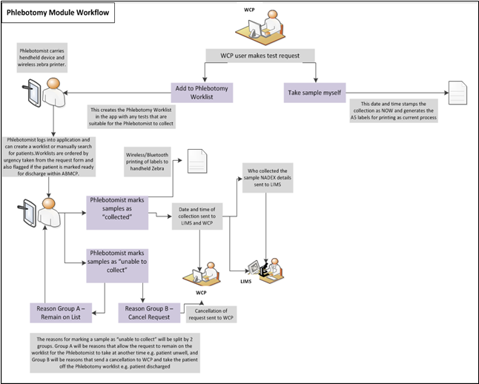

Conclusion
Explain and justify how you would assess the user experience, effectiveness, safety and efficiency of the proposed decision support tool. Try to come up with a “proposal” of some sort.
- Process mapping – existing workflow, potential pinch-points, acknowledge that existing workflow may not be perfect so workflow could be adapted with input from clinicians.
  - Most projects don't fail because the information is wrong, but because the flow is wrong.
  - Fitting CDS into real life workflows, cognitive load, social interactions.
  - Requires CDS in real time at the appropriate time (not just after the decision is made).
- User training – improves device safety, user experience, patient experience.
  - Also good XUI – explainable user interface (Jung 2025)
- Use cloud – flexibility, open architecture, cyber security.
- Pilot – start in a small site with a simple workflow process, evaluate, then use LSS tools to explore other sites that could be process mapped, and adapt. Build slowly and iteratively with stakeholder engagement.
  - E.g., start in small secondary care site e.g., NPT inpatients; then look at other secondary care settings with bleepers, or outpatient phleb, then look at community settings.
- Initial costings – analysis of costs of set up, implementation and ongoing maintenance.
- Ongoing evaluation – periodical evaluation points before, during and after implementation to assess user experience, effectiveness, safety and efficiency.
  - Learning health cycle - last stage is implementation - ongoing, refinement, continuous improvement
  - Surveys and observations – on-site and via email/Teams.
  - Allows identification of potential user-created workarounds, issues with data standards, issues with security, changes in guidelines / workflow, device issues, etc.
  - Build in feedback form to the product so users can easily identify issues and report them.
  - Build operational support model to deal with local / small issues.
  - Build product management model around the solution to ensure continuous improvement – ongoing business analysis, user interaction design and software development.

Note:
- If similar articles/reviews are found, consider adopting critical approach to analysing why they are different from this essay.
- Consider noting limitations, e.g., one researcher, lack of evidence of existing similar systems, brand new technology not yet tested, lack of validation by external domain experts (mitigated using PRISMA to show research process); date limitations if relevant (?)

Limitations
- Due to limited results, no date filter was applied - this may mean some research is out of date.
- "Despite best care and effort, it is possible that some references may have evaded our literature search and not be included in this systematic review, representing a potential limitation of this study."
- Focused on inpatient settings - there were papers on outpatient settings but this essay found that there is too much variation in the issues faced in inpatient vs outpatient settings to make findings from outpatient settings applicable.
- May mean these outputs cannot be generally applied across other clinical settings
- Heterogeneity between the studies - list the types of variation found
- Studies should have stronger designs, e.g., randomised control trials

References
Lord Carter (2006) ‘Report of the Review of NHS Pathology Services in England’. Available at: www.dh.gov.uk/publications (Accessed: 1 February 2026).
Chen, Z. et al. (2023) ‘Harnessing the power of clinical decision support systems: Challenges and opportunities’, Open Heart, 10(2). Available at: https://doi.org/10.1136/openhrt-2023-002432.
Digital Health and Care Wales (no date a) Electronic Test Requesting in GP Practices. Available at: https://dhcw.nhs.wales/product-directory/our-digital-services/electronic-test-requesting-in-gp-practices/ (Accessed: 25 January 2026).
Digital Health and Care Wales (no date b) Welsh Clinical Portal. Available at: https://dhcw.nhs.wales/product-directory/our-digital-services/welsh-clinical-portal/ (Accessed: 25 January 2026).
Jung, I.C. et al. (2025) ‘Overview of basic design recommendations for user-centered explanation interfaces for AI-based clinical decision support systems: A scoping review’, Digital Health, 11. Available at: https://doi.org/10.1177/20552076241308298.
Medlock, S. et al. (2016) ‘Modeling information flows in clinical decision support: key insights for enhancing system effectiveness’, Journal of the American Medical Informatics Association, 23(5), pp. 1001–1006. Available at: https://doi.org/10.1093/jamia/ocv177.
NHS Improvement (2011) ‘First steps in improving phlebotomy: The challenge to improve quality, productivity and patient experience’. Available at: https://www.england.nhs.uk/improvement-hub/wp-content/uploads/sites/44/2018/06/First-Steps-In-Improving-Phlebotomy.pdf (Accessed: 24 January 2026).
Page, M.J. et al. (2021) ‘The PRISMA 2020 statement: An updated guideline for reporting systematic reviews’, BMJ, 372. Available at: https://doi.org/10.1136/BMJ.N71.
Sutton, R.T. et al. (2020) ‘An overview of clinical decision support systems: benefits, risks, and strategies for success’, npj Digital Medicine 2020 3:1, 3(1), pp. 17-. Available at: https://doi.org/10.1038/s41746-020-0221-y.
Weiner, M. and Biondich, P. (2006) ‘The influence of information technology on patient-physician relationships’, Journal of General Internal Medicine, 21(SUPPL. 1), pp. S35–S39. Available at: https://doi.org/10.1111/j.1525-1497.2006.00307.x.

Other information
I confirm this essay is my own original work and does not include text created by a generative artificial intelligence tool.

