

PROFESSIONAL CAREER DEVELOPMENT

PROFESSIONAL CAREER DEVELOPMENT

PROFESSIONAL CAREER DEVELOPMENT

PROFESSIONAL CAREER DEVELOPMENT

STUDENT NAME: Justyna Szkibiel

STUDENT NUMBER: 1919904

LECTURER NAME: BARBARA CHINYANI

MODULE NUMBER: (BMSW4005_LON)

GROUP 2 /TERM 2

STUDENT NAME: Justyna Szkibiel

STUDENT NUMBER: 1919904

LECTURER NAME: BARBARA CHINYANI

MODULE NUMBER: (BMSW4005_LON)

GROUP 2 /TERM 2

STUDENT NAME: Justyna Szkibiel

STUDENT NUMBER: 1919904

LECTURER NAME: BARBARA CHINYANI

MODULE NUMBER: (BMSW4005_LON)

GROUP 2 /TERM 2

STUDENT NAME: Justyna Szkibiel

STUDENT NUMBER: 1919904

LECTURER NAME: BARBARA CHINYANI

MODULE NUMBER: (BMSW4005_LON)

GROUP 2 /TERM 2

TABLE OF CONTENTS:
INTRODUCTION………………………………………………………………………. 2
REFLECTION ON MY PLAY ROLE………………………………………………. 3
SELF EVALUATION REVIEW- SELF MOTIVATION ……………………… 4
CARRIER AMBITIONS………………………………………………………………. 6
PERSONAL DEVELOPMENT PLAN AND SWOT ANALYSIS…………. 9
REFERENCES………………………………………………………………………….. 10

INTRODUCTION
There is no such thing as an instruction for life so make your own! The more we think about what we want and how to get it, the more ideas come to mind. Lessons learned motivate us to take further actions, and these more and more they bring us closer to our goal. And when we achieve our goal, we will feel good, we will be more motivated, and we will boldly set ourselves even bigger and more difficult goals. We must do this.
The starting point for my personal transformation is to challenge the beliefs that hold me back. Thoughts that imply that I lack talent and skill, that I have an uninteresting personality. These are the limits that I have imposed on myself when I believed in them. I am done with it….
Those who consider themselves "unlucky" automatically behave like an unlucky one and must fail by necessity. A negative mind naturally misinterprets such a situation as "bad luck," although it is only the logical consequence of negative behaviour.
Whoever thinks is "lucky" behaves like that. Whoever does everything right must also necessarily be successful. There is no such thing as "happiness". Winning a million will be a happy accident only for a positive thinker. The next day a person who thinks negatively starts to worry about inflation, the possibility of theft, etc., etc. And from year to year, he will be more and more unhappy (and more and more sick).
This report is based on personal reflection about career development planning and role play. Regarding to this I would like to present my understanding for skills and knowledge needed for working effectively on position as health visitor, demonstrate readiness for the carrier, an understanding of personal strengths and areas for further development, my employment goals, and a personal action plan/development plan.

REFLECTION ON MY PLAY ROLE
To reflect on my role play I will use Gibbs reflective cycle, which can help me better understand how I worked towards this carrier, presenting personal developing plan, and SWOT analyses.


Gibbs Reflective Cycle (Source: Ed.ac.uk, 2020)
Many people and I find that they learn best from experience.
However, if we don't reflect on our experiences, and if we don't consciously think about how we could do better next time, it's hard for us to learn anything at all.
This is where Gibbs' Reflective Cycle is useful. We can use it to help us to make sense of situations at work or studies, so that we can understand what we did well and what is good to do better in the future.
In reflection on play role which was taking place in class with one of my colleagues I would say that I really enjoyed it, we dealt with various questions that we will need in the future interview it will help us to get ready for the future carrier. The main questions are how we would deal with patient struggle with pain management - and that was a good question because I will definitely be dealing with such situations as a health visitor. Applying to that as a health visitor I will always express feelings for my patient no matter if it will be children or adults. The patient is my priority and as health visitor I will always make sure that children feeling comfortable around me and I am here to help, I will do my best to relief their pain and I will make sure that the pain was managed in most effectively way. Another very important question of the interview was – how would I handle disagreement with colleague? As we know health visitor must be able to work in team but also as individual, so we need good teamwork skill. In regarding to this question my answer is that I will do everything to understand my colleague’s perspective, important is to listen not react and try to solve the issue as soon as possible and continue my work. Unfortunately, if we cannot manage to solve it, I would have to escalate the problem to manager. The main thing for me is not to hold a conflict when I am angry emotional or upset because I do not want my emotions effect my professionalism.
Central London Community Health Care that is the place I have chosen to work for as health visitor because that is the largest community health care in London. I wish to work for people, with people. CLCH provide services like nursing, health visiting, school nursing and psychotherapist. Almost 3.500 staff and supporting almost 2 million patients across London. I would briefly like to mention the last question- what was why should we hire you? That was the best question we had so far, I believe. I think so because I am made for this role, I am ready to work with people for people. I poses all the skills that the company is looking for, I know how to apply specialist skills and knowledge in the delivery of the health visiting service, and with the time and years of my education, which I hope to undertake, I will get even better.

SELF EVALUATION REVIEW- SELF MOTIVATION
It is what pushes us to keep going on tasks, especially those you are pursuing because you want to, not because someone told you to.
It's important during self-assessments to never stagnate; we are constantly adapting, learning and changing. Finding a job and work in my dream job is something wonderful that will allow me to think differently about myself. Yet self-confidence is not a matter of chance. It is a skill that can be learned as well as running a business, learn a new language, or driving a car. I do not want to waste my life dealing with things that do not matter to me. I am here for something, and my job is to discover what is my unique gift to the world. When I found out what I really want, I gained incredible energy to act. I will benefit from it and the people around me too. So, whatever you want to start doing, let yourself not be comfortable with it at first. This initial discomfort and doubt are a natural learning process. Do not let them stop you from doing what you really care about. One major goal of the self-evaluation is to highlight our accomplishments but also remember hard and difficult times in our professional development. A good self-assessment should point to specific tasks and projects that highlight mine best work.

CARRIER AMBITIONS
To become health visitor, it is required to be qualified nurse or midwife, registered with Nursing and Midwife Council (NMC) and then undertake one-year programme to qualify as a Specialist Community Public Health Nurse (health visitor).
To health visitor job role, I would like to illustrate briefly what does this profession do and what is its specialization about. Health visitors are nurses or midwives who are passionate about promoting healthy lifestyle and preventing illness, working with families to give preschool age children and babies the best potential start in life.
Health visitor role include:
-supporting parents in bringing up their young children
-assessing a child growth and development need of kids
-advice for new parents on hygiene, safety, bedtime etc.
-supporting children and babies with special needs
-advice parents how to reduce risk and prevent accidents
-coordinate child immunisation system
-preventing advice how to feed babies and kids in the age from 0+ to 5years old, especially for new mums (health care.nhs.uk accessed 20.12.2020)
Health visitor profession required excellent communication skills, be vell organized, confident and be able to cope with potential challenging situations. Sometimes health visitor work independently but they work as a team as well especially when it comes to children’s lives. Very important advantages which health visitor should have is honesty, sensitivity and understanding, but also the right sense of judgement which is necessary when it comes to the situation of a direct threat to the life or health of the child due domestic violence, then the assessment must be considered very well because it is about the welfare of children. Future health’s visitor must be able to prioritise effectively because they are responsible for people with a range of needs.
Nowadays especially in the pandemic crisis covid19 is heard more and more about violence against children. In the time of pandemic kids and babies just stuck in the houses because of lock down and parents trying to survive all over the world. Therefore, in my opinion health visitor position is impossible to replace.
Social distancing, school closures, lockdown measures and travel restrictions may reduce the transition of the infection disease, but they may also increase the risk of violence against children and youth around the world (Roje Dapic M, 2020) Therefore, during an epidemic, it is important to emphasize the importance of protecting children. A pandemic occurs when a new virus emerges, and it spreads. Sometimes it is very difficult to protect against disease, but with proper hygiene, you can largely reduce or prevent the spread of the virus. It is similar with the violence among children, which escalates in those families in which it was present before - it is intensifying when not detained. But it also appeared where it had not been before - it spreads like a dangerous disease. The perpetrators of violence, in order to remain unpunished, act deceptively and silently - like a virus. Violence against children is preventable and a health visitor role can contribute greatly to this. We know little about the amount of violence that children have faced in their homes since the beginning of the pandemic, and institutions like UNICEF have discourage the performance of epidemiological studies in children unless their protection can be quarantined (Inocenti; 2020). Children with special education needs at also at risk, they may become frustrated and short tempered due to the description of their daily routine’s due pandemic. (Lee.J,2020). These are just some examples where a health visitor may have fulfilled her role, but while continuing to do so, she would like to mention a very important thing that is maternal postpartum depression, and in the rarest cases, a health visitor after observation can tell. Health visitor has specialist training in identifying and supporting parents with postnatal depression and anxiety. They can come to parents’ home and help mums to feel better. They will spend time with mothers and help work out a plan to help 'get ahead of postnatal depression'. At other times just having the health visitor come on a regular basis to homes offering 'listening visits’ it may help parents realise that they are not alone and enable to make small but positive steps towards lifting the low mood. Health visitors’ visits are helping to work together, exploring the problem areas in parents and kids’ life, set goals and together find a new way to move forward and enjoy life as a parent.

Health visitors also work closely with the children's centres and they offer many activities that will allow you to have some quality time with your baby in a supportive nurturing environment.

The health visitor may also refer mums to a specialist group for supporting women with postnatal depression; guide to online courses or charitable organisations offering support groups.
Another issue where health visitor sometimes must deal with is parents depression and mental breakdown. Parental depression caused by various situations. sometimes it is caused by losing a job, being in financial trouble, or, as in the current pandemic, parents losing their jobs often do not have enough to support their families, they become depressed or start drinking alcohol because they claim that it allows them to forget about problems, which is not end of it. Is not good for the sake of the children as aggression towards children often worsens after the parents consume alcoholic beverages. Parental alcohol consumption at home (as a result of the closure of pubs, bars, hotels) in order to manage stress and tension can also contribute to increasing violence against children. (Reynolds J,2020)

PERSONAL DEVELOPMENT PLAN AND SWOT ANALYSIS

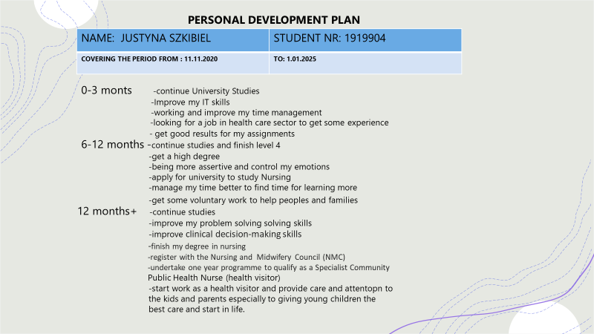

Learning a new language, practicing your public speaking skills, and committing to doing more active listening are all activities that can help with social personal development

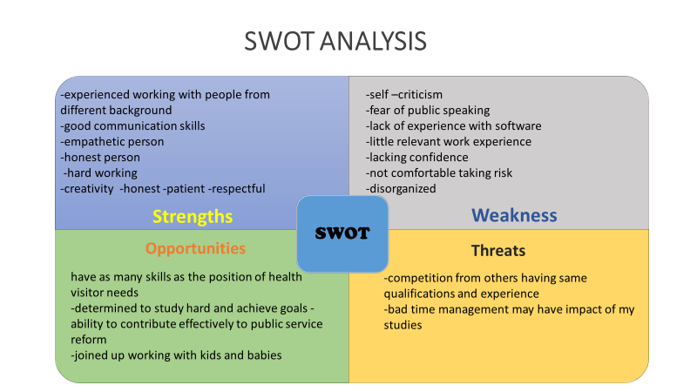
The SWOT analysis allows me to understand my goals so I can improve my skills on this health visitor carrier, it can help with the overload information’s and many tasks at the same time. SWOT analysis can help me be always update with the new methods and how to take the next step to success. SWOT can guide us define our goals develop new skills and get action.
REFERENCES
Uconn.edu, 2020 What-so-what-know-what-model viewed on: 30/11/2020 from: https://cetl.uconn.edu/what-so-what-now-what-model/#
Roje Dapic M. Bulian Flander G, Prijatelkj K. Children behind closed doors due to Covid 19 isolation: abuse, neglect domestic violence. A rich psychiatry res 2020; 56(2):181-92 https://doi.org/10.20471/dec.2020.56.02.06 accessed20.12.2020
Innocenti; 2020 Ethical considerations for evidence generation involving children on the covid19 pandemic. Florence: office of research accessed 20.12.2020
Golberstein E, Wen H, Miller Bf. Coronavirus disease 2019 Mental health for children and adolescents Jama pediatr 2020. Accessed 20.12.2020
Lee J. Mental health effects of school closures during Covid19. Lancet child adolesc health 2020;4(6):421 https://doi.org/10.1016/s2352 , accessed 20.12.2012
Reynolds J, Wilkinson C, Accessibility of essential alcohol in the time of Covid19, casting light on the blind spots of licensing. https://doi.org/10.1111/dar.13076 accessed 20.12.2020

