Carreg y Bwci: Where Roman Ruins Meet Welsh Folklore
During a tour of Lampeter on the 20th of September, I was interested to learn about Sarn Helen, the Roman road that runs through the town. Pausing near the now defunct train station site, the course lecturer casually pointed out a distant hill, remarking on some ancient Roman and Bronze-age ruins in the local area. Intrigued that ancient remains lay close to the town, I decided to investigate. While researching, I discovered one site named Carreg y Bwci. The site features a sizeable recumbent monolith set upon a deep, circular impression in the earth. Situated next to the Sarn Helen Road, it is believed the ruins are either a Roman watch tower or a Bronze Age round barrow. My subsequent research and visit to the site sparked a deep curiosity, as the site has become a place of local legend and folklore. As someone with a strong interest in mythology, I found the site’s connections to local legends particularly compelling.
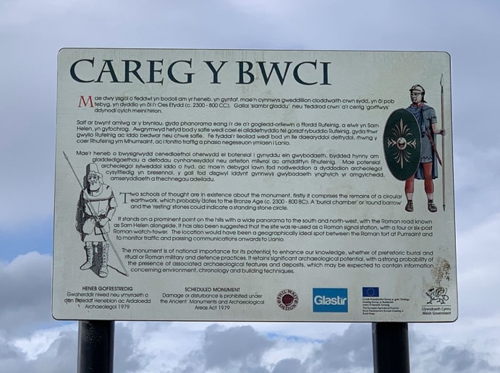
My online research revealed the ongoing mystery surrounding Carreg y Bwci’s origins. Signage at the site refers to it as either a Bronze Age round barrow or a Roman watchtower – its high altitude, sweeping views and proximity to Sarn Helen support this theory. Jeffrey L. Davis’s Archaeologica Cambrensis article Carreg y Bwci: A Roman Watchtower rejects the Barrow hypothesis. According to Davis, the site's layout is far more typical of a Roman watch-tower emplacement. It is ideally placed between the Roman forts of Llanio and Pumsaint, a key point on the Sarn Helen Road. What I found most intriguing in reading this report was how it does not adequately explain the giant monolith on the site. Davis postulates that the monolith was already in place and too large to move; thus, the watch tower was built to incorporate it. If this was the case, where did this colossal stone come from, and did it serve a purpose for an earlier civilisation? It occurred to me that the ambiguity of the site’s origin and the presence of the stone may have contributed to the development of local legends.
Figure 1: Photograph of Carreg y Bwci Interpretive Sign, taken by Lucy Negus on 29th September 2024
I delved into the online library to find local stories about the area. Folktales referred to the site as a place of buried goblin treasure and, therefore, cursed. Extreme weather dominates the area even now, and three men are said to have been struck by lightning during a thunderstorm while near stone.
Marie Trevelayan’s Folk-Lore and Folk-Stories of Wales recalls a tale from the seventeenth century, in which a passing traveller, choosing to rest next to the stone during the night, was awoken at midnight being tormented by several goblins:
He got up, and, looking around in the starlight, saw a goblin sitting on the stone, with many others around him. The man tried to runaway, but the master goblin would not permit him, and at his command his minions interlaced their grotesque arms around him and prevented him moving. They tweaked his ears and nose, pinched him, gave him pokes in his ribs, and tormented him all through the night in every conceivable manner.
Having explored the rich tapestry of folklore surrounding Carreg-y-Bwci, I was eager to experience the site firsthand and see how the atmosphere might evoke the same sense of the supernatural described in these tales.
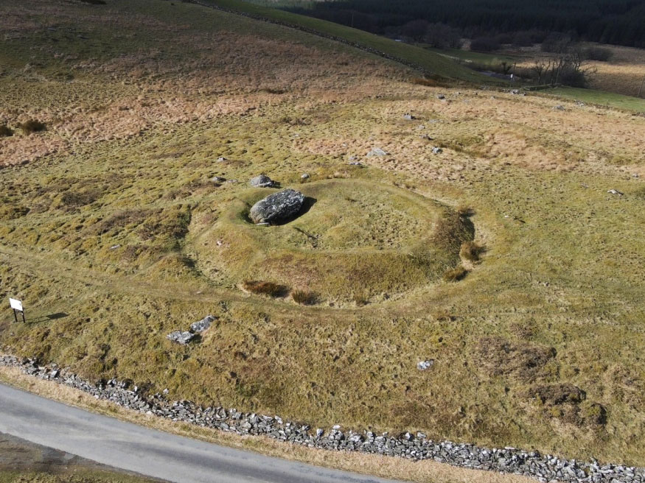
I left the university campus to visit Carreg-y-Bwci on a calm, grey-skied Sunday afternoon. The surroundings swiftly changed from the town centre to lush green fields. I was driving uphill through narrow tracks bordered by tall hedgerows, and soon, the hedges diminished to reveal panoramic views. The beauty of the local countryside enraptured me. No wonder, in such a place, mythology and human connection to the area's history is deeply felt. As I reached the moorland ridge approaching the site, I noticed the wind had picked up velocity rapidly. I could feel my car rocking at its growing intensity. When I parked next to the stone, the wind was so violent I could barely open my car door. Trees swayed dramatically, and I glanced upon a solitary crow, seemingly flying backwards in its efforts to battle the gale.
Figure 2: Photograph Carreg y Bwci viewed from above taken by Pebron on 27th February 2022. Source: < https://www.megalithic.co.uk/article.php?sid=36744>
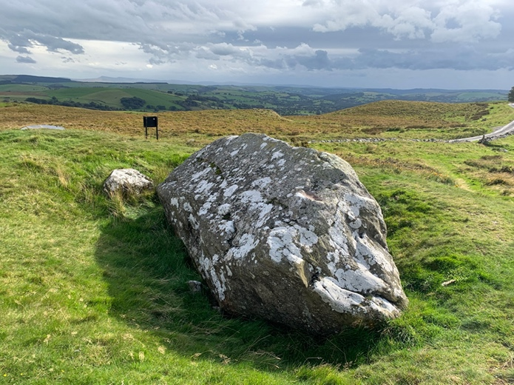
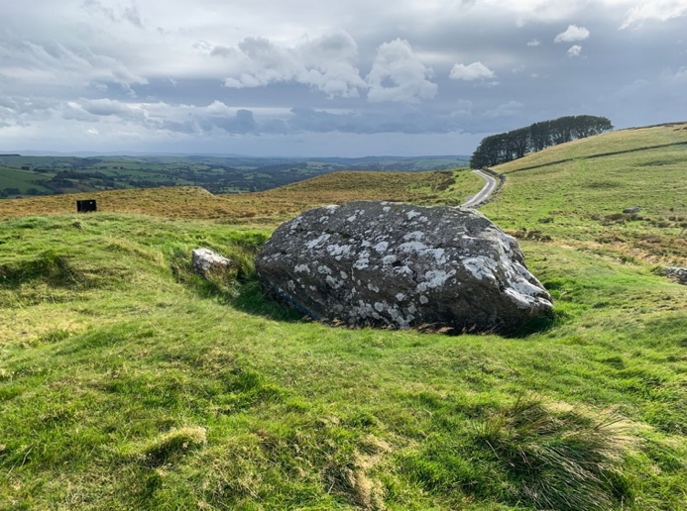
The magical and somewhat sinister atmosphere was well and truly set, and I proceeded to walk around the stone. The gale became even more violent, almost knocking me to the ground on several occasions, which induced feelings of mild panic. The site exudes an eerie sense of isolation; the beauty of the landscape, its exposed position and distant horizons amplify this. The site's layout, with the monolith sunk into the earth and the raised doughnut-shaped mound on which it sits, is glaringly out of place with its surroundings.
Figures 3 & 4: Photographs of Carreg y Bwci taken by Lucy Negus on 29th September 2024
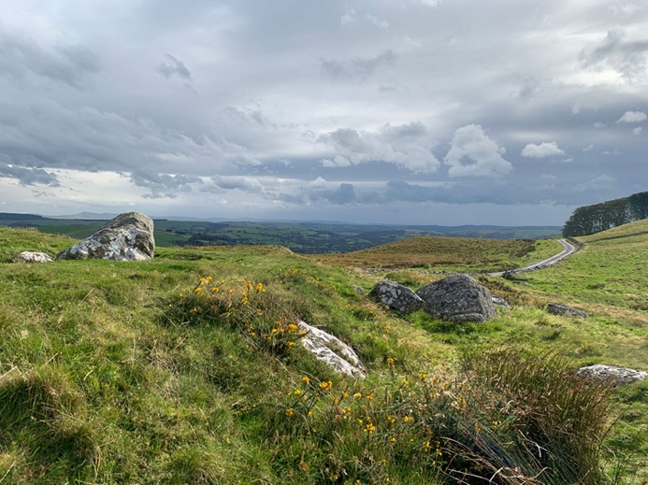
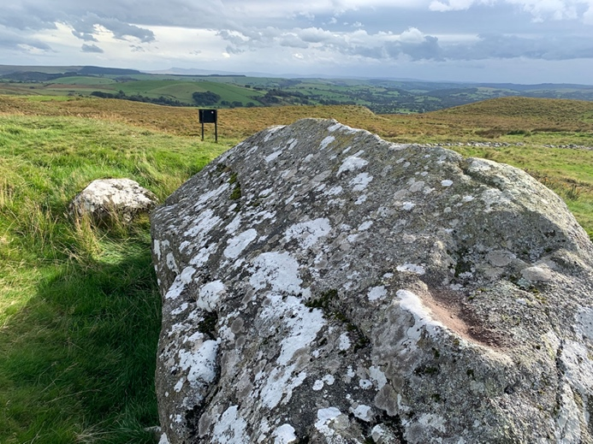
I quickly escaped back to my car before returning home, exhilarated. The fact I had also experienced sudden violent weather conditions during my visit made me feel connected to the local community throughout the ages: how many others through the centuries had ventured past the site and experienced the same phenomena, and what stories had they told to explain their experience?
Figures 5 & 6: Photographs or Carreg y Bwci taken by Lucy Negus on 29th September 2024
Overall, I am delighted that what began as a tour of an urban centre led me on a journey to find a connection with Lampeter that aligns with my interests. Visiting ancient remains and researching mythology so soon after commencing my academic career is both affirming and exciting. On a personal level, there is beauty in living in a country where the history of the land and its people is tangible, in the landscape and the stories people tell. I feel there is a disconnection with this in England, which saddens me, as I believe this connection is a vital part of the human experience. My visit to Carreg-y-Bwci inspired deep enthusiasm and excitement for the experiences that await me during my time in Lampeter.

Bibliography:
- Phil Wait Design & Welsh Government, Carreg y Bwci, Interpretive Sign, Carreg y Bwci, Lampeter, Ceredigion [accessed 29th September 2024]
- Davies, Jeffrey L. ‘Carreg y Bwci: A Roman Watch-tower’, Archaeologica Cambrensis Volume CXXXV (1986), 147-153 (p. 147 & 150) [accessed 1st October 2024]
- Figure 1: Photograph of Carreg y Bwci Interpretive Sign, taken by Lucy Negus on 29th September 2024
- Figure 2: Photograph Carreg y Bwci viewed from above taken by Pebron on 27th February 2022. Source: < https://www.megalithic.co.uk/article.php?sid=36744> [accessed 9th October 2024]
- Head Heritage Ltd, The Modern Antiquarian, < https://www.themodernantiquarian.com/site/6006/carreg-y-bwci > [accessed 5th October 2024]
- Trevelyan, Marie, Folk-lore and Folk Stories of Wales (London: Elliot Stock, 1909) p.128 [accessed 5th October 2024]
- Figure 3: Photograph of Carreg y Bwci, taken by Lucy Negus on 29th September 2024
- Figure 4: Photograph of Carreg y Bwci, taken by Lucy Negus on 29th September 2024
- Figure 5: Photograph of Carreg y Bwci, taken by Lucy Negus on 29th September 2024
- Figure 6: Photograph of Carreg y Bwci, taken by Lucy Negus on 29th September 2024

Phil Wait Design & Welsh Government, Carreg y Bwci, Interpretive Sign, Carreg y Bwci, Lampeter, Ceredigion
Jeffrey L. Davies, ‘Carreg y Bwci: A Roman Watch-tower’, Archaeologica Cambrensis Volume CXXXV (1986), 147-153 (p. 147 & 150)
Head Heritage Ltd, The Modern Antiquarian, < https://www.themodernantiquarian.com/site/6006/carreg-y-bwci > [accessed 5th October 2024]
Marie Trevelyan, Folk-lore and Folk Stories of Wales (London: Elliot Stock, 1909) p.128

