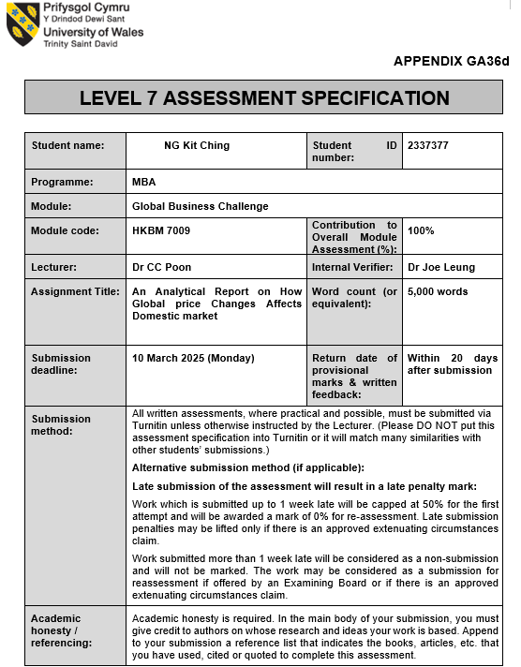
1

Synopsis

This article reports an empirical study on how global price changes affects the domestic retailing market by conducting a comparative analysis of the consumer inflation pattern in Hong Kong and Macau with a hope to explore investment opportunities for the company to expand its global business and to identify the relationship between global price fluctuations, geopolitical risk, consumer behavior and retail sales in Hong Kong and Macau.
The main objective is to analyze the retail prospects of these two places by studying the related data of the Consumer Pricing Index. Finally, provide an outward development plan for LC Department Store.

2

Table of Contents
Chapters | Topics | Pages
 | Synopsis | 2
1. | Introduction | 4
2. | Research Background | 7
 | 2.1 Theoretical Basis | 7
 | 2.2 Current Performance of Consumer Inflation and Retail Sales in Hong Kong and Macu | 8
 | 2.3 Dataset | 8
3. | Analysis and Discussion | 9
 | 3.1 The Pattern of Consumer Inflation and Retail Sales in Hong Kong | 10
 | 3.2 Correlation Analysis | 12
 | 3.3 Similarities and Difference in Patterns and Trends | 15
 | 3.4 Summary of Findings | 17
4. | Conclusion | 18
8. | Recommendation | 19
9. | Reference List | 21

3

- Introduction

As two of the world's most open and trade-reliant economies, Hong Kong and Macau are easily affected by the knock-on effects of global price fluctuations. Located at the crossroads of international commerce, deeply integrated into global supply chains, China's special administrative regions have already flourished on their roles as entrepots, financial centers and tourist destinations. However, their economic dynamism also makes them vulnerable to external shocks, particularly changes in global commodity prices, exchange rate fluctuations, and inflationary pressures from major economies (Yeung, 2022) (75, 2024).

Rising geopolitical risk, disruption caused by pandemic, trade restrictions and climate-related supply chain crises worsen global price instability in recent years, creating complex challenges for the domestic retail markets in Hong Kong and Macau (CFI, 2023).

The domestic retail markets of Hong Kong and Macau are intrinsically linked to global trends due to their reliance on imported goods. More than 90% of the food, consumer goods and raw materials in the two cities come from international markets, making retail prices highly sensitive to changes in global commodity prices, transportation costs and trade policies (www.censtatd.gov.hk, n.d.).

For instance, geopolitical conflicts such as the Russia-Ukraine war have led to higher energy prices, resulting in increased transportation and production costs, which in turn have driven up the prices of imported goods. Similarly, currency fluctuations, particularly the strength of the US dollar (which is pegged to the Hong Kong dollar) and the Chinese yuan (closely related to the Macao economy), directly affect import costs and retail pricing. These external pressures have accelerated domestic inflation trends, squeezed household budgets, and altered spending patterns (Hktdc.com, 2025).
4

Consumer behavior in both cities reflects interconnectedness. Hong Kong's retail industry accounts for more than 20% of GDP and relies heavily on luxury goods, electronic products and high-end services to meet the needs of local and international tourists. At the same time, Macau relies on the retail industry related to the gaming and tourism industries, focusing on duty-free products and hotel services. Global inflation and recession concerns in major markets such as mainland China, Europe and the United States have curbed tourism spending, a key source of revenue for both economies. Despite the pandemic being passed more than two years old, the retail industry's recovery has been uneven, in part because of ongoing inflation that has affected consumers' purchasing power.

Retailers in Hong Kong face a dual challenge: balancing profit margins amid rising input costs while remaining competitive in price-sensitive markets. Many have adopted strategies such as diversifying suppliers, absorbing partial cost increases, or passing expenses onto consumers. However, these measures risk alienating budget-conscious shoppers, particularly in Hong Kong’s hyper-competitive retail landscape (Hktdc.com, 2025b).

LC Departmental Store (LC), established in 1850 by Scottish entrepreneurs Thomas Ash Lane and Ninian Crawford, is Hong Kong’s oldest and most iconic luxury department store. Founded during the city’s colonial era, the brand initially catered to the needs of expatriates and merchants, offering imported goods ranging from household essentials to bespoke tailoring. Over its 170-year history, LC has evolved into a global symbol of luxury, renowned for curating an unparalleled selection of high-end fashion, beauty, and lifestyle brands. With its flagship stores strategically located in prime destinations such as Hong Kong’s IFC Mall and Beijing’s Financial Street, the retailer has become a cornerstone of Asia’s luxury retail landscape, celebrated for blending timeless elegance with cutting-edge design. Its enduring mission to "inspire a life of wonder" has solidified its reputation as a trendsetter and cultural hub for discerning shoppers.

5

LC plays a pivotal role in shaping Asia’s luxury market, introducing avant-garde designers like Alexander McQueen and Balenciaga to the region. LC has expanded its footprint cross key Asian cities, including Shanghai and Guangzhou. Renowned for exclusive collaborations with luxury houses and a commitment to sustainability, LC remains at the forefront of redefining modern luxury. Its influence extends beyond retail, hosting high-profile fashion events and art exhibitions, cementing its status as a cultural institution that bridges heritage with contemporary innovation (LC, 2024)

LC has faced significant challenges in recent years amid Hong Kong’s shifting economic and social landscape. Hong Kong’s high commercial rental costs have posed ongoing challenges to LC in recent years. Social unrest (2019-2020) and pandemic lockdowns, which led to a collapse in tourism and a drop in local demand, have exacerbated LC’s challenges in operating in Hong Kong (Billen, 2024) (Hktdc.com, 2025b) (Rosenbaum and Caminiti, 2020)

Geopolitical tensions and a prolonged economic downturn further dampened demand. Global supply chain disruptions and inflationary pressures complicate inventory management and pricing strategies. These factors highlight the urgency of understanding how external economic variables, such as global price fluctuations, affect local retail dynamics.

Research into the relationship between global price changes and Hong Kong retail sales could provide LC with actionable insights and changes. By analyzing this link, the brand can better respond to macroeconomic uncertainties and increase its resilience in the unpredictable luxury economy.

6

- Research Background

2.1 Theoretical Basis

As the world's most open and trade-reliant economy, Hong Kong is vulnerable to global price fluctuations due to its role as a financial centre, entrepot and tourist destination. Geopolitical risks (such as the U.S.-China trade war, Russia-Ukraine conflict) and supply chain disruptions caused by the epidemic have led to rising transportation costs and trade barriers, further destabilizing prices. Shifts in consumer behavior, driven by inflationary pressures and risk aversion, are having a disproportionate impact on industries such as luxury retail that rely on high-net-worth individuals and tourism.

Macau has always been a bustling world-class entertainment destination with booming tourism and gaming industries. Mainland Chinese tourists have always been Macau’s main source of income. In recent years, Macau has become China's main offshore bond market, a milestone in the city's efforts to expand its economy and reduce its reliance on the gaming industry. As China gradually moves towards the position of the world's largest personal luxury goods market. As LC faces multiple challenges arising from operations in Hong Kong and global price changes, it is time to study the positive impact that expanding their development to Macau will have on their company industry (South China Morning Post, 2025) (PricewaterhouseCoopers, 2024).

7

2.2 Current Performance of Consumer Inflation and Retail Sales in Hong Kong and Macau

Affected by fluctuations in global commodity prices, the cost of imported food and energy has increased, and Hong Kong is facing continued consumer inflation (annual growth of 2.6% in 2023). However, sectors such as electronics and staples showed resilience, with durable goods inflation holding steady at 1.9%. The Hong Kong dollar's peg to the U.S. dollar amplifies imported inflation as rising U.S. interest rates raise input costs for retailers (www.censtatd.gov.hk, n.d.).

In comparison, Macau's inflation is more modest (2.3% in 2023), buffered by a gaming-driven economy that accounts for 50% of GDP and supports stable retail demand. Tourism recovery after the pandemic - the retail industry increased by 49.5% year-on-year to MOP86.25 billion in 2023 led by duty-free shops and the hotel industry. Retail rents in tourist hubs such as Cotai rose 8% as luxury brands expanded, reflecting confidence in gaming-led consumption (Asia, 2024) (and, 2024).

2.3 Dataset

This study analyzes annual percentage changes in three key variables from 2014 to 2024: (1) Hong Kong retail sales, which measures year-on-year growth in the total value of goods sold by retail establishments, adjusted for inflation; (2) Hong Kong consumer price index (CPI) inflation, which tracks price changes in a basket of consumer goods and services (e.g., food, housing, transportation); (3) Macau's CPI inflation, which is calculated in the same way as in Hong Kong but tailored to Macau's consumption patterns.

8

All variables are reported annually, with retail sales and consumer price index for Hong Kong coming from the Census and Statistics Department and Macau's consumer price index from the Statistics and Census Service. The 11-year time frame (2014 to 2024) captures pre-pandemic stability, COVID-19 disruption, and post-pandemic recovery, allowing for robust analysis of inflation-retail dynamics in global shocks. Retail sales data and the CPI index for both regions are publicly available through their respective government portals, ensuring transparency and replicability.

- Analysis and Discussion

To assess how global price fluctuations affect domestic retail dynamics, this analysis examines the dependencies between Hong Kong retail sales (HKVRS), annual percentage change in Hong Kong retail sales (APCHKVRS), annual percentage change in Hong Kong consumer price index (APCHKCPI) and annual percentage change in Macau consumer price index (APCMCPI) market-dependent factors from 2014 to 2024. A Pearson correlation matrix is ​​employed to quantify the relationship between APCHKCPI/APCMCPI (a proxy for imported inflation) and APCHKVRS, isolating periods in which global commodity shocks (e.g., 2016 oil price collapse, 2022–2023 post-pandemic supply chain crisis) disrupt domestic demand. The 11-year time frame covers steady pre-pandemic growth (2014-2019), pandemic-induced volatility (2020-2022), and post-reopening recovery (2023-2024), allowing the identification of structural spending changes in consumer behavior under different inflationary (e.g., luxury versus necessities spending).

9

3.1 The Pattern of Consumer Inflation and Retail Sales in Hong Kong and Macau

Table 1 Annual percentage change (%) in value of retail sales in Hong Kong and consumer inflation in Hong Kong and Macau: 2014 to 2024
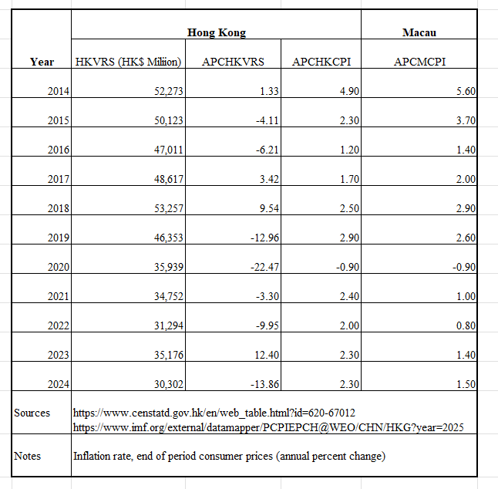
Based on the data analysis of The Pattern of Consumer Inflation and Retail Sales in Hong Kong and Macau shown in Table 1, the following interpretations can be identified:

10

Retail Sales Volatility and Inflation Elasticity in Hong Kong
Hong Kong retail sales growth (APCHKVRS) shows significant fluctuations, ranging from double-digit declines (e.g. -22.5% in 2020 during COVID-19) to sharp rebounds (e.g. +12.4% in 2023). This contrasts with relatively stable inflation rates (APCHKCPI), which range from -0.9% to 4.9%, reflecting less domestic price pressures compared with the global inflation surge after 2021. For instance, in 2018, driven by the influx of mainland Chinese tourists into Hong Kong's luxury market, retail sales surged 9.5% and inflation reached 2.5%. This resilience reflects trends in global luxury hubs. However, disruptions in Hong Kong, such as political unrest in 2019 (-13% retail sales) and pandemic border closures, highlighted vulnerabilities related to external demand and geopolitical stability.

Inflation Synchronization Between Hong Kong and Macau
Both regions experienced parallel deflation (-0.9%) in 2020 as COVID-19 led to the collapse of tourism, a lifeline accounting for 80% of Macau's GDP and 5-10% of Hong Kong's GDP. Their inflation trajectories also reflect changes in global commodity prices (for example, the 2014-2016 collapse in oil prices dampened inflation), but unlike broader Asia-Pacific trends, countries such as Japan and South Korea face longer-term deflation risks. The tight correlation highlights their reliance on imported goods and consumption patterns in mainland China. For example, Macau's higher inflation from 2014 to 2016 (peaking at 5.6%) was consistent with the casino-driven tourism boom, while Hong Kong's inflation remained subdued due to a highly competitive retail market. This synchronization reflects the inflationary dynamics of monetary unions such as the Eurozone, despite their unique status as special administrative regions within China's "one country, two systems" framework.

11

Different Post-pandemic Recovery and Structural Challenges
The post-2020 period shows a contrast, Hong Kong's retail sales rebound is uneven (for example, +12.4% in 2023, compared with -13.9% expected in 2024), mainly due to the reduced spending of mainland tourists (post-pandemic travel shifts) and increased restrictions on subsidies in the Hainan (China) duty-free zone. While Macau's inflation stabilizes at lower levels (1.5% in 2024) amid a recovery in the gaming industry.

Table 1 data reveal Hong Kong and Macau’s dual identities as globally connected but locally fragile economies. Their synchronized inflation reflects deep integration and shared vulnerabilities with mainland China, while volatility in retail sales highlights the risk of external shocks.

3.2 Correlation Analysis

Table 2 The Pearson Correlation Matrix of Annual Percent Change in Retail Sales Values and Consumer Inflation Rates in Hong Kong and Consumer Inflation Rates in Macau : 2014 to 2024
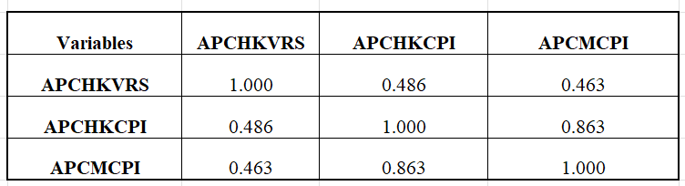

12

Based on the data analysis shown in Table 2, the following interpretations can be identified:

The Relationship Between Retail Sales and Inflation: Local versus Global Trends
There is a modest positive correlation between Hong Kong retail sales growth (APCHKVRS) and inflation (APCHKCPI: r = 0.486), which contrasts with global patterns in which rising inflation tends to depress real consumer spending. In developed economies such as the United States or the European Union, high inflation typically erodes purchasing power, leading to weaker real retail sales. However, Hong Kong's nominal retail sales appear to be resistant to inflationary pressures, possibly due to its unique role as a luxury retail hub for mainland Chinese tourists and high-net-worth individuals.

Such as, during periods of rising inflation (such as 2014 and 2018), retail sales growth remains strong, reflecting that demand for high-quality goods is less sensitive to price increases. This is consistent with the global luxury market, where affluent consumers prioritize status-driven purchases even amid economic uncertainty. However, the correlation is not very strong, suggesting that other factors - such as tourism fluctuations, currency stability (Hong Kong is pegged to the U.S. dollar) and policy shifts - also play an important role.

Synchronized Inflation in Hong Kong and Macau: Regional Integration
The strong correlation between inflation rates in Hong Kong and Macau (APCHKCPI vs. APCMCPI: r = 0.863) highlights their deep economic interdependence. Both regions have pegged currencies (HKD to USD, MOP to HKD), rely heavily on tourism (particularly from mainland China), and face similar cost structures for imported goods.

13

For example, the simultaneous decline in inflation in 2020 (APCHKCPI: -0.9%, APCMCPI: -0.9%) reflects the collapse of tourism and demand caused by the pandemic. This synchronization reflects a trend among closely integrated economies, such as euro area countries, where common monetary policy and trade links coordinate price movements. However, Macau has historically had slightly higher inflation (e.g. 2014 to 2016), possibly due to its single, gaming-driven economy, where surging demand from mainland tourists has had a disproportionate impact on housing and service prices. Globally, such tight inflation coupling is rare outside of a monetary union, highlighting the unique synergies between the two special administrative regions.

Retail Sales and Cross-Border Inflation: Structural Discrepancy
While retail sales in Hong Kong are weakly to moderately correlated with inflation in Macau (APCHKVRS vs. APCMCPI : r = 0.463), this link is weaker than expected due to geographical proximity. The disparity reflects structural differences: Macau's economy is dominated by gaming (85% of GDP), while Hong Kong's retail sector thrives on fashion,
electronics and jewelry. For example, Macau's inflation spike from 2014 to 2015 (APCMCPI: 5.6%, 3.7%) was consistent with booming casino revenue, but had limited overlap with retail trends in Hong Kong, which declined from 2015 to 2016 due to political unrest and anti-Mainland sentiment.

Above correlations reveal a combination of global luxury market resilience (the link between retail sales and inflation) and hyperlocal dynamics (the integration of Hong Kong and Macau). While inflation synchronized reflects conditions in currency union economies, retail sales trends reflect Hong Kong's niche position as a luxury goods gateway, insulated from wider inflationary pressures but highly impact by the health of mainland China's economy and geopolitical changes. These findings are consistent with research on tourism-driven economies, where external demand often overshadows domestic price mechanisms.

14

3.3 Similarities and Differences in Patterns and Trends

Table 3 Major Summary Statistics of Annual Percent Change (%) in Retail Sales Values in Hong Kong, Consumer Inflation Rates in Hong Kong and in Macau : 2014 to 2024
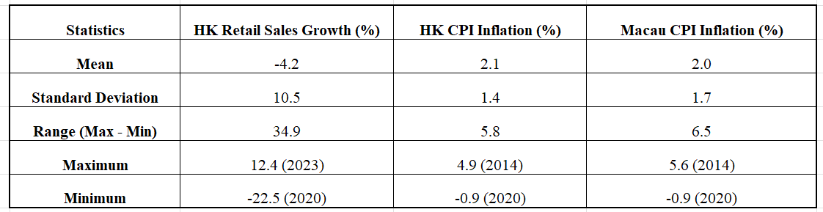

From 2014 to 2024, Hong Kong retail sales (APCHKVRS) showed extreme fluctuations, with an average annual decrease of -4.2% and a standard deviation of 10.5%, reflecting a severe boom-bust cycle driven by external shocks. The industry plunged during crises such as the 2019 protests (-12.96%) and the COVID-19 pandemic (-22.5% in 2020), but rebounded sharply in 2023 (+12.4%) as the travel industry recovered. This volatility contrasts with consumer inflation (APCHKCPI) in Hong Kong, which has a currency pegged to the U.S. dollar and relies on imported goods, which has remained relatively stable (mean = 2.1%, standard deviation = 1.4%). Even during global inflation surges, Hong Kong's inflation rate peaked at a modest 4.9% (2014) and slipped into deflation (-0.9% in 2020) when tourism collapsed. Likewise, inflation in Macau (APCMCPI) mirrors trends in Hong Kong (mean = 2.0%, standard deviation = 1.7%), with concurrent deflation (-0.9% in 2020) and a higher pre-pandemic peak (5.6% in 2014) driven by casino-driven demand.

15

Data in Table 3 highlights the structural loopholes of both economies. With a gap of 34.9% between the peak in 2023 and the trough in 2020, Hong Kong retail remains overly influenced by tourism and external demand, as evidenced by the retail slowdown in 2024 (-13.86%) amid competition from mainland China’s duty-free zones. At the same time, the inflationary stability of Hong Kong and Macau masks deeper dependence: their strong correlation (r = 0.863) results from a common monetary system, dependence on tourism and imported inflation dynamics. After the epidemic, Macau's inflation rate stabilized at 1.5% (in 2024), while the recovery of Hong Kong's retail industry has faltered.

Hong Kong's retail sector fluctuated 34.9% between 2020 and 2023, epitomizing boom-bust cycles driven by tourism, geopolitics and competition. At the same time, inflation in these two regions is stable due to currency pegs and import dependence.

These data highlight important lessons:
- Diversification is crucial, overreliance on tourism and narrow industries (retail, gaming) leaves the economy exposed to external shocks.
- Currency pegs are a double-edged sword, they stabilize prices but erode monetary sovereignty and increase vulnerability to changes in global inflation and interest rates.
- Regional competition is intensifying, Mainland China’s duty-free hub and geopolitical tensions threaten Hong Kong’s retail relevance, while Macau’s gaming niche faces long-term sustainability issues.
- Hong Kong's faltering recovery from the pandemic shows a different trajectory than Macau's stability.

16

3.4 Summary of Findings

Hong Kong's economy is polarized: retail sales fluctuate wildly in response to tourism/external demand, while inflation remains stable due to currency pegs and import price dynamics. The strong correlation with Macau’s inflation highlights Macau’s vulnerability to global shocks, but the different post-pandemic track (stabilization in Macau vs. retail slump in Hong Kong) reveal deeper structural flaws.

Hong Kong's retail sector rebounded in 2023 mainly due to the recovery in tourism, and Macau, which also relies on tourism, may reap similar benefits. Inflation in Macau in 2014 was driven by casino demand, indicating the existence of a group with high spending power. Luxury stores will cater to this demographic. Inflation is stable (2% on average) and less volatile than retail sales. This stability benefits business operations because costs do not fluctuate significantly. Currency pegs reduce exchange rate fluctuations, which is important in the imported luxury goods business. Data shows that even in periods of deflation (such as -0.9% in 2020), luxury goods may be less affected because high-end consumers are less price sensitive. Therefore, even if deflation occurs, luxury retail in Macau is likely to maintain better profit margins.

17

- Conclusion

The economic trajectories of Hong Kong and Macau from 2014 to 2024 reveal a stark dichotomy between volatility and stability through an analysis of retail sales (APCHKVRS), consumer inflation (APCHKCPI and APCMCPI) and their interdependence. Hong Kong's retail industry is highly volatile, with an annual growth rate of 34.9% (from -22.5% in 2020 to +12.4% in 2023) and a standard deviation of 10.5%, highlighting its sensitivity to external shocks. Events such as the protests in 2019 (-12.96%), the COVID-19 pandemic (-22.5%) and the 2023 rebound (+12.4%) highlight the structural vulnerabilities created by over-reliance on tourism and demand from mainland China. Despite a temporary recovery, Hong Kong's retail sector faces new challenges in 2024 (-13.86%), indicating an erosion of the sector due to regional competition and geopolitical tensions. In comparison, consumer inflation in Hong Kong has remained very stable, averaging 2.1% with a low standard deviation of 1.4%, helped by its dollar-pegged currency and reliance on imported goods. However, this stability masks the risk of deflation during crises, as exemplified by -0.9% deflation in 2020 when the tourism industry collapsed. Inflation trends in Macau are like those in Hong Kong, with a strong correlation (r = 0.863), reflecting a common monetary system and imported inflation dynamics. Both economies experienced simultaneous deflationary peaks in 2020 and pre-pandemic (Hong Kong: 4.9% in 2014; Macau: 5.6% in 2014), but Macau's post-pandemic stabilization (1.5% inflation in 2024) has outperformed Hong Kong's still-mired retail sector.

18

This divergence highlights an important insight that while Hong Kong’s retail industry grapples with an existential threat, Macau offers a resilient alternative. Compared to Hong Kong's retail fluctuations, Macau's inflation is stable (mean = 2.0%, standard deviation = 1.7%) and has a narrower range (-0.9% to 5.6%), indicating a more predictable operating environment. The city's gaming-driven tourism model has rebounded post-pandemic, with casino revenue set to exceed pre-COVID levels by 2023, providing a steady influx of high-net-worth tourists. Unlike Hong Kong, where retail growth is increasingly challenged by mainland China's duty-free zone and social unrest, Macau's integrated resort ecosystem - which combines gaming, hotels and retail - has created exclusive demand for luxury goods. In addition, Macau government prioritizes economic diversification and actively encourages investment in non-gaming facilities to reduce reliance on gaming. These factors make Macau a strategic market for high-end brands such as Lane Crawford, which require stability to maintain pricing integrity and customer loyalty.

- Recommendation for LC’s Entry into Macau

Three key observations strengthen LC’s data-driven case for expanding into Macau. First, Macau’s inflation stability (SD = 1.7% vs. Hong Kong retail’s SD = 10.5%) ensures predictable operating costs, a critical factor for luxury retail where pricing integrity and margin control are paramount. The USD-HKD-MOP peg system further minimizes currency risk, aligning with LC’s need for financial predictability. Second, Macau’s demand profile synergizes with luxury retail which 80% of its pre-pandemic tourists were mainland Chinese, a demographic that accounted for 70% of global luxury spending in 2023. While Hong Kong’s retail sector grapples with competition from Hainan’s duty-free hubs, Macau’s integrated casino-resort ecosystems—where high-rollers often splurge on gaming, hospitality, and retail—create captive demand. LC can capitalize on this traffic

19
by leveraging partnerships with premium resorts (e.g., Wynn, Galaxy) to provide curated in-store experiences that are in line with LC’s luxury brand image. Third, expansion into Macau can serve as a strategic hedge against volatility in Hong Kong. Although Hong Kong's retail industry remains a major revenue driver, its structural decline requires diversification. Macau’s smaller market size is offset by its higher per capita spending potential which the average visitor spending (excluding gaming) in Macau reached US$1,200 in 2023, three times that of Hong Kong. In addition, the Macau government prioritizes economic diversification beyond gaming and develops policies to encourage investment in non-gaming facilities and culture, which is a tailwind for LC. To reduce risk, LC should adopt a hybrid model, a flagship boutique in the heart of the casino hub (Cotai Strip) to attract tourists, supplemented by localized collections (such as limited editions in collaboration with Macau designers) to attract visitors. Pricing strategies should consider Macau’s stable inflation and avoid discount-driven strategies commonly used in Hong Kong’s volatile market. Crucially, given Macau’s relevance to global gaming cycles and Chinese consumer confidence, LC must invest in data analytics to monitor changes in demand.

In conclusion , the contrasting trajectories of Hong Kong and Macau - one grappling with retail erosion, the other stabilizing after the crisis - make Macau a prudent choice for LC 's expansion. By leveraging Macau's inflation elasticity, luxury demand synergies and strategic diversification policies, the brand can gain a foothold in a sustainable growth market while being immune to Hong Kong’s boom-bust cycles. This move is not only in line with macroeconomic trends but also positions LC as a pioneer in redefining luxury retail in Asia’s evolving landscape.

20

Reference List

