
Continental Hotel Budget Planner
Student Name: Catrianna Di Muzio


University of Wales Trinity Saint David
[Company address]

Executive Summary

This report was created in order to determine the definition of zero-based budgeting and how it operates. Following this, this report then looks at the advantages of using such a technique and why it is a better option to use as opposed to alternative methods- namely being, the traditional based budgeting method. Some of the advantages outlined were that zero-based budgeting can provide a far more in depth view into a companies financial behaviour. Using this method allows for far more clarity in regards to the businesses corporate mission and allows the organisation to be better aligned with it’s values and goals. As well as this, zero-based budgeting allows for a company to ensure they are continuously improving. It was determined that in order for a business to successfully carry out this budgeting technique, communication is a key factor. This includes not only senior management and management but also employees. This report came to the conclusion that zero-based budgeting is a far superior technique as opposed ot traditional based due to its ability to truly serve a business well by inspecting each aspect and in turn allowing for cost effective cuts to be made.

Table of Contents
Executive Summary 1
1. Introduction 100 3
2. Zero Based Budgeting 4
2.1 Zero-based budgeting 416 4
2.2 Advantages of Zero-based budgeting over Traditional Based 416 4
2.3 How the Organisation Might introduce Zero-based Budgeting 416 7
3. Conclusion 150 8
4. Budget Calculations 9
5. Reference List 10

Introduction

The purpose of this report is to highlight to the Regional Accounts director the details of zero-base budgeting. An in depth assessment will be carried out regarding the advantages of using a zero-base budgeting technique as opposed to traditional based budgeting. Once these advantages have been discussed, a detailed explanation on how the Continental Hotel could introduce this technique will be defined. Upon this information being assessed, this report will come to an appropriate conclusion. As well as the information contained pertaining to the definition and processes of zero base budgeting and its advantages, calculations regarding the Continental Hotel’s budget planner will be outlined.

Zero Based Budgeting

Zero-based budgeting

Zero based budgeting a is budgeting technique in which all expenses are returned to zero at the beginning of each new period. Within this process, the budget starts from a zero base. The Zero-base budgeting method does not include the previous years budget when making future resource allocation decisions (Peters, 2007). Zero-base Budgeting can be defined as budgeting from the ground up, approaches to this technique must act as if the budget were being completed for the first time (Burrows & Syme, 2000).
Each manager must consider the activities which are required to accomplish the companies objectives and is able to build an in depth budget request accordingly. This technique forces managers to thoroughly examine all expenses contained within each new period. This approach often forces managers into providing explanations for each expense within the budget to senior level management (McNally, 2017).

Advantages of Zero-based budgeting over Traditional Based

Before comparing the advantages of zero-based budgeting over traditional based budgeting it is first important to look briefly at traditional budgeting. This method takes into account the budgets of previous years. As opposed to the zero-based budgeting technique, traditional looks at previous years and uses the figures as a base, meaning that expenses will be adjusted in keeping with past years revenues and costs as well as inflation rates, consumer demands and market trends (Asogwa & Etim, 2017).
With both methods clearly defined it is now possible to examine the two to compare and analyse the advantages of using zero-based budgeting. When carried out successfully zero-based budgeting can allow an organisation to define business initiatives and help to appropriately allocate funds. It is a helpful asset in analysing spending and redesigning cost structures which should raise the companies competitiveness (McNally, 2017).
Zero-based budgeting can provide more clarity in regards to a companies corporate mission. It can be a useful tool in evaluating, reviewing and allocating resources to areas that support a companies key priorities. By using such a method, each manager must defend requests to senior management pertaining to budget choices which helps to clarify the organisations goals. Through this, senior management is able to ensure that each department and in turn each departments functions, are clearly aligned with the organisations overall corporate mission.
This is advantageous over traditional based budgeting which takes a more generic approach. Traditional based budgeting simply accounts for the previous years and adds cost changes on top, creating less room for introspection and as such fails to truly align a company and it’s values (Alipour et al, 2013).
This method helps with opening communication channels as it can result in discussions relating to a companies strategic objectives, goals for the future and the best approach to achieving them. By using zero-based budgeting it is possible to then align the companies funds and resources with that of its strategic goals which allows for enhanced resource allocation. If management is mindful of the companies corporate mission throughout the budgeting process it is more likely that resources will be allocated where they are most needed (Geiger, 1993).
Zero-based budgeting allows for a company to ensure they are continuously improving. Managers are expected to find alternative options to the way in which a department operates. By observing budgets from a zero-base, it can be determined whether a certain activity should remain a priority or if resources are better relocated towards other avenues (Warren, Reeve & Fess, 2005). Managers are able to determine where within the department they are able to streamline or even outsource work. It is also possible to view the cost and benefit of offering varying degrees of customer service or if it is possible to cut back in this area. By continuously reviewing alternatives, managers are able to discover more efficient ways of operating. Whilst this is the best method, zero-based budgeting can be a far more complicated approach to take and often incurs high costs and man hours to function correctly due to the detailed method the process calls for (Réka et al., 2014).
Zero-based budgeting allows space for organic and realistic budget inflation to be examined. This method requires management to link budgets to specific activities which can help to retain budget developments. This is in stark contrast to traditional budgeting which usually results in management taking budgets from previous years and adding a percentile on to totals to equate for inflation (Suver, 1989).
Arguably one of the key advantages of this method is that it helps to dispense with non-essential activities and can aid towards making redundancies (Van Schalkwyk, 2012). By pushing managers into prioritising resources that are most vital to the organisations goals, it allows for the identification of activities which have become redundant. This can aid in the decision to either outsource or eliminate this function altogether (Coyte, Messner & Zhou, 2020). During a zero-budgeting review, in which management will pass along the information for that financial period, senior management is able to cross-examine departments and can identify if multiple departments are performing the same activities. This is advantageous over traditional budgeting as the traditional does not allow for cost effectiveness, the rigidity of traditional means that wastage is not clearly examined and therefor not cut out from the budget (Antić & Novićević, 2011). By providing an in-depth evaluation, zero-based is the more attractive option of the two.
Traditional budgeting is an outdated method that, despite the simplistic approach it offers, ultimately does not serve a company. Whilst zero-based budgeting is extremely time-consuming, so can traditional budgeting be. Zero-based budgeting ensures a company is running cost effectively due to being detail-orientated which in turn allows for better profit generation and a more aligned company.

How the Organisation Might introduce Zero-based Budgeting

It is important to note that whilst there are many advantages of zero-based budgeting, these are only potential factors and the success of using such a technique is heavily reliant on the way it is carried out.
The first step to this is to update accounting rules in order to establish expenditures by cost category. It is imperative during this stage that actions are watched closely to ensure each expense is thoroughly and correctly analysed. At this point, any budget deviations should be highlighted. Full managerial training in these aspects is required to ensure that new methods are instilled in employees from a managerial level- communication must be open and honest between employee, manager and senior management (Ibrahim, 2019). In order to introduce Zero-based budgeting to an organisation, the organisation must have clear and defined roles for each manager within the company. Each manager would require a clear-cut plan on how to approach each project and activity. This would include a detailed evaluation of the companies values, costs and alternative courses of action (Wetherbe & Montanari, 1981). To implement zero-budgeting correctly managers must also change the thought-processes behind budgeting. The company must have a change of mindset in order to foster new behaviours. To introduce the budgeting technique, communication to all departments is essential. It is of utmost priority that individuals understand how the process works and why it helps to benefit the company (Funck, et al., 2021).
This of course can have a large impact on managerial hours, due to the nature and complexity of such a method, managers must be thorough and must make important decisions regarding departments. A solution to this could be to potentially introduce a hybrid system wherein a traditional approach is taken for several years consecutively and a zero-based budget is introduced every few years or when major changes occur. This would allow for the company to benefit from each method whilst not contributing large portions of managerial time.

Conclusion

In conclusion, zero-base budgeting has been identified as a budgeting system which requires expenses to be reduced to a zero-base at the beginning of each new budgeting period. This is opposed to traditional budgeting which takes into account the previous years, onto which inflation rates and behavioural trends influence cost changes made. By evaluating the benefits of a zero-based budget it is clear to see that in order for the business to minimise costs and boost revenue, this is the route the company should take. A zero-based budget is advantageous in many ways over the traditional based method for the benefits it creates in communication, company-value alignment and continuous improvement. Whilst the traditional method may be less time consuming, overall it does not serve a businesses purpose and can not truly provide an insight into how a company should be handling finances.
In order to introduce this to the business, communication is a vital aspect. Changes in mindset are required to ensure a zero-based budgeting technique can take root within an organisation. By clearly defining each individual project or activity and attaching realistic costing towards it, zero-based budgeting is sure to improve the organisations operations.

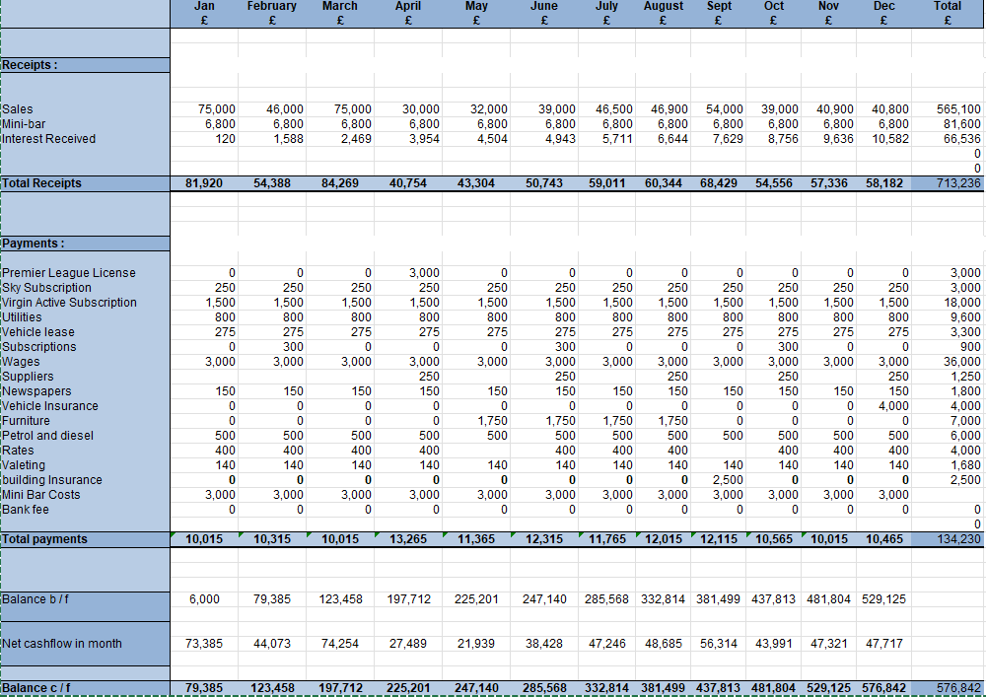
4.Budget Calculations

Reference List

Alipour. H et al, (2013). ‘Comparing Traditional Budgeting with Zero-Based Budgeting Method in the Units of Health Services of Gilan University of Medical Sciences’, Journal of Health Accounting, 2(3), pp.1-22.
Antić. L & Novićević. B, (2011), ‘Zero-Based Budgeting and Activity-Based Budgeting as Alternative Systems of Budgeting’. ECONOMIC, 12(6) p.363.
Asogwa. I & Etim. O, (2017) ‘Traditional Budgeting in Today's Business Environment’, Journal of Applied Finance and Banking, 7(3), p.111.
Burrows. G & Syme. B, (2000), ‘Zero-Based Budgeting: Origins and Pioneers’, ABACUS, 36 (2), pp. 226-241, DOI: 10.1111/1467-6281.00061
Callaghan, S., Hawke, K. and Mignerey, C., (2014) Five Myths (And Realities) About Zero Based Budgeting. Mckinsey & Company, pp.1-4.
Coyte. R, Messner. M & Zhou, S, (2020). ‘The revival of zero‐based budgeting: drivers and consequences of firm‐level adoptions’. Accounting & Finance. https://doi.org/10.1111/acfi.12884
Funck, et al. (2021) To Make Zero-Based Budgeting Work, Change Behaviour, Boston: Boston Consulting Group
Geiger. P, (1993), ‘Zero-Based Budgeting Redux’, American School Board Journal, 180(7), pp.28-30.
Hilton, W.(2005) Managerial Accounting: Creating Value in a Dynamic Business Environment. McGraw-Hill: London
Ibrahim. M., (2019). ‘Designing zero-based budgeting for public organizations’ Problems and Perspectives in Management, 17(2).
McNally. S, (2017), ‘Zero-Based Budgeting: Building for Success Again, and Again’, Pennsylvania CPA Journal, 87(4), pp. 30-33
Peters. J, (2007). Encyclopaedia of Public Administration and Public Policy, New York: Routledge
Réka et al. (2014), ‘Traditional Budgeting Versus Beyond Budgeting’ Economic Science Series, 23(1), pp. 573-581
Suver. J, (1989) ,Zero-Based Budgeting’, WO: Hadbook of health care accounting and finance (2) pp.311-331.
Van Schalkwyk. A, (2012)’ Results based budgeting’. IMFO: Official Journal of the Institute of Municipal Finance Officers, 12(3), pp.8-10.
Warren. C, Reeve. J & Fess. P, (2005), Accounting, Thomson; South-Western
Wetherbe. J. & Montanari,, J, (1981). Zero based budgeting in the planning process. Strategic Management Journal, 2(1), pp.1-14.

