Skills for the Workplace

Module Assignment Submission

Team C

Student’s Name & Number | Ratchada Caliendo-Chan (1916134)  Andras Szucs (1915302)
Module No: | BMSW4002_LON
Module Title: | Certificate of Higher Education in Skills for the Workplace
Assignment Title: | Effective Team Working and Communication
Lecturer’s Name: | Lloyd Beharry

Table of contents

Slide 1 & 2 ………………………………………………………………………………………… p3

Slide 3 & 4 ………………………………………………………………………………………… p4

Slide 5 & 6 ………………………………………………………………………………………… p5

Slide 7 & 8 ………………………………………………………………………………………… p6

Slide 9 & 10 ……………………………………………………………………………………… p7

Slide 11 & 12 ……………………………………………………………………………………. p8

Slide 13 & 14 ……………………………………………………………………………………. p9

Slide 15 & 16 ……………………………………………………………………………………. p10

Slide 17 & 18 ……………………………………………………………………………………. p11

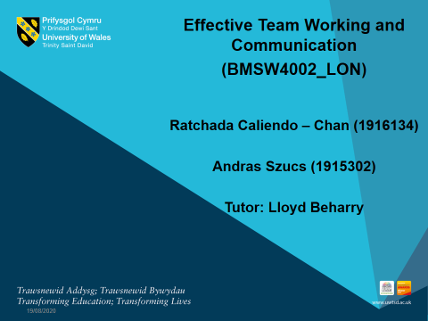
Ratchada Caliendo-Chan (1916134)

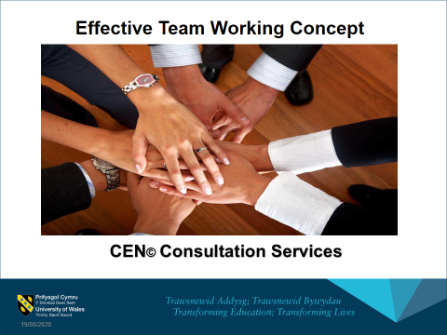
Trademark symbol source https://copyright.co.uk/copyright-symbol.html
Ratchada Caliendo-Chan (1916134)

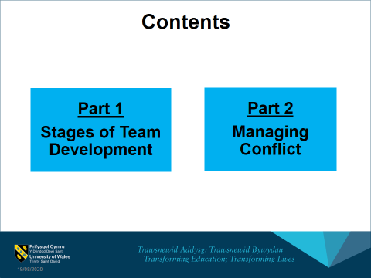
Ratchada Caliendo-Chan (1916134)

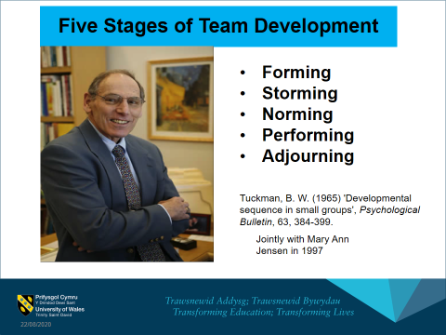
(Morgan, 2017, pp. 210-211) (Leadership Foundation for Higher Education, n.d.) Image from: https://luqmanhakimachmad.files.wordpress.com/2014/06/bruce.png
Ratchada Caliendo-Chan (1916134)

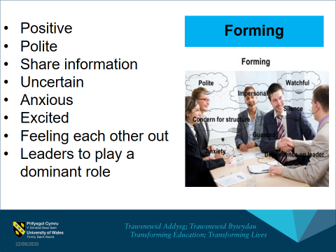
(Shook 2016) ​Image from: https://project-management.com/stages-of-team-development/​
Ratchada Caliendo-Chan (1916134)
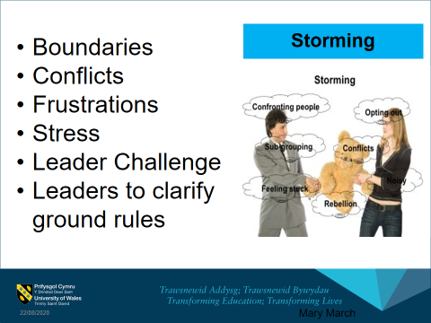
(Shook 2016) ​Image from: https://project-management.com/stages-of-team-development/​
Ratchada Caliendo-Chan (1916134)
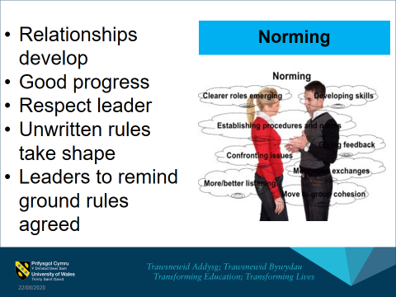
(Shook 2016) ​Image from: https://project-management.com/stages-of-team-development/​
Ratchada Caliendo-Chan (1916134)
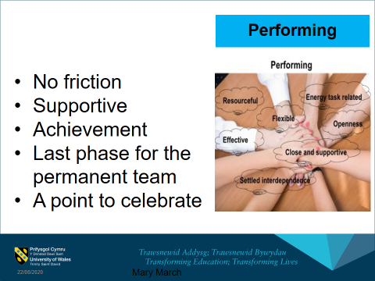
(Shook 2016) Image from: https://project-management.com/stages-of-team-development/​
Ratchada Caliendo-Chan (1916134)


(Shook 2016) Image from: https://project-management.com/stages-of-team-development/​ Ratchada Caliendo-Chan (1916134)

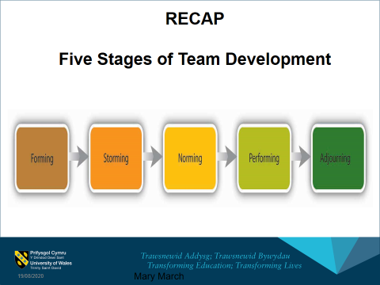
(Shook 2016)
Ratchada Caliendo-Chan (1916134)

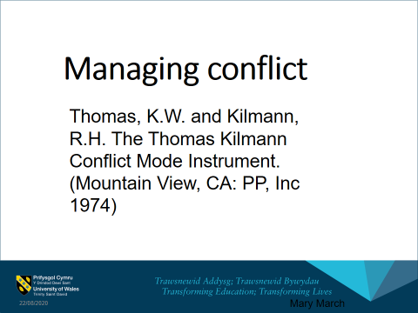
Andras Szucs (1915302)

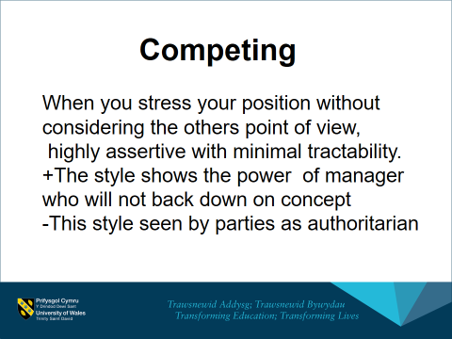
Andras Szucs (1915302)

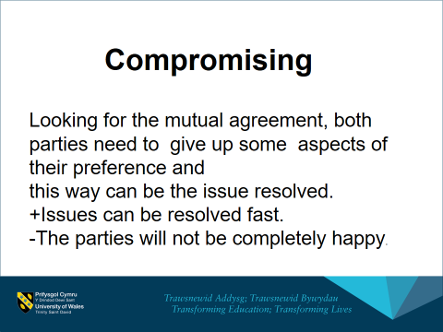
Andras Szucs (1915302)

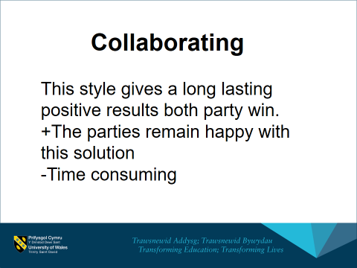
Andras Szucs (1915302)

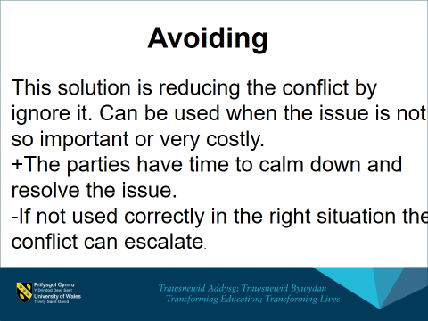
Andras Szucs (1915302)

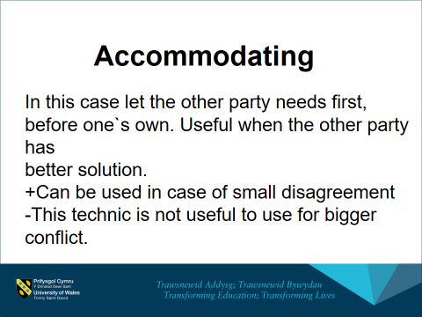
Andras Szucs (1915302)

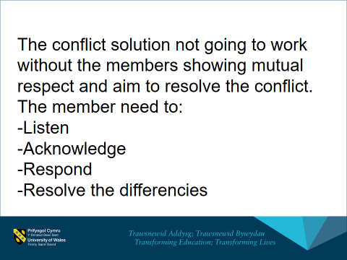
Andras Szucs (1915302)

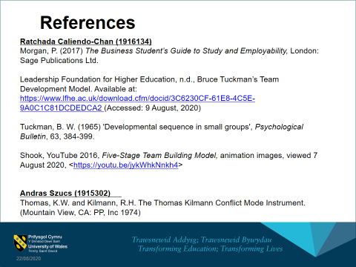
Ratchada Caliendo-Chan (1916134)

