Module Name: Network Operating Systems and Services
Module Number: ACCA5023
Assignment Title: Build and Deploy a Type 2 Hypervisor Platform based Virtualised Network

Student Name: Abigail Davies
Student Number: 2114472
Course: BSC2-PT Computing (Software Engineering)

Table of Contents
Introduction 3
Hypervisor Research 3
Virtualisation 3
Hypervisors 3
Types of Hypervisors 4
Justification 5
Network Setup 5
IP Address Research 8
IP Address 8
Transferring Data 9
Routers and Switches 9
Testing 10
Research on network testing (trouble shooting techniques) 10
Test Network 11
Conclusion 14
References 15

Introduction

This report evaluates the benefits of utilising strategies in the virtualisation world. It covers research into three main areas, which are hypervisors, IP Addresses, and testing. This is to ensure that there is suitable justification for the techniques that are implemented to create the network topology requested by the Multinational Corporation called NOSS. Furthermore, in this particular scenario, the hypervisor of choice will be type 2 due to the availability of the software and knowledge, which will be further explained throughout the research of the report.

Hypervisor Research

Virtualisation

Virtualisation is used to create a virtual infrastructure of devices, networks, storage and / or applications via software, instead of utilising the physical resources [1]. This can be achieved via four different approaches. These include full virtualisation, operating system assisted virtualisation, hardware assisted virtualisation and hybrid virtualisation [1]. Furthermore, it can also be split into different types. These include operating system virtualisation, network virtualisation, server virtualisation and desktop virtualisation [1].

Hypervisors

Hypervisors have evolved from the virtualisation world of technology. It is a software that has been developed to sit between virtual machines and hardware and therefore, it manages the communication between the two. Portnoy states that they the developers decided to name them hypervisors as operating systems were known as supervisors during this period and their new code could improve them [2].
There are many benefits of implementing hypervisors when utilising virtualisation. One of the main benefits would be that it provides a dashboard allowing users to manage a number of virtual machines that are running different operating systems. This allows administrators to centralise their management between all machines [3].
Another advantage of implementing hypervisors would be the flexibility that it provides when attempting to replicate data between machines. Previously, the methods available would require a lot of storage as the entire machine would have to be replicated, whereas hypervisors provide flexibility in the sense that the user can limit sections of the machine that they require to copy [3].

Types of Hypervisors
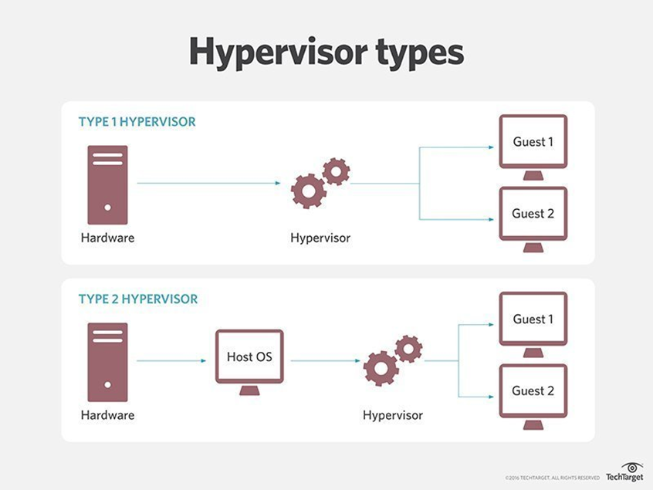
[4]

Type 1 and type 2 hypervisors both aim to run virtual machines, however they do have some differences, even though the end result is similar. Type 1 hypervisors are known as a bare-metal hypervisor, and type 2 hypervisors are known as hosted hypervisors [4].
One of the differences is how they allocate resource within the virtual machine. Type 1 can access the resources directly by introducing custom strategies, whereas type 2 has to consult what is available with the operating system. This means that the process of allocating is much slower for type 2 hypervisors [5].
Another difference would be the level of isolation within the hypervisors. As shown in the diagram above, type 2 hypervisor middle layer is shared with the operating system, whilst type 1 hypervisors do not. This allows type 1 hypervisors to offer better isolation for each environment. Furthermore, even though keeping a virtual machines security up to date is critical, type 1 hypervisors are often recognised as more secure that type 2 hypervisors for this reason [5].
Furthermore, the two hypervisors also have different levels of management needed. Type 1 hypervisors are known to be more complex than type 2 hypervisors. In addition, type 2 hypervisors can be operated with basic knowledge, whereas type 2 hypervisors would require intermediate level knowledge, e.g. system administrator [5].
As type 1 hypervisors can also be referred to as the embedded hypervisor, some examples of the software available for these would be Microsoft Hyper-V, Oracle VM Server, and Citrix Hypervisor [3]. Though some software examples of type 2 hypervisors that are available are VMware Workstation, Oracle VirtualBox, and Oracle Solaris Zones [3].

Justification

The hypervisor that has been implemented for this assignment is type 2. Research has suggested that type 2 is less complex to implement [5]. As a software engineering student, who has not had much experience in the networking world as such, this has become a large factor in the decision. That being said, research has also highlighted that type 1 hypervisors are best suited for large workloads whereas type 2 hypervisors are best suited for development environments and, therefore. it would not make sense to opt for a type 1 hypervisor in this assessment [5]. That being said, in the real-world type 1 hypervisor would mostly likely be the most efficient in the scenario given. Furthermore, one of the software’s that is readily available for type 2 hypervisors is Oracle VirtualBox which is one of the examples found during the research into hypervisors.

Network Setup

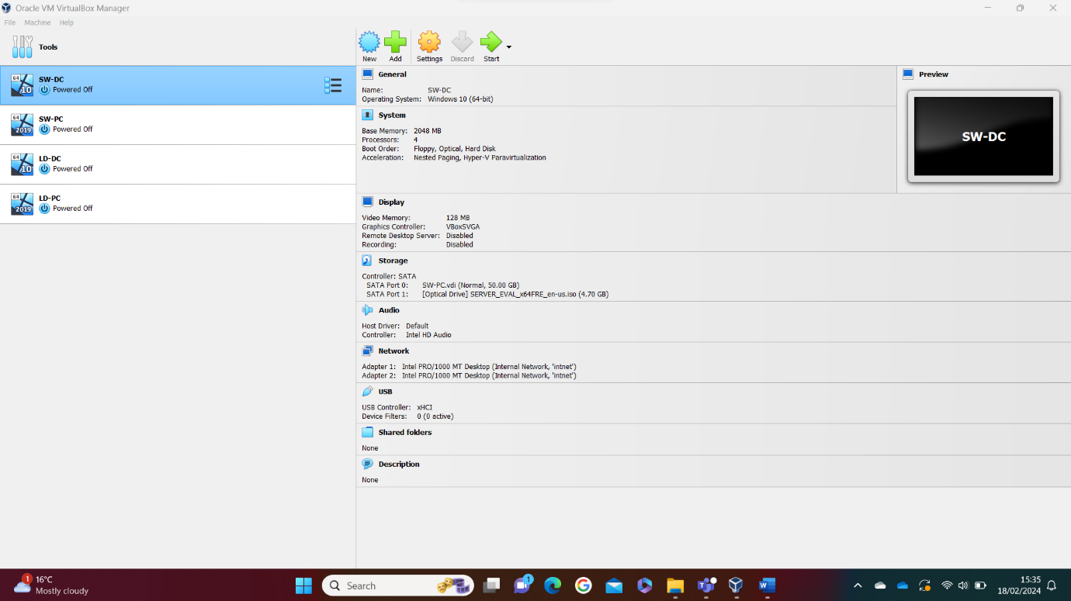
Below is a screenshot of the main page of Oracle Virtualbox settings.
Initially, I set up the server and client for Swansea then used the clone tool to create duplicate versions for the London server and client. This was completed before the configuration stage on each machine.
The next stage was to configure the networks on both SW-PC and SW-DC. The screenshots below show each machine after they were configured with the main menu.
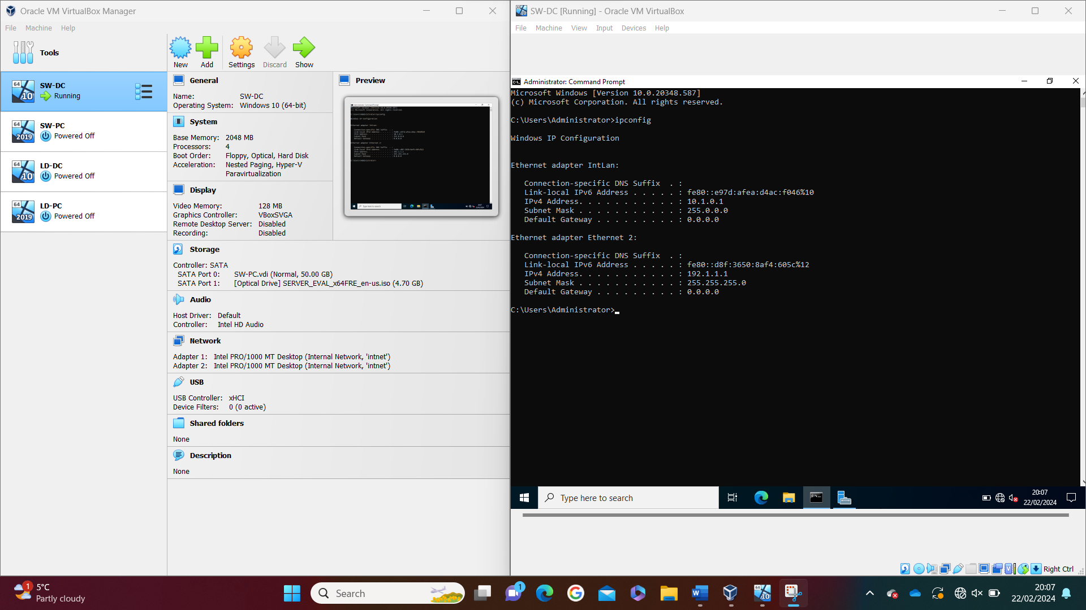
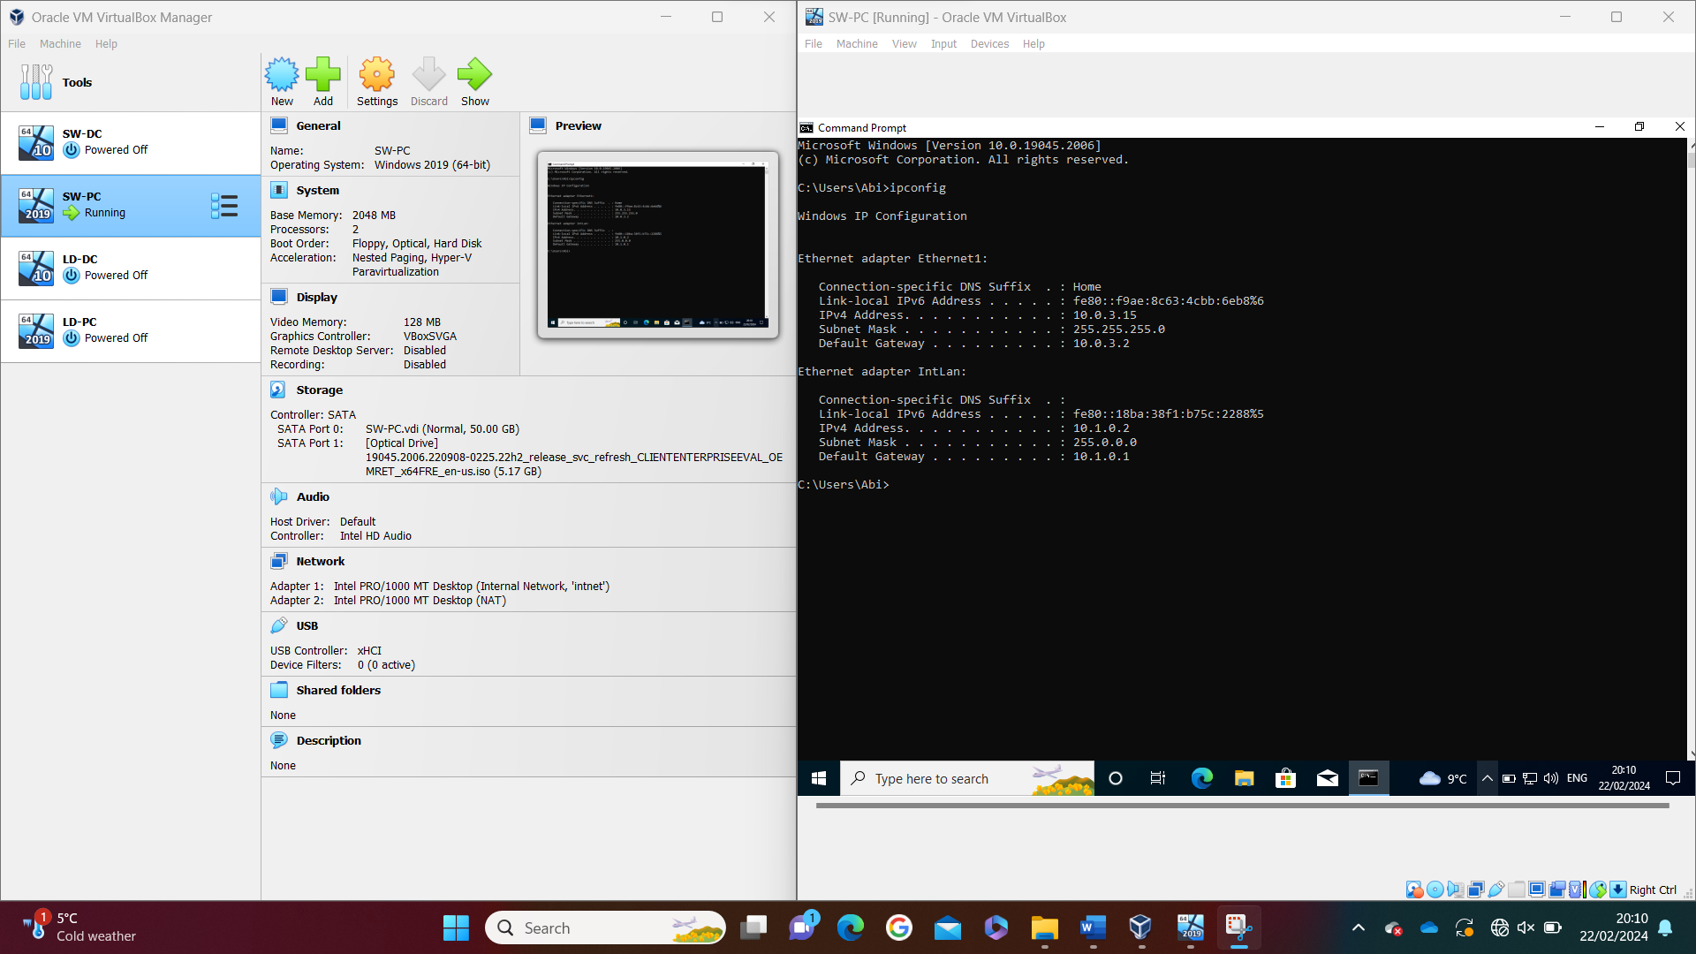

Following this, testing was completed between both machines to ensure that the networks were set up correctly. This is discussed in further detail in the testing section of this assignment.

Once the testing was completed and the connectivity between the two machines were successful. The same process was followed for the London server and client. The screenshots below show their configuration using the ipconfig command.
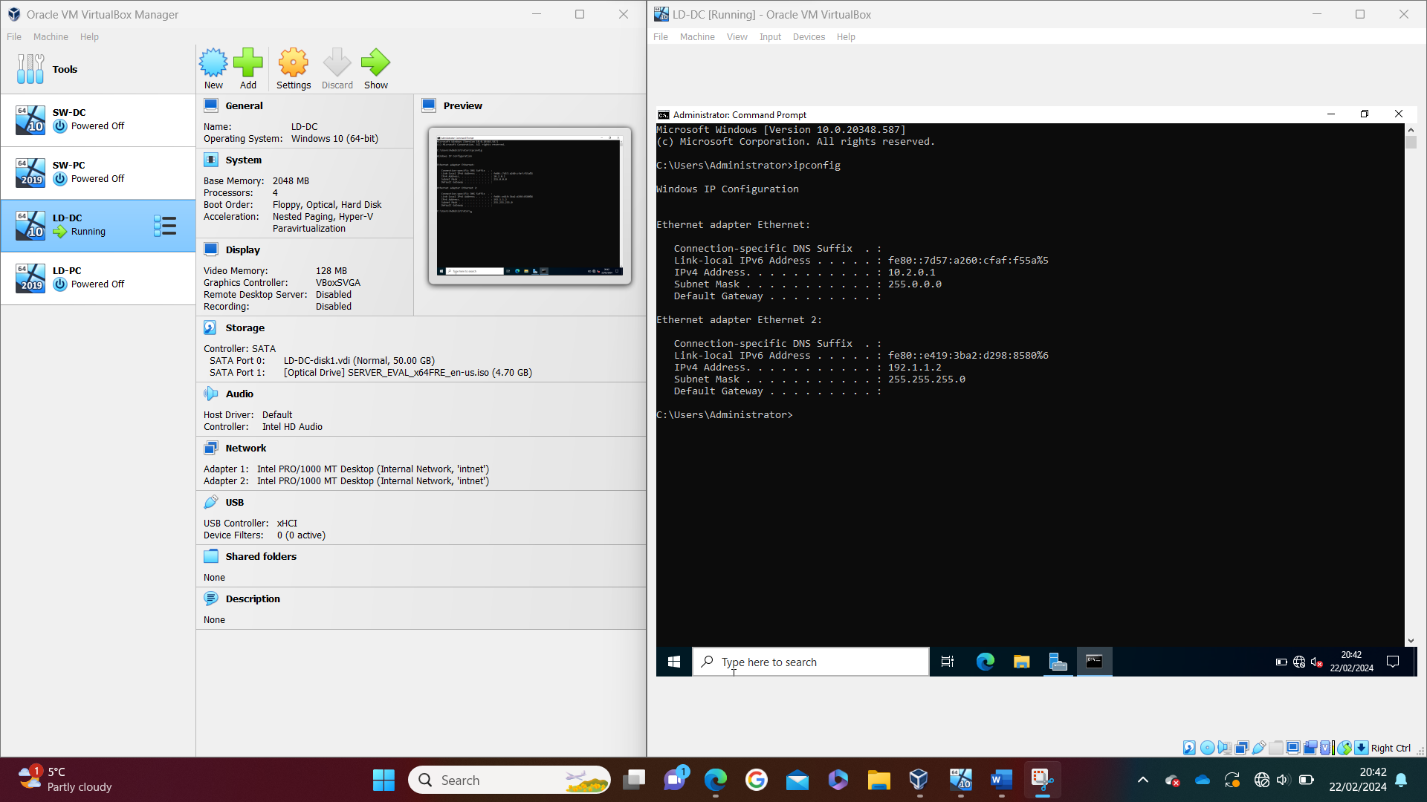

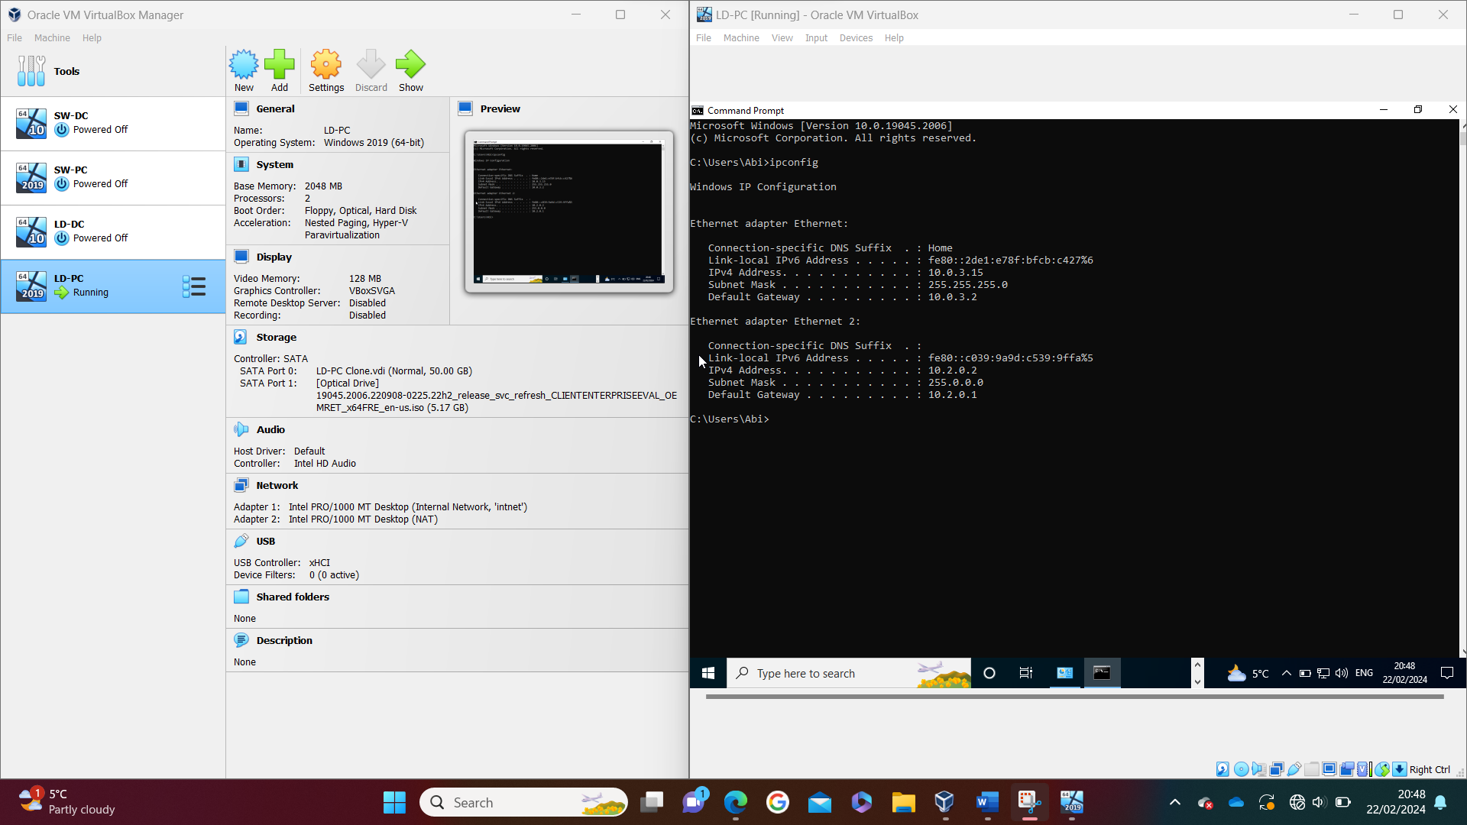

IP Address Research

IP Address

IP addresses are used to send data over networks from one device to another or multiple. Wallace suggests a good example that can be used to understand this is that when someone is attempting to send mail to another person, two addresses are needed; senders address and destination address [6]. Furthermore, the same thing happens when in technology, each device has an individual IP address which is part of the process that allows data to be transferred from one to another. Currently there are two versions that can be used. These are called IPv4 and IPv6. The diagram below shows the differences between the two versions.
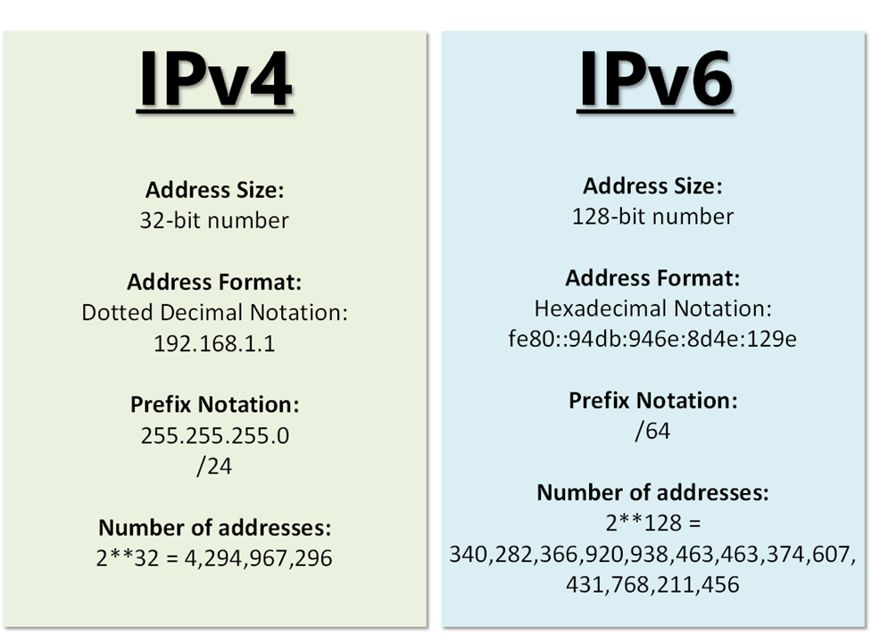
[7]

The bits in an IP address that is IPv4 can be divided into two. These are known as the network bits and the host bits. The subnet mask determines how this is broken up [8]. Similarly, an IP address that is IPv6 is also split into two, but these are known as the prefix length and host bits [9]. Wallace states that in IPv6, the prefix length is otherwise known as the network bits, even though it has been named differently [9].
Janssen states that a subnet organises a network into separate groups. Research suggests a life example of this would be that the network is a company, the subnets are the different areas within the company, where they have their own hosts (clients and printers etc) [10].
IP address management is very important when it comes to applying best practice within businesses or organisations. There are a few strategies that can be followed in order to ensure that efficient allocation and tracking is implemented in the network. Some of these tactics that are critical to ensure that a secure infrastructure is maintained, include centralised IP address management, structured addressing scheme, security measures and training and documentation. [11]

Transferring Data

The internet has two main concepts that are involved in transferring data. These are packets and protocols. Firstly, packets are the pieces of data that are broken down as part of the process to send data over the internet. These are then converted into bits and sent to the destination host via a number of networking protocols. Upon arrival to the destination host, the data is reassembled in order to display the data in the intended format. The protocol part of this process could also be known as the communication style or technique. There are a number of different protocols available, where some are specifically used for certain destinations. For example, one protocol is HTTP (hypertext transfer protocol), which is utilised when sending data via websites or applications. The communication type plays a part in how the data is formatted during the transfer. However, as any device connected to the internet has the capabilities to interpret any of the protocol, the internet will still work when any protocol type is used. [12]

Routers and Switches

A network switch and router both send data packets between devices on a network. However, a switch can only send data to one device at a time, whereas routers can send to multiple devices over a number of networks [13]. For this reason, switches are generally not needed for small home style networks but will be utilised in businesses where a large number of hosts are needed to be connected. On the other hand, routers are required for internet connectivity and therefore, they are generally found in both small, home networks and organisations [13]. This example is shown in the diagram below.

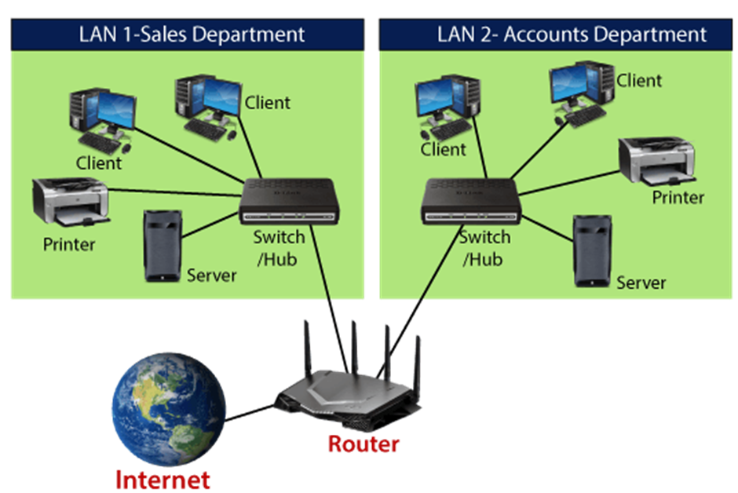
[14]

Testing

Research on network testing (trouble shooting techniques)

Research.
Network troubleshooting is the process of identifying and resolving uses within a network [15]. This could be in relation to the performance, connection and / or security [15]. It is very important for businesses to have an effective method in place to resolve the issue promptly. The slower it takes to resolve the issue, the longer the downtime of the system will be, and therefore, it is a very important aspect of supporting a network [15].
Cisco states that something that requires a troubleshooting investigation to take place is generally called a network event [15]. Work base experience has shown that a network event could occur at many stages, e.g. it could be during the initial development, any changes or updates being made or just during a normal run day where an unexpected incident occurs. Hence, in realistic terms, a network, and likewise with other part of technology, is always at some level of risk that a network event could take place. To reiterate Cisco’s point, this is an additional reason why it is vital to have a process in place to minimise the impact [15]. A network event is most commonly referred to as a failure in one of the following areas; connection, application, policy [15]. In addition, other examples of network events that require troubleshooting could be endpoint issues and security lapses [15].
During the testing stage of building a network for an infrastructure, the connectivity will need to be checked so that any issues can be rectified before proceeding onto the next stage of deployment. Research has provided a brief step by step guide on suggestions that can be followed to assist in identifying and rectifying an issue. Step one is to identify the problem, this should be a obvious step to include but without the initial testing that has been previously been discussed, something could be missed [16]. The linked in research is in regard to a physical machine, however as this project is a virtual machine, the suggestions can be missed or adapted to suit. Another recommendation would be to run a network diagnostics and monitor the network [16]. O’Reilly suggests that checking the basic networking connection can be performed by using a ping command or nslookup command [17]. Cisco also recommends using other commands such as tracert, netstat, iptables, route etc., in the command prompt to test the network connectivity [15]. Along with this, Microsoft advise that the firewalls are checked in as they could also have an impact [18]. Finally, another suggestion made by the linked in profile would be to seek help from others [16]. In university, there are other students and the lecturer who can assist with questions. It has been taught that working in teams for other type projects can help users to learn from others.

Test Network

The first test was to attempt to ping the server from the client. The error message returned was ‘Destination host unavailable’. At first, it was recognised that the server was not on which was believed to be the cause. This is shown the screenshot below.
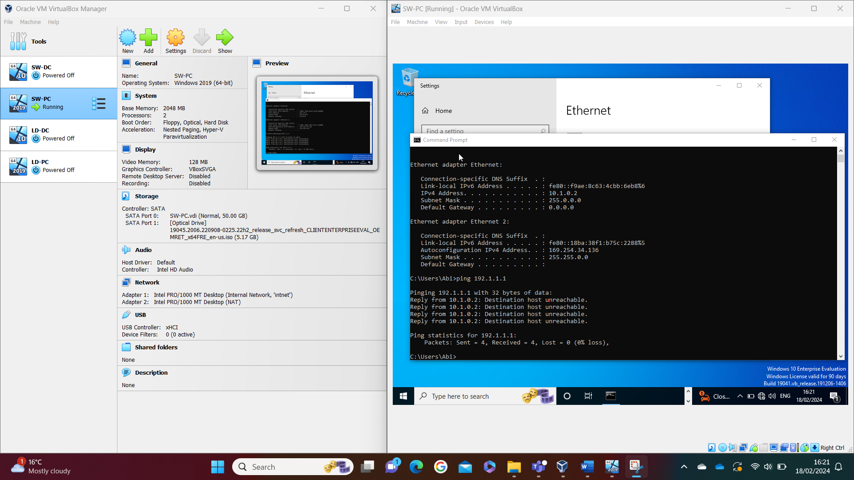
However, upon attempting to switch SW-DC on, the error message shown in the screenshot below was returned.
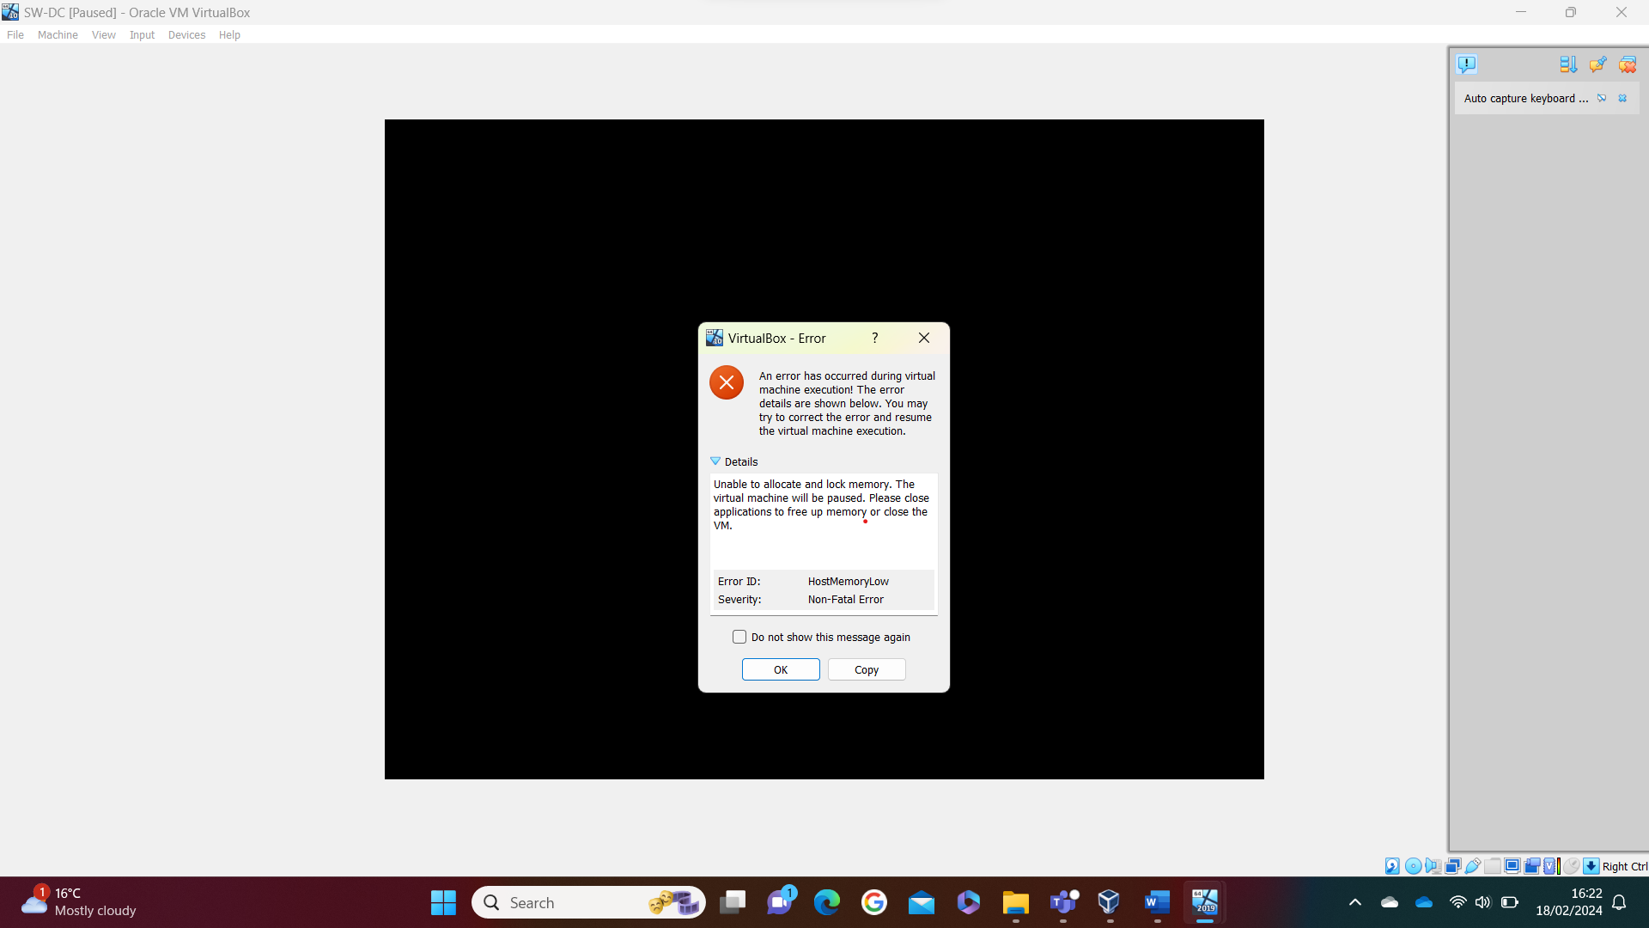
Research online resulted in the finding of closing other applications would reduce the memory issue [19].
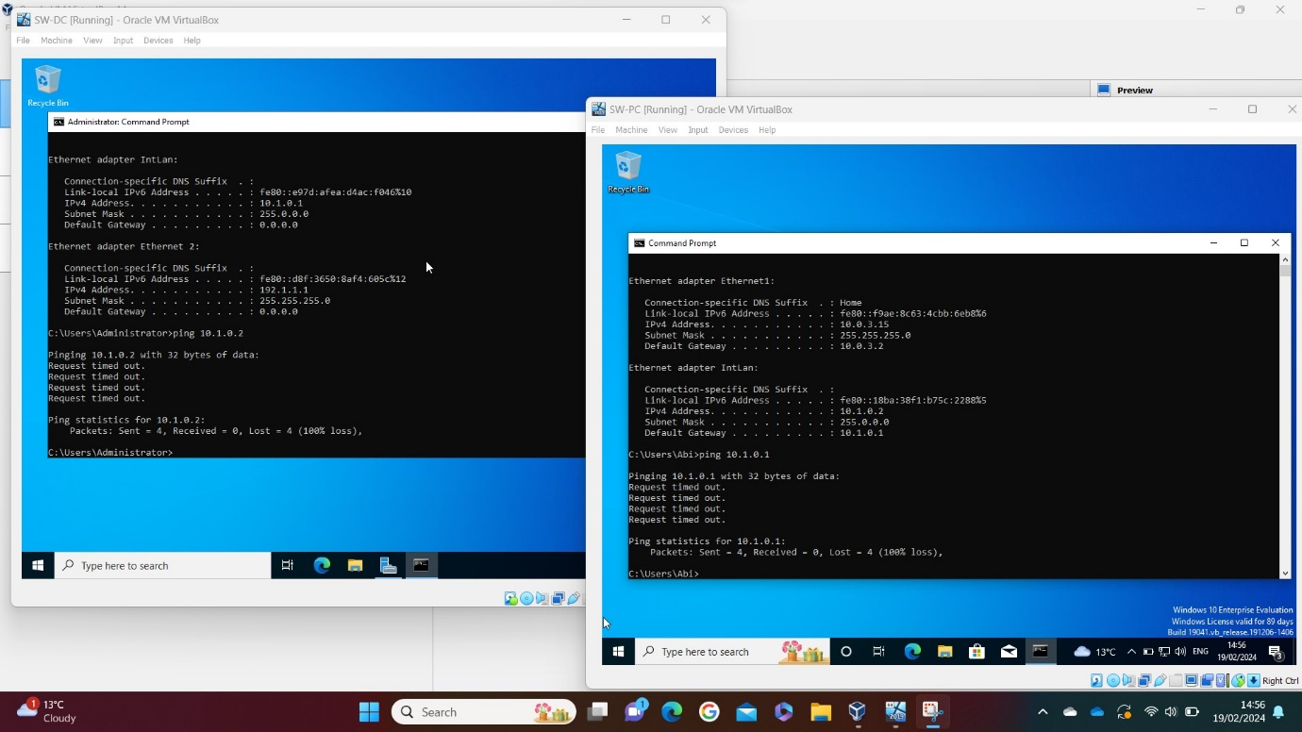
Once both the server and client were turned on, the error returned from the ping request on both machines were ‘Request timed out’, rather than ‘Destination host unreachable’ as shown in the screenshot below.

Research suggested that this could be a result of a number of things. Partition wizard suggested four following four methods with the hope to resolve this issue. The first method suggested was that a ping request was made to a knowledgeable website in order to identify whether the ping request was working correctly.[20]
Below is a screenshot of this being actioned on both the server and client. The server was expected to error due to no internet connection.
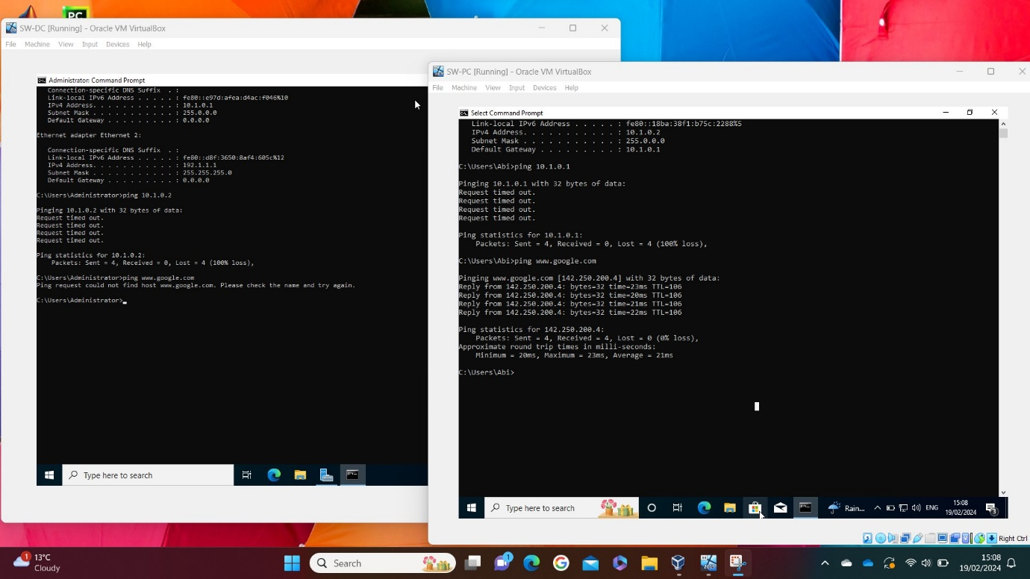
The second and third method were not advised. Therefore, these steps were skipped.
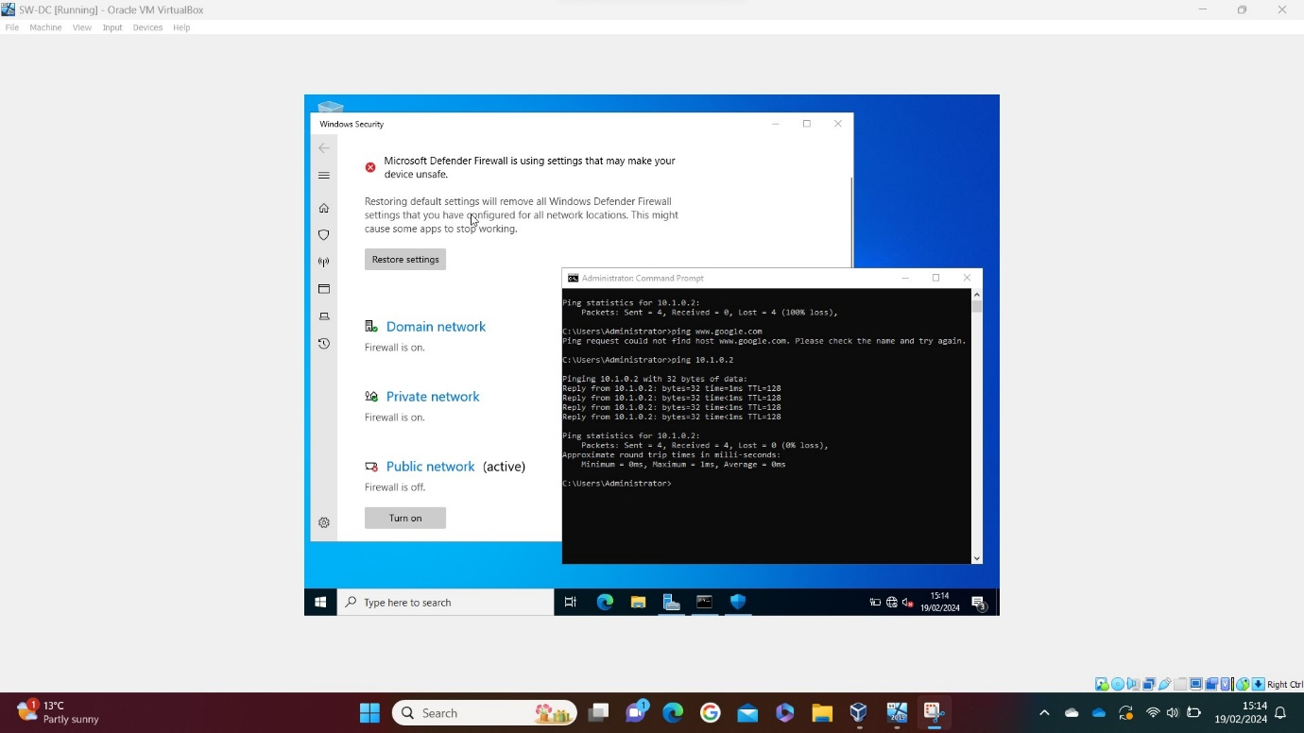
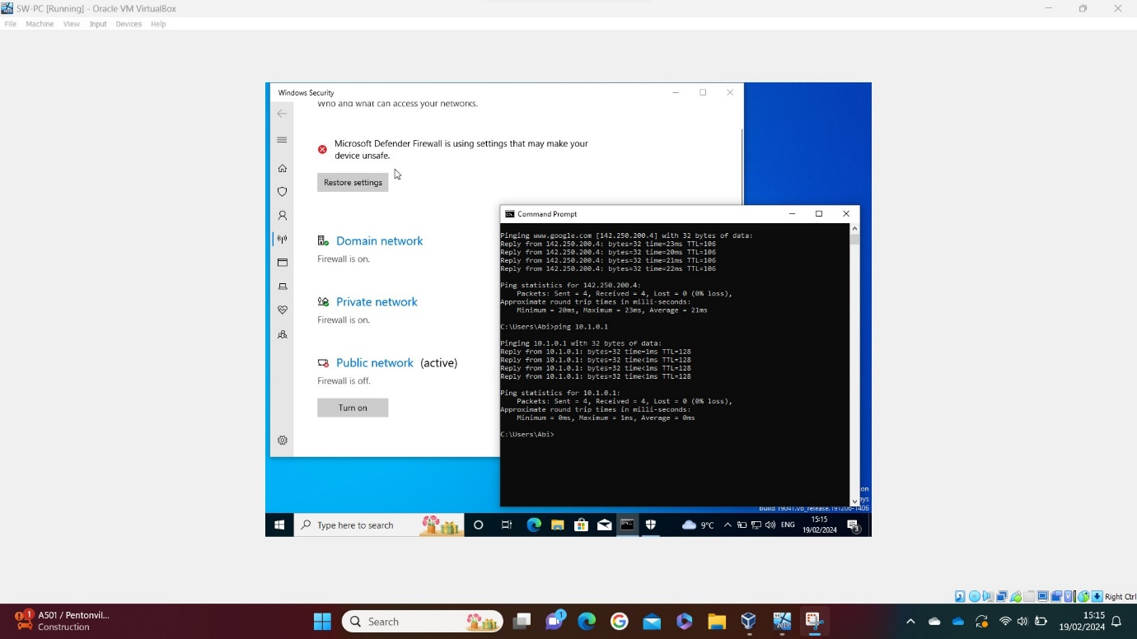
The fourth and final method recommended removing all firewalls from both the destination and sender machines. Initially, both public and private firewalls were turned off, resulting in a successful ping to both machines. However, after trial and error with a mixture of these combinations, it was identified that only switching off the public firewall on both the client and server, resulted in a successful ping. This meant that the private network firewall could stay on. This is shown in both screenshots below. [20]

Conclusion

To conclude, there are many aspects involved in transferring data over the internet. IP addresses and protocols are required to send the data that is split into smaller packets. The testing aspect of this assignment puts this into practice where it has shown when the packets are successfully received or lost during a ping command test. Moreover, when testing and maintaining a network in an organisation, it is vital to have a strong team that can adapt to different troubleshooting methods in order to resolve any issues in a quick and efficient manner. This is to prevent downtime in the services that the organisation provides.

References

[1] N.Kaliyamurthy, “Lecture 2”, Moodle. [Online]. Available: https://moodle.uwtsd.ac.uk/course/view.php?id=8759 [Accessed Feb. 15, 2024].

[2] M. Portnoy, “Virtualization essentials”, 2012. [Online]. Available: https://r2.vlereader.com/Reader?ean=9781118226988

[3] J. Macpherson, “What Is a Hypervisor? – Types, Benefits & How Does It Work?”, Park Place Technologies, Feb. 14, 2022. [Online]. Available: https://www.parkplacetechnologies.com/blog/what-is-hypervisor-types-benefits/ [Accessed Feb. 15, 2024].

[4] S.J. Bigelow, “What's the difference between Type 1 vs. Type 2 hypervisor?”, Techtarget, Jan. 13, 2021. [Online]. Available: https://www.techtarget.com/searchitoperations/tip/Whats-the-difference-between-Type-1-vs-Type-2-hypervisor [Accessed Feb. 15, 2024].

[5] Amazon, “What’s the difference between Type 1 and Type 2 Hypervisors?”, Amazon. [Online]. Available: https://aws.amazon.com/compare/the-difference-between-type-1-and-type-2-hypervisors/ [Accessed Feb. 15, 2024].

[6] K. Wallace, “Learning IP Addressing”, Linkedin, Sept. 06, 2019. [Online]. Available: https://www.linkedin.com/learning/learning-ip-addressing-2019/the-role-of-ip-addresses?resume=false&u=77966930 [Accessed Feb. 08, 2024].

[7] Network Academy, “What is IPv6?”, Network Academy. [Online]. Available: https://www.networkacademy.io/ccna/ipv6/what-is-ipv6 [Accessed Feb. 16, 2024].

[8] K. Wallace, “Cisco Networking Foundations: IP Addressing”, Linkedin, Aug. 15, 2022. [Online]. Available: https://www.linkedin.com/learning/cisco-networking-foundations-ip-addressing/ipv4-address-format?resume=false&u=77966930 [Accessed Feb. 16, 2024].

[9] K. Wallace, “Cisco Networking Foundations: IP Addressing”, Linkedin, Aug. 15, 2022. [Online]. Available:https://www.linkedin.com/learning/cisco-networking-foundations-ip-addressing/ipv6-address-format?resume=false&u=77966930 [Accessed Feb. 16, 2024].

[10] D. Janssen, “8 Steps to Understanding IP Subnetting”, Techopedia, Aug. 25, 2023. [Online]. Available: https://www.techopedia.com/6/28587/internet/8-steps-to-understanding-ip-subnetting [Accessed Feb. 08, 2024].

[11] Number Resource Society, “IP Address Management Best Practice”, Linkedin, Dec. 29, 2023. [Online]. Available: https://www.linkedin.com/pulse/ip-address-management-best-practice-number-resource-society-05sgf#:~:text=IP%20address%20management%20(IPAM)%20is,stable%20and%20secure%20network%20infrastructure [Accessed Feb. 15, 2024].

[12] Cloudflare, “How does the Internet work?”, Cloudflare. [Online]. Available: https://www.cloudflare.com/en-gb/learning/network-layer/how-does-the-internet-work/ [Accessed Feb. 01, 2024].

[13] Cloudflare, “What is a network switch? | Switch vs. router”, Cloudflare. [Online]. Available: https://www.cloudflare.com/en-gb/learning/network-layer/what-is-a-network-switch/ [Accessed Feb. 08, 2024]

[14] Javatpoint, “What is a Router?”, Javatpoint. [Online]. Available: https://www.javatpoint.com/router [Accessed Feb. 15, 2024].

[15] Cisco, “What Is Network Troubleshooting?”, Cisco. [Online]. Available: https://www.cisco.com/c/en/us/solutions/enterprise-networks/what-is-network-troubleshooting.html#~q-a [Accessed Feb. 15, 2024].

[16] Cloud 7 IT Services INC., “Network Troubleshooting: A Step-by-Step Guide”, Linkedin, Sept. 08, 2023. [Online]. Available: https://www.linkedin.com/pulse/network-troubleshooting-step-by-step-guide-cloud-7-i-t-services [Accessed Feb. 21, 2024].

[17] O’Reilly, “Network Testing and Troubleshooting”, O’Reilly. [Online]. Available: https://www.oreilly.com/library/view/essential-system-administration/0596003439/ch05s03.html [Accessed Feb. 21, 2024].

[18] Microsoft, “Troubleshoot virtual network peering issues”, Microsoft, Dec. 10, 2023. [Online]. Available: https://learn.microsoft.com/en-us/azure/virtual-network/virtual-network-troubleshoot-peering-issues [Accessed on Feb. 22, 2024].

[19] Virtualbox Forums, “HostmemoryLow and Unable to allocate and lock memory”, Virtualbox. [Online]. Available: https://forums.virtualbox.org/viewtopic.php?t=95438 [Accessed Feb. 18, 2024].

[20] Sherry, “How to Solve Ping Request Timed Out – 4 Methods”, Partition Wizard, Dec. 08, 2023. [Online]. Available: https://www.partitionwizard.com/partitionmanager/ping-request-timed-out.html [Accessed Feb. 19, 2024].

