
Master of Business Administration

Pioneer vs Follower: Product Life Cycle Strategic for Competitive Advantage

Module name : Marketing Management
Module code : LCMB7024
Lecture name : Dr. Laila Maazouz
Student name : Neel Mevalkumar Patel
Student ID : 2428324
Word Count : 2541
Submission Date : 28th March 2025

Table of content
Introduction: 2
Pioneer 2
The advantages of being a Pioneer 2
Follower 3
The advantages of being a Follower 3
The Product Life Cycle 4
PLC Strategies for Pioneer and Follower Companies 5
Conclusion: 7
References 7

Introduction: In this modern era marketing plays a significant role in the business field. The characteristics of modern market are fundamentally driven by the correlation between pioneer and follower companies. Pioneers are characterized by their introduction of new products and services. Pioneer companies operate with an innovative and pro-active approach to take advantage as first mover and they emphasize consumer preferences and making technological leadership. Followers enter the market after analysing the pioneer's entry, risk management and product development. They provide new solution with superior product quality and improved operational efficiency. The difference between pioneers and followers represented by the product life cycle (PLC). There are 4 stages in the Product life cycle strategies. The first stage is introduction, second is growth, third is maturity and fourth is decline stage. During the introduction stage, pioneers focus on market creation and consumer education, while followers focus monitor and prepare for market entry. Where in the growth phase pioneers and followers are both focusing on creating brand quality and expanding market performance. However, pioneer focus on continuously innovation and followers focusing on learning pioneers’ strategies. The maturity stage is having a competitive advantage so the pioneer uses their market experience while followers improving price differentiation and R&D. Finally, during the decline stage pioneer and followers are both focusing on how to survive in the market. This PLC analysis explain the advantages and disadvantages of both pioneer and followers.

Pioneer: it is a company that introduces a new product, service or technology to the market before competitors. For example, Coca-Cola company marketing for their soft drink product worldwide. They created soft drink., Apple company has pioneer in the tech industry. Apple invented personal computer and iPad.
The advantages of being a Pioneer:
- Brand recognition: Brand recognition is the first stage when company introduce their brand logo and name. Customers identify to a brand when they see or hear it. Companies aim to make their brand easily recognizable compared to the competitors (Conradie, et.al 2019).
For instance, McDonald company is best example of brand recognition. It makes their iconic brand logo "Golden Arches" and the name is "McDonald". The simple name "McDonald" is easily pronounced. It famous for burgers and fries; when people hearing the name "McDonald" bring to imagine of burger and fries. It shows strong customer identity.
- Customer loyalty: Customer loyalty is a valuable asset for the company. A loyal customers spend money of the company's product; they are satisfied with the product they buy again that company's Product. Loyal customers given valuable feedback to a company. Due to which, a pioneer company build strong relationship with the customer (Mandal, 2022).
For instance, Nike company unique marketing strategy like "Just Do It" inspire and motivates consumer to buy the product. The consumers who have experienced the Nike's products are more likely to buy product again, which shows customer loyalty to the company. They always value customer feedback to improve their products through social media platform and customer service channels. This builds a strong customer relationship with company.
- Innovative Product: Innovative product attracts the customer. it aligned with current market trends. Company observes consumer behaviour, taste and preference then it will introduce new product in the market. Innovative product connected with customer expectations thus customer buy that company's product. Innovative ideas improve company's market performance (Qadeer, et.al 2025).
For instance, Apple company famous for their innovative products. Recently, they introduce new product which is vision pro, it is basically a virtual reality headset, which is very good example of the observing market trends and identify consumer need. The company focuses on its customers’ expectations like privacy and security in their devices. Apple's new product and innovative ideas increase the company's market share and revenue.
- Technological leadership: Pioneer company are creating new markets; they are navigating business industry through different kind of technological innovations. Pioneer company create a culture that motivate to innovation and risk-taking activity. Pioneer company's leader has clarity of ideas thus they are taking every opportunity (Kodama, 2019).
For instance, Tesla is not only manufacturing electric vehicle but is creating advanced technological electric vehicles. Tesla invested heavily in improving battery technology to increase vehicle performance and also, they introduced autopilot and self-driving vehicles to the EV industry. This is the clear indication how they navigate industry. Elon Musk motivates his employees to think at the next level to achieve company's goals. He sees new opportunities with an advance vision, which is a sign of good leader.

Follower: It is a company that enters the market after the pioneer, learning from the pioneer’s successes and mistakes. For example, Apple pioneered company in the modern era, while Samsung is follower company. Samsung is following and improving their product constantly. Samsung observed apple's success, analysis area for improvement and offered a different range of devices with many features.
The advantages of being a Follower:
- Reducing Risks: Follower company analyse the risk management of pioneer companies through different source like industrial report and pioneer financial stability. Due to which follower's planning for entry in the new market, product development and calculate risk and return for their investment. Moreover, follower can reduce market challenges from the observing pioneer company face challenge where the company enter the first time in the market (Deselnicu, et.al 2020).
For instance, Swiggy is an Indian food delivery company that followed Zomato company. Swiggy observed Zomato's challenges with delivery strategy and restaurant partnerships. Swiggy focused on building a strong delivery network because it noticed Zomato's delivery network had weakness. Swiggy collects feedback after delivery, while Zomato focused on restaurant reviews. Swiggy also learned from Zomato that it had issue in maintaining its services in different cities, so Swiggy came up with different plans to solve this problem.
- Improve Product: Customer feedback is important for every company. Feedback plays crucial role for product development. Feedback identifies product problems thus company solve their product quality and improve the product. Follower companies use this approach from pioneers; thus, Follower can better product quality. Follower companies using this strategy for improvement of their product and learn from pioneer mistakes (Reilly, et. al 2016).
For instance, Burger King is often observed McDonald's new product launches and customer reactions. Thus, Burger King changes their menu. Burger King observed the rise of premium burgers so to compete with the McDonalds they change their menu. Burger King focusing on product quality and observing customers preference, Burger King has been able to have strong position in fast-food industry. Burger King has been able to avoid many of the downfall that McDonald's had in the past by observing them first.
- Learn from pioneer’s mistakes: Follower company learn from pioneer companies’ mistakes and put their product in the market. Learning from mistakes follower company develop product quality, build strong customer relationship and achieve profitability. Followers analyse the reasons which mistakes done pioneer and what impact for the customer. They are improving the product and services. They can take advantage of before launching the new product. This plays crucial roles for long-term success in the markets (Surdu, 2016).
For instance, Kia initially learned the production and quality control methods from the well-established companies like Toyota and Honda. Kia observed how to focus on some small things in the industry like how to make a fuel-efficient vehicle, much like the Japanese companies focused on. Kia also learned from the mistakes of other companies regarding warranty programs and kia created one of the best warranty programs in the industry.

The Product Life Cycle:
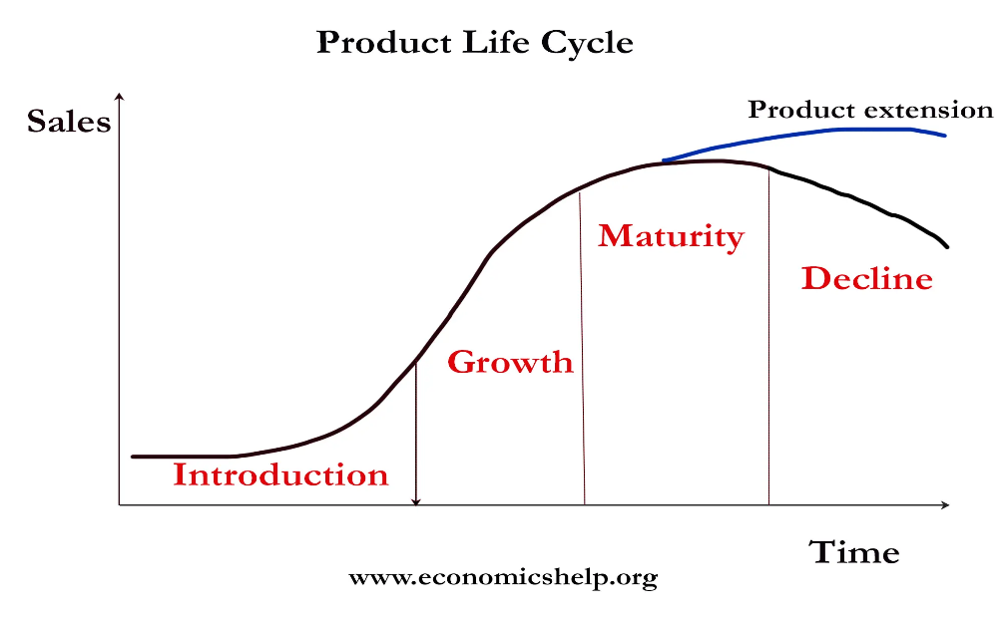

The Product Life Cycle has four stages (Pettinger, 2022).
- Introduction: This is the first stage when a company launch the new product in the market.
- Growth: This is the second stage of product Life Cycle. When a company advertises its product in the market thus retailers are attracting and the company increases its sales which indicating product growth.
- Maturity: It is an important stage in every company's product lifecycle, it shows the product has achieved its peak market share.
- Decline: The decline stage is when a company has failed to innovate a new product.

PLC Strategies for Pioneer and Follower Companies: Pioneer and Follower companies are both take their strategies to maximize growth and maintain a strong competitive advantages.
Introduction stage: Innovation and Market entry
Pioneer: Pioneers introduce new product with innovative ideas. They are creating market positions. Their aim is to increase their product valuation with more users. Pioneer companies focus on consumer preferences.
For Example, Dyson introduce vacuum technology, bladeless fans and hairdryers. It has built a successful global brand. It focuses on consumer preferences; it understand consumer needs to introduce new products.
Follower: Follower analyse the pioneer's innovation and network externalities. It helps them enter a market with a product to boost consumer acceptance. Followers increase the value of the product. Follower companies understand consumers perceptions through pioneer companies. It helps them enter at the right time in the market with a product (Jiang, et. al 2009).
For Example, Tineco is follower company. It observed Dyson's success in the vacuum cleaner market. Tineco entered the market with wet/dry vacuums and introduced new product. It focused on specific areas such as wet/dry smart vacuums, which helped to increase its value.
Growth stage: Building brand and market share
Pioneer: First movers are continuously innovating unique products and services. It indicates their growth and helps to maintain their brand image with consumers. They invest money in research and development of their products. They develop strong customer relationship management which helps to expand their market share. They increasing their product value through different sources like product launches and marketing campaigns. Their clear goals and ideas are illustrating robust growth of the company’s development (Zhang, et. al 2014).
For instance, Amazon is an e-commerce company. It innovates with different services like Amazon web Services, Kindle e-readers and Alexa AI. It invests in R&D and develops new innovations. Amazon launches new product and services regularly which enhance its brand value. It has clear ideas and goals; it focuses on building strong customer relationships.
Follower: Follower learns from the mistakes of the pioneer, so they monitor market trends and pioneer activity. They build a strong customer relationship and create a strong brand. Follower take customer feedback which help to improve the company's products and services. They focus on production processes and supply chain management, which helps to minimize risk and maximize return on investment. This indicates company performance better in the market (Zhang, et. al 2014).
For instance, Walmart observed Amazon's success in e-commerce and learned the importance of retailing and online sales. It has invested in the online grocery pickup and delivery services. It has worked to improve their online customer experience and build a strong brand. It collects customer feedback to improve its online services. Moreover, It try to minimize risk and maximize its return of investment.
Maturity Stage: Sustaining and Challenging
Pioneer: Pioneer companies monitor market trends and improve their products accordingly. Pioneers introduce new product with their unique ideas. This helps them stay ahead of competitors. Pioneers maintain strong relationship with the customers, which play a crucial role in their sustained growth. Pioneers have valuable market experience; this helps them to handle challenges and adapt to market trends and compete with follower companies. In short, pioneer companies monitoring market trends, innovation of new product and strong customer relationship help them sustain their competitors (Andersson et.al 2020).
For instance, Netflix started distributing DVD- by- mail. Observing the market trend, Netflix created an online streaming platform. They launched a subscription based streaming model like pay-per-view or rental services. It has expanded globally and has a huge impact on how people watch movies and TV shows. Netflix focused on user experience and collected user data to create content aligned with their desires.
Follower: Follower companies learn from the mistakes of pioneer companies, in two areas like differentiation and R&D. Firstly, followers focus on product price. Followers provide good products and services at a premium price. Followers invest in research and development of their products and services, which is beneficial for competing with pioneers. Followers understand customer needs and preferences, and prepare product according to their needs and preferences. Also, followers from strategic partnership with new companies; which helps followers to compete more effectively with pioneers.
For instance, Disney+ is the follower company of Netflix they entered the market with a competitive price point to give competition in the streaming industry. For their brand recognition they launched premium content quality in streaming. They invested in R&D of their products and services because they would like to create original content. To improve their customer service, they analysed customer's data to provide content customer like to watch.
Decline Stage: Harvest and Exit
Pioneer: During decline stage, pioneers focus on cost management. Pioneer companies reduce product cost and maximize profitability. Pioneer focus on their loyal customer base with make unique marketing, which benefits them, customer repeat purchases of the product.
For example, Zomato is a very well-known food delivery company in the India. In their decline stage, they heavily focused on cost cutting and reduced customer service. To increase company's profitability, they increased fees in their delivery service on the other hand they reduced customer service quality.
Follower: Followers are dependent on pioneers; they are analysing pioneer's weakness and problems and develop solutions. When their strategy fails, they exit the market or introducing modernized versions.
For example, Swiggy in the decline stage fail to improving logistics and customer service and they faced two potential outcomes: firstly, they were nearly to exit the highly competitive food delivery market and secondly, they could have attempted to introduce modernized version of their service.

Conclusion: In this highly competitive modern market, the strategies between pioneer and followers define the product evolution and market dominance. The pioneer with their visionary approach provides the foundation for the new market, implement brand value and do focus on customer loyalty. Their innovative approach helps them to develop products and technology, fulfil consumer need and provide the industry standards. However, being a pioneer there is a risk high initial cost and marketing uncertainties. On the other hand, followers analyse the pioneers' experience and after they enter into the market with improved product. Followers learn from pioneers' mistake and followers can minimize risk, improve product quality and company's efficiency. Followers' ability to learn and adaptation allows them to grape new opportunities.The product life cycle (PLC) gives a framework of critical understanding, each stage of (PLC) presents the unique challenges and opportunities for both of them pioneers and followers. During the phase of introduction and growth the pioneers make the market presence and build their brand quality. In contrast, the followers re build their market entry strategies. In the maturity stage both of they try to get a competitive advantage, the pioneer uses their market experience and the followers differentiating through their price of product/service and R&D. Lastly, in the decline, this stage it is necessary to make a decision about how they can survive or be in the market and considering the importance of adaptability. Finally, the success of both pioneer and followers depend on how they identify market trend, understand consumers need, and how strategically they navigate their involvement in the market.

References:
Conradie, E S et al. (2019). ‘The influence of eleven Ps: An internal marketing and brand awareness perspective in a service environment’.
Southern African business review, Vol.18 (1), p.100-121.
Mandal, Pratap Chandra (2022). ‘Managing Customer Satisfaction and Customer Loyalty in Organizations: Strategies and Initiatives’. Journal of Business Ecosystems, Vol.3, (1), p.1-16.
Shang, YuFan et al. (2025). ‘The three-way interaction: market innovation, state ownership, and managerial incentives’. The Journal of Developing Areas, Vol. 59, (1), p. 255-284.
Kodama, Mitsuru (2019). ‘Business Innovation Through Holistic Leadership‐Developing Organizational Adaptability’. Systems Research and Behavioural Science, Vol.36 (4), p.365-394.
Deselnicu, Dana et al. (2020). ‘Risk Assessment in a Startup Company’. FAIMA Business & Management Journal, Vol.8, (4), p. 56-63.
Reilly, Richard R et al. (2016). ‘Prototyping, customer involvement, and speed of information dissemination in new product success’. The Journal of Business & Industrial Marketing, Vol.31, (4), p. 437-448.
Surdu, Irina (2016). ‘Back again? the effects of organisational learning and institutional legitimacy on foreign market re-entry decisions’. Doctoral dissertation, ProQuest Dissertations & Theses.
Tejvan Pettinger (2022). ‘Product Life Cycle’. Economic. Help website, Available at: https://www.economicshelp.org/blog/140934/business/product-life-cycle/. (Accessed: 21 may 2022).
Jiang, Ying et al. (2009). ‘The Impact of Anticipated Follower Entry on Consumer Acceptance of Pioneer Brands’. Urbana: Association for Consumer Research; Advances in consumer research, 2009, Vol.36, p.781.
Zhang, Lian et al. (2014). ‘What are good R&D investment strategies for leaders and followers?’ Technology Analysis & Strategic Management, Vol.26, (8), p. 909-925.
Andersson, Svante et al. (2020). ‘How do mature born globals create customer value to achieve international growth?’ International Marketing Review, Vol.37, (2), p.185-211.

