

Entrepreneurship
Assessment 1

Student name: 2229251
Student Number: PARMOD KUMAR
Lecturer: Jaya Gopalkrishnan

Table of Contents
Introduction 3
Definition of Enterprise and Enterpreneurship 3
Conceptual foundation about Enterprise and Entrepreneurship 3
Analysis and critical evaluation of enterprise and enterpreneurship from an Entreprenur perspective 4
Conceptual foundation to personality trait theories 5
Key Traits, Characteristics, Attributes, and Motivation of Aman Gupta 5
Conceptual foundation to ‘for profit’ and ‘not for profit small organisation 8
Analysis and criical analysis of ‘for profit’ and ‘not for profit’ small organisations 9
Critical analysis of enterpreneurs values and beliefs in ‘for profit’ and not for profit small organisations 9
Conclusion 10
References 11

Introduction
The development of entrepreneurship includes the means and goods of maximizing the skill and knowledge of the entrepreneurs. The concept of entrepreneurship also involves one's ability and enthusiasm to readily develop, organise and run an enterprise. Besides entrepreneurship means leading an organisation along with difficulties and uncertainties to make a profit (Chatterjee, et al., 2023). In this study, different concepts and knowledge about the enterprise will be elaborated and different strategies implemented by the leaders will also be vividly discussed. The key traits, characteristics, attributes, and motivation strategies taken up by Aman Gupta, the CEO of Boat, to expand his business, will be examined thoroughly in this report. A precise idea will be given in comparison and contrast between "for profit" and "not for profit" small organizations in this study.

Definition of Enterprise and Enterpreneurship
The entrepreneurial strategies involve the discovery, consideration, assessment, and exploitation of given opportunities. In other words Elia, et al., (2019) mentioned that entrepreneurship encompasses both the development of novel products and the successful penetration of markets. It fosters the expertise and inputs from the new mind that can be implemented in new market strategies and product design which did not exist before. The concept of enterprise and entrepreneurship is correlated, as entrepreneurship is an entity that starts discovering the right time, right place, and the right opportunity for launching a business, whereas enterprise is an overall activity or a process that identifies market opportunity and executes plans to expand the business and make money.

Conceptual foundation about Enterprise and Entrepreneurship
Portfirio, et al., (2020), stated that the entrepreneurship theory assists in comprehending the way different entrepreneurs represent their behaviours more efficiently in order to understand this business notion. This perspective on entrepreneurship is further supported by Baker and Welter, (2020), as it directs a person to understand the value and importance of entrepreneurship and perceive why not everyone has the ability to possess entrepreneurial qualities.

Thompson and Byrne (2020) point out that the many theories that explain entrepreneurship provide insight into diverse approaches and the necessary leader's mindset. Moreover, According to Wood, et al., (2022), a more in-depth analysis requires “recognition of discrepancies between these theories and an understanding of the multiple dimensions of successful business practices.” Entrepreneurs are the people who show their willingness to generate product and service value and take ownership of it even in puzzling circumstances. Entrepreneurs must need to conceive entrepreneurial intentions and interests to produce value. Xiang & Feng (2020)claimed that, Enterprises are not supposed to be an unassisted process, instead, proper assistance from the entrepreneur is vital for business expansion. The efficient use of resources and business incentives are very important in business processes. A more comprehensive examination should focus on issues such as resource allocation and the complex relationship between motivations and external factors that affect business results. Thereby, Wang & Liu, (2023) mentioned that, by utilising proper resources and assistance entrepreneurs can make a long term profit and sustainable growth. The leaders are able to develop an impactful and sustainable brand value by catering to the consumers' individual choices and demand. Chalmers, et al., (2021) illuminate that, Entrepreneurs need to look for external resources, if necessary, to attain the benefits of entrepreneurship. On this note, Ritala, et al., (2021), stated that the most accepted theory of entrepreneurship states two steps of value generation and appropriation that are included in entrepreneurial processes. Furthermore, there is an additional theory regarding the economic development of the enterprise that was first published by Schumpeter in 1934 (Callegari & Nybakk, 2022).

Analysis and critical evaluation of enterprise and enterpreneurship from an Entreprenur perspective
Rosenhead, et al., (2019) contends that, the theory emphasises a leaders role in stimulating economic transformation and growth, but not that critical analysis should recognise complexity beyond leadership actions. According to (Callegari & Nybakk, 2022), the proposed theory of Schumpeter also defines the utmost necessity for entrepreneurs to combine the elements that ignite productivity as well as arrange external resources or organise internal resources and accumulate new talents to work together for the organization. The practicability of this theory is better understyood with the utilisation of the example of Aman Gupta, the Indian CEO nad Buinessman, owner of the company Boat. The emphasis states that, he being an enterpreneur has the needed notion on the respective technical advancmenet needed to establish an organisation, alike Boat and hence restructuring the same for more feasibility. This point is ovbserved to be an adhered fact that goes hand-in-hand with the theory, as stated.

Conceptual foundation to personality trait theories
The point of view of Schumpeter says technical advancement may result in better economic growth. Development of new and innovative market strategies, effective choices of marketplaces, findings of proper resources, or an industry restructuring, all collectively may provide immense economic success and generate community engagement. According to Silva & Wright (2019), value creation theory shapes inputs/outputs to grow exponentially, necessitating a crucial examination of practical feasibility and wider implications.
The entrepreneur effectively coordinates the resources for the marketing activities and the employees rely on their decisions. All the processes mentioned in theories and advice revolve around the functions the entrepreneur performs and the decisions that they make. Bauman & Lucy (2021) states that, the ultimate responsibility for creative thinking and effective economic performance is upon the entrepreneur of the organization. Entrepreneurs must be driven by aspirations or the rivalry around them or driven by profit-making in order to determine success and commit to the business.
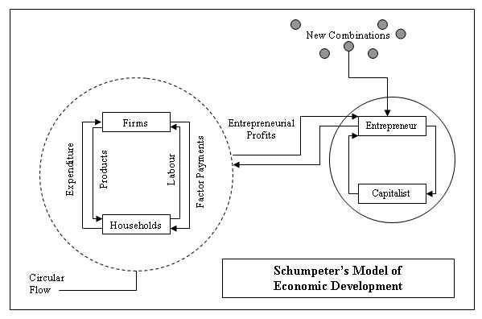
Figure 1: Economic Development Theory of Schumpeter
(Balana, n.d.)

Key Traits, Characteristics, Attributes, and Motivation of Aman Gupta
Key traits
Aman Gupta is the Indian businessman and CEO of Boat. The key trait of Aman Gupta that helped him to succeed in his venture is his creativity which has been successfully implemented in his business module. Diawati, et al., (2023) highlights, this is helpful and assists in creating creative skills. Therefore, from that it can be said that this has helped him to use his creative skills along with the problem-solving tactics that have immensely helped him to increase the effectiveness of his entrepreneurial skill. The most effective key trait of Aman Gupta that has helped him to successfully implement all the policies within his company is effective communication along with problem-solving techniques. When it comes to communication and problem solving, Kalogiannidis (2020) stresses on the notion that, lack of poor communication and problem solving techniques are major obstacles for running the business. Yue, et al., (2019)noted transparent communication of the leader with the rest of the employees helps in increasing the efficiency of the company among all the competitive rivalries operating worldwide.
Aman Gupta as a successful entrepreneur has a vision and mission for his company which is driven by the fact that he uses all his adaptive skills to understand the demand and supply chain of the market. This trait has helped him to enhance the production of the company to suit the needs of the common people. Aman Gupta possesses the trait of integrity at his workplace that has made it possible for all the employees of the company to treat all its customers with honesty and accuracy in the description of the products of the company.
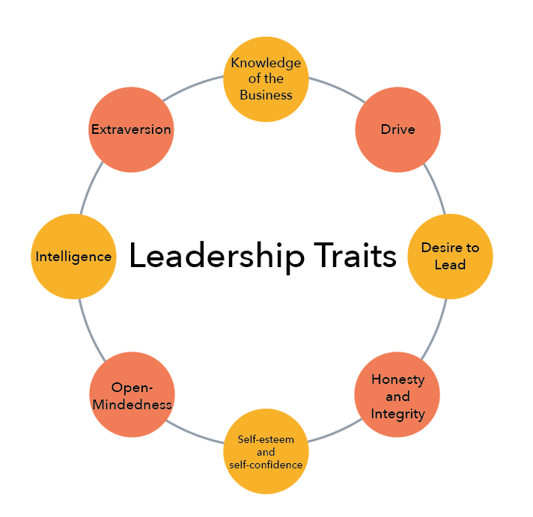
Figure 2: Key Traits of a Leader
(lumen, n.d.)
Characteristics
Aman Gupta possesses a clear and inquisitive mindset which is considered to be the most significant characteristic of an entrepreneur. Good innovative product ideas help in increasing the sustenance of the product at the international level. In contrast,Diamantidis & Chatzoglou (2019) mentioned that variance in the level of productivity is detrimental in evaluating the overall skill level of an individual.
Aman Gupta is confident regarding all the policies and programmes that are to be implemented within his company as he is well concerned about its consequences. However,Rickley (2023), stated that more than curriculum skills, proper communication and approach skill is necessary for building a compatible business environment. Interpersonal and entrepreneurial skill is more likely to surpass the lack of communication ability. Aman Gupta has the ability to communicate effectivity with all the employees in his company which has made it possible for a leader like him to understand the operational base of the company to to take policies based upon it.
Attributes
According to Durnali, et al., (2023), the attribute of the leader is considered to be the most significant part that helps in the overall growth and development of the organization. Meanwhile, Hunt, et al., (2019) opined that only a dynamic nature of a leader helps in incorporating the successful factors in the working system of an organisation. Aman Gupta has a series of attributes and features that act as the most significant part of the inherent growth of his company. The attribute of Aman Gupta is his self-assurance which has played a great role in the overall growth of his company.
Aman Gupta is self-assured in his endeavour and along with his confidence he has taken some of the best decisions for his company that have helped in achieving goals for his company. However, according to Zhao, et al., (2023), the inherent feature of the entrepreneur is considered to be the important characteristic skill of the leader. The exerting extensive interpersonal skills might aid the systematic running function of the organisation more transparently compared to its entrepreneurial skills. The prudential use of resources by Aman Gupta has instilled the fact that the company has acquired all the required goals and objectives for its functioning.
Motivations
Aman Gupta derives his motivation from the world-class leaders of the world along with some of the movies that are exclusively based on the successful stories of entrepreneurs. This motivation is diverse in nature and is not based on one factor. The motivation of the entrepreneur tends to be the most significant attribute as the entire functioning of the organization is based on the ultimate direction of the leader. Motivating leader created a congruent environment where all the staff and the employee co-exist together and makes the working function more exploitive in nature. Aman Gupta motivates himself by the fact that he wants to expand his business module to far-off regions, which would help in enhancing the brand value of the company.
The maximization of profit for the organization along with increasing the brand value of his company acts as the most significant motivation factor for Aman Gupta. However, according to Irwan, et al., (2020), the motivation of the leader is guided by four important parts that constitute financial gain, mind and creative control, along with maximum freedom based on the behavioural aspect of the individuals. In contrast, Purwanto et al. (2021) opined that the motivation factors prostrate after competing tremendously with well-established brands globally. This postulates the fact that Aman Gupta is guided by some of the basic principles of his life that motivate him to enhance his business module along with the overall development of the company. Aman Gupta along with motivating himself motivates the entire employee section of the organisation to increase the effective performance of the company.

Conceptual foundation to ‘for profit’ and ‘not for profit small organisation
The business collaborations and partnership strategies that encompass common funding and different goals as well as have no economic inducement are known as a "for-profit" organisation (Ambos & Tatarinov, 2022). This form of business indicates a significant effort to influence and motivate the public. The founders are held responsible for making effective income and profit in a "for-profit" form of business. Whereas a "not for profit" organisation's key objective is to make a charitable and cost-effective benefit to the community.A non-profit organsiation provides customer satisfaction through establishing credibility and “limited liability status”. In contrast most business is not made in a way to transfer individual assets following the process of hereditary credibility.
In a not-for-profit business like Feeding America, leaders gain no economic and financial support from their affiliation with the organisation. Not-profit and no-for-profit affiliations might seem a little similar but a vast difference is recognizable. The leaders motivate the workers to fulfil the outlined mission of improving community outreach and making effective donations.

Analysis and criical analysis of ‘for profit’ and ‘not for profit’ small organisations
Irrespective of profit-making or income, individuals in the organisation focus on achieving the main goal. The nonprofit approach significantly aids in receiving additional compensation. However, the objective of the organization never seems to be halted while receiving additional compensation. Nonprofit-making relationships of the organisation pay compensations to those organisation as a course of managing the relationship (Bonfanti, et al., 2023).

The organization attains this success by offering the best advantages to the population that are conceivable. On the other hand, a not-for-profit organisation sets a primary goal of generating profit in the form of benefits to society. The channel promotes social clarifications by offering services with basic human necessities. (Finkler, et al., 2022) stated that the channels of the non-profit organisation use moral needs, emotional needs, and circumstantial needs as a median. In contrast such forms of business invest in handling social issues and revolving them fundamentally, such as constructing housing, protecting threatened animals, obstructing pollution, preventing hunger, and providing domestic help to the people, and so on.

Critical analysis of enterpreneurs values and beliefs in ‘for profit’ and not for profit small organisations
Wadesango (2019) signified that companies partake in their initial financial help from entrepreneurs or the pioneers such as investors who offer loans, funding backers, and wages that originated from the use of services and products. However, such organisations are expected to use only government-granted crowdfunding supplements are to support the company's initiatives. While not-for-profit businesses are mostly concerned about adding a more interesting group, including business partners and volunteers, and public support, the for-profit organizations look after building an effective customer impression.
For-profit businesses like fashion industries and different automobile sectors, must pay taxes the same as required which is designed by law as these they make profit from their own interests. Albaz, et al., (2022) measured that Nonprofit organizations try to exempt the surplus profit to maintain sustainability in the business environment based on a long-term basis. In contrast, “For-profit” and “not-for-profit” businesses show distinguishing features only during the execution of the business in the International level.

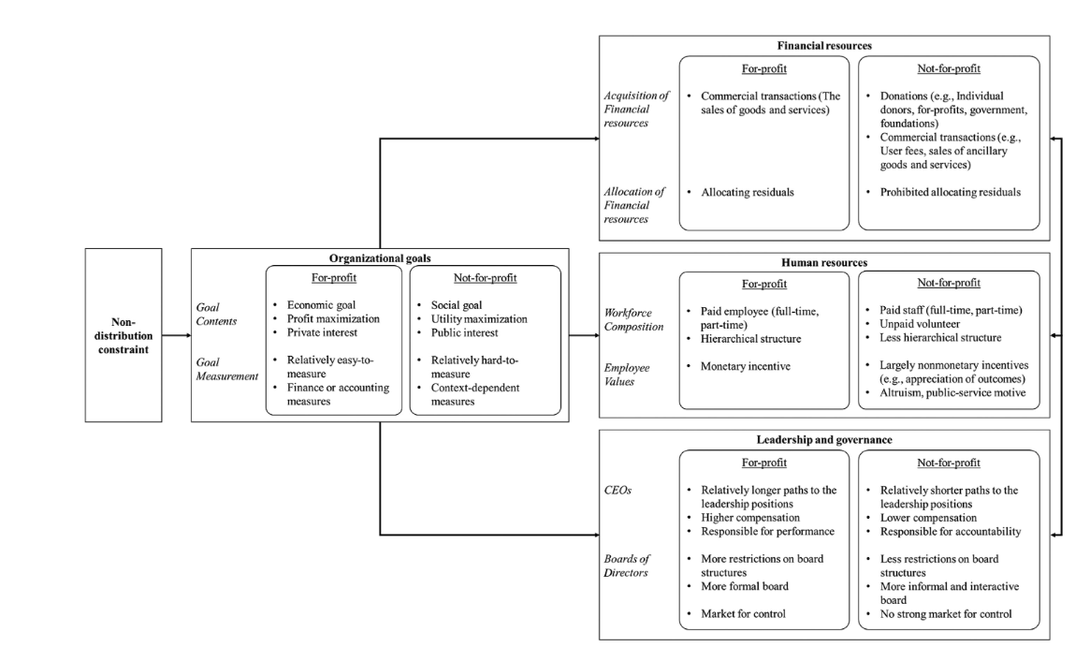

Figure 3: For-profit and Not-for-profit difference
(Gee, et al., 2023)

Conclusion
A business enterprise is an institution where one desires to set a creative and independent career objective. In this report, extra effort has been put to cover the entire concept of entrepreneurship and enterprises from an angle of professional perspective. This study remarkably notes the theories that associate fundamental features, motivators, and specific key traits of the entrepreneurs as well as leaders' vision-making ability and attributes towards business execution, along with small business owners. Besides that, the identity and line of work of the entrepreneurs have been highlighted in this report. Also, the contrast and comparisons have been drawn on this assignment, that address different categories of occupations in business making.

References
Albaz, M. M., Melegy, M. M., Abu-Sheashea, A. M. & Metwaly, A. Z., 2022. The Accounting Regulations for the Non-Profit: A Comparative Study Between Egypt and UK. International Journal of Accounting and Management Sciences, 1(2), pp. 171-184.
Ambos, T. C. & Tatarinov, K., 2022. Building responsible innovation in international organizations through intrapreneurship. Journal of Management Studies, Volume 59, pp. 92-125.
Balana, B. B., n.d. The role of Innovation in Development – could lessons be drawn for Ethiopia?. Ethioplan e-journal for Research and Innovation forsight, 6(2), pp. 43-51.
Bauman, A. & Lucy, C., 2021. Enhancing entrepreneurial education: Developing competencies for success. The International Journal of Management Education, Volume 19.
Bonfanti, A., Mion, G., Brunetti, F. & Sanchez, A. V., 2023. The contribution of manufacturing companies to the achievement of sustainable development goals: An empirical analysis of the operationalization of sustainable business models. Business Strategy and The Environment, 32(4), pp. 2490-2508.
Callegari, B. & Nybakk, E., 2022. Schumpeterian theory and research on forestry innovation and entrepreneurship: The state of the art, issues and an agenda. Forest Policy and Economics, Volume 138, p. 102720.
Chalmers, D., Matthews, R. & Hyslop, A., 2021. Blockchain as an external enabler of new venture ideas: Digital entrepreneurs and the disintermediation of the global music industry. Journal of Business Research, Volume 125, pp. 577-591.
Chatterjee, S., Chaudhuri, R. & Vrontis, D., 2023. Investigating the predictors and outcomes of social entrepreneurship in post-COVID-19 period: moderating role of dynamic technology capability.. TECHNOLOGY ANALYSIS & STRATEGIC MANAGEMENT, pp. 1-17.
Diamantidis, A. D. & Chatzoglou, P., 2019. Factors affecting employee performance: an empirical approach. Factors affecting employee performance, 68(1), pp. 171-193.
Diawati, P., Ausat, A. M. A. & Augustin, J., 2023. Creativity: How to Develop an Entrepreneurial Attitude of Creativity. Journal on Education, 5(3), pp. 11116-11122.
Durnali , M., Orakci, S. & Khalili, T., 2023. Fostering creative thinking skills to burst the effect of emotional intelligence on entrepreneurial skills. Thinking Skills and Creativity, Volume 47.
Elia, G., Margherita, A. & Passiante, G., 2019. Digital entrepreneurship ecosystem: How digital technologies and collective intelligence are reshaping the entrepreneurial process. Technological Forecasting & Social Change, Volume 150.
Finkler, S. A., Smith, D. l. & Calabrese, T. D., 2022. Financial Management for Public, Health, and Not-For-Profit Organizations. CQ press, Volume 6.
Gee, I. H. et al., 2023. Not-for-Profit Organizations: A Multi-Disciplinary Review and Assessment From a Strategic Management Perspective. Journal of Management, 49(1), pp. 237-279.
Hunt, T., J., Fedynich, L. C. & D., E., 2019. 20Leadership: Past, Present, and Future: An Evolution ofan Idea. Journal of Arts & Humanities, 08(2), pp. 22-26.
Irwan, A., M., Nujum, S. & Mangkona, S., 2020. The effect of leadership style, work motivation and organizational culture on employee performance mediated by job satisfaction. International Journal of Multicultural and Multireligious Understanding, 7(8), pp. 642-657.
Kalogiannidis, S., 2020. Impact of effective business communication on employee performance. European Journal of Business and Management Research, 5(6).
lumen, n.d. Lumen. [Online]
Available at: https://courses.lumenlearning.com/wm-principlesofmanagement/chapter/what-makes-an-effective-leader/
[Accessed 16 08 2023].
Porfirio, J. A., Feliciob, J. A. & Carrilho, T., 2020. Family business succession: Analysis of the drivers of success based on entrepreneurship theory. Journal of Business Research, Volume 115, pp. 250-257.
Rickley, M., 2023. A Systematic Review of Power in Global Leadership. Advances in Global Leadership, Volume 15, pp. 3-35.
Ritala, P., Albareda, L. & Bocken, N., 2021. Value creation and appropriation in economic, social, and environmental domains: Recognizing and resolving the institutionalized asymmetries.. Journal of Cleaner Production, Volume 290, p. 125796.
Rosenhead, J., Franco, L. A., Grint, K. & Friedland, B., 2019. Complexity theory and leadership practice: A review, a critique, and some recommendations. The Leadership Quarterly, 30(5).
Silva, M. D. & Wright, M., 2019. Entrepreneurial co‐creation: societal impact through open innovation. R&D Management, 49(3), pp. 318-342.
Wadesango, N., N, T., S, M. & Wadesango, N., 2019. The impact of cash flow management on the profitability and sustainability of small to medium sized enterprises. International Journal of Entrepreneurship, 23(3), pp. 1-19.
Wang, W. & Liu, C., 2023. Dynamic Capability Theory Based Study on Performance of Intelligent Manufacturing Enterprise under RFID Influence. Electronics, Volume 12, p. 1374.
Wood, M. S., Williams, D. W. & Drover, W., 2022. A theory of missed external enablement. Strategic Entrepreneurship Journal., Volume 17, pp. 485-504.
Xiang, T. Z. & Feng, J. C., 2020. Implementing total productive maintenance in a manufacturing small or medium-sized enterprise. Journal of Industrial Engineering and Management, 14(2), pp. 152-175.
Yue, C. A., Men, L. R. & Ferguson, M. A., 2019. Bridging transformational leadership, transparent communication, and employee openness to change: The mediating role of trust. Public Relations Review, Volume 45.
Zhao, Y., Zhang, Z., Lu, Y. & Ding, M., 2023. Standing in others' shoes: The role of leader prosocial motivation in facilitating employee creativity. Creative and Innovation Management, Volume 32, pp. 58-69.

