“The 7-7 Bombings terrorist attack- An evaluation of the effectiveness of Police, Emergency Services and Partner Agencies responses.”

2005728
Paula Agnieszka Kazmierczak
Contents Page
Contents Page 2
Introduction- 3
Consecutive summary 4
Main Body- 5
Main Information on the Terrorist Act/Summary- 5
Response times- 7
Radio Communication- 11
Partner Agencies- 13
Major Incident- 15
Lessons learnt – 17
Conclusion- 20
Reference List- 21

Introduction-

An emergency is defined as being ‘An Event and/or Situation which threatens serious damage to human welfare in the United Kingdom” (Civil Contingencies Act 2004)
The Emergency Servies(ES) have to deal with many incidents but only some are labelled as being either a major incident or a critical incident. A Major incident is defined in the College of Policing (CoP) as being “An event and/or situation, with a variety of profound consequences which requires special arrangements to be implemented by one or more emergency responder agencies” (College of Policing, 2021a). A Major incident described by the CoP can take many forms such as transport incidents, terrorism natural disasters and many more.
A Critical incident is defined by the as being ‘”an incident where the effectiveness of the police response is likely to have a significant impact on the confidence of the victim, their family and/or the community” (College of Policing, 2021b). A critical incident is deemed to be incidences such as serious sexual offences, hate crimes and homicides.

Consecutive summary

The aim of this report is to provide information and focus on how the emergency services, specifically Category 1 and Category 2 responders, reacted and responded to the Terrorist Attack in London on the 7th of July 2005. This report will evaluate the specific subject areas in the response to the terrorist attack and assess if precautions and decisions were made accurately.

Main Body-

Main Information on the Terrorist Act/Summary-

The terrorist act referred to as the 7/7 bombings by the public and media was an act of terror committed on the 7th of July 2005 in England's Capital London, in which four suicide bombers, armed with rucksacks containing explosives killed 52 people and injured hundreds (BBC, 2015).
Many services were involved in rescuing the public, providing care, and containing any other threats that could occur. The London Bombings was the first terrorist attack aimed towards the UK, and it was the largest attack on the UK since World War 2.
At 0849hrs, three concurrent explosions struck three different trains each located at different areas of London as indicated on the diagram below. One explosion occurred in Russell Square Station which brought on twenty-six deaths and more than 340 injuries, a further explosion occurred in Aldgate Station which resulted in the death of seven people and the injuries of more than 170, the last train explosion took place in Edgware Road Station which also ensued six deaths and injuries of more than 160 people (Ray, 2010a). The final explosion by the fourth bomber, transpired at 0947 hrs a full hour after the initial explosions, when he exited the Underground station by Tavistock Square and eventually boarded a crowded bus proceeding to kill a further 13 and injure around 100 people (Ray, 2010a).
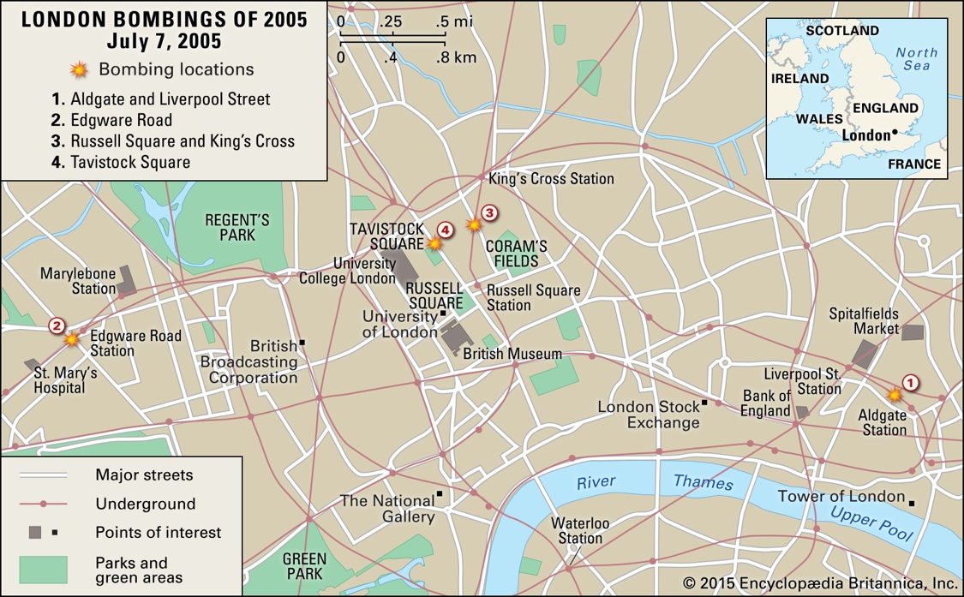(Ray, 2010 b)
The diagram above highlights where each explosion on the 7th of July occurred, the diagram also points out the points of interests that could have also been the focus of the terrorist attacks, plus the addition of the underground and major streets that the explosions occurred on or near to.

Response times-

Since the terrorist incident was split into four separate attacks, the response time for the Police force and Fire Brigade are different for all four of the incidents.
Aldgate Station Response Time-
For Aldgate Stations incident, it was indicated that the British Transport Police (BTP) received a call at 0849hrs from the London Underground team about a loud bang in Liverpool Street (BBC News, 2011). The BTP arrived at the scene first at 0855hrs and the London Fire Brigade (LFB) is then requested to attend Aldgate station at 0856hrs and arrives just four minutes later at 0900hrs (BBC News, 2011). The first Metropolitan officers only arrive at Aldgate Station at 0920hrs (BBC News, 2011)
Aldgate Station is located on the East side of Zone 1 in London, many of the emergency services are sent to this area as it is the first indicated spot of the yet to be known terrorist attack, it took the emergency services a wide range of time from 6 to 31 minutes to arrive at the scene of the explosion. Many would argue that even a 10–15-minute wait for the emergency services is incredibly dangerous.

Edgware Road Response Time-
When Edgware roads explosion occurred the emergency services were alerted at 0854hrs. At 0858 The LFB is informed to attend an incident at Praed street, which is close to Edgware Road tube, but it is not where the explosion has occurred, the fire crew arrive at Praed street at 0904hrs and receive a call to attend Edgware Road instead just three minutes later. The first Metropolitan police officers arrive at the scene at 0912hrs, 23 minutes after the initial explosion with the LFB arriving at the scene six minutes after the first Met officers arrive.
The biggest issue for the Edgware Road response time was the misinformation of where the fire brigade should be attending which marked the LGB arrival time at 29 minutes after the explosion all because of miscommunication. The Metropolitan police officers also arrived 23 minutes after the explosions happened.

Russell Square/King Cross Response Time-

Russell Square/King Cross explosion took place in central London, a big comparative to the other two underground explosions that were located on the outskirts of Zone 1 of London, With the Metropolitan Police being informed of incident at King’s Cross by CCTV Images just seven minutes after the bomb explosion, The LFB receive a call at 0902hrs, regarding smoke emerging from The Euston Square tube station and arrive at Euston Square five minutes later to have found that this was not the area where passengers were emerging from (BBC News, 2011). The LFB finally arrives at King Cross 24 minutes after the explosions has transpired.
Once again, the issue of miscommunication arises on the response time, the LFB was sent to the incorrect tube station and only arrived 24 minutes later to the correct location. The Metropolitan Police on the other hand arrive just 7 minutes after the explosion.

Tavistock Square Response Time-
The last explosion took place in Tavistock Square, with the Police being first to arrive on scene just moments after the explosion, the reason being is that there were Police officers already available on the scene on patrol, so they were able to report the blast (BBC News, 2011). The LFB receive a call minutes after the explosion has happened and their arrival time being 0952hrs (BBC News, 2011).
The reason the response time to the Tavistock Square explosion had the fastest and most positive response time was labelled on the grounds of the fact that the explosion occurred an hour after the first three explosions and the emergency services were already on high alert and spread out across London.

Radio Communication-

Communications between emergency services, partner agencies and command rose to be an issue on the day of the attack for example, London Fire Brigades radio network were busy, and procedures had to be put in place to enable priority radio traffic to take precedence, which should have been done beforehand.
Communicating underground also proved to be an issue but it did not significantly hinder the response time from any services. The London Underground radio communications system held up for both The London Underground team and The British Transport Police (London Resilience, 2006).
However, while the telecommunications challenges presented difficulties, they did not significantly affect the emergency services’ ability to respond effectively. It was recommended by London Resilience in 2006 that actions should be taken to make the responders primary way of communications, fully sufficient and to make sure that it meets their communications needs in any crisis (London Resilience,2006).
In the 7 July Review Committee follow-up report, it is brought to the attention that the Metropolitan Police Service, London Fire Brigade and London Ambulance Service are in need to provide the London Assembly with a clear update as to when the rollout of digital radio systems within their services would be occurring, so that it can be monitored, and the progress recorded to know that the full implementation of TETRA-based radio communications across London’s emergency services is in full action.

However, after revision there was an obvious lack of clarity over the timing on when the digital radios were going to be implemented across the emergency services in London, with different timetables being provided by the Home Office, the London Resilience Forum, and the emergency services. Which proved to cause more issues and an unruly amount of incoordination.
It has been emphasised that considerable progress done on the Emergency Response Unit obtaining an “interim/back-up solution to enable its staff to communicate underground, such as Personal Role Radios” (London Assembly, 2006, https://www.london.gov.uk/sites/default/files/gla_migrate_files_destination/archives/assembly-reports-7july-follow-up-report.pdf).
In addition to that the recommendation that the Emergency Response Unit “obtain Airwave radios so that they are able to communicate underground once the CONNECT project is completed” has also been fully implemented (London Assembly, 2006, https://www.london.gov.uk/sites/default/files/gla_migrate_files_destination/archives/assembly-reports-7july-follow-up-report.pdf).

Partner Agencies-

Organisations that are labelled at Category 2 responders play a crucial role in responding to emergencies and recovery. They will work with emergency services and any local authorities to be able to deliver the quickest and easiest restoration to peace and essential services to be able to help minimise any wider impact on the population affected (HM Government, 2013).
BBC montage video released in 2015 on how the day of the 7/7 bombing unfolded highlighted that the category 2 responder the British Red Cross was available and working at the time of the incidents(BBC, 2015b).
Transport for London was also available helping stuck passengers and sending out messages to emergency services to make work swifter and easier for both the category 1 and category 2 responders. This is exactly why the transport for London was already prepared for any emergencies and were able to help the emergency services swiftly. An example of a Category 2 responder helping was David Boyce, who was on duty as the station supervisor at Russell Square underground station on the day of the attack, He ran into the tunnel that an explosion was heard from to help any injured passengers walking in the tunnels (Taylor, 2015).
Being able to have partner agencies that were not under the constant pressure of having to perform at the best standard like the emergency services was a big positive for London at the time of the 7/7 bombings. The Partner Agencies had their own resources which proved to be a beneficial in helping the response to the initial attack.
As partner agencies are regulated by different laws and regulations certain things that have to be done by emergency services do not need to be orchestrated by the category 2 responders. However, Her Majesty's Government is still able to give recommendations and to review their acts, as commented:
The coroner recommended that Transport for London (TfL) review the protocols by which TfL (i) is alerted to major incidents declared by the emergency services that affect the underground network, and (ii) informs the emergency services of an emergency on its own network which includes the issuing of a ‘Code Amber’ or a ‘Code Red,’ or the ordering of an evacuation (HM Government, 2012).

Major Incident-

In the initial stages of an incident, information is passed between the emergency responders and the control room using the M/ETHANE mnemonic, as indicated by the diagram below.
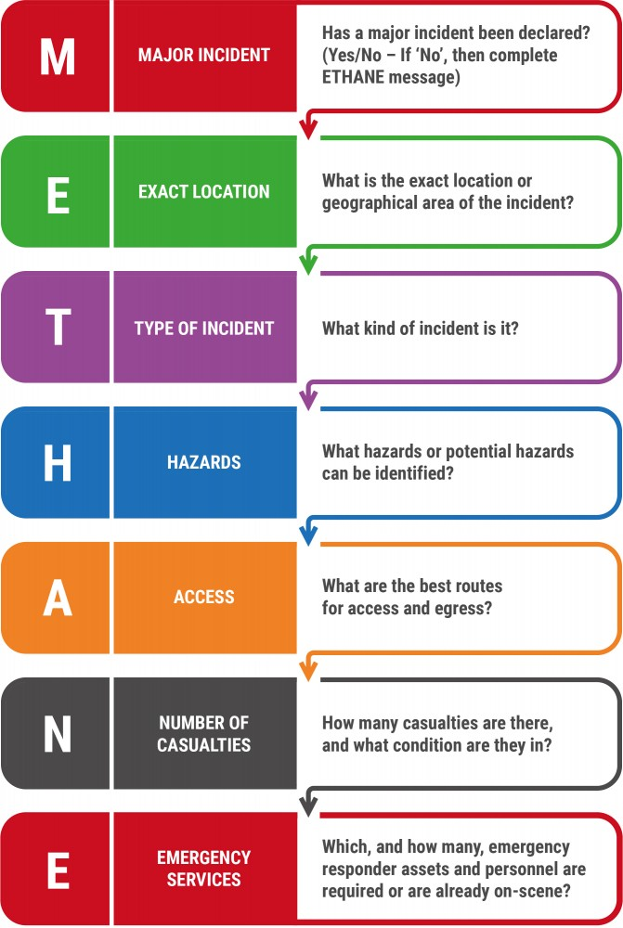(JESIP, 2022a)

Declaring the major incident caused to be an issue and compounded by the fact that the incident occurred over four separate locations simultaneously. As the first reports that came in labelled the incident as a power surge it caused more issues for the emergency services, with the correct information taking some time to emerge (Chapman, 2021).
Aldgate's explosion was declared a major incident at 0905hrs by London Fire Brigade and at 0906hrs by the British Transport Police.
Edgware explosion was declared a major incident at 0932hrs by The Metropolitan police and at 0934 by the London Fire Brigade
Russell Square/King Cross is declared a major incident by a British transport police inspector at 0858hrs and the Police at 0915 with no indication of the Fire Brigade declaring Russell Square/King Cross as a major incident.
Lastly at 1105hrs The London Fire Brigade confirm that the Police force have declared Tavistock as a major incident but yet again the Fire Brigade have not declared anything.
Overall, the London Bombing was declared a major incident at first by the British Transport Police at 0908hrs and other emergency services following such as City of London police declaring it at 0910hrs and the Metropolitan Police declaring it as 0932hrs (Chapman, 2021).
Timing is different since the work and focus was prioritised differently when ES arrived at the scene of the incident. The ES that is quicker was able to do so because they were instructed to do so by their commanders and the other ES took longer in different areas as they prioritised preserving life rather than declaring a major incident.

Lessons learnt –
When brought to perspective many lessons were learnt from the tragic incident of The London Bombings.
In 2012, the Joint Emergency Services Interoperability Programme was established, which was a two-year programme that would help improve the way the emergency services would work together when responding and working together at major incidents (JESIP,2016).
JESIP was established accordingly as the way the emergency services operated together, had been observed and scrutinised by the public after findings from several major incident reviews and reports came into view, such as the 7/7 Bombings (JESIP,2016).
These reviews highlighted many areas for improvement, centred on communication and information sharing at incidents. As well as the need of emergency services to increase their awareness and understanding of the other roles and responsibilities of other emergency services (JESIP, 2016).
The JESIP app indicates the main principles of JESIP:
- Co-locate
- Communication
- Co-ordinate
- Joint understanding of risk
- Shared Situational Awareness
(Eby Design, 2017)
If these principles are applied successfully the results that follow should be a jointly agreed working strategy where each party understands what is needed of them, whom it is going to be done by, what is going to happen and when it is going to happen.
One of the main difficulties that commanders had to face when working with different responder agencies is how to bring available information together, reconcile potentially differing priorities and then proceed to make effective decisions together. Due to this being a big issue The Joint Decision Model (JDM), indicated below was developed to try and resolve any of the issues that arose on the scene.
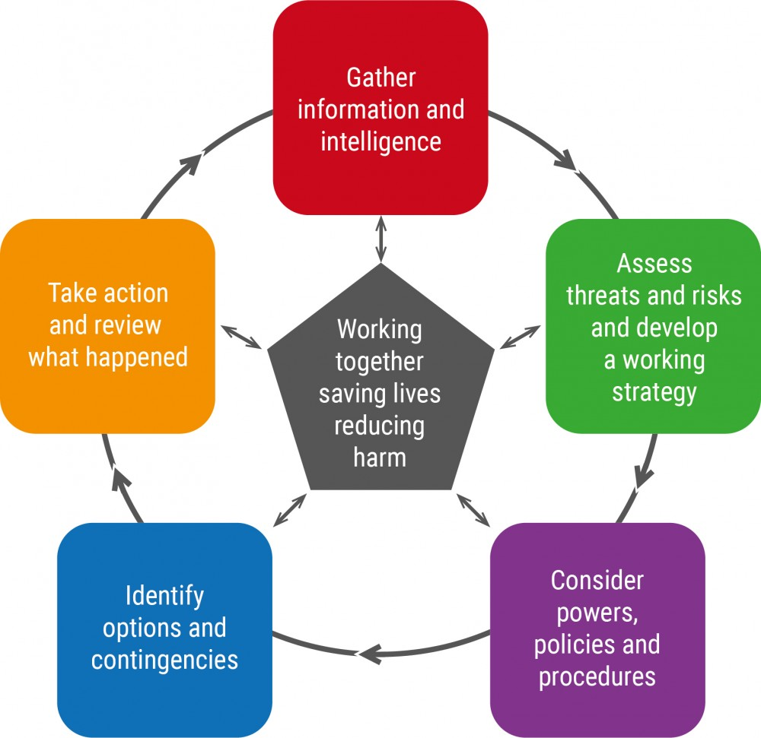(JESIP, 2022b)
JESIP is ran for the emergency services by the emergencies but also has the immediate support and oversight from many Government Departments such as, The Home Office, Department of Communities and Local Government (JESIP, 2022).
The Joint Emergency Services Interoperability Programme has proved to be a national success for the emergency services as more cooperation and understanding has been brought to the table at major incidents, with less disagreements happening.
Furthermore, even though the M/ETHANE protocol was being used by emergency responders during the London bombings is has only become more trustworthy in time over the past years, with more emergency service workers becoming more aware that it can be used in many different scenarios. In our ever-changing world emergency responders must adapt to the demands placed upon them. This means that working together, responding to emergencies on an ever-increasing basis must work swiftly and any feasible way to help them is a good outcome.

Conclusion-

As stated, prior in the report, new regulations came into effect after the tragic London bombings of 2005. Now being able to have access to JESIP and the Joint decision model, all the emergency services have the possibility of working together better without many issues. Working swiftly and sufficiently allows for many positives and better outcomes in specific subject areas of the responders. A multitude of things could have had different outcomes during the tragic incident of the London bombings however the lessons have been indicated and they have been learnt with progress being made.

Reference List-

- BBC News (2011) 7 July London bombings. Available at: https://www.bbc.co.uk/news/uk-13301195#time_0400 (Accessed: 4th January 2022)
- BBC News. (2015a) 7 July London Bombing: What happened that day? Available at: https://www.bbc.co.uk/news/uk-33253598 (Accessed: 19th December 2021)
- BBC News (2015b) London 7/7 attacks: How the day unfolded (montage) - BBC News. [online video] Available at: https://www.youtube.com/watch?v=gwyqT7rcCYk (Accessed: 4th January 2022)
- Chapman, S. (2021) ‘Terrorist Attacks in the UK’ [PowerPoint presentation]. BMPL5002: Policing Terrorism.UWTSD. Available at: https://moodle.uwtsd.ac.uk/course/view.php?id=8625
- Civil Contingencies Act 2004, c. 36. Available at: https://www.legislation.gov.uk/ukpga/2004/36/part/1/crossheading/introductory (Accessed: 20th December 2021)
- College of Policing (2021a) Defining a Major Incident. Available at: https://www.college.police.uk/ (Accessed: 21st December 2021)
- College of Policing (2021b) Defining a Critical Incident. Available at: https://www.college.police.uk/ (Accessed: 21st December 2021)
- Eby Design. 2017. JESIP (version number 2.8.4). [Mobile app]. (Accessed:6th January 2022
- HM Government (2012) Coroner’s Inquests into the London bombings of 7 July 2005: Review of progress. Available at: https://assets.publishing.service.gov.uk/government/uploads/system/uploads/attachment_data/file/97988/inquest-7-7-progress-report.pdf (Accessed: 6th January 2022)
- HM Government (2013) Emergency Response and Recovery, Non statutory guidance accompanying the Civil Contingencies Act 2004. Available at: https://assets.publishing.service.gov.uk/government/uploads/system/uploads/attachment_data/file/253488/Emergency_Response_and_Recovery_5th_edition_October_2013.pdf (Accessed: 6th January 2022)
- JESIP (2016) JESIP FACT SHEET 1. Available at: https://www.jesip.org.uk/uploads/media/pdf/JESIP_Fact_Sheet_1_V7_March_2016.pdf (Accessed: 6th January 2022)
- JESIP (2022a) Early Stages of an Incident & M/ETHANE. Available at: https://www.jesip.org.uk/early-stages-methane (Accessed: 4th January 2022)
- JESIP (2022b) Arrangements for Joint Working (Joint Decision Model). Available at: https://www.jesip.org.uk/arrangements-joint-decision-model (Accessed:6th January 2022)
- JESIP (2022c) Governance Structure. Available at: https://www.jesip.org.uk/governance-structure (Accessed: 6th January 2022)
- London Assembly (2006) 7 July Review Committee. Available at: https://www.london.gov.uk/sites/default/files/gla_migrate_files_destination/archives/assembly-reports-7july-follow-up-report.pdf (Accessed: 6th January 2022)
- London Resilience (2006) Lessons identified and progress since the terrorist events of 7 July 2005. Available at: https://terrorvictimresponse.ca/wp-content/uploads/2013/10/23_09_06_lrrfreport.pdf (Accessed: 6th January 2022)
- Ray, M. (2010a) London bombings of 2005. Available at: https://www.britannica.com/event/London-bombings-of-2005 (Accessed: 29th December 2021)
- Ray, M. (2010b) London bombings of 2005 [Table]. Available at: https://www.britannica.com/event/London-bombings-of-2005/images-videos (Accessed: 29th December 2021)
- Taylor, C.A. (2015) ‘Heroes of 7/7: How the day unfolded for the first on the scene’, Metro, 7 July, p.2.

