Exploring the effect of emotional intelligence on memory for emotion-induced stimuli

Abstract
Given the limited research on the relationship between emotional intelligence on memory, this study sought to explore the correlation between emotional intelligence and the memory recall of emotion-induced stimuli in a sample of 38 undergraduate psychology students. Participants undertook the Schutte Self Report Emotional Intelligence Test (SSEIT; Schutte et al, 1998) to assess their emotional intelligence levels, followed by a word-based memory recall task using SuperLabs. The data collected from both tasks underwent analysis using a mixed design ANOVA. The results of this study indicate that there was no relationship between emotional intelligence and the recall of emotion-induced words, F(2,72) = .73, p > .48, np² = .02. which contradicts a significant amount of previous research on this topic. The limitations of this study are addressed, including the reliability of the tasks and personal factors of participants.

Introduction

Emotions have been found to play a crucial role in cognition, however, there remains a limited understanding of the relationship between emotional intelligence and working memory, a fundamental cognitive mechanism (Mavrou, 2021). Emotional intelligence can be described as the ability to recognise, understand and regulate one’s own emotions and those of others (Mavrou, 2021). Individuals with high levels of emotional intelligence are believed to possess the ability to effectively manage emotional encounters (Mavrou, 2021). Working memory, however, entails holding a limited amount of information in a readily accessible state, and works to facilitate tasks such as planning, comprehension, problem-solving and reasoning (Cowan, 2014).
The research regarding the relationship between emotional intelligence and the working memory’s response to emotionally-induced stimuli remain limited. However, Orzechowski and his colleagues (2020) have explored this relationship with the aim of determining whether there is a positive correlation between emotional intelligence and working memory. The 2020 study involved two tasks assessing working memory, one featuring neutral stimuli and the other incorporating emotional stimuli (Orzechowski et al, 2020). Their findings revealed that the association between working memory updating (WMU) and emotional intelligence (EI) is significant, specifically when working memory engages with emotional content or materials that are directly linked to EI (Orzechowski et al, 2020). The study concluded that females with high levels of emotional intelligence exhibit greater memory updating abilities when tasks involve emotional stimuli than those with low levels of emotional intelligence (Orzechowski et al, 2020). However, the major limitation of this study is that it included only female participants, therefore the findings can only be generalised to women.
Likewise, a 2017 study aimed to examine the connection between emotional intelligence and working memory capacity while participants engaged in both ‘hot’ tasks, involving emotionally charged stimuli, and ‘cold’ tasks without emotional content (Guiterrez-Cobo et al, 2017). 203 participants underwent three emotional intelligence tasks, including a performance-based ability task and two self-report tasks, along with two 2-back tests (Guiterrez-Cobo et al, 2017). The findings of this study suggest that individuals with higher EI exhibited superior performance, particularly on the performance-based ability test, but solely on the task involving emotionally charged stimuli (the ‘hot’ tasks) (Guiterrez-Cobo et al, 2017). These findings imply a positive relationship between emotional intelligence and working memory, particularly in tasks involving emotionally induced stimuli.
The objective of this study is to delve deeper into the connection between emotional intelligence and memory on emotionally-induced stimuli. Building upon the existing literature, it is hypothesised that there will be a significant correlation between emotional intelligence and memory performance with emotion-induced words. Individuals who score high on the emotional intelligence test are anticipated to perform better on a memory recall task by recalling more positive words than participants who score low on emotional intelligence. It is also hypothesised that participants who score high on emotional intelligence will recall significantly more words overall than those who score low on emotional intelligence.

Method

Participants
Thirty-eight undergraduate psychology students were recruited for this study (14 males, 22 females, 2 non-binary). The participants ages ranged between 19 and 51 (M= 29.05, SD=8.88). Participants were recruited for this study through the University experiment management system (EMS).

Design
This study was a mixed multi-factorial design. The independent variable (IV) was emotional intelligence (EI), which was a between-subjects factor consisting of two levels; low and high emotional intelligence. The participants were then categorised into low and high levels of emotional intelligence based off their mean scores (M=105.81). Those who scored below the mean were categorised as low, while those who scored above the mean were categorised as high emotional intelligence. The second independent variable was the emotion-induced stimuli, which was a within-subjects factor consisting of three levels; positive words, negative words and neutral words. All participants were exposed to all three levels. The dependent variable for this study was the number of words correctly recalled per each trial (positive, negative, neutral). A mixed design ANOVA was used to analyse the data collected.

Materials
The Schutte Self Report Emotional Intelligence Test (SSEIT; Schute et al, 1998) was used to measure the emotional intelligence levels of participants (See appendix A). This test was comprised of 33 statements (including 3 negatively worded items that required reverse scoring prior to data analysis) which included aspects of emotional intelligence and participants’ overall self-perception. It included statements such as ‘I am aware of my emotions as I experience them’ and ‘I find it hard to understand the non-verbal messages of other people’. The participants were instructed to indicate their level of agreement or disagreement with each statement using a five-point Likert scale (1=strongly agree, 5=strongly disagree). The final scores collected from the test could fall between 33 and 160, with higher scores indicating higher levels of emotional intelligence.
The memory recall task for emotion-induced stimuli (words) was created using SuperLabs. The task consisted of three experimental trials; positive words, negative words, and neutral words (See appendix B) chosen from the Affective Norms for English Words list (ANEW; Bradley & Lang, 1999). In each trial, 20 words were presented individually for 200ms each, with each word separated by a blank screen that displayed for 400ms. Following each trial, participants were instructed to think of something for one minute (e.g. think of your favourite holiday). They were then prompted to recall as many of the 20 words they had just viewed and enter their answers into the designated box on the screen. The previous step was repeated for each of the three trials. A point was awarded for each word correctly recalled per trial (20 per trial), with final scores ranging from 0 to 60. The data was collected using both Qualtrics for the SSEIT and SuperLabs for the recall task.

Procedure
Participants were recruited through the University's experiment management system, which rewards students with credits for their participation. Upon arrival at the labs, they were greeted and directed to a laptop where the Qualtrics SSEIT study was loaded and ready. Each participant received an information sheet (See appendix C) outlining the study procedures, followed by a consent form (See appendix D) and a demographic form for data collection. Once forms were completed and consent was provided, participants began the Emotional Intelligence test using Qualtrics. Following the test, they proceeded to the memory recall task on the lab computer using SuperLab. Upon task completion, researchers provided debrief forms (See appendix E) and addressed any participant inquiries. Finally, participants were thanked for their involvement and dismissed from the labs.

Results

A two-way mixed design ANOVA was conducted to explore the effect of emotional intelligence (high/low) on memory for emotion-inducted stimuli (Positive, negative and neutral words). Descriptive statistics for all variables included within the analysis are shown in Table 1.

Table 1.
Descriptive statistics for variables included in study.
Variable | EI Groups | M | SD
Positive | Low EI | 11.40 | 2.42
 | High EI | 8.83 | 3.79
Negative | Low EI | 9.60 | 2.66
 | High EI | 8.11 | 3.16
Neutral | Low EI | 8.75 | 2.65
 | High EI | 7.33 | 3.32

The two-way interaction between emotional intelligence and emotion-induced words was not significant, F(2,72) = .73, p > .48, np² = .02. The main effect of emotional intelligence was significant (F (1, 36) = 5.72, p>.02, np²= .14) indicating that the recall of emotion-induced words was different depending upon participants level of EI. Participants who scored low in the assessment of EI recalled significantly more words overall (M =9.92, SD =1.65) than those who scored high in the assessment of EI (M= 7.98, SD=2.95).
The main effect of emotion-induced words was also significant, (F (2,72) = 1.56, p >.21, np² = .04), indicating that there is a difference in the recall of words based upon the emotion level of the word. Pairwise comparisons show that there was a significant difference between positive words recollected (M= 10.18, SD = 3.36) and negative words (M = 8.89, SD = 2.96; p = .04) and between positive and neutral words (M = 8.08, SD = 3.04, p = .004). There was no difference in the recall between negative and neutral words (p > .05). (See appendix F)
Based on these findings, the hypothesis that emotional intelligence would significantly affect the participants ability to recollect emotion-induced words was rejected. The hypothesis that anticipated that participants with high EI would recall more words overall than those with low EI must be rejected, as participants who scored low in EI recalled significantly more words overall than those with high EI. Finally, the hypothesis that those who scored high on the emotional intelligence test would recall significantly more positive words than those with low EI must be rejected as the two way interaction between emotional intelligence and emotion-induced words was not significant.

Discussion

As discussed above, the hypotheses suggesting that participants who scored high on the emotional intelligence task would recall a greater number of positive words and overall words compared to those with lower levels of emotional intelligence must be rejected. This contrasts with Orzechowski and colleagues' (2020) findings, which observed that females with high levels of emotional intelligence demonstrated greater memory capabilities in tasks involving emotional stimuli, compared to those with lower emotional intelligence levels. However, a limitation of Orzechowski’s study is its generalisability, as the findings are only applicable too women. In contrast, this study included a more diverse sample, including 14 males, 22 females and 2 non-binary participants, therefore a difference in results was to be expected. These findings also contradict those of Guiterrez-Cobo et al (2017) whose study proposed that individuals with higher EI demonstrate better performance on working memory task than those with lower levels of EI, particularly concerning ‘hot’ or emotion-induced stimuli, and suggested a positive correlation between the two variables. Therefore, the results of this study exhibit notable differences from the findings of earlier research.
The differences in results may be due to factors influencing the outcomes of this study. For instance, there may be a concern regarding social desirability bias, as the emotional intelligence test (SSEIT) relies on self-reporting, potentially leading participants to provide responses that portray them in a better light, boost their own self-esteem or to impress the researcher (Graeff, 2005). In contrast, Musonda et al (2019) conducted a study aimed at assessing the reliability and validity of the SSEIT scale. Through using a Cronbach coefficient test, they concluded that the SSEIT scale is a suitable and reliable tool for accurately measuring emotional intelligence. Despite the study’s limited sample size, it, there is a a diverse participant pool, including a variety of female, male and non-binary individuals aged between 19 and 51. The diversity increases the likelihood of generalising the findings to a broader population. However, it is important to acknowledge that all participants were undergraduate students studying Psychology, who potentially possess higher levels of emotional intelligence compared to individuals not enrolled in higher education. Consequently, the results may not fully represent the wider population.
In conclusion, the findings of this study do not support that of the previous literature regarding the association between emotional intelligence and the memory recall of emotion-induced stimuli. Future research in this area should consider incorporating measures of additional personality factors that could potentially influence emotional intelligence levels and memory abilities, such as education level and field of study. Additionally, expanding the participant size would enhance the generalisability and reliability of the findings.

Reference list

Bradley, M.M., & Lang, P.J. (1999). Affective Norms for English Words (ANEW: Instruction Manual and Affective Ratings.
Cowan, N. (2014). Working memory underpins cognitive development, learning and education. Educational Psychology Review, 26(2). 197-223. https://doi.org/10.1007%2Fs10648-013-9246-y

Graeff, T.R. (2005). Response Bias. Encyclopaedia of Social Measurement. https://www.sciencedirect.com/topics/psychology/social-desirability-bias

Guiterrez-Cobo, M.J., Cabello, R., & Fernandez-Berrocal, P. (2017). Performance-based ability emotional intelligence benefits working memory capacity during performance hot tasks. Scientific Reports, 7, https://doi.org/10.1038/s41598-017-12000-7

Mavour, I. (2021). Emotional intelligence, working memory and emotional vocabulary in L1 and L2 interactions and dissociations. Lingua. http://dx.doi.org/10.1016/j.lingua.2021.103083

Musonda, A., Shumba, O., & Tiloka, F.P. (2019). Validation of the Schutte Self Report Emotional Intelligence Scale in a Zambian Context. European Journal of Psychology and Educational Research, 2(2), 31-41. https://doi.org/10.12973/ejper.2.2.31

Orzechowski, J., Smieja, M., Lewczuk, K., & Necka, E. (2020). Working memory updating of emotional stimuli predicts emotional intelligence in females. Scientific Reports,10. https://doi.org/10.1038/s41598-020-77944-9

Schutte, N.S., Malouff, J.M., Hall, L.E., Haggerty, D.J., Cooper, J.T., Golden, C.J. (1998). Development and validation of a measure of emotional intelligence. Personality and Individual Differences, 25, 167-177.

Appendices

Appendix A – SSEIT Questionnaire
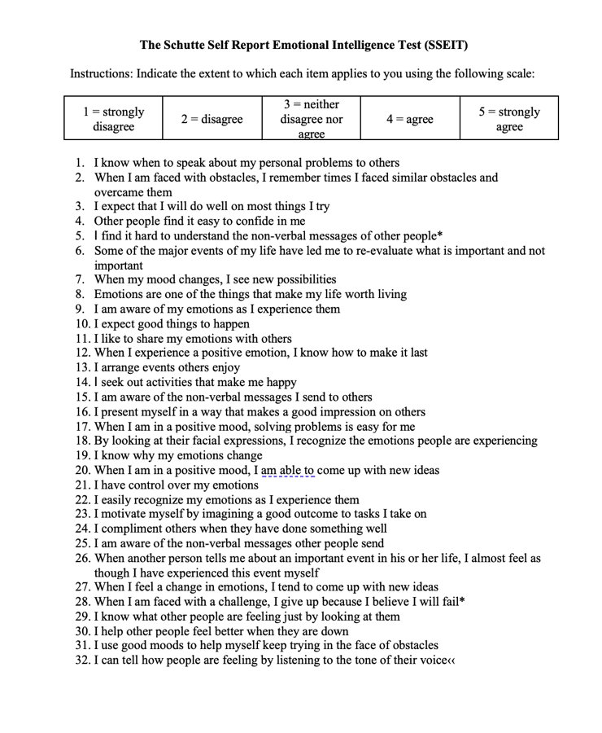
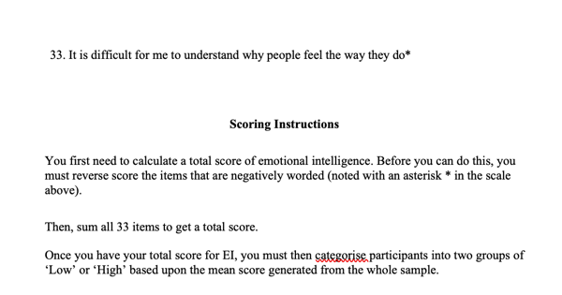

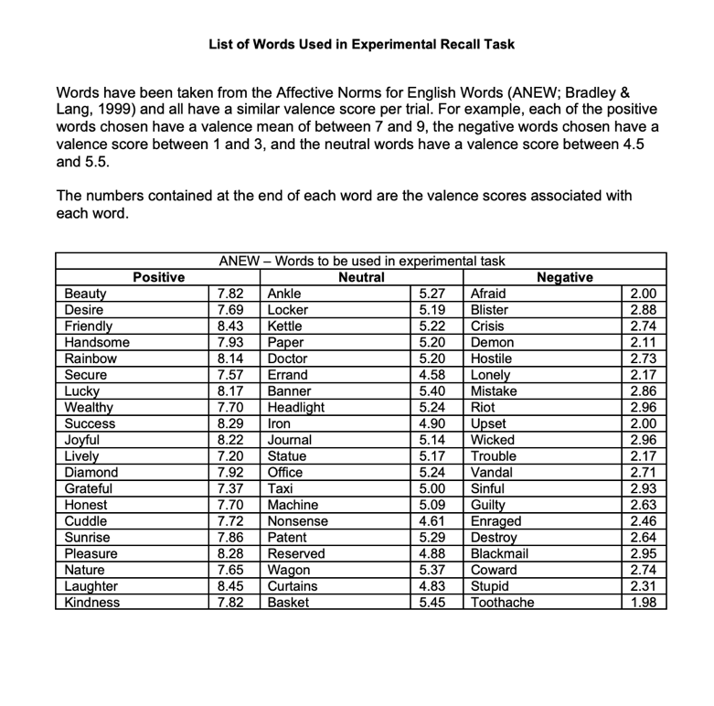
Appendix B – List of emotion-induced words.

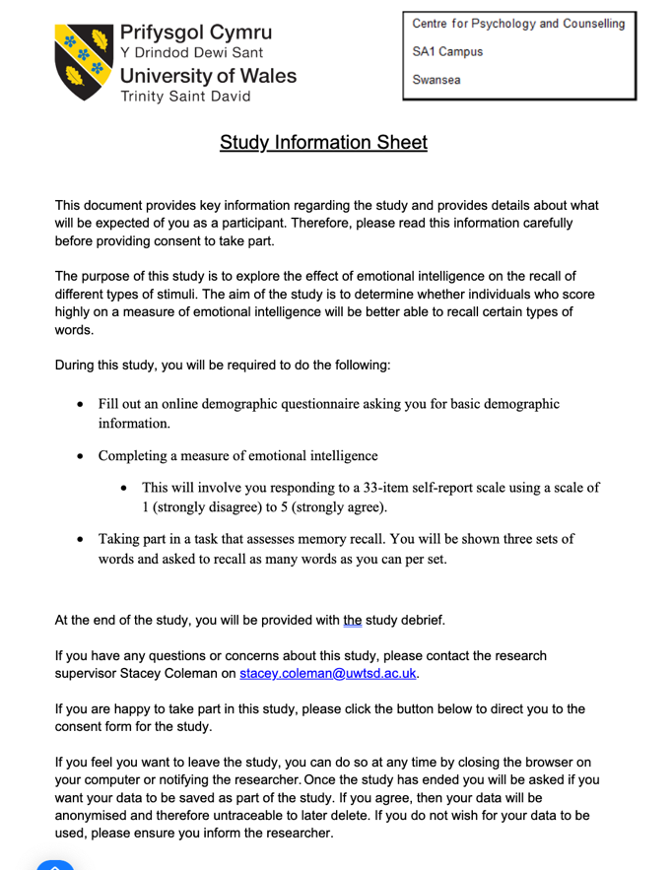
Appendix C – Information sheet

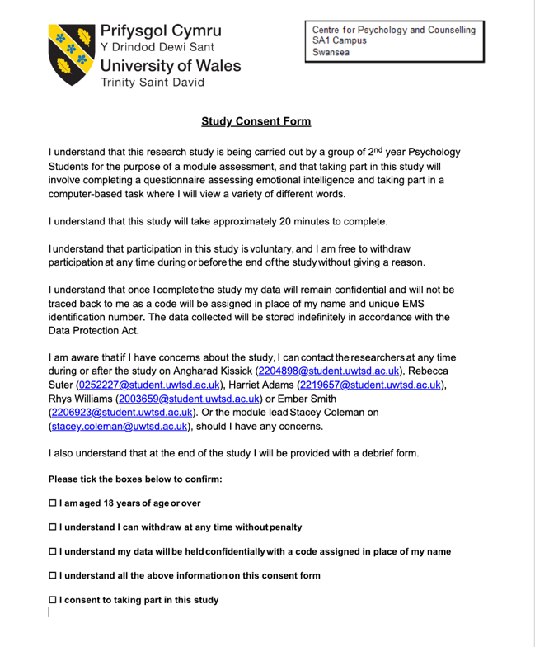
Appendix D – Consent form

Appendix E – Debrief sheet
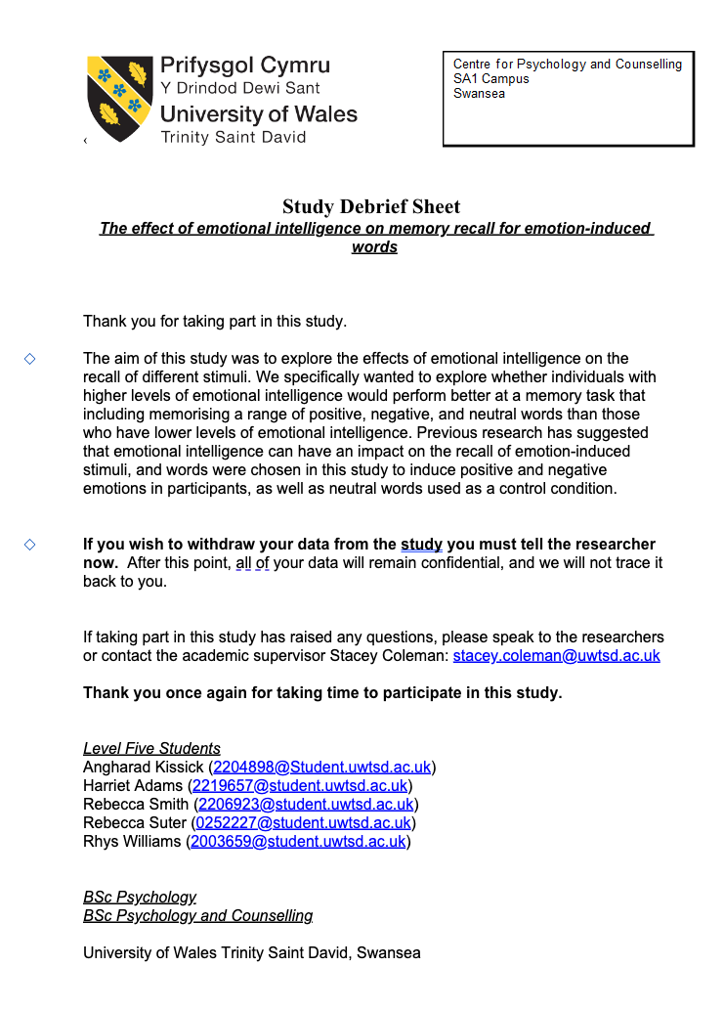

Appendix F- SPSS Output


