Report Case Study: The City Hotel

Name: Syed Maksum Zabid
Student ld: 2245066
ModuIe titIe: Financial Management for the Hotel Industry
ModuIe Code: BMIH5007

Al ACKNOWLEDGEMENT:

l confirm that l have not utilised any Al tools in the research and creation of this report. I confirm that I have not presented any AI-generated materials as my work. I confirm I have copies of my drafts, notes, and other resources I used, which I may be asked to provide in evidence.

Executive Summary
The paper illustrates that the City Hotel is a hospitality establishment that offers restaurant, bar functions, and event managing services. However, recent operational and financial challenges have been encountered in terms of revenue, occupancy rate, and the satisfaction level of clients. This report makes an exhaustive financial review, identifies key risks, and gives strategic recommendations for a turnaround. The report will consider The City Hotel's factors for recovery using Max Weber's organisation theory and an in-depth SWOT analysis to provide a phased recovery plan with a focus on profitability improvement, cost reduction, and better market positioning.

Table of Contents
1 Revenue Statement 3
1.1 Cash Flow and Solvency 3
1.2 Operating and Net Income: 4
Overheads on Operations: 5
1.3 Debt and Equity Situation in the Long-Term 6
2 Financial Summary: 6
3 SWOT Analysis 7
3.1 Strengths 7
3.2 Weaknesses 7
3.3 Opportunities: 7
3.4 Threats 8
4 Theories Applied for City Hotel 8
5 Recovery Potential and Strategic Interventions 9
Feasibility of Recovery 9
5.1 Short-Term Strategies 9
5.2 Medium- and Long-Term Strategies 10
6 Benchmarking and learning from an industry: Marriott International 11
7 Risk Assessment 11
8 Conclusion 12
9 Recommendations 12
10 References 12

Revenue Statement
Revenue at the City Hotel fell from £5.3 million in 2022 to £2.3 million in 2023, a 56% decrease. The decline in revenue may be caused by post COVID-19 price hike, the conflict in Ukraine, and ineffective pricing tactics (Lacalle, 2023). It is evident, employee costs remained a substantial burden, reaching £1,770,700 in 2022 before decreasing slightly to £1,233,160 in 2023 despite a steep fall in sales. The hotel also reported an operational deficit of £1.2 million in 2023 even though it held significant assets (i.e. £15.6 million), indicating the need for strategic adjustments to increase profitability (Denehy, 2022).
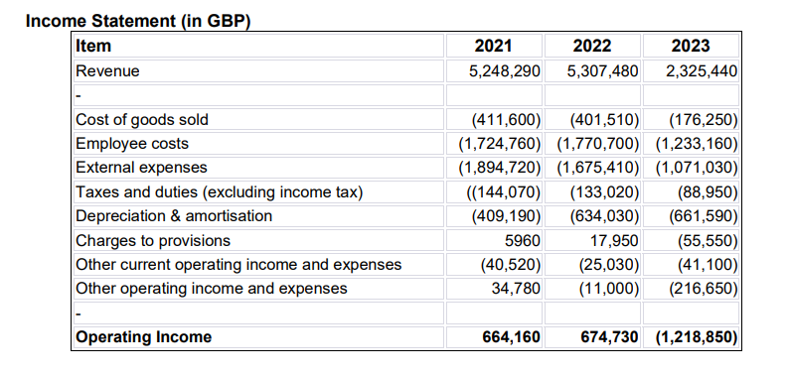

Cash Flow and Solvency
As seen in the graphic below (i.e. current asset information), there is a dangerous decline in cash reserve which is a significant trend that underscores liquidity concerns. This implies that the hotel is having trouble keeping enough cash on hand to pay for unforeseen financial needs or urgent bills (Investopedia, 2024). Furthermore, a decline in trade receivables, caused by fewer bookings or slower collections, may suggest reduced sales or delays in client payments, which in turn could indicate a weaker short-term financial condition (Kliestik et al., 2020).
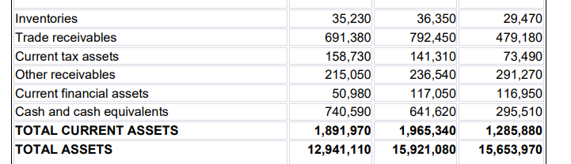

Operating and Net Income:
Significant financial difficulties were shown by the City Hotel's operational income. This is because, in spite of declining revenue, the operating, personnel, and external expenditures are not managed efficiently. In addition, decreased occupancy rates are caused by reduced tourism or even economic declines that negatively affect revenue flows (Lacalle, 2023). External factors such as increasing inflation, increasing competition, or changing consumer preferences could be the causes of deteriorating financial health for the hotel (Khan et al., 2020).
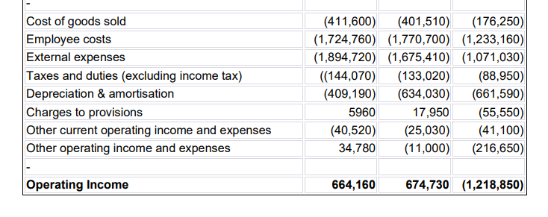Labor Expenses:
As evidenced, it can be said that the reduction in labour costs does not align proportionally with the sales decline which creates a big question. However, controlling labour costs without compromising service quality remains a challenge, as customer satisfaction in hospitality is closely tied to staff interaction (Jain, 2022). It is perceived that, striking an optimal balance between cost efficiency and service excellence is crucial for maintaining The City Hotel’s competitive advantage (PWC, 2024). Moreover, the consequence of this sort of changes in wages costs in proportion of sales is attention-grabbing for territorial hospitality establishments, which face greater competition and limited flexibility in increasing room rates to offset costs (Rout, 2024).
Overheads on Operations:
In 2023, the hotel's external overheads, such as maintenance and utilities, decreased profoundly. Because of supply chain issue, some costs may have ups and downs (STO, 2023). Therefore, the whole of external overhead reduction may not be directly connected with decline in sales figure. Despite management’s cost-saving efforts, the city hotel lost huge amount of market share.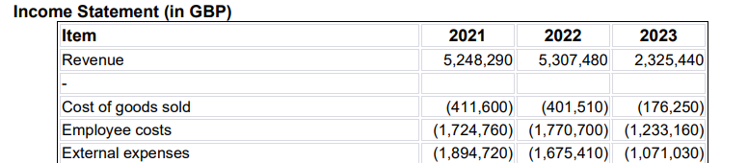

Debt and Equity Situation in the Long-Term
It is observed in 2023, the City Hotel became more dependent on prolong debt. Concerns regarding financial stability are raised as a result of this and the diminishing equity, which decreases the debt-to-equity ratio. Cash flow is strained by high debt because of principle and interest payments, which reduces flexibility during recessions. In such circumstances, it can be predicted that the future fund collection or expansion may be very challenging (Munro, 2022).
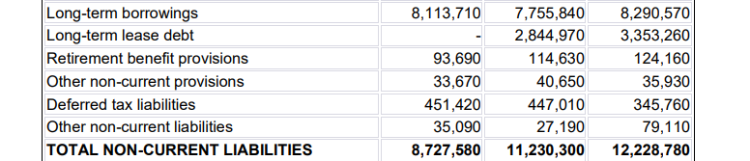

Financial Summary:
The analyses show that the financial management of City Hotel was pretty weak because it suffered from falling revenues, increasing debt, and lower cost savings in addressing those losses. It leaves it with a very huge labour and operational overhead cost even after a string of attempts to reduce the costs. Added to this are problems of liquidity constraint and an unfavourable debt-to-equity ratio; it points to a number that calls for immediate corrective action to arrest the situation from further erosion. If no strategic changes are put into practice, then City Hotel is threatened to suffer recurring losses and even be insolvent.
The study further shows that The City Hotel needs to improve the generation of revenue with diversified services, new customer segments, and targeted marketing to overcome these. Besides, further cost optimisation concerning labour and overhead is required. A phased recovery strategy, focusing first on expense control, revenue building, and debt management, works toward stabilising financial health and rebuilding profitability for The City Hotel (Alamry, 2019).

SWOT Analysis

Strengths
The CIty Hotel did not downsize the experienced staff drastically during the economic downturn, which gives them the confidence to come back with profit and serve the customers in a high standard manner. A good chemistry between the human resources and the customers potentially creates repeat sales. It draws both leisure and business tourists by assuring them of dependable and excellent experiences. Such support also improves brand reputation by establishing the hotel as a reliable, long-term participant in the market, much like The Ritz London, which uses its esteem to sustain demand (The Ritz-Carlton Leadership Center, 2022). However, the Inventory still looks like a good figure (i.e. 29,470) as it did not drop sharply in 2023, which will support smooth operation and getting positive reviews.

Weaknesses
The figures from financial statement indicate there is potential weakness in the management level of The City Hotel who are responsible for strategic planning. As observed, potential leasing of new assets is demonstrated by the rise in Right of Use Assets in 2023. Also, high capital investment was supported by the growth of total non-current assets, which increased from £11,049,140 in 2021 to £14,368,100 in 2023. These numbers imply that The City Hotel has been making significant investments in long-term investment while they clearly have liquidity shortage in short-term due to fall in revenue. It put a burden on the hotel's finances.

Opportunities:
With the rise of digital engagement, social media presents a valuable opportunity for City Hotel to enhance brand awareness, attract new guests, and foster customer loyalty. By leveraging platforms like Instagram and Facebook, The City Hotel can showcase its services, share guest experiences, and run targeted marketing campaigns to drive bookings (Nina, 2025). As learned from the industry, social media will be an excellent channel through which this business will enhance its brand awareness and interact with individuals in the entire world. For example, Hilton hotels boasts social media interaction in huge scale. In addition, the ads keep the message alive about the benefits of belonging to the Hilton Honors loyalty program, whose membership now has surpassed 118 million and is growing in all regions around the globe (Nina, 2025).
3.4 Threats
Threats to financial sustainability include growing financial liabilities, which reached from £10,684,940 (in 2021) to £14,243,390 (in 2023). A decline in shareholder equity and retained earnings which dropped worryingly in 2023 could make limited funding choices for The City Hotel and less appealing to the investors.
Additionally, rising business contest from other assorted hospitality establishments threatens adequate customer retention. City Hotel must actively manage its online presence and customer relations to mitigate these risks. For example, Marriott International faced a reputational crisis when negative reviews regarding service inconsistency on the TripAdvisor website. The company had a downgrade because of such negative reviews (tripadvisor, 2022).

Theories Applied for City Hotel
To uplift the fiscal performance of The City Hotel, Weber's Bureaucratic Theory should be applied, which suggests that all affairs concerning an organisation should be covered by rules. There is an ideal way of doing something and nothing else (Kanter, 2019). Applying Weber's principles to The City Hotel may give a framework towards better management and will help solve the various problems that are being experienced today in terms of operation and finance (Sayin, 2019).
The hospitality industry is currently facing many contemporary challenges that include managerial and operational aspects (Shamim et al., 2017). Structured operations and clearly defined hierarchies can improve efficiency and reduce mismanagement while enhancing accountability. Thus, it may result in better financial performance. Addressing operational issues such as retention of staff and inconsistency in service also reduces training costs and customer dissatisfaction. Moreover, well-crafted management strategies such as those found in leading hospitality brands can generate revenue, minimize costs, and provide for long-term financial sustainability for City Hotel.
Furthermore, implementing Total Quality Management (TQM) may enhance cost management and service quality (Jimoh et al., 2018). The City Hotel might solve the £1,218,850 operating deficit in 2023 by reducing waste and operational inefficiencies through the use of TQM. An example of successful deployments at Hilton Hotels, TQM might increase customer happiness, boost repeat business, and improve profitability by reducing costs and boosting efficiency (Ali and Allan, 2020).

Recovery Potential and Strategic Interventions

Feasibility of Recovery
The hotel’s fiscal health may bounce back by increasing revenue, streamlining operations, and rebranding (McCandless, 2023). Cost reductions that demonstrate the possibility of financial improvement include cutting external overheads by the business. Collectively, these actions may uplift the hotel's capacity to recover and raise its resistance to industry and competitive constraints.

Short-Term Strategies
Cost Control:
The City Hotel can work with suppliers to get better prices and renegotiate lease terms to lower rental costs. Controversial inefficiency is demonstrated by high staff expenses despite low revenue. Without compromising service quality, flexible shifts can help reduce labor expenses (Unifocus, 2024).
Revenue Generation:
Dynamic pricing is a critical tool for the improvement of cash flow. The hotel can attract price-sensitive customers during low-demand periods and maximise revenue during peak times by adjusting room rates based on demand patterns. This model has proven effective across the hospitality industry to balance both occupancy rates and profitability. According to Glion (2023), adaptive pricing, upselling, early check-ins, automation, food and beverage promos, local collaborations, and customised guest experiences are the ways that an establishment like City Hotel can increase revenue.

Customer Retention
Considering a steep fall in sales, The City Hotel could contact its old customers personally and offer better deals. Discounted stays, exclusive perks, or even early check-in can be used as incentives for repeat customers and encourage repeat bookings and customer loyalty. Personalised communication and targeted marketing campaigns will also enhance engagement and retention.

Medium- and Long-Term Strategies
Product Development:
Diversifying the hotel’s offerings can attract a broader customer base. Introducing wellness facilities, or community-based activities can cater to emerging travel trends, such as wellness tourism and corporate retreats (Akash et al., 2024). In other words, the drop in occupancy rates indicates that increasing service offerings may draw corporate clients and other niche sectors, stabilizing revenue over the course of the year.
Market Repositioning:
Improved digital engagement is critical to sustaining competitiveness. City Hotel could elevate its online presence by incorporating an easy booking system and tailored digital marketing campaigns (Santos-Arteaga, Tavana and Torrecillas., 2020). Partnering with local tourism boards would also enhance the visibility and facilitate customer visits from within the country. It is assumed that, since the overall cost of The City Hotel is higher than its revenue, cost saving way of marketing could be helpful.

Benchmarking and learning from an industry: Marriott International
Marriott International had faced similar problems during the pandemic but through strategic cost control, digital transformation, and better customer engagement, Marriott was able to recover. Marriott reduced fixed expenses, optimised operational efficiency, and introduced comprehensive loyalty programs to regain market share. The company enhanced customer experiences and profitability through the use of digital tools such as mobile apps and data-driven marketing (Hotel Management, 2023).
City Hotel can adopt Marriott’s strategies by focusing on cost-cutting measures that do not compromise service quality. As observed, City Hotel's operational income decreased drastically in 2023, demonstrating the need of reducing contract prices and utility bills in order to increase profitability.
Leveraging digital tools, such as a risk dashboard and personalised marketing campaigns can streamline operations and strengthen customer relationships (Guest Centric, 2024). Using digital engagement tactics like Marriott's might boost direct reservations and enhance financial stability for City Hotel, which has seen a decline in income and occupancy rates. Developing loyalty programs and offering flexible packages tailored to current customer preferences will also further aid recovery and establish a competitive edge in the market (Marriott International, 2025).

Risk Assessment
- The report outlines Market and Economic Risk: The turnover in the economy, inflation, and discretionary spending have hurt the hotel's competitiveness in the market.
- Operational Risks: Labor shortage and high energy prices pose a more harmful effect on the staffing level and continued quality service standards.
- Low returns generation and high debt servicing skills risk posing financial risks associated with long-term sustainability (Bouteraa et al., 2023).

Conclusion
The analyses finally conclude that the current position of the City Hotel exemplifies the need for an organised recovery plan with cost control and risk mitigation, as well as revenue diversification. Thus, with the adoption of Weber's organisational principles and staged approach, the operations of the hotel can be stabilised, while placing it competitively in the market (Adeyeri, 2024). If these recommendations are well implemented, The City Hotel can increase profitability, regain customer trust, and build a sustainable model for long-term success.

Recommendations
- Strict framework for cost management along with labour and operational costs.
- Diversification of services to open up new segments in the market (Chowdhury, 2024).
- Debt management through negotiation with creditors and enhancement of liquidity

References
Adeyeri, T. B. (2024). ‘Enhancing Financial Analysis Through Artificial Intelligence’. A Comprehensive Review Journal of Science & Technology, 102-120. Available at: https://www.thesciencebrigade.com/jst/article/view/167 (Accessed: 11 February 2025)

Akash, Tanvir, R., Jafrin, R., & Ashraful. (2024). ‘Evaluating financial risk management in corporation financial security systems’. World Journal of Advanced Research and Reviews 23, 2203-2213. Doi: 10.30574/wjarr.2024.23.1.2206

Alamry, S.J.M. (2019) ‘Chapter (8): Financial Ratios Analysis’, in Analysis of Financial Statements. Sammawa, Iraq: Al-Alalamia for Printing and Designs, pp. 137–173.

Ali, N., and Allan, M. (2020).‘ The impact of total quality management (TQM) dimensions on achieving competitive advantage: managerial perspective of the quality department staff at five-star hotels. Case of Jordan‘. International Journal of Scientific and Technology Research 9(2), 2578-2587. Available at: https://www.researchgate.net/publication/339310049_The_Impact_of_Total_Quality_Management_TQM_Dimensions_on_Achieving_Competitive_Advantage_Managerial_Perspective_of_the_Quality_Department_Staff_at_Five-Star_Hotels_Case_of_Jordan (Accessed: 25 February 2025)

Bouteraa, M., Tamma, E., Aichouche, M. E. H., Achour, S., Lada, S., Ansar, R., Fook, L. M. and Chekima, B. (2023) ‘International joint ventures’ knowledge acquisition: Critical literature review’, Sustainability, 15(8), p. 6364. DOI: 10.3390/su15086364.

Chowdhury, R. H. (2024). ‘The evolution of business operations: unleashing the potential of Artificial Intelligence, Machine Learning, and Blockchain’. World Journal of Advanced Research and Reviews, 2135-2147. Doi: 10.30574/wjarr.2024.22.3.1992

Denehy, D. (2022) 'The importance of financial planning in the hospitality industry', Funding Bay. [blog]. 10 October. Available at: https://fundingbay.co.uk/the-importance-of-financial-planning-in-the-hospitality-industry/ (Accessed: 26 February 2025).

Glion (2023). Strategies to increase revenue in the hospitality industry. Available at: https://www.glion.edu/magazine/strategies-to-increase-revenue/ [Accessed 26 February 2025].

Guest Centric, 2024. 5 Hotel Digital Marketing Strategies to Boost Direct Bookings. [blog]. 12 April. Available at: https://blog.guestcentric.com/5-hotel-digital-marketing-strategies-to-boost-direct-bookings/ [Accessed 26 February 2025].

Hotel Management. (2023). Marriott's Strategy for a Post-Pandemic Future. Available at: https://www.hotelmanagement.net/development/marriotts-strategy-post-pandemic-future (Accessed: 20 February 2025)

Investopedia. (2024). ‘Liquidity Crisis: A Lack of Short-Term Cash Flow’, Investopedia. [blog]. 13 November. Available at: https://www.investopedia.com/terms/l/liquidity-crisis.asp (Accessed: 26 February 2025).

Jain, H., (2022). ‘Customer Satisfaction and the Importance of Human Connect in Hospitality’, LinkedIn [blog]. 9 January. available at: https://www.linkedin.com/pulse/customer-satisfaction-importance-human-connect-hospitality-jain/ (accessed: 26 February 2025)

Jimoh, R., Oyewobi, L., Isa, R., and Waziri, I. (2018). ‘Total quality management practices and organizational performance: the mediating roles of strategies for continuous improvement’. International journal of construction management, 19(1):1-16. Doi: 10.1080/15623599.2017.1411456

Kanter, R. M. (2019). ‘The future of bureaucracy and hierarchy in organizational theory: a report from the field’. Social theory for a changing society (pp. 63-93). Doi: 10.4324/9780429306440-3

Khan, N., Hassan, A. U., Fahad, S., and Naushad, M. (2020). ‘Factors affecting tourism industry and its impacts on global economy of the world’. SSRN Electronic Journal. Doi: 10.2139/ssrn.3559353

Kliestik, T., Valaskova, K., Lazaroiu, G., Kovacova, M., and Vrbka, J. (2020). ‘Remaining financially healthy and competitive: The role of financial predictors’. Journal of Competitiveness, 12(1):74-92. DOI:10.7441/joc.2020.01.05

Lacalle, E. (2023) '6 reasons your hotel is losing revenue', Mews, [blog]. 4 May. Available at: https://www.mews.com/en/blog/hotel-revenue-loss (Accessed: 26 February 2025).

Marriott International, (2025). Discover Your Member Benefits. Available at: https://www.marriott.com/loyalty/member-benefits.mi [Accessed 26 February 2025]

McCandless, R. (2023) ‘10 strategies for revenue growth without expanding the sales team’, Kiss the Fish. [blog]. 25 July. Available at: https://kissthefish.net/10-strategies-for-revenue-growth-without-expanding-the-sales-team/ (Accessed: 26 February 2025)

Munro, O. (2022) ‘Common cash flow problems (+ how to solve them)’, Unleashed. [blog]. 23 December. Available at: https://www.unleashedsoftware.com/blog/common-cash-flow-problems-how-to-solve-them/ (Accessed: 26 February 2025)

Nina, S. (2025). Hilton Hotels Marketing Mix 2025: A Case Study. Available at: https://www.latterly.org/hilton-hotels-marketing-mix/ (Accessed: 19 February 2025)

PWC. (2024). Sharp rise in labour costs and slowing demand put spotlight on cost control and profitability margins for UK hotels in 2024. Available at: https://www.pwc.co.uk/industries/hospitality-leisure/insights/labour-costs-sharp-rise-slowing-demand-spotlight-cost-control-profitability-margins-hotels-2024.html (Accessed: 15 February 2025)

Rout, P. (2024). ‘How Are Rising Staffing Costs Transforming the Hospitality Industry?’, QX Global Group. [blog]. 24 September.Available at: https://qxglobalgroup.com/fa/uk/blog/rising-costs-of-staffing-in-hospitality/ (Accessed: 26 February 2025).

Santos-Arteaga, F., Tavana, M., & Torrecillas, C. (2020). Innovation dynamics and financial stability: A European Union perspective. Technological and Economic Development of Economy, 1366-1398. Available at: https://journals.vilniustech.lt/index.php/TEDE/article/view/13521 (Accessed: 19 February 2025)

Sayin, K. (2019). The Effect of Communication Problems on Productivity in Hotel Operations: A Qualitative Application. Mednarodno inovativno poslovanje = Journal of Innovative Business and Management, 51–58. Available at: https://journal.doba.si/ojs/index.php/jimb/article/view/11-2-6 (Accessed: 10 February 2025)

Shamim, S., Cang, S., Yu, H., & Li, Y. (2017). Examining the feasibilities of Industry 4.0 for the hospitality sector with the lens of management practice. Energies, 10(4), 499. Doi: 10.3390/en10040499

STO. (2023). The Impact of Economic Changes on the Hospitality Industry. [blog]. 25 October. Available at: https://blog.stocktake-online.com/impact-of-economic-changes-on-the-hospitality-industry (Accessed: 18 February 2025)

The Ritz-Carlton Leadership Center (2022) The Power of Our Employee Promise. Available at: https://ritzcarltonleadershipcenter.com/2022/05/11/our-employee-promise/ (Accessed: 27 February 2025).

Tripadvisor. (2022). Worst Marriott Experience Ever, Hands Down. Available at: https://www.tripadvisor.com/ShowUserReviews-g293797-d14058380-r836651667-Accra_Marriott_Hotel-Accra_Greater_Accra.html (Accessed: 21 February 2025)

Unifocus (2024) Keeping Your Staff Happy: Flexible Working Tips for Hoteliers. [blog]. 29 August. Available at: https://www.unifocus.com/blog/keeping-your-staff-happy-flexible-working-tips-for-hoteliers?hs_amp=true (Accessed: 27 February 2025).

