

Module Name: Problem Solving and Innovation
Module code: (BMSW4041)
Assessment 1: AI Washing (RCA)
Student name: Alhaji Isah
Student number: 2510741
Lecturer: Chris Wilkin
Deadline: 12th June 2026.

Speaker Note:
To understand why some organizations, adopt and implement AI washing we must understand the Root Cause or reasons behind it. This includes, among others, desperation by companies to attract investors, maximize profit, weaker government policies as well as consumer ignorance among others.
This unethical practice means exaggeration and claims the use of AI or some of its function in their products or services when it’s not. And because of its complex nature, investors often find it difficult to understand whether the company is engaged in AI washing or not. In business, people invest their funds in companies that seem to be future ready, technological advancement and great market potential.
Also, Consumer ignorance about AI and the concept of AI washing is huge, so much that majority of the population that uses AI are not aware about AI washing. A global survey found 80% of professionals had never heard of “AI washing” and only 14% were familiar with it. (Russell, 2019)
This creates a knowledge gap where people interact with AI-labelled products without fully understanding whether those claims are genuine which creates room for companies practicing AI Washing to go un notice especially given its complex nature and technicality.
Poor or weaker policies about AI washing from various regulators and governments has helped companies with an enabling environment. Technological advancement and huge knowledge about the practice of AI washing required by the policy makers before they can successfully enact a law that would guard against the practice.
However, given that the practice of AI Washing is growing, countries like USA through security and exchange commission one of its agencies are starting to take notice of this ill practice. For instance, recently two investment advertising firms were charged for false and misleading claim on the use of AI. While in UK rules and laws are already in place, in fact Advertising standard authority code of conduct states that marketing communication must not mislead.
AI CRITIQUE:
Not long-ago institutions, students and organizations were not using AI, but now the world has shifted to a technological era where the use of it is becoming a daily routine. However, Understanding AI is very difficult because of the way it’s built and how it works. Therefore, no matter how much you try to educate people, there are few that will understand with majority falling behind.
Similarly, when I queried AI about the exact percentage of companies engaged in AI washing, it turned out without the actual percentage.
Also, when I tried searching for consumer ignorance level about AI washing and AI globally, an answer with the exact percentage pop up. In fact, the appendix below shows multiple number of criticisms of AI and solutions received.
Despite the above limitations AI has greatly transformed our access to information and knowledge; the technology enables the society to access lots of data via its technology. Though not all its data are 100% credible or accurate but at least it supported learning and skills, collaboration and educational guidance.
Generally, what I expect of the AI technology is to be able give me enough and most current data about certain query’s giving that the technology is capital intensive and constantly changing due to technological advancement.

Slides (RCA) of AI Washing:
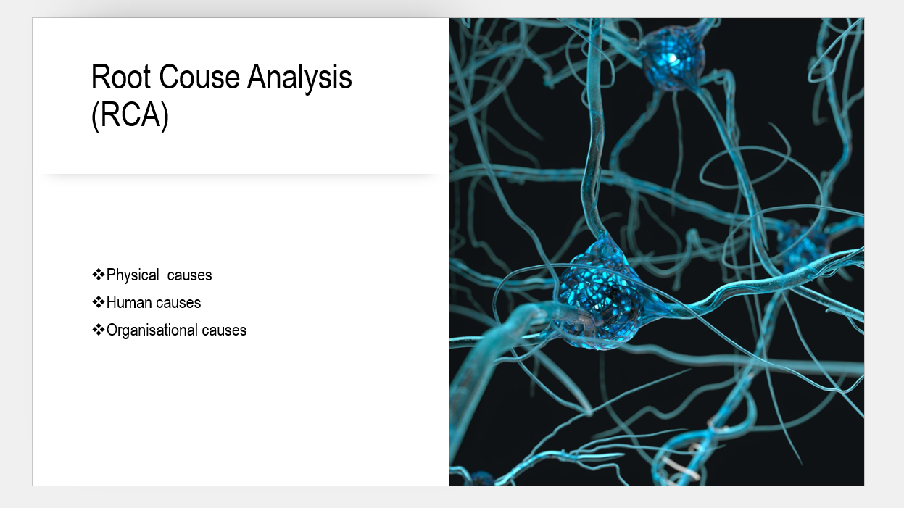

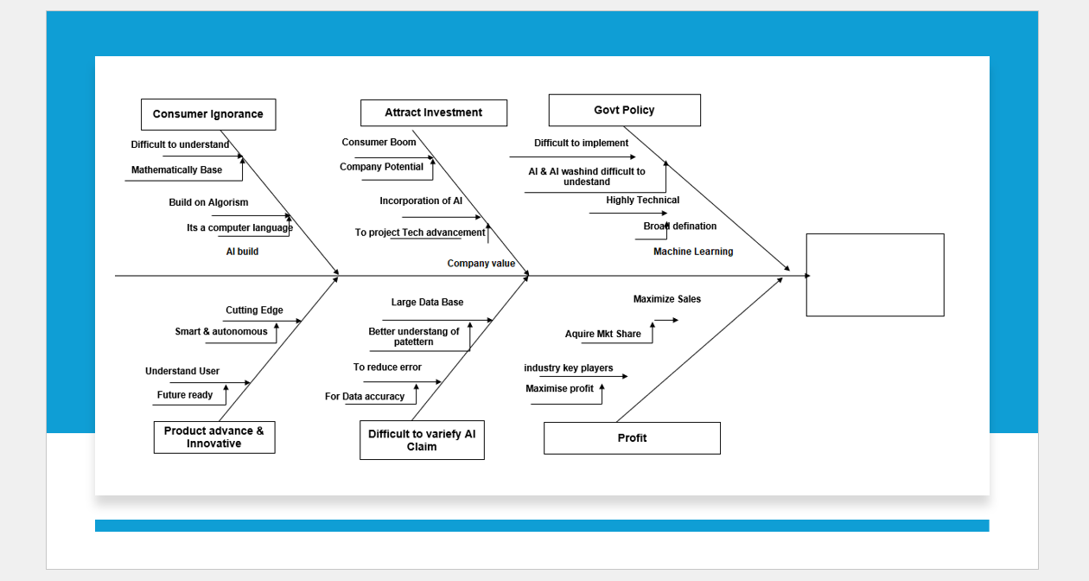

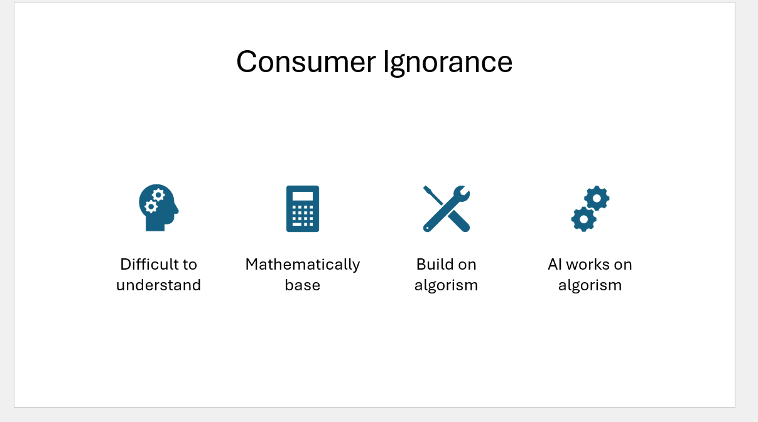



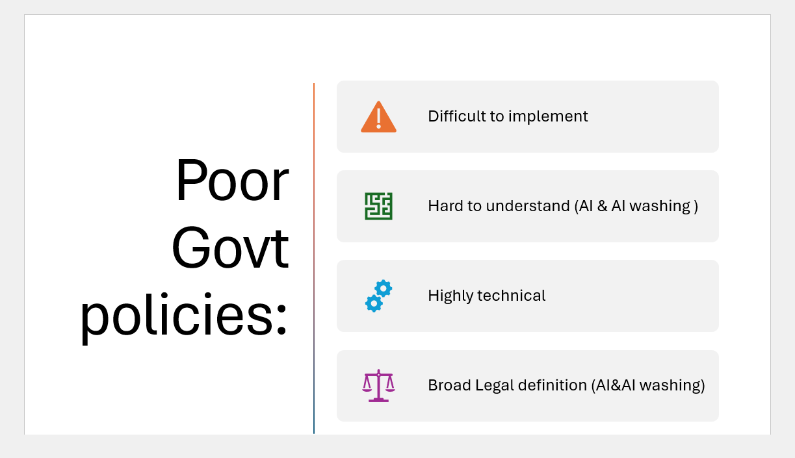

References:
- Alhaddi, H. (2024) ‘AI washing: The cultural traps that lead to exaggeration and how CEOs can stop them’, California Management Review. Available at: <https://cmr.berkeley.edu/2024/12/ai-washing-the-cultural-traps-that-lead-to-exaggeration-and-how-ceos-can-stop-them/> (Accessed: 22 May 2026).
- Boden, M.A. (2016) AI: its nature and future. Oxford: Oxford University Press.
- Bostrom, N. (2014) Superintelligence: paths, dangers, strategies. Oxford: Oxford University Press.
- Brynjolfsson, E. and McAfee, A. (2017) Machine, platform, crowd: harnessing our digital future. New York: W.W. Norton.
- Daugherty, P. and Wilson, H.J. (2018) Human + machine: reimagining work in the age of AI. Boston: Harvard Business Review Press.
- Davenport, T.H. and Ronanki, R. (2018) Artificial intelligence for the real world. Boston: Harvard Business Review Press.
- Dignum, V. (2022) Responsible artificial intelligence: from principles to practice. Available at: <https://arxiv.org/pdf/2205.10785> (Accessed: 22 May 2026).
- Domingos, P. (2015) The master algorithm: how the quest for the ultimate learning machine will remake our world. New York: Basic Books.
- Elsayed, N. (2026) AI washing and the erosion of digital legitimacy: a socio-technical perspective on responsible artificial intelligence in business. Available at: <https://arxiv.org/abs/2601.06611> (Accessed: 22 May 2026).
- Eubanks, V. (2018) Automating inequality: how high-tech tools profile, police, and punish the poor. New York: St Martin’s Press.
- Floridi, L. (2019) The logic of information: a theory of philosophy as conceptual design. Oxford: Oxford University Press.
- Gillespie, T. (2018) Custodians of the internet: platforms, content moderation, and the hidden decisions that shape social media. New Haven: Yale University Press.
- Kaplan, J. (2016) Artificial intelligence: what everyone needs to know. Oxford: Oxford University Press.
- Li, B. (2025) AI washing. Available at: <https://bpb-us-e2.wpmucdn.com/sites.utdallas.edu/dist/8/1090/files/2025/08/AI-Washing.pdf> (Accessed: 22 May 2026).
- McQuillan, D. (2022) Resisting AI: an anti-fascist approach to artificial intelligence. Bristol: Bristol University Press.
- Mitchell, M. (2019) Artificial intelligence: a guide for thinking humans. London: Penguin.
- O’Neil, C. (2016) Weapons of math destruction: how big data increases inequality and threatens democracy. New York: Crown.
- Russell, S. and Norvig, P. (2021) Artificial intelligence: a modern approach. 4th edn. Harlow: Pearson.
- Susskind, R. and Susskind, D. (2015) The future of the professions: how technology will transform the work of human experts. Oxford: Oxford University Press.

Appendix:


