BMSW4007
Cotemporary Challenges: Making a Difference
Group Presentation

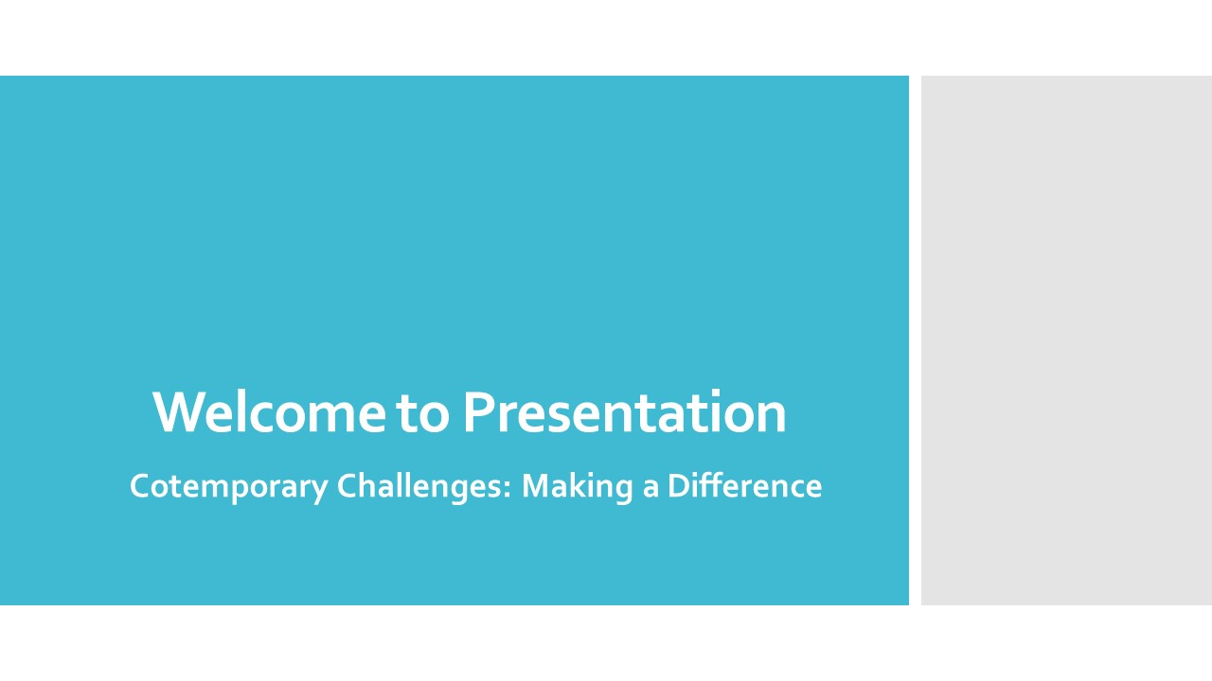
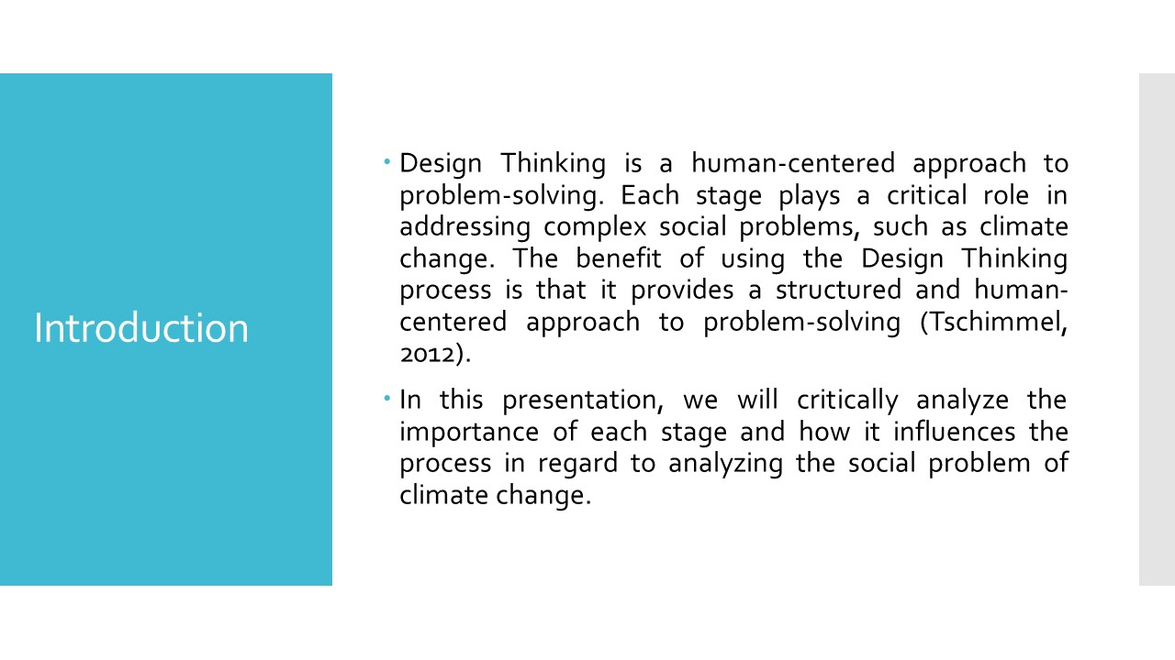Design Thinking is a human-centered approach to problem-solving. Each stage plays a critical role in addressing complex social problems, such as climate change. The benefit of using the Design Thinking process is that it provides a structured and human-centered approach to problem-solving (Tschimmel, 2012). It encourages empathy, creativity, and iteration, resulting in innovative solutions that address the needs of the people affected by the problem. Design Thinking also fosters collaboration and interdisciplinary thinking, bringing together diverse perspectives and expertise to generate ideas and solutions. Ultimately, the Design Thinking process helps to create solutions that are user-friendly, effective, and sustainable over the long term (Tschimmel, 2012). In this presentation, we will critically analyze the importance of each stage and how it influences the process in regard to analyzing the social problem of climate change.
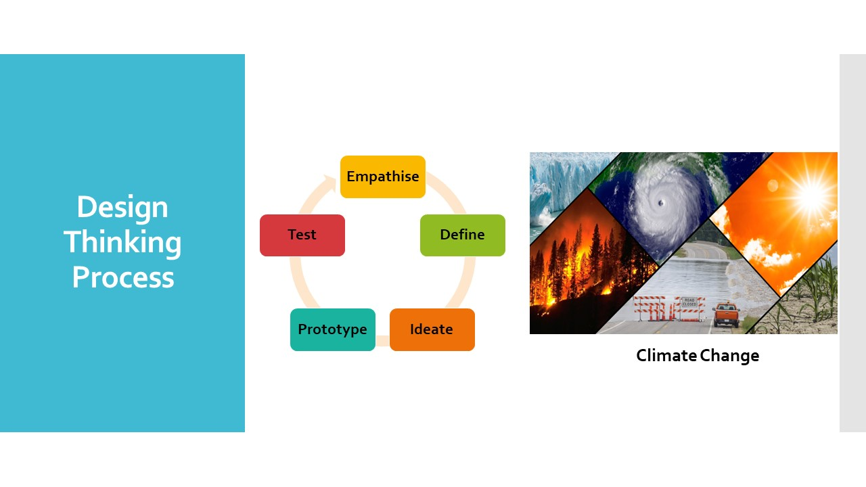Empathize, define, ideate, prototype, and test are the five steps that make up the Design Thinking process. This process offers a methodical and empathic approach to problem-solving, and it is comprised of the understanding and resolving complicated issues, such as climate change, requires going through each step of the process in its entirety (Nagai & Noguchi, 2013). The phases build on one another, enabling designers to get a profound understanding of the issue at hand, think up creative solutions to the issue, then put those answers to the test in actual-life scenarios. In order to effectively address the difficult societal problem posed by climate change, we must develop solutions that are user-centered, practical, and successful through the use of the Design Thinking approach (Robbins Schug, et al., 2023). Here, Design Thinking process is going to use for exploring the climate change.
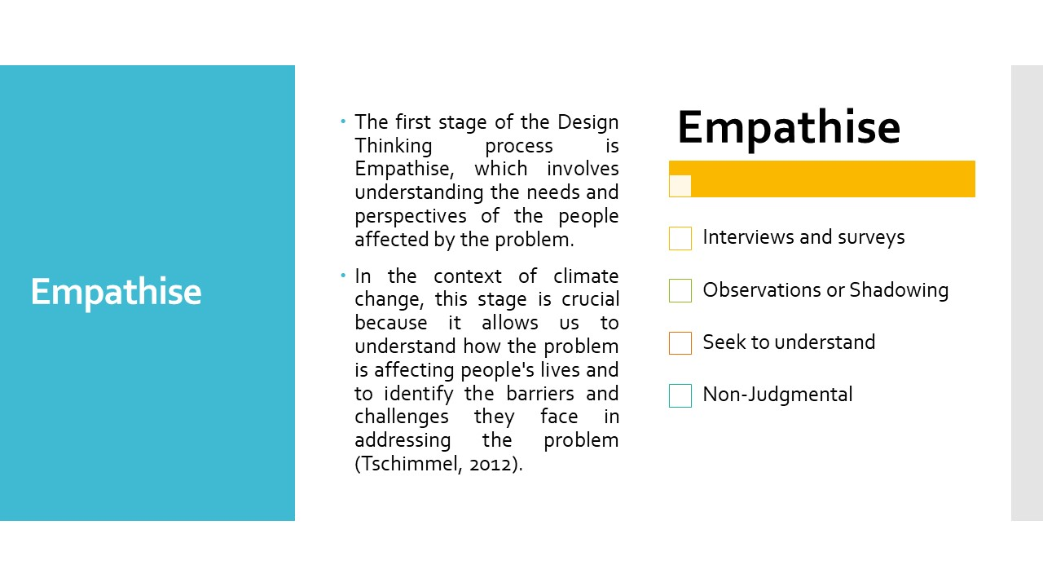The first stage of the Design Thinking process is Empathise, which involves understanding the needs and perspectives of the people affected by the problem. In the context of climate change, this stage is crucial because it allows us to understand how the problem is affecting people's lives and to identify the barriers and challenges they face in addressing the problem (Tschimmel, 2012).
To empathize with the people affected by climate change, designers must use qualitative research methods, such as interviews, observations, and surveys. By doing so, we can learn about people's experiences, thoughts, and feelings about climate change, and the impact it has on their lives (Urry, 2015).
For example, through empathy observations, we learned that low-income communities are disproportionately affected by climate change, as they may lack the resources to adapt to the changing climate. This understanding can inform subsequent stages of the Design Thinking process, such as defining the problem and ideating potential solutions (Robbins Schug, et al., 2023). By doing so, we can learn about people's experiences, thoughts, and feelings about climate change, and the impact it has on our lives.
Empathy research helps us to identify and define the problem in a way that resonates with the people affected by it. It helps us understand the complexity of the problem, including its causes, effects, and potential solutions for climate change (Meinel & Leifer, 2012). By empathizing with the people affected by climate change, we develop solutions that are more relevant, meaningful, and effective.
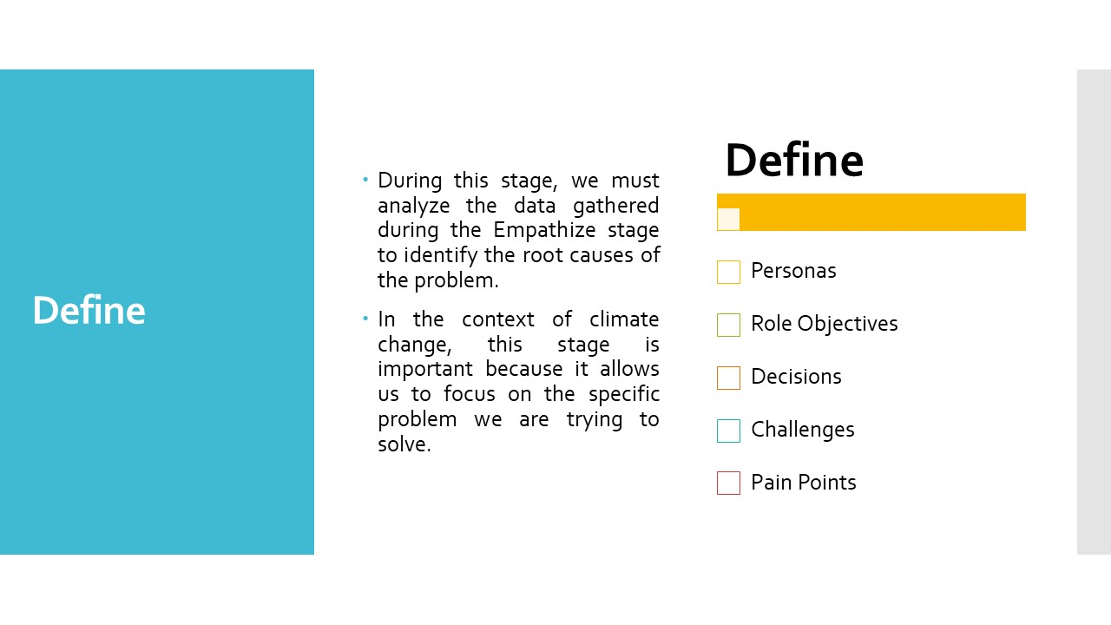
The second step of the Design Thinking process is called "Define," and it entails compiling the information assembled from the "Empathize" step into a coherent whole and pinpointing the most fundamental aspect of the issue that needs to be solved (Razzouk & Shute, 2012). In the context of climate change, this stage is important because it allows us to focus on the specific problem we are trying to solve.
During this stage, we must analyze the data gathered during the Empathize stage to identify the root causes of the problem. We must also prioritize the most important problems to solve and define the scope of the problem to avoid solving a symptom instead of the cause (Meinel & Leifer, 2012).
For example, based on our empathy observations, we might define the problem as "low-income communities lack the resources to adapt to the changing climate." Because of this definition, we are now able to proceed with the Design Thinking process while having a crystal clear grasp of the issue we are attempting to address as well as the particular requirements of the individuals who are impacted by it (Meinel & Leifer, 2012).
Defining the problem is critical because it ensures that the solutions developed address the core issue, and not just the symptoms. By defining the problem, we can develop solutions that address the needs and perspectives of the people affected by climate change (Nagai & Noguchi, 2013).
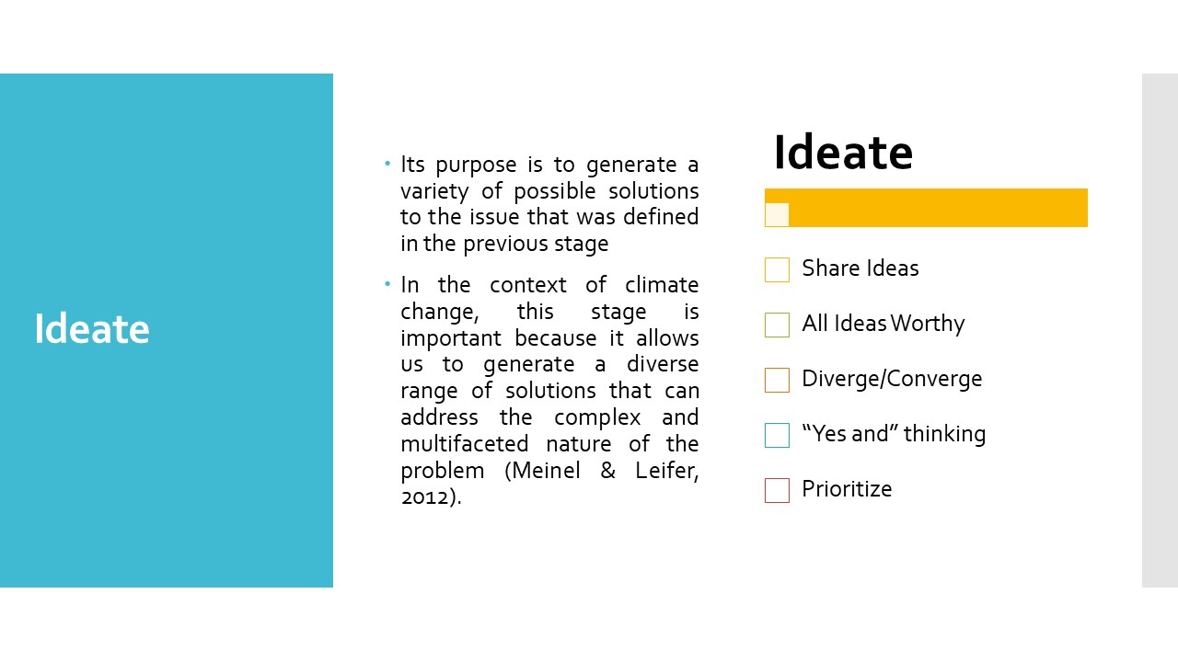Ideate is the third step of the Design Thinking process, and its purpose is to generate a variety of possible solutions to the issue that was defined in the previous stage. In the context of climate change, this stage is important because it allows us to generate a diverse range of solutions that can address the complex and multifaceted nature of the problem (Meinel & Leifer, 2012).
To ideate effectively, we use creative thinking techniques, such as brainstorming, mind mapping, and lateral thinking. By generating a wide range of ideas, designers can identify and evaluate potential solutions that can address the needs of the people affected by climate change (Tschimmel, 2012).
For example, we ideate potential solutions such as community-led climate adaptation projects, policies that prioritize low-income communities in climate adaptation efforts, or partnerships with local businesses to provide resources for climate adaptation (Meinel & Leifer, 2012).
At the ideation stage, we were urged to think creatively and explore novel approaches to the problem, some of which may not have been explored before. It also encourages collaboration among team members, which can lead to a more diverse and creative range of solutions (Tschimmel, 2012).
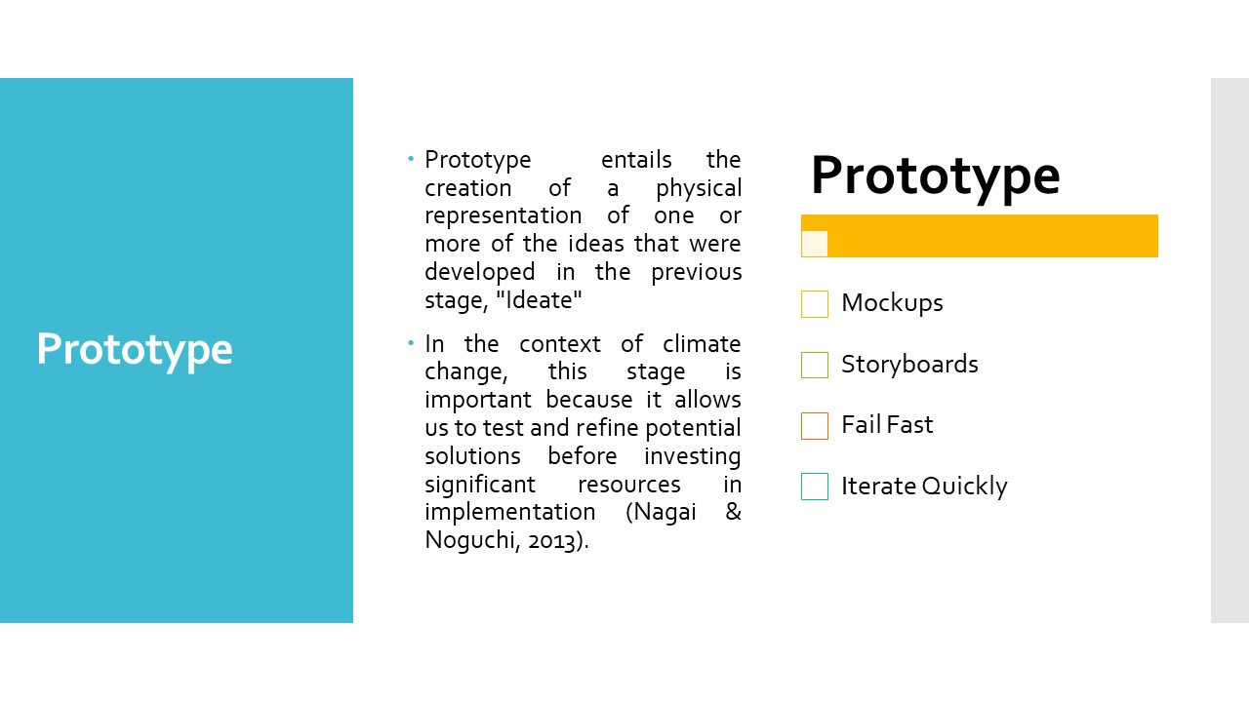The fourth step of the Design Thinking process is called "Prototype," and it entails the creation of a physical representation of one or more of the ideas that were developed in the previous stage, "Ideate." In the context of climate change, this stage is important because it allows us to test and refine potential solutions before investing significant resources in implementation (Nagai & Noguchi, 2013).
Prototyping can take many forms, including creating physical or digital models, simulations, or sketches. By prototyping solutions, designers can test their assumptions, gather feedback from stakeholders, and refine their solutions based on the insights gained (Meinel & Leifer, 2012).
For example, we prototype a community-led climate adaptation project by conducting a small-scale pilot program in one neighborhood, and using feedback from participants to refine the program before scaling up (Change, 2017).
Prototyping allows us to identify and solve potential problems early in the process, saving time and resources in the long run. It also allows us to communicate their ideas more effectively to stakeholders, making it easier to get buy-in and support for the proposed solutions (Meinel & Leifer, 2012).
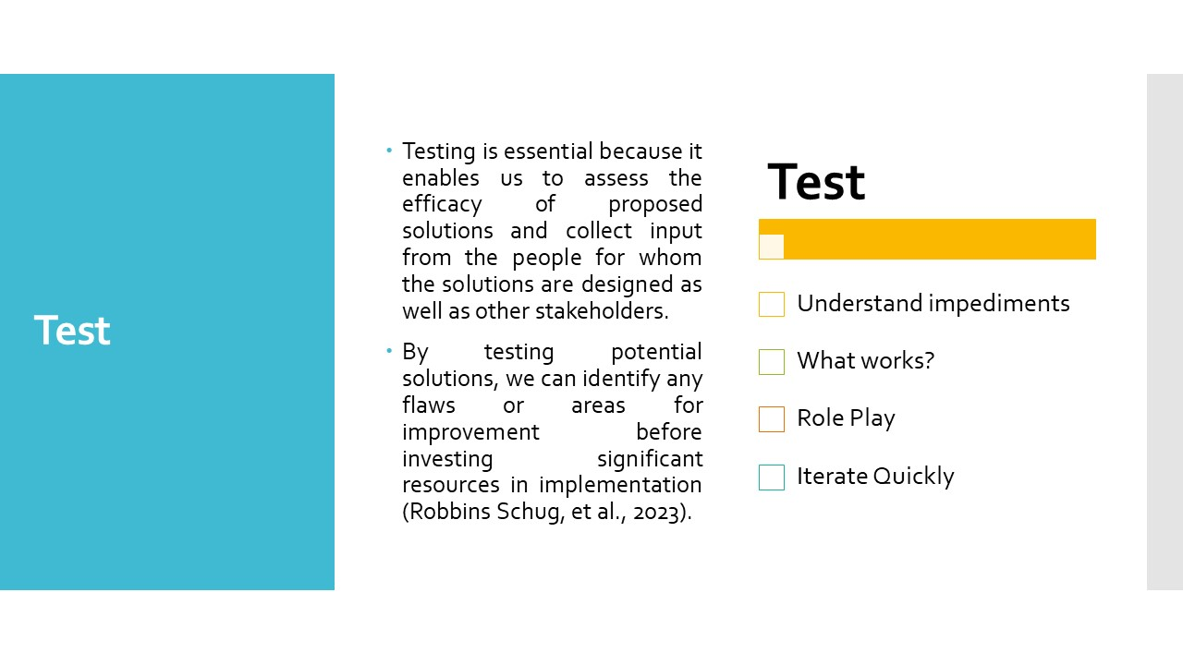The fifth and final step of the Design Thinking process is called "Test," and it consists of putting the prototype (or prototypes) that were built in the previous stage, "Prototype," through their paces with the users and stakeholders who were meant to utilize them. This stage is very important in the context of the issue of climate change because it gives us the opportunity to assess the efficacy of prospective solutions and collect input in order to modify and enhance those solutions (Urry, 2015).
Testing is essential because it enables us to assess the efficacy of proposed solutions and collect input from the people for whom the solutions are designed as well as other stakeholders. By testing potential solutions, we can identify any flaws or areas for improvement before investing significant resources in implementation (Robbins Schug, et al., 2023).
In the context of climate change, testing potential solutions is especially important because the consequences of inaction are severe and potentially irreversible. Therefore, it is critical to evaluate the effectiveness of potential solutions before implementing them on a larger scale (Meinel & Leifer, 2012).
Through testing, we can refine and improve potential solutions, ensuring that they effectively address the needs of the people affected by climate change. Additionally, testing allows us to gather feedback from the intended users and stakeholders, ensuring that the solutions are user-friendly and sustainable over the long term (Robbins Schug, et al., 2023).
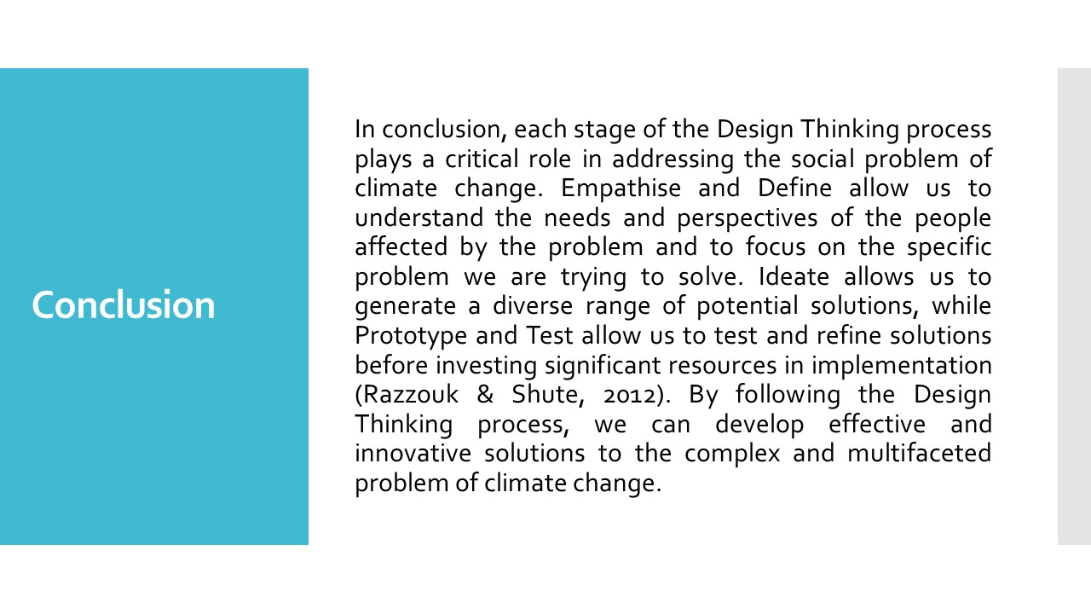In conclusion, each stage of the Design Thinking process plays a critical role in addressing the social problem of climate change. Empathise and Define allow us to understand the needs and perspectives of the people affected by the problem and to focus on the specific problem we are trying to solve. Ideate allows us to generate a diverse range of potential solutions, while Prototype and Test allow us to test and refine solutions before investing significant resources in implementation (Razzouk & Shute, 2012). By following the Design Thinking process, we can develop effective and innovative solutions to the complex and multifaceted problem of climate change.
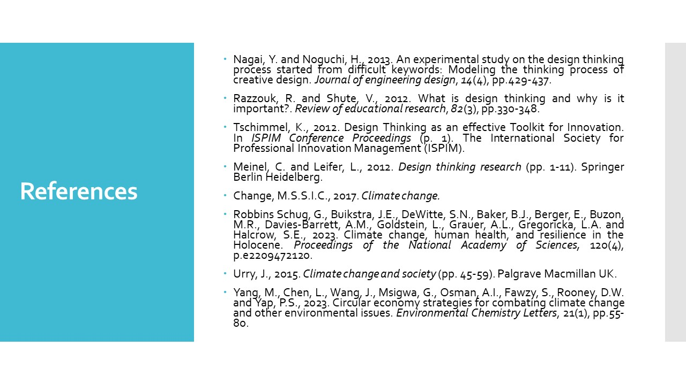
Nagai, Y. and Noguchi, H., 2013. An experimental study on the design thinking process started from difficult keywords: Modeling the thinking process of creative design. Journal of engineering design, 14(4), pp.429-437.
Razzouk, R. and Shute, V., 2012. What is design thinking and why is it important?. Review of educational research, 82(3), pp.330-348.
Tschimmel, K., 2012. Design Thinking as an effective Toolkit for Innovation. In ISPIM Conference Proceedings (p. 1). The International Society for Professional Innovation Management (ISPIM).
Meinel, C. and Leifer, L., 2012. Design thinking research (pp. 1-11). Springer Berlin Heidelberg.
Change, M.S.S.I.C., 2017. Climate change.
Robbins Schug, G., Buikstra, J.E., DeWitte, S.N., Baker, B.J., Berger, E., Buzon, M.R., Davies-Barrett, A.M., Goldstein, L., Grauer, A.L., Gregoricka, L.A. and Halcrow, S.E., 2023. Climate change, human health, and resilience in the Holocene. Proceedings of the National Academy of Sciences, 120(4), p.e2209472120.
Urry, J., 2015. Climate change and society (pp. 45-59). Palgrave Macmillan UK.
Yang, M., Chen, L., Wang, J., Msigwa, G., Osman, A.I., Fawzy, S., Rooney, D.W. and Yap, P.S., 2023. Circular economy strategies for combating climate change and other environmental issues. Environmental Chemistry Letters, 21(1), pp.55-80.

