Reflections on Early Years Practice

Element 1-
This element will discuss reflection, the benefits of reflection, using theories and models to do with reflective practice in the early years. Also explains advantages and disadvantages in settings.
According to Early Years Careers (2021) Reflection is contributed in many ways, thinking about how a practitioner works, knowing strengths and acknowledge the weaknesses. Reviewing methods to improve practice and identifying problems to solve.
Pacey (2016) goes on to saying reflective practice is a continuous cycle, from analysing, changing, challenging then modify, to developing and improving. Practitioners reflect from this by evaluating and identifying professional needs within.
Benefits for reflection in early years can include -
- Developing new skills in the practice.
- Helps build relationships.
- Improves decision making.
- Being better with organization.
- Have a better engagement, from playing and learning- reflects on a child’s interests and experiences which stimulates an effective environment.
- Creating and thinking critically , provides opportunities within the experiences for children to explore and develop to problem solving themselves enhancing language through their reflection on experiences.
Hutchison, M (2016).
Advantages of reflective practices-
- Improves self-esteem through learning and engaging.
- Facilitates the theory to revise in practices encouraging holistic, and a flexible approach for children’s future activities.
- Encourages critical thinking for practitioners to progress decision making.
Disadvantages of reflective practices-
- Frustration when solving problems.
- Not enough time to go through all of the reflections.
- The process can be inveigled to meet predictable outcomes.
Early Years careers (2021)

Models used from theorists –
University of Cambridge Libguides (2021)
Schon (1991) defines reflective practice as professionals that become aware of an implicit knowledge base to learn from experiences. Splitting his theory in to two sections
Reflection in action – according to Infed.Org (2013) in action works on getting to the bottom of what the professionals process in decision making and feelings at the time of an event or interaction. In early years settings practitioners approaches a child if misbehaving or if the child is un-engaged addressing issue. In action can also be reviewing the problem to improvise so experiences can be viewed upon differently, looking over things that went well or things that did not. Observing and note taking can be done for other practitioners to adhere.

Reflection- on- action – works on sifting over a previous event with new information or have theoretical perspectives, with practitioners’ actions and feelings. This type of reflection happens regularly in settings, practitioners undertake informal observations of children during activities. This gives time to sit and reflect on action with efficiency and accuracy using the information written down Infed.org (2013).
In the varied structure of a professional practice stands a high ground for practitioners to make an effective research based with their techniques and theory. Swampy lowland shows solutions where are confusing with an incapable technique. Difficult problems of a high ground are un useful to clients in a larger society.
( Schon 1983: 42)
This argument is based on the swampy lowlands , reflective can have own assumptions about own practices , where systematic assessments need to be identified first before overcoming the problems in a reflective way.

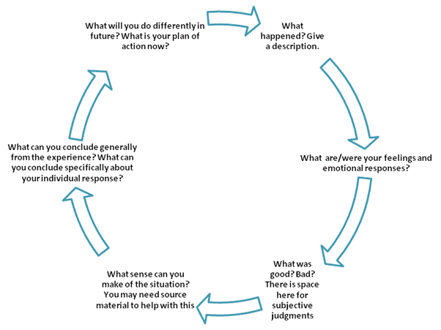
(Source: Pinterest, no date)
Here is Schön’s reflective thinking model.
Schön model is made with reflection in action – during an event.
Where the experience starts, thinking what to do next , acting straight away.
Reflection on action- after the event or activity.
Analysing something that has already happened , thinking what can be done differently , taking time.
Reflection in on action involves a planned course of action , if children are not meeting the outcomes or challenges, then practitioners need to change the plan of reflection to an appropriate level.
Aubrey and Riley (2019) say Donald Schön who was born in Boston 1930, made a significant contribution with the understanding and learning of reflection in and on action, Schon’s work encourages practitioners to reflect in a critical way which would be beneficial of developing and improving the practice they work within. Schön emphasis to recognise professional knowledge to be key to any organisations. Schön uses experiences in a variety of ways to examine the effectiveness, seeing reflection being the essential component in a learning process. Both Schön and Dewey saw a reflective practice as an alternative to technical rationality which suggested that the knowledge used by the practitioner, then the use of science should adhere the force behind a reflective practice. Dewey saw a place for science where Schön did not.
When Schön applied himself to the classroom he believed experienced practitioners and reflective practitioners who use their knowledge on a daily basis for assessing existing theories with the observations develop new theories.

Fietcher (2020) - explains Kolb’s Model (1984) starts with what experience is used firstly then to move on to how to reflect on it, whilst reflecting fresh ideas should be developed for new experiences to overcome. For final stages of the model, you reflect with all of the ideas and experiences to put into the conclusion of what was learnt. However, comparing theorists with their models and cycles shows that Gibbs model, which is demonstrated in the poster below, shows his theory for reflective cycle comes in six stages comparing and evaluating the experiences what were the pros and what were the cons. Gibbs model starts off with the description of the event , what thoughts were shared, who was there what was happening. Then on to the feelings and thoughts about the experience, evaluating what went well or what did not. Gibbs point four goes on to analysing the status breaking down each part giving a conclusion before the last part of cycle an action plan for future changes than can be used Williams (2017).
Gibbs repeats his model with principles and stages to apply equally, for single experiences for an action plan for practitioners to use for conclusions to the future. Using Gibbs cycle in practice defines reflection more breaking up each point.
- What happened.
- Where it happened.
- What the outcome was.
- Who was there at the time?
- What could be done differently.

The Foundation phase in early years for practitioners have the skills and knowledge of working with reflectiveness and reflection in their practice, not reflecting properly discourages practitioners from planning future outcomes and assessments. This is why reflection is important Furlong (2010).

Reflecting in practice needs to be more than a consideration, of technical organizational aspects for presenting problems, flagging up political and cultural issues and questioning a purpose of intention if appropriate.
(Reynolds, 2011)
What is Reflection?  According to Early Years Careers (no date) reflection means to analyse children’s activities they have accomplished improving them making them more challenging. | Importance of Reflective Practice  Improve working relationships with practitioners and children.  Evaluate how effective plans , routines policies and procedures work within the setting.  Identify how the environment meet the care and learning of children’s needs.  Hcpc (2019).
What is the purpose ?  According to Longford Childcare (2017) the purpose is to have positive impacts in the early years with reflection in action and on achieves the best outcomes.  - Provides everyone to work together building relationships.  - Reflecting critical for diverse groups of practitioners and professionals.  - Professionals in learning communities supports early childhood with different networks. | How early years practitioners reflect effectively?  According to Early Years Matters (2021) practitioners reflect effectively by observing and planning for next steps, practitioners work together to support children with their development, play and learning.
- Pacey (2021) says having experienced practitioners with the knowledge at the workforce enables children and young ones to reach their potential, understanding children’s requirements in day-to-day activities helps to plan further for the future. | Practitioners also play a big part in early years from  - supporting a positive way for children to sense their identity and culture.  - Keep children and young ones safe. Identify additional support.
Element 2 - Reflective and Reflection Part 1& Part 2
A Model of Kolb’s demonstrates 4 stages to the cycle.  - Beginning with concrete experience – (being aware of)  - Reflection – watching and reflecting.  - Conceptualisation- creating and analysing.  - Then on to Active Experimentation – trying out things or prepare for action. | Gibbs Cycle of model of reflection with an example can be found at this link below-  Gibbs' Reflective Model with an Example - Simplest Explanation Ever - YouTube  Youtube (2020).
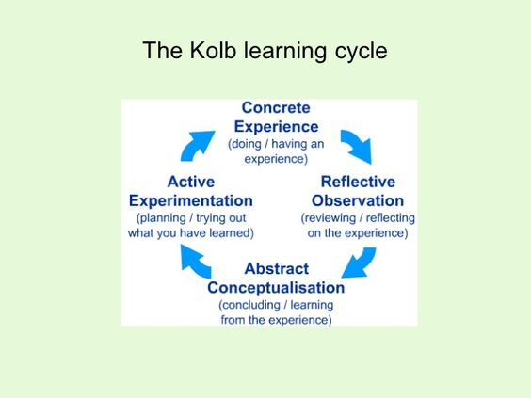Pinterest (no date). | Gibbs (1998)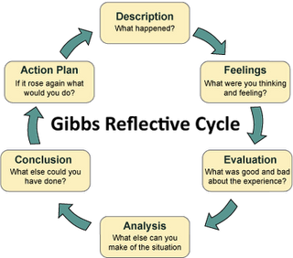
How to reflect in different ways:  North Yorkshire county Council (2017) says you can reflect by summarising a description what happened or looking back with previous events , in how you feel , what the outcome was looking at prime areas.  - Using personal, social developments- provides children’s experiences to be reflected on which they feel comfortable within.  - Language and communication need, reflects on asking children questions in how they think the activity went.  - Physical Development- seeing what activities they would like to do next. | Barriers to reflections can be from  - Time management. Not having enough time to do the planning.  - Communication and interacting with children in a positive way , meaning if they respond to activities to help you assess.  - Environment- making your reflection is a comfortable area.  - Personal awareness- how to overcome personal barriers.  North Yorkshire County (2017)

Elfen 3 Log adfyfyriol – Element 3 Reflective log

Brief description of the activity (no more than 50 words) –
Here we have an activity on baking cakes, using children motor skills, developments teaching them step by step how to make cakes and having fun the same time. Using their knowledge, having patience, and taking in turns with their friends.
Baking Activity – Making cakes.

Aim/Objective of the activity
To supervise and assist in making cakes for a Christmas activity.

Your role
To Demonstrate how to bake cakes with the children.

Positive aspects – why? How could these be developed further?
- The setup of the activity is inviting for the children, with the different ingredients set up – as in colourful, sparkly.
- The children enjoyed and engaged in the activity as it was a hands-on practical activity, that encouraged the children to take part.
- Positive aspects in cake baking includes children are –
gives children hands on using their social and emotional development- this can be by following the recipe, problem solving skills are used.

- Using physical development – using their motor skills, coordination by mixing, sprinkling, kneading.

- Baking cakes can encourage and use more language development by – using maths, arts, counting how much spoonful’s they need to use, changing colour of cakes with food colouring, feeling the texture if it’s too soft or too hard.

Challenging aspects – why? Link to your own practice.
- Children would lose interest when it was another child’s turn.
- The activity may be too long for some to concentrate.
- The children were already excited as they seen the set-up table with the activity on.

What knowledge did you demonstrate?
- I have a lot of experience in baking, and enjoy cake making and decorating.
- Knowledge used - is how to make the cake.
- Using mathematics for numbers of weighing and counting.
- Following instructions step by step.
- Familiar with the group of children that took part in activity.
- Children to use bilateral coordination, using both hands , rolling out or flatten dough, using eye coordination.
- I was aware within the group language barriers, so I used picture cards for children to understand.

What skills did you demonstrate?
- Preparation- I prepared the activity in advance, the equipment and ingredients were ready for the children.
- Time management- timed activity, I knew how long it would take.
- Communication- I spoke to the children and explained what to do following the guide and instructions.
- Answered any questions the children addressed.
- Patience- when the children showed a lack of interest.
- Taking in turns, so all took part.
Which values did you demonstrate?
- Inclusion- involved the children to bake cakes, Respect- respected their decision if they would like to take part, enough time- making time for the children to design cakes however long they needed, differentiation for development delays – choose an easy activity where it was appropriate for all children and given assistant or help that was needed to all.
- Patience with the children going over what we need to do giving instructions clearly.
- I listened to each child, answering any questions they asked.
- Sharing – we all shared having same quantity of cakes, had a turn of mixing the ingredients taking in turns with everyone.
- Children having a voice to share anything- they liked or disliked.

What could be done differently in future? Why?
- Perhaps bake a variety of cakes or even biscuits, so it would be fun and more portions.
- We could write down what to make each week and put our ideas into a hat and draw out from a child.
- Sharing the activity with another practitioner so we could do bigger groups having fun to decorate cakes or design their own.
- Length of time - so it is no to quick and not to long for children to get bored or distracted.
- Looking online at other things to bake e.g., biscuits, muffins, ginger bread houses.
- All dress up in activity to all be cooks with own equipment areas.
- Critical reflection looking back what went well and what could be improved on.

Element 4 Personal Development Plan

Area for further development (provide further details) | Why? | How? | Who/Where? | When?
Do a ALN course. | More of an understanding about additional learning needs I aint covered yet. | Apply for courses online.  Through work.  Or employability week | Swansea.Gov site.  Look online. | Soon as available.
Time Management | Not to have to many extensions for assignments to muddle me up. | Once I have had my baby. | On maternity  At home. | After level 5 completed in May.
Reading | I tend to speak to fast and rush a story not knowing what it’s about or any reading. | Nerves.  Need to take a breath, to pace myself and not rush. | Practice in my setting.  Or at home. | Continuous.
Apply for a job I would want to do once I finish University.  Perhaps in a hospital part time as I have dependants. | - With babies is my interest.  - Job goal. | - Check on the NHS sites.  - Ask lecturers for a letter to the hospital for me to Volunteer/ or be paid.  - Giving a reference? | Online websites.  Ringing up the hospitals nearby. | Preferably September 2021.
Attend more courses – Safeguarding , First Aid. | - To update and refresh my knowledge. | - Ask my manager.  - Search on Swansea Gov site. | Asking lecturers also. | As soon as available.
ADHD course | Ive never been on and would love to learn the knowledge how children who got ADHD cope and what helps them daily. | - Check online,  or courses.  Ring up Civic Centre Swansea see if they can help me. | Ask UNI. | As soon as available.

References
Aubrey, K. and Riley, A. (2019) Understanding & Using Educational Theories. 2nd Ed. London: SAGE.
Dallos, R. and Stedman, J. (no date) Flying over the swampy lowlands: Reflective and Reflective Practice. Available at: 5820-McGraw-MayPowel (uwtsd.ac.uk) (Accessed: 24/01/21).
Dallos. R and Stedman, J. ( no date) Flying over the swampy lowlands: Reflective and reflective Practice. Available at: https://moodle.uwtsd.ac.uk/mod/resource/view.php?id=225248 (Accessed: 10/04/21).
Early Years Careers (2021) Reflective Practice. Available at: Reflective Practice (earlyyearscareers.com) (Accessed: 09/01/21).
Early Years Careers (no date) Reflective Practice. Available at: www.earlyyearscareers.com (Accessed: 06/04/21).
Early Years Matters (2021) Effective Practice. Available at: Effective Practice - Early Years Matters (Accessed: 06/04/21).
Fietcher, K. (2020) Differences between Gibbs and Kolb cycles. Available at: Differences Between Gibbs and Kolb Cycles (ehow.co.uk) (Accessed: 08/04/21).
Furlong, J. (2010) The Foundation Phase. Available at: https://dera.ioe.ac.uk/ (Accessed: 09/04/21).
Gibbs reflective model with an example (2020). Available at Gibbs' Reflective Model with an Example - Simplest Explanation Ever - YouTube (Accessed: 09/04/21).
Hcpc (2019) Benefits of becoming a reflective practitioner. Available at: benefits-of-becoming-a-reflective-practitioner----joint-statement-2019.pdf (hcpc-uk.org) (Accessed: 09/04/21).
Hutchison, M. (2016) Benefits of a Reflective Practice. Available at: Home ~ Wellness With Moira (Accessed: 18/01/21).
Infed.org (2013) Donald Schon (Schön): learning, reflection and change. Available at: Donald Schon (Schön): learning, reflection and change – infed.org: (Accessed: 29/01/21).
Leading in action Gibbs model of reflection (1998) [image]. Available at: Gibbs Model of Reflection | Leading in Action (wordpress.com) (Accessed: 09/04/21).
Longford Childcare (2017) Reflective Practice in the Early Years. Available at: Reflective Practice in the Early Years - Longford Childcare Committee (Accessed: 10/04/21).
North Yorkshire County Council (2017) How to reflect? Available at: Suggested headings for Quality Improvement Toolkits: (northyorks.gov.uk) (Accessed: 08/04/21).
Pacey (2016) Developing Self Reflective Practice. Available at: https://www.pacey.org.uk/ (Accessed: 18/01/21).
Pinterest (no date) Schon Reflective thinking model [image]. Available at: https://i.pinimg.com/originals/f8/80/98/f88098c0a34a22973acb581b1f41828c.jpgn (Accessed: 27/01/21).
Pinterest (no date) The Kolb learning cycle [image]. Available at: (287) Pinterest. (Accessed: 08/04/21).
Reynolds, M. (2011) ‘Reflective practice: Origins and interpretations, Action Learning’, Action Learning Research and Practice, 8:1, Pg. 5-13,Routledge.
University of Cambridge Libguides (2021) Models of Reflection. Available at: Models of reflection - Reflective Practice Toolkit - Libguides at University of Cambridge Subject Libraries (Accessed: 02/02/21).
Williams, O. (2017) Kolb and Gibbs Reflective Cycle. Available at: https://owenwilliams82.wordpress.com/ (Accessed: 08/04/21).

