MealSwift Website Redesign
BSc Applied Computing

Student Name: Dmytro Zavalskyi
Student ID: 2337224
Module Name: Business and Web Management
Module code: ACCA5019
Assignment Title: Component 1 – Website Redesign
for Online Business Presence

Table of Contents
1. Introduction
2. MealSwift Website Redesign
2.1 Current Issues with the MealSwift Website
2.2 Proposed Solutions
3. Responsive Design Implementation
4. Implementation Section
4.1 Prototype Screenshots
4.2 How the Mood Board and Wireframe Influenced the Design
5. Conclusion
6. References

1. Introduction
This report has been put together as part of a design brief to redesign the MealSwift website — a food delivery platform that connects customers with local restaurants. The main goal of this project was to go through the full UI/UX design process, starting from researching what is wrong with the existing site, building a mood board to set the visual direction, sketching out wireframes for the main pages, and finally putting together an interactive prototype that shows how the redesigned website would actually work.

Throughout this project I focused on making the site feel easier and more enjoyable to use, especially on mobile, while also making it look more modern and trustworthy. The report covers my research into MealSwift's current problems, the solutions I have proposed, an analysis of why responsive design matters for e-commerce, and a reflection on how the mood board and wireframe phases shaped my final prototype. Screenshots of the finished prototype are included in Section 4.

2. MealSwift Website Redesign

2.1 Current Issues with the MealSwift Website
When I first looked at the MealSwift website brief, it became clear that there were quite a few fundamental issues holding the platform back. These were not just small visual tweaks that were needed — some of the problems ran quite deep in terms of how the whole thing was structured and how users would interact with it.

The first and most obvious issue is the navigation. The current site has a confusing layout where it is not immediately clear how to find a specific type of cuisine, browse restaurants, or even get to the checkout. When users cannot quickly figure out where to go, they tend to leave — especially on a food ordering platform where people are usually hungry and want to find something fast. Poor navigation is one of the most commonly cited reasons for high bounce rates on food delivery websites, and it is something that really needed fixing from the ground up [1].

The visual design was another major problem. The site uses outdated styling — old-fashioned fonts, muted or mismatched colours, and low-quality images of food that do not make you want to order anything. For a food delivery service, imagery is everything. If the food does not look appetising in the photos, customers are less likely to place an order. There is also a lack of consistent branding, which makes the platform feel unprofessional and untrustworthy compared to competitors like Deliveroo or Uber Eats [2].

Perhaps the biggest technical issue is that MealSwift's current layout is not responsive. This means it does not adapt properly to smaller screens like smartphones or tablets. Given that the vast majority of food delivery orders are placed on mobile devices — often while people are on the sofa or commuting — this is a serious problem. A site that requires zooming in and out or that breaks visually on a phone is going to lose customers almost immediately [3].

Other issues I identified include: an inefficient and unclear checkout process with too many steps and no real confirmation feedback; a complete lack of personalised recommendations such as an "order again" feature or suggested restaurants based on past choices; virtually no customer reviews or star ratings visible on restaurant listings; and weak call-to-action buttons that do not encourage users to actually click and order. On top of all this, there is no real-time order tracking feature, which is now considered standard in the food delivery industry. Slow page loading times were also highlighted in the brief as a contributing factor to user drop-off.

2.2 Proposed Solutions
For the redesign, I aimed to tackle each of these issues directly rather than just making things look prettier on the surface. The navigation was completely restructured with a clean, sticky top navigation bar that stays visible as users scroll. Category filter chips were added to the homepage so users can immediately jump to their preferred cuisine type — burgers, pizza, sushi, Indian, and so on — without having to hunt around. The restaurant listing page includes a full set of filter buttons covering top rated, fastest delivery, and free delivery options, which allows users to narrow down results quickly.

In terms of visual identity, the redesign is built around a deep orange (#FF6B2B) as the primary brand colour. Orange works well for food platforms because it is associated with warmth, appetite, and energy — you see it used by McDonald's and Amazon for exactly this reason. This was paired with clean white space and a modern sans-serif font to keep things feeling fresh and easy to read. Consistent use of this colour palette across all five prototype pages creates a cohesive and recognisable brand identity [2].

The checkout was simplified into a three-step flow: basket review, delivery details, and payment. Each step is shown clearly in a progress bar at the top so users always know where they are in the process. An order summary panel sits on the right-hand side so customers can see exactly what they are paying before confirming. This removes the confusion and uncertainty that the current checkout creates, reducing the likelihood of abandoned orders.

Personalisation was addressed through a live cart that updates in real time as users add items on the menu page, giving immediate visual feedback. The order tracking page introduces a status bar with five clear stages — Order Placed, Confirmed, Preparing, On the Way, and Delivered — along with a simulated map view and an estimated arrival time. Customer reviews and star ratings were added to every restaurant card across the homepage and listing page, and call-to-action buttons were made larger, bolder, and higher contrast to guide users naturally through each step [4].

3. Responsive Design Implementation
Responsive design is the practice of building websites so that they look and work properly across all different screen sizes — from a large desktop monitor down to a smartphone. It is achieved through a combination of fluid grids, flexible images, and CSS media queries, which tell the browser to rearrange or resize content depending on the width of the screen being used [3].

For an e-commerce platform like MealSwift, responsive design is not just a nice feature to have — it is absolutely essential. Mobile commerce has grown enormously over the past decade, and food delivery in particular is a category dominated by mobile users. People place orders from their phones while watching television, waiting for a bus, or sitting at a desk at work. If a website does not work well on a phone, those users will simply go elsewhere. Research into food delivery UX has consistently identified non-responsive layouts as one of the top reasons for mobile cart abandonment [3].

From a user experience perspective, responsive design removes friction. When content reflows cleanly on a smaller screen — menus stack vertically, buttons are large enough to tap with a thumb, and text is readable without zooming — the ordering process feels effortless. For MealSwift specifically, this means the restaurant cards that appear in a three-column grid on desktop should collapse to a single column on mobile, the search bar should stretch to full width, and the checkout form should be easy to fill in using a mobile keyboard. These are not small details — they directly affect whether a user completes an order or gives up halfway through [5].

From a business perspective, responsive design has a direct impact on sales. Google uses mobile-first indexing, meaning it crawls and ranks websites based on how they perform on mobile rather than desktop. A non-responsive MealSwift website will therefore rank lower in search results, leading to reduced organic traffic [4]. Conversion rates are also significantly higher on responsive sites because the path from landing on the page to completing a purchase is smoother, with fewer points at which users are likely to give up. There is also a trust factor — a website that looks broken or difficult to use on a phone immediately raises doubts about the professionalism of the service, which in the food delivery industry translates directly to lost revenue.

Accessibility also improves meaningfully with a responsive layout. Larger tap targets make the interface easier to use for people with motor impairments, and properly scaled text reduces barriers for users with visual difficulties. These improvements are not only ethically important but also commercially sensible, as they broaden MealSwift's potential customer base. In the prototype, responsive principles were applied throughout — the card grid adapts to screen width, navigation is structured for mobile viewports, and all interactive elements are sized for touch input.

4. Implementation Section

4.1 Prototype Screenshots
Please see the attached exported PNG screenshots of the five prototype pages, included as Appendix A. These were exported directly from the interactive HTML prototype built as part of Task 1.

The five pages included in the interactive prototype are as follows:
- Homepage: Features a full-width hero section with a location-based search bar, cuisine category filter chips, and a grid of six featured restaurant cards complete with star ratings and delivery time information.
- 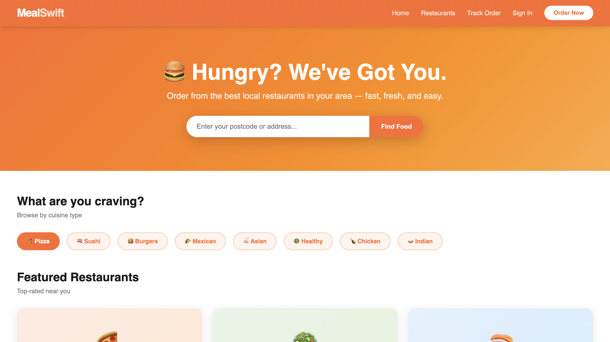

- Restaurant Listing Page: A filterable directory of restaurants with filter buttons for cuisine
type, top-rated, fastest delivery, and free delivery options. A results count is displayed clearly above the grid.
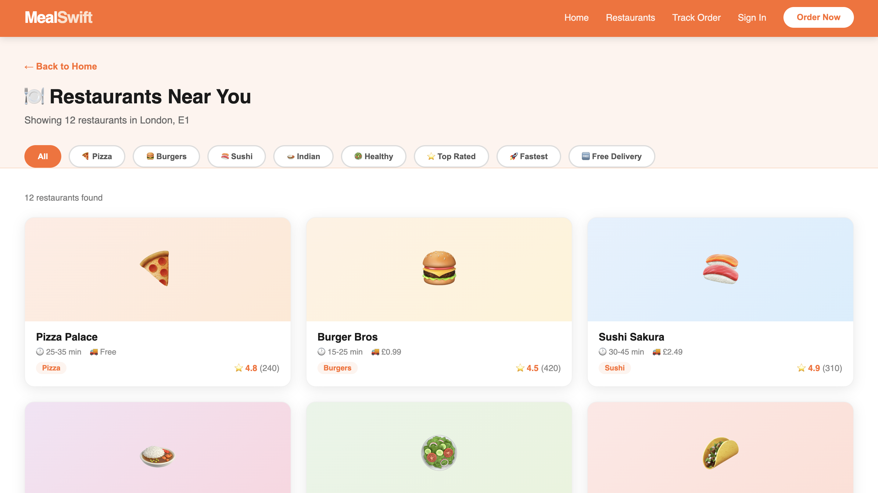

- Menu Page: Individual restaurant page for Pizza Palace showing a full categorised menu across pizzas, sides, and drinks, with a live cart panel on the right-hand side that updates in real time when items are added.
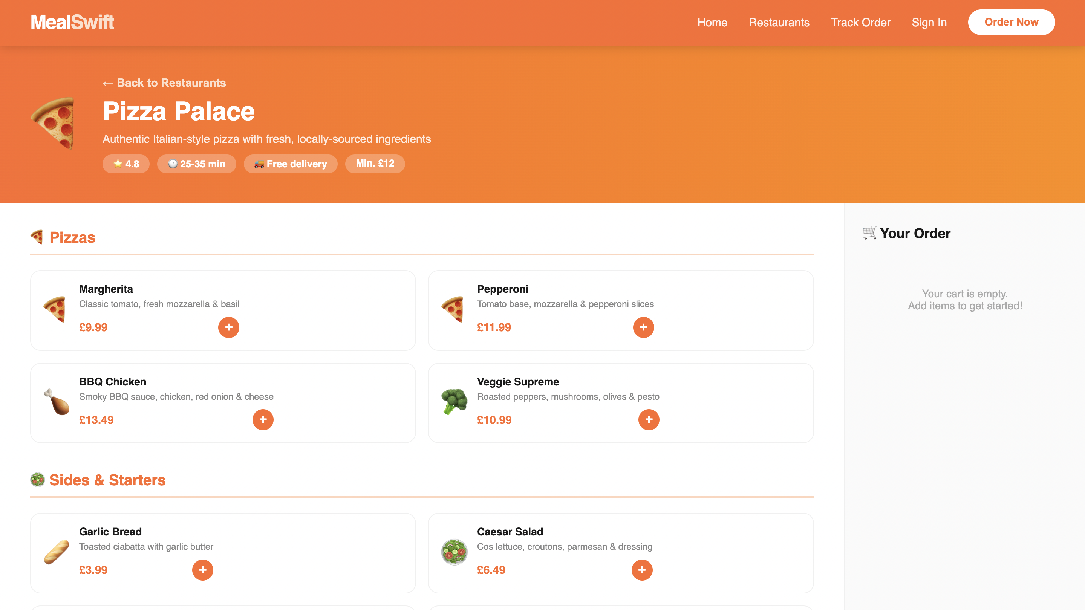

- Checkout Page: A three-step checkout flow with a visual progress indicator at the top, delivery details form, payment section, and an item order summary panel.
- 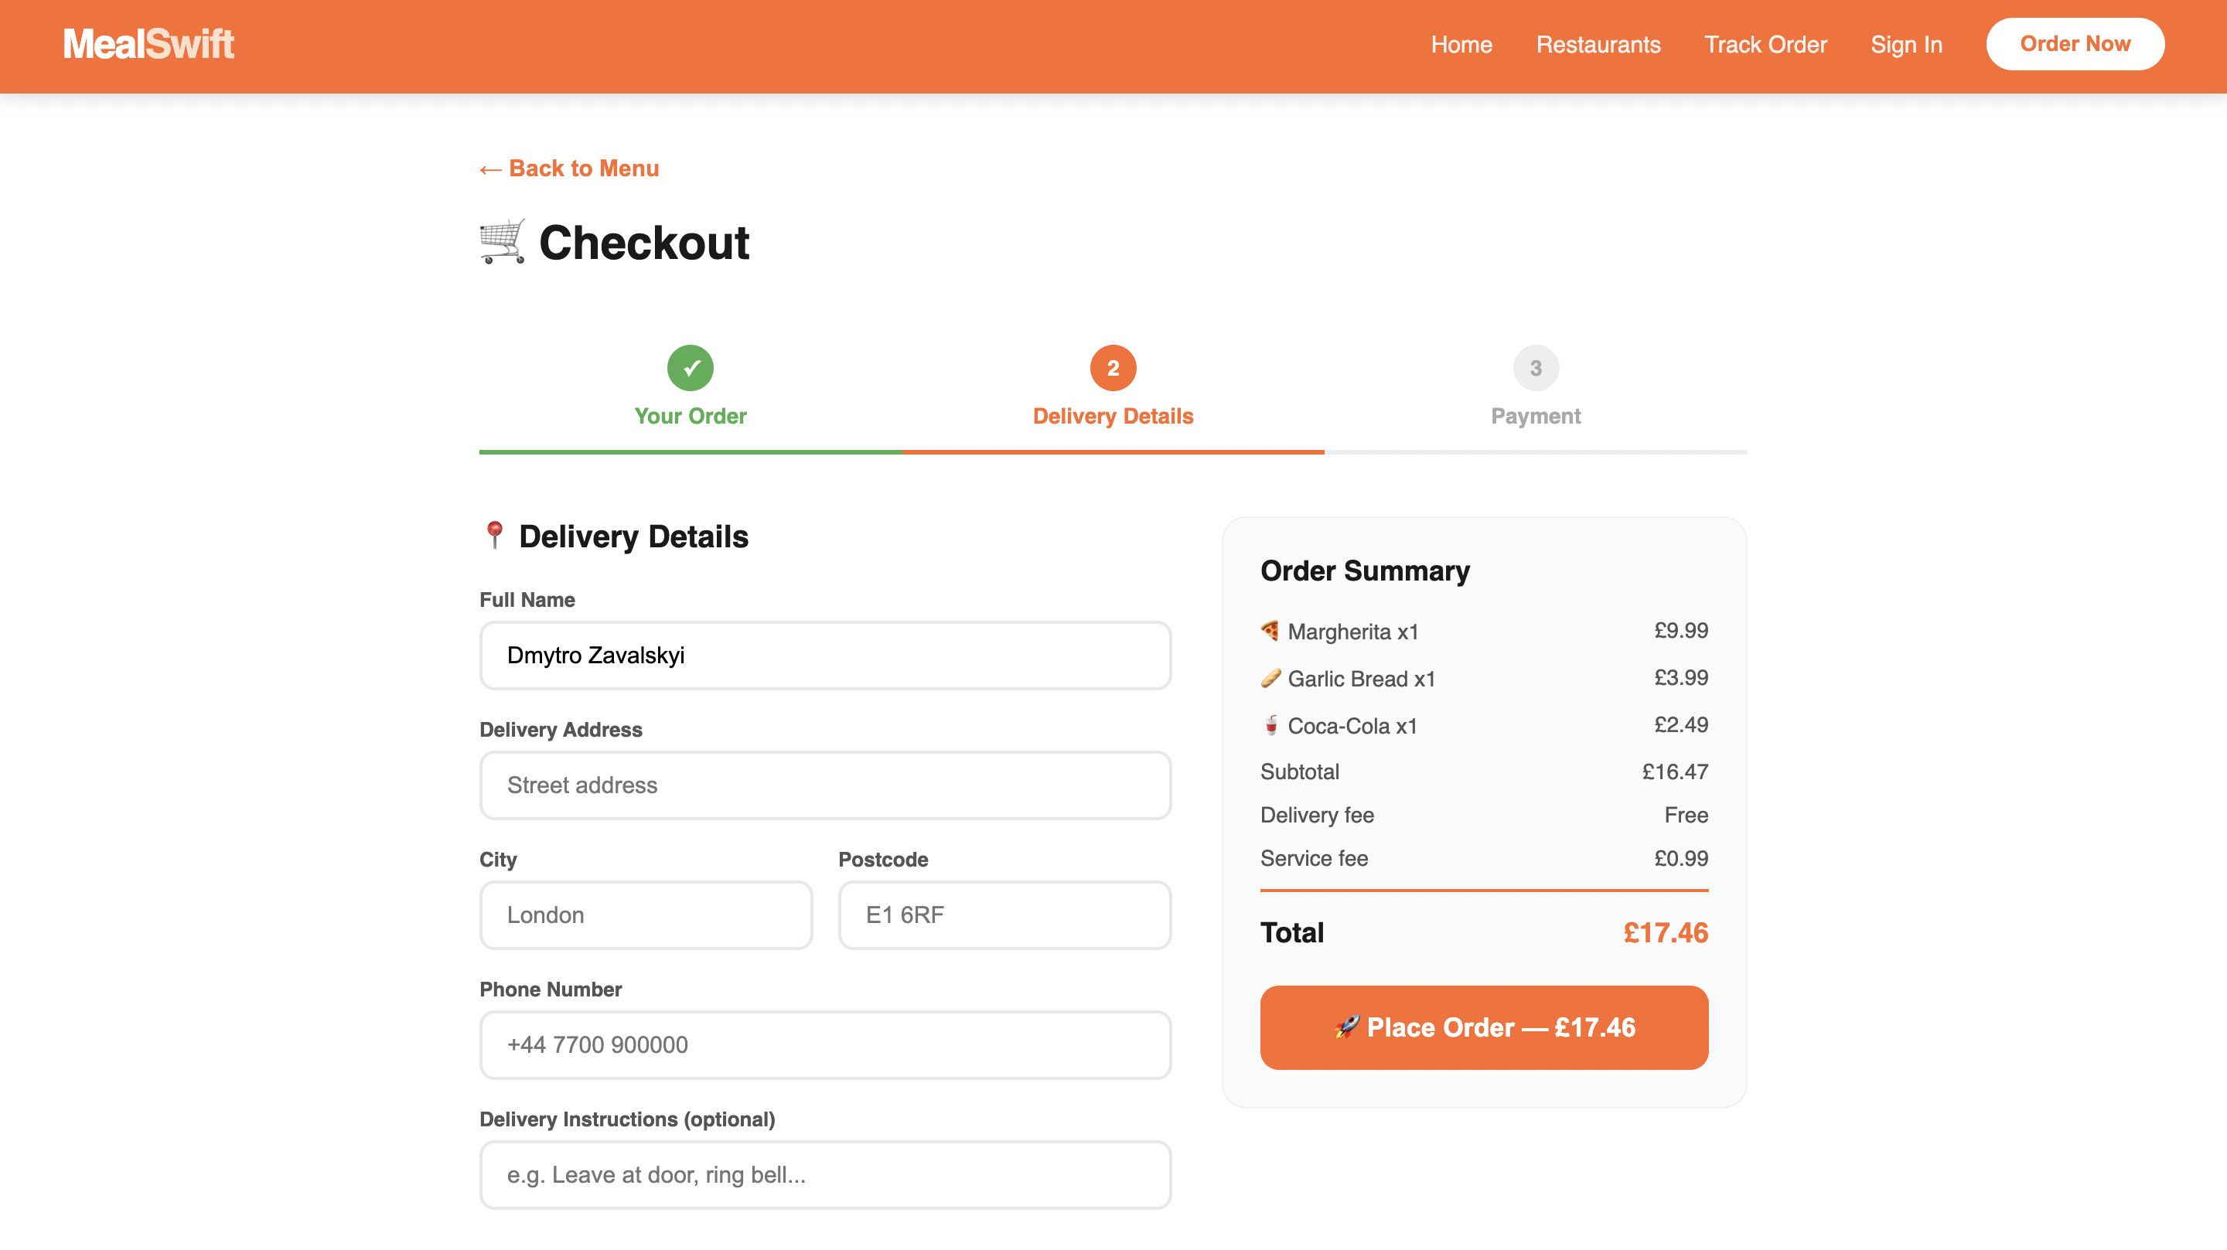

- Order Tracking Page: A live-style order status tracker with five stages, an animated map view, estimated arrival time, rider information with a star rating, and a complete breakdown of the order items.
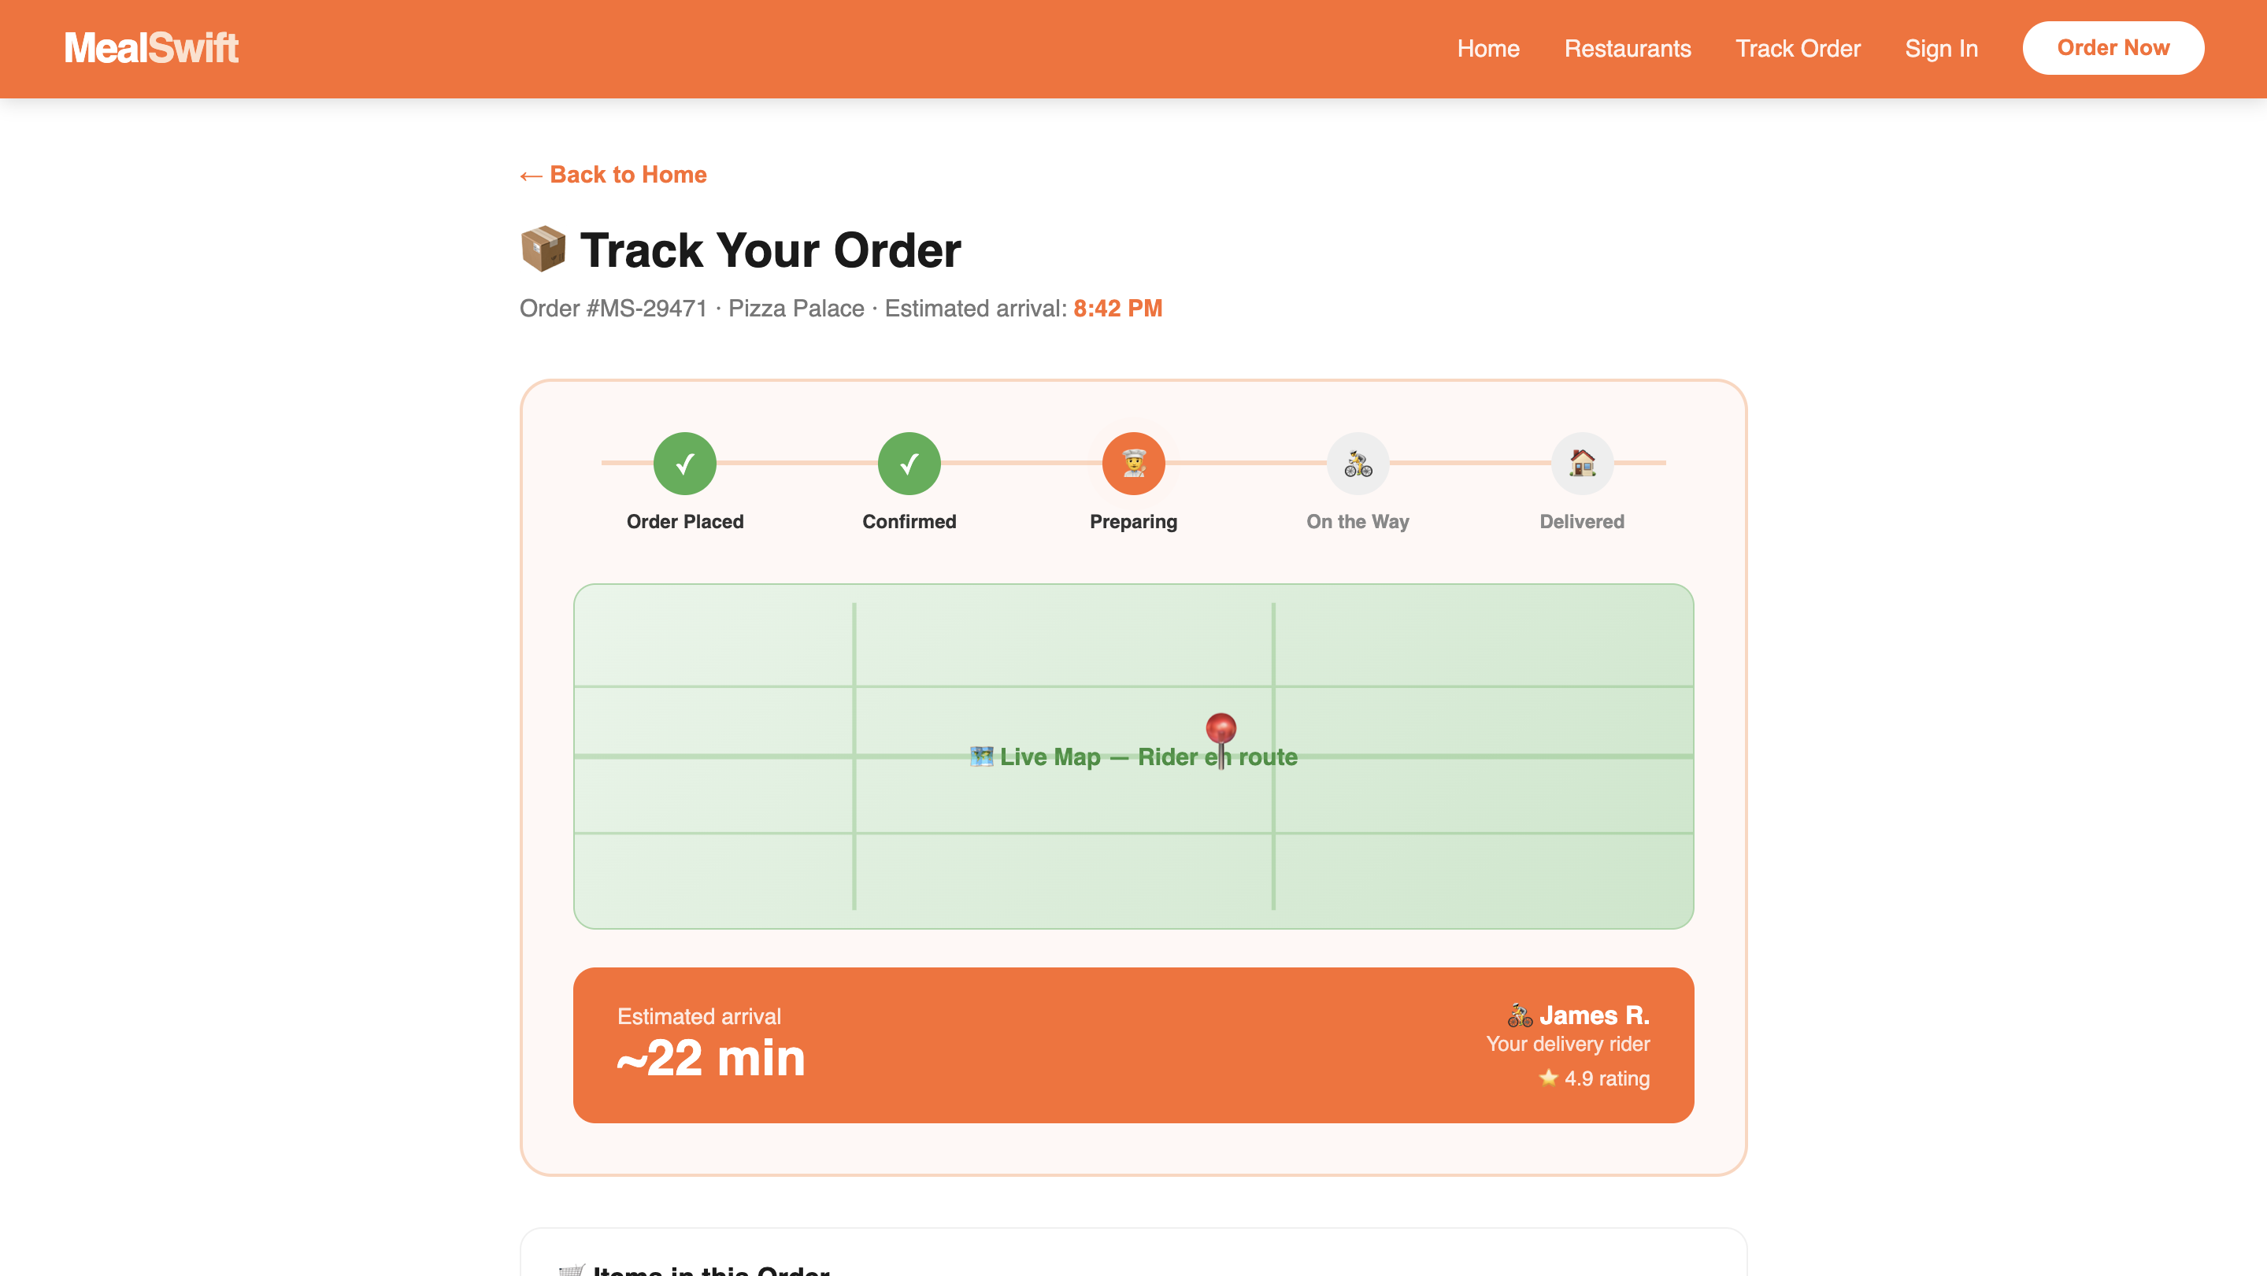

4.2 How the Mood Board and Wireframe Influenced the Design
The mood board was the very first stage of the design process, and it shaped a significant number of the decisions that followed. The purpose of a mood board is to pin down the visual personality of a brand before any actual design work begins — establishing colours, typography, photography style, and the general emotional tone of the product [2]. For MealSwift, I wanted the mood board to communicate warmth, speed, and quality. I gathered references from other food platforms, bold typographic layouts, warm food photography featuring rich oranges and ambers, and examples of clean, minimal UI components.

The orange and white colour scheme emerged directly from this process — it appeared consistently across the reference imagery and felt immediately right for a food delivery brand. The decision to keep white space generous also came from the mood board phase, as the most trustworthy-looking food platforms in my research had a clean, uncluttered aesthetic rather than cramming everything onto the screen. Clear, bold typography for restaurant names and pricing was another visual principle the mood board reinforced, as users browsing a menu or listings page need to be able to scan quickly without straining.

The wireframes followed the mood board and had a different but equally important role — translating the visual direction into actual page layouts, content hierarchy, and user flows. At the wireframe stage I was not thinking about colours or decorative elements at all; the focus was purely on structure, positioning, and the logic of how users would move through the site [1]. The homepage wireframe went through a couple of revisions before settling on a search-first hero approach, which puts the most important action — finding food — immediately at the top of the page.

The wireframes also surfaced a problem with the checkout flow that would not have been obvious without laying it out structurally. Having the order summary only visible at the end of the checkout introduced unnecessary uncertainty — users could not easily check what they had ordered while filling in their payment details. Placing a persistent order summary sidebar in the wireframe solved this before any visual work had been done, saving significant time later in the process.

Perhaps the most valuable thing the wireframes did was encourage thinking about the complete user journey rather than individual pages in isolation. By mapping out how a user would navigate from the homepage through to order tracking, it became possible to identify where the experience might feel disconnected or confusing. This led directly to design decisions like the persistent navigation bar, back buttons on every page, and the consistent placement of call-to-action buttons — all of which make the experience feel cohesive and professionally considered rather than assembled from separate pieces.

5. Conclusion
Looking back on this project, the structured design process made a genuine and significant difference to the quality of the final outcome. Going in with just a vague idea of making things look better without a proper process would likely have produced something superficially polished but still frustrating to actually use. Each phase — mood board, wireframes, prototype — required a different kind of thinking: visual, structural, and interactive respectively. Together they produced a much more considered and complete result than any single phase could have achieved on its own.

For MealSwift specifically, the redesign addresses every issue identified in the original brief. Navigation is intuitive and clearly structured, the visual identity is strong and consistent, the checkout is simplified and reassuring, mobile usability is designed in from the very beginning, and features like real-time order tracking and visible customer reviews bring the platform up to the standard that users now expect from food delivery services. The prototype demonstrates a user journey that is smooth, confident, and genuinely enjoyable to move through.

This project has also reinforced how much the early stages of design — the research, the mood board, the low-fidelity wireframes — actually matter to the final result. It is tempting to skip straight to making things look polished, but the time invested in understanding the problem and planning the structure pays back enormously at the build stage. Good design, ultimately, is not about aesthetics alone. It is about solving real problems in a way that feels natural, intuitive, and almost invisible to the person using the product. For MealSwift, that means a platform that gets out of the way and lets people do what they came to do — order great food, quickly and confidently.

6. References
[1] Daffodil Software, "Redesigning Grubhub App using Design Thinking Approach," Daffodil Insights, Oct. 2021. [Online]. Available: https://insights.daffodilsw.com/blog/redesigning-grubhub-app-using-design-thinking
[2] Nielsen Norman Group, "Mood Boards in UX: How and Why to Use Them," NNGroup, Feb. 2023. [Online]. Available: https://www.nngroup.com/articles/mood-boards/
[3] K. Das, "Responsive Web Design for ordering street-food online," UX Planet, Nov. 2021. [Online]. Available: https://uxplanet.org/responsive-web-design-for-ordering-street-food-online-6ae134ddb8be
[4] Figma, "Top Web Design Trends for 2026," Figma Resource Library, Jan. 2026. [Online]. Available: https://www.figma.com/resource-library/web-design-trends/
[5] Interaction Design Foundation, "What are the Benefits of Mood Boards?" IDF, Nov. 2025. [Online]. Available: https://www.interaction-design.org/literature/topics/mood-boards

