Academic and Employability Skills – Assignment

Lecturer: Joy Botu
Student: Claudiu Stelian
Student Number: 1815744
University of Wales Trinity Saint David
1st Term

Table of Contents

- Personal brief
- HE learning skills
- Employability skills
  - Communication and interpersonal skills
  - Problem solving skills
  - Using your initiative and being self-motivated
  - Working under pressure and to deadlines
  - Organizational skills
  - Team working
  - Ability to learn and adapt
  - Numeracy
  - Valuing diversity and difference
  - Negotiation skills

- Self-Evaluation exercise
  - Comparation

- Short term and long-term goals

I was born in Craiova, Romania.
I had my education in Craiova.
I was born in Craiova, Romania.
I had my education in Craiova.
- Personal brief
I was born in Romania in the very well-known city Bucharest, where I spent 20 years of my life. I finished my studies there improving my Mathematics and Computer Science skills. After I finished my studies, being an active person, an office job was not ideal for me, so I decided to work in a night club as waiter. It was quite easy to get a job as I am having good communication skills and the ability of understanding people’s needs. 

In 2015, I took the decision to improve my waiting skills by moving in London. The decision has been taken as I was looking forward to meeting new people with different mentalities. I came here with a job offer by a recruiting company from Romania which helped me to accommodate faster to the new lifestyle. At the beginning of 2019 I have been pushed by my friends to continue my studies by applying to UWTSD as I have a good Mathematics and Computer Science skills, so I did it. Now I am looking forward to finishing the 1st year and find a job which does match to my passion.

The previous words are taken from “Myself presentation” project wich was presented verbally in front of the calss. This presentation was helpfull in improving the PowerPoint skills, and making us to understand that is not about how you use it and about the message you want to get across. The presentation covers the most crucial pieces as you are the creator of it so you should elaborate it. The most important key point was learning how you talk and address to an audience. Everything about your audience must be taken into account when making anything on PowerPoint. So, when making PowerPoint presentations, these are just some of the questions you should ask yourself:
- What’s my audience’s technical skill level like? Would they understand words like ‘Hypercholesterolemia’ or would they prefer me to state ‘High Cholesterol’ instead?
- Would they prefer a list of all of the points, or should I go over the main ones?
- I want to respect my audience’s time. How many slides should I be putting into this presentation?
- How can I use colour to create a contrast so that my audience can easily pinpoint out the important pieces of information on the slide?
PowerPoint skills are not only relevant, but in many cases, they are essential. It’s not about becoming the person who can make the awesome PowerPoint presentations (or decks, reports, or whatever). Rather, it’s about being the most effective communicator in the workplace. By becoming a PowerPoint genius, you will have the ability to make messages that appeal to various audiences, master the ability to practice empathy, and have a keen eye on design.

- HE learning skills

Higher education is 3rd level of education after you leave school. It takes places at universities and Further Education colleges and normally includes undergraduate and postgraduate study. Higher education gives you the chance to study a subject you are interested in and can boost your career prospects and earning potential. Your choice of career might be a key reason in deciding whether to go into higher education and what course to take. Some careers, including medicine, dentistry, IT engineering and architecture require you to have a degree.
The focus of the course is on developing skills such as academic writing and oral presentation, notetaking and revision, locating information, and managing deadlines and heavy reading loads. It also emphasizes techniques of self-reflection, so that learners can gain a better understanding of their own strengths and weaknesses, and be able to utilize these on other courses of study.
  - Aims:
The aims are:
- To give students a grounding in the basics of higher education study and presentation skills;
- To develop best practice in academic thought, writing, and verbal exposition;
- To advance skills of critical reflection, so the student can develop independent responsibility for her or his own learning;
- To support and nurture the student's confidence and orientation within higher education to lay the foundations for success at university.
  - Learning Outcomes:
By the end of the module, a student will be able to demonstrate:
- An awareness of good study practice in higher education;
- Experience of communicating effectively, in both spoken and written academic forms;
- The capacity to critically reflect on her or his own learning and recognize links between different courses of study, and between academic and broader life experiences;
- A recognition of her or his individual strengths as learners, and how these can be put to best use within higher education.

- Employability skills

Employability Skills can be defined as the transferable skills needed by an individual to make them ‘employable’. Along with good technical understanding and subject knowledge, employers often outline a set of skills that they want from an employee. These skills are what they believe will equip the employee to carry out their role to the best of their ability. Employability depends on your knowledge, skills and attitudes, how you use those assets, and how you present them to employers. (Hind, 2005)
  - Communication and interpersonal skills
  - Problem solving skills
  - Using your initiative and being self-motivated
  - Working under pressure and to deadlines
  - Organizational skills
  - Team working
  - Ability to learn and adapt
  - Numeracy
  - Valuing diversity and difference
  - Negotiation skills

- Communication and interpersonal skills
The ability to explain what you mean in a clear and concise way through written and spoken means. To listen and relate to other people, and to act upon key information / instructions. Some people have a natural talent for interpersonal skills. They implicitly understand what’s needed to get along with others, perhaps without ever knowing what interpersonal skills are!
And that is the true beauty of interpersonal skills. With or without knowing how to define them, you can possess and cultivate these life-changing abilities to sculpt and define your future for the better.
Good interpersonal skills include the following:
- Active listening
- Collaboration
- Problem-solving
- Conflict resolution
- Empathy
- Diplomacy
- Adaptability
- Leadership
- Mediation
- Patience
- Problem solving skills

Problem solving skills help you determine the source of a problem and find an effective solution. Although problem-solving is often identified as its own separate skill, there are other related skills that contribute to this ability. (Hind, 2005)
Some key problem-solving skills include:
- Active listening
- Analysis
- Research
- Creativity
- Communication
- Dependability
- Decision making
- Team-building

Problem solving skills are important in every career at every level. As a result, effective problem solving may also require industry or job-specific technical skills. For example, a registered nurse will need active listening and communication skills when interacting with patients but will also need effective technical knowledge related to diseases and medications. In many cases, a nurse will need to know when to consult a doctor regarding a patient’s medical needs as part of the solution.

- Using your initiative and being self-motivated

Self-motivation is a power that drives us to keep moving ahead. It encourages continuous learning and success, whatever be the scenario. Self-motivation is a primary means of realizing our goals and progressing. It is basically related to our inventiveness in setting dynamic goals for ourselves, and our faith that we possess the required skills and competencies for achieving those challenging goals. We often feel the need for self-motivation. (Hind, 2005)
Self-motivation techniques are:
- Communicate and talk to get motivated
- Remain optimistic
- Discover your interest area
- Self-acknowledgement
- Monitor and record your success
- Uplift energy level
- Assist, support and motivate others
- Encourage learning
- Break your bigger goals into smaller goals

- Working under pressure and to deadlines

Under pressure a constraining or compelling force or influence. People are constantly stressed about work. This is because they are working under pressure. Every job has its own pressures. Some examples of working under pressure are: (Hind, 2005)
- You must complete by tomorrow and it's already 4am., this is a very common example of people in the business world.
- In many jobs there will always be a deadline or quota that you have to meet. This is a big part of pressure in the workplace.
- If you work in the service industry you may have to show your skills to your boss. This is very stressful and tense.
- Organizational skills

Organisational Skills leads to getting works done quickly and more efficiently. Along with communication and computer skills, organizational skills is one of the most important transferable job skills a worker can possess. Companies need workers who can stay organized and focus on the projects at hand. So, without further delay improve your organizing skills with course.
Organizational skills in the workplace can include general organizing, planning, time management, scheduling, coordinating resources and meeting deadlines. The ability to keep work organized allows workers to focus on different projects without getting disoriented or lost, thereby increasing productivity and efficiency in the workplace. The key for efficient working is to have the proper time management skills. Staying organized in the workplace can save a company time and money. Organizational skills are essential for multitasking and keeping a business running smoothly and successfully. (Hind, 2005)

- Team working

Teamwork is a great way for you to learn from others, share skills and get support when you need it. With most workplaces being hugely collaborative, it’s good to know how to work together - it can spark creativity and show you new ways of working.
Top tips to take away
- Get to know the people in your team and build good working relationships. It will widen your support network
- Get collaborating! Use your skills, but remember others in your team may be able to contribute different talents or approaches. As brilliant as you may be, you’re not expected to have the skills to do everything
- When you can, offer help and be supportive - this demonstrates you’re a team player, and you may need the same in return one day
- Remember, everyone’s job role is significant. No role is too small and others may bring skills you don’t have to the table - work together to make things run smoothly and reach the end goal!

- Ability to learn and adapt

Being adaptable means being a perpetual optimist and exhibiting extraordinary resilience. Adaptability skills can be possessed both in both attitude and action, and one can’t exist without the other. Learn how you can adapt to change better with these tips.
Benefits of being adaptable
- You’ll embrace challenges better
- You’ll become a better leader
- You’ll always be relevant

- Numeracy
Numeracy is the ability to use data and mathematics to support evidence or demonstrate a point. (Hind, 2005)

- Valuing diversity and difference
Cultivating a diverse workforce should be one of your biggest priorities. People often misunderstand or underestimate the power that it can bring — both internally and externally — to your business. (Hind, 2005)
- Negotiation skills

Negotiation is a method by which people settle differences. It is a process by which compromise or agreement is reached while avoiding argument and dispute.
In any disagreement, individuals understandably aim to achieve the best possible outcome for their position (or perhaps an organisation they represent). However, the principles of fairness, seeking mutual benefit and maintaining a relationship are the keys to a successful outcome. (Hind, 2005)

- Self-Evaluation exercise

After the Self-Evaluation exercise made on https://richardstep.com to discover my strengths and weaknesses have I have received the following results:
My Top 5 Strengths Are:
Adaptability (88%):
* Your success depends on ability to accommodate the unforeseen.
* You find planning work very boring - find ways to minimize this chore while still achieving.
* Get on teams that need to make progress - you won't sit around and sulk.
* Focus on many quick jobs/tasks rather than long, drawn-out assignments.
* Foster others' desire to learn and experiment by giving them room and tools.
* Goal-setting meetings and career-counseling are boring to you - minimize it.
Teamwork (81%):
* You organize your life around your close relationships and should keep them in planning exercises.
* Don't move around too much - you enjoy close, strong, genuine bonds and could be shaken up otherwise.
* Knowing people's goals helps you bond with them - seek to find out more about the people you meet.
* You are loyal, place a high value on trust, and will not betray people - be the person people can come to.
* Build genuine trusting relationships with critical people you want around.
* Generosity is a strength - be aware, get noticed, and keep it up.

Innovation (81%):
* Actively seek out positions where your ideas will be valued and encouraged.
* Be a designer, sales strategies, marketing guru, or customer service rep for new products and ideas.
* Search out and request ideas from others to stimulate your thinking.
* Constantly think of ideas that can improve businesses and the lives of others.
* You enjoy the power of words; punchy ideas stimulate your thinking - focus and play with this fact.
* For decisions, you need to know that everything fits together. Be aware and plan for decisions.
* If a decision seems to stand out as particularly bothersome, then check if it is an exception before worrying about it.
Resourcefulness (75%):
* You thrive on responsibility - sign up for opportunities that foster it.
* Capitalize on your talent to be a manager or supervisor.
* You are good at figuring out how to fit others' strengths into the team - help them.
* You thrive in situations where many things are happening at same time - seek them.
* Make efforts to figure out other ways to do things - you enjoy this.
* Reject working with someone who you believe is dishonest or shoddy worker.
Optimism (75%):
* Look for positions where you can be as close to customers as possible.
* Actively help plan events - like new product launches and user groups.
* Do use your humor and good attitude to excite people.
* Being positive does not mean you'll be in good mood - be aware and let others know, as needed.
* Cynics quickly sap your energy and you dislike cheering negative people - minimize these instances.
* You enjoy celebrating and should actively find ways to recognize achievements

Comparation
Adaptability (88%): I am a very adaptive person so comparing with the results I highly agree with the percentage shown in the Self-Evaluation.
Teamwork (81%): I am a very helpful person and I like working as a team but not at all time, at one point when I get tired, I prefer just to mind my business and avoid the others problems.
Innovation (81%): I am an innovative persona as I like to find new and successful solutions in a weird way.
Resourcefulness (75%): I never run out of ideas. I am a person which always find solutions for everything and if not, I have the right sources which can help me in any situation.
Optimism (75%): I am a very optimistic persona by seeing success in every failure.

From this exercise I have learned what my weaknesses and strengths are, like this I can focus on them and use it as strengths even if they are weaknesses.

- Short term and long-term goals

In terms of goals I don’t have many. The first and the most important long-term goal is to travel, get married and have at least 1 kid. Another long-term goal will be me to advance in IT career which always been my hobby. Travelling hobby, I discovered 5 years ago when I had to leave my country Romania for leaving in UK where I have met all types of people. Those people influenced me by discovering their country as they all come from different once. This year I just visited Greece (Rhodes) which opened my appetite for travel. IT Career is an along term goal as I have to finish my Cloud Computing Study to be able to get the right job which can make me happy from all he points. A short-term goal is to finish my University as will help me in improving my computing skills

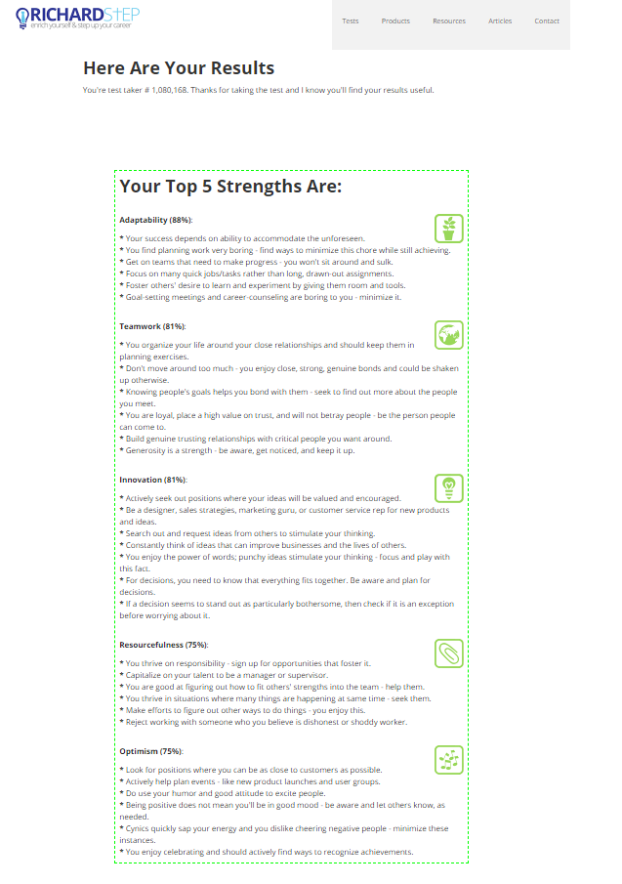
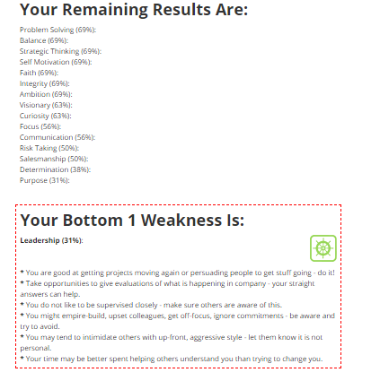

References
Hind, D. W. (2005). Employability Skills. Business Education Publishers Ltd.

