Student name:
Student Number:
Programme of Study: Illustration (BA)
Module: Research in Practice
Word count: 2666
Tutors Name: Delyth Lloyd-Evans
Three Keywords: Picture Books, Colourism, Culture

Context
For this proposal I will be exploring three key topics; Picture books, Colourism and Culture. Using semiotic analysis, I will further explore the meaning behind illustrations surrounding these topics. I will be implementing various viewpoints from different theories and practitioners to then compare and contrast two books. By researching these three key words, I hope to have better understanding of how colourism and culture can impact children's well-being and how picture books can tackle these themes relevant to today's society. I will be using two books, Sulwe and The Proudest Blue, to further analyse colour and symbolism used to convey the story.

Picture Books
Pictorial storytelling has ancient origins, with cave wall paintings serving as early examples of visual narratives. However, the true picture book form emerged during the late 19th century (Ollenberger, 2023). Artist and illustrator, Randolph Caldecott, played a key role in elevating images beyond mere decoration for text (Henry Blackburn, 2024). His innovative approach transformed illustrations into powerful storytelling. Rather than merely accompanying text, Caldecott’s images became integral to the narrative (Henry Blackburn, 2024). His work introduced an ingenious juxtaposition of pictures and words, creating a rhythmic syncopation that had not been seen before. Caldecott’s innovation marked the birth of the modern picture book (Henry Blackburn, 2024).
In the fifteenth century, Leonardo Da Vinci observed that “the more you describe, the more you will confine the mind of the reader” (Popova, 2012). He believed it was essential to simultaneously draw and describe because colour, pace, rhythm, and suspense contribute to storytelling, whether in a painting or a picture book (Words&Pictures, 2014).
Picture books serve a dual purpose: they visualize information and inspire meaning into stories (Booktrust, 2023). When parents read to their children, they not only entertain but also impart the importance of reading (Niland, 2023, p. 511). Picture books help young readers understand that words convey meaning, bridging the gap between text and imagery within the book (Booktrust, 2023). Picture books have the remarkable ability to engage young readers, spark conversations, and foster empathy. When it comes to discussing race and resilience, these books play a crucial role in shaping children’s understanding of diversity, adversity, and the power of resilience.
In this discussion, we will explore how picture books address these themes, the impact they have on young minds, and some notable context that inspire resilience in children.

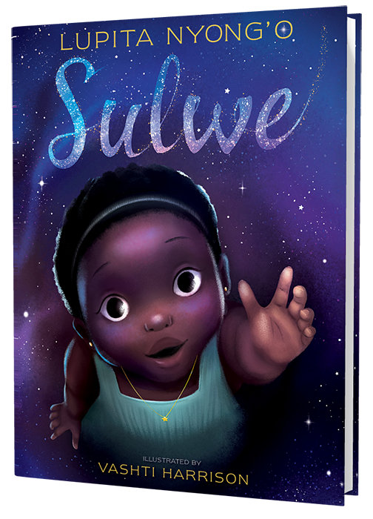
Fig. 1, Lupita Nyong’o, Sulwe, 2019
Lupita Nyong'o's Sulwe is a compelling children's picture book that dives into the sensitive topics of colourism and self-esteem. This wonderful, illustrated book, published in 2019, emphasises that true beauty is from within (Sulwebylupita, 2024). We will investigate the symbolism, practitioners, and semiotic analysis buried in Sulwe.
The plot revolves around Sulwe, a young girl whose skin is as dark as midnight (Sulwe, 2019, p.3). Her deeper complexion distinguishes her from her family and peers (Sulwebylupita, 2024). Sulwe wants to be as beautiful and dazzling as her mother and siblings (Sulwe, 2019, p.5). Desperate for acceptance, she tries every means to lighten her skin, yet nothing works. Then, one wonderful night, a star transports her on an adventure, telling the story of two sisters: “Day and Night” (Nyong’o, 2019). The name Sulwe translates as "the star" (Nyong’o, 2019). Throughout the story, Sulwe wears a star necklace as a powerful representation of the light she carries within herself (Sulwebylupita, 2024). Her name and the jewellery serve as reminders that true brightness comes from accepting one's individuality (Nyong’o, 2019). The Sisters, Day and Night, are a symbol for acceptance and self-love (Pat, 2020). Initially, Night (representing darkness) is mistreated, while Day (representing brightness) is praised (Sulwebylupita, 2024). However, Night finally realises her own elegance and beauty despite her darkness. Sulwe’s skin colour serves as a powerful symbol (Guest Blogger, 2019). It represents not only her physical appearance but also the broader societal biases related to skin tone (Guest Blogger, 2019). This story underscores the concept that each shade has its own distinct charm (Sanford, 2021). Lupita, the author, draws on her firsthand experiences as a dark-skinned girl growing up. Her battles with colourism and self-acceptance influenced Sulwe (Sanford, 2021).
Vashti Harrison's striking illustrations add life to the story. She pays close attention to details, like Sulwe's star necklace, and even adds Lupita's famous Nairobi blue Prada gown from her first Oscar presentation (Guest Blogger, 2019). The juxtaposition between Sulwe's dark complexion and her desire for brightness represents the fight with colourism (Guest Blogger, 2019). Her skin tone becomes a powerful sign of self-esteem and acceptance (Sulwebylupita, 2024). The star necklace symbolises Sulwe's natural brilliance. It is both something that can be seen and a symbol of her inner light (Nyong’o, 2019). Sisters represent the duality of existence: night and day. Night's abuse and ultimate acceptance parallel Sulwe's quest for self-love (Sulwebylupita, 2024). Sulwe encourages readers to accept their individual beauty while confronting conventional preconceptions and enjoying the diversity of all colours. It acts as a mirror for dark-skinned Black children, giving empathy and empowerment (Sulwebylupita, 2024).

Colourism
This essay explores the intricate dynamics of colour discrimination and its far-reaching consequences on Black individuals (kcl, 2015). Colour discrimination, often referred to as colourism, is a pervasive issue that deeply affects individuals of African descent, amplifying the challenges faced by Black communities (kcl, 2015). This form of discrimination is rooted in biases associated with varying skin tones within the Black population (Greenidge, 2019). Those with darker skin tones may internalise negative stereotypes, leading to feelings of inadequacy and inferiority (though, 2021). The impact of colour discrimination is profound, influencing various aspects of life, from self-esteem and identity formation to socio-economic opportunities (kcl, 2015). Colour discrimination originates from the historical legacies of slavery and colonialism (though, 2021). Lighter complexion tones were generally connected with privilege, whilst darker skin tones were dehumanised and marginalised (though, 2021.
Colonial beauty standards maintained the notion that lighter skin was superior, which contributed to the internalisation of colourist ideals among Black communities (Jstor.org, 2024). The media and societal beauty standards that favour lighter skin contribute to a distorted sense of beauty, impacting the mental well-being of individuals who do not conform to these standards (Daftary, 2023 pp. 92–92). Colour discrimination infiltrates economic domains, impacting educational opportunities, employment prospects, and career growth (O'Halloran K, 2017). Research indicates that individuals with lighter skin tones receive preferential treatment during hiring and enjoy greater access to economic resources (Daftary, 2023 pp. 92–92). Unfortunately, the persistence of colourist biases in workplaces exacerbates existing socio-economic disparities within the Black community, impeding progress and perpetuating systemic inequalities.
Media plays a pivotal role in shaping societal perceptions (2013). The underrepresentation of dark-skinned individuals in positive roles contributes to the reinforcement of colourist ideals. Positive representations of diverse skin tones in media are essential for challenging stereotypes and fostering a more inclusive and accepting society (O'Halloran K, 2017). Picture books can give varied and positive depictions of characters with different skin tones. By highlighting a variety of ethnicities and appreciating differences, these books may help youngsters realise the beauty of diversity (Susan E, 2018 p.5).
Well-illustrated picture books may engage children in stories about characters' encounters with colourism, encouraging empathy and understanding (George, 2021). These books, which show the emotional consequences of colourism, urge children to develop compassion and regard the views of others (George, 2021).

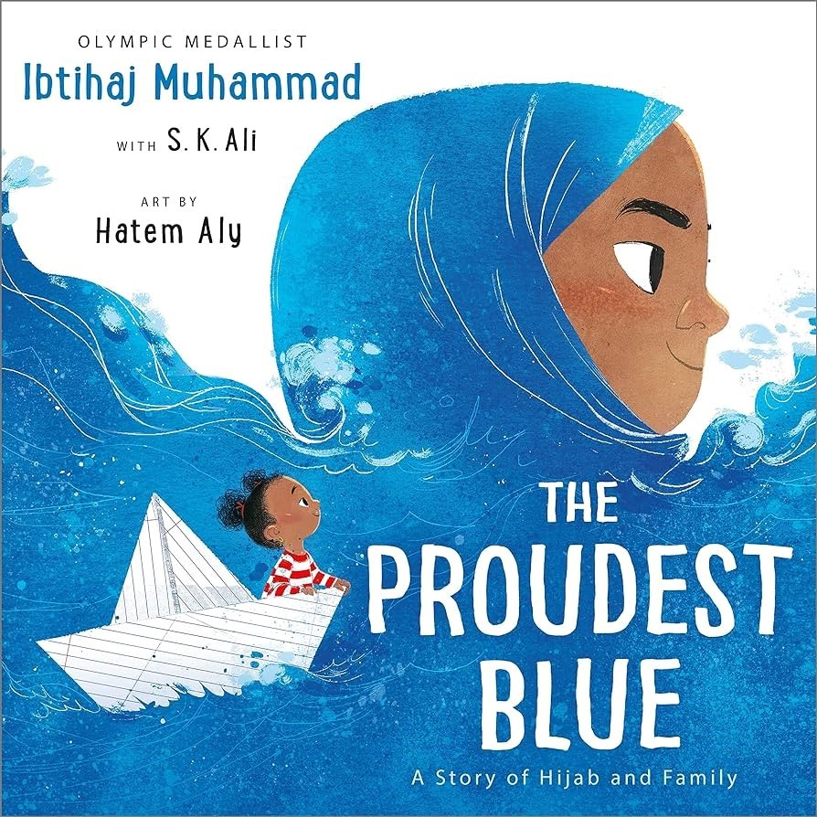
Fig. 2, Ibtihaj Muhammed and S.K.Ali, The Proudest Blue, 2019

On the other hand, The Proudest Blue is a children's picture book that explores themes of identification, sisterhood, and ethnic pride. Written by Olympic medallists Ibtihaj Muhammad and Morris S.K. Ali, with stunning artwork by Hatem Aly. This book honours the strong relationship between siblings and the power that comes from accepting one's own self (Ibtihaj, 2019).
On Faizah's first day of school, she joyfully accompanies her elder sister, Asiya, who is dressed in a gorgeous blue hijab. Asiya's hijab is like the ocean and the sky, no boundary between them, greeting with a loud wave (Sheen, 2018). But not everyone thinks hijab is lovely. Faizah is subjected to cruel and misleading statements from her classmates, which challenges her resilience (Sheen, 2018). This inspiring narrative demonstrates the strength of family love, ethnic pride, and the unwavering drive to be loyal to oneself (Ibtihaj, 2019).
Asiya's hijab is more than just a piece of fabric; it symbolises her faith, identity, and power (Chandler, D. 2007). The stunning blue fabric serves as a barrier against hate and ignorance (Chandler, D. 2007). Asiya's hijab blends into her sense of self in the same way as the water and sky do (Thebright, 2019). The analogy of Asiya's hijab to the ocean and sky conveys a feeling of continuity and expanse (Ibtihaj, 2019). Waves, like Asiya's steady determination, can bear external pressure without breaking. The hijab becomes a sign of perseverance and unwavering pride (Keogh, S 2014). As an Olympic winner and social justice crusader, Ibtihaj utilises her own experiences as a Muslim woman who wears a hijab (Ibtihaj, 2019). Her authenticity influences the text with genuine passion and understanding.
Co-author S.K. Ali contributes her experience in writing varied and realistic storytelling. Her participation guarantees that the narrative connects with readers from all cultures and perspectives. The emotive illustrations by Hatem Aly (practitioner) bring the characters and their feelings to life (Ibtihaj, 2019). His visual narrative compliments the text, highlighting the book's profound message. The colour blue has many different cultural significances. In Western cultures, it might elicit feelings of melancholy or sadness "feeling blue" (Cerrato, H. 2012). However, in The Proudest Blue, blue denotes power, tranquilly, and pride. Asiya's hijab, like the ocean, stays firm despite external difficulties (Robinson, 2017). The bullies who mock Asiya have faceless silhouettes (2019). Their remarks are like a cloud of dust: inconsequential and fleeting (Chandler, D. 2007). By depersonalising them, the book emphasises the significance of dismissing unpleasant words. The Proudest Blue encourages readers to enjoy their ethnic history, accept their uniqueness, and find strength in family bonds (Kirsten, 2021). Asiya's hijab becomes a symbol of perseverance, telling us that pride comes from keeping true to oneself (Kirsten, 2021).
Culture
The hijab is more than just a piece of fabric; it is an important sign of religion, modesty, and identity in the Islamic culture (eogh, S. 2014). Its cultural relevance extends beyond religious traditions, including personal expression and a sense of connection (Gordon, 2017). Many Muslim women wear the hijab as a visible symbol of their devotion to their faith and cultural heritage (Gordon, 2017).
Despite its cultural and religious significance, the hijab frequently becomes a focal point for societal issues (Sheen, 2018). Muslim women who choose to wear the hijab may face prejudices, bigotry, and even discrimination in many aspects in society (O’Halloran, 2017) y. The hijab becomes a tool for empowerment, challenging societal norms and expectations (O’Halloran, 2017). By choosing to wear the hijab, Muslim women reclaim control over their narrative, asserting their right to religious freedom and personal expression. In this sense, the hijab becomes a symbol of resilience and strength against societal pressures.
It is essential to recognize the diversity within the Muslim community (Sheen, 2018), as the choice to wear the hijab is influenced by various factors, including culture, geography, and personal interpretation of religious teachings (Sheen, 2018). Intersectionality plays a crucial role in understanding the experiences of hijab-wearing individuals, acknowledging that their identities encompass a myriad of social, cultural, and economic factors (Khan, S.2019). When children encounter characters from picture books breaking free from stereotypes, it broadens their perspective and encourages critical thinking. By reading about characters from diverse backgrounds, children learn to empathize with people who are different from them (Susan Elswick, 2018). This helps children Understanding others’ experiences promotes tolerance, compassion, and a sense of global interconnectedness (Susan Elswick, 2018)
Compare and Contrast
Both books explore the delicate subject of identity, encouraging readers to accept their authentic selves. In Sulwe, we follow the journey of Sulwe, a girl with midnight skin who desires for acceptance. Her star necklace becomes an indicator, representing inner light. Similarly, in "The Proudest Blue," Asiya's hijab symbolises more than just fabric; it conveys strength and faith. Asiya's resilience in dealing with unpleasant words mirrors Sulwe's determination to overcome ignorance.
While both books encourage individuality, their cultural surroundings differ. Sulwe navigates colourism by reflecting on the experiences of those with dark complexion. It says, "You are beautiful just as you are." In contrast, The Proudest Blue introduces us to Faizah and Asiya, who make the hijab a powerful symbol of pride. The two books explore the delicate context of identity, guiding readers towards self-love. Despite the differences in cultural and thematic backgrounds between Sulwe and The Proudest Blue, both books explore self-empowerment. Sulwe and Asiya struggle with societal standards of beauty and identity, and both go on transforming journeys that lead to self-acceptance and satisfaction in their individuality. The practitioners use colour and symbolism to convey a meaning in the story.
Furthermore, both stories emphasise the value of familial support in traversing the difficulties of self-discovery. Sulwe seeks relief and direction from her mother, while Faizah's adoration and support for her sister Asiya fosters family harmony.
Proposal Context
For my proposal I will be illustrating a picture book, named Journey of Colour. This picture book is aimed at children aged 8 and older. Research indicates that children begin developing a sense of understanding around this age, making it easier for them to comprehend and grasp the concept of colourism discrimination. The picture book serves as a bridge connecting my personal stories to the hearts of children. I aim for this book to be a comforting companion for those who tread similar paths. My objective is to use watercolours as a visual tool within the book, effectively portraying the contrasting emotions between the darkest and brightest days. By doing so, the audience will gain a deeper understanding of emotional juxtaposition, providing solace and insight to children. I wanted Sulwe and the Proud Blue to join my journey, to whisper tales of self-love and acceptance. Sadness is not forever; it is a transient shade. In my picture book, I will paint resilience, the golden thread that weaves through every page. Through the eyes of characters (bullies), readers will gain insight into their stories, understanding why they behave as they do. The impact of a child’s environment significantly influences their cognitive development and behaviour. Ultimately, the book conveys a powerful message: there is always an escape route, a bridge of courage leading to a vibrant palette of possibilities and self-acceptance.

Context: Journey of Colour
My journey begins with the rustling of passports, the fluttering pages that carry memories across borders. I moved between two lands, each with its own scent, language, and rhythm. The excitement of new beginnings mingled with the ache of leaving behind familiar streets. The colours of my emotions danced, sometimes harmonious, sometimes discordant.
My ethnicity painted my experiences, sometimes in bold strokes, sometimes in delicate watercolours. I faced judgment based on shades, light or dark, accepted or bothered. But within this struggle, I found strength. My worth transcended skin tones.
Words became my companions and adversaries. Learning a new language was like deciphering a secret code. The struggle etched lines on my heart, but it also opened doors. I stumbled over syllables, but with each misstep, I discovered resilience. Friendships bloomed through broken sentences, and I realised that language is not just about words, it is about connection.
In conclusion, Journey of Colour is more than a picture book; it is an immersive experience that invites young minds to witness characters facing storms, seeking refuge in rainbows, and discovering that within the darkest hues, hope blossoms. It is a narrative that emphasises the universality of experiences, the strength found in diversity, and the transformative power of resilience. Through each carefully painted illustration and heartfelt storyline, this book aims to be a source of inspiration, offering young readers a bridge of courage and a palette of possibilities as they embark on their unique journeys of self-discovery. This book aims to be a source of inspiration, offering young readers a bridge of courage and a palette of possibilities as they embark on their unique journeys of self-acceptance.

Bibliography
- Adwoa, B and World Economic Forum (2020). What is colourism and how can skin-tone bias affect your career? [online] World Economic Forum. Available at: https://www.weforum.org/agenda/2020/08/racial-equality-skin-tone-bias-colourism/ [Accessed 12 Mar. 2024].
- Ajhw.co.uk. (2024). Randolph Caldecott: A Personal Memoir of His Early Art Career, by Henry Blackburn. [online] Available at: https://www.ajhw.co.uk/books/book386/book386.html [Accessed 2 Apr. 2024].
- Booktrust.org.uk. (2023). Why picture books are crucial to child development and education. [online] Available at: https://www.booktrust.org.uk/news-and-features/features/2023/february/why-picture-books-are-crucial-to-child-development-and-education/ [Accessed 2 Apr. 2024].
- Chandler, D. (2007). Semiotics: The Basics. [online] Routledge eBooks. Informa. doi:https://doi.org/10.4324/9780203014936. [Accessed 2 Apr. 2024]
- Children’s Literature Review. (2015). Caldecott, Randolph 1846–1886. [online] Available at: https://web.archive.org/web/20160309022629/https://www.highbeam.com/doc/1G2-3443200010.html [Accessed 7 Mar. 2024].
- Daftary, K. Sneha, P. Patel, N., Shramuk, M., Muhammad, L. and Kundu, R.V. (2023). Colorism attitudes and use of skin lightening agents in the United States. International Journal of Women’s Dermatology, [online] 9(3), pp.e092–e092. doi:https://doi.org/10.1097/jw9.0000000000000092 [Accessed 7 Mar. 2024]
- Field, H. (2019) Playing with the book : Victorian movable picture books and the child reader. Minneapolis, Minnesota ; University of Minnesota Press [18 April 2024]
- George, A. (2021). Youth and Innocence: Colorism in Picture Books - Diverse BookFinder. [online] Diverse BookFinder. Available at: https://diversebookfinder.org/news-views/youth-and-innocence-colorism-in-picture-books/ [Accessed 2 Apr. 2024].
- Gordon, A. (2017). Muslim women answer: ‘What does the hijab mean to you?’ [online] The Beacon. Available at: https://www.upbeacon.com/article/2017/04/meaning-of-the-hijab [Accessed 2 Apr. 2024].
- Greenidge, K. (2019). Why black people discriminate among ourselves: the toxic legacy of colorism. [online] the Guardian. Available at: https://www.theguardian.com/lifeandstyle/2019/apr/09/colorism-racism-why-black-people-discriminate-among-ourselves [Accessed 2 Apr. 2024].
- Guest Blogger (2019). Review: ‘Sulwe’ Sends a Powerful Message of Love. [online] Black Girl Nerds. Available at: https://blackgirlnerds.com/review-sulwe-sends-a-powerful-message-of-love/ [Accessed 2 Apr. 2024].
- Hannele Kauppinen, R. and Marie-Nathalie, J. (2018). Using colour semiotics to explore colour meanings. Qualitative Market Research: An International Journal, [online] 21(1), pp.101–117. doi:https://doi.org/10.1108/qmr-03-2016-0033. [Accessed 2 Apr. 2024]
- https://www.facebook.com/thoughtcodotcom (2021). The Origins of Colorism and How This Bias Persists in America. [online] ThoughtCo. Available at: https://www.thoughtco.com/what-is-colorism-2834952 [Accessed 2 Apr. 2024].
- Jstor.org. (2024). TWO BLACK IN A WHITE WORLD from Foreigners in Their Own Country: Identity and Rejection in France on JSTOR. [online] Available at: https://www.jstor.org/stable/jj.6879769.6?searchText=&searchUri=&ab_segments=&searchKey=&refreqid=fastly-default%3A6c25fea063af280774f4e14d95bbe631 [Accessed 2 Apr. 2024].
- King's College London (2015). Understanding colourism among young people in the UK. [online] King’s College London. Available at: https://www.kcl.ac.uk/research/understanding-colourism-among-young-people-in-the-uk#:~:text=Colourism%2C%20skin%20shade%20prejudice%20in,job%20prospects%20and%20relationship%20opportunities. [Accessed 2 Apr. 2024].
- Knight, R. (2017). The power of picture books in the primary classroom - Primary Education Network. [online] Primary Education Network. Available at: https://blogs.nottingham.ac.uk/primaryeducationnetwork/2017/06/05/power-picture-books-primary-classroom/ [Accessed 2 Apr. 2024].
- Lysaker, J.T. (2019) Before words : wordless picture books and the development of reading in young children. New York, New York ; Teachers College Press [18 April 2024]
- Niland, A. (2023). Picture Books, Imagination and Play: Pathways to Positive Reading Identities for Young Children. Education sciences (Basel), [online] 13(5), pp.511–511. doi:https://doi.org/10.3390/educsci13050511. [Accessed 2 Apr. 2024]
- O’Halloran, K. (2017). Religious Discrimination and Cultural Context. Cambridge Core, [online] pp.i–i. Available at: https://www-cambridge-org.ezproxy.uwtsd.ac.uk/core/books/religious-discrimination-and-cultural-context/religious-discrimination-and-cultural-context/0B42D0B75891336B4D959081746F2150 [Accessed 2 Apr. 2024].
- Ollenberger, E. (2023). The History of Storytelling: Unveiling the Ancient Art of Sharing Tales - Storytelling.com. [online] Storytelling.com. Available at: https://www.storytelling.com/articles/the-history-of-storytelling-unveiling-the-ancient-art-of-sharing-tales/ [Accessed 2 Apr. 2024].
- Popova, M. (2012a). A Brief History of Children’s Picture Books and the Art of Visual Storytelling. [online] The Marginalian. Available at: https://www.themarginalian.org/2012/02/24/childrens-picturebooks/#:~:text=In%20Children's%20Picturebooks%3A%20The%20Art,be%20going%20next%2C%20with%20case [Accessed 2 Apr. 2024].
- Popova, M. (2012b). None. [online] The Atlantic. Available at: https://www.theatlantic.com/entertainment/archive/2012/02/a-brief-history-of-childrens-picture-books-and-the-art-of-visual-storytelling/253570/ [Accessed 7 Mar. 2024].
- Proquest.com. (2024). ProQuest Ebook Central - Reader. [online] Available at: https://ebookcentral.proquest.com/lib/trinity/reader.action?docID=5215491 [Accessed 2 Apr. 2024].
- Reading Partners. (2019). How picture books help kids develop literacy skills | Reading Partners. [online] Available at: https://readingpartners.org/blog/picture-books-develop-literacy-skills/#:~:text=At%20a%20most%20basic%20level,the%20names%20of%20new%20objects. [Accessed 7 Mar. 2024].
- Reddit.com. (2023). Reddit - Dive into anything. [online] Available at: https://www.reddit.com/r/india/comments/1289ndx/lets_talk_about_the_hijab_cultural_expression_or/?rdt=60671 [Accessed 2 Apr. 2024].
- Robinson, J. (2017). Colour semiotics and what they mean in other cultures | Buzzword. [online] Buzzword | Branding, Design and Digital Agency Chichester London. Available at: https://buzzwordcreative.co.uk/colour-semiotics-and-what-they-mean-in-other-cultures/ [Accessed 11 Mar. 2024].
- Sanford, C. (2021). Lupita Nyong’o Speech on Black Women in Hollywood 2014 Transcript | Rev Blog. [online] Rev Blog. Available at: https://www.rev.com/blog/transcripts/lupita-nyongo-speech-on-black-women-in-hollywood-2014-transcript [Accessed 2 Apr. 2024].
- Elswick, S 2018, Using Picture Books to Enhance Children's Social and Emotional Literacy : Creative Activities and Programs for Parents and Professionals, Jessica Kingsley Publishers, London. Available from: ProQuest Ebook Central. [18 April 2024].
- Sheen, M., Aman, H. and Jordan, T.R. (2018). Investigating the effect of wearing the hijab: Perception of facial attractiveness by Emirati Muslim women living in their native Muslim country. PLOS ONE, [online] 13(10), pp.e0199537–e0199537. doi:https://doi.org/10.1371/journal.pone.0199537 [Accessed 2 Apr. 2024].
- Sulwebylupita.com. (2024). SULWE by Lupita Nyong’o and Vashti Harrison. [online] Available at: https://sulwebylupita.com/ [Accessed 2 Apr. 2024].
- Thebrightagency.com. (2019). Behind the Book: The Proudest Blue — The Bright Agency. [online] Available at: https://thebrightagency.com/us/blog/behind-the-book-the-proudest-blue [Accessed 2 Apr. 2024].
- Uwtsd.ac.uk. (2017). Skin Color and Colorism: Global Research, Concepts, and Measurement on JSTOR. [online] Available at: https://www-jstor-org.ezproxy.uwtsd.ac.uk/stable/44863239?sid=primo&seq=2 [Accessed 2 Apr. 2024].
- Uwtsd.ac.uk. (2024). Alexander Street, a ProQuest Company. [online] Available at: https://video-alexanderstreet-com.ezproxy.uwtsd.ac.uk/watch/un-veiled-muslim-women-talk-about-hijab?utm_campaign=Video&utm_medium=MARC&utm_source=aspresolver [Accessed 2 Apr. 2024].
- Muhammad, I., Ali, S.K., & Aly, H. (2019). The Proudest Blue. Little, Brown Books for Young Readers.
- Nyong'o, L. and Harrison, V., 2019. Sulwe. Simon & Schuster Books for Young Readers.

