

MODULE CODE: Digital Skills for Personal Development and Business Growth BMSW4008

ASSESSMENT COMPONENT: PORTFOLIO

STUDENT NAME: Anas Khallaf

STUDENT NUMBER: 2510329

LECTURER: Aqsa Shabir

DATE: 26 November 2025
Contents
Task 1 3
Assessment of Digital Skills 3
References 3
Task 2 4
LinkedIn Learning Certificates for Office365 4
Task 3 5
Essay on Relevance of Excel in professional and personal life. 5
References 5
Task 4 6
7 Minute Reflective Presentation 6
References 6

Task 1

Assessment of Digital Skills
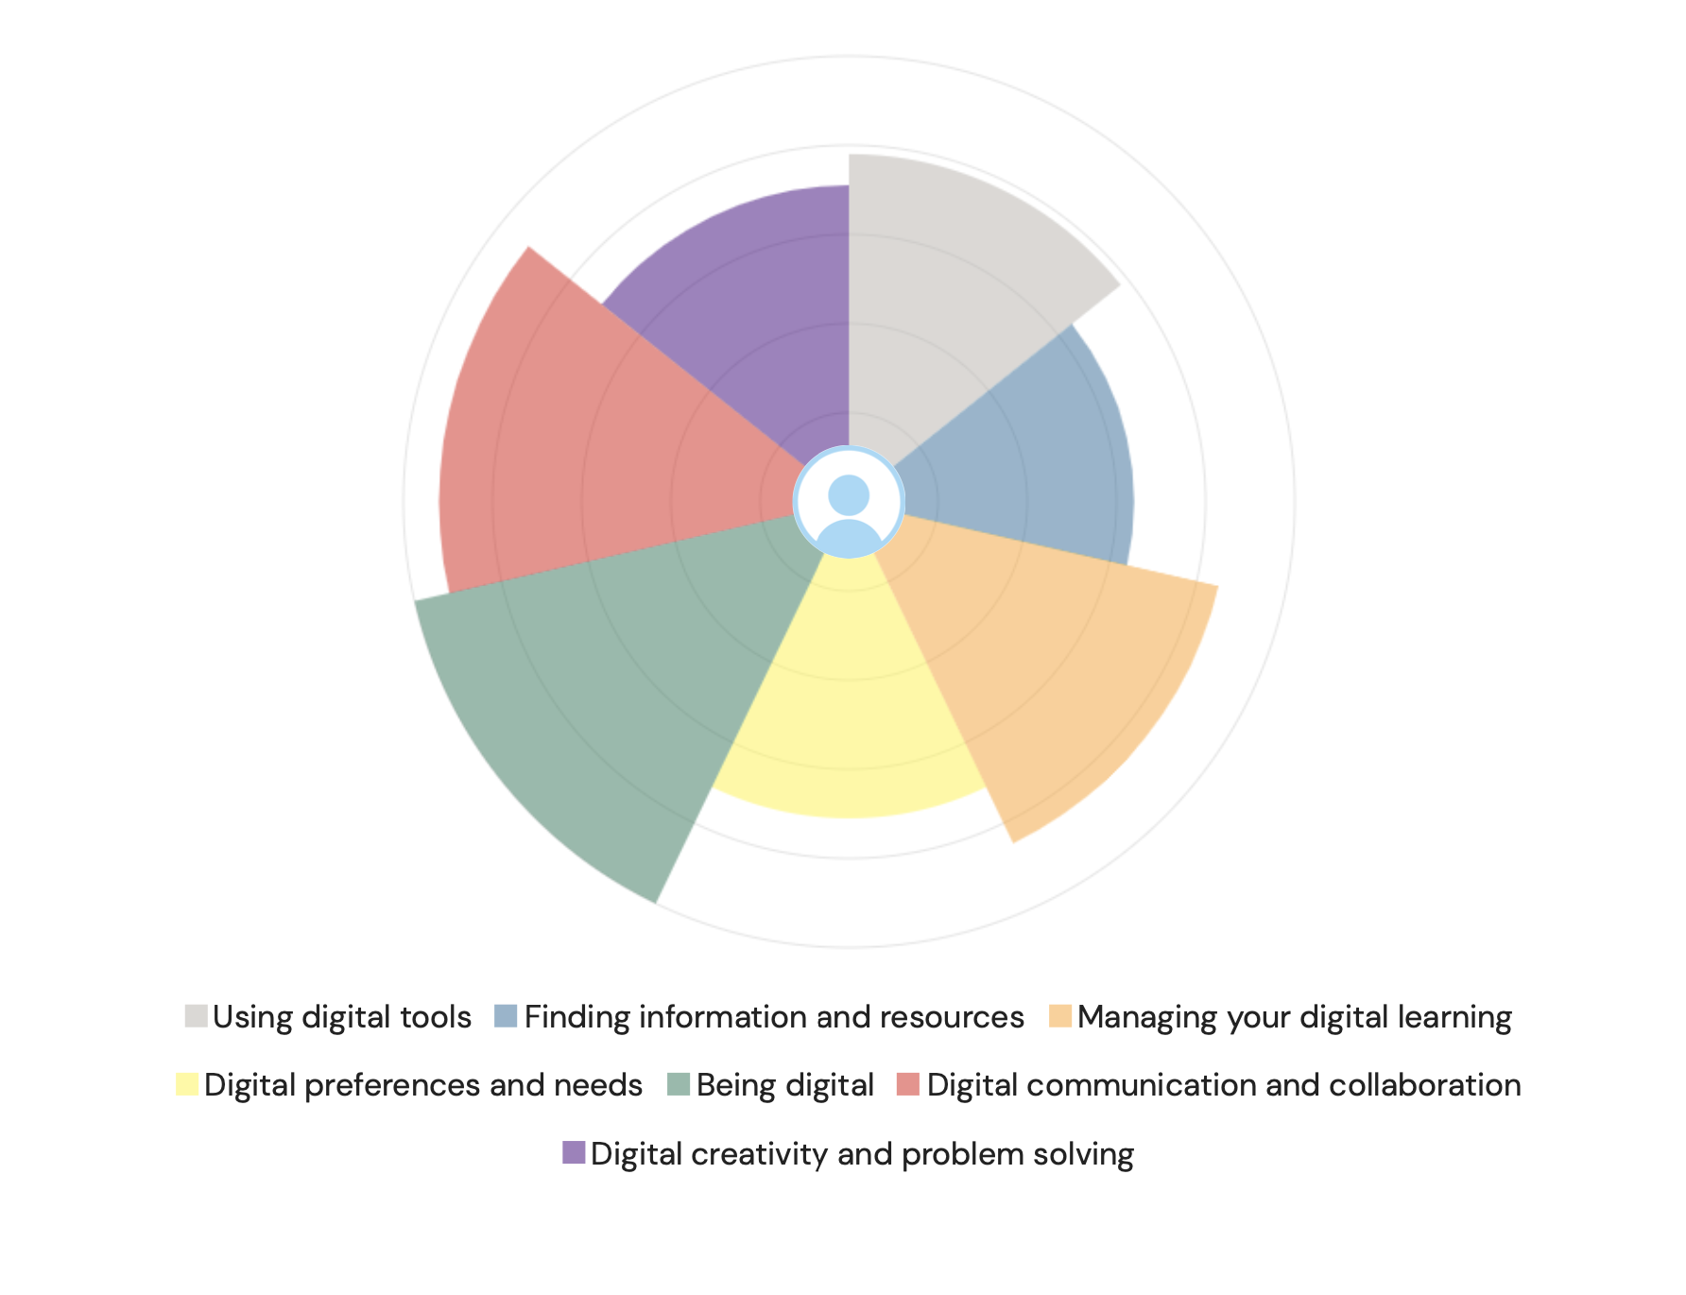

Introduction
Digital skills are important in modern life because as technology continues to evolve rapidly it is hard to keep up the pace with these changes in both academic and everyday settings, it is essential to keep developing our digital abilities. Strong digital skills help us work more effectively, adapt to new tools, and increase our future career opportunities in an increasingly technology-driven world. According to Jisc (2018), digital capability is important for learners and educators, supporting effective participation in education and enabling success in a connected society. This highlights how developing digital confidence is not only beneficial for study, but also crucial for engaging fully in a digital world.

Digital Skills Summary Table
Digital Skill Area | Rating
Digital Communication and Collaboration | Proficient
Digital Creativity and Problem Solving | Proficient
Using Digital Tools | Capable
Finding Information and Resources | Capable
Digital Preferences and Needs | Capable
Being Digital | Capable
Managing Your Digital Learning | Developing

The results from the table indicate that I am confident in majority of my digital skills. For example, Digital Communication and Digital Creativity/Innovation were both assessed as proficient, showing that I’m strong in ability in these areas. I also demonstrated solid understanding in categories such as Digital Proficiency and Digital Skills for Work which were rated as capable. This suggests that while I can use these skills effectively, there is still scope to develop them further. However, the assessment also showed Digital Wellbeing and Managing Digital Learning as an area that I require improvements, as it was rated developing. This highlights the need for me to build stronger habits and increase my confidence in managing my digital workload and online learning more effectively.

Strengths and Weaknesses for Improvement

Strength 1: Digital Communication and Collaboration
One of my strongest areas is Digital Communication and Collaboration. Being rated as proficient shows that I can confidently use online tools to communicate, share ideas, and work effectively with others. This strength helps me succeed in group work, stay connected with tutors, and contribute clearly in online discussions.

Strength 2: Digital Creativity and Problem Solving
Another key strength is Digital Creativity and Problem Solving. This means I can use digital tools in creative ways, adapt quickly to new systems, and find solutions when issues arise. This ability supports my learning because I can troubleshoot problems independently and explore new approaches when completing assignments.

Weakness 1: Managing Digital Learning and Wellbeing
An important area for improvement is managing my digital learning and wellbeing. Being rated as developing suggests I need to work on staying organised, keeping on top of tasks, and reducing digital distractions. Improving this area will help me manage my workload more effectively and support my overall wellbeing while studying.

Weakness 2: Digital Proficiency
Another weakness to develop is Digital Proficiency, which was rated as capable. Although I can use most digital tools well, I still have room to grow in areas such as handling unfamiliar software and improving my technical confidence. Strengthening this skill will make me more independent and prepared for the digital demands of both study and future work.

References
Jisc (2018) Building digital capability: The six elements of digital capability. Jisc.

Task 2

LinkedIn Learning Certificates for Office365

Task 3

Essay on Relevance of Excel in professional and personal life.

Introduction
Microsoft Excel is a program used to manage money, organise information, do calculations and handle different types of data. “Excel is one of the most popular and widely used spreadsheet software applications worldwide” (ExcelDelta, 2025). It is used at home, in education and in the workplace.
Excel is useful in daily life for tasks such as budgeting, planning schedules and keeping track of personal information. In professional environments, it is mainly used to create reports, analyse data and organise large amounts of information in a clear and structured way.
It also helps save time by automating repetitive tasks through tools like formulas and keyboard shortcuts. These features make information easier to understand and keep everything well-organised. “Excel is an incredibly powerful tool for getting meaning out of vast amounts of data. But it also works well for simple calculations and tracking almost any kind of information” (Microsoft, ND).
The use of Excel in Personal Organisation and Finances
Excel is useful for managing personal and household money because it lets you track income, expenses and savings in an organised way. You can use simple formulas like SUM to add up total income or spending and subtraction to work out how much money you have left at the end of the month. For example, a budget spreadsheet can help a family list wages and costs such as rent, bills and shopping to see whether they are spending more than they earn. Excel also offers ready-made budgeting templates that calculate totals automatically and make it easier to check financial health over time (Microsoft, 2025).
Excel is also helpful for organising schedules and keeping track of information. It has space for data, tools for formatting and features that let you keep all your information together, which makes it useful for budgeting, tracking expenses or organising personal details. For instance, you can make a weekly timetable to plan study hours, work shifts and appointments so you stay organised and manage your time better. You can also track lists such as shopping, payments or household tasks, which makes everyday chores easier to handle because everything is in one place (Smartsheet, 2025).
For students, Excel can help with school tasks too. It allows you to list deadlines, plan revision timetables and store research notes. By breaking larger tasks into smaller steps and counting planned study hours, students can stay organised all year. Using Excel this way can reduce stress and help students manage their time more effectively (ProjectManager, 2025).

The use of Excel as a Professional User
A phone shop owner can use Excel to organise stock and business information in a simple and efficient way. Excel allows a shop owner to list all products, such as phones, chargers and accessories, along with their prices, quantities and supplier details. By setting up stock sheets and using formulas, the owner can update inventory levels automatically as items are sold or restocked. This makes it easier to see how much stock is available and when products need to be reordered (Microsoft Support, 2025).
Using Excel also helps the owner track sales and understand business performance. For example, sales data can be entered into a spreadsheet so that totals and trends are shown at a glance. Tools like charts and pivot tables help the owner compare which products sell the most and which sell slowly, so they can make better decisions about ordering and pricing. Excel also enables simple financial tracking by recording income and expenses, helping the owner understand profits and losses over time (Web4Business, 2021).
Excel is cost-effective for small businesses because most owners already have access to it and do not need to buy expensive software to manage stock. It also lets the owner customise their records to fit the unique needs of their phone shop, such as tracking warranties or repairs. Although Excel has limits when a business becomes very large, it remains a powerful tool for a small shop owner to stay organised, save time and improve inventory control.

Conclusion
Microsoft Excel is a very useful tool for both personal and work tasks. At home, it helps people manage money by keeping track of income, spending and savings, making budgets, and planning schedules (Microsoft, 2025). Using formulas and templates makes it easier to add up costs and check that spending does not go over the budget. Students can also use Excel to plan study time, keep track of deadlines and organise research notes (ProjectManager, 2025). Having all the information in one spreadsheet helps people stay organised and reduces mistakes. It also makes planning daily tasks simpler because everything is clear and easy to follow.
In a professional setting, Excel is especially useful for small business owners, like someone who runs a phone shop. It can store all the information about products, such as phones, chargers and accessories, including their price, quantity and supplier (Microsoft Support, 2025). Formulas can automatically update stock levels when items are sold or restocked, which helps prevent running out of popular products or keeping too much of what does not sell. Excel can also track sales and show which products are selling best, helping owners make better decisions about what to order and when (Web4Business, 2021). Keeping track of income and expenses in Excel helps the owner understand profits and losses and plan for the future.
Overall, Excel is a simple but powerful tool that helps people stay organised, save time and make better decisions. Whether it is used to manage money at home, plan study schedules at school, or run a small business, Excel makes it easier to organise information and see important details at a glance. Its wide range of features, from simple calculations to analysing data, makes it useful for many different situations (Smartsheet, 2025).

References
Microsoft (2025) Top 5 Excel tools for budgeting. Available at: https://www.microsoft.com/en-us/microsoft-365-life-hacks/budgeting/top-5-excel-tools-for-budgeting (Accessed: 12 December 2025).
Smartsheet (2025) Free Excel spreadsheet templates. Available at: https://www.smartsheet.com/32-free-excel-spreadsheet-templates (Accessed: 12 December 2025).
ProjectManager (2025) 25 Excel spreadsheet templates for tracking tasks, costs and time. Available at: https://www.projectmanager.com/blog/tracking-excel-spreadsheets (Accessed: 12 December 2025).
Web4Business (2021) Small Businesses: 11 Most Useful Excel Features. Available at: https://www.web4business.com.au/excel-for-small-businesses/ (Accessed: 12 December 2025).
Microsoft Support (2025) Track product inventory. Available at: https://support.microsoft.com/en-gb/office/track-product-inventory-df87e413-3c9f-46be-87d4-173882c19a07 (Accessed: 12 December 2025).

Task 4

Reflective Presentation

