Digital Skills and research methods (BMSW4003_LON)
Nursel Aleksandrova (1905701)
University of Wales trinity Saint David
Date: 1/09/2020
Lecturer: Terry Walcott

Contents
Introduction……………………………………………pg3
What is Virtual Learning?..........................pg4
Literature Review……………………………………pg5
What is a Questionnaire?..........................pg8
Open Ended questions……………………………pg9
Closed ended questions………………………….pg10
Qualitive and Quantative Data………………..pg12
Analysis…………………………………………………..pg13-19
Conclusion………………………………………………pg20
References………………………………………………pg21

Introduction

As of the current situation with the pandemic most lessons are taught online. Referring back to my assignment request I have created a questionnaire based on virtual learning. In this questionnaire I have published open ended and closed ended questions. I have asked my colleagues to complete it. Furthermore I have collected primary and secondary data which I will analyse in this report. The main purpose of my report writing is to establish the different views on virtual learning. Having collected enough data I will be able to tell if virtual learning is becoming the new way of learning and how do students feel about it. Moreover with the data collected I will be able to demonstrate the difficulties students had while connecting to online classes and how these can possibly be improved for a better and clearer way of understanding and learning.
As (Beek, 2011) explained schools are offering more virtual learning options for a number of reasons. First, virtual learning can meet the needs of students who struggle to succeed in the conventional classroom setting. Second, virtual classes let student’s access courses and programs that might not be available to them in their local school. Third, virtual learning provides flexibility: Students do not need to adhere to a traditional school schedule to complete their work and earn a diploma.

What is Virtual Learning?

Virtual Learning is distance learning that requires internet connection. This is the process of students downloading their class app in my case it was Microsoft teams. Joining at a certain timetabled time is the second step. Virtual learning is an example of classroom learning that is from a distance and from the comfort of your own home. This is the same as classroom lessons however there is no interaction between students or the lecturer. This can be difficult during group activities. However is a very convenient way of learning as there is no time spent for travelling and no money spent on journeys. Virtual learning is very beneficial to those who work at the same time as there is no time consumption.

Literature Review
(Mugridge, 2020) Used the term "e-learning" is short for "electronic learning." This refers to learning through digital resources that are delivered online.
Some e-learning is synchronous, which means that multiple learners take part at the same time. They can often interact with one another, and with the person leading the session. This states an example of virtual learning which is used to combine classmates and lecturers to continue their learning cycle safely.
While virtual learning has its challenges, it also has its conveniences. Explained (Turner, 2019) for one, families spent less time commuting, which is especially appealing to those with multiple children who attend different schools. Virtual learning can also be hugely beneficial for families with students who may not be able to attend school due to illness or other stressors. And for some students, virtual learning isn’t even an entirely new concept. Even before the pandemic, some school districts across the country had processes and digital resources in place to ensure students did not miss school due to events like snowstorms. They could carry on with their assignments without missing a beat. According to Turner her view on virtual learning is in the positive way she believes that virtual learning allows everyone to continue their lessons without travelling and missing any lessons as in the comfort of their home.
(Morgan, 2017) Suggests that you can have a globally-diverse audience in the same ‘room’, bringing together different people who may never normally meet due to their location. This can enhance engagement and foster a sense of collaborative working much quicker than rolling out learning programmes across different locations one at a time. Morgan is optimistic about the idea of virtual learning as he believes it combines people of different backgrounds without discriminating.
You can ask “How does a teacher build community across screens?” (Khan, 2020) Has the perfect answer for this “Well, right when a teacher gets on to their video conference and highly recommend at least one touch point per day.
And first of all, they can rethink how that is. It doesn't have to be what you were doing in the physical environment where it was an hour a day, five days a week. It could be 10 minutes each day but with a smaller group of students that you can focus in on and make sure you get to know them.When you get on the conference call or the video conference, try to pull them out. Ask them what they're doing today. How are they feeling? Spend five minutes doing that.
And then as much as possible, ask them interesting questions and ask them to work with each other, ideally in virtual breakouts or whatever else. That's going to that's what's going to really get the kids interacting and get to a good mental place.” Khan explains how to bring students together and get them to focus during virtual learning. As this is not face to face where lecturers can see what students are physically doing getting them to focus can be difficult. On this topic Khan gives some tips to make this happen. He believes that virtual learning can help everyone connect and improve their understanding of the lessons.
The convenience of online education means it fits your life and your schedule. Some weeks are busier than others with work projects, so you can adjust the learning schedule so you can focus on and prioritize your tasks at hand.
The idea of virtual learning is nothing new. (Reuters, 2011) has delivered the classroom experience to individual users for several years. But with the onset of the COVID-19 pandemic causing government leaders to order non-essential employers and services to close their doors, companies have moved to a remote model. The same applies to schools, which began promoting remote learning opportunities.
While some online classes meet at a set time (this is known as an asynchronous class), the flexibility allows you to mesh the course with your personal schedule. Additionally, you can learn at your own pace. Usually, you can go back and review an item more than once, giving you the chance to fully grasp a concept before moving on to something new. Routers has experienced virtual learning therefore believes is a great way of learning with many benefits. Some of these benefits include that this is a more convenient way of learning as there are no travelling money or time spent.

What is a Questionnaire?
With the word of (Mcleod, 2018) a questionnaire is a research instrument consisting of a series of questions for the purpose of gathering information from respondents. Questionnaires can be thought of as a kind of written interview. They can be carried out face to face, by telephone, computer or post.
Questionnaires can be an effective means of measuring the behaviour, attitudes, preferences, opinions and, intentions of relatively large numbers of subjects more cheaply and quickly than other methods. An important distinction is between open-ended and closed questions.
Often a questionnaire uses both open and closed questions to collect data. This is beneficial as it means both quantitative and qualitative data can be obtained.

Open Ended questions
Open-ended questions are questions that cannot be answered with a simple ‘yes’ or ‘no’, and instead require the respondent to elaborate on their points explained (Dosseto, 2020)
Open-ended questions help you see things from a customer’s perspective as you get feedback in their own words instead of stock answers. You can analyse open-ended questions using spreadsheets, view qualitative trends, and even spot elements that stand out with word cloud visualizations.
Open-ended questions can give a lot of information about the specific generation or group of people individually. It can be very useful for data collection as there are no yes or no answers. Instead there would be totally different answers based on the individual that can be analysed later.
However open ended questions can be too stressful for people to answer as not everyone wants to express their ideas. This can be daunting as readers most likely will skip those questions. Therefore there wouldn’t be any data to analyse for them.

Close-ended Questions

Closed questions structure the answer by only allowing responses which fit into pre-decided categories (Mcleod, 2018).
Data that can be placed into a category is called nominal data. The category can be restricted to as few as two options, i.e., dichotomous (e.g., 'yes' or 'no,' 'male' or 'female'), or include quite complex lists of alternatives from which the respondent can choose (e.g., polytomous).
Closed questions can also provide ordinal data (which can be ranked). This often involves using a continuous rating scale to measure the strength of attitudes or emotions. For example, strongly agree / agree / neutral / disagree / strongly disagree / unable to answer.

There are loads of benefits of close end questions. For example they can be economical. This means they can provide large amounts of research data for relatively low costs. Therefore, a large sample size can be obtained which should be representative of the population, which a researcher can then generalize from. Also the respondent provides information which can be easily converted into quantitative data (e.g., count the number of 'yes' or 'no' answers), allowing statistical analysis of the responses. Moreover the questions are standardized. All respondents are asked exactly the same questions in the same order. This means a questionnaire can be replicated easily to check for reliability. Therefore, a second researcher can use the questionnaire to check that the results are consistent.

However there are also disadvantages of close end Questions. Some of these include lack of detail. Because the responses are fixed, there is less scope for respondents to supply answers which reflect their true feelings on a topic.

Qualitive and Quantative Data
The difference between qualitive and quantative data is that Quantitative data can be counted, measured, and expressed using numbers. Qualitative data is descriptive and conceptual. Qualitative data can be categorized based on traits and characteristics.
What is qualitative data?
According to (Picknell, 2019) Qualitative data is non-statistical and is typically unstructured or semi-structured in nature. This data isn’t necessarily measured using hard numbers used to develop graphs and charts. Instead, it is categorized based on properties, attributes, labels, and other identifiers.
Qualitative data can be used to ask the question “why.” It is investigative and is often open-ended until further research is conducted. Generating this data from qualitative research is used for theorizations, interpretations, developing hypotheses, and initial understandings.
What is quantitative data?
Contrary to qualitative data, quantitative data is statistical and is typically structured in nature – meaning it is more rigid and defined. This type of data is measured using numbers and values, which makes it a more suitable candidate for data analysis.
Whereas qualitative is open for exploration, quantitative data is much more concise and close-ended. It can be used to ask the questions “how much” or “how many,” followed by conclusive information.
Qualitative data will almost always be considered unstructured data or semi-structured. This type of data is loosely formatted with very little structure. Because of this, qualitative data cannot be collected and analysed using conventional methods.
Quantitative data will almost always be considered structured data. This type of data is formatted in a way so it can be quickly organized and searchable within relational databases. Perhaps the most common example of structured data is numbers and values found in spreadsheets.

Analysis: 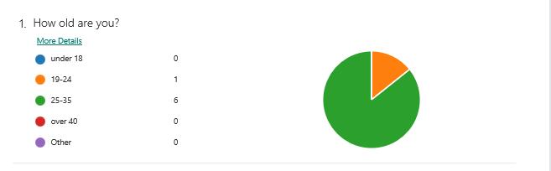
From this diagram I can see that most of my respondents were between 25-35 years old.This means that most of the answers can be simmillar.

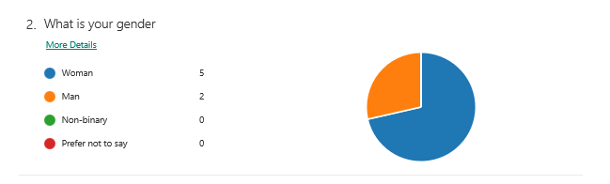
According to my pie chart my respondents were mostly female. From this data I can see that make and female individuals have different views. The differences in views can be analysed in the next questions.
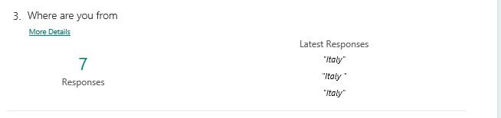
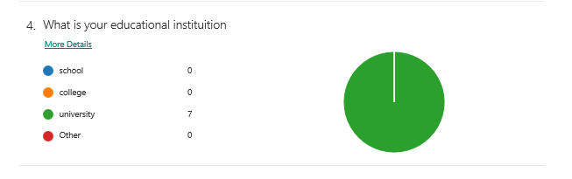
I have only asked my colleagues from university therefore this data collected is biased as we all from the same university. However everyone has different views and opinions therefore I don’t think it will affect my data collection

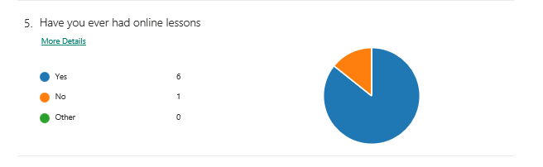
This questions can give me a lot of information as someone who has never had online lessons wouldn’t be able to answer the rest of the questionnaire. However their opinions can help me analyse if online learning Is something everyone wants to be introduced to
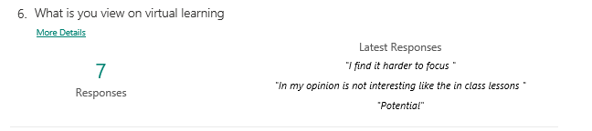
The responders view on virtual learning can be a very sufficient way of data collection because it elaborates how they feel about the online lessons .Using open ended questions allows me to find out my responders personal thoughts and feelings. Using this information I can get a general idea about views on virtual learning
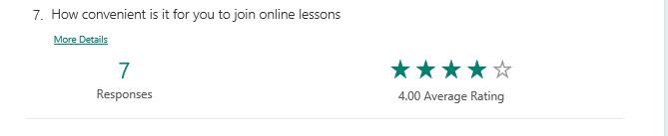
Using rating charts for my questionnaire allows be to get a general understanding. From this chart I can see that it is mostly convenient for my responders to join online lessons. Having an average rating with four stars means that there are some responders who have difficulty joining the lessons.

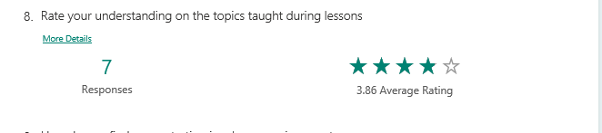
From this rating I can see that mostly my responders understand the topics they are taught. However they are still some responders who find it challenging to engage during virtual classes.
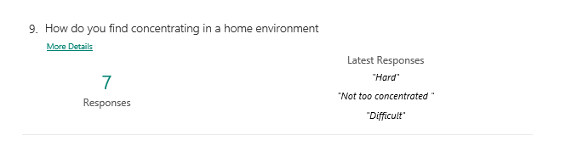
Asking this questions allows me collect and analyse personal data because the responders are asked open ended question. They are required to answer from their point of view. According to their responses I can see that everyone finds it hard to concentrate in home environment. Perhaps virtual learning isn’t so great and everyone misses face-to-face classes.
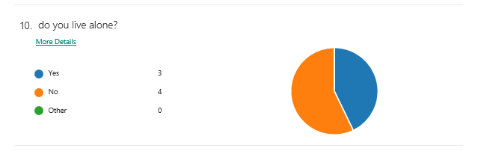
I chose to ask this question because from the responders I would be able to gather how they can concentrate if there are other members also joining online lessons from the same house. How would the Wi-Fi cope? From the pie chart I can see that mostly my responders don’t live alone. This can have an impact on their learning as concentrating and engaging can be hard if there are members that can distract

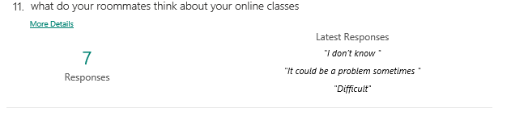
This question was chosen to analyse other people view on virtual learning. However from the responders I couldn’t get a detailed answer.
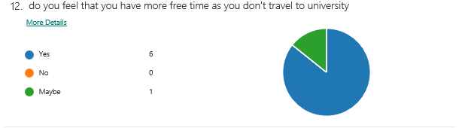

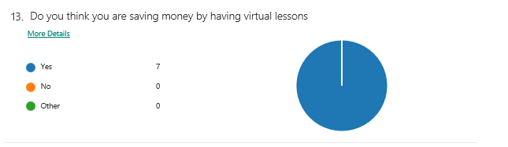
From these responses I can see that virtual learning definitely beneficial to students as they are saving travel and lunch money by joining lessons online

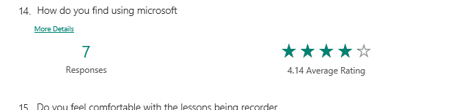
From the data collected I can analyse that mostly students are okay with using Microsoft. However some may need help. Using this information it can be beneficial for universities to find out the vulnerable students and teach them step by step how to easily use Microsoft and attend their online classes.
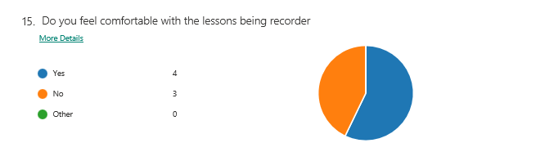
I have designed this question mainly because not everyone can speak up and say they don’t feel comfortable being recorded in the lessons. With this data I can examine the necessary steps to take to make sure everyone feels comfortable during the classes. Being comfortable in lessons allows students to concentrate more on the subject.
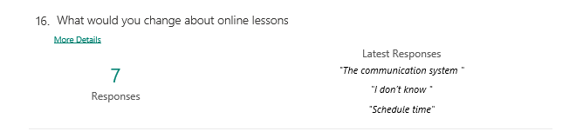
From this question I had a range of answers. One of them being the communication system. I can analyse from that point that students cannot get their ideas and messages across during online classes. Another concern is the scheduled that. My understanding from that is my responders require one to one sessions where they can have the time to ask anything comfortably.

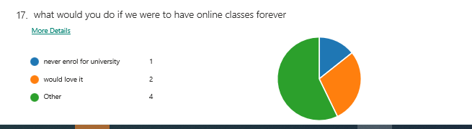
For this question I gave the responders a wider selection for answers. Most of the responders picked other which I cannot analyse as it is such a broad answer. On the other hand some responders said the will love it and some said they will never enrol for university course. From this question I can analyse that everyone has different opinions about virtual learning but on the good side most students like being taught online from the comfort of their own home

Conclusion
In conclusion of my findings. I can confirm that Virtual learning is becoming the new teaching and learning method. From the questionnaire I have developed I can analyse that most students find virtual learning as a positive impact. However most students find it hard to concentrate and join lessons due to the use of Microsoft. I believe that virtual learning can be adapted for everyone to enjoy by teaching students step by step how to use Microsoft. Also lecturers should be encourage to arrange scheduled time for individual one-to-one lessons. This will help monitor students’ progress and understanding.

References
Beek, M. V. (2011). Virtual learning and student achievement. makinac.
Dosseto, F. (2020). Open-ended questions vs. close-ended questions: examples and how to survey users. Hotjar, 2-3.
Khan, S. (2020). Making virtual learning work for you: Tips from Khan Academy founder Sal Khan. london.
Mcleod, S. (2018). Questionnaire: Definition, Examples, Design and Types. simplepshycology.
Morgan, N. (2017). The new possibilities of virtual learning. Training journal.
Mugridge, T. (2020). Virtual Learning. Mind tools.
Picknell, D. (2019). Qualitative vs Quantitative Data – What’s the Difference? Learning Hub.
Reuters, T. (2011). The benefits of virtual learning: A convenient way to learn right from your desk. Thomson Routers the owner company.
Turner, L. (2019). Sylvan Learning Views the Future of Virtual Learning to be Filled With Possibility. CISION.

