Lecturer name: Dr. Rexon Nting
Student name: Ventsislava Kostadinova (2023558)
Assessment date: 07/05/2021

Table of Contents
Introduction 3
Main body 3
H&M’s sustainability practices 3
Impact on competitive advantage 7
Conclusion 10
Reference list 12

Introduction
The reputation of the fashion industry as a major polluter has been quite notorious. It is a very resource-intensive sector of the economy which also causes pollution and greenhouse gas emissions. More specifically, the fashion industry is accountable for 4% of global greenhouse gas emissions (Granskog et al., 2020). To put the number in perspective, it is more than the emissions released by Germany, France and UK combined (Granskog et al., 2020). Having said this, industry players, consumers, regulators and other relevant stakeholder groups have recognised the need for change towards a more sustainable development (Joy and Pena, 2017). The focus in placed on reducing the negative impact on the environment, as well as coping with labour exploitation practices and other socially important issues. It is suggested that the development of sustainable practice would lead to benefits for fashion brands, suppliers, consumers and other stakeholder groups (Joy and Pena, 2017).
Given the case of fashion brands, most of the expected benefits are likely to originate from the adoption of more efficient sustainable technologies and the positive reputation as sustainable brands. This is particularly important, as the number of sustainable consumers in the UK has been increasingly; thereby, placing sustainable as a major determinant in the purchasing decision, as explained by Carlile (2018).
The current report explores the evidence from H&M. It is a global fashion brand with operations in 72 countries worldwide and a portfolio of 4,900 physical stores (H&M, 2019). Moreover, the brand employs 177,000 people in order to achieve annual revenue of more than €20 billion (H&M, 2019; Reuters, 2021).

Main body

H&M’s sustainability practices
The brand has been engaged in sustainability policies and practices for some time already. The strategy of H&M in the field has been guided by several key values focused on achieving social and environmental goals which in turn regulate the sourcing, production, supply chain and other processes at H&M. A more focused look at the sustainability goals of H&M shows that many of them have a direct impact on improving the management of the pollution issue. For instance, the emphasis on recycling is essential for reducing pollution, whereas the intended improvements in processes, resource management and product life-span extension are also factors with a beneficial role in the process (Albouy and Adesida, 2018). In this light, many of the strategic sustainability goals of H&M directly or indirectly aim at addressing the pollution issue.
Figure 1 – Sustainable business initiatives
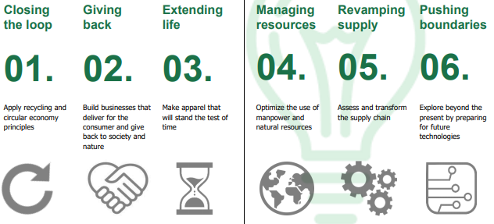
Source: Albouy and Adesida (2018)
In addition, H&M is also strategically oriented towards being the leader in the process of transformation towards sustainability (H&M, 2020). This is seen as a key for differentiating the brand in the marketplace and strengthening competitiveness.
There are several key pieces of evidence in the case of H&M demonstrating its commitment to reducing pollution. One of the key achievements in this respect refers to focus on reusing and recycling of materials. In 2019 alone, H&M managed to collect almost 30,000 tons of obsolete textile products which were eventually converted to new fabrics (H&M, 2019). Having said this, the use of recycled materials has reached a share of 35%. Despite the success it is away from the goal of 100% sustainably sourced and recycled materials by year 2030; yet, the fast growth in the application of these sustainable materials in the recent year has demonstrated the organisational commitment to sustainable development (H&M, 2020).
Figure 2 – Trends and goals in recycled and sustainably-sources materials in the production process of H&M
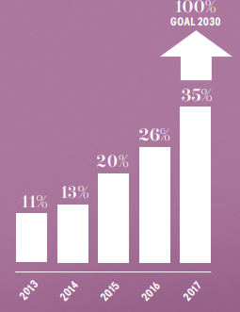
Source: H&M (202019)
Another key element of the sustainable development strategy of H&M is related to the increasing use of sustainable energy sources. According to performance data for year 2018, production operations of the brand were supplied by 96% sustainable energy (H&M, 2020). This key achievement has a major role for reducing the problem with pollution and achieving a more sustainable development.
Special attention should be placed on H&M approach towards re-shaping its production model from a linear to a circular one. The traditional linear approach requires the performance of several stages, such as supply of raw materials, design, production, selling and waste. According to evidence, 87% of all fashion products are eventually turned into waste; thereby, suggesting the dominance of the linear model (H&M, 2018). This also leads to an approximate value of $100 billion when measuring the missed opportunities of not using old products for the production of new ones (H&M, 2018).
In the alternative circular model, recycling plays a key role in transforming used products to new materials which are used for the production of new items (H&M, 2018). As shown below, the model plays a key role towards the reduction and complete elimination of waste which in turn strengthens sustainable performance and pollution management. For the fashion brand, the full application of the circular model is considered as a key opportunity to maximise performance, reduce costs and develop a sustainable brand.
Figure 3 – Circular model of production
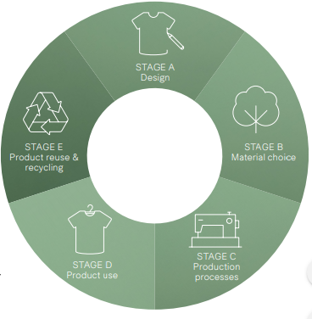
Source: H&M (2018)
In order to achieve the key goal of closing the loop, as suggested by the model, special attention should be placed on collection of old clothes and re-using them for the design of new products; thereby, minimising waste and pollution (Albouy and Adesida, 2018). In this respect, H&M collets almost 18,000 tones of textile per annum and this is a considerable progress for achieving circular model (H&M, 2018). This leads to minimised waste and pollution but additional efforts are necessary in the future.
In addition to quantity, H&M has also invested in quality of materials in order to reduce pollution. For example, the focus is placed on developing technologies and processes for the development of toxic-free materials (H&M, 2018). This is another key pillar for reducing pollution.
The overall performance of H&M is positively assessed not only in relation to the key goal for zero pollution and circular business model by 2030, but also in respect to the control of its supply chain. H&M adopts the Higgs index in order to better control and evaluate the partners from its supply chain. Thus, the brand ensures that international suppliers also comply with the stated sustainable principles (H&M, 2018).
Higgs index is the only measurement tool used in the fashion industry and H&M is one of the first companies adopting it in operations and assessing business partners in all brands on the basis of it (H&M, 2018).

Impact on competitive advantage
The impact on competitive advantage is assessed by applying the Porter’s Five Forces model. In general, this model is used to analyse the overall competitiveness of a given industry (Porter, 1979). The strategic importance of the theoretical framework is extensive, as it takes into consideration the impact of five distinct forces affecting profitability; thereby, creating a holistic analysis. These include the bargaining power of suppliers and customers, threats of new entrants and alternatives, as well as industry rivalry (Porter, 1979). While the model is applied to understand the profitability of the fashion industry, specific evidence from H&M will be added accordingly with the idea of describing the impact of sustainability on the differentiation ability of the brand.
The bargaining power of suppliers is generally low in the fashion industry. This is explained by the availability of a large pool of suppliers and the easiness in differentiating them due to the production of undifferentiated products (Giokarini, 2015). Having said this, fashion brands have the opportunity of switching suppliers without experiencing any significant switching costs. However, this situation is slightly changed when relying on suppliers of ethically-sourced materials. The delivery of such supplies differentiates suppliers which also creates an opportunity for higher bargaining power. As a result, H&M is likely to experience higher supply costs as a part of its sustainability strategy.
Customers in the UK have a high bargaining power as they can switch fashion brands in the mass segment with very insignificant switching costs (Giokarini, 2015). Moreover, the recessionary environment in the UK, accompanied by unprecedented decline in income level equal to 11% in 2020, has also made UK consumers more price sensitive (Harari, 2021). Thus, profit margins of fashion companies are even tighter due to the increasing price sensitivity of the demand curve amid the recession (Krugman and Wells, 2017). In this situation, the development of a valuable sustainable brand may be a key for differentiating in the marketplace. As shown by fig. 4, UK consumers are increasingly interested in ethical fashion products; therefore, they may not easily substitute the unique H&M products with alternatives which in turn reduce their bargaining power.
The threat from substitute products is also considered as high. In general, branded fashion products are easily substituted with alternative unbranded items, such as homemade apparel, handmade items, vintage clothing and other alternatives (Giokarini, 2015).
The threat from new entrants is low. This is evident from the effective entry barriers in the industry. There are significant capital requirements in order to develop a global supply chain and extensive research and development, consumer research and other key activities (Giokarini, 2015). These capital requirements discourage the emergence of new global brands. Moreover, existing brands, including H&M, have large production volumes which strengthen economies of scale and demonstrate the existence of loyal customers. The multi-billion revenue of H&M testifies for its production size and cost advantages from economies of scale which discourage new competitors (H&M, 2020). In addition, the customer loyalty, which is another entry barrier, may be clearly seen from the value of the H&M brand - $14 billion (Statista, 2021). The development of sustainable brand may add extra value to the H&M brand. This may additionally protect the fashion retailer from newly emerging competitors.
The existing rivalry also determines the level of profitability in an industry (Porter, 1979). There are numerous fashion brands which compete for a share of the market. The competition has been intensified by the significant decline in the industry in 2020. As explained by BBC (2021), the sales of new clothes in the UK declined by more than 20%. The smaller marketplace additionally intensifies the level of competition which puts pressure on fashion brands to reduce costs in order to maintain a reasonable profit margin level. The development of a sustainable brand by H&M should be considered as a way of differentiating in such a competitive environment. Hence, it is a key to sustain positions amid a shrinking marketplace and a growing interest of consumers to sustainable products. As shown below, the ethical consumption of fashion products has actually increased in the recent years which show the existence of a market niche which contrasts the general market trends. Thus, H&M can find new sources of revenue in largely unsaturated segments by being more sustainable.
Figure 4 – Ethnical clothing sales in the UK (£, million)
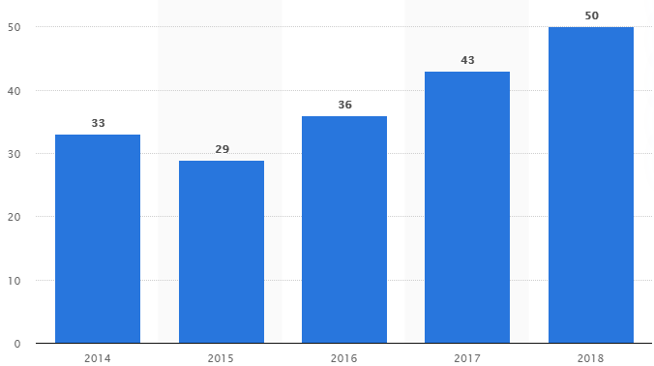
Source: Statista (2019)
The industry analysis shows that the fashion industry is less profitable place amid the economic crisis due to the increased bargaining power of consumers and increasing rivalry. The development of a sustainable brand by H&M is a key for reducing consumers’ bargaining power, discouraging new competitors and effectively differentiating in the marketplace. Hence, the decision to address sustainability can be seen as a strategically plausible decision with positive influence on competitiveness in the long-run, especially given consumer trends towards ethical and sustainable consumption in the UK (Carlile, 2018; Statista, 2019).
So far, H&M has demonstrated progress in respect to numerous sustainability goals, including pollution elimination (H&M, 2019). External recognition for the efforts of the company is abundant. H&M has already received a wide range of rewards for its efforts to become a more innovative and sustainable organisation. Awards have been received from reputable organisations, such as Dow Jones Sustainability Europe Index, FTSE4Good, Global 100 Most Sustainable Corporations, Newsweek Green Ranking, Sustainable Cotton Ranking, etc. (H&M, 2018).
The evidence recommends that the company has to continue implementing its strategy. H&M is advised to increase the speed of change, especially given the economic pressure to minimise costs. Special attention should be placed on the circular model as a way of reducing costs and deliver sustainable practices which are appreciated by customers and deliver brand value.
The fashion brand should also maintain its flexibility and ability to respond to changes in the external environment and consumer preferences. Such flexibility would allow for understanding the most relevant external changes which provide directions for relevant changes in business models and practices.

Conclusion
In conclusion, the evidence shows the relevance of achieving sustainable development in the case of global fashion industry. Given the changing and challenging external environment, fashion brands were found to experience increasing pressure for transformation. In the case of H&M, the need for change has already been recognised and used as an inspiration for developing a strategy for sustainability. The evidence from the company demonstrates the steady path of progress towards the sustainability goals. Moreover, research findings show that sustainability contributes not only to responding to growing societal and customer needs in the fields, but also as a strategic source for differentiation. According to the industry analysis, sustainable values and development in the case of H&M could be viewed as key pillars for differentiation and adding value to the products and brand itself. Hence, fashion brands as a whole should use sustainability as a key performance driver in the future.

Reference list
Albouy, D. and Adesida, O. (2018) Sustainable Fashion Blueprint 2018, [online] Available: http://www.technofashionworld.com/files/2018/07/Mamoq-Sustainable-Fashion-Blueprint-2018.pdf [Accessed: 2 May 2021]
BBC (2021) Shoppers stuck at home shun new clothes in 2020, [online] Available: https://www.bbc.com/news/business-55762644 [Accessed: 3 May 2021]
Carlile, C. (2018) The rise and rise of the ethical consumer: UK ethical markets worth over £83bn, [online] Available: https://www.triodos.co.uk/articles/2018/the-rise-and-rise-of-the-ethical-consumer [Accessed: 5 May 2021]
Giokarini, M. (2015) ZARA’s Business Strategy, [online] Available: https://www.slideshare.net/marigiok/zaras-business-strategy [Accessed: 5 May 2021]
Granskog, A., Lee, L., Magnus, K. and Berg, A. (2020) This is how the fashion industry can reduce its carbon emissions, [online] Available: https://www.weforum.org/agenda/2020/11/sustainable-fashion-reduce-greenhouse-gas-emissions#:~:text=The%20fashion%20industry%20was%20responsible%20for%20at%20least%204%20percent,and%20the%20United%20Kingdom%20combined [Accessed: 2 May 2021]
H&M (2018) H&M Group Sustainability Report 2017, [online] Available: https://about.hm.com/content/dam/hmgroup/groupsite/documents/masterlanguage/CSR/reports/2017%20Sustainability%20report/HM_group_SustainabilityReport_2017_FullReport.pdf [Accessed: 3 May 2021]
H&M (2019) About Us, [online] Available: https://about.hm.com/en/about-us/h-m-group-at-a-glance.html [Accessed: 1 May 2021]
H&M (2020) Sustainability Performance Report, [online] Available: https://hmgroup.com/wp-content/uploads/2020/10/HM-Group-Sustainability-Performance-Report-2019.pdf [Accessed: 3 May 2021]
Harari, D. (2021) GDP – International Comparisons: Key Economic Indicators, House of Commons, [online] Available: https://commonslibrary.parliament.uk/research-briefings/sn02784/ [Accessed: 3 May 2021]
Joy, A. and Pena, C. (2017) Sustainability and the Fashion Industry: Conceptualizing Nature and Traceability, [online] Available: https://www.researchgate.net/publication/318237366_Sustainability_and_the_Fashion_Industry_Conceptualizing_Nature_and_Traceability [Accessed: 3 May 2021]
Krugman, P. and Wells, R. (2017) Essentials of economies. 4th edition, Macmillan Learning
Porter, M. (1979) How Competitive Forces Shape Strategy, Harvard Business Review, Vol. 57(2), pp. 137–145.
Reuters (2021) H & M Hennes & Mauritz AB, [online] Available: https://www.reuters.com/companies/HMb.ST [Accessed: 5 May 2021]
Statista (2019) Revenue from ethical clothing sales in the United Kingdom (UK) from 2014 to 2018(in million GBP), [online] Available: https://www.statista.com/statistics/283233/ethical-clothing-sales-revenue-in-the-united-kingdom-uk/#:~:text=This%20statistic%20displays%20ethical%20clothing,50%20million%20pounds%20in%202018 [Accessed: 5 May 2021]
Statista (2021) Fast fashion: brand value comparison of H&M and Zara worldwide from 2010 to 2020(in million U.S. dollars), [online] Available: https://www.statista.com/statistics/1071147/brand-value-comparison-of-handm-and-zara-worldwide/ [Accessed: 1 May 2021]

