

Managing Enterprise in the 21st Century

Business Plan



Submission Date: 30th of March 2026

Lecturer: Dr Charles Oham

Table of Contents
Group Information 2
Business Concept 4
Business Description 5
Product Description 5
Business Objectives (SMART Objectives) 5
Short-Term Objectives (less than a year) 5
Long-Term Objectives (less than a year) 5
Market Analysis and Marketing Plan 6
Market Analysis (Competitors, Customers, Target Groups) 6
PESTEL Analysis…………………………………………………………………………………..6
SWOT Analysis 6
Marketing Mix (4Ps) 6
Management Team 6
Management Team and Their Background 7
Organisational Chart 7
Key Milestones 7
Financial Plan (One Year) 7
Sources of Finance 7
Cash Flow Forecast 7
Sales Forecast 7
Cost of Production Forecast 7
Break Even Analysis 7
Operations and Management Plan 7
Production of Good and Service 7
Technology Plan 7
Human Resource Plan 7
Expansion Plan 8
Reference List 8
Appendices: 9
Executive Summary………………………………………………………………………………16

Business Concept

GreenPath Consulting is a sustainability consultancy social enterprise in the United Kingdom.
We provide educational training to communities on sustainable practices to ensure that people look after their environment through living sustainably.
The company provides professional advisory services to people living in homes and small and medium-sized enterprises (SMEs) seeking to reduce their environmental impact while improving operational efficiency and reducing costs.
The business focuses on supporting people that often lack the knowledge, time or internal resources to implement sustainable practices such as food recycling. GreenPath Consulting offers practical and affordable solutions tailored to each client’s needs, helping people and organizations transition towards more environmentally responsible operations.

Business Description

GreenPath Consulting is a service-based business focused on environmental education and sustainability solutions.

Product Description

GreenPath Consulting offers specialised sustainability consultancy services, including education of residents’ businesses in:
- Environmental audits to assess business impact
- Waste reduction and recycling strategies
- Energy efficiency improvement plans
- Sustainability action plans for SMEs
- Guidance on environmental compliance and certifications
- Environmental education outreach
The services are designed to be accessible, practical and cost-effective, allowing small businesses and people to adopt sustainable practices without significant financial investment.
Green Path differentiates itself by focusing specifically on residents and SMEs and providing personalised consultancy rather than generic sustainability solutions.

Business Objectives (SMART Objectives)

Short-Term Objectives (Less than a year)

- Establish as a social enterprise by registers as a company ltd. by guarantee
- To launch operations within the first 3 months.
- Develop a professional website and social media presence within 6 months.
- Acquire at least 1 grant during the first year of operation.
- To recruit 10 volunteers
- To get contracts from local authorities and businesses of £10,000
- Build partnerships with at least three local business networks or organisations.
- Develop relation with Lewisham council

Long-Term Objectives (1 – 2 Years)

- Expand the client base to 30-40 small business in Lewisham and neighbouring areas within 2 years.
- Reinvest 30% annual profits into environmental education programmes and community sustainability initiatives.
- Develop specialised sustainability training programmes for SMEs in the local area.
- Help client business reduce waste and energy consumption trough measurable sustainability strategies.
- Stablish GreenPath Consulting as a trusted sustainability consultancy for small business in Lewisham.

Market Analysis and Marketing Plan

GreenPath Consulting will focus on supporting small businesses located in the London Borough of Lewisham. The area has many independent businesses such as cafés, restaurants, retail shops and small offices.
Many SMEs are becoming more interested in sustainability due to rising energy costs, environmental regulations and customer expectations. However, small business often lacks the knowledge or resources to implement sustainable practices.

The marketing strategy will focus on building relationships with small business and community leaders in Lewisham.
GreenPath Consulting will promote its services through a professional website, social media and networking with local business organisations. The company will also attend local business events and offer introductory sustainability workshops.
Pricing will be affordable and flexible to attract SMEs. Services will be delivered through online consultations, on-site visits and training workshops.

Competitors
There are sustainability consultancy firms operating in London e.g. McKinsey & Company, Oliver Wyman, PA Consulting, L.E.K. Consulting, Roland Berger among others. However, many of them focus on large companies and offer expensive consultancy services. This creates an opportunity for GreenPath Consulting to target small local business by offering affordable practical sustainability advise tailored to SMEs.

Customers and Target Group
The main target customers are small and medium-sized enterprises (SMEs) located in Lewisham. These include independent cafés, restaurants, retail stores and small offices. Many of these businesses want to improve their environmental practices but lack the knowledge or time to implement sustainable strategies.

PESTLE Analysis

GreenPath Consulting (Social Enterprise)

Political: UK government policies promoting sustainability and Net Zero
Targets create opportunities.
Borough of Lewisham may need support to comply with environmental policies.
(UK government 2021). This will create demand for GreenPath consulting services.

Economic: Rising energy costs encourage SMEs to seek cost-saving solutions.
Local cafes and shops in Lewisham may hire GreenPath Consulting to reduce energy and lower operating costs.

Social: Increasing environmental awareness influences businesses.
(Johnson, G., Scholes, K. and Whittington, R. 2017)
Customers in Lewisham may prefer eco-friendly businesses, encouraging SMEs to
improve sustainability with consultancy support.

Technological: Digital tools support sustainability monitoring.
GreenPath Consulting can use online tools to provide remote audits and track client’s
environmental performance.

Legal: UK environmental regulations require compliance. SMEs may need guidance to meet waste management and environmental standards,
which GreenPath Consulting can provide.

Environmental: Climate change and waste issues increase demand for solutions.
(Kotler, P. and Keller, K. 2016)
Businesses in Lewisham may need help reducing waste and improving recycling practices.

SWOT Analysis

GreenPath Consulting

Strengths:
GreenPath Consulting offers affordable sustainability services tailored to SMEs in the London Borough of Lewisham with a strong focus on local business needs.

Weaknesses:
As a new business in Lewisham, it has limited brand recognition and a small client base.

Opportunities:
Lewisham has a high number of small independent business and increasing interest in sustainability, creating strong demand for consultancy services.

Threats:
Competition from established consultancies in London and economic uncertainty may reduce SMEs’ willingness to invest in external services.

Marketing Mix (4Ps)

Product:
GreenPath Consulting provides sustainability consultancy services for SMEs and residents in the London Borough of Lewisham including environmental audits, waste reduction strategies and energy efficiency advise. As a social enterprise, it also offers low-cost workshops to support local business and the community.
Price:
Affordable and flexible pricing tailored to small business. As a social enterprise a proportion of profits will be reinvested into community sustainability initiatives and environmental education.
Place:
Services will be delivered through online consultations an on-site visit in Lewisham ensuring accessibility and strong local engagement.

Promotion:
Promotion will focus on social impact and community value, using social media, a professional website, local networking and partnerships with community organisations.

Management Team

GreenPath Consulting will be led by small and focused management team with skills in sustainability, business management and community engagement in the London Borough
of Lewisham.

Organisational Chart

Management Team and Their Background

Founder
Yvonne Yepes

Responsible for delivering consultancy services conducting environmental audits and managing client relationships. The founder has knowledge in environmental sustainability an business development.

Training and Education officer (volunteer program)
Marketing and Community Manager (volunteer program)

Responsible for promoting the business, managing social media and building relationships with local organisations. This role supports the social enterprise mission by engaging with the local community.
Responsible for delivering sustainability workshops and training sessions for local businesses and community groups. This role plays a key part in creating social impact through education and awareness.

The team combines environmental expertise, business skills and community focus to achieve both commercial success and social impact.

Key Milestones

To launch the business and be operations
To be a profitable in the first one year
To begin marketing activities
To acquire first clients and start delivering consultancy services
To deliver initial sustainability workshops for local business and community groups
To achieve stable monthly revenue and stablish presence in the local market
To expand client base, develop training programmes and social impact activities

Financial Plan (One Year)

Sources of Finance

Grants
Loans
Sponsorship
Founders’ contribution
Reinvestment of business profits

Cash Flow Forecast
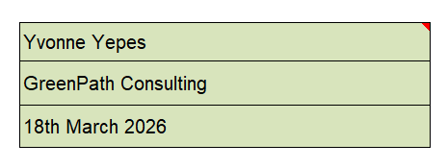
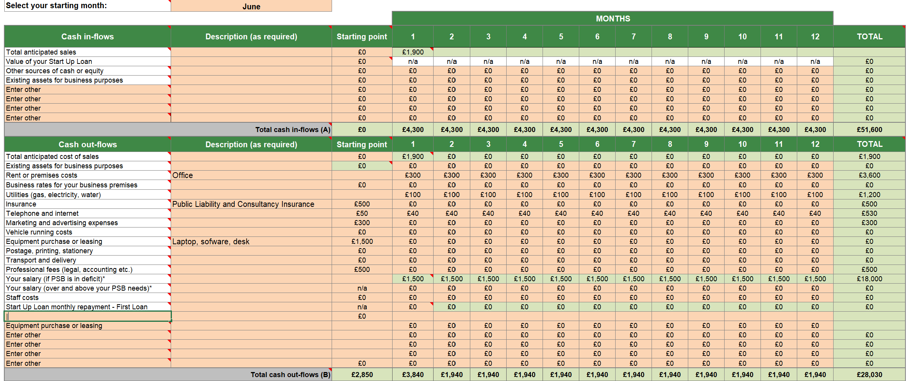
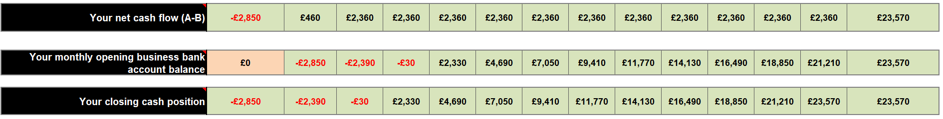

Sales Forecast

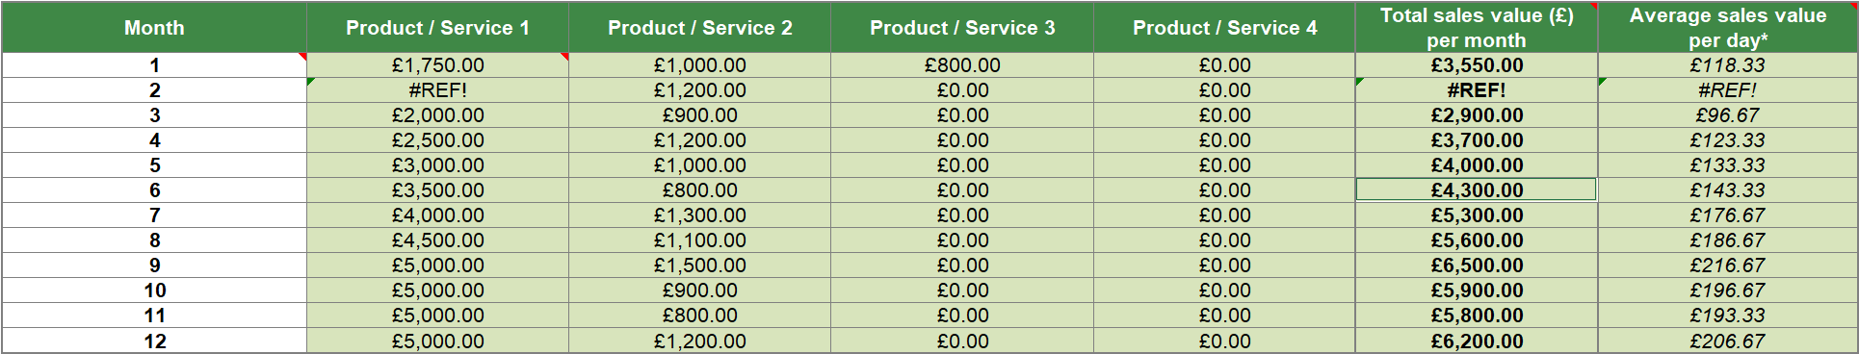

Cost of Production Forecast

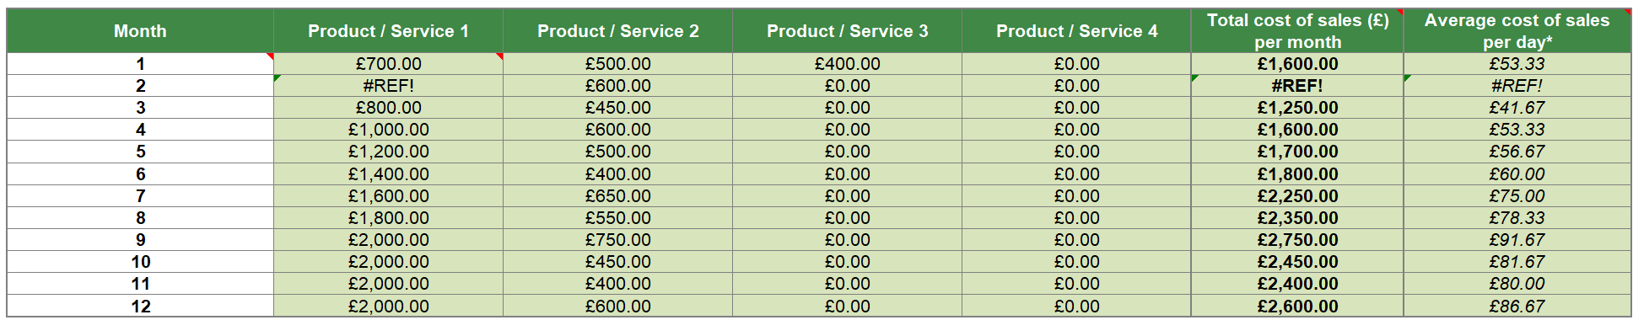

Break Even Analysis

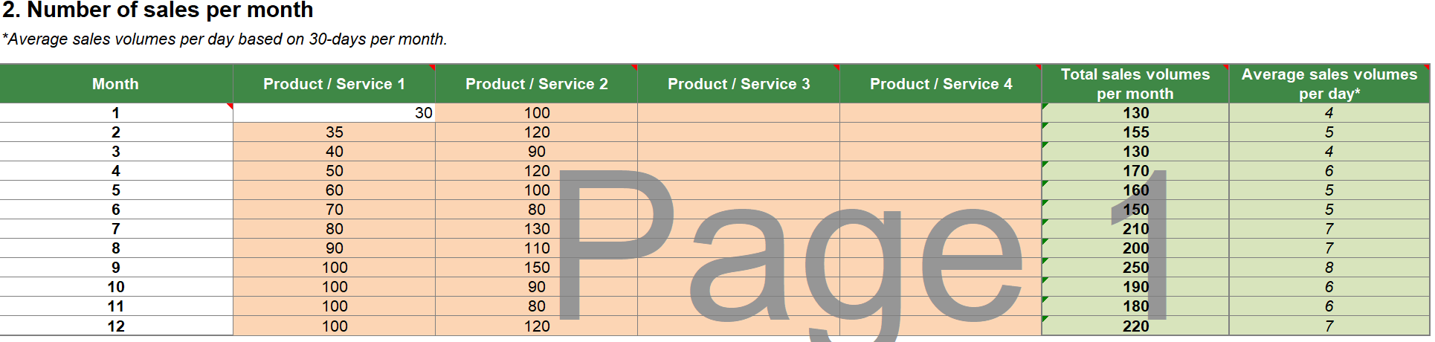

Operations and Management Plan

GreenPath Consulting will operate as a small consultancy providing services to SMEs in Lewisham. The founder will manage daily operations, client relationships, and service delivery, supported by small team (volunteers) responsible for marketing and training.

Production of Goods and Service

The business will provide consultancy services rather than physical products. Services include environmental audits, sustainability plans and training workshops tailored to client needs.

Technology Plan

The business will use digital tools such as laptops, online communication platforms and sustainability monitoring software to deliver services efficiently, including remote consultations.

Human Resource Plan

The business will start with a small team: the founder, a marketing and community manager (volunteer) and a training officer (volunteer). Additional staff may be hired as the business grows.

Expansion Plan

In the long term, GreenPath Consulting will expand its client base beyond Lewisham, develop new training programmes and increase its social impact through partnerships and community initiatives.

Reference List
Johnson, G., Scholes, K. and Whittington, R. (2017) Exploring Strategy. 11th edh. Harlow: Pearson.

Kotler, P. and Keller, K. (2016) Marketing Management. 15th edh. Harlow: Pearson.

UK Government (2021) Net Zero Strategy: Build Back Greener. Available at: https://www.gov.uk (Accessed: 29 March 2026).

Social Enterprise UK (2022) What is a social enterprise? Available at: https://www.socialenterprise.org.uk (Accessed: 29 March 2026).

Burns, P. (2016) Entrepreneurship and Small Business. 4th edh. London: Palgrave.

Appendages:

Appendix 1: SWOT Analysis
Summary of the internal strengths and weaknesses, and external opportunities and threats affecting the business.

Appendix 2: PESTEL Analysis
Overview of the external macro-environmental factors influencing the business.

Appendix 3: Financial Calculations
Detailed breakdown of startup costs, revenue forecasts, and break-even analysis.

Appendix 4: Key Milestones Timeline
Timeline of business development stages during the first three years.

Executive Summary

GreenPath Consulting is a sustainability consultancy company based in the United Kingdom.
The business aims to support small and medium-sized enterprises (SMEs) in reducing their environmental impact while improving efficiency and reducing costs.
The company will offer affordable and tailored sustainability solutions including environmental audits, waste reduction strategies and energy efficiency plans. GreenPath consulting focuses on helping businesses become more environmentally responsible without requiring large investments.
The target market includes small businesses such as cafes, retail shops and offices that want to adopt sustainable practices but lack the knowledge or resources to do so.
The main objective is to become a trusted sustainability partner for SMEs and contribute to a greener economy in the UK.
GreenPath Consulting will operate as a social enterprise with a sole trader structure during the initial stage, allowing for simple management and low start-up costs. The business will be started with a small initial investment funded through personal savings and potential local support for start-ups.

The estimated turnover for the first year is approximately £18,000, based on consultancy services and training workshops delivered to SMEs in the London Borough of Lewisham. The business aims to grow steadily while reinvesting part of its profits into community sustainability initiatives.

