Student Name: Jacqui Fowler Student Number: 1703065
Course: BA Architectural Arts: Glass
Tutor's name: Julia Lockheart Date: December 2018 Words: 2000
What is the role of the designer in the 21st Century and how might this role change in the next 10 years? Discuss your ideas with reference to two of the practitioners or thinkers discussed in your lecture strand.

Introduction
There is a long tradition across the developed world of stained-glass in religious and public buildings. In the Victoria and Albert Museum in London, there are examples of traditional and contemporary stained-glass dating from the 12th Century through to the present day (V&A Museum, 2018). The traditional methods for designing, making and installing these pieces of art have changed very little until the latter part of the last century (Foister, 2007).

The specialist role of the stained-glass designer is discussed here, including how the role will need to evolve to keep up with changing technology, trends and culture, to avoid the craft falling into decline.

Role of the designer in the 21st Century
Donald Judd, a 20th Century minimalist artist and designer, is quoted as saying “design has to work, but art does not” (Mooth, 2013). However, in the case of stained-glass the art does have to work and it is the role of the designer to ensure that it does.

The Oxford English Dictionary (2018) defines a designer as “a person who plans the look or workings of something prior to it being made, by preparing drawings or plans”. The stained-glass designer may or may not be the person who creates the artwork or the craftsperson that makes the piece. However, they will be the person who puts in a bid for the commission, liaises with the client to ensure the design meets the brief and that it fits the space for which it has been commissioned. This will include considerations of light and place and that it works as an installation, not forgetting the contractual boundaries such as health and safety, budget and environmental considerations.

How might this role change in the next 10 years?
It cannot be denied, there are many ways stained-glass designers must change and adapt their practice. They will need to move with the times in order to become more competitive, more in tune with their commissioners and more aware of their effect on the environment, because the public demands it. They will need to pay attention to the constant change of culture otherwise the craft of stained-glass will come under threat of demise.

Even Brian Clarke, renowned contemporary stained-glass artist and designer, recognises that there is “a tremendous danger of it [stained-glass] becoming extinct, because it has become so universally associated with the church” (Clarke, 2018). For stained-glass to survive as an architectural medium it needs to be commissioned as art in public places such as schools, libraries, airports and shopping centres.

The age of technology
Cartoons, the technical drawings of stained-glass, have traditionally been drawn and redrawn by hand using charcoal and ink. Glass has been cut using hand-tools, lead is soldered using a handheld soldering iron. All of these tasks have historically been undertaken by experienced craftspeople by hand.

Contemporary stained-glass designers have a whole raft of new and emerging technologies to draw on. With the event of computer aided drawing and design, water-jet cutting and state of the art bonding products, traditional stained-glass design skills are becoming outmoded. The designer still needs to draw up a cartoon showing where the glass cut lines need to be and where the lead might be required, but in this “fourth industrial revolution” (Schiuma, 2017, p2) the designer is increasingly more likely to use technology to help them achieve their goal. The ability to print to scale, make constant changes, achieve precise measurements etc. are all invaluable reasons for the designer to adapt their practice from ‘by hand’ to state of the art technology.

The philosopher Pallasmaa believes that “the computer creates a distance between the maker and the object, whereas drawing by hand or building a model puts the designer in skin-contact with the object or space… Ultimately the object becomes an extension and part of the designer’s body” (Pallasmaa, 2009, p97). However, when a designer is up to the wire with deadlines, irritating changes in brief or lack of resources they may well forego the luxury of being “in skin-contact with the object”.

Even Pallasmaa admits “it would surely be an ignorant and prejudicially Luddite view to deny the benefits of the computer” (Pallasmaa, 2009, p95).

The stained-glass designer will need to stay well appraised of and trained in the use of artificial intelligence. For instance, in the hands of a skilled designer a digital theodolite can take detailed, measured, three dimensional images of the space, including a forecast of what the installation will look like and print out a 3D scale model. If a designer is competing for a commission they will need to impress the client with this type of technology, or their competitor may get the upper hand.

However, they will also need to extoll the uniqueness and value of the craft, lest we fall into a culture where traditional stained-glass is completely replaced with computer generated patterned vinyl stuck onto clear glass which, although has its place in commerce, would be a travesty in a more formal setting.

Environmental issues - Reuse, recycle, recreate
Wahl and Baxter, speaking about the designer’s responsibility to help solve “wicked problems” state:

Real-world problems that acknowledge the complex interdependence of diverse factors and stakeholders, call for integrated and flexible design solutions, appropriately adapted to the eco-social complexity of their scale-linking context (Wahl and Baxter, 2008, p75).

The world’s big issues like climate change, over harvesting of natural resources, pollution of air and sea and the destruction of rain forests, can only be solved when whole systems are redesigned to reduce their impact on our environment.

Wahl and Baxter take their point a step further when they suggest “designers can effect changes in life-styles and resource use that will drive the sustainability transition” (Wahl and Baxter, 2008, p83). If every designer took responsibility for their part in the cause of these wicked problems, then as a profession we could effect change for the better.

This isn’t a new suggestion. As long ago as mid 20th Century complex issues were identified and solutions suggested:

Design must become an innovative, highly creative, cross-disciplinary tool, responsive to the true needs of men. It must be more research oriented, and we must stop defiling the earth itself with poorly-designed objects and structures (Papanek, 1972, p2).

For society to be more sustainable designers of all disciplines must take responsibility for the impact they have on the world and think hard about the potential of their designs to have life after life, or cradle to cradle potential as advocated by Braungart, M. et al. (2007). One of the benefits of traditional stained-glass is that once installed it tends to be in place for decades if not centuries and often subject to conservation and restoration giving it an even longer lifespan. Once its life is over and it’s not deemed worth saving then the individual parts of glass and lead can be recycled or repurposed.
David Hockney, Helen Whittaker of Barley Studios and The Queen’s Window
This 21st Century stained-glass window measuring 28 feet by 12 feet (figure 1) was inaugurated at Westminster Abbey on Tuesday 2nd October 2018.
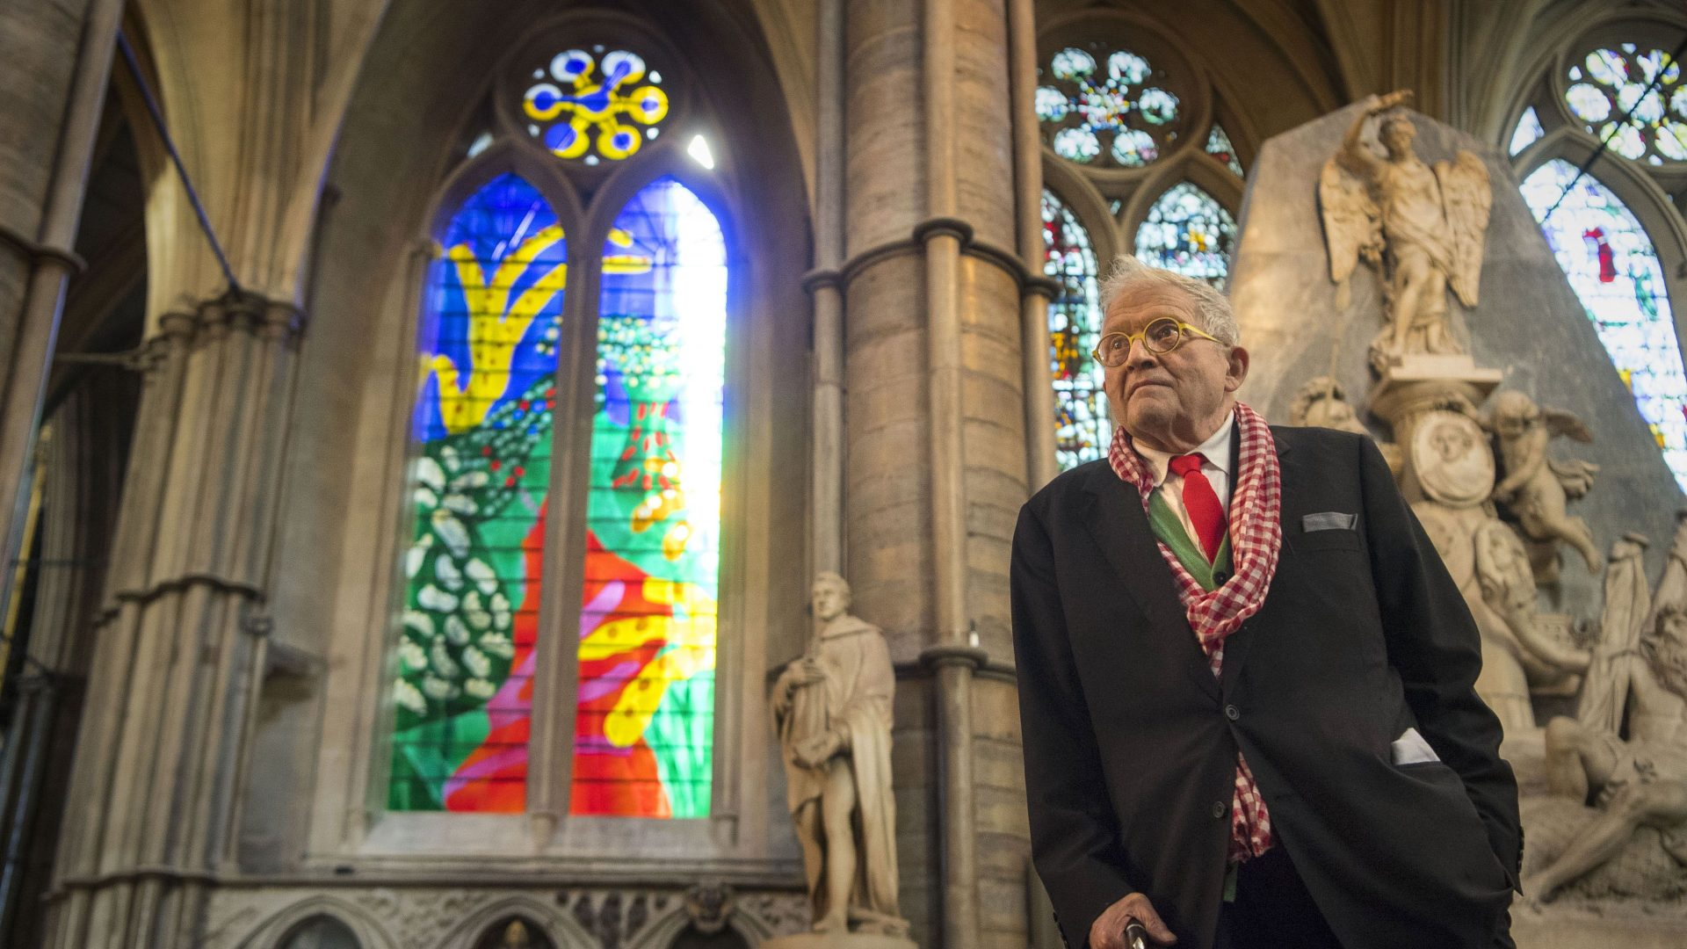
Figure 1.
When asked by Nayeri of the New York Times about his inspiration for the piece Hockney reflected “The hawthorn is celebratory, it’s as though champagne had been poured over bushes”. Hockney explained how “he had reworked the design from an earlier painting using an iPad” (Nayeri, 2018). When asked in an interview with Channel4 if the iPad had helped him with the design, he replied that he found the backlight of the device mimicked the light behind a window (Snow, 2018).
Nayeri (2018) reports that The Very Rev. John R. Hall, the Dean of Westminster Abbey and commissioner of the window, contacted Hockney because he is “the most celebrated living artist, whose fame coincided with the Queen’s reign”. The Dean believes the window to be “absolutely vibrant: It’s very legible, so in that sense it’s very accessible, and I think people will be very excited by it” (Nayeri, 2018).

The Queen’s Window is very different from all the other stained-glass windows in the Abbey. Its vibrant colours, abstract design and lack of traditional stained-glass painting make it stand out amongst its peers and could well start a new trend for informal designs of stained-glass in churches and cathedrals.

This window will be forever known as David Hockney’s window. The name of this renowned artist, recognised with an Order of Merit and as a Companion of Honour (Westminster Abbey, 2018), brings with it a certain amount of celebrity and curiosity. Hockney’s Portrait of an Artist (pool with two figures) has recently sold for over £90m at Christies’ Auction House (Christie’s, 2018). This bears witness to how popular the artist has become since graduating from The Royal College of Art in London in the 1960s. It seems the promoters of tourism at Westminster Abbey are fully exploiting the pull of the Hockney name, as shown in the photograph below (figure 2) distributed on the Barley Studio’s Instagram feed.
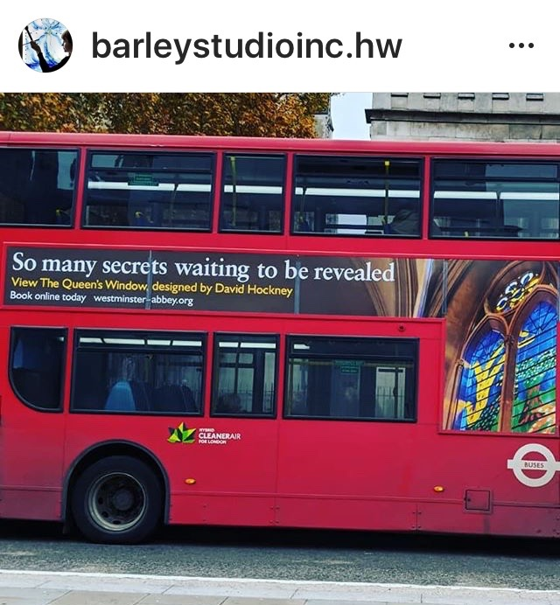
Figure 2.

Helen Whittaker, the Creative Director of Barley Studios, led the team that designed and created the window from Hockney’s artwork. She told The New York Times:
“It was a joy to work with him, because he’s very respectful of what we do. We’re very grateful that he’s putting our profession on the map, because stained-glass is always seen as the poor sister to the art world” (Nayeri, 2018).
All of this publicity can only benefit the business of designers and makers of stained-glass. Who’d have thought that an octogenarian using an iPad to make art for the Queen would create such a good news story, worthy of publicising on the side of a bus, with the outcome of promoting the traditional craft of stained-glass? It seems a revival has begun – God Save the Queen!

Adapting the craft for the modern age
Brian Clarke, has radically updated and innovated the medium of stained-glass (Clarke, 2018). His stand-alone panels can be moved from place to place, hired out to events and festivals and even accompany Santa Claus on his procession, like the ones in Swansea’s Christmas Parade, 2018 (Figure 3).

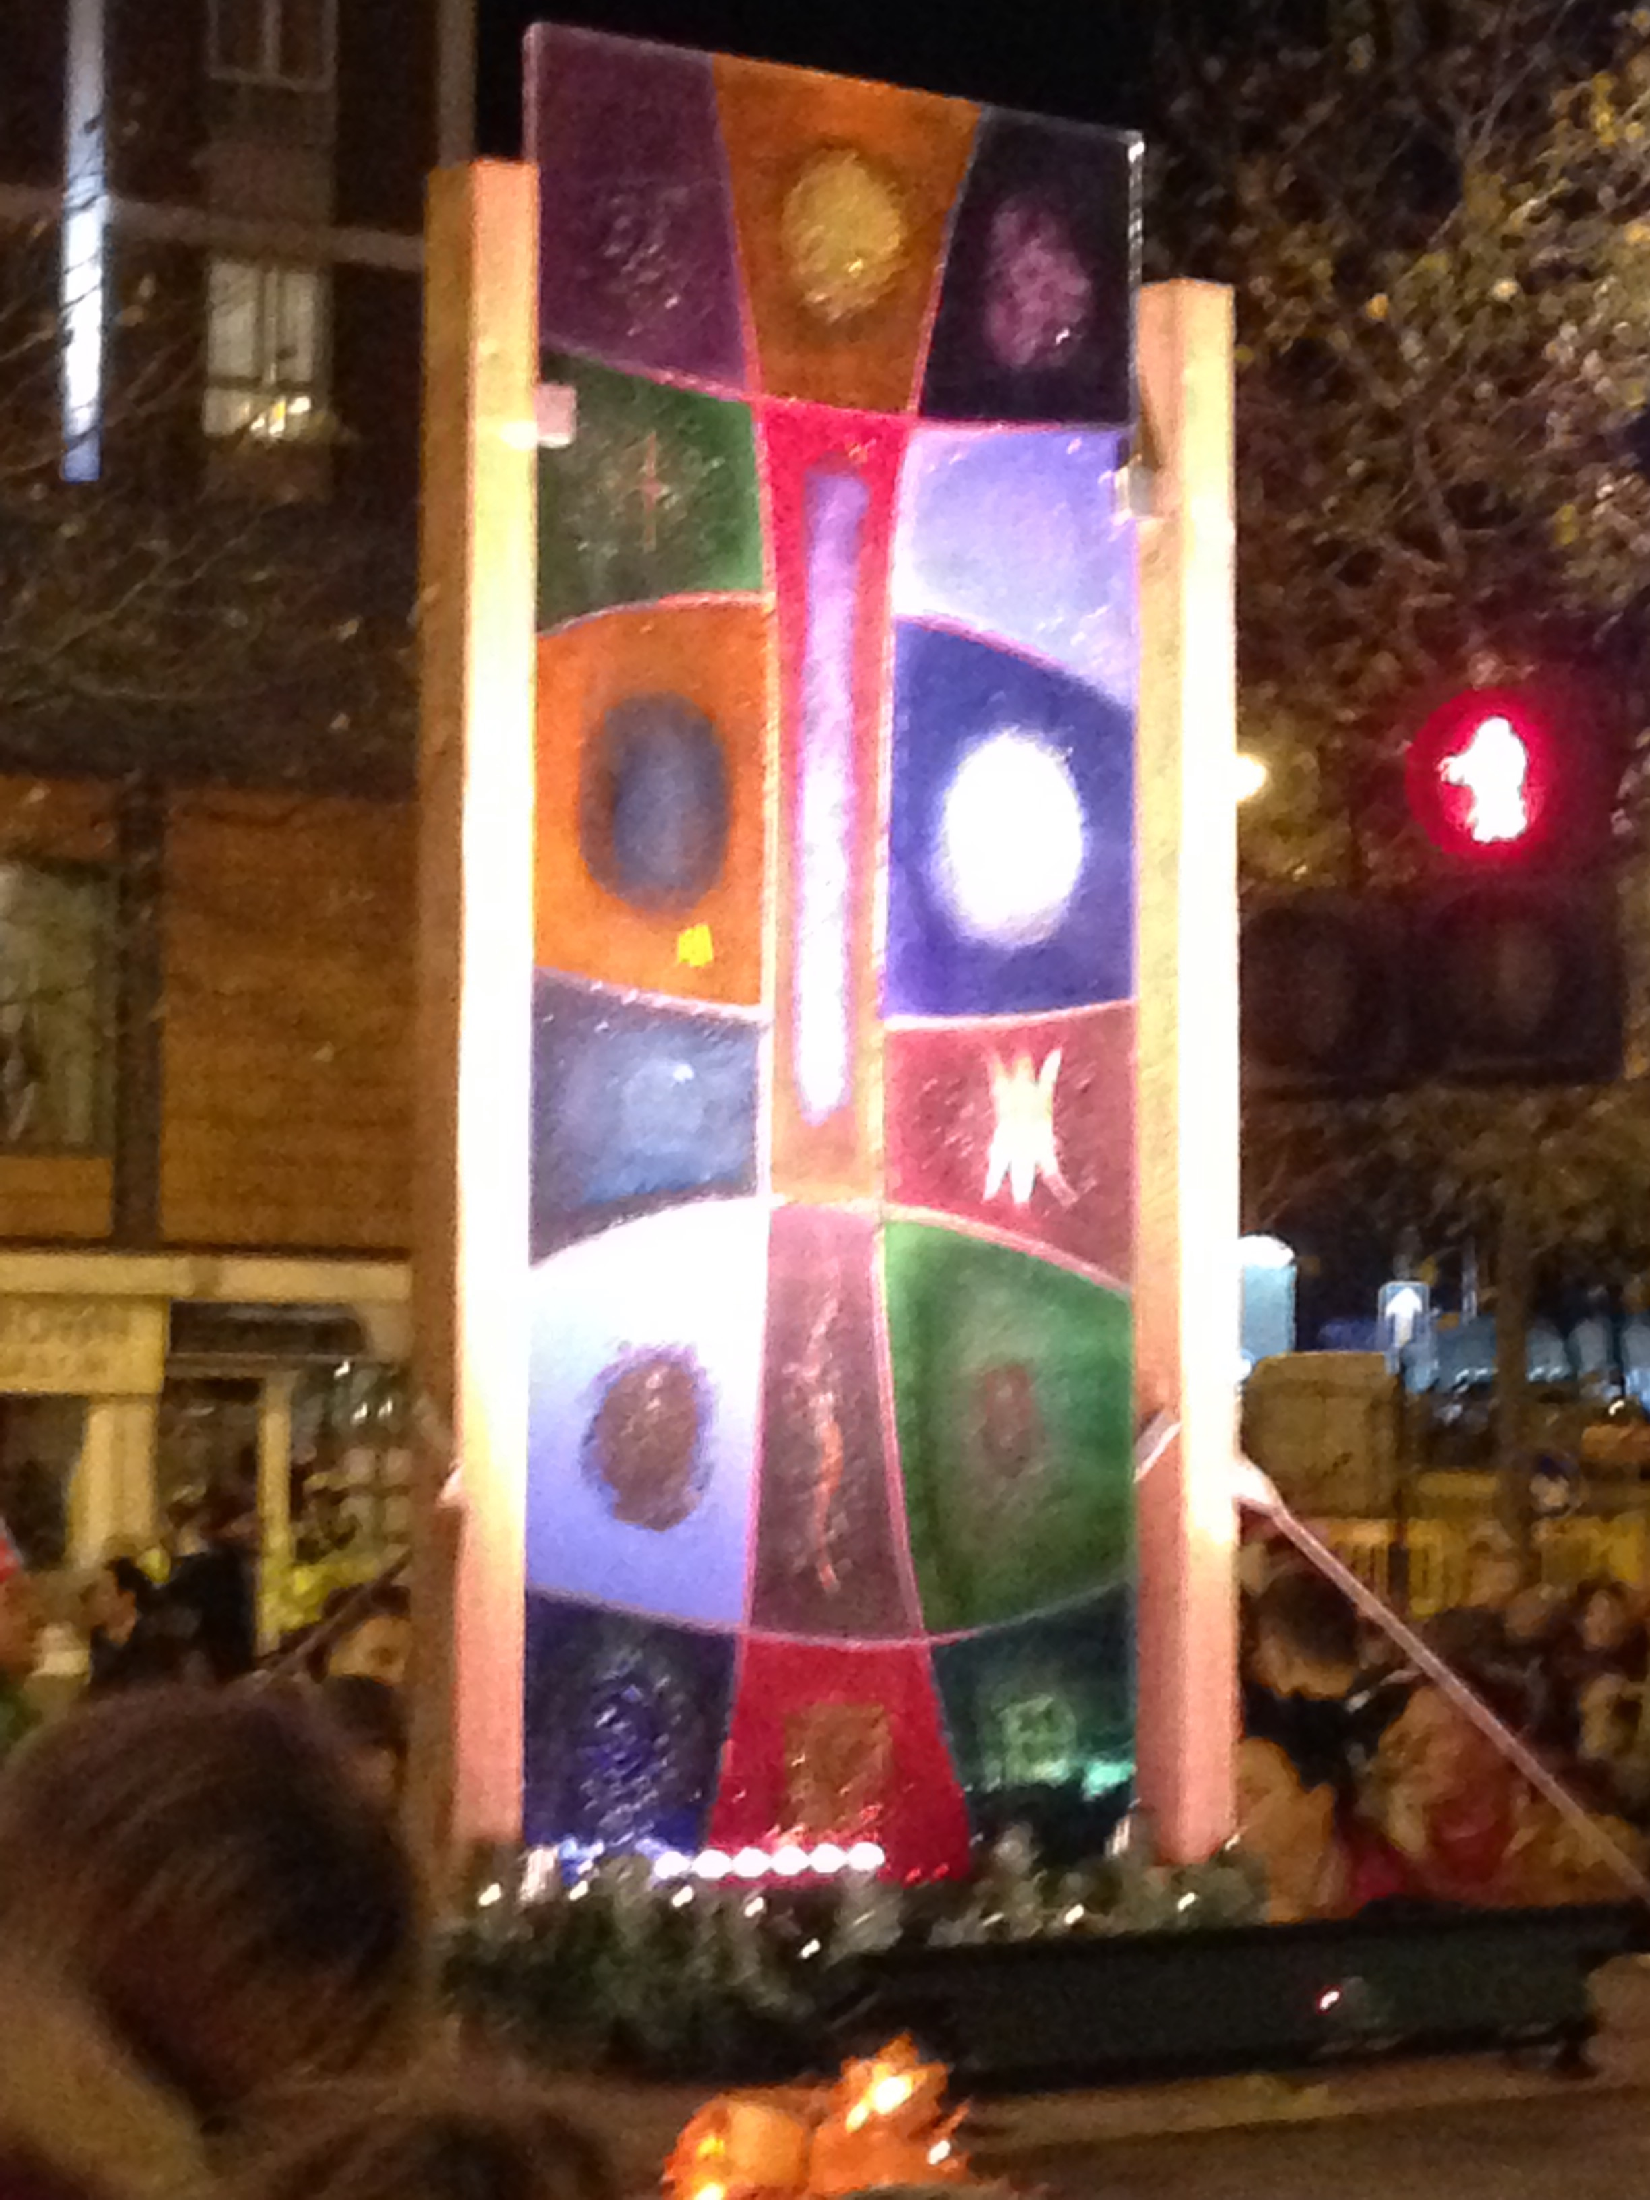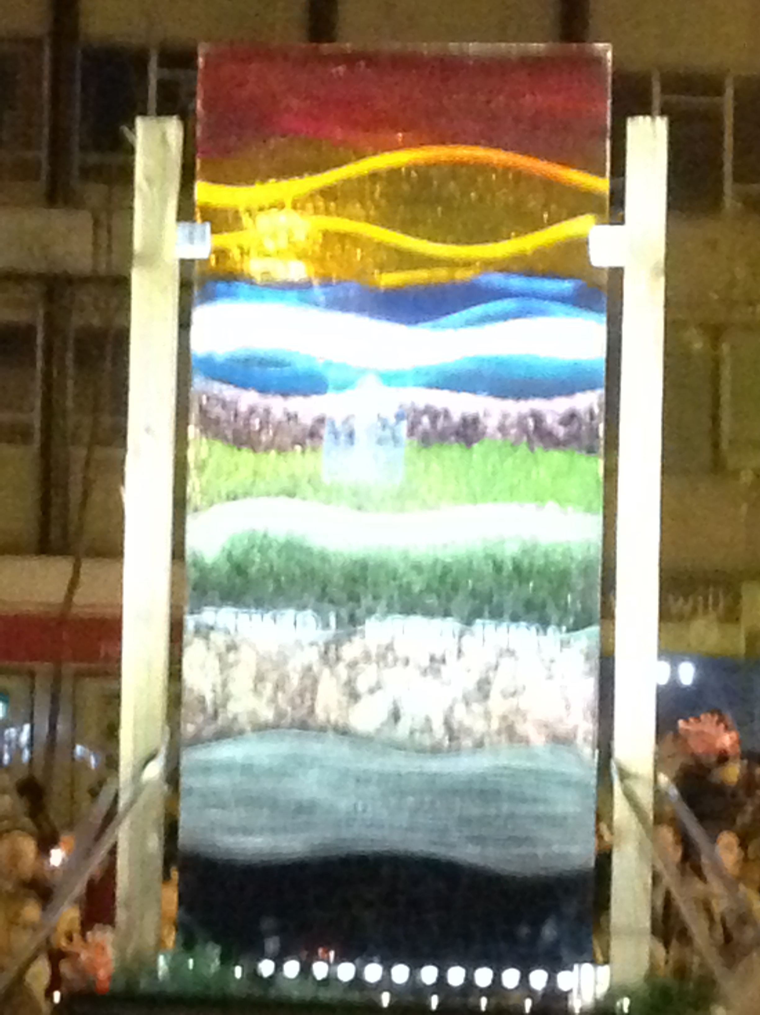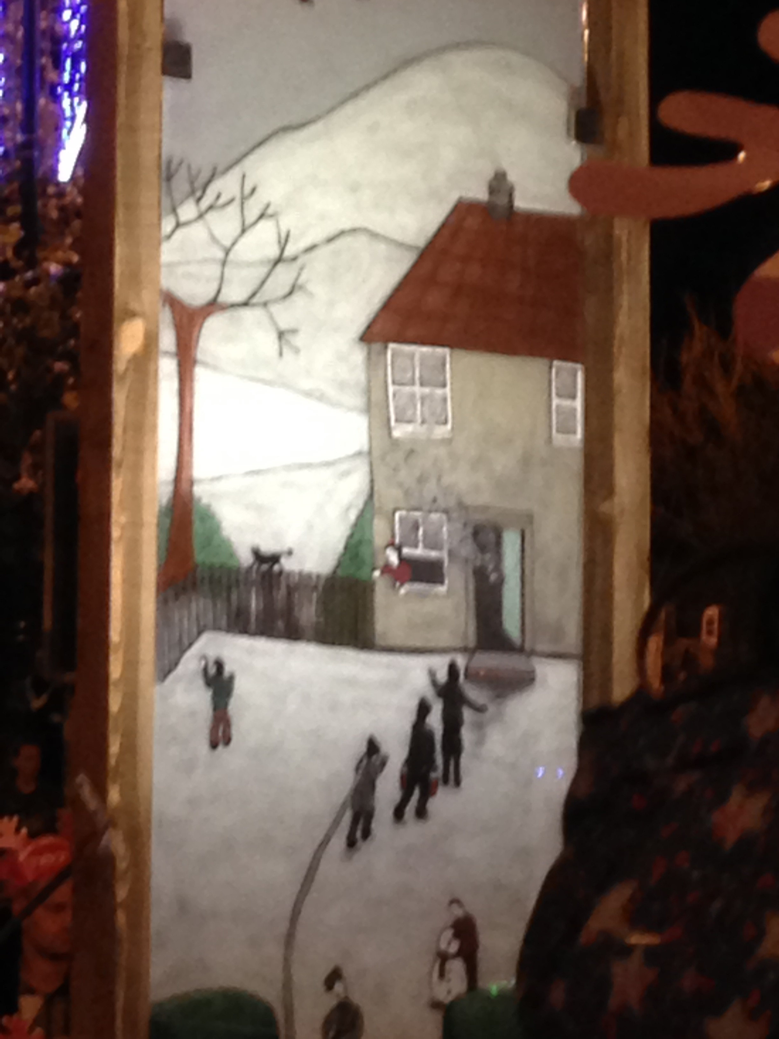
Figure 3.

Clarke is optimistic about the future. He believes “Stained-glass has the potential to contribute to the urban fabric of the 21st century as successfully as it did to the 15th" (Clarke, 2018).

Conclusion
Fundamentally the role of the stained-glass designer is, and always will be, to make art work in the space it was commissioned for. To collaborate with commissioners, artists and makers to create pieces of vibrant art, whether for specific spaces with definite dimensions and considerations of light and purpose or more contemporary pieces that can be moved and displayed on a temporary basis.

The variables over the next 10 years and beyond are likely to be:

1. How designing is done.
Whether by hand using traditional charcoal, pen and ink, by computer using artificial intelligence and specifically developed computer programs, or a mixture of both, will be determined by each individual designer. Their resilience will be tried and tested in the emergent market.

2. The core resources that the designer has available.
Artists, designers and makers of stained-glass must be mindful of the potentially detrimental effect the industry is having on the environment. Finite resources such as lead and the silicon sand from which glass is manufactured can be recycled and reused. It is only by the whole industry pulling together to make changes that the negative effect on the environment can be reduced. The role of the designer is pivotal to those changes.

3. The popularity of the craft.
David Hockney has done much to promote the medium of stained-glass during the launch of The Queen’s Window. Hockney and Whittaker together make a winning team, collaboration being the key to success. Hopefully a positive outcome of this type of collaboration will be to bring us back to an age of appreciation of traditional crafts, working with our hands to create art that makes the heart sing.

Figures:
Figure 1: Photograph of David Hockney in front of the Queen’s Window at Westminster Abbey ©Channel4 Television Corporation, (Snow, 2018)
Figure 2: Photograph of a London bus advertising The Queen’s Window. ©Barley Studios (Barley Studios, 2018)
Figure 3: Photograph of stained-glass panels on a float for the Christmas Parade through Swansea, ©Jacqui Fowler, 2018

Bibliography
Barley Studios (2018) London Bus. Available at: https://www.instagram.com/p/BqStqQZHjXH/?utm_source=ig_share_sheet&igshid=1kr0rburz8eqg (Accessed: 1 December 2018).

Braungart, M. et al. (2007) ‘Cradle-to-cradle design: creating healthy emissions – a strategy for eco-effective product and system design’. Journal of Cleaner Production, 15(13/14), pp.1337–1349.

Christie’s (2018) David Hockney’s Portrait of an Artist (Pool with Two Figures).
Available at: https://www.christies.com/features/David-Hockney-Portrait-of-an-Artist-Pool-with-Two-Figures-9372-3.aspx (Accessed: 18 November 2018).

Clarke, B. (2018) The Art of Light [video]. Available at: http://www.brianclarke.co.uk (Accessed: 17 November 2018).

Cross, N., and Board of International Research in Design (2007) Designerly Ways of Knowing. Basel: London: Birkhäuser.

Foister, S. (2007) Art of Light: German Renaissance Stained-Glass. London: National Gallery.
Marinovich, G. (2015) Design Quotes. Available at: https://eyeondesign.aiga.org/design-quote-donal-judd-design-has-to-work-art-does-not (Accessed: 18 November 2018).

Mooth, B. (2013) Stefan Sagmeister on Art, Design and Happiness. Print. Available at: http://www.printmag.com/featured/stefan-sagmeister-on-art-design-and-happiness (Accessed: 18 November 2018).

Nayeri, F. (2018) David Hockney wouldn’t paint the Queen. But he made her a stained-glass window. The New York Times Online. Available at: https://www.nytimes.com/2018/10/02/arts/design/david-hockney-stained-glass-westminster-abbey.html (Accessed: 17 November 2018).

Oxford English Dictionary online (2018) Definition of Designer. Oxford University Press. Available at: https://en.oxforddictionaries.com/definition/designer (Accessed: 29 November 2018).

Pallasmaa, J. (2009) The Thinking Hand: Existential and Embodied Wisdom in Architecture. Chichester: Wiley.

Papanek, V. (1972) Design for the real world. London: Thames and Hudson. Available at: https://designopendata.files.wordpress.com/2014/05/design-for-the-real-world-victor-papanek.pdf (Accessed: 2 December 2018)

Schiuma, G. (2017) ‘Arts catalyst of creative organisations for the fourth industrial revolution’. Journal of Open Innovation: Technology, Market, and Complexity, 3(1), pp.1–12.

Snow, J. (2018) David Hockney Stained-Glass Window Unveiled at Westminster Abbey. Channel4 Online. Available at: https://www.channel4.com/news/david-hockney-stained-glass-window-unveiled-at-westminster-abbey (Accessed: 19 November 2018).

Steenson, M. (2018) Why architecture and artificial intelligence? XRDS: Crossroads, The ACM Magazine for Students, 24(3) pp.16–19.

V&A Museum (2018) Stained and Painted Glass. Available at: http://www.vam.ac.uk/page/s/stained-glass (Accessed: 18 November 2018).

Wahl, D.C., and Baxter, S. (2008) ‘The designer's role in facilitating sustainable solutions’, Design Issues, 24(2), pp.72–83.

Westminster Abbey (2018) The Queen’s Window by David Hockney Revealed. Available at: https://www.westminster-abbey.org/abbey-news/queens-window-david-hockney (Accessed: 18 November 2018).

