

Marketing Management LCMB7024
Assessment component 2: Marketing Portfolio

EcoEssence: New Brand of Zara in the UK Personal Care Market

Lecturer: Dr Laila Maazouz

Student Name: Md. Habibur Rahman
Student ID: 2432474
Words Count: 2590

Table of Contents
Introduction 1
Element 1: STDP Analysis 2
Company Overview 2
New Brand Concept: EcoEssence. 2
Appeal to the Current Market 3
Emerging Trends 3
Consumer Behaviour and EcoEssence's Appeal 4
Segmentation 4
Targeting 5
Differentiation 5
Positioning 5
Element 2: Marketing Mix 7
Product 7
Key Product Features 8
Price 8
Place 9
Promotion 10
Element 3: Marketing Strategy Pitch 12
Element 4: Reflection 14
Reflection on the Process 14
Key Skills and Insights 14
Conclusion 16
References 17
Appendix 20
Appendix A Market Competitiveness 20
Appendix B Product list with prices 20

Introduction
The motivation to create EcoEssence, a luxury brand of zero-waste personal care, is a good opportunity to address the growing number of customers who would like to use more sustainable, luxurious products. EcoEssence, as part of Zara’s supply chain for sustainability planning, is projected to offer high-quality care products produced from natural resources and packaged in environmentally friendly, biodegradable materials. The target market will consist of green professionals willing to pay for sustainable, luxurious products. The report is a contemplation of the challenges and processes involved in developing the brand concept, developing a marketing strategy, and a review of the most critical competencies.

Element 1: STDP Analysis

Company Overview
Zara is a Spanish multinational company that deals in the retailing of fashion, and it was founded in 1975 by Amancio Ortega and Rosalia Mera in A Coruna, Galicia. It belongs to the Inditex group and is the brand mother of the company. It has close to 2000 stores spread across over 90 countries (Zara, 2025).

Figure: Logo of ZARA (Source: Zara, 2025).
Zara is a leader in fast fashion, which is characterised by releasing new designs in its stores in a few weeks, a business that makes it unique in the retailing industry. Its global presence, superior supply chain integration and trend-based products make its brands have a huge presence in the fashion industry.

New Brand Concept: EcoEssence.
EcoEssence will offer personal care products in the business of zero waste, including conditioners, body washes, shampoos, and skin care. Any products will be made using naturally and sustainably sourced ingredients in environmentally friendly, recyclable, or biodegradable packaging. The blending of the sustainability credentials that are already present within Zara and the provision of high-quality products, EcoEssence will target the market segment composed of those consumers who already demand high-quality products, but do not want them to adversely affect the environment (Deloitte ,2024). Inditex will launch a sustainable luxury personal care product in the market through its brand EcoEssence, which is going to be a section of its brand, Zara (Forbes, 2025). Based on the lessons learned by Zara in the light and trend-based design, EcoEssence will offer luxury and sustainability in the guise of high-end and eco-friendly personal care products using natural ingredients and reusable and waste-free packaging materials.

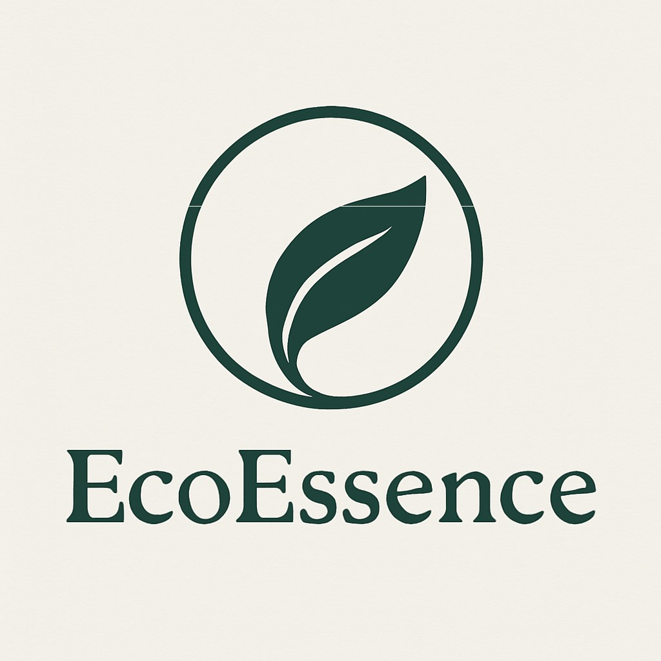
Figure 2: Brand Logo.

Appeal to the Current Market

Emerging Trends
The eventual personal care market is sustainable. In 2024, the market size will amount to USD 54.36 billion, with its CAGR amounting to 7% by the year 2032 (Fortune Business Insights, 2025). The driving force in this growth is the increased demand for products that eliminate waste by consumers. This is specifically true of the personal care sector, whereby consumers are said to be shifting towards plastic-free and refillable solutions.
Table 1 Emerging Trends.
Metric | Value
Global sustainable personal care market (2024) | USD 54.36 billion (Fortune Business Insights, 2025).
Projected market size (2032) | USD 90.40 billion (Fortune Business Insights, 2025).
Projected CAGR (2025-2032) | ~7% (Insightace Analytic, 2025)

Consumer Behaviour and EcoEssence's Appeal
The focus has been a shift in consumer behaviour; the younger generations, like the Millennials and Gen Z, have been at the forefront in expressing this preference, as 73 of the 60 countries record that they embrace a brand that shows environmental responsibility. Further, Millennials (60%) will be willing to pay a higher price for products that have environmentally friendly packaging (Insightace Analytic, 2025). EcoEssence is constructed to respond to the growing demand for highly sustainable personal care products at the high end.

Segmentation
For the EcoEssence, the table shows its segmentation for the brand.
Table 2 Segmentation.
Factor | Details
Demographics | Young professionals aged 25-40, with disposable income and a strong inclination towards purchasing sustainable, premium products.
Psychographics | Consumers who value environmental responsibility, lead an active lifestyle, and seek eco-friendly products that align with their ethical beliefs (Aggarwal, 2025).
Behavioural | Environmentally-conscious buyers who prefer brands with sustainable packaging and cruelty-free ingredients.
Geographics | Urban areas with a high concentration of eco-conscious consumers, including metropolitan cities in North America, Europe, and parts of Asia (Nikolova, 2022).

Targeting
EcoEssence's target market is a 25- 40-year-old urban and environmentally conscious group of professionals. These customers are willing to pay for environmentally friendly personal care items since they hold high values on the conservation of the environment. Such fitness will include hiking, cycling, or yoga, and they will buy the products that are befitting to their active and wellness lifestyle (Prakash et al., 2024). Being oriented to the high-income earners who are sensitive to quality and sustainability, EcoEssence will target individuals who would like to experience luxury but are still concerned about making sure that the planet they are currently on is green.

Differentiation
The company can differentiate itself by offering quality personal care goods of zero-waste, which are zero per cent hard chemicals, zero per cent cruelty, and one hundred per cent biodegradable goods (Harper, 2025). Unlike the other personal care brands available to ordinary people, EcoEssence will engage in a new method of packaging through refill shops and compostable packages and attempt to make the entire line of products plastic-free. It bases its positioning on luxury with sustainability and therefore will target consumers who would not think that it is acceptable to compromise on performance and environmental performance (Aggarwal, 2025). With essentially the backing of Zara, the image of quality offered by the EcoEssences will be appealing to consumers who have faith in the established brands of quality that are sustainable.

Positioning
EcoEssence will be a high-end, nature-friendly personal care brand that delivers high-performance products with low environmental impact. It will be regarded as a luxurious brand that does not compromise on quality and style in an attempt to be sustainable (Nikolova, 2022). The target audience will be women and men who are concerned with their personal care routine, with the brand philosophy based on personal care, excellence, and sustainability. Turning sustainability into the theme of all operations, including raw materials and packaging, EcoEssensions will be a brand that embodies an image of luxurious and ecologically conscious attitude development in the personal care market.

Element 2: Marketing Mix
The marketing mix of EcoEssence will be grounded on the 4Ps Model (Kotler and Armstrong, 2018). The associated blend is appropriate to the differentiation and positioning theories that are cantered on unique value propositions that attract the whims of the consumer and morals of the surroundings.

Product
EcoEssence will offer a luxury collection of zero-waste personal care products in conditioners, deodorants, body washes, skincare products, and shampoos (Prakash et al., 2024). It will design its products using natural ingredients such as organic aloe vera, essential oils, and environmental preservatives, and no harmful chemicals or other toxins (Harper, 2025). The brands will be sustainable as indicated in ingredients, packaging, production process, and so on, in such a way that all the products will not only bring luxury to the market, but will also be responsible.
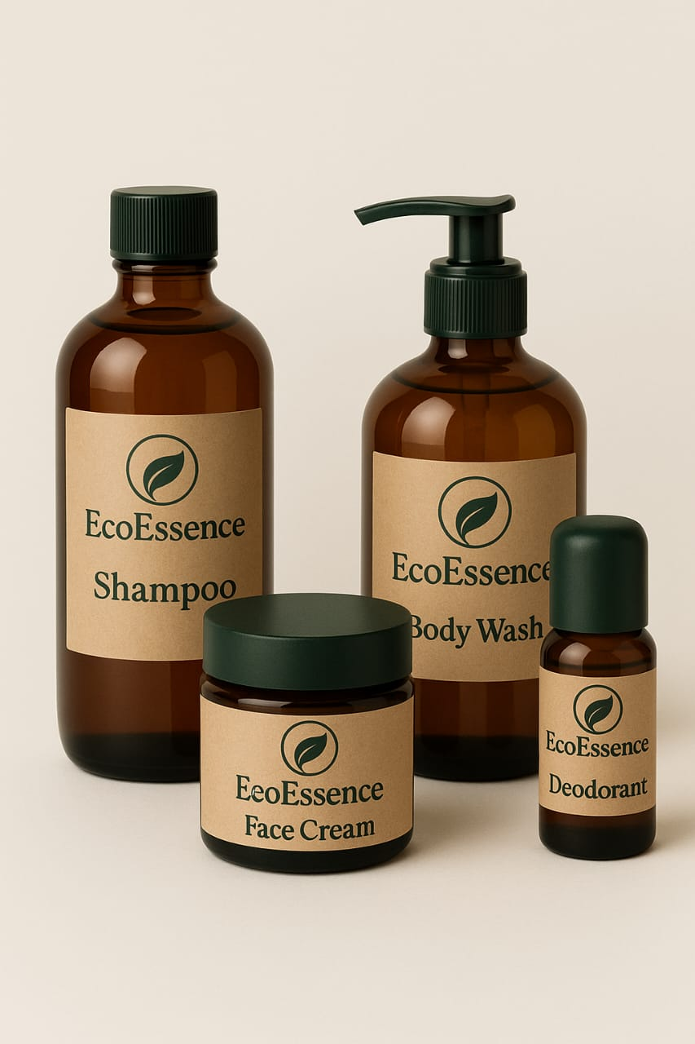
Figure 2 Product Design.

Key Product Features
- High Quality: High-quality formulations prepared using natural and friendly ingredients.
- Sustainable Packing: Reusable Bottles, Compostable Packages, and Recyclable Packages (Sang et al., 2022).
- Luxury Experience: The focus on the high-performance results, which do not rely on environmentally based values.
- Innovation: Store refill stores and delivery of sustainable products via the Internet by subscription
This is a product line that will be environmentally friendly and aimed at high performance. One of them will be an EcoEssences shampoo that will be developed to provide moisture and shine, but with 100% biodegradable packaging, and which uses only natural surfactants (Bogusz et al., 2021).
Table 3 Product type and features.
Product Type | Key Features
Shampoo | Natural ingredients, biodegradable packaging (Simboli et al., 2024).
Conditioner | Eco-friendly packaging, cruelty-free
Body Wash | Refillable options, organic ingredients
Deodorants | Non-toxic, plant-based formulas
Skincare | Customizable, organic, and eco-friendly

Price
Environmentally friendly and high-quality products, EcoEssence will position itself at the premium price positioning strategy (Harper, 2025). The approach will be aimed at those customers with the potential of purchasing luxury, eco-friendly products. It will be priced based on the sustainability and performance of the brand, so that it does not compare prices with the mass-market, non-sustainable, personal care brands. The price point will be higher than that of the regular personal care products owing to the fact that the products will be of high quality, which is sustainable (Simboli et al., 2024).
Table 4 Product Pricing.
Product Type | Price Range | Notes
Shampoo | £25–£30 | Premium quality with eco-friendly packaging
Conditioner | £20–£25 | Includes natural ingredients and refill options
Body Wash | £22–£28 | Refillable packaging, sustainable sourcing
Skincare | £35–£50 | High-performance, natural, and eco-friendly

Additionally, EcoEssence will introduce value-added pricing that will provide an alternative, such as refill stations in the large cities, because in this way the consumer will be able to refill their products at a fair price, and this will introduce the advantage of saving in the long run and minimize package waste (Setiawan and Rizkalla, 2024). They will also provide a subscription plan that will be used to give a discount to customers who choose to make regular deliveries, thus boosting customer loyalty.

Place
To reach its target market, EcoEssence will adopt direct-to-consumer (D2C) and select retailers to influence its target market as well as convenience and access amongst its customers, without seeking to compromise its premium brand image (Romero, 2020).

- E-commerce: EcoEssence will be a company with its own Internet resource, where its high accessibility will be offered with all the capabilities of the products and services of the specified subscription and a refill option (Mintel, 2025).
- Premium Retail Partnerships: EcoEssence will sign partnerships with high-end retail department stores, as well as environmentally friendly retailers and organic health stores. Through retailers like Whole Foods, Selfridges, and John Lewis, EcoEssences will be stocked in stores so that the brand will retain its high-end brand image.
- Sustainability Pop-ups and Refill Stations: EcoEssence will also introduce refill stations in the larger cities, where customers can enjoy the possibility to refill their products and reduce packaging waste, in addition to an option of refill stations that are not so expensive (Loken et al., 2023). That is in accordance with the growing trend of environmentally-conscious customers.
- Subscription Service: As an incentive to build brand recognition, they will have the option to have monthly/quarterly subscriptions on the site at a discounted price when purchased repeatedly. It is also able to have add-on subscriptions that are green, like reusable refill pouches.

Promotion
EcoEssence shall adopt the multi-channel promotion approach to generate brand awareness, attract customers, and capture a base of loyal customers (Romero, 2020).
Digital Marketing:
- Social Media Campaigns: Instagram, Facebook, and TikTok will show the attitude of the brands to the environment, performance, and environmentally friendly campaigns. Wellness and sustainability celebrities will be approached and requested to check.
- SEO and Content Marketing: The Website will consist of blogging, customer reviews, and information on a zero-waste lifestyle. The contents will be searching engine optimized to pay off organic traffic (Mintel, 2025).

Partnerships with Eco-Conscious Influencers:
- Influencer Marketing: EcoEssence will partner with influencers and celebrities who are eco-friendly, particularly in the health and wellness and eco-friendly fashion industries. These types of influencers will be promoting EcoEssence products through natural and authentic ways to their followers (Lim and Kwon, 2023).
Public Relations (PR), Discounts and Promotions
EcoEssence will also sponsor and attend the eco-related events including the eco-celebration events and eco-expos meetings. Product demonstrations, green workshops will make the brand more familiar among others (Muliyati et al., 2023). The package offerings will include a discount at EcoEssence when the product is launched, the first time or the first-time order or subscriptions. This will encourage early customers of the products. Brand loyalty will be achieved through reward programmes where customers will be rewarded whenever they make a purchase with offers such as discounts and exclusive products. EcoEssence will be positioned in such continuums as a high-end, eco-friendly, and an outstanding personal care brand.

Element 3: Marketing Strategy Pitch
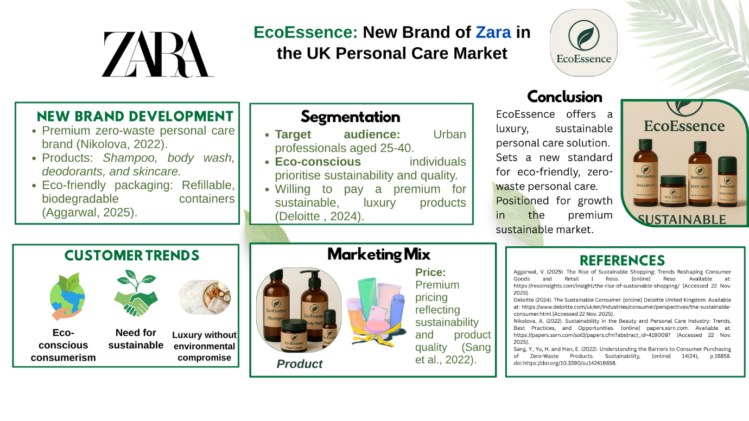
Figure 3 Poster.

Element 4: Reflection

Reflection on the Process
The process of creating the brand concept of EcoEssence was linked to addressing the most significant barriers, and, in particular, the fusion of sustainability and the opportunity to sell high-quality products. The biggest problem was ensuring that the brand is perceived as a luxury product, and at the same time ensuring that it becomes more environmentally friendly (Sharma and Bansal, 2023). Sustainability in personal care is not new, but EcoEssence was expected to stand out due to its high quality, zero-waste packaging, and natural ingredients. The problematic issue here has been to ensure that the customers do not consider these ecologically friendly products as compromises to the product quality, but rather as an enhancement to the luxurious image of the brands.
The marketing strategy development was progressive, where I applied concepts of segmentation, targeting, and differentiation (Dixit et al., 2021). The first one was to segment the market to identify who it would target, and the outcome is that I had chosen to focus on young professionals aged between 25 and 40 years old who are environmentally conscious and willing to purchase environmentally friendly luxury products. As the target audience was developed, the second step was targeting these individuals with the help of many different messages that emphasised both performance and being environmentally responsible. This marked out the final phase of presentation of the brand using marketing strategy. The pitch composition also assisted scientifically in making an intrusion between the luxury and sustainability pitch and market facts. The thought was to show the marketability aspect of a sustainable luxury brand, and pass on the message on how the EcoEssence could be fulfilling the consumer demand of being environmentally conscious without compromising on the quality.

Key Skills and Insights
It is because of this that I learned skills that would come in handy when I undertake future projects. Strategic thinking, creativity, and market analysis are the core competencies developed.
Table 5 Key skills and insights.
Skill | Description | Application for Future Projects
Strategic Thinking | Analysing long-term market potential and aligning the brand with sustainability trends (Dixit et al., 2021). | Essential for positioning future products in growing markets.
Creativity | Developing a brand that balances sustainability with luxury (Zutshi et al., 2021). | Critical in developing innovative products with market impact.
Market Analysis | Identifying trends like zero-waste solutions and understanding consumer behaviour. | Helps in creating effective targeting strategies for new markets.
Communication Skills | Structuring the pitch to be persuasive for investors and engaging for customers. | Vital for presenting future projects and proposals.

The EcoEssence development process has assisted me in augmenting my mental abilities of strategizing, branding, creativity, and market analysis. The skill is expensive with regard to the production of consumer-based and innovative brands (Zutshi et al., 2021). Next time, I will work to improve my skills in data presentation, and the means through which the trends and market potential need to be represented should be easier to comprehend and more significant.

Conclusion
The report EcoEssence also provided significant learning, which has led to the enhancement of such aspects of strategic thinking as creative thinking and market analysis. After a development process, the company was forced to be extremely sensitive to sustainability without tainting the image of a premium brand. With the help of segmentation, targeting, and differentiation, EcoEssence can appeal to the minds of the eco-conscious professional who expects his/her personal care to be luxurious and sustainable at the same time. The marketing pitch preparation experience increased the necessity to communicate effectively.

References
Aggarwal, V. (2025). The Rise of Sustainable Shopping: Trends Reshaping Consumer Goods and Retail | Reso. [online] Reso. Available at: https://resoinsights.com/insight/the-rise-of-sustainable-shopping/ [Accessed 22 Nov. 2025].
Bogusz, M., Matysik-Pejas, R., Krasnodębski, A. and Dziekański, P. (2021). The Concept of Zero Waste in the Context of Supporting Environmental Protection by Consumers. Energies, [online] 14(18), p.5964. doi:https://doi.org/10.3390/en14185964.
Deloitte (2024). The Sustainable Consumer. [online] Deloitte United Kingdom. Available at: https://www.deloitte.com/uk/en/Industries/consumer/perspectives/the-sustainable-consumer.html [Accessed 22 Nov. 2025].
Dixit, S., Singh, S., Dhir, S. and Dhir, S. (2021). Antecedents of strategic thinking and its impact on competitive advantage. Journal of Indian Business Research, ahead-of-print(ahead-of-print). doi:https://doi.org/10.1108/jibr-08-2020-0262.
Forbes. (2025) Zara. Available at: https://www.forbes.com/companies/zara/ (Accessed: 25 November 2025).
Zara. (2025) Zara official website. Available at: https://www.zara.com/ (Accessed: 25 November 2025).
Fortune Business Insights (2025). Sustainable Personal Care Products Market Size, Share [2032]. [online] Fortunebusinessinsights.com. Available at: https://www.fortunebusinessinsights.com/sustainable-personal-care-products-market-110903 [Accessed 22 Nov. 2025].
Harper, I. (2025). Zero Waste Beauty Products & Personal Care Trends for 2025. [online] Vanity Hero. Available at: https://vanityhero.com/zero-waste-beauty-products-personal-care-trends-for-2025/ [Accessed 21 Nov. 2025].
Insightace Analytic (2025). Low/Zero Waste Household Products Market Analysis 2025-2034. [online] Insightaceanalytic.com. Available at: https://www.insightaceanalytic.com/report/lowzero-waste-household-products-market/3078 [Accessed 22 Nov. 2025].
Kotler, P. and Armstrong, G. (2018). Principles of marketing. Singapore: Pearson/Prentice-Hall.
Lim, H.Y. and Kwon, K.H. (2023). Sustainable Assessment of the Environmental Activities of Major Cosmetics and Personal Care Companies. Sustainability, [online] 15(18), p.13286. doi:https://doi.org/10.3390/su151813286.
Loken, B., Joiner, C. and Houston, M.J. (2023). Leveraging a Brand Through Brand Extension: A Review of Two Decades of Research*. Psychology Press eBooks, pp.11–42. doi:https://doi.org/10.4324/9781003421320-4.
Mintel (2025). The Clean Beauty Market & The Rise of Conscious Cosmetics | Mintel. [online] Mintel. Available at: https://www.mintel.com/insights/beauty-and-personal-care/conscious-cosmetics-the-rise-of-clean-beauty/ [Accessed 22 Nov. 2025].
Muliyati, M., Fajariani, D.E., Nurhayati, N., Jaya, R. and Suryawan, R.F. (2023). Implementation Strategy Branding New Product: Promotion, Quality Product and Influencer. Journal of Economics, Management, Entrepreneurship, and Business (JEMEB), [online] 3(1), pp.43–48. doi:https://doi.org/10.52909/jemeb.v3i1.120.
Nikolova, A. (2022). Sustainability in the Beauty and Personal Care Industry: Trends, Best Practices, and Opportunities. [online] papers.ssrn.com. Available at: https://papers.ssrn.com/sol3/papers.cfm?abstract_id=4190097 [Accessed 22 Nov. 2025].
Prakash, G., Sharma, S., Kumar, A. and Luthra, S. (2024). Does the purchase intention of green consumers align with their zero-waste buying behaviour? An empirical study on a proactive approach towards embracing waste-free consumption. Heliyon, [online] 10(3), pp.e25022–e25022. doi:https://doi.org/10.1016/j.heliyon.2024.e25022.
Romero, M. (2020). Zero waste products are the future of beauty and personal care. [online] Spreading Clean Beauty. Available at: https://blog.weareprovital.com/zero-waste-products/ [Accessed 21 Nov. 2025].
Sang, Y., Yu, H. and Han, E. (2022). Understanding the Barriers to Consumer Purchasing of Zero-Waste Products. Sustainability, [online] 14(24), p.16858. doi:https://doi.org/10.3390/su142416858.
Setiawan, M.H. and Rizkalla, N. (2024). Exploring Attitude and Behavior Towards Shopping at Zero-Waste Store: An intra-personal and external factors approach. Environment-Behaviour Proceedings Journal, [online] 9(SI19), pp.39–44. doi:https://doi.org/10.21834/e-bpj.v9iSI19.5766.
Sharma, A. and Bansal, A. (2023). Digital Marketing in the Metaverse: Beginning of a New Era in Product Promotion. [online] www.igi-global.com. Available at: https://www.igi-global.com/chapter/digital-marketing-in-the-metaverse/323879 [Accessed 22 Nov. 2025].
Simboli, A., Sinibaldi, L., Taddeo, R., Rimano, M., Cutarella, L. and Casolani, V. (2024). Product Ecodesign: An Application of Bio-Based Materials in the Personal Care Packaging Industry. Circular Economy and Sustainability. doi:https://doi.org/10.1007/s43615-024-00383-5.
Zutshi, A., Mendy, J., Sharma, G.D., Thomas, A. and Sarker, T. (2021). From Challenges to Creativity: Enhancing SMEs’ Resilience in the Context of COVID-19. Sustainability, 13(12), p.6542.

Appendix

Appendix A Market Competitiveness
Competitor | Strengths | Weaknesses | Opportunity for EcoEssence
Neal’s Yard Remedies | Established UK natural brand, organic credentials, loyal customer base. | Premium pricing may limit mass appeal; less focused on zero-waste packaging (Deloitte , 2024). | EcoEssence can differentiate via zero-waste packaging + luxury performance.
Beauty Kitchen | Strong sustainability claim, use of reusable/recyclable materials. | Being niche small size; may lack premium luxury feel or broad distribution. | EcoEssence can position higher up as “premium sustainable” brand with wide reach.
Baylis & Harding | Good UK distribution, “affordable luxury”, some natural/vegan ranges. | Not purely zero-waste; packaging may still use conventional plastics. | EcoEssence can build on “100% zero-waste + luxury” to target consumers who demand both (Muliyati et al., 2023).
EcoEssence | Premium positioning, zero-waste packaging, natural high-performance formulation. | Must build brand awareness; premium pricing could reduce initial adoption. | Opportunity to lead the niche “luxury zero-waste personal-care” category in UK.

Appendix B Product list with prices
Product Type | Size | Price (GBP)
Shampoo | 250ml | £25
 | 500ml | £45
 | 1L | £85
Conditioner | 250ml | £22
 | 500ml | £42
 | 1L | £80
Body Wash | 200ml | £20
 | 500ml | £40
 | 1L | £75
Deodorant | 50g | £18
 | 100g | £35
Face Cream | 50ml | £30
 | 100ml | £55

