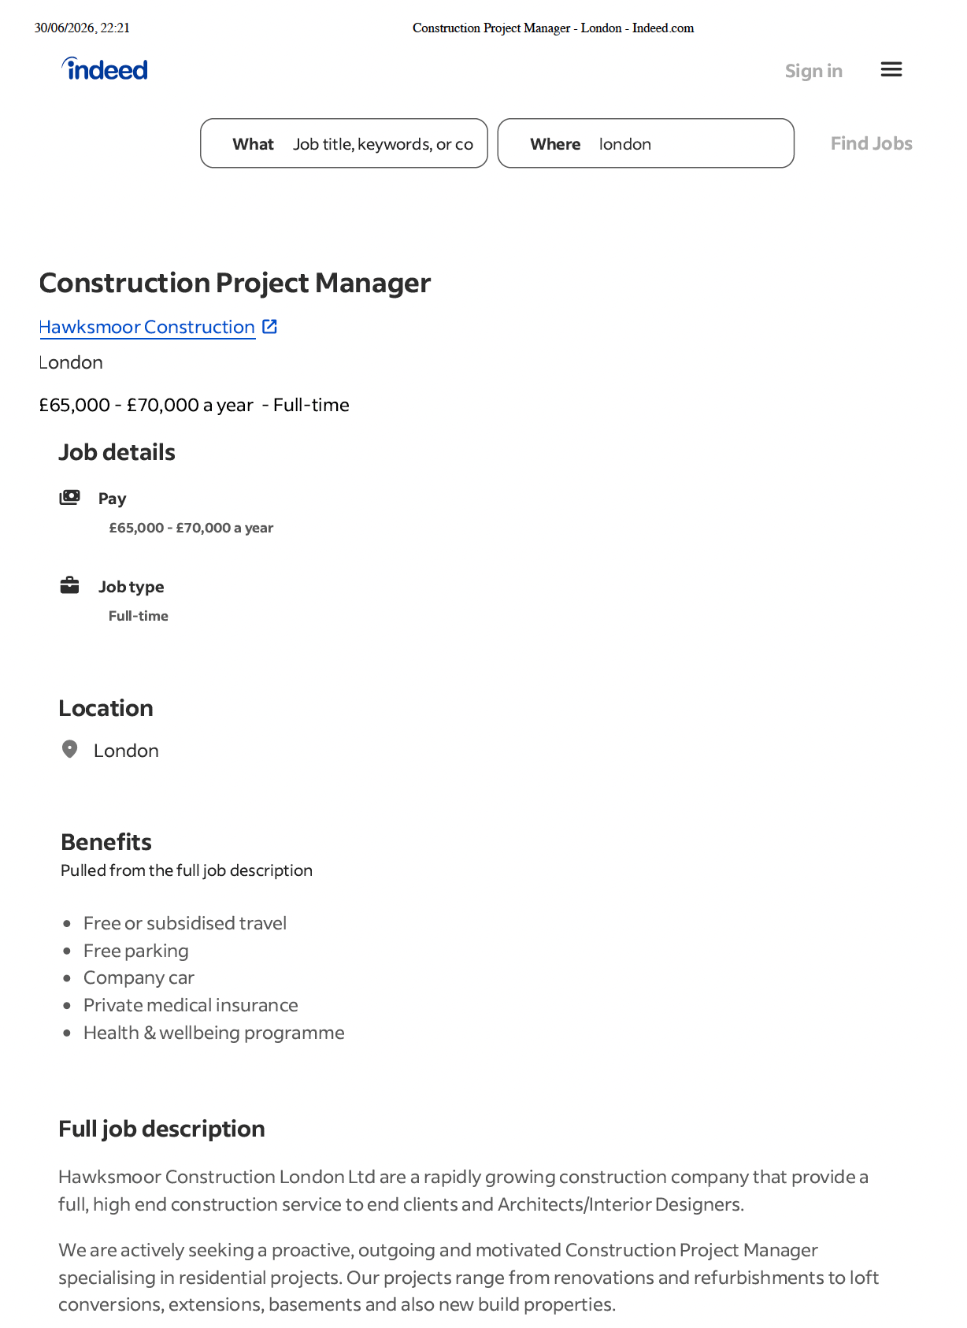

COVER LETTER

Ion Cupcea
15 Andrew Close
IG6 2UG, London
ion96cupcea@gmail.com
07404 163726

Hawksmoor Construction LTD
Unit 4, ABBOTS BUSINESS PARK
Kings Langley, WD4 8FR

Date: 10/07/206

Dear Hiring Manager,

I am writing to apply for the position of Construction Project Manager at Hawksmoor Construction. Having worked in construction for over a decade in the UK, I have gained extensive hands-on experience of site operations, project coordination and leading teams. As a Construction Fixer I have worked closely with Site Managers, subcontractors and project teams to ensure work is carried out safely, efficiently and to the highest standard. During my career I have frequently coordinated small teams, planned daily work tasks and aided in the successful completion of residential and commercial projects throughout London. These duties have allowed me to further develop my communication, organisation and problem-solving abilities and have inspired me to seek a career as a Construction Project Coordinator. I am currently holding a Blue CSCS Card, as well as a Full UK Driving Licence. I also have advanced English language skills. I am comfortable working in fast-paced environments, multi-tasking and forming strong working relationships with colleagues, contractors and clients. I look forward to the possibility of joining your company and bringing my experience to the team, whilst further developing my career in construction project management.

Thank you for your time and consideration.

Yours faithfully,
Ion Cupcea

ION CUPCEA
CONSTRUCTION PROJECT COORDINATOR
Contact:
074041163726
Ion96cupcea@gmail.com
London

PERSONAL PROFILE

Dedicated and highly experienced construction professional with over 10 years of experience delivering residential and commercial construction projects throughout London. Extensive practical knowledge gained as a Construction Fixer, combined with proven experience coordinating site teams, organising daily work activities and supporting Site Managers to ensure projects are completed
safely, efficiently and on schedule.

SKILLS

- Construction Project Coordination
- Team Leadership
- Time Management
- Quality Assurance
- Reading Technical Drawings
- Problem Solving
- Site Operations & Planning
EDUCATION

- High School Diploma (Moldova, Vasile Alexandri)
- University of Wales Trinity Saint David (UWTSD), London
- Certificate of Higher Education (CertHE) – Business Skills for the Workplace

PROFESSIONAL CERTIFICATIONS

- Blue CSCS Card
- Gold Card
- First Aid
- IPAF
- Pasma
EXPERIENCE

Construction Fixer (2015 – Present)
Various Construction Companies – London
Key Responsibilities:

- Installed construction systems following technical drawings and project
- specifications.
- Coordinated daily activities of site operatives to ensure work was completed
- safely and efficiently.
- Assisted Site Managers in organising daily workloads and monitoring project
progress.
- Worked closely with subcontractors, engineers and different construction
trades.
- Maintained excellent communication between site teams and management.
- Ensured compliance with Health & Safety regulations and company
procedures.
- Monitored quality standards throughout construction works.
- Reported site progress and potential issues to senior management.
- Supported successful completion of residential and commercial developments

LANGUAGES

Romanian and Russian native

REFERENCES: On Request

