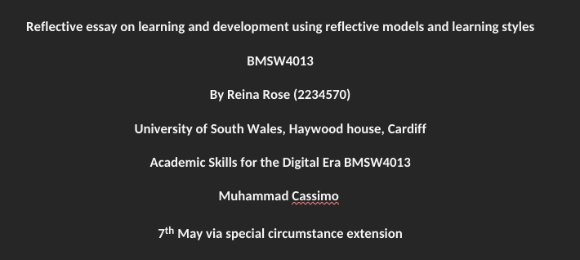

Retrieving a definition from the recommended reading list The Oxford Handbook of Career Development - Robertson. Hooley & McCash,(page 275), eloquently explained the definition of reflective writing for students, ‘reflective writing enables young people to discover themes in their lives, focus on the positive elements..., and explore future scenarios by telling their story’. I must stress in this case it must be stressed that here the style of writing is ‘reflective’ as opposed to ‘descriptive’ (source slide snapshot on reflective piece on canva) for the sole reason we will be offering thoughts, reflecting on them and applying questions where it can increase the depth in probing our reflective learning experience and my experiential development on the course. When we go into the course we veer into what resonates with our interests, abilities and past professional, vocational and academic undergoing. For some students it would be something very new in terms of choosing an academic course, for others it may be a scaffolding to their previous learning, for me it was more specific, as I did an NVQ in IT & Administration level 2 in college and then went onto studying business studies in GCSE and then I watched business-related online content for some years before doing a foundation degree year in advertising. I have other disciplines that work with this course such as soft skills from my interest in psychology in communication and persuasion, yet I feel it is still very important to become more detailed in our/my approach to self-exploration in terms of refining our portfolio of learning and looking for an end goal. In his landmark writing Frank Parsons (1909) Choosing a vocation, Houghton Mifflin publications he writes (page 2) about ‘a threefold matching process of occupational choice: understanding yourself, understanding the requirements of different lines of work, and ‘true reasoning’ on the relationship between them’. This is an excellent starting point at any stage of your career. Yet unfortunately when we do not probe these questions we end up flogging to the next opportunity en masse, often determined to fit into those roles so badly that we actively shoe-horn ourselves into those roles. Also when we are unable to retrospect as Parsons inspires us to do we end up unconsciously thinking in the inversion (https://www.dictionary.com/browse/inversion ) -a noun; an act or instance of reversing in position, changing to the contrary, or turning upside down, inside out, or inward), in critical thinking, ‘you consider the opposite of what you want, is known as inversion’ (https://jamesclear.com/inversion - (author of New York Best Seller ‘Atomic habits’), a deeply unconscious, unspoken anxiety resulting from a void where there wasn’t encouragement to retrospect this way. Yet the blog by the ‘Atomic habbits’ author tells us ‘Great thinkers, icons, and innovators think forward and backward.

Occasionally, they drive their brain in reverse’. Which just means in layman’s terms, what if it worked and what if it did not?

The above points lead us to look at discovering the newfound opportunities for personal growth within the course. We have been introduced to many models of reflection and Gibbs is one -re referred to in lectures. I feel the Gibbs method lacks objectivity, to understand exactly how Gibbs intended for this form of reflection to work I would have to read his book ‘Learning by Doing, Graham Gibbs’ and I have been unsuccessful in retrieving this book in print or electronic format from any libraries. Hence feeling suspended in the vagueness and what it means when asked ‘feelings, what were you thinking/feeling’, instantly in my logical mind I am led to think what I was feeling is wrong. It’s just my feeling and hence I would have liked Gibbs to provide a key with his reflective learning diagram that explains the intent of reflecting on feelings is to work on and turn your fears around, or to take yourself out of that situation and look to where it is more comfortable so you can gradually build yourself up. Some sources say the purpose of Gibbs is to learn through repetition which might be interpreted as immersive learning, but I would like to read that in Gibbs own writing not through secondhand sources. Although I far prefer Kolb to demonstrate immersive learning (compared to Gibbs), I chose SWOT reflection method for this paper. (Appendix. Why Kolb’s learning is more affective)

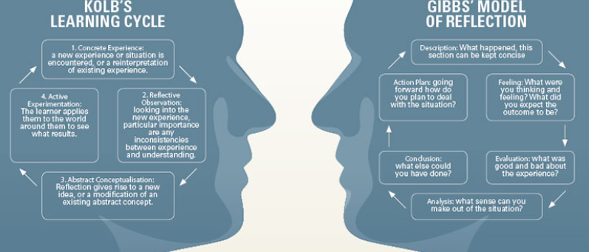
Strengths  My strengths are that I have an eye and ear for learning to identify processes. When and how often to use intermittent communication to remind /convert clients to customers. To identify reasons why customers spend and why they don’t spend. To apply classifications in the socio-economic market and what is the motivation or underlying reason to be in that category. i.e primary, secondary, tertiary, and other theories related to this and related to marketing. I have good articulation and likeability and an understanding of what personal branding is.  Opportunities  My opportunities lie in the opportunities I am aware of  and potentially in the blindspots. Opportunities can arise  in the talent others see in you or the talents we can see in ourselves but may not show, these are both blindspots,  the latter we have to do something to take our skills to others because they are likely not to approach us (Johari Window model).  I see opportunities in the community currency sector, in  acting as an agent to help uncover ways of reaching  customers for a variety of industries that peak my  attention.  I have learned there are many separate mechanisms  that make a business work. Luckily we can source some of these outside of ourselves, and delegation is a very real possibility. | Weaknesses  My weakness is my strength. When I find myself struggling, I pivot and move. I often return when I have better insight on what did not work. More knowledge can be acquired as a buffer, but sometimes a successful business plan doesn’t require so much planning. So perhaps I can dip my toe into trying more.  In the past, I beat myself mentally over my lack of ability with numbers/meeting targets/lack of insight or energy.  So maybe I don’t fit into an organisation, but I can still benefit from the presence of the organisations even if it is finding the right person to sell my knowledge through them.Alas the weakness I most have is doubting I appear  enough of a ‘personal brand’ to a wider section of people.  Threats  My mechanism for combating threats is to be niche,  and stay niche. Any product you sell that has a strong  resonance with the sense of identity of the client  makes the client stay. Understand through facets of critical thinking, why this customer came to me?  What do they want? Why have they stayed? What will make them stay? How to stay relevant to them?  Many a time customers think many companies do not represent them but give precedence to their 'high ticket clientele'
A big requisite for success is to learn. Or rather apply information in the real world. From the class questionnaires (source class questionnaires) to determine learning styles I have a healthy balance of ‘reflector’, ‘activist’ and pragmatist’ (Honey and Mumford learning styles). Which means I will find new ways of actively and immersively doing things even in a capacity to observe or volunteer or just my natural inquisitiveness to put pieces together to see the connecting factors. In the world of marketing, a component of bringing in business is also a substantial component, and we need to hold onto that skill and rejoice until we can create structures with as little or as many components needed. By components I mean people or systems that can generate a successful outcome. I have a decent balance of being ‘intuitive’, ‘logical’, ‘doing’ and ‘observing’. Although I appreciate theorists I find other modes of information and pattern-seeking in my free-flow nature for learning. Once I have the information - I weave together principles and seek out disparities or complimentary qualities, I am not one to mull over. But an idea stays with me a long time and even if I forget, my places of interest bring me back there, hence I believe in a formula called ‘Schema building’ or scaffolding and that is how I learn.
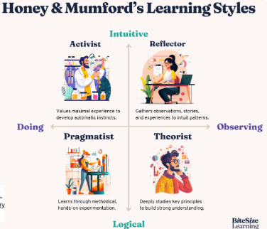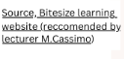

I will conclude the essay with the ‘fishbone’ reflective diagram, and using the ‘3 why’s’ where we look at causal effects leading to outcome. This fish diagram can also be perceived as an Inversion theory diagram, the outcome is to develop through graduating the class, why do I want to graduate? Reason, it’s a worthy investment, why is it a worthy investment? It’s wasted time put to good use, why is it wasted time put to good use? Because I will learn the vital tools for self-branding. What is self-branding? It is a combination of hard and soft skills, it’s a combination of knowledge and the self-awareness and tools to achieve self-branding. What do you hope to achieve from self-branding? A sense of purpose, some ability to maximise income (no set limit) with a growth mindset, to find satisfaction in your sense of self-worth and to keep trying to achieve a lifestyle closer to your dreams, not necessarily defined by the monetary outcome but by good decisions.


