Effective Team Working and Communication

Student Name: Chis Ileana Ioana
Student ID: 1818454

Lecturer Name: Navami Sudarsan
Submission Date: 26 August 2019

Contents
Introduction 2
The ways communication can be made effective in BT (British Telecommunication group) 3
Relevant theories (Shannon and Weaver, Schramm and Berlo) 3
The essence of “noise” between encoded and decoded messages 4
Not just physical noise as in case study Pedro and Maria 4
But noises created by different educational/social/language difficulties (Schramm and Berlo) as in “the professor and the village people” 5
The need for feedback between decoder and encoder so that message is clarified 5
The importance of effective communication (from my own experience) 6
Methods of communication-verbal, written etc. 7
How does communication work between management and employees and to what purpose? Tone/choice of language/level of formality 7
Conclusion 8
References 9

Introduction
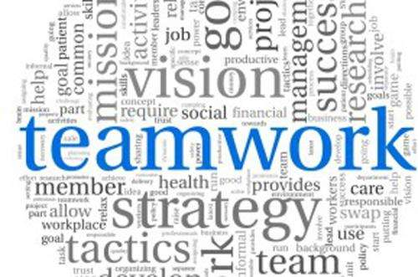
When a/an work or activity or task which is accomplished through several people with collective efforts then it is called teamwork. While effective teamwork denotes the teamwork which becomes efficient and effective from all perspectives like productivity, input, outcome, coordination etc. and so on. Communication has been used for introducing different things of any sorts in an organization or any other sphere to the relevant members while communicating means to do so that means exchanging or introducing information (Edx.org, 2019). Now, comes the effective communication which is like to exchange or introduce information in accordance with the assigned rules and instructions in any entity. Aside from these ,the portfolio will demonstrate in a business organization the ways relevant authorities can make communication effective, theories like Shannon and Weaver, Schramm and Berlo in regards to the communication related aspects , own or friend’s experience on the significance of effective communication ,different methods of communication like the verbal , written etc., and lastly ,the ways communication works in between the management and employees and for what purposes as well as the level of formality observed there from the perspective of BT(British Telecommunication group).
The ways communication can be made effective in BT (British Telecommunication group)
BT is a telecommunication group of the UK which has businesses across the globe. In around 180 countries of the world it has activities while it headquarter in London, UK .As, it is telecommunication group it deals with issues of communication (in general terms) as well as communication is very significant for this organization. But, the communication of this organization is not that much effective therefore, some ways have been explained through which communication of this organization can be made effective (Brooks, 2019). Such as-developing a communication strategy- the organization has communication lack for making the communication effective it needs to develop a strategy , a communication process which might be through verbal or any other processes which will make the communication smooth and effective as everything follows specific process, listening is the number one way to make communication effective therefore, the company should focus more on this ,the ways the company will communicate or fix for communication should be better explained for the purposes of getting better outcome from the communication process and communication itself ,lastly , the feedbacks processes that means the company must have feedbacks processes through which the stakeholders of the company can be able to share their ideas and different issues regarding to the communication which can make the communication effective of this organization .If the organization follows the mentioned ways then its communication is must for being effective as the ways are the best ones out of others around.
Relevant theories (Shannon and Weaver, Schramm and Berlo)
Communication is the processes which can be made through different ways and when it will be in line with the demands of an organization then it is must for the organization to come up with something good for it. There are some theories of communication such as-
Shannon and Weaver -model of communication
This model is defined as the mother of communication which describes that communication is a process which follows a specific process and involves several stakeholders or mediums like sender ,receiver, noise and so on (Al-Fedaghi, 2012).This model is also regarded to the social processes and policy in terms of analyzing them moreover, shows the difficulties regarding to the effective communication .But, with the passage of time this model now-a-days is not discussed or used that much in communication.
Schramm and Berlo-model of communication
Berlo provided the explanation of linear transmission model of the communication which includes the sender, receiver, messages and others. While on the other hand, Schramm provided the model which identified some variables of communication like transmitter, encoding, decoding and so on.
These two theories of communication together with have enormous influence on communication as well as effective communication.

The essence of “noise” between encoded and decoded messages

Encoding of message refers to producing message which has coded meanings while on the other hand, decoding refers to the ways the audience can understand the coded messages (Bradley, 2010). In the process of communication the noise has great influence specifically the effective communication. Apart from that , noise is the influences which influence the process of communication .The noise can be of like physical and psychological and so on which can be created by stakeholders who are in communication process. Anyway, in between the encoded and decoded messages noise refers to the influencers or influences which have impacts on coding or decoding of messages.

Not just physical noise as in case study Pedro and Maria
In line with the case study of the Pedro and Maria, the communication is a process which gets started from the end of sender or source and ended by target or receiver. Moreover, the message follows a channel which includes semantic, physical, psychological, and physiological noises. According to the study of Pedro and Maria, the physical noise is the stimulus from environments around us which distract us from the effective process of communication. But, except the physical noise in this case study there are other noises like semantic, psychological, and physiological noises which also have influences on the communication processes.

But noises created by different educational/social/language difficulties (Schramm and Berlo) as in “the professor and the village people”
Noise is not only created by the factors or influencers mentioned in the case study of Pedro and Maria like semantic ,physical ,psychological , and physiological noises but also by other many factors or actors like different difficulties of society ,language and education as per the model of communication of Schramm and Berlo. In line with their theory, noise can be created or can come from different factors or stakeholders of the society like people while from the educational institutions the students, teachers can be the creators of noise, while lastly, language difficulties are like different languages in communication and so on.

The need for feedback between decoder and encoder so that message is clarified
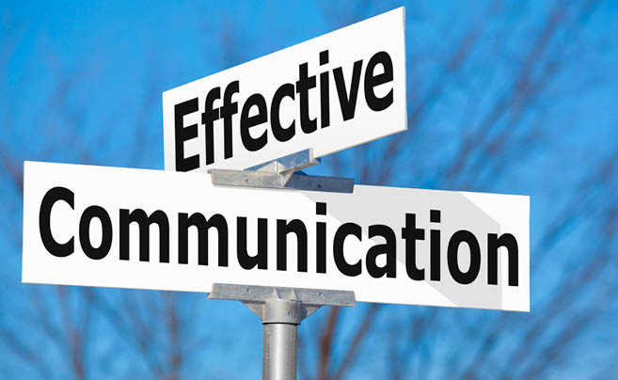
Coding and decoding are getting famous day on day in case of communicating and exchanging messages. In case of communicating through coding and decoding the messages should be clarified and the two ends need feedbacks properly (Electronics et al., 2019). There have needs of feedbacks in between these two ends for the purposes like when feedbacks will be available then the difficulties in communication will be specified and identified which is very significant for making communication effective, the sender and receiver of information can understand the problems regarding to them thus they can rectify and get prepared for communicating effectively and for so many other purposes.

The importance of effective communication (from my own experience)
Effective communication as already described, is very significant for any entity .In this segment the significances of effective communication will be illustrated from my perspective or experiences. Such as-effective communication is the only one way which can facilitate communication (Lincoln, 2010) .When in an organization there will have communication then there will have the opportunities for free flow of information when information will flow free then different ideas will be easily gathered which can result in or contribute in innovation enormously. Effective communication can build and maintain relationships in organization perfectly. In an organization there might have different sorts of communication which stay alive due to the effective communication .In team building the effective communication can be the best assister as it helps building the relationships better and perfect moreover, the members of team have the opportunities to share ideas among them .When from the all levels of management proper or effective communication can be maintained then it becomes easier to manage employees as better communication can provide the ways to manage the employees properly .Every organization or company has a goal among others to grow organization as long as it can . Apart from that, when everything will be effective in organization then organization will grow faster and to the extent an organization desires and here the effective communication can play the most significant role to make everything effective through building relationships and creating a sense of ownership among the employees and other stakeholders of the organization .thus, effective communication can be effective for an organization.
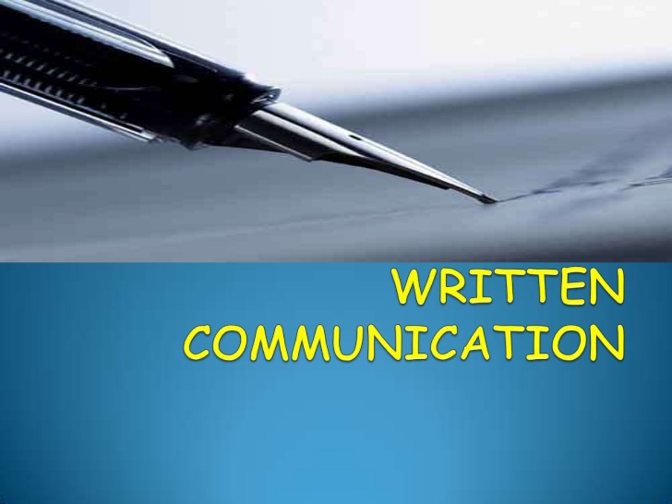
Methods of communication-verbal, written etc.
Communication can be accomplished through several processes and channels as well as methods. Some most discussed and widely used methods are written, oral or verbal and others (Robinson, 2019). In this segment for effective communication the methods of communication like the written and verbal will be illustrated. Written communication and the verbal are the mostly used methods in the world and different organizations for maintaining communication effectively. For written communication the sender and receivers or the actors involved in the communication process some tools for communication like pen ,papers ,and relevant alphabets in order to communicating with one another . Written communication system or method made the communication process effective and easier for long since as through it the communication becomes more facile and clear than any other methods. On the other hand , the verbal which is the first among the communication methods and has been used from the time of inception of human civilization (Special Issue on Computational Methods, 2017).At the inception of human civilization the written and other methods were absent sans the verbal one . It illustrates to communicate face to face or using tools like mobile, pc or other means while the stakeholders of this method stay connected or present which does not take place in written communication .Verbal communication is easier, time and cost saver and instantly can be communicated through this method.in an organization for making or maintaining effective communication both of the ways or methods of communication are used widely.
How does communication work between management and employees and to what purpose? Tone/choice of language/level of formality
Organizations use communication for various purposes while out of these for management and employees communication is used the most (Singh, 2014) .The management side of organization uses communication for managing the employees of this organization better. For the purposes like managing the employees , for encouraging the employees ,for making better relationships as well as maintaining these, for involving employees in different processes of the organization, for checking the extent of goals or objectives achievement , and for evaluating the performance of employees the communication is used between the management and employees. Between the management and organization virtually both the formal and informal language and level of tone or voice is used to communicate but it depends on situations as well as the types of communication or understanding between management and employees .Interestingly, all of these are seen in my organization BT.

Conclusion
Effective teamwork depends heavily on effective communication which can build effective teams as well as relationships among the members of the teams. Aside from these, in an organization there are no alternative of effective teamwork as well as effective communication .In BT there needs effective communication more which can help it to reach an altitude which is unthinkable. However, this portfolio has demonstrated in a business organization the ways relevant authorities can make communication effective, theories like Shannon and Weaver, Schramm and Berlo in regards to the communication related aspects , own or friend’s experience on the significance of effective communication ,different methods of communication like the verbal , written etc., and lastly ,the ways communication works in between the management and employees and for what purposes as well as the level of formality observed there in the context of BT(British Telecommunication group).

References
- Al-Fedaghi, S. (2012). A Conceptual Foundation for the Shannon-Weaver Model of Communication. International Journal of Soft Computing, 7(1), pp.12-19.
- Bradley, D. (2010). Noise. New York: Bantam Spectra.
- Brooks, S. (2019). 5 ways to make communication more effective. [online] Blog.ttisuccessinsights.com. Available at: https://blog.ttisuccessinsights.com/5-ways-make-communication-effective [Accessed 25 Aug. 2019].
- Edx.org. (2019). [online] Available at: https://www.edx.org/course/communication-skills-and-teamwork [Accessed 25 Aug. 2019].
- Electronics, B., Electronics, D., Instrumentation, E., kumar, v. and Virani, A. (2019). Difference Between Encoder and Decoder (Comparison Chart) - Electronics Coach. [online] Electronics Coach. Available at: https://electronicscoach.com/difference-between-encoder-and-decoder.html [Accessed 25 Aug. 2019].
- Lincoln, M. (2010). Fundamentals of communication skills. Delhi: Manglam.
- Robinson, L. (2019). Effective Communication - HelpGuide.org. [online] HelpGuide.org. Available at: https://www.helpguide.org/articles/relationships-communication/effective-communication.htm [Accessed 25 Aug. 2019].
- Singh, S. (2014). Communication management. New Delhi: Anmol Publications.
- Special Issue on Computational Methods. (2017). Communication Methods and Measures, 11(2), pp.150-150.



