
Master of Business Administration
Human Capital Management (Module Code: LCMB7023)

Lecturer: Dr. Charles Oham

Assignment Title: Integrated Human Capital Blueprint

Student Name: Abu Siddik
Student ID: 2504940
Group: 02

Word Count: 2693

Executive Summary
Aether Innovations is a fast-gaining technology company that employs 300 people but experiences stagnational growth, high employee turnover, and poor user satisfaction. This report will have a detailed Human Resource Management (HRM) strategy in order to solve these problems by re-engineering the performance appraisals and job design. The plan utilises modern HRM science, such as 360-degree feedback and OKRs (Objectives and Key Results) to improve employee engagement, motivation, and performance.
The report suggests a contemporary performance appraisal system to combine 360-degree feedback with the use of OKRs to align organisational goals with personal ones to provide staff members with continuous feedback on their development. Also, the Job Characteristics Model (JCM) will enlighten job redesign to promote autonomy, skill variety, and task significance in key roles. This integrative strategy will build the culture of performance at Aether Innovations to guarantee long-term growth and success through enhancing employee motivation, satisfaction, and retention.
Such an integrated HR approach will help to improve performance in the organisation, foster innovation and coordinate individual efforts to the overall business objectives.

Table of Contents
1. Introduction 4
2. Part 1 - Re-Engineering Performance & Job Design 5
2.1 Current Practices in Performance Appraisal in Tech Industries 5
2.2 The job design approaches among the tech companies 6
2.3 Proposed Performance Appraisal System 6
2.3 Job Analysis, Job Descriptions, and Job Specifications for Key Positions at Aether Innovations 8
2.3.1 Job Analysis Approach 8
2.3.2 Job Descriptions for Key Executive Roles 9
2.3.3 Job Specifications for Executive Roles 9
2.3.4 Application of the Job Characteristics Model in Leadership Job Design 10
2.4 Linking Performance & Job Design 11
3. Conclusion 12
4. Part 2 - Reflection 13
4.1 Learning from Human Capital Management 13
4.2 Future Career in the AI Era 15
5. References 16

1. Introduction
. According to Ulrich (1997), the term Human Capital Management (HCM) focuses on the alignment of HR practises to organisational objectives to lead to business performance and innovation. Aether Innovations is one of the technology companies that is currently undergoing tremendous problems in case of its HCM, such as low growth rate, high rate of employee turnover and poor customer satisfaction though the company is a fast-growing company with a workforce of 300 employees. To address these concerns, this report proposes an integrated Human Resource Management (HRM) solution, both in terms of job design and performance appraisal re-engineering.

2. Part 1 - Re-Engineering Performance & Job Design

2.1 Current Practices in Performance Appraisal in Tech Industries
Performance appraisal system can be defined as the methodical assessment of the performance of the employees to enhance their productivity, development and alignment to the organisation objectives (Atchison, Belcher, and Thomsen, 2024).
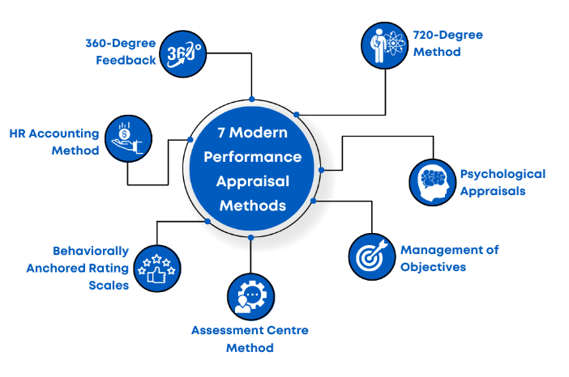
Figure 1: Performance Appraisal Systems
Source: (Pocket HRMS, 2026)
In the current technology companies, performance appraisal has become more and more based on continuous feedbacks, data-driven performance evaluation and human development to remain innovative and responsive. In particular, Atlassian implements a performance framework that focuses on frequent check-ins in the form of so-called Health Monitor and team feedback that is built into the Jira platform to allow tracking collaboration and productivity in real-time (Atlassian, 2024). similarly, Salesforce operates under a model of continuous performance management, its so-called V2MOM (Vision, Values, Methods, Obstacles, Measures) framework, where the individual goals are aligned with the organisational strategy, and a high level of feedback and transparency are encouraged (Salesforce, 2023). SAP has replaced the annual reviews with a model of continuous performance and coaching, backed by its SuccessFactors platform, a combination of real-time feedback, goal tracking, and development conversations to increase the engagement of the employees (SAP, 2024). Along with it, Intel has a developed application of an OKR-based appraisal system with continuous performance discussions and peer feedback that makes sure it is aligned with the strategic priorities and impetuses accountability and innovation (Intel, 2023).
These institutional practices prove that current form of appraisal systems feature agility, transparency, and life-long learning which are paramount towards overcoming certain issues like lack of engagement, high turnover, and deteriorating performance in Aether Innovations.

2.2 The job design approaches among the tech companies
The technology companies have job design based on flexibility, collaboration, and autonomy to boost innovation and engagement. Indicatively, Atlassian encourages team independence by using cross-functional squads and its Team Playbook, which allows employees to manage themselves and enhance the efficiency of the work process (Atlassian, 2024). Salesforce bases their roles on V2MOM framework, which helps provide clarity in purpose and alignment between specific tasks, as well as the organisational objectives (Salesforce, 2023). Likewise, SAP embraces flexible and working hybrid jobs with the assistance of digital platforms to promote collaboration and skill building (SAP, 2024). Intel focuses on team-based work and empowerment, which enables employees to work in any area, which promotes innovation and responsibility (Intel, 2023).

2.3 Proposed Performance Appraisal System
In the case of Aether innovations, the appraisal system will be rebuilt in the form of quarterly OKR with monthly check-in and targeted 360-feedback form, as opposed to a generic annual review.
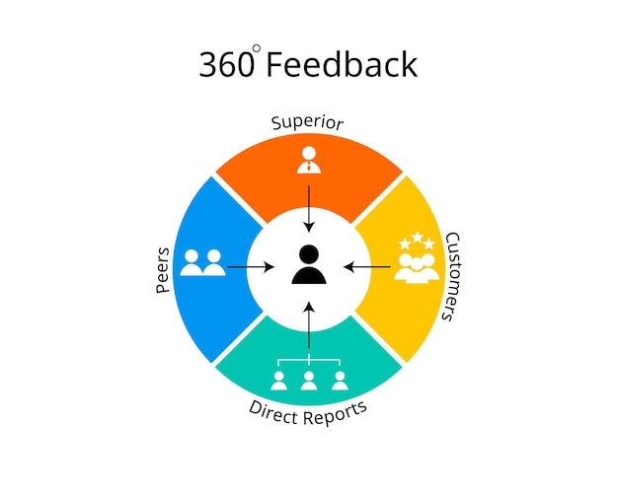
Figure 3: 360-Degree Feedback; Source: (BrioHR, 2024)

Since the corporation experiences flat growth and high turnover, as well as declining customer satisfaction, the appraisal of every employee must be based on three business-specific outcomes such as, the speed of product delivery, the quality of innovation, and the experience of customers. To illustrate, engineers are expected to be evaluated based on the reliability of the sprints, the decrease of defects, and contribution to new features; product managers on the feature adoption and delivery across the functions; customer success teams on the resolution of the tickets, the improvement of the NPS/CSAT, and the retention support (BrioHR, 2024). This directs performance to the current business issues that Aether has instead of utilising broad behavioural ratings in isolation.
An effective system would establish 3 quarterly OKRs per employee, 2 role-performance OKRs, and 1 growth OKR, such as, “20% fewer post-release bugs” or “AI product analytics certification”. Managers are then advised to implement monthly coaching check-ins of 30 minutes that are based on progress blockers, wellbeing, and skill development as opposed to the previous aspect of annual-only (Deloitte, 2025). It helps to embrace ongoing performance dialogues, which facilitate the work in fast-paced companies better than retrospective reviews.
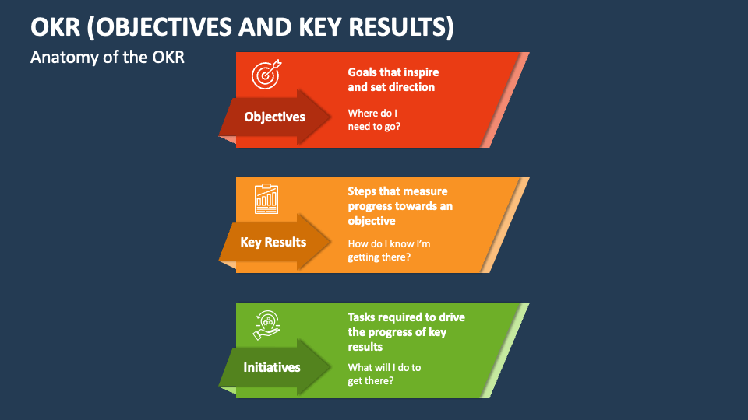
Figure 4: The OKRs Framework, Source (Deloitte, 2025).
To minimize silo working and enhance teamwork Aether ought to employ 360-feedback on the team leaders, managers, and high-impact cross functions every half-year, and peer feedback, direct reports, and internal stakeholders. This is significant since incompetent teamwork in technology companies usually harms creativity and consumer experiences (BrioHR, 2024).
Lastly, the results of appraisals ought to be associated with individualised development plans, internal mobility, and recognition, as opposed to pay alone since growth-based systems enhance engagement and retention since employees are able to observe clear career progression (Boxall and Purcell, 2016).

2.3 Job Analysis, Job Descriptions, and Job Specifications for Key Positions at Aether Innovations
Job analysis is fundamental to the establishment of precise roles, skills and objectives of every position at Aether Innovations (Brannick, Levine, and Morgeson, 2019). The selected process will facilitate autonomy, skills utilisation, and innovation through the Job Characteristics Model (JCM), which will raise the motivation and satisfaction of employees by designing jobs with high task significance and feedback.

2.3.1 Job Analysis Approach
The job analysis of key executive positions will determine the job content and context, core responsibilities, skills and the overall role purpose. The objective is to incorporate the appropriate competencies in every position to facilitate high performance and organisational objectives. Job Characteristics Model will be used to improve the motivation of employees by adding autonomy, skills variety, task importance, and feedback to every role.
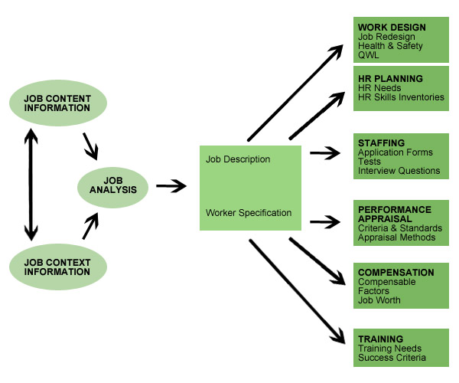
Figure 4: Centrality of Job Analysis, Source; Source: (Atchison, Belcher, and Thomsen, 2024)
Atchison, Belcher, and Thomsen (2024) argue that job analysis provides crucial information on what work is and how it satisfies the organisation.

2.3.2 Job Descriptions for Key Executive Roles
The six executive positions in Aether Innovations are outlined below, and they are structured to achieve innovation, autonomy and use of skills.
Position | Job Description
CEO | Establishes strategic direction, which is in line with business objectives, and manages innovation and organisational development.
CFO | Financial planning, budgeting, and risk management Involved in advising the executive team on financial matters.
CTO | Manages technology strategy, alignment with business goals, new technology management, and system scalability.
CIO | Drives innovation strategy to streamline technology and business processes to enhance efficiency and competitiveness.
HR Directors | Manages recruiting, training and organisational development, aligning HR practises with business objectives.
Head of R&D | Heads the R&D department, with interests in innovation, technological advancement, and product development.
Table 1: Job Descriptions for the six key positions of Aether Innovations

2.3.3 Job Specifications for Executive Roles
Job descriptions will be aimed at the required qualification, skills and experience to attract the right candidates to occupy each post:
Position | Job Specifications
CEO | Qualifications: MBA or equivalent; Skills: Leadership, strategic thinking, innovation; Experience: 10+ years in executive roles, ideally in tech.
CFO | Skills: Financial analysis, forecasting, risk management, CPA, CFA; Experience: 8+ years in finance, experience in high-growth environments.
CTO | Qualifications: Engineering/Computer Science degree; Skills: Technical leadership, IT strategy; Experience: 8+ years in tech leadership.
CIO | Qualification: Master in IT or Business; Experience: 8+ years in technological innovation.
HR Directors | Qualifications: Bachelor of HR Management, Skills: Communication, Leadership; Experience: 7+ years in HR management including scaling experience.
Head of R&D | Qualifications: Ph.D. or master’s in engineering or science; Skills: Product Development; Experience: 7+ years of managing R&D teams.
Table 1: Job Specifications for the six key positions of Aether Innovations

2.3.4 Application of the Job Characteristics Model in Leadership Job Design
The Job Characteristics Model (JCM) proposed by Hackman and Oldham (1976) plays a crucial role in constructing leadership roles in Aether Innovations. Using the five most important job characteristics skill variety, task identity, task significance, autonomy and feedback to every position, the company will create a culture of high engagement and motivation.
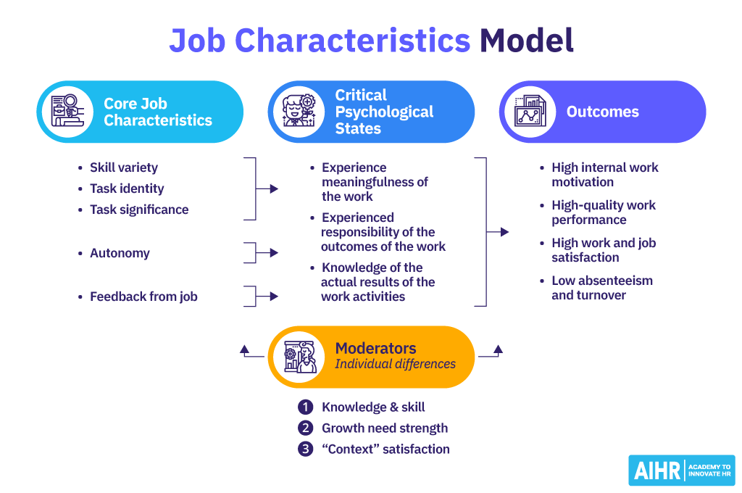
Figure 5: Job Characteristics Model; Source: (Lucas, 2024)
The Job Characteristics Model can be used in the leadership positions at Aether Innovations in order to directly handle the flat growth, high turnover, and declining customer satisfaction (Lucas, 2024). The CEO and the CIO must be very autonomous to realize quicker strategic and digital decisions, whereas CTO position should both vary in skills and be relevant in tasks to enhance the quality and speed of products production. The HR Director must possess strong feedback loops, task identity which would help to minimize turnover by work of talent and culture intervention, and the Head of R&D must be designed to be autonomous and have end-to-end responsibility of innovation outcomes (Armstrong and Taylor, 2020).
This correlates the job design of leadership with the appraisal system of Aether based on the concept of OKR and enhances motivation, accountability, and innovation.

2.4 Linking Performance & Job Design
It is essential to integrate job design with performance management systems to create a performance-oriented culture at Aether Innovations. In case performance appraisal mechanisms, including 360-degree feedback and OKRs, are integrated in job design, employees will be more motivated, responsible, and engaged (Ulrich, 1997). Job design when augmented by the Job Characteristics Model (Hackman and Oldham, 1976) augments autonomy, skill variety, feedback, and subsequently, performance.
As an example, 360-degree feedback offers comprehensive information as it stands with the daily job of the employee as stipulated in job description. This feedback process makes employees constantly develop and finalise their projects on the objectives of organisations (Brannick, Levine and Morgeson, 2019). Additionally, the use of OKRs enables the presence of clear, quantifiable goals, which underpin the sense and meaning of the work of the employee. When the employees realise that their personal performance affects larger organisational objectives, it develops a feeling of ownership and responsibility, which are important elements of the Job Characteristics Model.

3. Conclusion
To sum up, a coordinated HR plan comprising of both performance appraisal systems (360-degree feedback and OKRs) and an efficient job design can greatly increase the organisational performance of Aether Innovations. Using modern HRM theories, such as the Job Characteristics Model, Aether Innovations can also achieve a performance-oriented culture that increases employee motivation, satisfaction, and engagement. Not only will these changes enhance employee retention but also align the individual performance to organisational objectives, resulting in growth and innovation.

4. Part 2 - Reflection

4.1 Learning from Human Capital Management
In this module on Human Capital Management (HCM), I have acquired important lessons on the role of aligning the practises of human resources with organisational strategy to lead performance and promote growth (Dessler, 2020). These lessons have made me understand how HRM can contribute greatly to the success of an organisation especially in regard to employee engagement, performance appraisals and job design. The combination of theories, including the Human Resource Champions model of Ulrich (1997) and the Job Characteristics Model (Hackman and Oldham, 1976) helped me to gain a clear system according to which the practises of HRM may be adjusted to the particular requirements of an organisation.
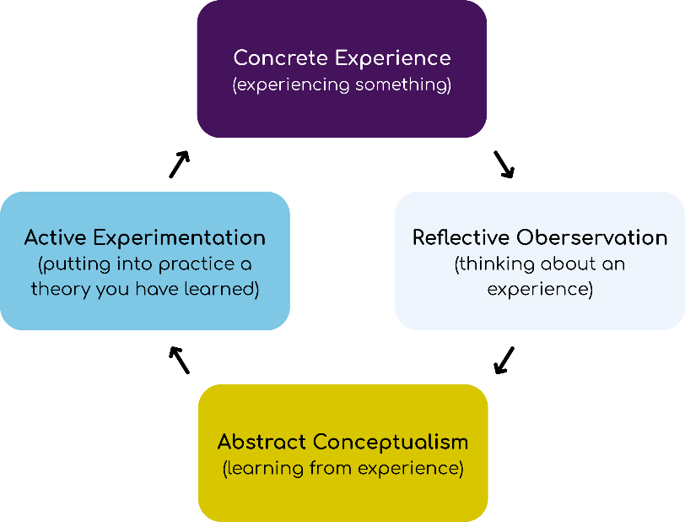
Figure 6: Kolb’s Cycle of Reflective Model
Source: (Piernikarch, 2024)
When looking back at my learning process, I am able to pinpoint the different phases of Experiential Learning Cycle proposed by Kolb (1984), which has served to enable me understand the theoretical concepts and their application in practise. The cycle includes four parts: Concrete Experience, Reflective Observation, Abstract Conceptualization, and Active Experimentation, and I will utilise these parts to consider how I have handled this module and how I can enter this learning in the future.
Concrete Experience: During the first stage, I was exposed to the module materials where I got to learn important issues such as performance appraisal systems, job analysis and the role of HR in organisational development. Case studies and lectures exposed me to real-life situations, and I learned about the issues that HR practitioners in the technology sector are tackling, including high turnover and stagnant growth (ISACA, 2025). The experience has provided me with a background knowledge on the strategic role of HRM in the development of high-performance culture.
Reflective Observation: Once having gotten acquainted with the material I thought about how the conventional HR practises in organisations tend to be unhelpful of the special problems of the modern workforce. As an example, I noticed that traditional performance appraisals can be quite narrow and concentrate on the past performance that might not stimulate the idea of constant improvement or innovation (Envisia Learning, 2024). After additional examination, I came to understand that the 360-degree feedback technique is more comprehensive and growth-centred, which is closer to the current organisational demands (BrioHR, 2024).
In addition, when I considered the Job Characteristics Model, I found that job design has a direct impact on job satisfaction and performance. I also learned that employees require high levels of autonomy, skill variety, and task significance to be motivated and develop a culture of continuous improvement, particularly at the leadership level (Boxall and Purcell, 2016). This observation helped me determine how HR practises at Aether Innovations might be re-engineered to promote innovation and growth.
Abstract Conceptualization: I started to transfer these considerations into a wider theoretical context as I proceeded to the next stage of abstract conceptualization. The model by Kolb made me observe the connexion between job design and performance appraisal systems in the formation of performance driven culture. I imagined the way of using the concept of the OKRs (Objectives and Key Results) to align the individual performance with the company aim, and offer the direct and specific objectives to the employees (Boston Consulting Group, 2024). This theoretical knowledge has become part of my future HR strategy approach where performance management and job design are combined to improve individual and organisational performance.
Active Experimentation: Lastly, during the active experimentation phase, I will use the information derived throughout this module to develop HR strategies that could enhance innovation and employee engagement in my future career. I would like to help to provide employees with empowerment, engagement, and motivation by improving work environments through the integration of multiple sources of feedback (360-degree feedback), skill-based job design, and continuous performance monitoring with the help of OKRs (Armstrong and Taylor, 2020). I will also test the same HR practises in my career practise by using job enrichment techniques and asking my mentors and peers to provide feedback on how to improve my leadership and decision-making abilities.

4.2 Future Career in the AI Era
With the further development of artificial intelligence (AI), it is getting more and more competent in executing traditional jobs that used to require human work, including data analysis, simple customer support, and manual work (Boxall and Purcell, 2016). Nevertheless, even though AI can automatize most of the processes, in my opinion, human abilities, including creativity, emotional intelligence, strategic approach, and innovation, will be crucial in the future workforce. To remain relevant in the AI era therefore, it is necessary to adjust to the dynamics that come with ai but use its capabilities to boost human potential and not to destroy it.
To be sure that my future career is not outdated, I will concentrate on the lifelong learning and I will be open to new technologies that may help to work more efficiently. With AI processing data, supporting decisions, and improving productivity, I will be able to spend more time on creative and strategic work that involves the human factor. An example is that AI can be applied in performance reviews, data-driven analytics, and predictive analytics, but I would prioritise the human aspect of decision-making, including relationship-building, leadership, and data interpretation (Deloitte, 2025).
In addition, flexibility and a growth attitude are key to survival in the AI-dominated world (Kolb, 1984). I will also aim to acquire skills in AI ethics, strategic leadership, and emotional intelligence in order to supplement AI technologies. In this way, I will be able to make AI an extension of my abilities, not a substitute and rely on it to develop new solutions and build partnership between technology and human input.

5. References
Armstrong, M. and Taylor, S., (2020). Armstrong’s handbook of human resource management practice. 15th ed. London: Kogan Page.
Atchison, T.J., Belcher, D.W. and Thomsen, D.J., (2024). Job analysis. ERI Economic Research Institute. Available at: https://www.erieri.com/dlc/onlinetextbook/job-analysis
Atlassian. (2024). Team playbook and health monitor practices. https://www.atlassian.com/team-playbook
Boston Consulting Group, (2024). Unleashing the power of OKRs. Available at: https://www.bcg.com/publications/2024/unleashing-the-power-of-okrs
Boston Consulting Group, (2025). Skills-based organizations aren’t reaching their potential. Here’s how they can succeed. Available at: https://www.bcg.com/publications/2025/how-skills-based-organizations-can-succeed
Boxall, P. and Purcell, J., (2016). Strategy and human resource management. 4th ed. London: Palgrave Macmillan.
Brannick, M.T., Levine, E.L. and Morgeson, F.P., (2019). Job and work analysis. 3rd ed. Thousand Oaks, CA: SAGE.
BrioHR, (2024). How 360-degree feedback redefines performance management. Available at: https://briohr.com/blog/360-feedback-maximise-productivity/
Deloitte, (2025). Employee performance management. Available at: https://www.deloitte.com/us/en/insights/topics/talent/human-capital-trends/2025/employee-performance-management-optimization-effective-strategy.html
Dessler, G., (2020). Human resource management. 16th ed. Harlow: Pearson.
Envisia Learning, (2024). 360 degree feedback vs traditional performance review. Available at: https://www.envisialearning.com/blog/360-degree-feedback/360-degree-feedback-vs-traditional-feedback/
Hackman, J.R. and Oldham, G.R., (1976). Motivation through the design of work: test of a theory. Organizational Behavior and Human Performance, 16(2), pp.250-279.
Intel. (2023). OKRs and performance management at Intel. https://www.intel.com/content/www/us/en/corporate-responsibility
ISACA, (2025). 1 in 3 tech pros switched jobs in past two years, leaving 74% of firms worried about IT talent retention. Available at: https://www.isaca.org/about-us/newsroom/press-releases/2025/1-in-3-tech-pros-switched-jobs-leaving-74-of-firms-worried-about-it-talent-retention
Kolb, D.A., (1984). Experiential learning: experience as the source of learning and development. Englewood Cliffs, NJ: Prentice-Hall.
Lucas, S. (2024). Job Characteristics Model: A Practical Guide. AIHR. Available at: https://www.aihr.com/blog/job-characteristics-model/
Piernikarch, G. (2024). Kolb’s Cycle of Reflective Practice. Cambiana. Available at: https://www.cambiana.com/kolbs-cycle-of-reflective-practice/
Pocket HRMS, (2026). 7 modern performance appraisal methods. Available at: https://www.pockethrms.com/blog/7-modern-performance-appraisal-methods/
Salesforce. (2023). V2MOM: The secret to aligning teams. https://www.salesforce.com/company/culture/v2mom/
SAP. (2024). SAP SuccessFactors performance and goals. https://www.sap.com/products/hcm/performance-goals.html
Ulrich, D., (1997). Human resource champions: the next agenda for adding value and delivering results. Boston, MA: Harvard Business School Press.

