Koushik Modak
Atanas Atanasov Maslev
Student ID: 2115672
Cloud Computing
03/28/2022
Data Analysis and Visualisation

Table of Contents
Introduction 2
Brief analysis of Task 1 2
Evalution based on the seven point that need addressing 2
Identifying the message 2
Assess the way color is used 2
Assess the way text is used 3
Assess the suitability of graph 3
Assess the way graphics are incorporated 3
Cognition -is good for user 3
Improving the infographic 3
Conclusion 4
References 4

Introduction

The process of developing and publishing is called data visualization. Visual representation of information and data with simple diagrams, text, images, symbols and schema.

Brief of Task 1
In general, posters are a very effective method of presenting information not only about problems (such as rising crime) but also about useful and enjoyable events (such as a prom invitation). The poster presents the basic idea that activity in the adults has a beneficial effect on human health. But I would change the size of some text, there are no more colours, and you can't list all the activities.

Evaluation based on the seven points that need addressing:

1.Identifying the message
The poster provides us with information about physical activity in the elderly and old people, what is good to do and the benefits of it and to give up some bad habits to reduce the incidence of disease and improve your health by doing some of those showing in the poster activities.

2. Assess the way colour is used
Choosing infographic colour schemes can feel like a completely impossible task. There are so many different options and combinations. Colour increases readers’ attention spans and recall and makes an impression more memorable. Some of the colour is not very visible.[1]
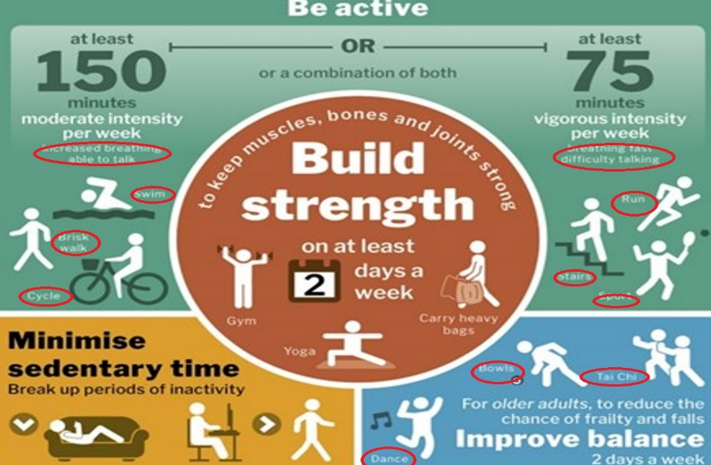
Тhe colours used as a background are not suitable for the descriptive texts that are placed next to the icons
Dance

3. Assess the way text is used
The text that describes the activity is very small and illegible and if the picture is inappropriately chosen you cannot understand what the action is from the text.[2]
Dance Dance Dance

When the correct font is not used, illegible text is obtained, and the difference is obvious.
4. Assess the suitability of the graph
I can't give an objective assessment of the suitability of the chart, because you need to have a basis for comparison (such as Build Strength) for the two weeks mentioned by how much I will be stronger than before or how much my muscle joints and bones will be stronger
5. Assess the way graphics are incorporated
In my opinion, the connection between all the images of activity in the poster shows the specific actions they need to take and the description with the picture for this purpose is good
6. Cognition (is it suitable for the user)
In general, the poster provides the information required to develop a mental model of the data which we can see.
7. Improving the infographic
I would present a "Reduces your chance of " with the graph so that the reader can imagine against the numbers presented in the text compared to the whole percentage what a huge difference there is and make him realize these benefits.

Conclusion
Visual image processing has a long history dating back to primitive man. Graphics have developed to such an extent as tools that make it possible to model relationships between data. Graphics have found a wide application (everywhere nowadays such as events, posters and many others) for a simpler idea and perception of the information provided.

References

[1] | “https://visme.co/blog/infographic-color-schemes/,” https://visme.co/blog/infographic-color-schemes/, 09 09 2022. [Online]. Available: https://visme.co/blog/infographic-color-schemes/. [Accessed 09 09 2020].
[2] | ““Infographics vs. Text: How Does Visual Content Affect Reading Comprehension?” Visme.co, 27 May 2019, visme.co/blog/infographics-vs-text/.,” [Online]. Available: “Infographics vs. Text: How Does Visual Content Affect Reading Comprehension?” Visme.co, 27 May 2019, visme.co/blog/infographics-vs-text/..

