Writing Module: Entrepreneurship

Student Name: Renaldo Jose Juman

Student ID: 2114362

Module Code: LCBB5001

Tutor: Mr. Masud Ibrahim

Assignment Title: Business Plan Written Report

Table of Contents
SmartCollection Customized Adults Gym Wear Business Plan 4
Overview of Business Idea 4
Growing Market 5
Legal Structure for SmartCollection Adults Gym Wear 6
Business Formation Documents 6
Governing Documents 6
Intellectual Property Assignment Agreement 6
Nondisclosure Agreements (NDA) 6
Shareholder Agreements 6
Employee Contracts 6
Management of the Company 7
The Management 7
Evaluation Using SWOT Analysis Model 8
Strengths 8
Weaknesses 8
Opportunities 9
Threats 9
Marketing Strategy (4Ps of Marketing) 10
Product 10
Price 10
Place 10
Promotion 10
Financial Analysis: Cash Flow Forecast for The First 12-Month Period 12
Startup Funding Allocation 13
Cash Flow Forecast for the First 12 Months 14
References 15

Figure 1: The Customised Gym Wear 5
Figure 2: SWOT Diagram 8
Figure 3:Logo of SmartCollection Adults Gym Wear 11

SmartCollection Customized Adults Gym Wear Business Plan

Overview of Business Idea
SmartCollection Customized Adults Gym Wear is a brand of clothing that seeks to penetrate the fast-growing market for adults who lead active lifestyles and discover comfortable gym wear as their training and even casual attire. The company will offer a broad range of gendered custom gym apparel, including shorts, pants, jumpers, t-shirts, and blouses for both genders. SmartCollection will target active adults aged 25-45 interested in leading healthy lives and stylishly wearing comfortable clothing. Over the years, there has been a rising demand for activewear, given the increased focus on health and fitness strives among adults. However, most of what is available in the market is either too expensive or needs more quality creativity and comfort features. SmartCollection aims to fill this gap by offering high-quality quality, stylish, and affordable gym wear to adults. The company’s competitive advantage will be in the form of the product customization, whereby customers will have some touch or input regarding the design and how their gym wear will be sized. This will provide a competitive advantage to the competitors and would help in gaining a loyal customer base.
SmartCollection is recommended to be an online store as it provides a more significant reach to potential customers and a more cost-effective operation. In addition, the brand will capitalize on sustainable and ethical means of production, targeting the rising tide of conscious consumerism. The significant way by which the customers will get to have othe products is by purchasing them from the website. We will also work with renowned fitness influencers in particular social media platforms to increase brand exposure, hence ultimately converting sales. The company’s product line should represent all sizes and body types, showcasing a safe and inclusive place. The management will make the attire from high-quality material that is moisture-wicking, thus ensuring comfort and durability during the workouts. Organization’s customization process will be applied using high-level technology, ensuring precisely fit sizes are available regarding personalized design options for all the customers (Liu et al., 2020). This will help the mangement provide the customers with a more top-notch and personalized experience. The management will also introduce a loyalty program so as to reward the recurring customers and build brand loyalty. Company’s vision is to be the go-to brand for any adult looking for comfortable, stylish, and sustainable gym wear.

Growing Market
SmartCollection Customized Adults Gym Wear aims to cater to the growing market of active adults. Advancements in technology and shifts in consumer behavior have manifested as dramatic changes in regard to digital retailing, a global fashion industry at large, almost 2% of the world's GDP. This also affords marketers to capture diverse generational cohorts such as Gen X (1965-1981), Gen Y (1982-1999), and Gen Z (2000-2012) (Adeola et al., 2021). SmartCollection would want to tap into the market with a cheap, high-end quality piece of gym wear. This would be available on the online store platform, which will focus on customization, sustainability, and inclusivity in the design options for all body sizes and shapes.

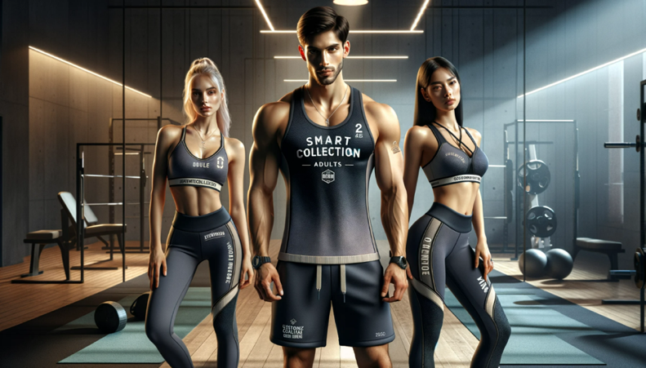
Figure 1: The Customised Gym Wear

Legal Structure for SmartCollection Adults Gym Wear

Business Formation Documents
To formalize SmartCollection as an actual business, it will require us to record its existence with the government and acquire the licenses and permits required for businesses. The preferable legal structure for the organization’s kind of business is the Limited Liability Company (LLC) because it can offer various personal asset securities for the business owners, has flexibility on management structures, and is flexible on matters related to taxation (Mancuso, 2020).

Governing Documents
The operational agreement of the organization LLC is the governing document that states what company members are responsible for, their rights, and how profits will be distributed. In addition, the agreement also cites decisions made within the organization to elude future conflicts or misunderstandings.

Intellectual Property Assignment Agreement
One of the SmartCollection values is innovation; the management shall keep the organization’s intellectual property to succeed. Thus, all employees are obliged to sign the Intellectual Property Assignment Agreement in due time they join to have everything created or brought to be exclusively for the business.

Nondisclosure Agreements (NDA)
Confidentiality is the essence of financial data or development plans about products/designs. NDAs are very important before dealing with outsiders such as investors and partners who have access to such information (Sharma & Srivastav, 2020).

Shareholder Agreements
As such, we can consider finding shareholders for the business who may be able to bring in additional funds and expertise needed for expansion. Based on this factor, we must ensure that the Shareholder Agreement will define their rights, roles, and responsibilities between each other based on the need to restrain unwarranted interventions by any third party/external parties.

Employee Contracts
Building an effective team of employees and protecting both the company's and their interests in working arrangements with SmartCollection incorporates information regarding packages remuneration (salary/benefits/perks), job description (roles/responsibilities), and non-compete/non-solicitation clauses.

Management of the Company
As a founder of SmartCollection Adults Gym Wear, I am interested in fashion retail and have a powerful desire for foralth and fitness. The background in business management will help the management acquire the required skill set to head this venture fruitfully. To be able to attain the vision of SmartCollection, the management would need the following key people in the organization:

The Management
- Production Manager: This individual will look at all kinds of production activities, from procuring raw materials to completing finished products.
- Operations Manager: He or she will monitor inventories, shipment logistics, and customer service.
- Marketing Specialist: Design marketing strategies through influencer collaborations and content creations on social media to promote the organisation’s brand image.
- Website Developer/Administrator: Maintain an effective e-commerce website that accurately reflects company’s brand story and provides a non-necessarily frictionless user experience.
- Sales Representative(s): Someone who is proactive, forward-thinking, and capable of identifying potential sales channels, such as using the independent trainers base in the popular gyms and suggesting useful local strategic partnerships (knowing where people hang out and commit to fitness regimes, i.e., fitness studios).
Other than the key roles above, we might also require professional services/experts From Outside
- Legal Advisor - To ensure observance of the laws governing online businesses (e.g., on data protection)
- Accountant/Bookkeeper – To keep proper books of records regarding finances
- Fashion Designer/Consultant - To help in keeping up with the trends/designs
The management will also work with the team in every aspect of the business to influence the incorporation of company brand's values and vision in every decision we make. This involves regular meetings to brainstorm marketing strategies, monitor production timelines, and analyze customer feedback and market trends. Satisfied employees shall ensure the cultivation of a positive culture in the company where every employee is working towards achieving the same objective, with competitive salaries, benefits packages, and promising internal progression schemes (Murtiningsih, 2020).

Evaluation Using SWOT Analysis Model

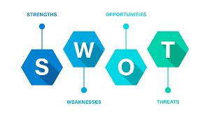
Figure 2: SWOT Diagram
(https://www.google.com/url?sa=i&url=https%3A%2F%2Fwww.score.org%2Fresource%2Fchecklist%2Fimportant-questions-ask-your-swot-analysis&psig=AOvVaw3dLjO7-jinUntdqvLG-kez&ust=1706459993324000&source=images&cd=vfe&opi=89978449&ved=2ahUKEwjoton_gP6DAxUDa6QEHY15B_wQr4kDegUIARCPAg)

Strengths
- Customization: The business unique selling point is the customization of gym wear as per the fashion and needs demanded by the customers. This will allow for a personalized experience, which will help us stand a chance to maintain an edge over their competitors.
- High-quality products: The management are going to utilize top-end moisture-wicking material that bestows comfort and durability while having a training task. This will aim to maintain high quality, which the customers anticipate.
- Online presence: Being an online store will give us access to a broader market coverage at a price lower than bricks and mortar. It also provides the management with a platform that is unique to them and conveniently accessible, and it can be from anywhere and at any time of their desire.

Weaknesses
- Limited initial funds: There may be a hurdle regarding marketing and expanding operations on such limited funding.
- Technology dependency: Customization impacts depend largely on high-end technical processes such as 3D scanning/printing or digital design aids; any technical malfunction may cause hiccups in the production schedules, leading to delivery tardiness.

Opportunities
- Growing market potential: The overall activewear industry worldwide has been recording an increasing size of people seeking, most comfortably, clothes that can be worn while one remains active. Health and wellness awareness is now heightened, making the business idea well-adapted to such a market.
- Sustainable and ethical manufacturing: Over the years, there has been an impending consumer responsibility toward the environment affected by unscrupulous production methods. Sustainable and ethically made products are demanded to be growing apace. Thus, development in the direction of sustainable and environmentally friendly materials has also to be thought over responsible manufacture.

Threats
- Competition: The activewear industry is competitive, with big players like Nike, Adidas, Lululemon, Gymshark and others presently dominating the market. These brands are reputable and compete for the same target customers the organization seek to target, which could impact the sales, especially during the early stages of establishment.
- Economic slowdown: During economic uncertainty or recession, discretionary spending on non-essential products such as gym wear might decrease, thus hurting the company’s sales and revenue.

Marketing Strategy (4Ps of Marketing)

Product
The SmartCollection products will include shorts, trousers, sweaters, tops, and blouses for men and women. The organization’s main differentiating factor will be the customization feature that best meets customers' design preferences and body sizes. All the company’s products will be made of high-quality material that takes away moisture and gives durability and the possibility to wear the business’ clothes during workouts. Such custom personalization in the clothes for the gym will put us ahead of competitors in the market. The company’s gym wear production process also includes using ethically sourced materials like bamboo or organic cotton, as the management believe in sustainable practices.

Price
The pricing strategy implied by SmartCollection is competitive prices with no dilution on the quality or sustainability standards. For most adults, cheap but still fashionable clothing attires certainly top their list when it comes to activewear, and thus, the management intend on maintaining attractive price points that are affordable for all the company’s products while ensuring they stay of superior quality through ethical sourcing only. In addition, operating online instead of having brick-and-mortarores enables us to keep overhead costs low, making it easier for us to maintain reasonable retail prices without inflating overhead expenses related to physical stores.

Place
SmartCollection will mostly run online as a store that suits customers looking for comfortable shopping right from their homes. We ensure that all the products can be ordered and delivered anywhere in the USA so that we are reachable to larger audiences without any geographical disputes. The management will also make associations with the top fitness influencers on the Instagram and YouTube social media platforms to increase brand visibility and grab the attention of prospective customers. This strategy allows us to engage a more significant percentage of customers and gain credibility by joining hands with celebrated dentists and health and fitness gurus.

Promotion
Website creation and optimization through search engine optimization (SEO) techniques will expose SmartCollection Adults Gym Wear to its target market customer base via an email marketing campaigning strategy using influencer collaborations and paid advertisements on any social media platform such as Facebook. Not only does it provide us with a cost-effective way of promoting the organization’s brand, but at the same time, it also eases the job in ensuring that the advertisements target specific demographics who are more likely to be interested in inexpensive gym wear. Additionally, word-of-mouth promotion due to excellent company's customer service provision because of short shipping times and easy return policies helps further the business's brand advertising for longer and is proven effective when well strategy-field.
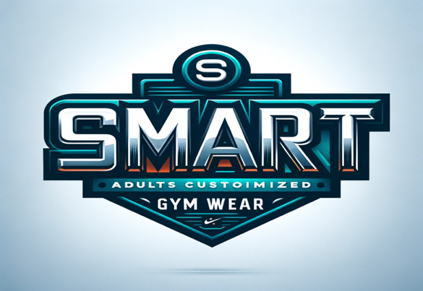
Figure 3:Logo of SmartCollection Adults Gym Wear

Financial Analysis: Cash Flow Forecast for The First 12-Month Period
The management is getting an investment of £25,000, which sets a significant opportunity for SmartCollection Adults Gym Wear to lay a sound financial foundation. The following is a down-to-earth analysis of the finances revealing the strategic way this funding will be used and projecting how the cash flows in the first 12 months.
This chart shows the breakdown of the £25,000 allocation investment to specific sectors. In contrast, a particular portion represents how a certain positive amount affects a particular detail of SmarCollection Adults Gym Wear's business scheme.
Funding Allocation | Amount (£) | Percentage (%)
Product Development and Manufacturing | £8,750 | 35%
Website Development and Marketing | £7,500 | 30%
Operations and Logistics | £5,000 | 20%
Sustainability Initiatives | £2,500 | 10%
Contingency and Miscellaneous | £1,250 | 5%
Total Investment | £25,000 | 100%
Table 1: Allocation of the £25,000 investment

Startup Funding Allocation
A) Product Development and Manufacturing (£8,750 - 35%)
- Premium moisture-wicking fabric outsources out.
- Set up state-of-the-art customization technology.
- Measures were put in place to ensure prototyping and initial production runs.
B) Website Development and Marketing (£7,500 - 30%)
- Develop a user-friendly and aesthetics-wise e-commerce platform.
- Commencement of brand positioning through targeted digital marketing campaigns.
- Make partnerships with fitness influencers across social platforms to enhance the visibility of company’s brand.
C) Operations and Logistics (£5,000 - 20%)
- To have enhanced systems in place for optimum processing and dispatching of orders.
- State-of-the-art systems integration for managing inventories.
- Source eco-friendly parcels for packaging to be more part of the solution rather than being a part of the problem by continuing to contribute more to environmental pollution through packaging.
D) Sustainability (£2,500 - 10%)
- Ethical and sustainable application of production ethics.
- Purchase eco-friendly running qualifications.
E) Contingency and Miscellaneous (£1,250- 5%)
- Prepare contingency for unpredictable expenses or some adjustments that may be realized.
- Transportations or shipping etc

Cash Flow Forecast for the First 12 Months
1. Month 1-2: Starting Up
- This time shall be mainly on product development and production.
- Anticipation of initial marketing.
2. Month 3-4: Launch of the Website and Impact of Initial Marketing Effort
- E-commerce website's launch in the market.
- Digital marketing effort stepping up.
- Social media space dominion with influencer tie-up.
3. Month 5-6: Break-Even and Initial Growth of Sales
- There is a lot of online traffic at the business gate, and first sales have started flowing in.
- The target to hit the break-even point comes at the end of the sixth month.
4. Month 7-12: Growth and Optimization
- Sustained growth is to be backed by a continued marketing lineup.
- Efficient optimization of operation and logistics.
- Assessment of sustainability measures on effect for brand loyalty.

References
Adeola, O., Moradeyo, A. A., Muogboh, O., & Adisa, I. (2021). Consumer values, online purchase behaviour and the fashion industry: an emerging market context. PSU Research Review. https://doi.org/10.1108/PRR-04-2021-0019
Liu, N., Chow, P. S., & Zhao, H. (2020). Challenges and critical successful factors for apparel mass customization operations: recent development and case study. Annals of Operations Research, 291, 531-563. https://link.springer.com/article/10.1007/s10479-019-03149-7
Mancuso, A. (2020). LLC Or Corporation?: Choose the Right Form for Your Business. Nolo. https://books.google.com/books?hl=en&lr=&id=cFwEEAAAQBAJ&oi=fnd&pg=PP1&dq=The+preferable+legal+structure+for+our+kind+of+business+is+the+Limited+Liability+Company+(LLC)+because+it+can+offer+various+personal+asset+securities+for+the+business+owners,+has+flexibility+on+management+structures,+and+is+flexible+on+matters+related+to+taxation.&ots=U7bBV1lY58&sig=ZBwcLLSPKF6Jdui8MnPgzhEnuoM
Murtiningsih, R. S. (2020). The Impact of Compensation, Training &Development, and Organizational Culture on Job Satisfaction and employee Retention. Indonesian Management and Accounting Research, 19(1), 33-50. http://download.garuda.kemdikbud.go.id/article.php?article=3041860&val=27619&title=The%20Impact%20of%20Compensation%20Training%20Development%20and%20Organizational%20Culture%20on%20Job%20Satisfaction%20and%20employee%20Retention
Sharma, T., & Srivastav, R. (2020). Non-Disclosure Agreement: A Curve in a Glossy Path. DME Journal of Management, 1(01), 126-145. http://www.dmejournals.com/index.php/DMEJM/article/view/79

