BMIH5005
Personnel Resourcing and Development
Student Name: Ionica Costache
Student ID: 2246358

Table of Contents
Introduction 3
Background of the hotel 3
Identification of various socio-economic issues 4
Different work modes practised in Marriot 4
Discussion 5
Description of the socio-economic factors, a part of PESTLE Analysis 5
Description of the industry trends including but not limited to retention rates, turnover rate 6
Discussion on different work modes in the hospitality industry over the last 5 years 7
Evaluation 8
Conclusion 9
References 10

Introduction

Background of the hotel
Marriott Hotel is a well-reputed international hotel brand that has included various hotel chains and resorts in their business (Marriott, 2024)). The company is a U.S.-based hotel chain with its headquarters in Bethesda, Maryland (Marriott, 2024). The company has incorporated various innovative and sustainable business strategies into their business to ensure the growth and profitability of the brand in the global market.
The core value of the brand: The company has a value of growing and changing with time. The main aim of the business is to recapitulate excellence by considering the demands and choices of the consumers (Marriott, 2024)). The mission statement of the company is “being part of Marriott men being part of a proud history and thriving culture” (Marriott, 2024).
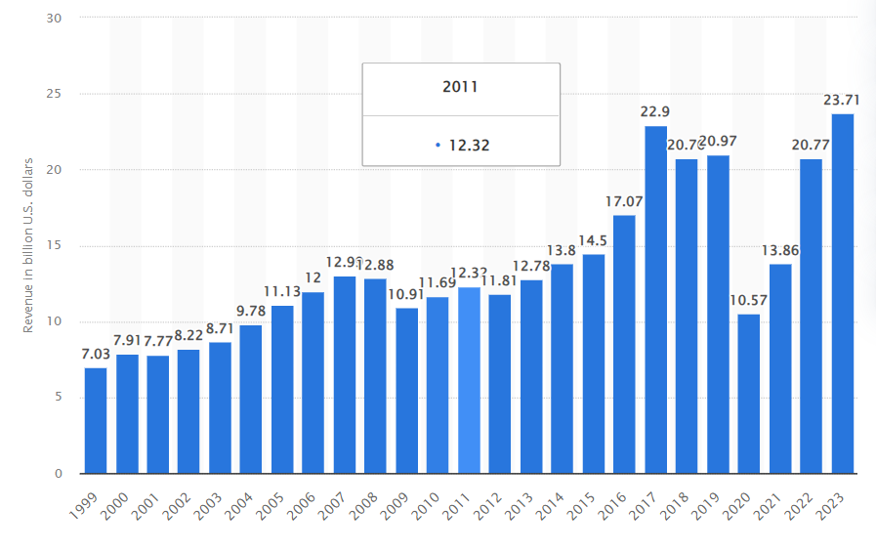
The current revenue of the brand is 23.71 billion US dollars (Statista, 2024). In the management approach of the company both the classical and systematic approaches have been followed. The company adheres the systematic approaches that help to evaluate all the managerial policies and practices. In contrast to that, the classical approach of the company refers to the method of dividing the work among the various groups of staff and paying them appraisals and rewards based on their performance.

Identification of various socio-economic issues
The sudden emergence and outbreak of the pandemic has impacted the choices of consumers and consumers have become highly concerned about health and hygiene factors (BBC, 2021). In this situation, the management of the hotel chain is highly required to change their managerial practices and is required to enhance the quality of service of their employees. The inflation rate of the UK has suddenly increased 11.1 % and the rate of inflation in the US has increased 3.5 % (Statista, 2024). Due to the pandemic and lockdown, the hotel and hospitality industry is facing the problem of labour shortage and as a result, the management of the company is required to incorporate some effective strategies like reward management, providing training, and promoting a flexible workforce for increasing the employee engagement rate towards the business.

Different work modes practised in Marriot
SAF Matrix | Strategic Options
SAF Matrix | Hybrid Working | Remote Working | Flexible working
Sustainability | 6 | 5 | 6
Feasibility | 5 | 6 | 7
Acceptability | 7 | 6 | 7
Total | 18 | 17 | 20
Table 1: SAF Matrix
(Created by the learner)
From the report of Forbes, it has been analysed that the management of the company is prioritising the demand and financial benefits of their employees (Forbes, 2020). Marriott International has been termed as one of the best brands in the hotel business as the company has prioritised their consumers as well as their employees (Marriott, 2024). The management of the company has introduced different types of working modes including virtual work mode, flexible work mode and hybrid work mode analysing and considering the demand and needs of their consumers (Great Place Work, 2023). The points provided to each of the working modes suggest that all of these methods are high in demand in the workforce of Marriott Hotels.

Discussion

Description of the socio-economic factors, a part of PESTLE Analysis
After the hit of the Covid-19 pandemic, the global economic and social condition has been extremely unpleasant. Additionally, hospitality including the hotels, leisure and equivalent sectors have seen the highest downfall. The UK economy is still facing issues in terms of inflation which is 11.1% (Statista, 2024). Thus, operating business smoothly from the hospitality organisations has become tough and the growth including the recovery process has slowed down.
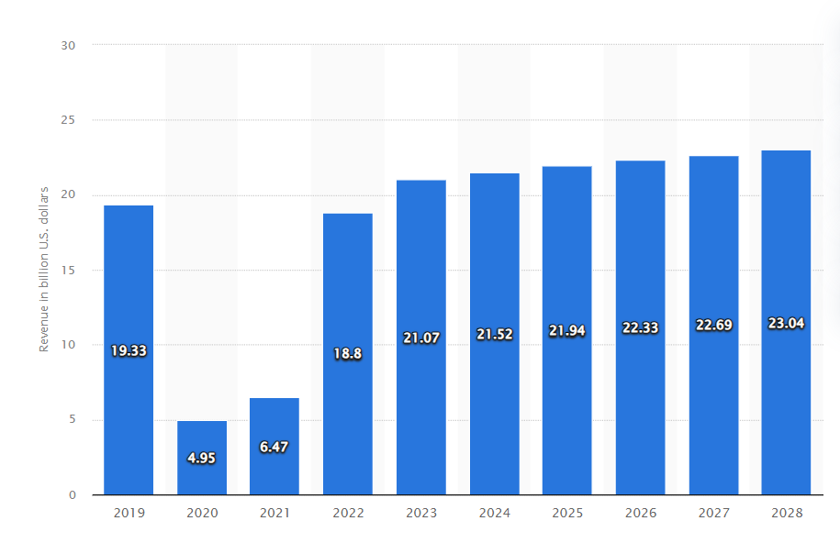
Figure 2: Revenue projection of the UK hotel sector
(Source: Statista, 2024)
As per the above statement, from Figure 2 it could be evaluated that the financial performance of the UK hospitality sector has become average after 2022. On the other hand, the salary deduction, and job cuts during the pandemic situation have affected the employment scenario of the hospitality industry adversely. The entire hospitality industry in the United Kingdom has been facing a huge worker shortage for the past few years (BBC, 2022). Additionally, lower pay scales towards female employees have been another major result of such regrettable socio-economic conditions.
For example, Whitbread was supposed to cut almost 6000 jobs as the demand for the hotels dropped during the pandemic and initial post-pandemic situations (BBC, 2020). Further, as a result of Brexit, there have been changes in rules and regulations for business conduct between the EU and the UK. This could be another major reason for the staff shortage in the hospitality industry, where EU workers are highly needed in the UK hospitality industry (BBC, 2023). Considering the same, it could be stated that the hospitality industry, including Marriot hotels, has faced challenges in managing employees and their performances.

Description of the industry trends including but not limited to retention rates, turnover rate
The development and financial growth of an organisation or an industry highly depends on effective employee performance. As mentioned by Awan et al. (2020), performance management and monitoring is the process of measuring the alignment between organisational and employee objectives. It is evident that a constant follow-up on employee performance and monitoring helps organisations to analyse the potential development which also further helps organisations to retain employees. To begin with, the industry trends that are going on within the hospitality sector, need to be stated that after the hit of Covid-19, there have been huge changes in the overall working process. As a result, the entire employee retention rate and turnover rates have also been changed within the industry.
It has been observed that the hospitality employee turnover in the global hospitality industry is 70-80% (Roosted, 2024). On the contrary, it has been clearly mentioned that an employee turnover of around 10-15% can be considered a healthy factor in the hospitality industry. In particular, there could be major reasons based on which employee turnover rates tend to increase, that includes inadequate match and pay, improper leadership, unclear expectations and many others (Roosted, 2024). The number of employees in Marriot as of 2023 has been 148 thousand, which is a bit higher than last year (Statista, 2024). Considering the above statement it could be stated that the performance management scenario in Marriot has been assertive, which is helping the brand retain and attract talents all over the world.
As mentioned earlier the Covid-19 pandemic has brought a huge change in the hospitality industry, and the employee burn-out rate has increased. According to an editorial by BBC (2021), prolonged working hours and lower pay scale have already been major reasons for staff burnout. However, since the pandemic situation, the staff shortage and inadequately sensitive consumers within the industry have significantly made the situation harder for service workers. In reference to the staff shortage issue, it needs to be stated that, in the last two years, the UK hospitality industry has really seen the highest staff shortage since 2017 having 90,000 or more vacancies (BBC, 2021). Further, when it comes to recent trends within the hospitality industry, it needs to be stated that, female employees are not able to see or experience progress due to lower pay scale. As per another editorial by BBC (2022), the hospitality industry can be considered a workplace where women might experience “meaningful career development”. However, women are not getting properly paid for their work or responsibilities, which could be another major reason for the higher turnover rate in the stated industry.
Considering the working modes and performance evaluation, it has been observed that, the industry has implemented different types of work culture after the pandemic period. Kloutsiniotis and Mihail (2020), talked about the high-performance work culture, a combination of specific work structures, HRM practices, and processes that eventually maximise knowledge, flexibility and skills. In reference to this, it could be stated that Radisson Hotels firmly believes in job creation sharing common values and people development. Moreover, to boost employee morale, the hotel group is found to be providing rewards for the diverse and global workforce (Radisson Hotels, 2024).

Discussion on different work modes in the hospitality industry over the last 5 years
Considering the different working modes that are currently given to hospitality employees, this has enhanced the work-life balance of workers at a larger scale. It has been observed that the hospitality industry too has implemented modes like flexible working, remote working and work-from-office. As mentioned by Bhatt et al. (2023), the Covid-19 pandemic has induced a slowdown in business, which further resulted in salary deductions, layoffs and many more in the hospitality sector. On the other hand, it has already been observed that female employees are deprived of getting proper growth. Bhatt et al. (2023), in their study, have been able to showcase that, remote work management and fair pay improve and boost female worker performance in the hospitality industry. Along with that, remote working facility helps individuals to have a proper work-family balance, especially female managers who work in the hospitality industry. Although the study talked about the pre-pandemic situation, it needs to be stated that the concept of flexible and remote working processes was introduced in the concerned industry a few years back.
To make an HPWS, the management of the company is incorporating various strategies for promoting the motivation and engagement of the employees towards the workforce. The company has planned for some training and skill development programs for their employees to enhance their performance and thus contribute to the productivity of the company (Marriott, 2024).
The hospitality sector has seen a major change and shift in the last five years towards flexible office spaces as well as hybrid work patterns. Many hospitality firms have embraced remote work solutions for administrative functions. They are however keeping on-site staff for guest-facing positions. These actions have been considered in response to technological improvements along with altering work cultures. This strategy saves money on office space, improves employee satisfaction along with permitting more scheduling flexibility (Umrani et al., 2 022). It also makes it harder to keep the team cohesive and communicate well. In order to satisfy the demands of a shifting labour force and shifting market conditions, the industry has generally adjusted to include hybrid work models. This combines remote and on-site employment.

Evaluation
The UK hospitality sector has been a leader in the implementation of hybrid work arrangements. This is due to shifting employee expectations along with the requirement for flexibility as well as cost-effectiveness. An instance of this can be observed in the Marriott Hotel Group. This has instituted diverse tactics to oversee and oversee staff members in a variety of work environments. Marriott first offered flexible scheduling software. This lets staff members choose whether to work remotely or on-site and in their chosen hours. With the aid of this software, managers can better manage staffing requirements. Considering individual preferences promotes employee retention and happiness (Heimerl et al., 2020). Marriott uses performance measurements and digital tools like task management software along with virtual communication platforms. This ensures productivity and responsibility in distant work environments. Video conferencing is used for regular check-ins and team meetings to keep everyone collaborative. This will make them capable of handling any problems that may come up. Marriott uses a combination of technology and conventional management strategies for its on-site employees. Systems for keeping track of time and employee feedback are used to monitor performance and quickly remedy any issues. Furthermore, managers have frequent in-person meetings along with training sessions. This helps to promote a feeling of community and offer chances for professional growth. Marriott also stresses how essential it is to preserve a uniform corporate culture throughout all working environments (Kloutsiniotis and Mihail, 2020). Both on-site and remote workers are made to feel equally appreciated along with a part of the company. This can be done by frequent contact, team-building exercises along with recognition initiatives.

Conclusion
The hospitality sector in the UK has adopted hybrid work arrangements as a strategy to adjust to evolving worker dynamics. The company maximises its operational effectiveness. The Marriott Hotel Group is a prime example of how to manage employees well in a variety of work environments. They utilise technology-enabled communication, performance tracking along with flexible scheduling. The firm focuses on employee satisfaction, efficiency along with a coherent corporate culture. Marriott serves as an example of how businesses in the hospitality industry may effectively manage the benefits along with problems posed by flexible work schedules.

References
Awan, S.H., Habib, N., Shoaib Akhtar, C. and Naveed, S., (2020). Effectiveness of performance management system for employee performance through engagement. SAGE open, 10(4), p.2158244020969383.
BBC, (2020). Whitbread to cut 6,000 jobs as hotel demand slumps [Online] Available at: <https://www.bbc.com/news/health-54246403>. [Accessed on 13 May 2024]
BBC, (2021). Is there a solution to the hospitality staff crisis? [Online] Available at: <https://www.bbc.com/news/business-57817775> [Accessed on 13 May 2024]
BBC, (2021). Why service workers are so burned out [Online] Available at: <https://www.bbc.com/worklife/article/20211007-the-service-roles-that-lead-to-burnout> [Accessed on 13 May 2024]
BBC, (2023). Hotels and bars need more EU workers, say bosses [Online] Available at: <https://www.bbc.com/news/uk-england-bristol-65026562> [Accessed on 13 May 2024]
BBC, 2021. Impact of Covid-19 on the hospitality sectors [Online] Available at:<https://www.bbc.com/news/uk-56064759> [Accessed on 13 May 2024]
Bhatt, D., Sharma, S. and Rana, V., (2023). A study of the remote work-family balance of female hotel managers. African Journal of Hospitality, Tourism and Leisure, 12(3), pp.989-1010.
Forbes, 2020. Marriott taking care of the employees [Online] Available at:<https://www.forbes.com/sites/serenitygibbons/2020/04/30/3-things-you-can-learn-from-marriott-about-taking-care-of-employees/?sh=720ce1492bca> [Accessed on 13 May 2024]
Great Place Work, 2023. Certified business [Online] Available at:<https://www.greatplacetowork.com/certified-company/1000152> [Accessed on 13 May 2024]
Heimerl, P., Haid, M., Benedikt, L. and Scholl-Grissemann, U., (2020). Factors influencing job satisfaction in hospitality industry. SAGE open, 10(4), p.2158244020982998.
Kloutsiniotis, P.V. and Mihail, D.M., (2020). High performance work systems in the tourism and hospitality industry: a critical review. International Journal of Contemporary Hospitality Management, 32(7), pp.2365-2395.
Kloutsiniotis, P.V. and Mihail, D.M., 2020. High performance work systems in the tourism and hospitality industry: a critical review. International Journal of Contemporary Hospitality Management, 32(7), pp.2365-2395.
Marriott, 2024. Best hotel chain [Online] Available at:<https://news.marriott.com/news/2021/04/14/marriott-international-named-one-of-fortunes-100-best-companies-to-work-for-a-record-24th-year-in-a-row> [Accessed on 13 May 2024]
Marriott, 2024. Business [Online] Available at:<https://www.marriott.com/culture-and-values/core-values.mi> [Accessed on 13 May 2024]
Radisson Hotels, (2024). Think people [Online] Available at: <https://www.radissonhotels.com/en-us/corporate/responsible-business/people> [Accessed on 13 May 2024]
Roosted, (2024). 8 Reasons for Employee Turnover in Hospitality [Online] Available at: <https://www.roostedhr.com/8-reasons-for-employee-turnover-in-hospitality/#:~:text=Most%20HR%20experts%20agree%20that,around%2070%2D80%25%20annually.> [Accessed on 13 May 2024]
Statista, (2024). Number of Marriott International employees worldwide from 2007 to 2023 [Online] Available at: <https://www.statista.com/statistics/297269/number-of-marriott-international-employees-worldwide/> [Accessed on 13 May 2024]
Statista, (2024). Revenue of the hotels market in the United Kingdom from 2019 to 2028 [Online] Available at: <https://www.statista.com/forecasts/515548/revenue-in-the-hotels-market-in-the-united-kingdom> [Accessed on 13 May 2024]
Statista, 2024. Inflation rate [Online] Available at:<https://www.statista.com/topics/7694/inflation-in-the-uk/#:~:text=The%20inflation%20rate%20in%20the%20United%20Kingdom%20reached,a%2041-year-high%20of%2011.1%20percent%20in%20October%202022.> [Accessed on 13 May 2024]
Umrani, W.A., Channa, N.A., Ahmed, U., Syed, J., Pahi, M.H. and Ramayah, T., (2022). The laws of attraction: Role of green human resources, culture and environmental performance in the hospitality sector. International Journal of Hospitality Management, 103, p.103222.
Statista, 2024. Revenue rate of Marriott [Online] Available at:<https://www.statista.com/statistics/266279/revenue-of-the-marriott-international-inc-hotel-chain/> [Accessed on 13 May 2024]

