E-Commerce Business Model
Table of Contents
Introduction to Domino’s 2
SWOT Analysis 2
Analysing the Domino’s Business Model 3
Micro Factors 3
Macro Factors 3
Assessing the existing Domino’s website with a potential customer 3
E-Procurement 4
E-Marketing 5
Internationalisation of the website 6
Can Dominos use technology for online purchasing? 7
Bibliography 8
Appendix 10

Introduction to Domino’s
Domino’s Pizza is mainly a B2C business. The reasoning behind this is because it is a fast food joint and will cater mainly with customers, as customers will mainly want to eat food instead of businesses. The reason that it is mainly a B2C and not just a B2C is because Domino’s does deliver to businesses but the businesses act more like customers rather than businesses.
There are also some signs of Domino are being a B2C business, an example would be the price of the products being sold and the fact that they aren’t really being bought in bulk (this is mainly a B2B trait). A different example would be that Domino’s website is catered towards more customer aspects rather than business aspects – the colour scheme and the catchy images and text (a B2B website wouldn’t have this and would look more like a catalogue).

SWOT Analysis
Strengths | Weaknesses
Quick Service  A lot on the menu  Option for healthy toppings  Well known  Good line of communication between store, drivers and customer. | High delivery driver turnover  A lot of Domino’s don’t allow sitting in to eat  High number of branches: Problem with quality control  Expensive prices without a deal
Opportunities | Threats
Expanding into other countries with high populations, i.e. China  Low calorie options  A change to the demographic: Cater to elder people instead of mainly millennials/families | Health conscious trends: People might want a low calorie option instead of the high calories Domino’s gives them.  Customers might go to other stores because of the price at Domino’s  Problems with quality control might lead to a lot of the stores being shut down
This SWOT analysis will go over, briefly, some of the underlying strengths, weaknesses, opportunities and threats that face Domino’s, and will give the reader a quick over view of what is to come in this report; each point will be explained in the report.

Analysing the Domino’s Business Model
When analysing the Domino’s Business model there will be considerations from Chaffey’s Micro and Macro environmental factors. These will be items such as customers and competitors, for the micro factors. For the macro factors there will be considerations such as society and Technologies [1].

Micro Factors
Dominos has a business model that prides itself on the delivery of food in less than thirty minutes. This business model when compared to the competitors, i.e. Papa John and Pizza Hut is rather effective in maintaining customers. This is because the “Free if over 30” rule is not in the competitors. This gives Dominos customers an edge to go with Domino’s rather than the competitors [2].
With different competitors like McDonalds or Burger King, Dominos has a delivery system and is mainly all about delivering food to the customer’s houses. This was a niche in the market at the time and has given customers more of a reason to go with Domino’s over McDonalds when wanting to stay in at home because the customer doesn’t have to leave their house [3].

Macro Factors
There are different technologies that can be used for ordering at Dominos, this includes items like phone and tablets but more recently involves technologies like the Amazon Echo. The Amazon Echo factor allows the customer to order the pizza on the comfort of their own sofa while not needing to go on the computer. This gives Domino’s an edge over the competitors as Domino’s is one of the only businesses to allow this.
A different macro factor would be the society in which the business is in. Dominos is all over the globe and will remain so in the future. This is because each branch operates depending on what society it is based in. For example, in places that value information privacy, i.e. UK all the delivery slips – the slips that help the driver to get to the houses and holds customer information such as telephone numbers are all destroyed at the end of the shift. When comparing this to the places that do not really mind about the privacy, i.e. America the slips are not destroyed and will be thrown away instead.

Assessing the existing Domino’s website with a potential customer
In regards for assessing the Domino’s website a potential customer was asked about the site and how it feels to get from browsing food to ordering. A number of questions were asked in regards to the process. An analysis will also be done for each of the answers in regard to the website.
The first question was; “When you open up the website, is it clear to you what is available?”
The answer to this was this; “When I open the website I can see the pizza but not a lot else. I cannot see the deals or the drinks, which is fine as I want to get some pizza.”
This answer shows us that this customer, like many others, will want to go on the website and see pizza for the first item that they see. This is fine as the website does show this. This, however, does also show that a potential customer would want to see the other items that Domino’s have, for example the drinks and sides. This follows the usability guidelines [4] that say that a customer should be able to see the different items on the website and should be able to scroll through them all at a reasonable pace without too many images/text appearing at once.
The second question was; “How do you feel like when you see the colours of the website; for example do they all stand out or is there too many of them?”
The answer to this was; “I feel like the colours are generally subtle. I also feel like that they kind of complement each other and don’t hurt my eyes. I also feel like the text doesn’t blend into the background of the website, either.”
This answer seems to coincide with the guideline that discusses the colour schemes of the website. This guideline goes on to say that a good usability guideline is a group of colours that complement each other; this would be colours with a dark background and a light forefront or vice versa. The Domino’s website does do this (the light background with the darker colours in the forefront) with the white background that progressively gets “darker” as it gets closer to the user – white, then a blue and red coloured border and finally black text. This colour scheme seems to make the text stand out, which is another point that the potential user has stated.
The third question was; “How easy is it to actually purchase an item from the website?”
The answer to this question was; “Honestly, when going to purchase an item it is generally an easy task to do, rather straight forward and with little hassle. There are many items to choose from and that seems to be the hardest part – apart from the scrolling that is sometimes needed.”
This answer seems to show two different aspects of the website; Aspect number one is that the process from choosing the item to purchasing is relatively easy. As an avid customer, there has to be some agreeance with this; Domino’s make it easy for a customer to add an item to the basket and for the customer to purchase said item. This goes with the guideline that the customer should be able to easily purchase an item from the website.
The second point from this quote is that the Domino’s website has a poor feature on their website, this being the high amount of scrolling that a customer can do – this is only if the customer does not click the headings bar. This goes against the usability guidelines and says that having to scroll a lot can make the user of the website go to a different one. This is bad practice for a website and an ecommerce website as it will make the customer, potentially, not get to the bottom of the page and might miss on different items that might have been bought if the amount of scrolling has been minimised slightly.

E-Procurement
The current system for procurement at Domino’s is a form of e-commerce, although this differs slightly from other businesses. The reason that the procurement system at Domino’s differs from other companies is because Dominos have various “middlemen” supply stations [5] scattered throughout Britain.
The current Domino’s e-procurement system follows these steps; at the end of every night the shift manager will take an audit of all the stock, this includes items in the freezer to the store room. The manager will then enter the details into the PC, mainly the Domino’s system. This will then keep track of the items that have been used and how many items are left, i.e. twenty boxes of cheese. The system will alert the managers if any items are running low and will be marked as in desperate need of procurement. When 70%-80% of the items are running low then the manager will send the document off to the closest supply chain [5]. The supply chain will then, most likely, go through an online documentation based system, this includes ringing the various stores to make sure that they need the items that are running low, and will send the relevant supplies to the relevant stores. The items will then arrive the same day via a lorry. Once the items are all in store an audit will be made of the items that have arrived and then that audit document will be sent out to the supply chain to make sure that the delivery has been made successfully. There are also other items needed to procure, i.e. the supply stations would need to get the milk for the cheese or the cocoa for the chocolate discs.
In terms for my recommendations for the current e-procurement system, I would allow the audit to happen automatically. This would be done by every order taking place would show how much of item, i.e. cheese, has been used, this would allow for a more accurate form of tracking the amount of an item is left. This is not really possible, apart from estimating, without the computer.
If I were to analyse this form of e-procurement I would say that it is really efficient as, from what I have seen from working at a Domino’s store, the store that I work at never runs out of any ingredients. This includes “peak times” such as during the six nations or NYE. This form of procurement does seem to be rather standard, and therefore very efficient, for a fast food business, as McDonald’s have the same/a similar form of procurement [6].
The e-procurement system might also have to change with the UK because of Brexit. Brexit would mean that the method of securing these various items from across the globe would change, this being mainly the price of the items (insert Brexit link). Instead of Domino’s getting their milk for the cheese from France they could maybe support local farmers and get the milk from Britain. This might seem like a small item to consider but the amount of milk that is needed for the amount of cheese is an incredible amount and could save the company hundreds of thousands of dollars/pounds annually.

E-Marketing
My recommendations for e-marketing for Domino’s would be to use a SOSTAC model. This model is generally the standard option [7] for businesses to use as it allows for the planning of different options and allows an easy option for structuring plans that can be implemented in the future [7].
This would be a recommendation because SOSTAC is used widely throughout most companies and is a very simple buy a very effective form of planning and analysis for a company. Domino’s currently uses a SOSTAC plan and has shown that it works incredibly efficient and effective.
SOSTAC stands for the options that can be chosen for e-marketing; for example, the first S is for Situation Analysis and this allows the company to monitor where they are, i.e. monitoring competitors, market trends, and customer insights.
The O stands for objectives, this would include ideas such as where the business wants to be. This will allow the use of monitoring a business’s objectives, for example this would include retention targets, customer satisfaction targets and engaging with customers.
The second S stands for Strategy and involves the overall strategy that is going to need to be undertook to achieve a goal, for example this would include how does the company get to where they want to get to and would include the target markets, i.e. who the product is going to be sold to and their overall value proposition.
The T stands for tactics and will include how the company will get to their goal. The options for this will include eight P’s of marketing and an overall plan for various ways of selling products and/or communicating with customers.
The A stands for Actions and will include the details for the tactics, i.e. who/what will do what and when will it be done. An example of the actions taking place would be the processes and systems taking place and the external agencies that are going to be communicated with.
The C stands for Control and will include monitoring performance, for example this will include the use of reports, i.e. monthly reports will show how the company is performing, while annual reports will allow the user to see how the company is doing across an entire year; Domino’s currently uses an annual report system.
SOSTAC is generally one of the main options that companies / businesses use when applying emarketing to their overall plan, this is the main reason that using SOSTAC would be highly recommended. As you can see SOSTAC covers mainly all the different areas of emarketing. [8]
So, the reason that SOSTAC has been chosen is that it seems to be the most popular (insert link here) form of emarketing, or more accurately the better choice for e-marketing when deciding on how to go about it. This is because SOSTAC covers everything the business would want to have when considering what they are going to do and how they are going to go about it. Not only does SOSTAC cover everything but it also goes into detail of how each letter and/or step will help the business in achieving their final goal. SOSTAC also complements each step with the previous step before it, i.e. the planning comes before the monitoring of success – this is helpful for obvious reasons, for example planning is necessary before monitoring how well the venture went (insert link here).
This even considers the options of what to do when the company has done the feature that they want and how they will monitor the overall success and/or failure of the venture; this is done by the final letter, the C, of the SOSTAC theme.

Internationalisation of the website
Domino’s is currently already utilising internationalisation, as the company is American and is being used all around the world; with the website changing for every country that there has a Domino’s store. The items being discussed here will be done using the Hofstede Dimensions scale, as this is highly effective in the internationalisation of different items [9]
If there were to be a recommendation for going to a different country that is vastly different to the UK or the USA, such as Malaysia, there would have to be a lot of considerations. Some of these considerations would have to be the amount of information being shown on the website to who is shown on the website. For example, in Malaysia there is a higher amount of “power distance” [10] than compared to Britain; this would mean that possibly on the Malaysian website there might be the Domino’s branch manager on the website with someone who is in power in Malaysia. This, of course, wouldn’t be normal in Britain as we have a low power distance and wouldn’t take any notice if an AM was standing with the branch manager at a Domino’s branch on the website.
Another point would be that in Malaysia there is a high score on the Indulgence section of the Hofstede Dimensions scale. This means that people in Malaysia tend to spend money on what they want to, compare this to a country such as China and it shows that the people of China will tend to spend money on the good of the family over themselves. In regards to Domino’s, this means that there might be more deals on the Malaysian website as they will spend more money on indulging in a pizza when compared to other countries [11].
A third factor to consider would be the individualism of the country. On the Hofstede scale it shows that Malaysia has a very collective society, as it has a very low score on the scale. This means that the country seems to care more about the “we” more than the “I”. Taking this into consideration would mean that there could be a higher emphasis on family deals than meals for one, as the people in Malaysia might be more prone to buying the meal for their families than for themselves [12].

Can Dominos use technology for online purchasing?
Domino’s does currently allow the use of technology to aid the customer in purchasing their pizza [13]. This piece of technology is the Amazon Echo and is very effective in buying and ordering pizza. All the customer has to do is to say the triggers phrase “Alexa feed me” and the Amazon Echo will allow the customer to choose between various establishments, Domino’s being one of them. This does come with some pitfalls though, as the customer will need to pre-set the items they want before hand - a customer cannot just say “Buy me a pepperoni pizza” but they have to say “Buy me my saved choice”.

Bibliography

[1] | P. Timmers, Business Models for Electronic Markets, European Commission, 1998.
[2] | A. Bansal, “Domino’s India – 30 min or free..creating the market,” rctom, 9 December 2015. [Online]. Available: https://rctom.hbs.org/submission/dominos-india-30-min-or-free-creating-the-market/. [Accessed 25 Jan 2018].
[3] | Domino's Pizza, “GET YOUR PIZZA EASIER THAN EVER BEFORE WITH THE NEW DOMINO’S PIZZA SKILL FOR AMAZON ALEXA,” Domino's Pizza, 22 September 2017. [Online]. Available: https://www.dominos.co.uk/blog/dominos-amazon-echo-alexa-skill/. [Accessed 25 Jan 2018].
[4] | ewebarchitecture, “User Requirements,” ewebarchitecture, [Online]. Available: http://ewebarchitecture.com/ecommerce/user-requirements. [Accessed 20 January 2018].
[5] | Domino's Pizza Group PLC, “The Domino's Difference,” Domino's Pizza Group PLC, London, 2016.
[6] | W. Green, “McDonald's finds recruitment is top priority for farmers,” Supply Management, 31 August 2017. [Online]. Available: https://www.cips.org/en/supply-management/news/2017/august/mcdonalds-finds-recruitment-is-top-priority-for-farmers/. [Accessed 20 January 2018].
[7] | D. Chaffey, “SOSTAC® marketing planning model guide,” Smart Insights, 8 March 2016. [Online]. Available: https://www.smartinsights.com/digital-marketing-strategy/sostac-model/. [Accessed 22 January 2017].
[8] | C. Bustamante, “Digital Marketing Strategy,” smartinsights, 16 December 2016. [Online]. Available: http://prsmith.org/sostac/. [Accessed 22 January 2018].
[9] | hofstede-insights, “COUNTRY COMPARISON,” hofstede-insights, [Online]. Available: https://www.hofstede-insights.com/country-comparison/malaysia,the-uk/ . [Accessed 28 January 2018].
[10] | The Articulate CEO, “Cultural Differences - The Power Distance Relationship,” The Articulate CEO, 18 September 2011. [Online]. Available: http://thearticulateceo.typepad.com/my-blog/2011/09/cultural-differences-the-power-distance-relationship.html. [Accessed 27 January 2018].
[11] | collinsdictionary, “Definition of 'indulgence',” collinsdictionary, [Online]. Available: https://www.collinsdictionary.com/dictionary/english/indulgence. [Accessed 28 January 2018].
[12] | andrews.edu, “Hofstede: Individualism / Collectivism,” andrews.edu, [Online]. Available: https://www.andrews.edu/~tidwell/bsad560/HofstedeIndividualism.html. [Accessed 28 January 2018].
[13] | N. Summers, “Alexa will now order you a Domino’s pizza in the UK,” engadget, 25 July 2017. [Online]. Available: https://www.engadget.com/2017/07/25/dominos-pizza-amazon-echo-speaker-uk/. [Accessed 28 Jnauary 2018].

Appendix
Appendix Number | Image
1 | 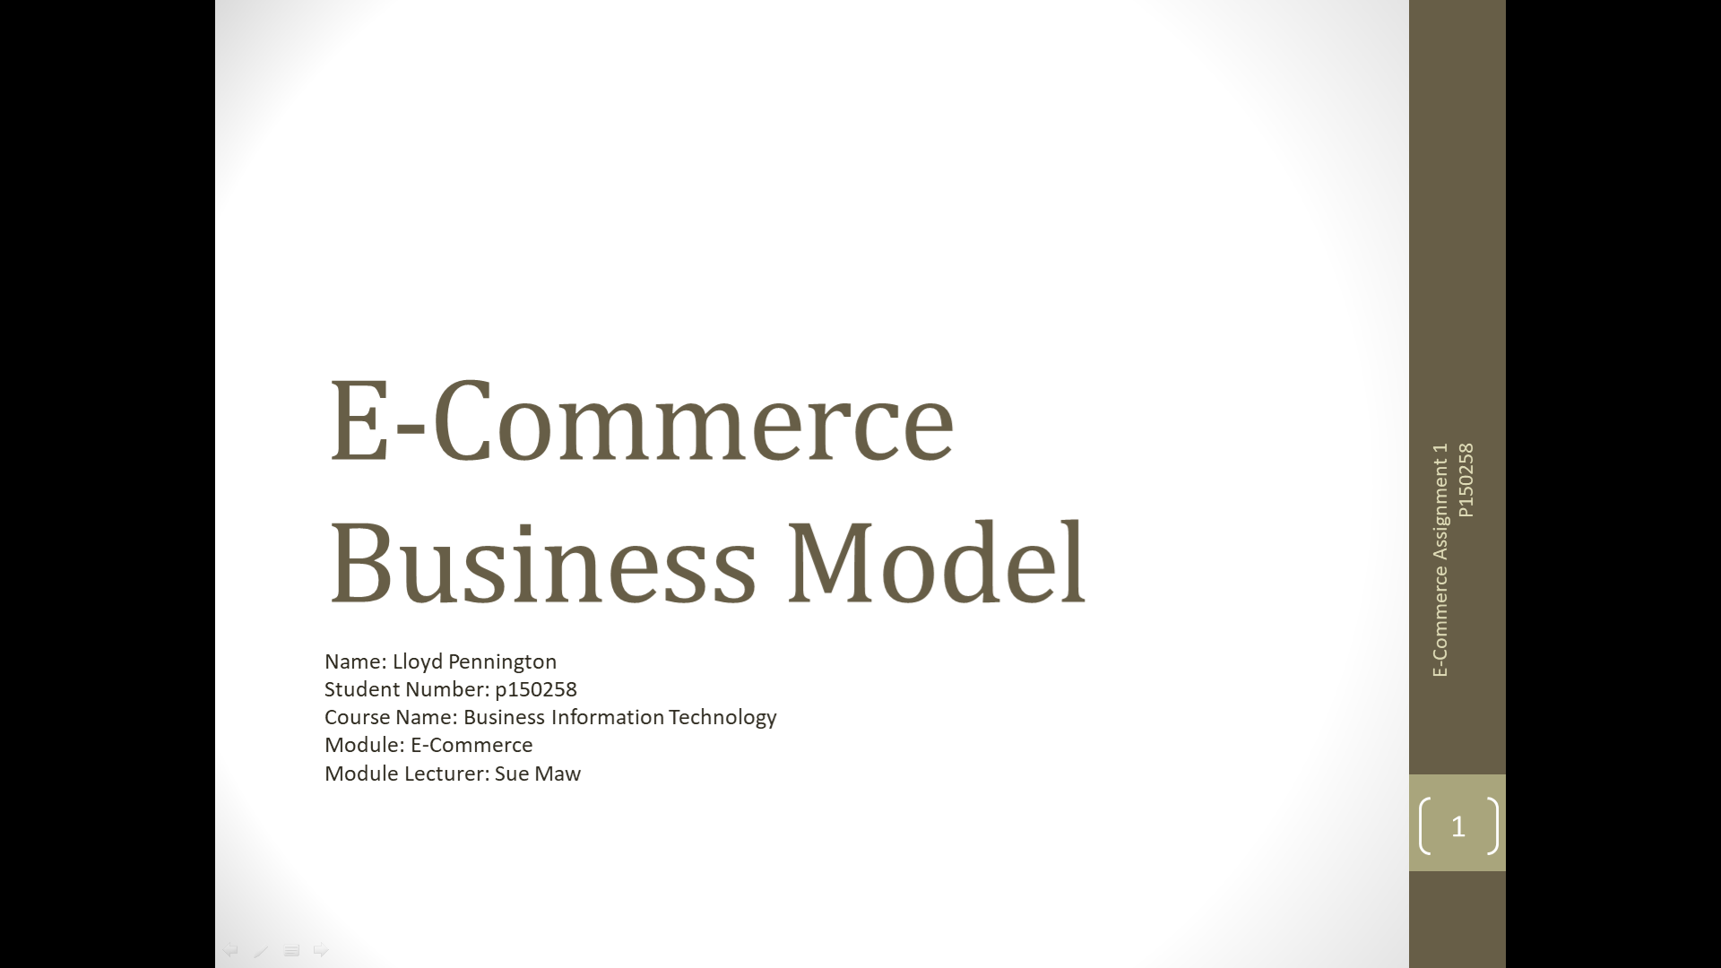
2 | 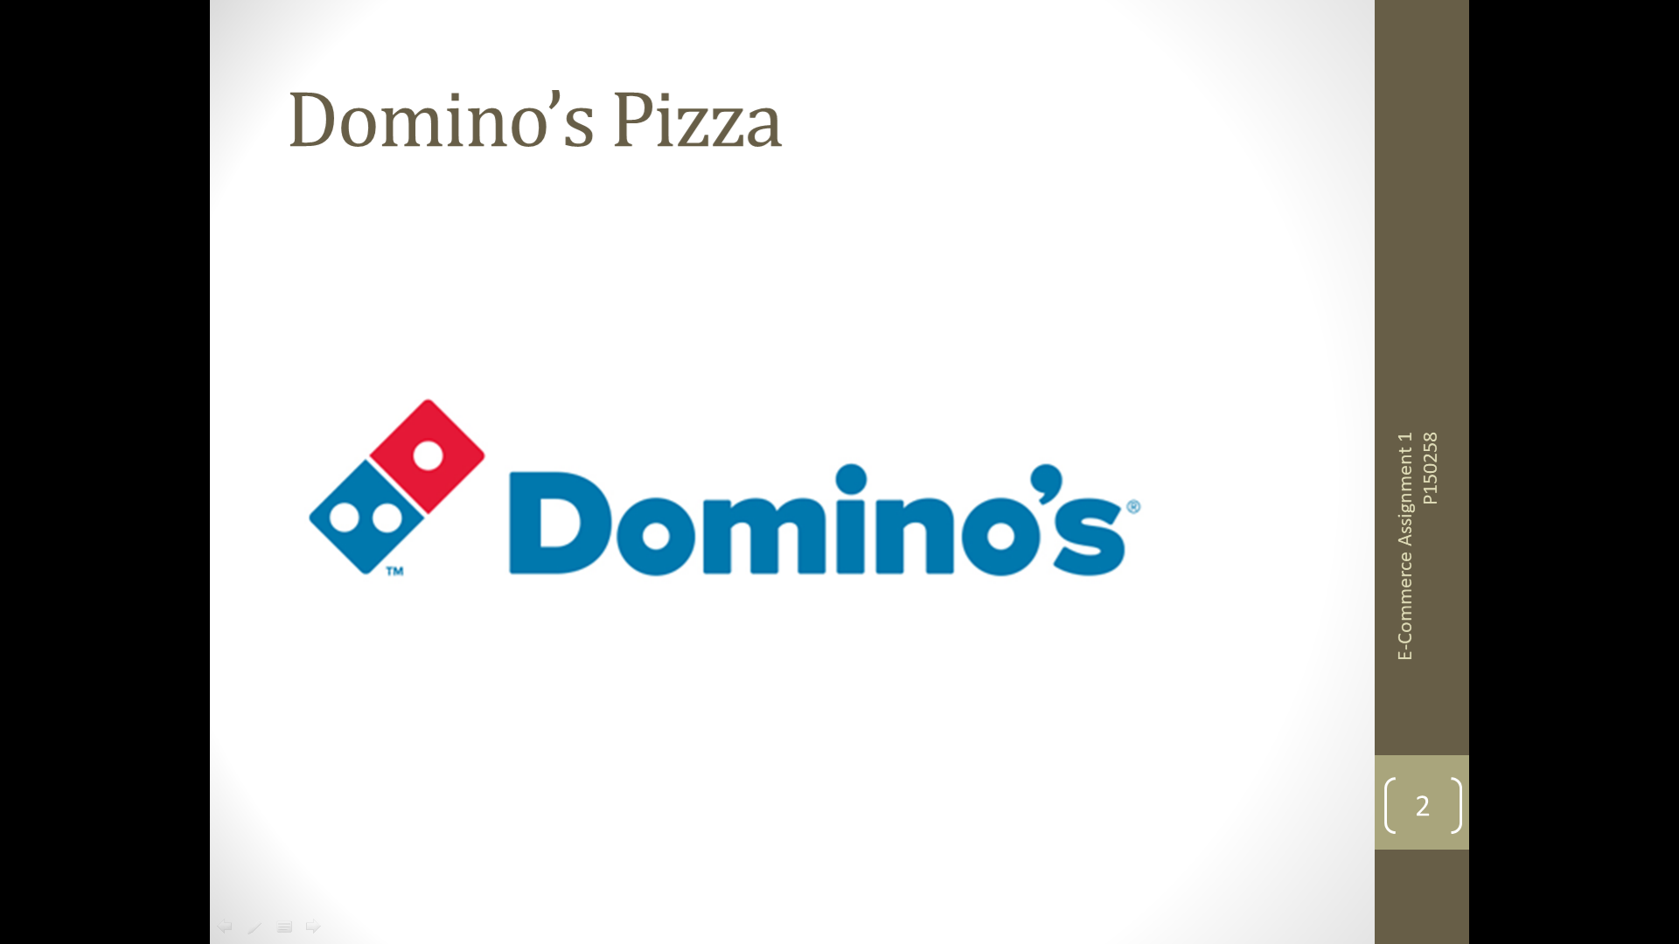
3 | 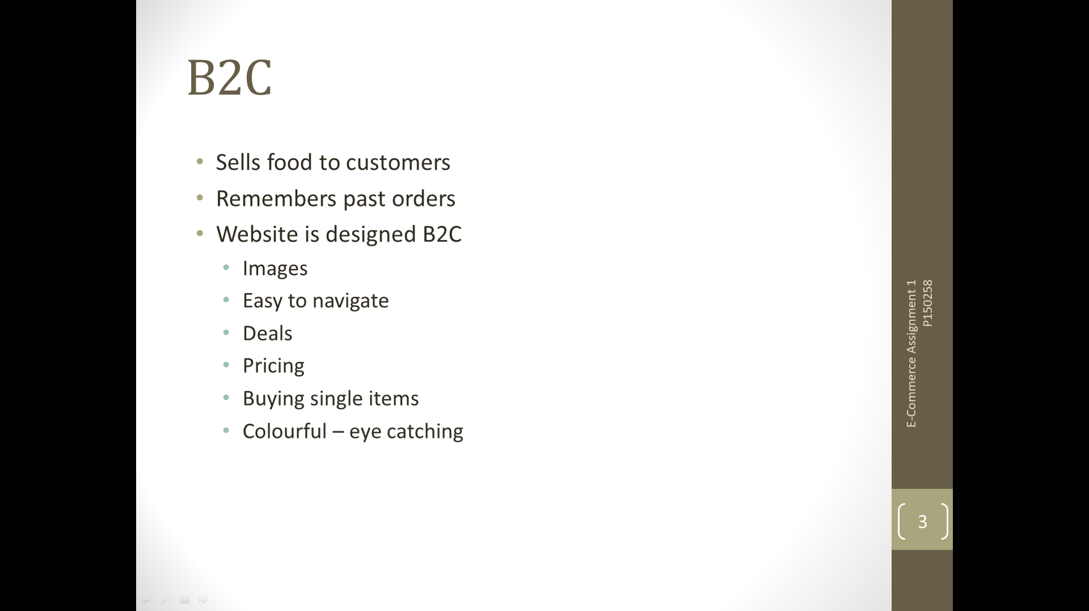
4 | 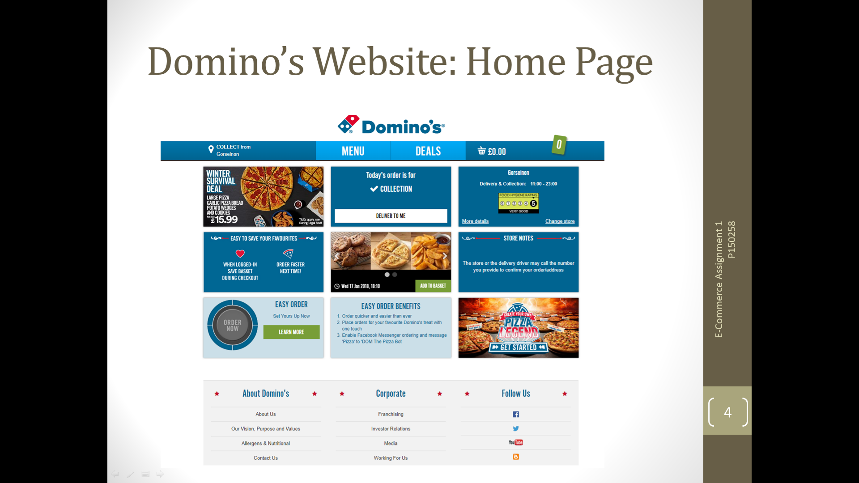
5 | 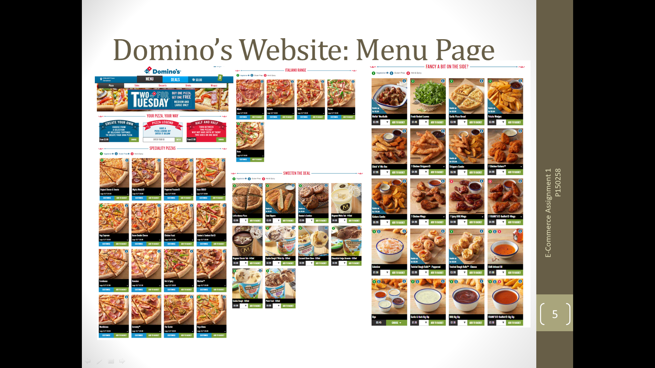
6 | 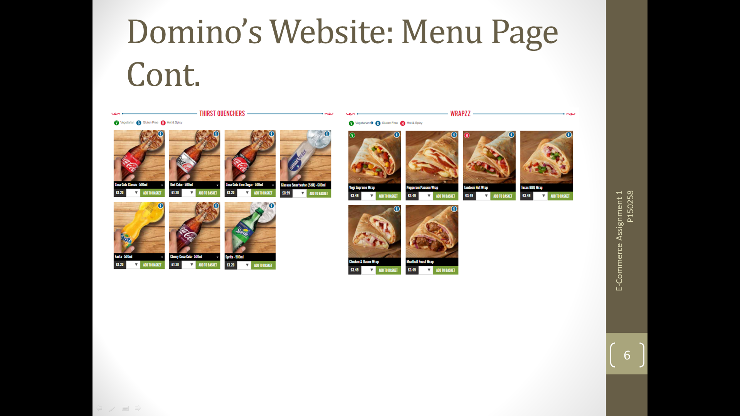
7 | 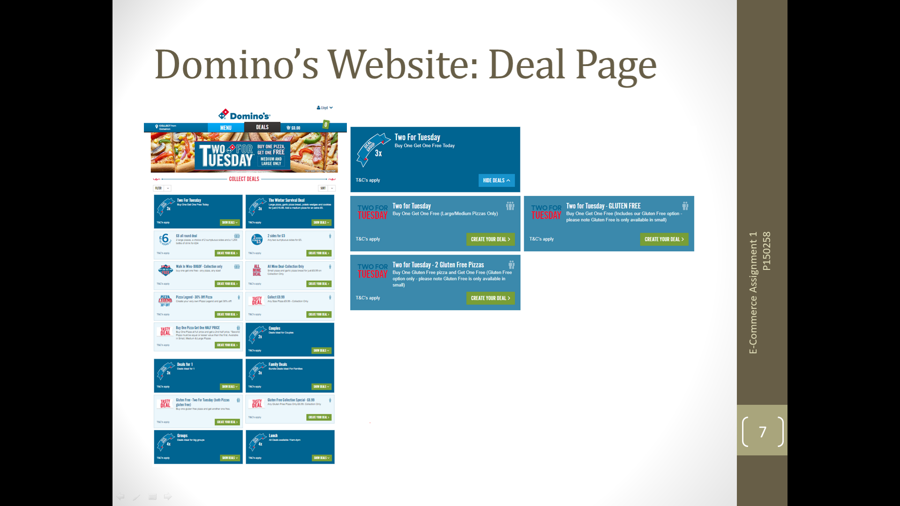
8 | 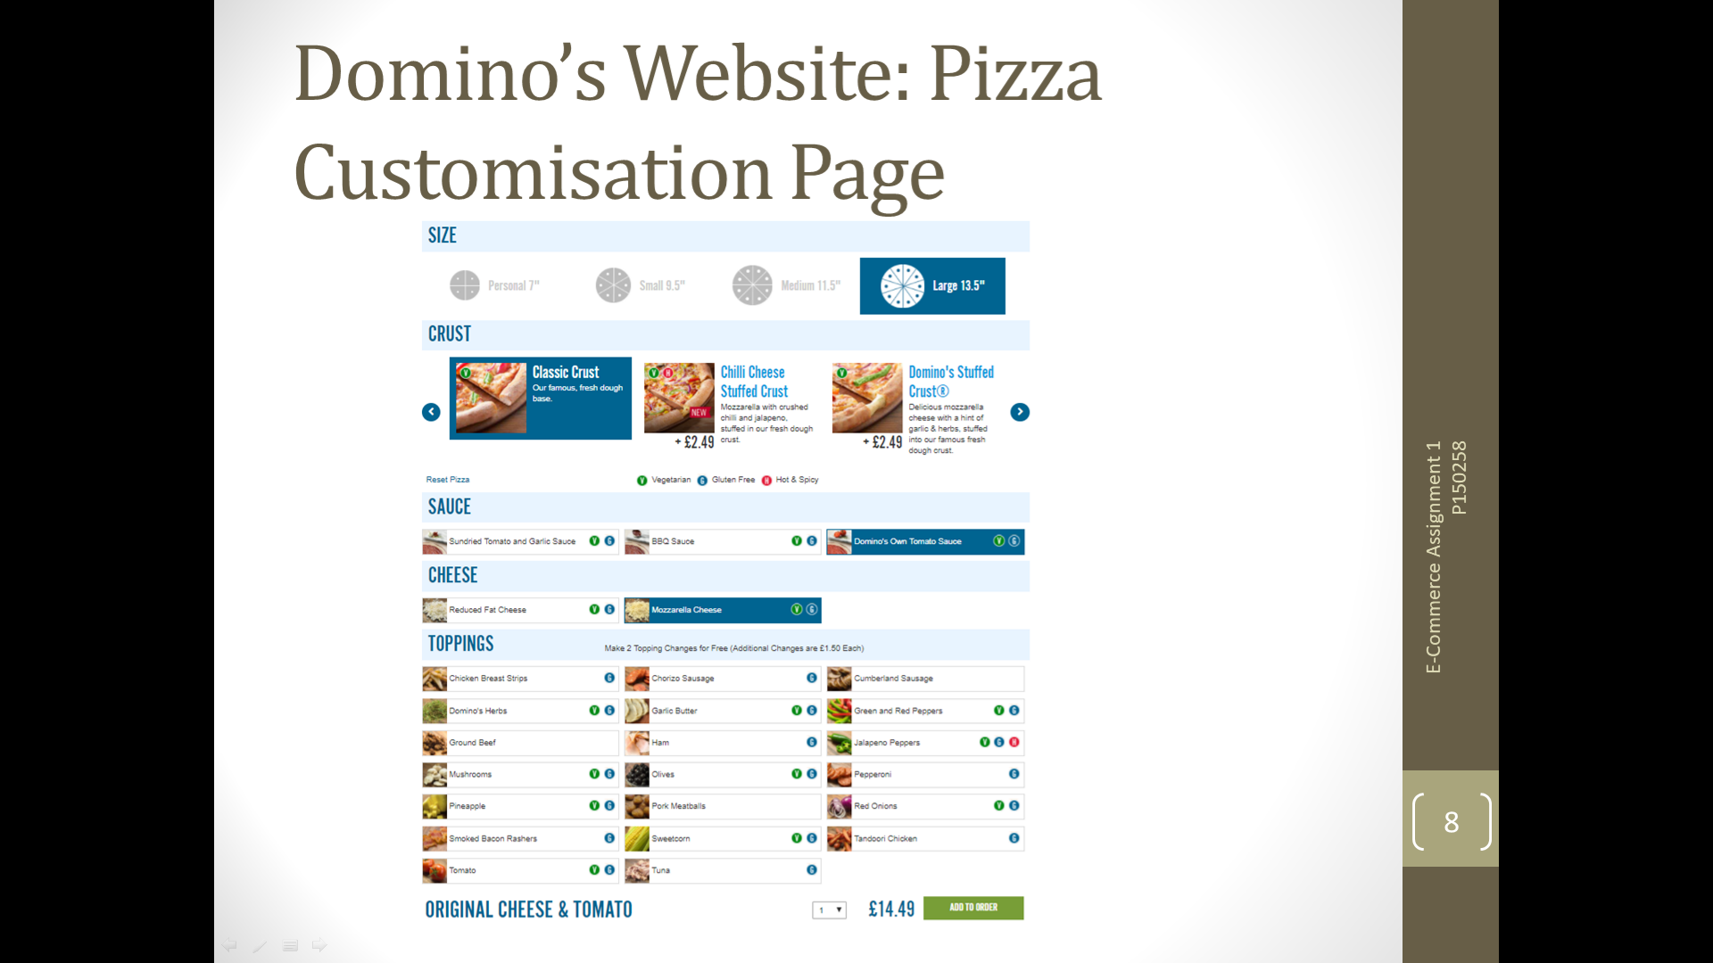
9 | 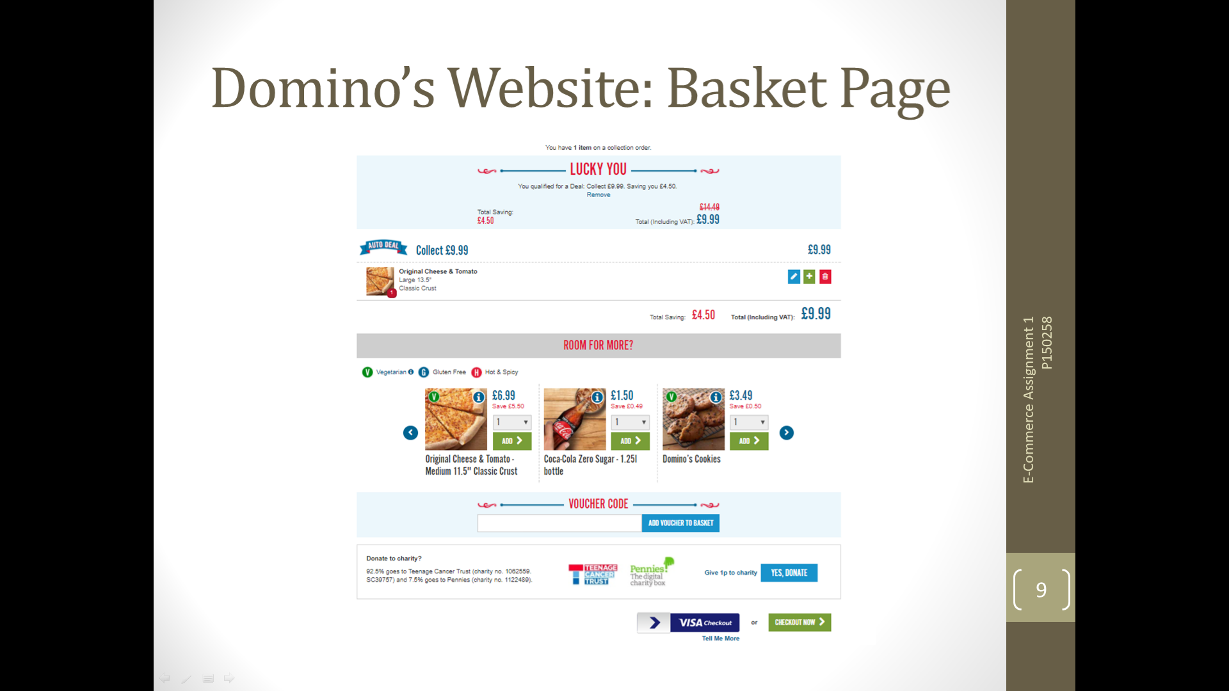
10 | 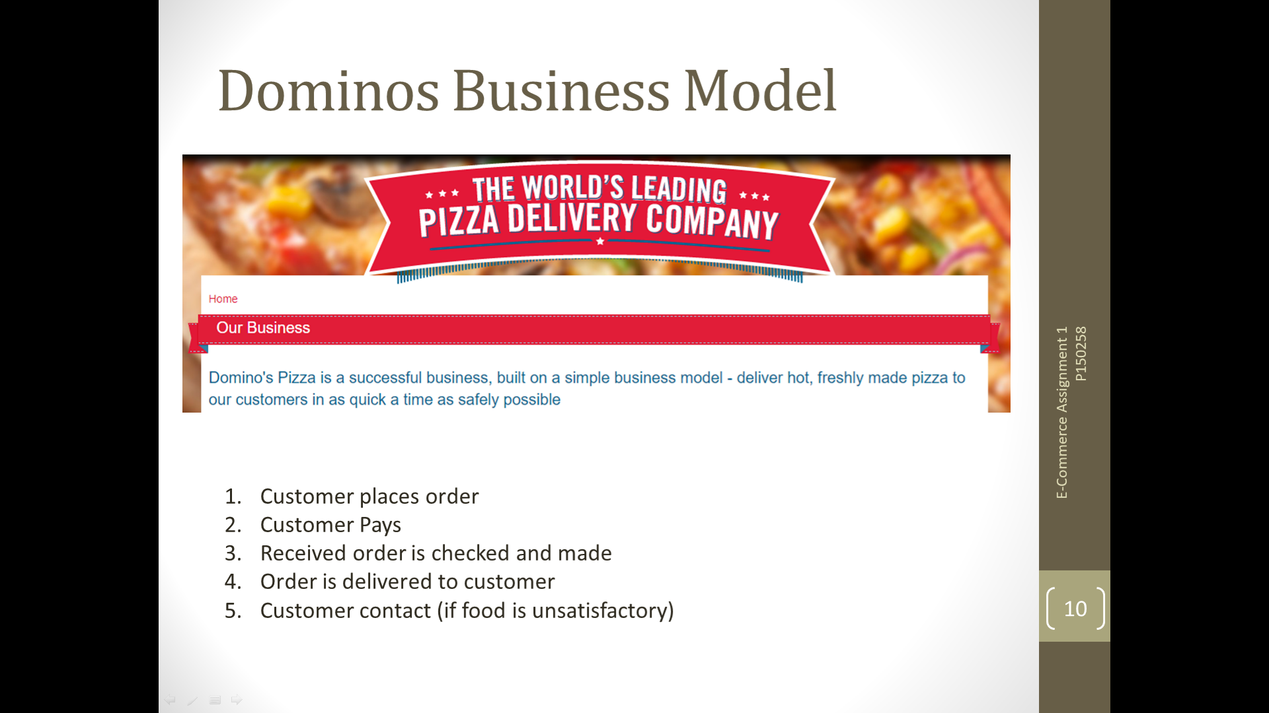
11 | 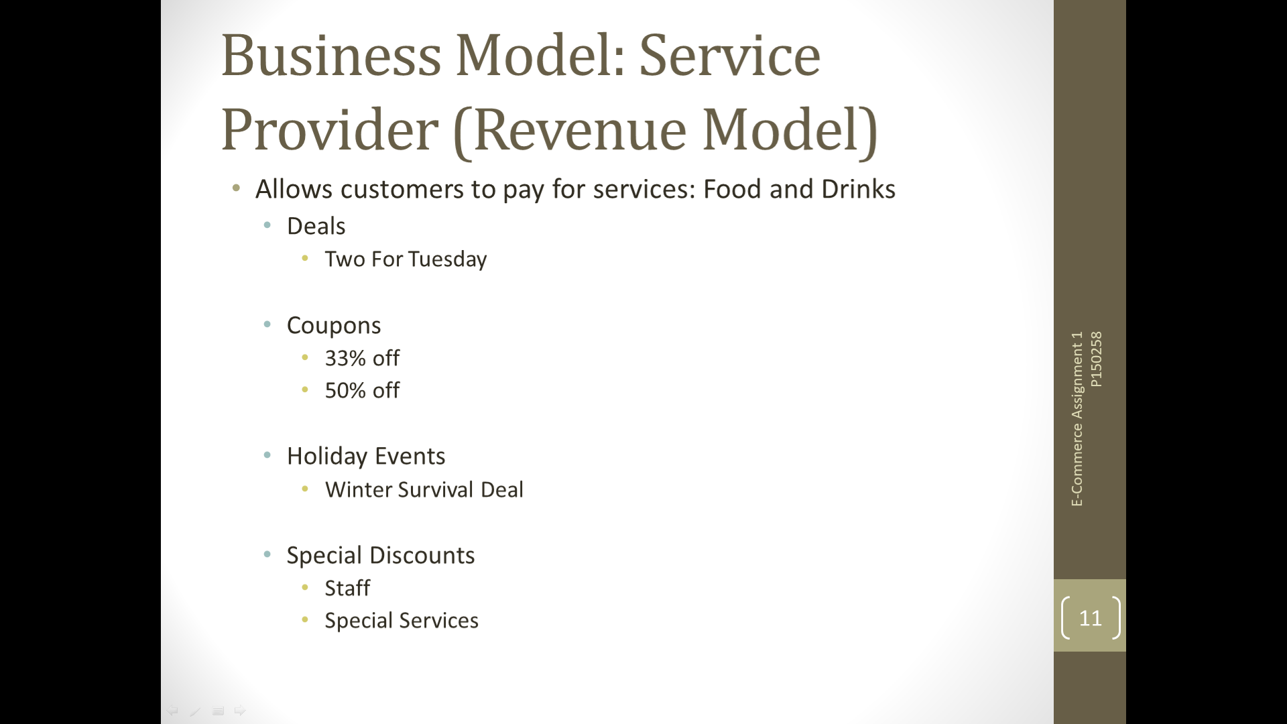
12 | 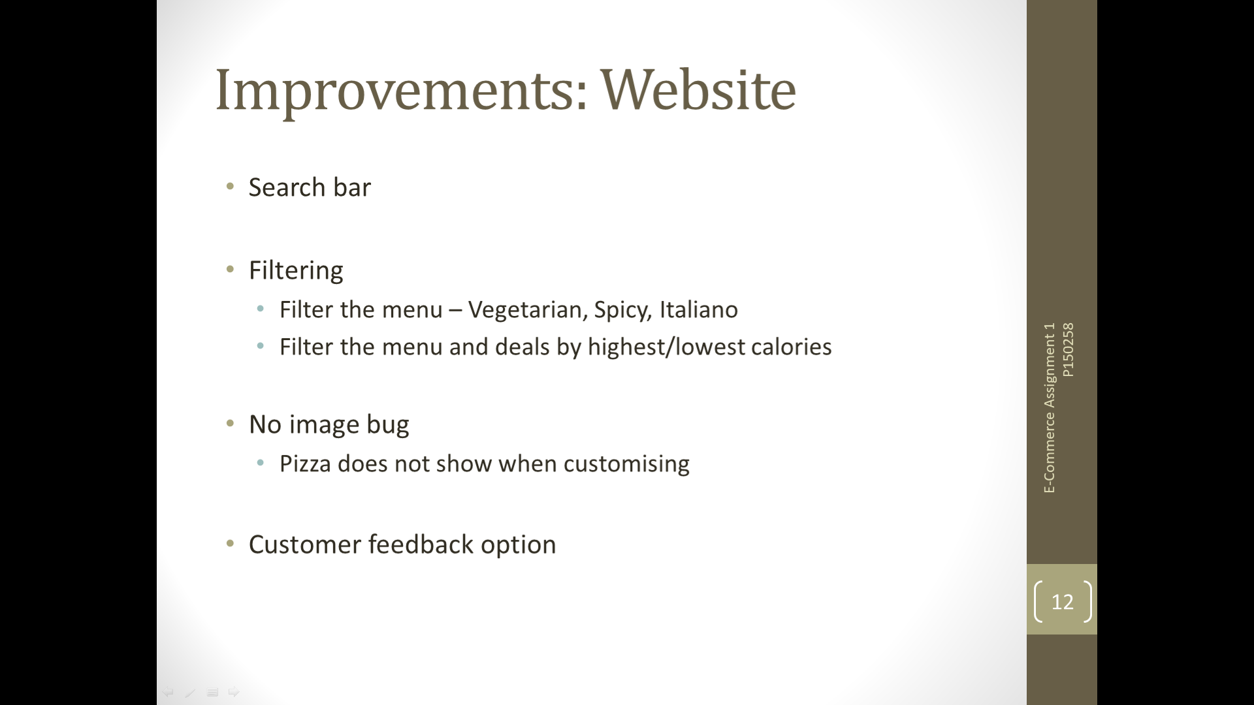
13 | 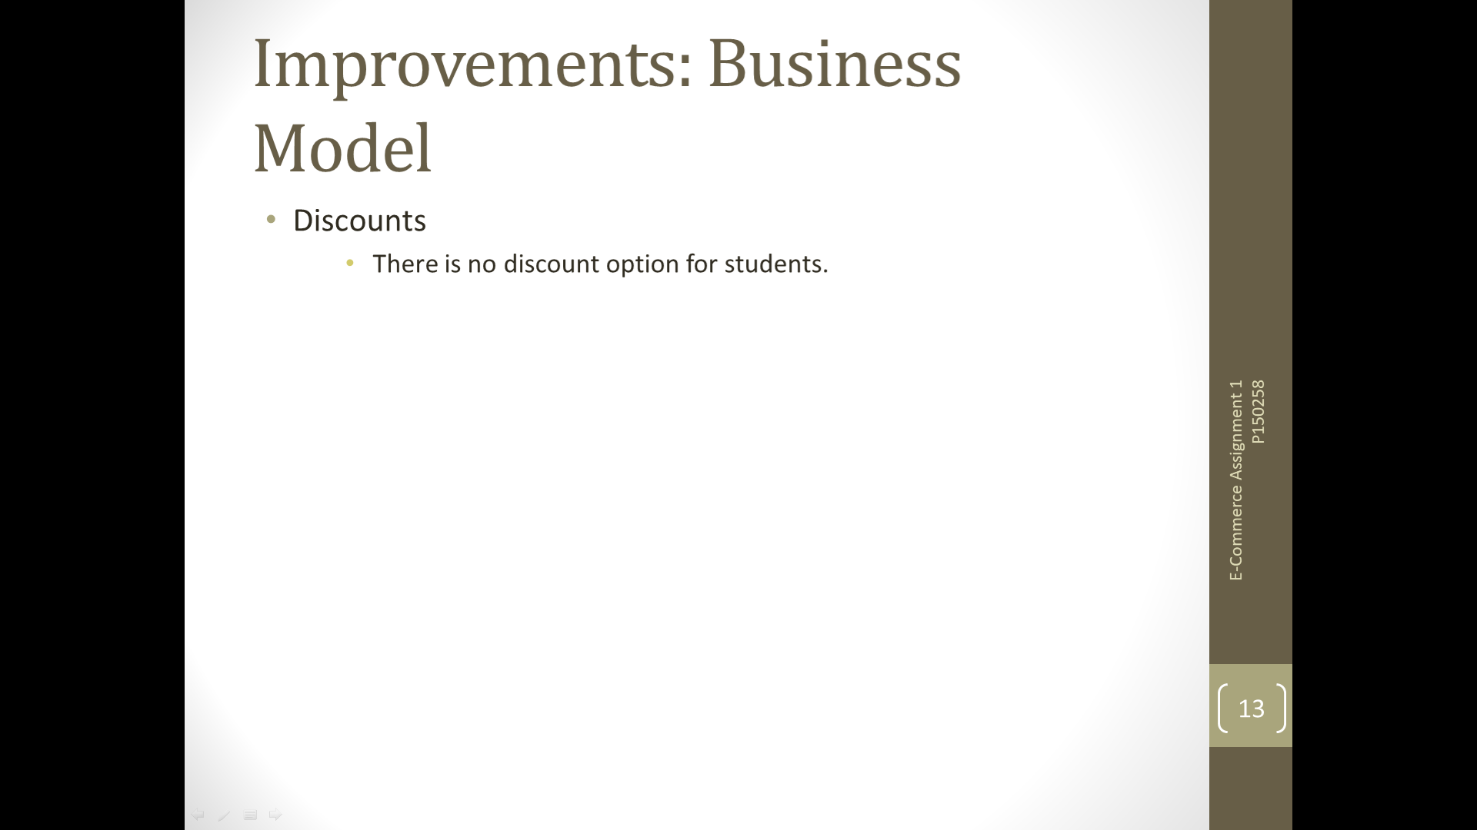
14 | 

