Research page

For my photo book I will be creating a book with a series of images using the splash art kit. I will be using the splash art kit because it will allow me to capture the collision between two waterdrops. I want to do this because it shows how I have to experiment with shutter speed.

What is a splash art kit?
A splash art kit is a liquid drop control system using. Solenoid and nozzle connected to a trigger system for camera flash. The splash art kit is something that allows you to have two separate waterdrops that you control on a timer so that they collide with each other. With using the splash art kit, it makes it easier for you to create a splash collision. Another advantage that a splash art kit has is that you connect the splash art kit up to your camera which makes it easier to take the photos because you also set a timer on the remote to your camera and once the second waterdrop falls your camera will go off which makes it easier to take the photos. Although this makes it sound easy to take the photo there are also a lot of technical aspect that you need to consider when taking them. One thing to consider is your timing of the water splash if you turn one of the dials to far then it will make the waterdrops fall to quick or to slow. Another thing to consider when taking waterdrop photos is your shutter speed, you need to consider your shutter speed and lighting because you need to make sure you shutter speed isn’t too high. If it was to high then it would make you images have a black line going through them where the flash doesn’t go off fast enough with the camera, but if your shutter speed was to be to low then you would not be able to capture the collision between the two water drops as your camera is not going off quick enough to capture the movement.

How to create waterdrop collisions

- A camera with manual settings.
- A macro lens
- Flash and two artificial lights
- A tripod
- Backgrounds
- A waterdrop kit

What I learnt while taking my images:

- Work in manual mood
- Keep the ISO low to avoid adding noise
- Use a fast shutter speed
- Use a large aperture
- Take the pictures from a short distance
- Try and avoid natural light and use artificial light or an external flash
- To focus on exactly where the waterdrop lands otherwise it might be out of focus

I did a lot of research into waterdrop collision to see what is needed and how to take the images. There was a lot that I needed to consider when taking my photos and even though the internet told me what settings to have my camera on I still had to change the setting to what worked best for me.

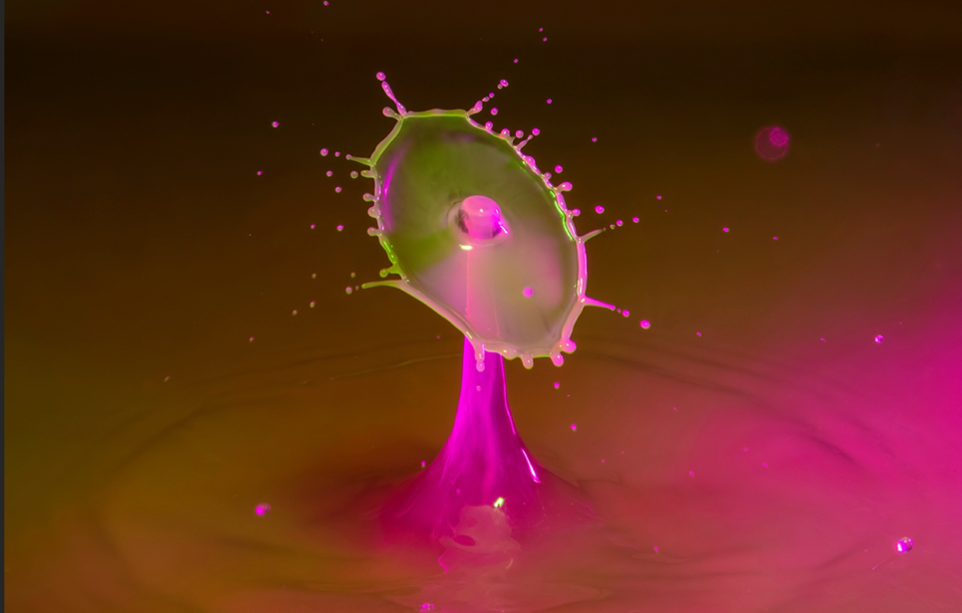

Figure 1 “waterdrop collision, march 18th 2018, Jim Zuckerman”

This image is a photo taken by Jim Zuckerman which I have chosen to look at for inspiration because I like the way that the photo is taken and presented. Jim Zuckerman took this photo using milk and water and added some colour to it to allow the photo to look bold. Jim Zuckerman took this photo using a Canon 100-400 lens. His settings were f/32, 1600 iso. I like the way that this image is presented because the photographer considered the colours that he was using and consider the background for his photo to make sure that the colours doesn’t take away your attention from the actual image.

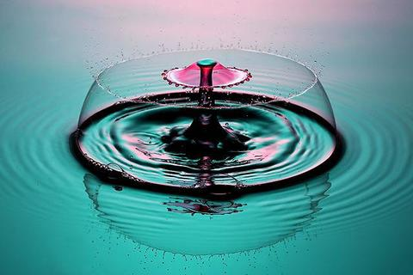
Figure 2 “bursting out” Corrie White 2010

I chose to look at this photo taken by Corrie White because to me the photo has an emotional meaning to it. I feel it has an emotional meaning because it is titled as bursting out. This to me makes me feel that it’s about someone breaking free. Which is why I am choosing it. I feel the title matches the image because there is a dome around the water drop that makes it look like the waterdrop is breaking free from the dome. Corrie White is a fine art photographer who focuses on taking photos of water drop collisions and selling them.
Corrie White’s work gave me inspiration because I like how he has put an emotional connection to his images. By the photo having an emotional connection it makes the photo stand out a lot more and makes people want to look at it.

Bibliography

https://iso.500px.com/high-speed-water-drop-photography-tutorial/

https://www.jimzuckerman.com/blog-post/water-drop-collision

illustrations

Figure 1 “waterdrop collision, march 18th 2018, Jim Zuckerman”
Figure 2 “bursting out” Corrie White 2010

