Energy in a Flywheel
Engineering science 1
Robin Williamson-gillie
1800974
Abi Summerfield
Contents
Introduction 2
Experimental procedure 3
Equipment list: 3
Method 3
Results 0
Analysis 0
Evaluation 2
Further work 3
Conclusion 4
Bibliography 5

Introduction
This experiment is trying to show how the increase of masses on a flywheel affect its kinetic energy as well as looking at the correct inertia from the flywheel. As an inertia of the cord and the flywheel have been given, so a comparison needs to be looked at between the given values and the values found from the results of the experiment.
The prediction before the experiment begins was that the kinetic energy would increase as the masses on the line increased, this was due to there being an increase in the force acting down, away from the flywheel.

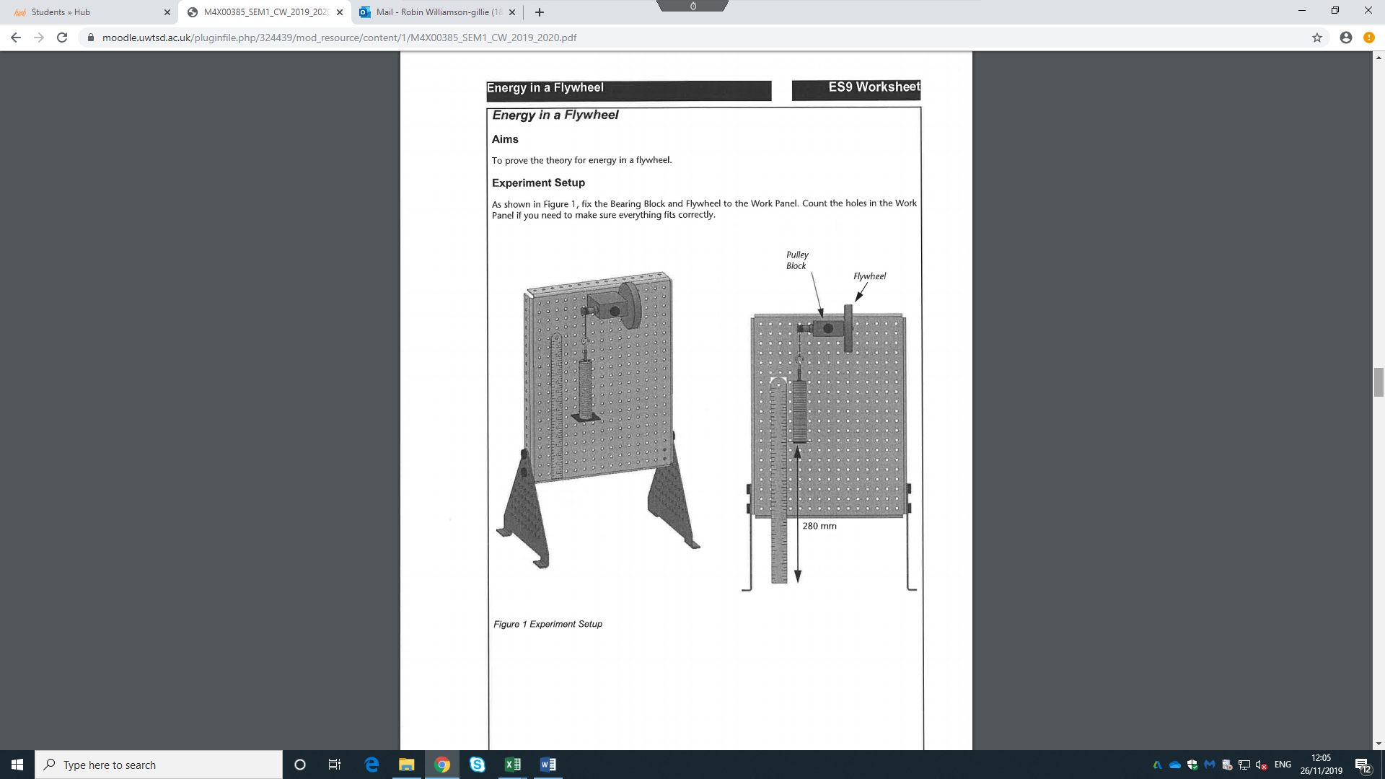
Experimental procedure

Equipment list:
- Work panel
- Metal rule
- Pulley block
- Fly wheel
- 3X screws
- Masses hook
- 50X 10g masses
- Cord
- Work panel legs
- Stopwatch

Figure 1 equipment set up (Ltd, 2012)

Method
- First set up the equipment provided in the same way as shown in figure 1
- The cord needs to be cut to a length of 300 mm
- Place the metal rule against the work piece, with 10 mm between the bottom of the rule to the table the experiment is being done on
- Then attach the cord to the weights (there should be 9 masses on the weight hook as this with the weight hook equals 100g) and the pulley block
- Turn the flywheel until the bottom of the weights are at 280mm
- Release the flywheel and time how long it takes for the masses to move from 280mm to 0mm and then too the maximum height, the maximum height is the point where the masses begin to fall again after the first fall of the masses
- The results that need to be recorded are; the time taken for the masses to reach their maximum height and at what height this is
- Once the first result is taken, repeat steps 5 to 7, increasing the mass by 100 grams each time, until 500g is reached
- These are the results from the experiment

Results

This is a table showing the raw data taken from the experiment, as well as showing the results calculated from the original raw data.
Mass m (kg) | Potential energy PE (J) | time to fall and rise (seconds) | height 2 (m) | mg | PE loss adjusted (J) | Falling time (seconds) | Acceleration (m/s^2) | Velocity (m/s) | Angular velocity (rad/s) | a/r | (mg-ma)r | KE
0 | 0 | 0 | 0 | 0 | 0 | 0 | 0 | 0 | 0 | 0 |  | 0
0.1 | 0.27468 | 4.06 | 0.24 | 0.981 | 0.02112923 | 2.1861538 | 0.05858637 | 0.12807882 | 19.7240918 | 9.01328767 | 0.006338419 | 0.09142435
0.2 | 0.54936 | 3 | 0.25 | 1.962 | 0.03109585 | 1.5849057 | 0.111468254 | 0.17666667 | 27.206603 | 17.1489621 | 0.012608091 | 0.17394682
0.3 | 0.82404 | 2.38 | 0.253 | 2.943 | 0.04174311 | 1.2502814 | 0.179119337 | 0.22394958 | 34.4881546 | 27.556821 | 0.018780217 | 0.27951671
0.4 | 1.09872 | 1.94 | 0.249 | 3.924 | 0.06438624 | 1.0268431 | 0.265552169 | 0.27268041 | 41.9926853 | 40.8541798 | 0.024815564 | 0.41439562
0.5 | 1.3734 | 1.78 | 0.24 | 4.905 | 0.10564615 | 0.9584615 | 0.304795571 | 0.29213483 | 44.9886588 | 46.8916262 | 0.030891914 | 0.47563516

Table 1: fly wheel results

Analysis
This is a graph showing (mg-ma)r against a/r, from this the gradient can be worked out, the gradient is then the inertia of the flywheel.

There are several calculations that are needed to be done to gain all the results from the experiment. All of the numbers used in the equations need to be in base units.
The calculations are:
- Firstly the weights of the masses that are being added to the cord, this is a simple calculation of mass multiplied by gravity, gravity in this case is 9.81 m/s.
- The second calculation is the PE (potential energy), this equation is the weight (as done above), multiplied by the initial height (h1), h1 was 280mm.
- The 3rd calculation is the potential energy loss adjusted. The equation for this is PE loss*h1(h1-h2), however we first need to work out the PE loss, this equation is mg*(h1-h2), the result for this can then be put into the PE loss adjusted equation.
- The 4th calculation is too work out the falling time of the masses. Too work this out use; (h1/h1+h2) multiplied by the time to fall and rise.
- From this the linear velocity needs to be worked out, this is simply h1/(time too fall^2)
- Then linear acceleration needs to be calculated, this is the linear acceleration multiplied by the falling time
- The next calculation is to work out the angular velocity, the equation for this is; 2 multiplied by PI multiplied by velocity all over the diameter of the cord on the pulley which is 0.0408
- To work out the angular acceleration, divide the linear acceleration by the radius of the cord which is 0.0065m
- Next calculation to be worked out is the tension in the cord, this is (mg-ma)r, mg was previously calculated, ma is the mass multiplied by the linear acceleration. This is then all multiplied by the radius of 0.0065 m
- The final calculation is to work out the Kinetic energy of the flywheel. To do this the inertia is needed, the inertias given come too a sum of 4.7 x10^-4 kgm^2. Then to work out the kinetic energy, use the equation 0.5*0.00047*(angular velocity ^2).

There is a direct correlation between the increase in masses and the increase in potential energy, this can be seen in Table 1. For example, at the initial mass of 0.1 kg (100g) the potential energy is 0.27468 J compared to the final mass of 0.5 kg, where the potential energy is 1.3734 J, this is a difference of 1.1 J. However, the PE loss is also proportional to the increase in mass, because at greater masses the potential energy loss is far greater, however these are not in consistent increments. This loss can be seen when the potential energy and kinetic energy are compared as they are not equal and the potential energy is greater, this loss is most likely caused by the frictional force, as this will increase as the mass increases.
The moment of inertia calculated from the gradient of the graph, using the equation y=mx+c. the result found was 0.00061 kgm^2, this compared to the numbers given for the flywheel and the shaft and pulley, the total moment of inertia for these two was 0.00047 kgm^2. This result is 0.2 less than the inertia calculated from the graph, this shows that the there are both errors in work and other factors affecting the inertia. One of these is the friction force caused between the string and the fly wheel, this will affect the inertia as the force will increase the resistance of angular acceleration in the flywheel.

Evaluation
There were a large amount of errors that could have occurred and some that did occur during the practical.
One of the possible errors that was considered when the experiment was being carried out, was a parallax error on working out h2, to stop this from happening, the readers of the height sat at eye level to the ruler so that the angle could not affect there judgement on when the bottom of the masses had reached h2.
Another issue that did occur which caused both confusion when taking the reading and errors in the results, was when the stopwatch should begin, as there were two timers, the first was starting the stopwatch once the person releasing the flywheel said too start them, the second was starting the stopwatch once they saw that the flywheel was moving, the first person was correct however as the flywheel would have still been accelerating even if it could not been seen, this error was fixed, however it still meant that some of the results needed to be redone.
To reduce the amount of errors and anomaly’s in the work, multiple readings were taken at each mass and then an average calculated from that, this as said above allowed any anomalies to be easily identified and discounted before taking and average.
Another cause of errors is the reaction time of the person releasing the flywheel, as when they say they release it, there would have been a delay between them saying its begun and there hand moving, this may only be half a second on the time, but overall especially with the large quantities of calculations done from the results, that half a second can greatly affect the results.

Further work
If the experiment and there was an unlimited budget on the experiment there are a lot of different ways that the experiment can be improved.
One of the big ways is to use a highspeed camera that can take pictures throughout each run of the experiment. This would mean that the fall and rise of the masses can be tracked frame by frame, this would mean that it could be seen the exact moment where they stop moving after they have risen after falling once, this would mean the results for h2 would be far more accurate. It would also show the actual result of the height as the frame could be paused seeing the exact value.
Another improvement that could be made is to use a light gate or a laser, this could be connected to the stopwatch. This would mean that as soon as the light beam or laser is broken by the bottom plate of the masses the stopwatch will begin. Overall this would give a far more accurate reading as it means the stopwatch won’t start before the masses have begun accelerating.
Something that wasn’t fully considered during calculations was the possible air resistance reducing the velocity of the masses, increasing the fall and rise time. To stop this from occurring, the practical could be done in a vacuum, this would remove the air and stop any possible air resistance affecting the experiment.
Another way that the experiment could be improved is by having the release on the flywheel automated, so that the flywheel is set in position, and too release it a switch could be used, or it could on a time. This would get rid of any human error in terms of the reactions on releasing the flywheel.

Conclusion
The results found in the experiment were the expected findings to get from this practical experiment. Which to reiterate was that as the masses increase, the force acting on the flywheel would increase, this would in turn increase the kinetic energy of the flywheel. The other aspect was looking into how it would affect the inertia of the flywheel and how that compared to the values given in the practical report hand out. It was found that there was a large difference between them due to a few different reasons, which were spoken about in the analysis.
To validate the findings a comparison with results found in another practical experiment were needed, there was a lack of information regarding the affects of the masses on the flywheels kinetic energy, however a comparison could be found for the inertia: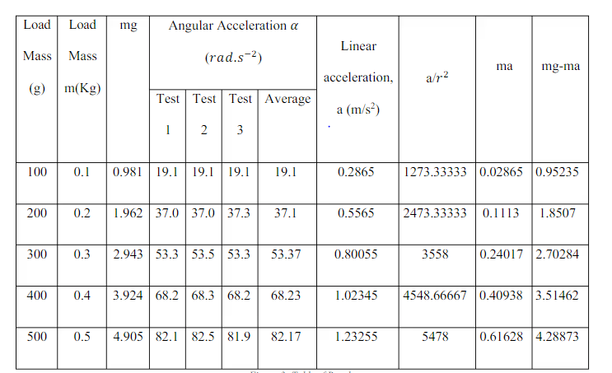
Figure 2 results from another experiment carried out by external source
This was the table of results found from the online experiment, from this they calculated the moment of inertia, the value was not the same as the inertia found in the experiment being talked about in this report, as the value initially given in the experiment was 1.8926 x10^-5, however then from the graph it was worked out to be 1.20264 x10^-5 (Macharia, 2019) This shows that there was a larger reduction in the inertia of the flywheel, this would have been due to the same factors as described in the analysis, this proves the results found in this report, as they show a very similar trend of reduction in inertia, compared to the values given.

Bibliography
Ltd, T. (2012). Potential and Kinetic Energy Kit ES9. TecQuipment limited.
Macharia, D. (2019). Flywheel lab report . David Macharia .

