Chapter 2- Literature Review
2.0 Introduction
This chapter is used to review all the existing research and literature accessible to myself regarding how police are attempting to improve relations between themselves and the communities they serve. I will be trying to focus on literature regarding policing in deprived areas. I will be I will review the articles, giving an overview and key points that are being presented within. I will be analysing the articles and literature, looking for gaps in research and any possible biases within. I will also be looking at techniques that police have attempted to use within the community to improve the relationship between them and the community and the overall effectiveness since the early 2000s. This process is not only gaining a better understanding of the subject matter chosen but also to set the stage of future research, myself and others who are attempting to navigate the subject field of policing. This chapter will be targeted to complete the first objective I have set out within this dissertation which is:
- I am looking to research the different approaches that police forces are using to try and become more transparent and trustworthy with the community they police.
This review of literature within the chapter will contain a large range of sources that have been located through google scholar, online documents, and articles as well as the University of Wales Trinity Saint Davids online library. The literature within this chapter have been reviewed and considered to assist myself in the creation of future research and the method of collecting data. Mostly consistently searched terms included ‘Deprived areas’, ‘Protected characteristics’, ‘Poverty’, ‘Neighbourhood policing’, ‘Policing techniques’, ‘Ethnicity and deprivation’, ‘Newport Census’, ‘Ethnicity’ and ‘Wales’. The literature presented in this chapter can be regarded as a valuable resource in developing primary research and establishing the methodology for data collection.

2.1 Deprived areas
Since the 1970s, the Ministry of Housing, Communities and Local Government, along with its predecessor organizations, has been assessing and analysing local levels of deprivation across England, this is named the Indices of Deprivation and is released with updated statistics and findings throughout the years. (Ministry of housing communities and local government, 2019). Deprivation is widespread throughout England, with 61 percent of local authority districts housing at least one of the most disadvantaged neighbourhoods in the country.
It is important to note that not everyone living within the deprived neighbourhoods of England and Wales are actually deprived, there are many people that are deprived living within an area that is classified as non-deprived. Although this is the case for some, there is a high number of deprived people living within a particular area meaning that the area is more likely to be deprived (GOV.UK, 2020)
Deprivation happens across the Britain and can vary due to different characteristics and number of people living within that area. Whilst looking at research into deprived areas on a geographical side, I have seen a difference between rural and urban areas. Compared to just 1% of people in rural areas, 12% of urban dwellers reside in areas that fall within the 10% most deprived category of the Index of Multiple Deprivation (GOV.UK, 2019). Although this shows a clear higher level of deprivation within urban areas, population within them is more dispersed making in disproportionate to evaluate these together.
Although rural areas are being defined as being less deprived within Britain as a whole, just under one third of the Welsh population are currently living within a rural area, 32.8 percent (UK Parliament, 2020). This is a large amount and although the general ideology is this is less deprived the number of deprived is considerably higher compared to other parts of the UK. Over twenty percent of the population in Wales, specifically 23%, is currently experiencing poverty, representing the highest rate among all nations in the United Kingdom. This statistic indicates that approximately 710,000 individuals in Wales are living below the poverty threshold, which includes 185,000 children, 405,000 adults of working age, and 120,000 elderly individuals (Senedd Cymru, 2018). Below is the estimated percentage of the population in poverty between 2019-20 to 2021-22 (Senedd Cymru, 2018).
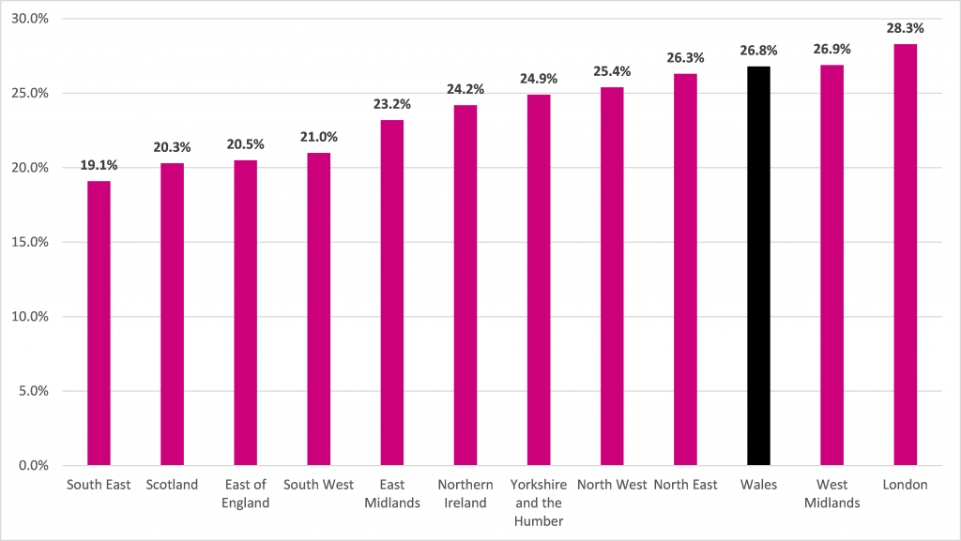
Poverty and deprivation can be assessed through multiple methodologies; however, the primary metric employed by the UK Government is known as 'relative low income' or 'relative poverty.' A household is classified as experiencing relative poverty if its income falls below 60% of the median household income, considering housing costs. This assessment encompasses all forms of income, including earnings from employment and social benefits, and is calculated after taxation. Official poverty statistics do not account for various individuals residing in institutions, including nursing homes, dormitories, military barracks, or correctional facilities, as well as those experiencing homelessness who are living on the streets or in temporary lodging such as bed and breakfast establishments. These can be defined as some of the most deprived and poverty-stricken people, (Senedd Cymru, 2018).
With the mention of homeless people with Wales, these are required to be addressed as they can be identified within deprived areas and seems to be some of the most deprived people within the local communities of England and Wales. On a 2021 Census, an estimated 13,955 individuals were residing in hostels and temporary shelters for the homeless. This figure accounts for merely a minor fraction of the overall population facing homelessness, suggesting a considerably reduced number in comparison to other official estimates for this group. This identifies that people living within the communities homeless are going under the radar and not being identified, therefore not given the support and essentials that they require from the society around them.

2.2 Protected characteristics
In 2010, a new act came into place named The Equality Act 2010, this is used to protect people from discrimination in the workplace as well as within society. This act defined protected characteristics and replaced anti-discrimination laws with one single act, making it easier to understand for everyone no matter the situation (GOV.UK, 2013. These protected characteristics are now identified within societies of the UK and are known by many. The nine protected characteristics are age, pregnancy or maternity leave, disability, gender reassignment, married or civil partner status, race, religion or belief, sex, and sexual orientation (E. Brown, 2023). These are all seen to provide a disadvantage in day-to-day life and therefore have been identify and protected.
These protected characteristics have been used by many to identify attributes of people within deprived areas and many have looked at them on the whole as well as specific characteristics and how these effect deprived areas within England and Wales. An analysis completed on behalf of the Welsh Government has looked into correlation between protected characteristics and deprivation within Wales (Welsh Government, 2020). This analysis determines the locations where individuals from different protected characteristic groups are most likely to reside, taking into account small area demographics, relative deprivation, and any variations that may exist among these groups. This found many findings including that 52.1% of people living within the most deprived areas within Wales are female as well, meaning there is higher disproportion of females but only slight. Another interesting finding that this analysis found was people with a declared disability were more likely to live within these areas of deprivation with 1 in 3 people living there being disabled.
Another characteristic that seems to be looked at when speaking about deprived areas is race, this has been highly analysed with deprivation as well as cohesion with local policing forces. One research looking into the 2011 Census saw that people from Pakistani and Bangladeshi ethnic groups were over three times more likely as people identifying to White British ethnicity to live in the top ten percent of deprived neighbourhoods (GOV.UK, 2020). This means that people from the Pakistani and Bangladeshi ethnic were the most likely to live within these deprived areas.
There is a clear diversity within these deprived areas is evident and this can create the ideology of smaller communities due to sharing these characteristics as well as the social problems they face day to day in the neighbourhoods. Newport, Wales is no different and can be seen to be ever changing, with the greatest increase of population in Wales between 2011 and 2021, increasing by 9.5 precent (Office for National Statistics, 2023). A closer look into Newport in Wales shows that there are ethnic dense areas such a Pillgwenlly which as 44.8 percent of the ethnic minority within the central area of Newport (One Newport, 2021). This is high numbers but the correlation with deprivation in Newport makes this number alarming as Newport contains the largest number of the "most deprived" regions in Wales. Approximately 23 out of Newport's 95 areas rank within the top 10% of the most deprived areas in the country (Nation Cymru, 2022).
2.3 Policing in deprived areas
Police forces depend on confidence and cohesion from the communities they police to effectively interact and communicate with the community; however, certain individuals and groups exhibit greater reluctance for this to take place, with some going as far as hating the uniform and police forces. According to F. Cosgrove and P. Ramshaw (2013), the lack of engagement from particular groups creates an obstacle in neighbourhood policing, yet it is precisely these groups that law enforcement should prioritize for engagement. Police forces across England and Wales have tried to improve the engagement with these groups and areas within they live, many techniques have been used and some have made great improvements.
An efficient approach employed in law enforcement to foster and establish new lines of communication between various social groups and the police is neighbourhood policing, which can be regarded as the foundation of policing in Wales (Andy Higgins, 2017). Neighbourhood policing involves a collaborative team comprising police officers, civilian staff, and police community support officers (College of Policing, 2024). The position of community support officer was established following the Police Reform Act of 2002, aimed at fostering a visible presence and facilitating engagement within the community without the associated stigma of being a police officer. This initiative addresses community issues that response officers and other teams, which are not specifically designed for community interaction, may find challenging (Jonathon Merritt, 2010). Police community support officers serve as a bridge between the community and the police force, enhancing the presence of law enforcement within the community and bolstering public confidence and trust in the police. These officers strive to promote better cohesion by actively engaging with local residents, gathering information, and gaining insights into the dynamics of the community.
Police forces have also started to use technology to advance their communications and attempt to improve the support and confidence from the communities they police. The utilization of social media and various digital communication platforms plays a significant role in understanding both the physical community present and the virtual communities that exist beyond it (College of Policing, 2024). Through social media, law enforcement agencies can disseminate information regarding events, report missing individuals, and demonstrate their engagement with the community. The latest posts being uploaded by many forces to their social media accounts is footage of warrants being executed and arrests being made. This transparency fosters a sense of involvement among residents, allowing them to feel connected to the policing efforts within their community. Furthermore, social media has become integral to the lives of younger individuals. Research conducted by Ruddell and Jones indicates that social media users are predominantly younger, while older members of the public exhibit minimal engagement with these platforms (Ruddell and Jones, 2013).
A cycle that is used by all policing teams and is the focus point of Neighbourhood policing is “The Confidence Cycle” (College of policing, 2024). This cycle improves confidence, increase information, and with an end goal of potentially driving down criminal activity. This approach depends on the collaborative problem-solving efforts of the team, which subsequently tackles issues within the neighbourhood. As these problems are resolved, levels of confidence and trust within the community rise, enabling residents to share information that can be transformed into actionable intelligence. Consequently, community engagement can be enhanced, allowing for the identification of priorities that the policing team can address to better the local area. This cyclical process is employed by all neighbourhood teams and has proven effective in fostering cohesion in most communities.
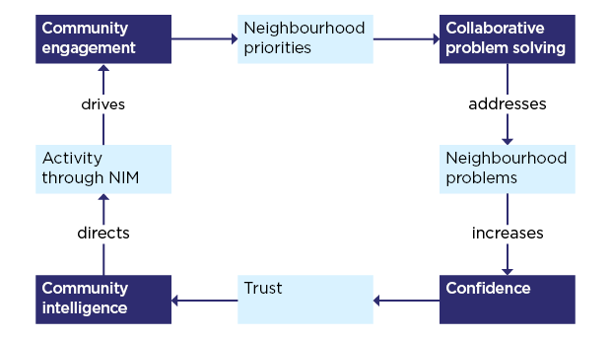
The Confidence Cycle (College of Policing, 2024).
The insights gained from interactions with the community are instrumental in developing intelligence regarding issues that impact neighbourhoods, which can subsequently be integrated into strategies for policing local areas. This process should encompass data derived from standard operational policing, social media platforms, and investigative efforts. It is essential that engagement and intelligence collection methods are interconnected and harmonized with broader strategic initiatives (College of Policing, 2024).
2.4 Conclusion
Chapter 2 of the dissertation is dedicated to an examination of the existing literature regarding the efforts made by police to enhance their relationships with the communities they serve, particularly in deprived areas. This chapter aimed to complete the first objective I set out within this dissertation, and I believe that I completed this:
- I am looking to research different approaches that police forces are using to try and become more transparent and trustworthy with the community they police.
I have researched into the deprivation within England and Wales and the issues this causes within the communities, I found that protected characteristics were a key factor in the issues police were facing and corelated to the deprivation within neighbourhoods in Wales. Protected characteristics, including age, disability, and race, on levels of deprivation in Wales, revealing significant disparities in living conditions. I identified that Newport has the fastest growing population and is the most ethnically diverse. I have various strategies employed by police departments since the early 2000s aimed at increasing transparency and fostering trust within these communities. The discussion highlights the critical role of community engagement and the utilization of technology, such as social media, to improve communication and build support. Furthermore, neighbourhood policing is identified as a vital approach in strengthening the relationship between police forces and communities, with the confidence cycle serving as a fundamental component in establishing trust and mitigating criminal behaviour. The chapter emphasizes the necessity of integrating intelligence-gathering techniques to effectively address local concerns and inform future policing strategies. This literature review has outlined the gaps in research surrounding the topic of police engagement in deprived areas.
Word court: 2401

Bibliography
A. Higgins (2017), A study on the future of neighbourhood policing. Available at: https://www.police-foundation.org.uk/project/future-neighbourhood-policing/
(Accessed: 12th October 2024)

College of policing (2024), Engagement. Available at: https://www.college.police.uk/app/engagement-and-communication/engagement
(Accessed: 20th October 2024)

College of policing (2024), Neighbourhood policing career pathway. Available at: https://www.college.police.uk/career-learning/career-development/career-pathways/neighbourhood-policing
(Accessed: 12th October 2024)

E. Brown (2023), Protected Characteristics, Discrimination & The Equality Act. Available at:
https://lawhive.co.uk/knowledge-hub/employment-law/protected-characteristics-discrimination-and-the-equality-act/
(Accessed: 24th September 2024)

F. Cosgrove and P. Ramshaw (2013) It is what you do as well as the way that you do it: the value and deployment of PCSOs in achieving public engagement. Available at:
https://www.tandfonline.com/doi/full/10.1080/10439463.2013.802787
(Accessed: 12th October 2024)

GOV.UK (2019) Deprivation. Available at:
Deprivation_2019.pdf
(Accessed: 18th September 2024)

GOV.UK (2013), Equality Act 2010: guidance. Available at:
https://www.gov.uk/guidance/equality-act-2010-guidance
(Accessed: 24th September 2024)

GOV.UK (2020) People living in deprived neighbourhoods. Available at:
https://www.ethnicity-facts-figures.service.gov.uk/uk-population-by-ethnicity/demographics/people-living-in-deprived-neighbourhoods/latest/
(Accessed: 18th September 2024)

Jonathon Merritt (2010), Policing: An International Journal- W(h)ither the PCSO? Police perceptions of the Police Community Support Officer's role, powers, and future directions. Available at: https://www.emerald.com/insight/content/doi/10.1108/13639511011085105/full/html
(Accessed: 20th October 2024)

Ministry of housing communities and local government (2019) The English Indices of Deprivation
2019 (IoD2019). Available at:
https://assets.publishing.service.gov.uk/government/uploads/system/uploads/attachment_data/file/835115/IoD2019_Statistical_Release.pdf
(Accessed: 18th September 2024)

Nation Cymru (2022) Politicians respond to report confirming Newport has most deprived areas in Wales. Available at:
https://nation.cymru/news/politicians-respond-to-report-confirming-newport-has-most-deprived-areas-in-wales/
(Accessed: 10th October 2024)

Officer for National Statistics (2023) How life has changed in Newport: Census 2021. Available at:
https://www.ons.gov.uk/visualisations/censusareachanges/W06000022/
(Accessed: 10th October 2024)

One Newport (2021) Community Well-being Profile, Central. Available at:
https://www.gwentpsb.org/wp-content/uploads/2022/10/Central-Profile-2021_EN-v1.2-1.pdf
(Accessed: 10th October 2024)

Ruddell and Jones (2013), social media and policing: matching the message to the audience. Available at: https://www.researchgate.net/publication/319453091_An_Analysis_of_UK_Policing_Engagement_via_Social_Media
(Accessed: 20th October 2024)
Senedd Cymru (2018), Poverty in Wales: are we getting the full picture? Available at:
https://research.senedd.wales/research-articles/poverty-in-wales-are-we-getting-the-full-picture/
(Accessed: 18th September 2024)

UK Parliament (2020), Fact file: Rural economy. Available at:
https://lordslibrary.parliament.uk/fact-file-rural-economy/#:~:text=The%20proportion%20of%20the%20population%20of%20Wales%20living,areas%20is%20estimated%20as%20under%20one%20third%20%2832.8%25%29.
(Accessed: 18th September 2024)

Welsh Government (2020) Analysis of protected characteristics by area deprivation: 2017 to 2019. Available at:
https://www.gov.wales/analysis-protected-characteristics-area-deprivation-2017-2019
(Accessed: 24th September 2024)

