Contents page
Appendix | Page number
Appendix 1a- Blank questionnaire | 2
Appendix 1b- Questionnaire responses | 3
Appendix 2a- Blank observation schedule | 4
Appendix 2b- Observation schedule | 5
Appendix 3a- Interview questions | 6
Appendix 3b- Interview notes | 7
Appendix 4- Consent form | 8
Appendix 5- Ethics | 9-20

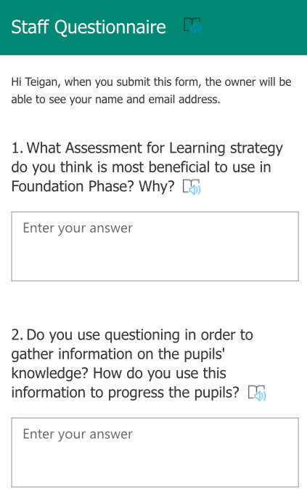
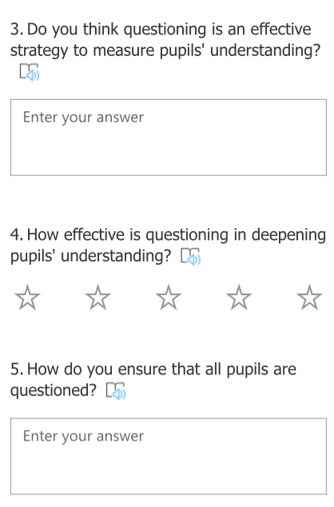
Appendix 1a

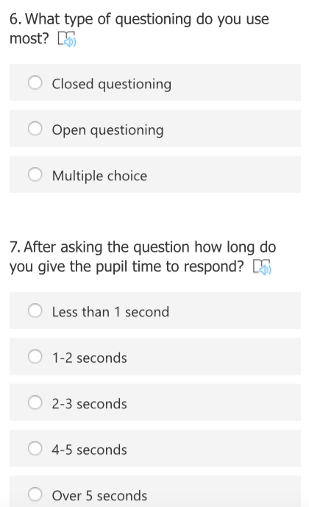
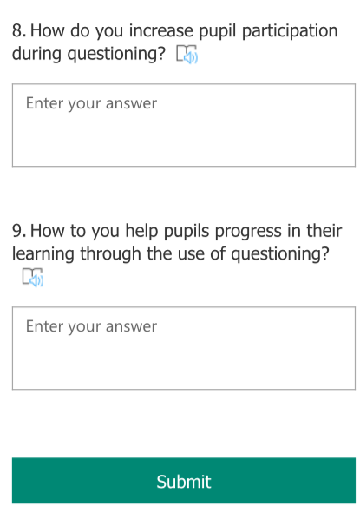
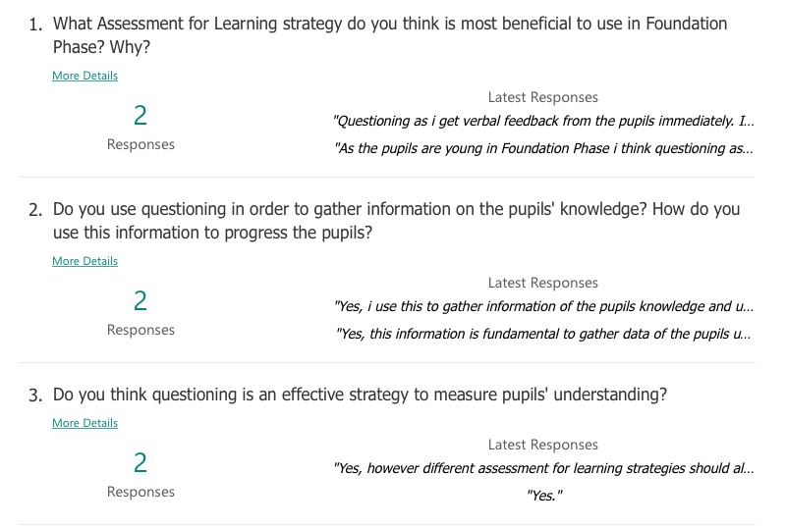
Appendix 1b
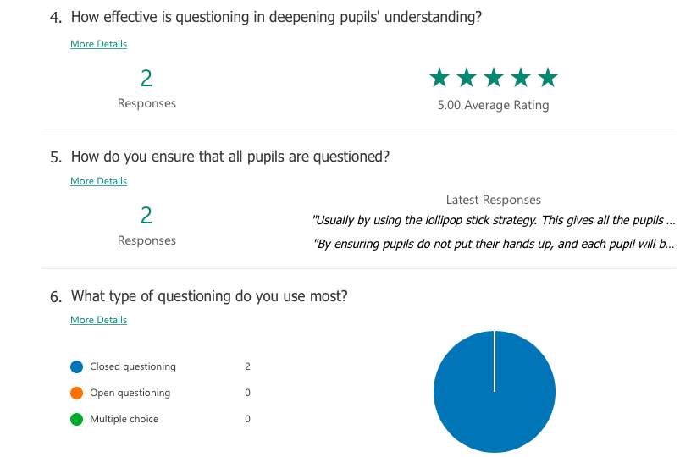
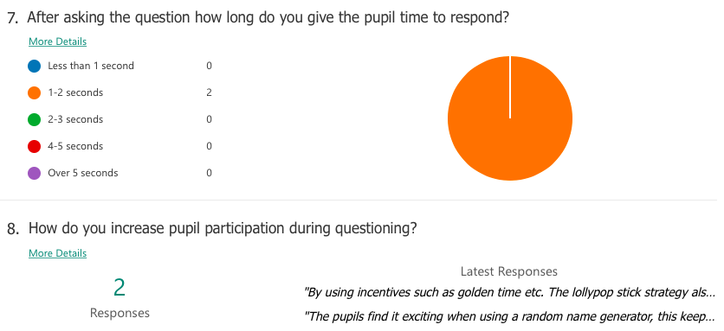
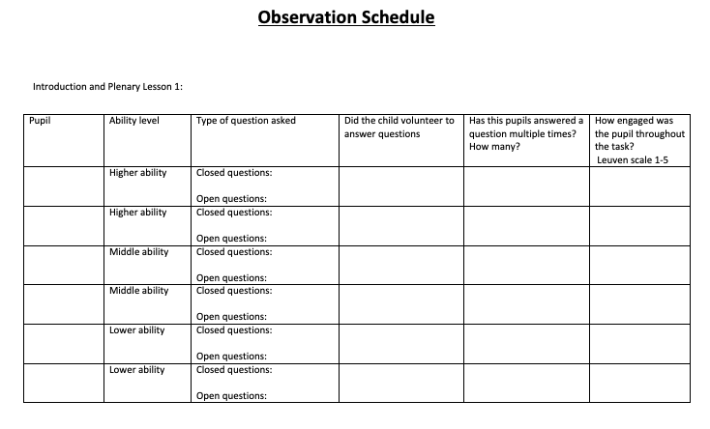
Appendix 2a
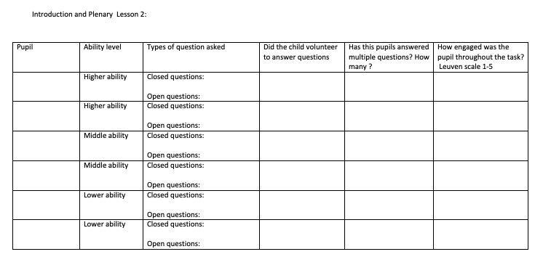
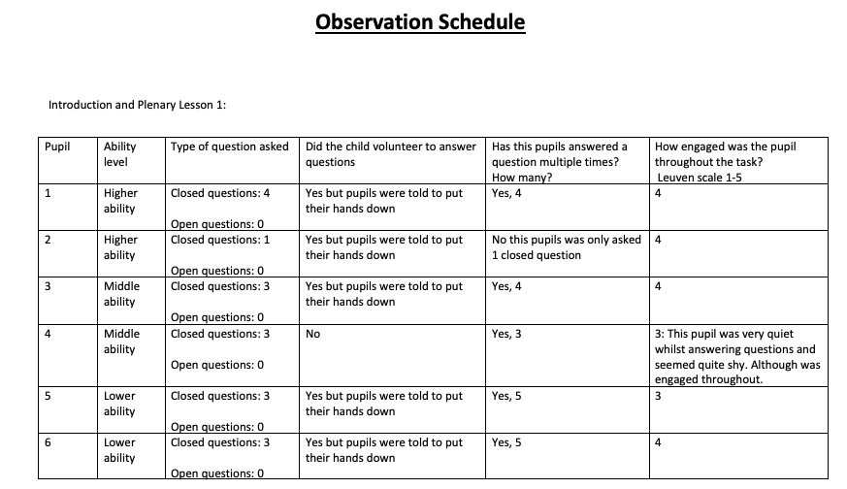
Appendix 2b
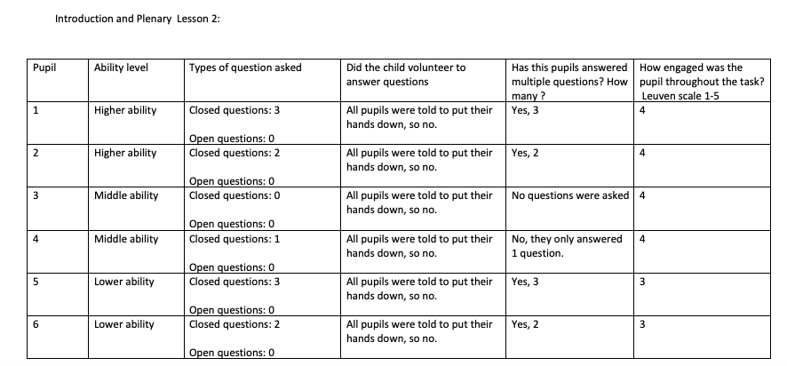
Pupil interview questions
Appendix 3a

- What’s your favourite thing about school?

- Does miss ask you questions in the lesson?

- Do you get asked a question every lesson/day?

- Do you like answering questions?

- Do you listen to your friends answering questions?

- How do you feel when miss asks you a question?

- Does it help you understand your work?

- Do questions help you get better at your work?

- Have you done any work that you were proud of?

Pupil interview questions
Appendix 3b

- How do you feel when miss asks you a question?
LA: Happy because I love school
LA: Happy, because I like answering questions
MA: Good, because I enjoy doing
MA: sometimes I don’t know and I get shy
HA: good, because I love answering questions
HA: Happy, because I like answering questions

- Does it help you understand your work?
LA: Yes, they help me talk
LA: Yes,
MA: Yes, because I listen when miss asks questions
MA: Yes,
HA: Yes,
HA: Yes, because miss tells me what to do

- Do questions help you get better at your work?
LA: Yes
LA: Yes, because miss tells me
MA: yes because I enjoy doing the work and I be quiet when miss asks me a questions
MA: Yes
HA: Yes, because it makes me think
HA: Yes, because miss helps me

- Have you done any work that you were proud of?
LA: I’m good at reading
LA:
MA:
HA: I can’t remember
HA: Maths

- What’s your favourite thing about school?
LA: Playing with tots, doll house
LA: Playing
MA: Play with my friends
MA: The house area
HA: Dinner
HA: captain America costume

- Does miss ask you questions in the lesson?
LA: yes
LA: Yes
MA: Yes
MA: Yes
HA: No
HA: yes

- Do you get asked a question every lesson/day?
LA: Not every lesson
LA: yes
MA: yes
MA: Yes, sometimes
HA: Not everyday
HA: Almost every lesson

- Do you like answering questions?
LA: Yes I like it
LA: Yes, because I like teachers
MA: Yes
MA: Sometimes
HA: Yes
HA: Yes

- Do you listen to your friends answering questions?
LA: Yes
LA: no
MA: no
MA: No
HA: Yes
HA: Yes
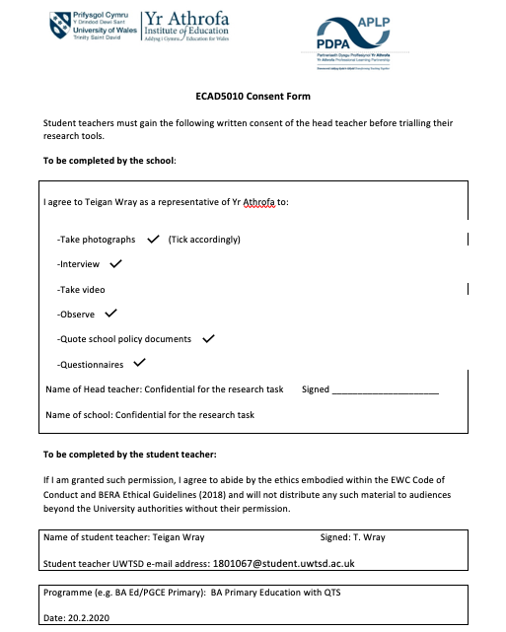
Appendix 4

Appendix 5
APPLICATION FOR ETHICAL APPROVAL

In order for research to result in benefit and minimise risk of harm, it must be conducted ethically. A researcher may not be covered by the University’s insurance if ethical approval has not been obtained prior to commencement.

The University follows the OECD Frascati manual definition of research activity: “creative work undertaken on a systematic basis in order to increase the stock of knowledge, including knowledge of man, culture and society, and the use of this stock of knowledge to devise new applications”. As such this covers activities undertaken by members of staff, postgraduate research students, and both taught postgraduate and undergraduate students working on dissertations/projects.

The individual undertaking the research activity is known as the “principal researcher”.

Ethical approval is not required for routine audits, performance reviews, quality assurance studies, testing within normal educational requirements, and literary or artistic criticism.

Please read the notes for guidance before completing ALL sections of the form.

This form must be completed and approved prior to undertaking any research activity. Please see Checklist for details of process for different categories of application.

Delete the Guidance Notes at the end of the form BEFORE submitting your application

SECTION A: About You (Principal Researcher)
Full Name: |  | Teigan Olivia Wray
Tick all boxes which apply: |  | Member of staff: | ☐ | Honorary research fellow: | ☐
Undergraduate Student | ☒ | Taught Postgraduate Student | ☐ | Postgraduate Research Student | ☐

Faculty/School/Centre: | Initial Teacher Education, Yr Athrofa
Campus: | Carmarthen
E-mail address: | 1801067@student.uwtsd.ac.uk
Contact Telephone Number: | 07947364289
For students:
Student Number: | 1801067@student.uwtsd.ac.uk
Programme of Study: | BA Primary Education with QTS
Director of Studies/Supervisor: | Dr. Sioned V. Hughes

SECTION B: Approval for Research Activity
Has the research activity received approval in principle?  (please check the Guidance Notes as to the appropriate approval process for different levels of research by different categories of individual) |  | YES | ☒ | NO | ☐
 |  |  |  | Date
If Yes, please indicate source of approval (and date where known): Approval in principle must be obtained from the relevant source prior to seeking ethical approval | Research Degrees Committee |  | ☐
 | Faculty Research Committee |  | ☐
 | Other (write in) ECAD5010 Module Lead |  | ☒ | 27.02.20

SECTION C: Internal and External Ethical Guidance Materials
Please list the core ethical guidance documents that have been referred to during the completion of this form (including any discipline-specific codes of research ethics, and also any specific ethical guidance relating to the proposed methodology). Please tick to confirm that your research proposal adheres to these codes and guidelines.
UWTSD Research Ethics & Integrity Code of Practice | ☐
UWTSD Research Data Management Policy | ☐
I’ve consulted with BERA Guidelines in order to conduct my research:  BERA Guidelines (2018). Available at  file:///Users/Teigan/Downloads/BERA-Ethical-Guidelines-for-Educational-Research_4thEdn_2018%20(1).pdf | ☒
 | ☐

SECTION D: External Collaborative Research Activity
Does the research activity involve collaborators outside of the University? |  | YES | ☐ | NO | ☒
If Yes, please provide the name of the external organisation and name and contact details for the main contact person and confirmation this person has consented to their personal data being shared.as part of this collaboration.
Institution
Contact person name
Contact person e-mail address

Has this individual consented to sharing their details on this form? |  | YES | ☐ | NO |  |  | ☐
Are you in receipt of a KESS scholarship? |  | YES | ☐ | NO |  |  | ☐
Is your research externally funded |  | YES | ☐ | NO |  |  | ☐
Are you specifically employed to undertake this research in either a paid or voluntary capacity? | Voluntary | YES | ☐ | NO |  | ☐
 | Employed | YES | ☐ | NO |  | ☐
Is the research being undertaken within an existing UWTSD Athrofa Professional Learning Partnership (APLP) | If YES then the permission question below does not need to be answered. | YES | ☒ | NO |  |  | ☐
Permission to undertake the research has been provided by the partner organisation | (If YES attach copy)  If NO the application cannot continue | YES | ☐ | NO |  |  | ☐

Where research activity is carried out in collaboration with an external organisation
Does this organisation have its own ethics approval system? | YES | ☐ | NO | ☒
If Yes, please attach a copy of any final approval (or interim approval) from the organisation

SECTION E: Details of Research Activity
Indicative title: | How is questioning used to identify learners understanding?
Proposed start date: | 02.03.20 | Proposed end date: | 01.04.20
Introduction to the Research (maximum 300 words)
Ensure that you write for a Non-Specialist Audience when outlining your response to the three points below:
- Purpose of Research Activity
- Proposed Research Question
- Aims of Research Activity
- Objectives of Research Activity
Demonstrate, briefly, how Existing Research has informed the proposed activity and explain
- What the research activity will add to the body of knowledge
- How it addresses an area of importance.
Purpose of Research Activity
- To explore how questioning is implemented in Foundation Phase as an AfL strategy
- To trial and use different research tools in practice
- To improve and develop my own research skills and ethical knowledge
Research Question: How is questioning used to identify learners understanding?
Aims of Research Activity
- To explore staff and learners’ perceptions of questioning as an AfL strategy?
- To critically evaluate the different research tools that I will use throughout my study
- To further develop personal knowledge and understanding of questioning in order to improve my own professional practice.
Objectives of Research Activity
- To explore questioning strategies and approaches used by staff to support and develop pupils’ learning using a questionnaire.
- To interview pupils in reception to capture their views about questioning and being questioned.
- To observe the introductions and plenary’s of two lessons.
- To critically reflect on the process of using different research tools to collect data.
Proposed methods (maximum 600 words)
Provide a brief summary of all the methods that may be used in the research activity, making it clear what specific techniques may be used. If methods other than those listed in this section are deemed appropriate later, additional ethical approval for those methods will be needed.
Interview: I will interview 6 pupils in a reception class from mixed ability groups. This interview will be semi-structured. The pupils will not be forced to participate in this interview and will be given the option to participate. The pupils will be given a smiley face and sad face card to show whether or not they want to be part of the study, they will be told that they do not have to answer all questions and that they can stop at any time. I will check the pupils feelings regularly and ensure that they still wish to continue. This interview will be anonymous, therefore no names will be recorded.

Questionnaire: I will dispute a questionnaire to the Reception class teacher and possibly the year 1 and 2 teacher. The questionnaire will include a range of open and closed questions. These questionnaires will gather qualitative data which will give me more in-depth responses.

Observations: I will observe the introductions and plenary’s of two lessons throughout the day. I have chosen to focus on these parts of the lessons as this is where the pupils will be questioned most in order to identify their understanding on the topic.

Location of research activity
Identify all locations where research activity will take place.
The research activity will take pace in a small village primary school in Wales, which has 4 mixed-year classes. The school has approximately 120 pupils.
Research activity outside of the UK
If research activity will take place overseas, you are responsible for ensuring that local ethical considerations are complied with and that the relevant permissions are sought. Specify any local guidelines (e.g. from local professional associations/learned societies/universities) that exist and whether these involve any ethical stipulations beyond those usual in the UK (provide details of any licenses or permissions required). Also specify whether there are any specific ethical issues raised by the local context in which the research activity is taking place, for example, particular cultural and/or legal sensitivities or vulnerabilities of participants.
N/A
Use of documentation not in the public domain: Are any documents NOT publicly available? | NO | ☒
 | YES | ☐
If Yes, please provide details here of how you will gain access to specific documentation that is not in the public domain and that this is in accordance with prevailing data protection law of the country in question and England and Wales.

SECTION F: Scope of Research Activity
Will the research activity include: TICK ALL RELEVANT BOXES HERE | YES | NO
Use of a questionnaire or similar research instrument? | ☒ | ☐
Use of interviews? | ☒ | ☐
Use of diaries? | ☐ | ☒
Participant observation with their knowledge? | ☒ | ☐
Participant observation without their knowledge? | ☐ | ☒
Use of video or audio recording? | ☐ | ☒
Access to personal or confidential information without the participants’ specific consent? | ☐ | ☒
Administration of any questions, test stimuli, presentation that may be experienced as physically, mentally or emotionally harmful / offensive? | ☐ | ☒
Performance of any acts which may cause embarrassment or affect self-esteem? | ☐ | ☒
Investigation of participants involved in illegal activities? | ☐ | ☒
Use of procedures that involve deception? | ☐ | ☒
Administration of any substance, agent or placebo? | ☐ | ☒
Working with live vertebrate animals? | ☐ | ☒
Other primary data collection methods, please explain in this box  For example, ‘focus groups’. Please indicate the type of data collection method(s) in this box and tick the accompany box. | ☐ | ☒
Details of any other primary data collection method:  (this box should expand as you type) | ☐ | ☒
If NO to every question, then the research activity is (ethically) low risk and may be exempt from some of the following sections (please refer to Guidance Notes).

If YES to any question, then no research activity should be undertaken until full ethical approval has been obtained.

SECTION G: Intended Participants
Who are the intended participants: | YES | NO
Students or staff at the University? | ☐ | ☒
Adults (over the age of 18 and competent to give consent)? | ☒ | ☐
Vulnerable adults? | ☐ | ☒
Children and Young People under the age of 8? (Consent from Parent, Carer or Guardian will be required) | ☒ | ☐
Prisoners? | ☐ | ☒
Young offenders? | ☐ | ☒
Those who could be considered to have a particularly dependent relationship with the investigator or a gatekeeper? | ☐ | ☒
People engaged in illegal activities? | ☐ | ☒
Others (please identify specifically any group who may be unable to give consent) please indicate here and tick the appropriate box. | ☐ | ☒
Other – please indicate here: | ☐ | ☒

Participant numbers and source
Provide an estimate of the expected number of participants. How will you identify participants and how will they be recruited?
How many participants are expected? | Approximately 8 participants.
Who will the participants be? | Approximately 6 pupils from mixed ability groups in Reception and 2 staff members.
How will you identify the participants? | This research will be carried out in my previous PTE2 placement. As I already know the pupils and their abilities, I have decided to choose 2 pupils from the lower, middle and higher ability groups.

Information for participants: | YES | NO | N/A
Will you describe the main research procedures to participants in advance, so that they are informed about what to expect? | ☒ | ☐ | ☐
Will you tell participants that their participation is voluntary? | ☒ | ☐ | ☐
Will you obtain written consent for participation? | ☐ | ☐ | ☒
Will you explain to participants that refusal to participate in the research will not affect their treatment or education (if relevant)? | ☒ | ☐ | ☐
If the research is observational, will you ask participants for their consent to being observed? | ☒ | ☐ | ☐
Will you tell participants that they may withdraw from the research at any time and for any reason? | ☒ | ☐ | ☐
With questionnaires, will you give participants the option of omitting questions they do not want to answer? | ☒ | ☐ | ☐
Will you tell participants that their data will be treated with full confidentiality and that, if published, it will not be identifiable as theirs? | ☒ | ☐ | ☐
Will you debrief participants at the end of their participation, in a way appropriate to the type of research undertaken? | ☐ | ☐ | ☒
If NO to any of above questions, please give an explanation
(this box should expand as you type)

Information for participants: | YES | NO | N/A
Will participants be paid? | ☐ | ☒ | ☐
Is specialist electrical or other equipment to be used with participants? | ☐ | ☒ | ☐
Are there any financial or other interests to the investigator or University arising from this study? | ☐ | ☒ | ☐
Will the research activity involve deliberately misleading participants in any way, or the partial or full concealment of the specific study aims? | ☐ | ☒ | ☐
If YES to any question, please provide full details
(this box should expand as you type)

SECTION H: Anticipated Risks

Outline any anticipated risks that may adversely affect any of the participants, the researchers and/or the University, and the steps that will be taken to address them.

If you have completed a full risk assessment (for example as required by a laboratory, or external research collaborator) you may append that to this form.
Full risk assessment completed and appended? |  | Yes | ☐
 |  | No | ☒
Risks to participants
For example: emotional distress, financial disclosure, physical harm, transfer of personal data, sensitive organisational information
Risk to Participant:  The pupils may not understand the objective of the research. | How will you mitigate the Risk to Participant  As the pupils are only 5 they’re only able to give assent. I will ensure that the pupils understand that I’m coming in to watch them answer questions and will explain that they can withdraw from the research.
If research activity may include sensitive, embarrassing or upsetting topics (e.g. sexual activity, drug use) or issues likely to disclose information requiring further action (e.g. criminal activity), give details of the procedures to deal with these issues, including any support/advice (e.g. helpline numbers) to be offered to participants. Note that where applicable, consent procedures should make it clear that if something potentially or actually illegal is discovered in the course of a project, it may need to be disclosed to the proper authorities
N/A
Risks to investigator
For example: personal safety, physical harm, emotional distress, risk of accusation of harm/impropriety, conflict of interest
Risk to Investigator:  There may be allegations made by the pupils when undertaking the research. | How will you mitigate the Risk to Investigator:  The majority of the research will be during a normal activity in the classroom. There will be another researcher present while interviewing is taking place.
University/institutional risks
For example: adverse publicity, financial loss, data protection
Risk to University:  - Not behaving in a way that could impact the relationship between school and university. | How will you mitigate the Risk to University:  - I will behave in a professional manner, at all times.

Disclosure and Barring Service
If the research activity involves children or vulnerable adults, a Disclosure and Barring Service (DBS) certificate must be obtained before any contact with such participants. | YES | NO | N/A
Does your research require you to hold a current DBS Certificate? | ☒ | ☐ | ☐

Feedback
What de-briefing and feedback will be provided to participants, how will this be done and when?
N/A
Informed consent
Describe the arrangements to inform potential participants, before providing consent, of what is involved in participating. Describe the arrangements for participants to provide full consent before data collection begins. If gaining consent in this way is inappropriate, explain how consent will be obtained and recorded in accordance with prevailing data protection legislation.
I will converse with my class teacher and senior mentor and inform them of the research I will be undertaking, providing reason and rationale behind the research. However, I will verbally ask children identified to participate whether they wish to participate, by using a smiley face and sad face. If the pupils show a smiley face, then they are happy to participate in the interview to answer the questions, if not then I will know they are not happy to participate. The pupils will participate in the semi-structured interview individually, this will ensure that the children are encouraged to respond honestly with their interest and well-being in mind. The pupils will not have the option to copy a friend, therefore will need to think of their own opinion. The pupils will be informed that they can approach me at any time to ask questions about the study.
Confidentiality / Anonymity
Set out how anonymity of participants and confidentiality will be ensured in any outputs. If anonymity is not being offered, explain why this is the case.
The questionnaires and interviews will be anonymous , therefore no names will be recorder. My research will not include the schools name. I will not discuss any of the participants names and I will also ensure that the date collected is disposed of after conducting my research. The date will not be given to any secondary source.
SECTION I: Feedback, Consent and Confidentiality

SECTION J: Data Protection and Storage
In completing this section refer to the University’s Research Data Management Policy and the extensive resources on the University’s Research Data Management web pages (http://uwtsd.ac.uk/library/research-data-management/).
Does the research activity involve personal data (as defined by the General Data Protection Regulation 2016 “GDPR” and the Data Protection Act 2018 “DPA”)? | YES | NO
“Personal data” means any information relating to an identified or identifiable natural person (‘data subject’). An identifiable natural person is one who can be identified, directly or indirectly, in particular by reference to an identifier such as a name, an identification number, location data, an online identifier or to one or more factors specific to the physical, physiological, genetic, mental, economic, cultural or social identity of that natural person. | ☐ | ☐
If YES, provide a description of the data and explain why this data needs to be collected:
(this box should expand as you type)
Does it involve special category data (as defined by the GDPR)? | YES | NO
“Special category data” means sensitive personal data consisting of information as to the data subjects’ –  (a) racial or ethnic origin,  (b) political opinions,  (c ) religious beliefs or other beliefs of a similar nature,  (d) membership of a trade union (within the meaning of the Trade Union and Labour Relations (Consolidation) Act 1992),  (e) physical or mental health or condition,  (f) sexual life,  (g) genetics,  (h) biometric data (as used for ID purposes), | ☐ | ☐
If YES, provide a description of the special category data and explain why this data needs to be collected:
(this box should expand as you type)
Will the research activity involve storing personal data and/or special category data on one of the following: | YES | NO
Manual files (i.e. in paper form)? | ☐ | ☐
University computers? | ☐ | ☐
Private company computers? | ☐ | ☐
Home or other personal computers? | ☐ | ☐
Laptop computers/ CDs/ Portable disk-drives/ memory sticks? | ☐ | ☐
“Cloud” storage or websites? | ☐ | ☐
Other – specify: | ☐ | ☐
For all stored data, explain the measures in place to ensure the security of the data collected, data confidentiality, including details of password protection, encryption, anonymisation and pseudonymisation:
(this box should expand as you type)
All Data Storage
Will the research activity involve any of the following activities: | YES | NO
Electronic transfer of data in any form? | ☐ | ☐
Sharing of data with others at the University? | ☐ | ☐
Sharing of data with other organisations? | ☐ | ☐
Export of data outside the European Union or importing of data from outside the UK? | ☐ | ☐
Use of personal addresses, postcodes, faxes, emails or telephone numbers? | ☐ | ☐
Publication of data that might allow identification of individuals? | ☐ | ☐
Use of data management system? | ☐ | ☐
Data archiving? | ☐ | ☐
If YES to any question, please provide full details, explaining how this will be conducted in accordance with the GDPR and DPA (and/or any international equivalent):
(this box should expand as you type)
List all who will have access to the data generated by the research activity:
(this box should expand as you type)
List who will have control of, and act as custodian(s) for, data generated by the research activity:
(this box should expand as you type)
Give details of data storage arrangements, including security measures in place to protect the data, where data will be stored, how long for, and in what form. Will data be archived – if so how and if not why not.
(this box should expand as you type)
Please indicate if your data will be stored in the UWTSD Research Data Repository (see https://researchdata.uwtsd.ac.uk/ ). If so please explain. (Most relevant to academic staff)
(this box should expand as you type)
Confirm that you have read the UWTSD guidance on data management (see https://www.uwtsd.ac.uk/library/research-data-management/) | YES | ☐
 | NO | ☐
Confirm that you are aware that you need to keep all data until after your research has completed or the end of your funding | YES | ☐
 | NO | ☐

SECTION K: Declaration
The information which I have provided is correct and complete to the best of my knowledge. I have attempted to identify any risks and issues related to the research activity and acknowledge my obligations and the rights of the participants.

In submitting this application I hereby confirm that I undertake to ensure that the above named research activity will meet the University’s Research Ethics and Integrity Code of Practice
Signature of applicant: | T.Wray | Date:  27.02.20

For STUDENT Submissions:
Director of Studies/Supervisor: | Dr. Sioned V. Hughes | Date:
Signature: |  | Date:

For STAFF Submissions:
Head of School/Assistant Dean: |  | Date:
Signature: |  | Date:

Checklist: Please complete the checklist below to ensure that you have completed the form according to the guidelines and attached any required documentation:
☒ | I have read the guidance notes supplied before completing the form.
☒ | I have completed ALL RELEVANT sections of the form in full.
☒ | I confirm that the research activity has received approval in principle
☐ | I have attached a copy of final/interim approval from external organisation (where appropriate)
☐ | I have attached a full risk assessment (and have NOT completed Section H of this form) (where appropriate) ONLY TICK IF YOU HAVE ATTACHED A FULL RISK ASSESSMENT
☒ | I understand that it is my responsibility to ensure that the above named research activity will meet the University’s Research Ethics and Integrity Code of Practice.
☒ | I understand that before commencing data collection all documents aimed at respondents (including information sheets, consent forms, questionnaires, interview schedules etc.) must be confirmed by the DoS/Supervisor, module tutor or Head of School.
☒ | I have deleted the guidance notes before submitting the PG2 for consideration

RESEARCH STUDENTS AND STAFF ONLY
All communications relating to this application during its processing must be in writing and emailed to pgresearch@uwtsd.ac.uk , with the title ‘Ethical Approval’ followed by your name.
You will be informed of the outcome of your claim by email; therefore it is important that you check your University and personal email accounts regularly.

STUDENTS ON UNDERGRADUATE OR TAUGHT MASTERS PROGRAMMES should submit this form (and receive the outcome) via systems explained to you by the supervisor/module leader.

This form is available electronically from the Academic Office web pages: http://www.uwtsd.ac.uk/academic-office/

Application Process

All staff research projects and all research students must submit the Ethical Approval Form to the University Ethics Committee via the Academic Office (pgresearch@uwtsd.ac.uk). Staff research directly in relation to personal study for taught undergraduate or Masters programmes should be submitted via the Faculty procedures explained below.

Taught masters and taught undergraduate research Ethical Approval Forms are considered within Faculties. Faculties will provide details of the specific processes for this. Where the Ethical issues within any single ethical application are of particular concern the Faculty will refer these to the University Ethics Committee. Any student activity that involves the collection of primary data needs to undergo Ethical approval, this includes assignment work as well as dissertations.

