Student Name:
Jess Parry

Student Number:
1701355

Course:
BA(Hons) Fine Art: Studio, Site & Context

Module:
Level 5 Research Practices - 'Practice in Context' (ADAD5001)

Word Count: 2567
(excluding in-text image references and bibliography/reference list but includes in-text quotations and titles)

Lecturer: Sarah Tombs

Gender, Body & Gaze
An Independent Research Document Proposal

A short context of this writing is to explore three words supported by a minimum of three images, in synthesis with three visual artists/ philosophers. This research will attempt to the link the three key words of gender, body and gaze to form a question for my independent research document, exploring areas of interest via construction, discourse, and critical examinations. These will relate to visual artists including Jenny Saville (Body), Titian (Gaze) and Botticelli (Gaze) that indicate a variety of contemporary and historical contexts. These shall co-exist with philosophers including Judith Butler (Gender), Naomi Wolfe (Body) and John Berger (Gaze).

Gender

''The notion of gender can be understood to be referring to the cultural assumptions and practices that govern the social construction of men, woman and their social relations'' (Barker. 2004:73)

The exploration of the term gender can be read under numerous contexts and concepts. It's classified as a word of misunderstandings and trouble. With the word trouble in mind, this has lead the research seeking into the gender theorist and philosopher, Judith Butler and the book titled Gender Trouble. However, upon research into the book, the discovery of A MACAT ANAYSIS Judith Butler's Gender Trouble has been a dissection into the notions behind the concepts of gender.
Gender as a language and means of expression is argued through perceptions of performance, identifications through sexual means such as from birth by given genitalia and ''social relations'' (Barker. 2004:73), where one must feel they need to follow that labelling of binaries in social politics and acceptance. The questions that have been generated so far are, what is Gender? How is Gender classified within a contemporary culture?
Butler uses the complex term of performance when denoting depictions of gender. For example, as stated by Butler herself, ''gender is not a fact, the various acts of gender create the idea of gender and without those acts, there would be no gender at all'' (Laing. 2017:37) (Butler. 2006).
This has introduced the theory of gender as performance. Gender as a creation through a performative act can conflict the biological characteristics of the given sexual genitalia from one's birth. Sexual characteristics that don't depict or represent the ''binary: an either/or distinction in which no other options or categories exist'' (Laing.2017:75) of a gender are abandoned. A performative act can replace the tradition of what defines the masculine over the feminine. It can also be considered these acts contribute to the behaviour of the human psyche including how body language is perceived, as well as the classification of clothing that influences the performative clarity of a gender identification.
The performance of gender allows one the freedom to choose gender (Gender- fluidity), over societies rules and being active within binary systems as a guideline from social norms. The critical examination of an object to suggest performative gestures of gender is in an intriguing process of playing a gendered role.
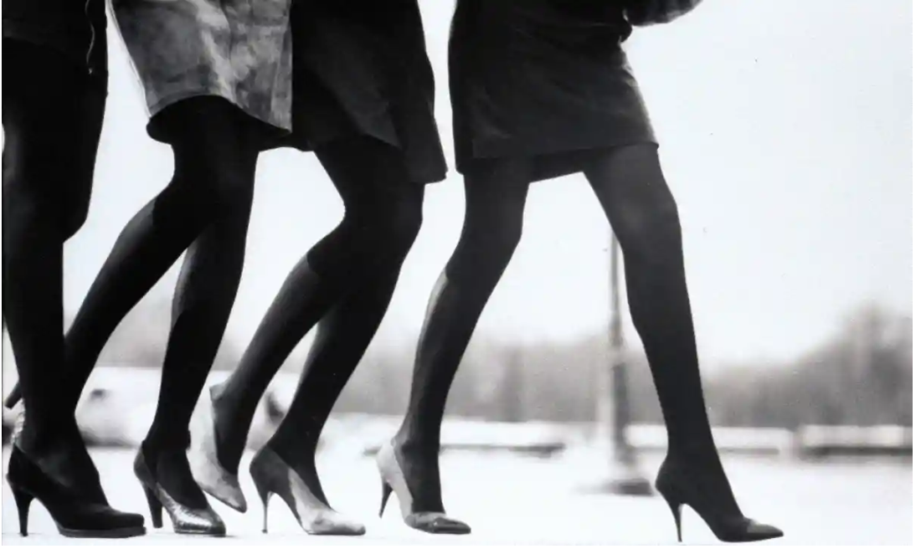
Elgort. Nast. (1987) Four Models in a 1987 Vogue photoshoot.
(Accessed: 9th April 2019)

For example, the object of the high heel has been described by the American Journalist, Summer Brennan as ''shoe for sex'' and can also be considered an object for ''display, performance and authority''. (Brennen.2019)
These descriptions challenge the gendered object in terms of femininity and hierarchy and can be argued as an object of performance both positively and negatively. It can be suggested that, in a photograph by VOGUE, the heel is documented as an object of the working woman, therefore she has been removed from the domestic environment. However, it can be argued that for this disruption to occur, the woman must be wearing the heel, as the performative gesture. Positively, the object represents a sense of empowerment and authority together with the subsequent influential posture, body language and dominance of the female in the gendered objects open stride. Negatively, the sadistic value of the object represents a symbol of sex. A gendered object symbolic of the sexualisation of the woman yet if its colour was suggested, then semiotic analysis would enhance this object further. If the gendered object was red, then this would enhance that visual, symbolic dialect of the object, being an object of sex. The colour red is symbolic of the sexualisation and lust and through the superior reading, the colour is commonly associated with prostitution. This discussion of the colour red will be developed upon further in the exploration into Gaze, as well as the representation of the woman within that discussion.
In this beginning exploration into gender as a key word, questions have been generated with numerous topics for further arguments. The question of, 'why are objects gendered?' has been triggered.
An examination into the construction of the word gender has led to considerations of sub-genre words such as, feminism, masculinity, performance, domesticity and sex all of which can be taken under further investigation within reaching a conclusive question generated upon this proposal.

Body

"The body is commonly understood to be the physical flesh and bones of an organism'' (Barker. 2004:15)
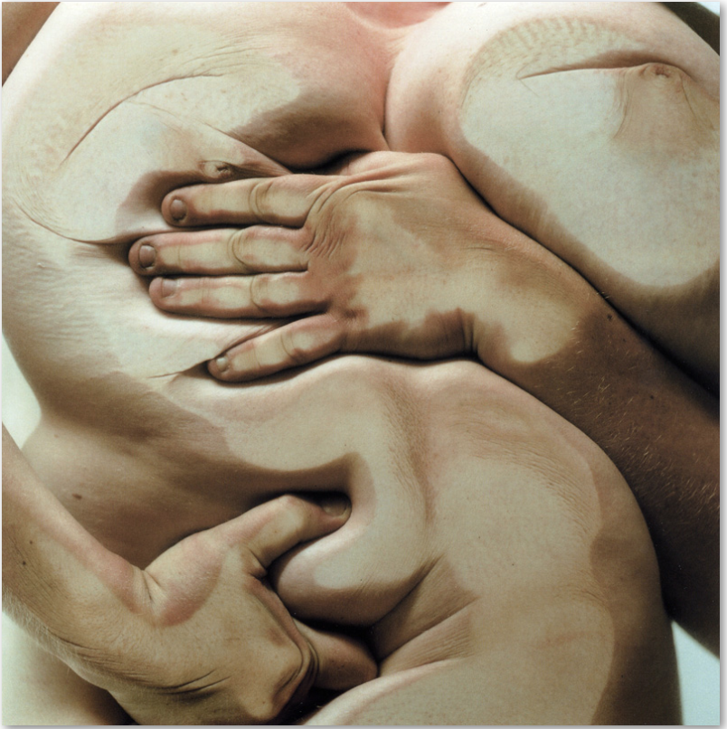

Saville. J. Luchford. G. (1995-6) Closed Contact 3 [photograph] Gagosian.
(Accessed: 10th April 2019)

Jenny Saville is a core visual practitioner upon contributing towards the representation of the body within the visual arts.
As outlined within the photograph on the previous page, the female body has been exposed as visceral as possible, emphasising upon the concept of the grotesque and the raw aesthetics of the landscape of flesh. A new identity of the body has been constructed. An uncontrolled boundary of disgust and a monstrosity against the traditional, portrayals of the female nude such as the likes of Titian's Venus of Urbino, which will also be discussed within 'gaze' in comparison to this claustrophobic, sensual and carnivalesque hybridity of a borderless body.
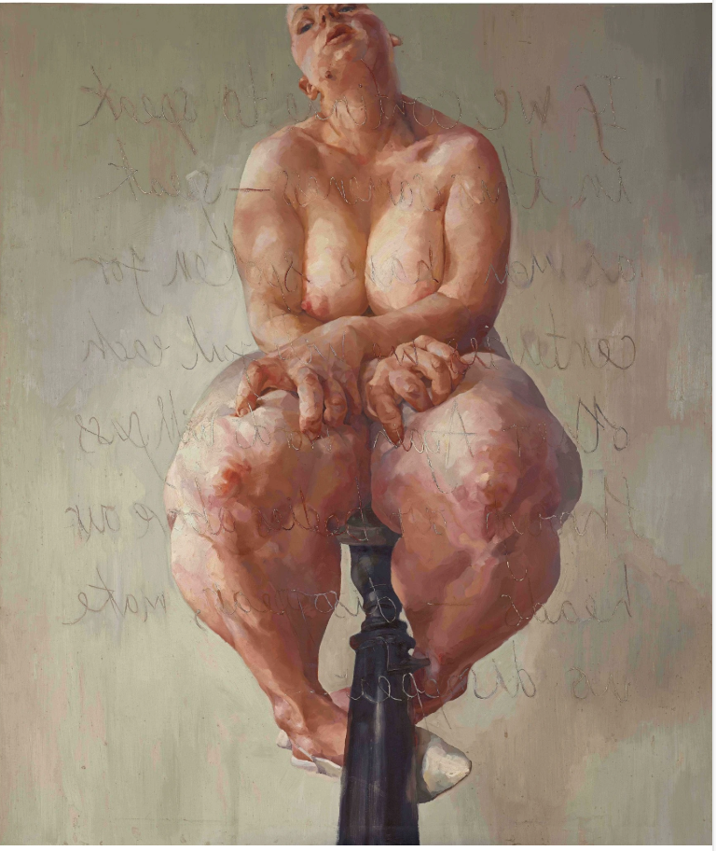
In contrast to the photographic abstraction of skin, Saville has created a disruption of flesh through painterly gestures, where Saville is "trying to make paint behave in the way flesh behaves" (Meagher. 2003:37).

Saville. J (1992) Propped [painting] 84" x 72" (Accessed: 10th April 2019)

Propped by Saville reveals how paint and the movement of flesh can co-exist. The paint layered in such a movement, depicts a new amorphous suggestion of anatomy. The internal external. The artist's observation of how a plastic surgeon manipulates the flesh, is the same in how Saville sculpts the body through paint.
The representation of the body through two mediums by Saville have been analysed and both capture the body in its challenging depiction of making the viewer ''become conscious of their own body." (Meagher. 2003:34), as well as strongly challenging the ideologies of traditional female nudes. Agreeing with Saville, the viewer does become increasingly conscious of their own body due to the mass of the claustrophobic flesh suffocating the viewer through scale. However, it could be argued that anyone with an eating disorder may find the awareness of flesh triggers their own body image and self-identity.
Saville's painting Propped includes text by the Feminist writer Luce Irigaray and this inscribing of text has been stated by the contemporary art specialist, Emma Baker ''like its cut into the flesh'' (Baker. 2018). This finding critically examines the language proposed by Saville's approach in depicting the distorted body as the artist's influence from observing cosmetic procedures.
Developing upon Baker's statement, it can be argued it's suggestive of anatomy, in relation to the artist's fascination with the internal and replicating its presence upon the external skin through paint. The terminology of "cutting into the flesh" could be a reflection upon the human psyche and attitudes towards the body in conflicting correspondence to ideology and contemporary beauty standards. A sadistic reaction of cutting one's skin, not in a positive performative gesture, but in a negative dialect or action of self-mutilation resulted from contemporary beauty standards within the narcissistic, world of today. The question triggered here is, is the body a site of positivity or negativity through the reactions inflicted from contemporary culture? Do we still have that ideology to follow and are we conflicting against or with this? It's obvious that contemporary perspectives and perceptions of the female nude have been heavily constructed from historical contexts, however Saville reacts against this, embracing the body in its purest form down to its bare minimum- "the physical flesh and bones of an organism"(Barker. 2004:15)
A potential question of discussion for an independent research document is, 'is flesh a fetish or a phobia?' A fetish through the concept of gaze and a fetish in the terms of the grotesquely, disgustingly textural satisfaction of meat will be discussed further. A phobia in relation to the conscious awareness through the human psyche of the presence of dense skin and flesh conflicting between the dysmorphic mirrored body and the influences upon one's psyche through the social political aesthetics of the contemporary culture will also discussed.

A philosopher Naomi Wolf explores the concept of beauty through the body within The Beauty Myth, which embraces multitudes of perspectives through identities from the body. Wolf argues that "the feel of her flesh, the shape of her breasts [...] - is being reclassified as ugly, and ugliness as disease'' (Wolf. 2002:232).
Saville has within her subject matter revealed the raw clarity of the body, exposing its ugliness through the physical manipulation of flesh and skin. Embracing its folds, the feeling of flesh and the shapes transformed within her material. This can be identified and observed within Closed Contact 3 an admiration of ugliness and the perfect imperfections of the body.
Through this exploration into Body, sub-genre words such as Identity, Ideology, Carnivalesque, Anatomy, Plastic surgery, Fetishes, Psychoanalysis, Social politics, Performance, Self-mutilation, Eating disorders and Age have arisen.

Gaze

"Look steadily and intently, especially in admiration, surprise or thought'' - Oxford Dictionaries Online
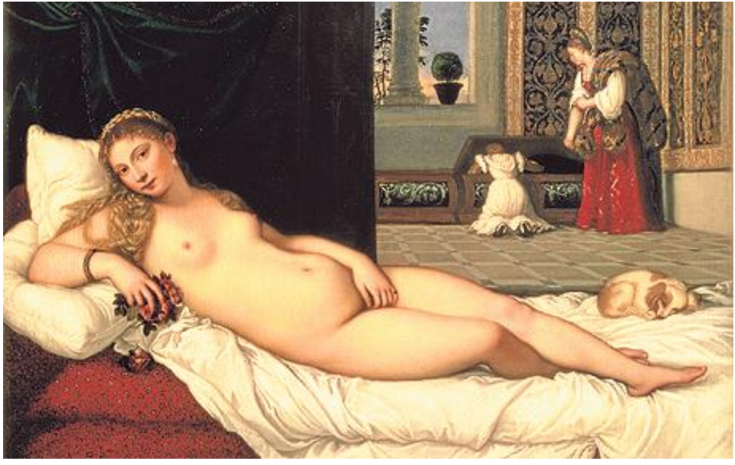
Titian. (1538) Venus of Urbino [painting] (Accessed: 15th April 2019)

The construction of the term Gaze can be directly linked to the confrontational and direct gaze within a portrait. A prime example of this is Titian's Venus of Urbino that depicts the female nude in all its exposed ideologies through the raw male gaze of the painter himself.
As suggested by the philosopher John Berger within the book Ways of Seeing, he compares Titian's painting to the later appropriated composition by Manet and the piece Olympia - "Titians original, one sees a woman, cast in the traditional role, beginning to question that role, somewhat defiantly" (Berger. 1972:63). This leads into the question of who is being challenged by the gaze? The audiences or the sitters?
It can be argued that considering the painter was male, he had painted what he wanted to observe for his own pleasure, over what was directly in front of him. However, it can also be suggested that Titian's "movement of hand eye as his brush describes the contours of Venus's flesh" as stated by Hudson in The Telegraph newspaper, could also depict some realistic graphicness of the portrayal of the nude. The titling of this painting enhances the argument of the female nude being portrayed for pleasure through the male gaze. "Venus" is typically associated with the terminologies of Greek mythologies and goddesses. By Titian titling the piece after The Goddess of Love- Venus, and considering the subject is a prostitute, it can be significantly suggested that the painting was produced for his own pleasure. Developing upon this further, the colour red used within the painting can enhance that form of sexualising the female nude. The colour red is also commonly associated with prostitution and can enhance that nude female subject for the artist's own pleasure.
The question of whether the painting is pornographic is in debate. What suggests pornography within the visual arts? has been triggered by this discussion. The sitter is seductive of body language and invites this upon the male gaze, as well as the gesture of the hand, seductively even being read as playfully gesturing her genitalia for lust. For sex. The subject's eyes are mischievous in inviting that male attention. That provocative intimacy. That male gaze. This painting has been described as "one of the sexiest paintings ever created" by Hudson, as well of a "Platonic symbol of love, beauty and bodily perfection" both stated by the male gaze. It can strongly be argued that the painting is still being seen by the modern man, as a painting of sex, lust, invitation which is a repulsion and an absurdity. It heavily contrasts over Jenny Saville's revolutionary portrayal of the female nude from the female gaze. For example, Closed Contact 3, as previously discussed, with all its perfect imperfections and flaws exposed.
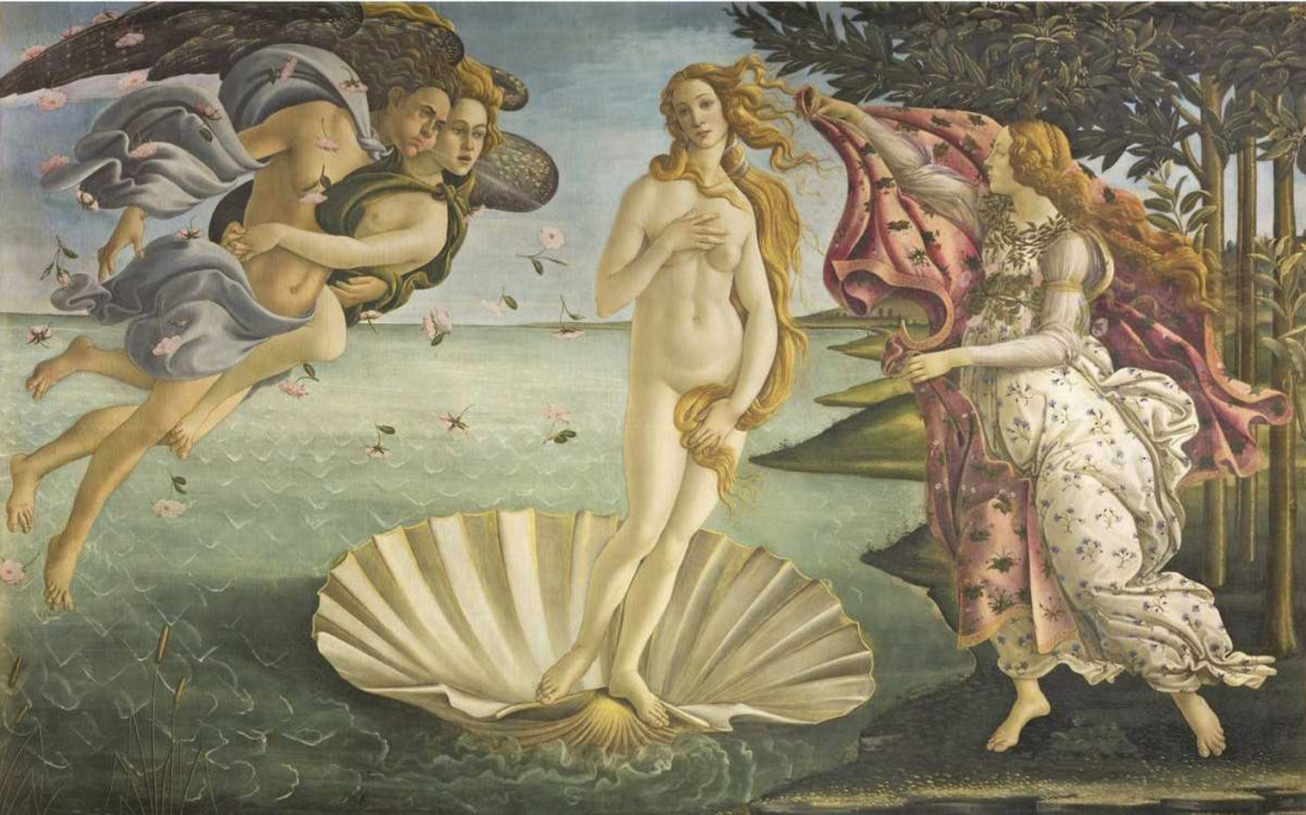
.

Botticelli (1485) Birth of Venus [painting] (Accessed: 15th April 2019)

Through the female perspective arguing against Hudson's ludicrous and absurd comments of this painting by Titian, the concept of bodily perfection is similarly portrayed by the traditional nude goddess as demonstrated in Botticelli's painting, Birth of Venus. This evidently reveals the curvaceous flesh of the idealised form, as the titling of the piece, once again featuring "Venus" signifies that notion of how the male gaze views the female nude- for pleasure. Even though Botticelli's painting was produced many years prior, the man still had that distorted perception and gaze of the idealistic female nude. The question of "is a body, an object of sexualisation?" has been triggered by the discussion of the opposing conflicts and views of gendered gazes, both male and female.
The historical notions and presentations of the female nude have given the contemporary female a dysmorphic gaze on the status of their own bodies within modern culture. These historical presentations of the female nude from the male gaze has influenced the modern female to desire a body presented as those of a goddess, therefore demanding that ideology, begging for perfection and being over-ruled by narcissism. On the contrary, Saville has removed these ideologies and has embraced the concept of the body for what it is, and the gaze as a direct confrontation against that traditional male gaze. The question triggered here is, 'has the female gaze of the female nude within the contemporary, overruled and obliterated that conceived by the male gaze?'. This question may be proposed as a starting point for further expansion, combining the body and gaze and even gender.

An examination into the construction of the word gaze has led to considerations of sub-genre words such as, the female and male gaze, appropriation, ideology and pornography all of which can be taken under further investigation within reaching a conclusive question generated upon this proposal.

Upon exploring the three keywords, contextualising these have led to numerous questions as well as multiple sub-genre words in relation to the proposed question. There is a strong relationship between gender, body and gaze.
The working research question of 'How does body ideology exist within the contemporary and is this an addiction or confliction upon the notions of gendered gazes?' is the working question proposed for the independent research document, yet may act as a starting point. Numerous sub-questions generated from this proposal can be explored more in depth such as, 'How is gender classified within contemporary culture?, 'Why are objects gendered?, 'Is the body a site of positivity of negativity?, 'Do we still have that ideology to follow and are we conflicting with or against this?, 'Is flesh a fetish or a phobia?', 'What suggests pornography within the visual arts?', 'Is a body an object of sex?' and 'Has the female gaze of the female nude overruled and obliterated that conceived by the male gaze?'.
The concepts of feminism, masculinity, performance, domesticity, pornography/sex, identity, ideology, carnivalesque, plastic surgery, fetishes, psychoanalysis (self-mutilation & eating disorders), social politics, age, symbolism and appropriation have been considered for further exploration within the independent research document, under my working question for next year.

Bibliography/ Reference List:

Barker, C. (2004) The SAGE Dictionary of Cultural Studies. London: SAGE Publications Ltd.
ISBN: 978-0-7619-7341-690000

''The notion of gender can be understood to be referring to the cultural assumptions and practices that govern the social construction of men, woman and their social relations'' (Barker. 2004:73)

"The body is commonly understood to be the physical flesh and bones of an organism'' (Barker. 2004:15)

Butler. J. (2006). Gender Trouble. London: Routledge. ISBN 10: 0415389550
ISBN 12: 9780415389556

''gender is not a fact, the various acts of gender create the idea of gender and without those acts, there would be no gender at all'' (Butler.2006).

Laing, T.S. (2017) A MACAT ANAYSIS Judith Butler's Gender Trouble. London: Macat International Ltd.
ISBN: 978-1-912127-76-4

''gender is not a fact, the various acts of gender create the idea of gender and without those acts, there would be no gender at all" (Laing.2017:37)

''Binary: an either/or distinction in which no other options or categories exist'' (Laing.2017:75)

Brennen.S (2019) 'Sex, power, oppression: why woman wear high heels' The Guardian
Available at: https://www.theguardian.com/fashion/2019/mar/20/sex-power-oppression-why-women-wear-high-heels
(Accessed: 8th April 2019)

''shoe for sex''

''display, performance and authority''

Image Reference:
Elgort. Nast. (1987) Four Models in a 1987 Vogue photoshoot.
Available at: : https://www.theguardian.com/fashion/2019/mar/20/sex-power-oppression-why-women-wear-high-heels
(Accessed: 9th April 2019)

Harris. B. Zucker. S. Manet, Olympia: Khan Academy [video]
Available at: https://www.khanacademy.org/humanities/ap-art-history/later-europe-and-americas/modernity-ap/v/manet-olympia-1863-exhibited-1865
(Accessed: 9th April 2019)

Rosel. M. Criado, L. (2019) ORLAN, beyond and conception of the body.
Available at: http://www.clotmag.com/orlan
(Accessed: 9th April 2019)

Wolf. N. (2002) The Beauty Myth. E-book. New York: HarperCollins Publishers.
ISBN: 0060512180
(Accessed: 10th April 2019)

"the feel of her flesh, the shape of her breasts, [...] - is being reclassified as ugly, and ugliness as disease'' (Wolf. 2002:232)

Kuspit. D. (2011) 'REVIEWS. Jenny Saville' Artforum International; New York. New York, Artforum Inc. (Art, Museums And Art Galleries)
Available at: https://search-proquest-com.ezproxy.uwtsd.ac.uk/docview/910020302/fulltext/F016218CCAE6469FPQ/2?accountid=130472
(Accessed: 10th April 2019)

Meagher. M (2003) 'Jenny Saville and a Feminist Aesthetics of Disgust' Woman, Art, and Aesthetics. Hypatia, 18(4). p.p 23-42
Available at : https://www-jstor-org.ezproxy.uwtsd.ac.uk/stable/pdf/3810973.pdf?ab_segments=0%252Fdefault-2%252Fcontrol&refreqid=excelsior%3A301baf56b0dcdf99e56c9bf8ff49cce1
(Accessed: 10th April 2019)

"trying to make paint behave in the way flesh behaves" (Meagher. 2003:37).

''become conscious of their own body.''(Meagher. 2003:34).

Cooke. R. (2012) ' I WANT TO BE A PAINTER OF MODERN LIFE, MODERN BODIES [...]' Observer Review Features Pages. The Observer.
Available at: https://search-proquest-com.ezproxy.uwtsd.ac.uk/docview/1019540386/fulltext/41E4BFA81F5244B1PQ/18?accountid=130472 (Accessed: 10th April 2019)

Jenny Saville & Glen Luchford: Closed Contact. (1995-6). Gagosian Gallery.
Available at: https://gagosian.com/media/exhibitions/2002/jenny-saville-glen-luchford-closed-contact/Gagosian_Jenny_Saville_Glen_Luchford_Closed_Contact_2002_Press_Release.pdf
(Accessed: 10th April 2019)

Image Reference:
Saville. J. Luchford. G. (1995-6) 'Closed Contact 3'' [photograph] Gagosian.
Available at: https://www.vincentborrelli.com/pages/books/105841/jenny-saville-glen-luchford/jenny-saville-and-glen-luchford-closed-contact-limited-edition-no-print-signed
(Accessed: 10th April 2019)

Manatakis. L. (2018) 'How to be an artist, according to Jenny Saville' Dazed.
Available at: http://www.dazeddigital.com/art-photography/article/42244/1/how-to-jenny-saville-british-painting-most-expensive-living-female-artist-tate
(Accessed: 10th April 2019)

Image Reference:
Saville. J (1992) Propped [painting] 84" x 72"
Available at: https://gagosian.com/artists/jenny-saville/
(Accessed: 10th April 2019)

Thurmond. N (2015) 'The Connection Between Body Image and Eating Disorders' Eating Disorder Hope
Available at: https://www.eatingdisorderhope.com/information/body-image/the-connection-between-body-image-and-eating-disorders
(Accessed: 15th April 2019)

(2012) 'Emotional Bodies. Andrea Hasler Interview' Ladies & Gents
Available at: http://www.ladiesngents.com/en/curator/Andrea-Hasler-Interview.asp?thisPage=5
(Accessed: 15th April 2019)

Baker. E. (2018) The Painting That Propelled Jenny Saville to Global Prominence. [video]
Available at: https://www.sothebys.com/en/articles/the-groundbreaking-self-portrait-that-launched-jenny-savilles-career
(Accessed: 10th April 2019)

''like its cut into the flesh'' (Baker. 2018)

Betterton, R. (1996) An Intimate Distance Woman, Artists and The Body. London: Routledge.
ISBN: 0-415-11085-8

Oxford Dictionaries Online. OXFORD UNIVERSITY PRESS (2019) Gaze. Verb
Available at: https://en.oxforddictionaries.com/definition/gaze
(Accessed: 15th April 2019)

"Look steadily and intently, especially in admiration, surprise or thought'

Scruton. R (2009) Beauty New York : Oxford University Press Inc.
ISBN : 978-0-19-955-952-7

Image Reference:
Titian. (1538) 'Venus of Urbino' [painting]
Available at : https://www.google.com/search?q=venus+of+urbino&oq=ve&aqs=chrome.0.69i59j69i57j69i60l3j0.1192j0j7&sourceid=chrome&ie=UTF-8
(Accessed: 15th April 2019)

Berger, J. (1972) Ways of Seeing. London: British Broadcasting Corporation. London: Penguin Books/Penguin Group.
ISBN: 0-14-013515-4O

"Titians original, one sees a woman, cast in the traditional role, beginning to question that role, somewhat defiantly" (Berger. 1972:63).

Hudson. M (2009) 'Titian: wheeler dealer who created a goddess' The Telegraph
Available at: https://www.telegraph.co.uk/culture/art/art-features/6093122/Titian-wheeler-dealer-who-created-a-goddess.html
(Accessed: 15th April 2019)

"movement of hand eye as his brush describes the contours of Venus's flesh"

"one of the sexiest paintings ever created"

"Platonic symbol of love, beauty and bodily perfection".

Image Reference:
Botticelli (1485) 'Birth of Venus' [painting]
Available at: https://www.widewalls.ch/the-birth-of-venus-botticelli-painting/
(Accessed: 15th April 2019)

