
Master of Business Administration
International Business pathway
International Marketing: Principles and Practices
Assessment 1: Individual report. Weight: 100%
Module name: International Marketing: Principles and Practices
Module code: LCMB7026
Topic name: Toyota
Lecturer name: Dr Amir Homayounfard
Student name: Asthaben Rajubhai Chabhadiya
Student ID: 2529402
Word count: 5007
Submission date: 13th August 2026

AI use acknowledgement
1. Grammar
I acknowledge the use of Grammar (https://www.grammarly.com/) on 26th July, 2026 to check grammar, spelling, sentence structure, and citation formatting.
I used the following prompt(s):
- Please check this text for grammar, clarity and readability.
- Review the citation formatting and referencing consistency in Harvard style."
I confirm that I have not presented any AI-generated text as my own work. I confirm that I have copies of my drafts, notes and other resource materials or tools, which I may be asked to provide as evidence of my original work.
2. Claude (https://claude.ai/)
I acknowledge using Claude to review my writing for flow, clarity, and grammatical correctness.
Prompts Used:
- Check this section for flow and transition between paragraphs.
- Identify any awkward phrasing or grammatical mistakes in this text.
I declare that all writing and analysis in this document represent my own effort. Claude was used strictly as an editing assistant, and I retain all background notes and prior drafts.

Table of Contents
Introduction 3
Comparative Market Analysis 4
PESTLE Analysis 4
Hofstede Cultural Comparison 9
Comparative STP Strategy 11
Market Entry Strategy 13
Product Strategy 15
Price Strategy 15
Place (Distribution) Strategy 16
Promotion Strategy 16
Process Strategy 17
Physical Evidence Strategy 17
Ethical Issues 19
Recommendations 20
Section 2: Reflective Account 21
Description 21
Feelings 21
Evaluation 21
Analysis 22
Conclusion 23
Action Plan 23
Conclusion 25
References 26

Introduction
International marketing has emerged as an important growth driver for organisations seeking to expand across national borders to access new markets and enhance competitiveness. Firms need to be aware of variations in economic conditions, government policies, consumer behaviour and cultural values, and must have a unified global brand image to be successful in international markets (Hasan, et al., 2024). Toyota Motor Corporation is a global leader in the automotive industry with operations in over 170 countries and regions (Toyota, 2026). Toyota had sold around 10.8 million vehicles globally, secured its position as the world's largest automaker for the sixth consecutive year and generated more than ¥48 trillion in revenues in 2025 which shows its strong international market presence and operational capability (Nippon, 2026; Toyota, 2025).
The report critically evaluates Toyota's international marketing strategy by comparing its home market (Japan) and its host market (the United States) which together represent large market shares for the company's international business operations. The analysis also uses the PESTEL model to analyse the external environment and Hofstede's model to study cultural differences in marketing decisions. Moreover, it analyses Toyota's segmentation, targeting and positioning (STP) approach, examines the firm's adaptation of the 7Ps marketing mix, reviews Toyota's market entry strategy in the USA, examines ethical issues in its marketing and marketing practices and offers evidence-based recommendations for the future success of Toyota's international marketing efforts.

Comparative Market Analysis

PESTLE Analysis
Political -Japan and the USA have a political environment that is considered stable which allows Toyota to plan in the long-term but there is a growing issue in the countries policy priorities. Close government-industry cooperation is a key pillar in Japan to foster industry competitiveness especially in advanced manufacturing, hydrogen technologies and electrified mobility. Automotive innovation is being boosted by government subsidies and green investment programs even in the face of budget constraints due to an ageing population.Green transition policies and public investment continue to be significant factors contributing to the development of industrial value in Japanwhich is beneficial for domestic manufacturers(OECD, 2025).On the other hand, the United States has a bigger consumer market but a strong political environment with many changes in policy over the course of administrations. Global manufacturers have been facing uncertainty as a result of recent changes to the trade policy including the imposition of new tariffs on imported vehicles and parts.
While automobiles show that around 28.3% of Japan’s exports to the US market in 2024, any limited trade policy impactsToyota's international operations and supply chain business activities (Kihara and Sugiyama, 2025).Toyota has factories in both countries but there is a significant difference in the political risk factor. Long-term industrial policy in Japan is predictable which makes long-term production planning possible while policy uncertainty in the United States has led Toyota to invest in expanding production and sourcing in Japan to reduce tariff risks.
Economic -The economy has a big impact on the demand for vehicles, pricing and investment. The United States continues to be the largest economy in the world with a GDP value of around US$30.77 trillion in 2025 compared to Japan's GDP of US$4.44 trillion (World Bank, 2026).
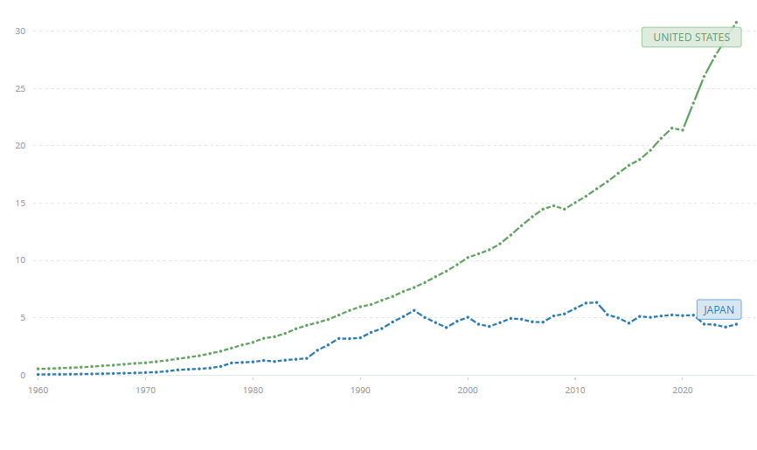
Figure 1: United States and Japan GDP Rate
(Source: World Bank, 2026)
Similarly, the U.S. GDP per capita increased to US$90,026 significantly higher than the Japanese GDP per capita of US$35,951 meaning that the purchasing power is greater for more expensive vehicles and premium automotive technologies (World Bank, 2026).
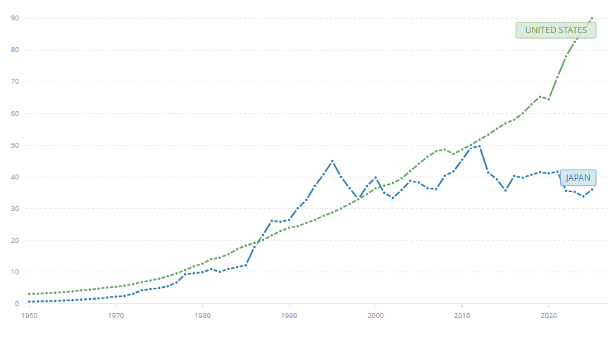
Figure 2: United States and Japan GDP Per Capita
(Source: World Bank, 2026)
Although the U.S. economy is bigger in size but it is characterised by more labour costs and macroeconomic fluctuations. In 2025, the unemployment rate in the United States is approximately 4.1% (BLS, 2025).
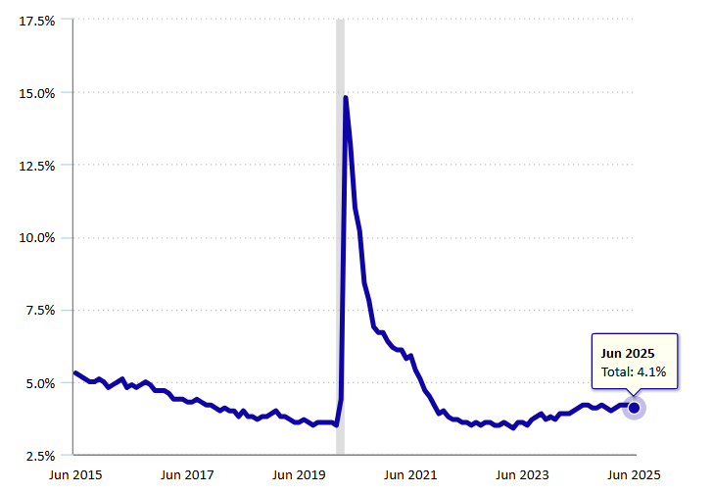
Figure 3: Unemployment Rate in the US
(Source: BLS, 2025)
Despite the slower economic growth, Japan had a lower level of unemployment rate of 2.5% in 2026as compared to the United States, suggesting a more stable labour market (Husna, 2026).These differences provide contrasting opportunities for Toyota. Rising U.S. incomes protect demand for cars with good profit margins such as SUVs, pickups and luxury models including hybrid cars.
Social -Social factors affect vehicle preferences, mobility patterns and the longer-term market demand. Japan's population isexpected to decline by 123.4 million in 2025 with an annual rate of –0.5%one of the fastest ageing societies in the world. However, the population of the United States was around 341.8 million increasing by 0.5% due to immigration and an increase in birth rates (World Bank, 2026).
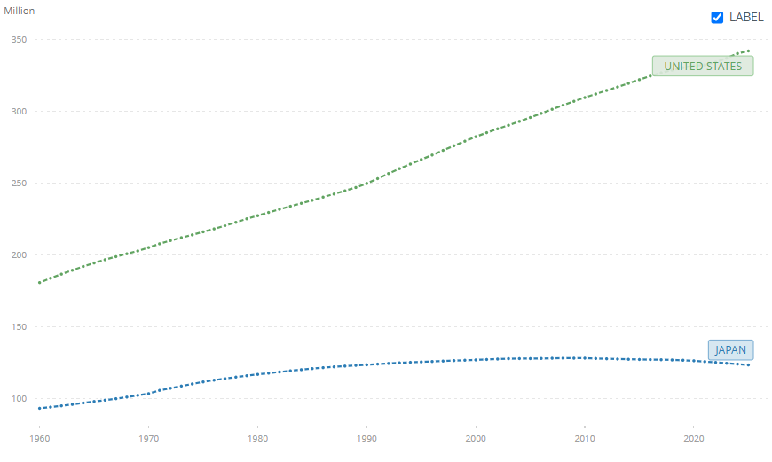
Figure 4: Population Value of Japan and the United States
(Source: World Bank, 2026)
All these differences in the population create different consumer behaviour. Urban residents in Japan show a preference for compact, low-emission and hybrid vehicles that are more suitable for urban environments and a decrease in household formation is expected to reduce the demand for vehicles in the long-term. On the other hand, Americans remain strong in demand for bigger SUVs and pickup trucks with more profitable margins for manufacturers. In the United States, the increasing disposable incomes and mobility also promote car ownership.
Technological -While there are differences between the innovation systems of Japan and the United States technological capacity is a significant competitive strength for both countries. The automotive industry in Japan is renowned for its sophisticated manufacturing processes, robotics and lean production methods which help to ensure a high standard of quality and operational efficiency in the production of vehicles. Japan continues to be one of the leading OECD economies in public funding for energy research and development while environmental technology patents increase some total patent claims indicating ongoing innovation in electrification and hydrogen technologies (OECD, 2025). This is an environment that aligns well with the long-term investments made by Toyota into hybrid cars, fuel-cell technology and smart manufacturing.The United States is promoting digital innovation through artificial intelligence, software development and autonomous driving technologiesand is supporting them with cooperation between the automotive emerging EV makers innovation cycles are reduced and R&D expenses rise.
Environmental -Automotive production and marketing decisions are becoming increasingly influenced by environmental regulations in both countries. The Japanese government has made a stronger push to reach carbon neutrality by 2050 with policies encouraging clean energy, resource efficiency and practices of the circular economy. Additionally, Japan's GHG emissions have declined over time with a growing focus on investments in clean energy technologies and the promotion of circular economy practices (OECD, 2025).The U.S. has also strengthened environmental regulationby creating more strict vehicle emission standards, offering massive electric vehicle incentives and investments in the clean transportation sector. However,the priorities for the regulators are politically sensitivewhich creates higher uncertainty than in Japan. Therefore, Toyota needs to determine how to comply with new U.S. environmental legislation while keeping profitableacross traditional, hybrid and battery electric vehicles.
Legal -Japanese and U.S. laws set strict rules on vehicle safety, competition, consumer protection and environmental protection. The regulatory framework is well enforced and the level of uncertainty is low enabling manufacturers to make long-term investments with confidence. The ongoing innovation in the local automotive sector is also fostered by stable labour legislation and IP protection. However, in the United States the laws are more complicated as both federal and state laws apply to the manufacturer. The lack of compliance can lead to significant consequences such as financial penalties and damage to the company's reputation. For instance,the US$180 million settlement awarded to Toyota in 2021 by the U.S. Environmental Protection Agency for failing to report emissions-related defects in compliance with the Clean Air Act(EPA, 2021). A more rigorous legal regime can boost compliance costs but it can also minimise consumer concerns by ensuring that products are made safer and corporations are more accountable.

Hofstede Cultural Comparison
Hofstede's cultural dimensions can help to identify significant differences between two or more countries (Escandon-Barbosa, et al., 2022). For instance, Japan’s score of Power Distance (54) is high as compared to the United States (40) showing that they have a higher acceptance of hierarchical structures and authority. In Toyota formal organisational relationships and structured decision-making are key elements of the company's business while the flatter organisational structures found in the United States are more focused on customer engagement and employee empowerment.The highest difference is in Individualism with the USA at 60 and Japan at 62 where both nations have fairly individualistic qualitiesbut the USA are more practically concerned with personal freedom and self-expression.
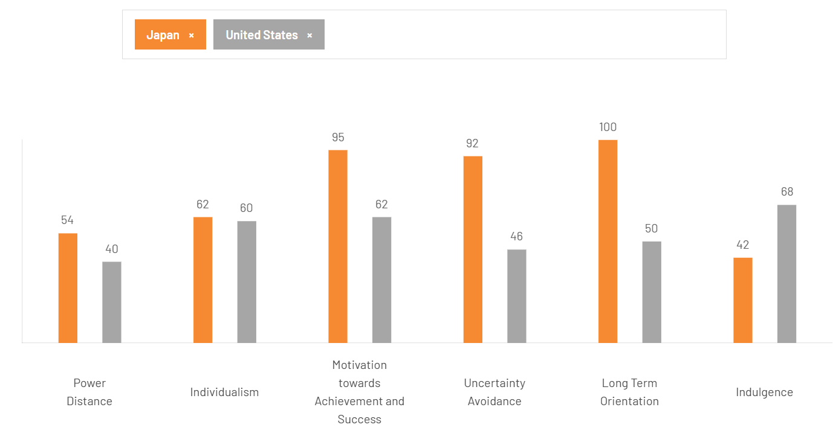
Figure 5: Hofstede Cultural Comparison of Japan and the US
(Source: The Culture Factor, 2026)
The motivational score of Japan is much higher than that of the United States,95 to 62 indicating a much more achievement-oriented culture with a high appreciation for performance, precision and ongoing improvements. Similarly, Japan's Uncertainty Avoidance (92) is significantly higher than the U.S. score (46) meaning that Japanese consumers are more likely to be loyal to those technologies that are well established product reliability and risk reduction are important.The biggest gap is in Long-Term Orientation with Japan at 100 compared to the 50 of the U.S. which highlights Toyota's focus on future innovation, sustainable actions and long-term investment decisions. On the other hand, Indulgence is significantly higher in the United States (68) than in Japan (42) demonstrating consumer values on pleasure, convenience and personal satisfaction (The Culture Factor, 2026).

Comparative STP Strategy
Segmentation -Toyota's segmentation strategy is differentiated both in Japan and the USA and the segmentation criteria are different in each market. Demographic shifts in Japansuch as ageing, low birth rates, and greater urbanisationhave driven a preference for compact, hybrid and fuel-efficient cars.Toyota markets its products mainly based on the age of the customer, the size of the household, environmental issues and urban mobility needs. Reliability, fuel economy and value of ownership are key factors consumers considerso hybrid models such as Prius, Corolla Hybrid and Aqua are good buys (Toyota, 2021). Toyota also has a premium segment for customers with high-end needsunder the name Lexus and commercial vehicle segments for customers who use the vehicles for business. Through Lexus, Toyota sales reached 882,231 units in 2025 which is 104% higher than the previous year (Toyota, 2026).
The United States offers more segment opportunities due to its size, the diversity of its geography and high disposable income. Toyota categorises its customers according to lifestyle, income, vehicle usage and performance preferences. Further, the number of electrified vehicles sold in the United States accounted forone million in 2024 accounting for 43.1% of all Toyota vehicles sold (Lexus, 2025).
Targeting -Toyota targets different groups of customers but the same maximum profit. The company targets mainly the middle class in Japan who are urban commuters and eco-conscious consumers looking for reliable and eco-friendly transport. Toyota's emphasis on vehicle safety, the use of advanced driver assistance systems and long-term reliability ensures the brand is appealing to older car owners.On the other hand, Toyota's strategy in the United States is to reach a broader audience of consumers from families to professionals and luxury customers to commercial buyers. Its productsare dominated by high-margin SUVs, pickup trucks and crossover vehicles with Lexus serving high-end consumers who are interested in high-tech and high-class technology.Further, this strategy of diversified targeting was paying off with Toyota's U.S. sales rising 3.7% in 2024 that demonstrate hybrid demand increased Toyota's sales growth (Reuters, 2025).
Positioning -Toyota has a global brand name based on quality, durability and innovation and it modifies its brand positioning to the local market's expectations. The company positions itself as a trusted domestic manufacturer and provides technological excellence, continuous improvement and sustainable mobility in Japan. Toyota continues to be a key strength in its home market with its long-term reliability and manufacturing quality accounting for some 50.9% of retail sales (SEC GOV, 2026). Toyota claims to be a reliable car company in the U.S. with a quality range of vehicles that is both cost-effective and high-tech with hybrid technology. As electrification and digital connectivity are increasingly considered key features for successful products the positioning of products such as the RAV4 and Camry is now increasingly emphasising their suitability for lifestyle. On the other hand, for the Tacoma its capabilities and suitability for the market have been emphasised.

Market Entry Strategy
Entry Mode
The arrival of Toyota in the U.S. is one of the most successful cases of internationalisation of an auto company's strategy. In 1957, the company began to directly export its production, the Toyota Crown, to the United States (Toyota, 2026). However, the model did not have commercial success as it was not right for American driving conditions and consumer expectations. Hence, Toyota repurposed its products and created new models such as the Corolla and Corona which were more targeted to the U.S. market with reliability, fuel economy and affordability (Toyota, 2026). With growth in sales, Toyota began to gradually progress from export to foreign direct investment (FDI) with the opening of manufacturing facilities in the United States. The landmark event was the establishment of the New United Motor Manufacturing Inc. (NUMMI) partnership with General Motors in California in 1984. This allows Toyota to learn about the manufacturing methods in the United States and to break tariff barriers (Toyota, 2026)
Entry Strategy Reasons
The most significant reasons for Toyota's shift from export to local production were market size, trade restrictions and operational efficiency. In the 1980s, the U.S. imported fewer Japanese vehicles than the Japanese were willing to export to the U.S. market which saw strategic importance of local production. The production plants allowed Toyota to reduce transportation costs, delivery times,mitigate tariff risksand build relationships with American suppliers. In addition, the production in the United States boosted Toyota's flexibility to meet local tastes enabling it to create cars based on local demands including SUVs, pickup trucks and larger cars for passengers. Toyota has a long history of localisation, having 11 North American manufacturing plants that support over 50,000 jobs (Toyota, 2025).
Evaluation of Marketing Strategy
Toyota has established significant advantages for itself in the market without relying on exports. Local manufacturing has improved the resilience of supply chains, added to brand legitimacy and lowered sensitivity to fluctuations in exchange rates. Toyota's investment has also led to innovation in its research facilities and regional production networks which allow the company to respond quickly to consumer demand. In 2024, Toyota also sold around 2.33 million vehicles in the US which indicates a 3.7% increase from the previous year while electrified vehicles are approximately 43.1% of total vehicle sales highlighting adaptation to changing market preferences (Lexus, 2025).These advancements demandthat Toyota enhance domestic sourcing efforts, speed up its efforts to electrify the vehicle and increase investments in digital manufacturing capabilities.

Comparative International (7Ps) Marketing Mix

Product Strategy
Toyota follows a product adaptation approach that matches its vehicle lineup to customers' needs in each market segment. In Japan, due to high urbanisation and relatively compact road infrastructure, Toyota prioritises fuel-efficient compact cars, hybrid vehicles and kei-inspired vehicles that match the need for economical and environmentally friendly transportation (Toyota, 2026). Models such as the Prius, Aqua and Yaris are attracting environmentally conscious consumers which is supported by Japan's commitment to achieving carbon neutrality by 2050 (Toyota, 2024). In contrast, the United States exhibit higher demand for large vehicles due to its high household income, longer travelling distances and a preference for spacious family cars (Delmas, et al., 2017). Thus, Toyota focuses more strongly on SUVs and pickup trucks such as the RAV4, Highlander, Tacoma and Tundra with an increasing range of hybrid variants.
This product change demonstrates considerable variation in market demand. Toyota's sales in 2025 reached almost 2.52 million vehicles in the U.S., of which 47% were electrified vehicles, highlighting the increasing acceptance of hybrid and electric powertrain technologies from customers (TMNA, 2026). Toyota adapts its vehicle size, engine performance, safety equipment and styling to meet the expectations and requirements of customers and regulations of each market instead of producing the same design in all countries (Toyota, 2025). This strategy helps consolidate customer satisfaction and allows the company to compete with the domestic manufacturers in both countries.

Price Strategy
Toyota's pricing policy also considers market differences and maintains the reputation of providing value. Toyota's competitive prices in Japan are aided by low distribution costs and a strong domestic manufacturing basis that enables the company to supply dependable vehicles to different income groups (Toyota, 2025). However, pricing in the United States is affected by the size of the vehicles, local manufacturing costs, financing options and heavy competition from manufacturers such as Ford, General Motors and Honda (CRS, 2026). Apart from these differences, Toyota always frames itself as a brand that delivers superior quality, durability and lower lifetime ownership costs instead of competing on price alone. Flexible financing, leasing programmes and promotional incentives in the United States further increase affordability, whereas Japan emphasises long-term customer loyalty and perceived product quality. Hence, Toyota successfully appeals to diverse customer segments across both markets by adapting its pricing strategy to local economic conditions without compromising brand value.

Place (Distribution) Strategy
Toyota's distribution strategy combines global operational efficiency with strong local market responsiveness. In Japan, the company has an extensive domestic dealership network which is supported by efficient logistics and close coordination between manufacturing plants and retailers. The technology allows for quicker product availability, reduced transport expenses and uniformity in after-sales service, further strengthening Toyota's commitment to quality and customer satisfaction (Toyota, 2025). In comparison, the United States needs a more decentralised distribution strategy given its size and variety of consumer markets. Toyota has 11 manufacturing plants in North America with over 1500 authorised dealerships throughout the country which enables the company to reduce delivery times, decrease import costs and quickly meet the needs of the region (Toyota, 2026; AWT, 2025). Local production also safeguards Toyota against exchange rate fluctuations and trade uncertainties, building long-term involvement in the U.S. market. These differences prove that Toyota adjusts distribution with respect to a particular market size and infrastructure without sacrificing efficiency.

Promotion Strategy
Toyota uses different promotion strategies in Japan and the USA and its brand image is focused on reliability, innovation and sustainability. Promotional campaigns are mostly about fuel efficiency, technological advancements and environmental responsibility which emphasise the importance of sustainable consumption and product quality in Japan. Modern marketing increasingly employs digital platforms along with conventional media for targeting younger audiences and building long-term brand loyalty (Umoren, et al., 2022). However, promotional campaigns in the United States focus more on the performance, safety, versatility and lifestyle benefits of vehicles, especially SUVs and pickup trucks which dominate consumer demand (Buss, 2022). Toyota also makes strong investments in sports sponsorships, experiential marketing and social media campaigns to enhance brand awareness. In 2025, nearly 47% of Toyota's U.S. sales consisted of electrified cars, allowing the company to promote its hybrid and electric products as viable options for decreasing fuel expenses and emissions (TNMA, 2025). Toyota strengthens customer engagement and enhances its competitive advantage in both Japan and the United States by tailoring promotional content to local cultural values and purchasing motivations while maintaining consistent global brand positioning.
People Strategy
Toyota's employees and dealership personnel are crucial components of its global marketing efforts as they directly shape customer engagement and loyalty. Toyota prioritises individualised service, relationship management and ongoing support which fits well with the Japanese business centred on service (Toyota, 2025). In contrast, customer service in the United States focuses on responsiveness, technical expertise and efficient problem resolution to meet the expectations of a diverse customer base. Toyota's dedication to service excellence is further underscored by its impressive results in the 2025 J.D. Power U.S. Vehicle Dependability Study, where multiple Toyota models earned top scores for reliability and customer satisfaction (J.D. Power, 2025).

Process Strategy
In both countries, Toyota has digitised various customer processes to increase convenience and after-sales service. Customers can now personalise vehicles, compare vehicles, schedule maintenance services and track vehicle maintenance on online platforms (Toyota, 2025). However, digital retail and online customer service have been a priority in the U.S. due to its expansive geographical reach and rising need for online shopping. These streamlined processes minimise wait times, optimise service operations and enhance customer relationships which empowers Toyota to stay competitive in both markets (Toyota, 2025).

Physical Evidence Strategy
Toyota reinforces its global brand image through modern dealerships, well-designed showrooms and consistent corporate branding. Japan's dealerships are known for their hospitality, comfortable customer lounge areas and personalised consultancy, which align with Japanese service standards of “Omotenashi” (Toyota, 2019). However, showrooms in the United States incorporate larger display areas, interactive digital technologies and test-drive facilities to enhance the customer experience (Toyota, 2021). While the physical environment varies between the two countries, both methods help foster customer confidence and convey Toyota’s commitment to quality, innovation and reliability, and help maintain a unified international corporate image.

Ethical Issues
Toyota has built a good reputation for quality and reliability but a few ethical problems have arisen in the marketing mix of Toyota in the USA. An important issue is the company's commitment to environmental compliance and sustainability. Although hybrid is considered a major part of Toyota's environmental policy, it has been criticised that the transition to fully battery electric vehicles (BEVs) is relatively slow which has impacted the company's leadership role in zero-emission mobility. As other companies have aggressively grown their EV portfolios, Toyota has been more cautious as its efforts to market EVs have faced issues on whether its approach is aligned with the expectations of the environment (Reuters, 2024).
In 2021, the U.S. Environmental Protection Agency (EPA) issued a US$180 million civil penalty against Toyota for its failure to file the legally required reports for emissions defects in the Clean Air Act for about a decade (EPA, 2021).Toyota's response has been to increase investment in battery electric vehicles, hydrogen technologies and carbon-neutral manufacturingto further enhance compliance and sustainability reporting processes. However, there needs to be greater similarity in the U.S. between environmental performance, regulatory compliance and promotional claims. Toyota's international marketing strategy will build its long-term competitive edge by keeping its products in top condition and consistently communicating ethical corporate behaviour to its customers.

Recommendations
Toyota should strengthen its international marketing strategy by accelerating the expansion of its battery electric vehicle (BEV) portfolio in the United States while maintaining its leadership in hybrid technology. Hybrid vehicles accounted for more than 47% of Toyota's U.S. sales in 2025 but increasing consumer demand and government incentives for fully electric vehicles require greater investment in battery innovation and charging partnerships (TMNA, 2025). The company should also enhance data-driven digital marketing by using artificial intelligence and customer analytics to deliver more personalised promotional campaigns and improve customer engagement across online platforms (Kudapa, 2024).
Moreover, Toyota should continue investing in sustainable manufacturing by increasing the use of renewable energy and low-carbon production technologies across its global operations to strengthen its environmental reputation and meet evolving regulatory requirements. The reinforcement of localised marketing communication in the United States is equally important, because campaigns that reflect regional lifestyles and cultural preferences can improve customer relationships and brand loyalty. At last, Toyota should further integrate digital retailing with its dealership network by expanding virtual showrooms, online vehicle configuration and seamless after-sales services. These initiatives would enhance customer experience, strengthen Toyota's competitive advantage and support its long-term growth in both domestic and international markets.

Section 2: Reflective Account

Description
Comparing the situation of Toyota in Japan as its home market and Toyota in the U.S. as its host market that is an extensive analysis of Toyota’s international marketing strategy required in the preparation of this report. The research included an analysis of differences in political, economic, social, technological, environmental and legal environments and how these differences affect Toyota's marketing decisions. Besides, Hofstede's cultural dimensions are used to analyse the influence of cultural differences on consumers and the adaptation of Toyota's marketing strategy in the international market. Further, the report critically analysed segmentation, targeting and positioning strategies, adaptation of the seven elements of the marketing mix, market entry strategy into the USA market and the ethical issues of Toyota's marketing activities. The process of developing the report involved blending academic concepts with current industry information from government documents, corporate reports, international bodies and reliable business news outlets.

Feelings
I thought that examining the marketing strategies of a firm that is very successful such as Toyota on a global scale would be the most important thing to do in this assessment. However, as I went through the research I found that international marketingneedsan in-depth critical analysis that I had not thought.Gathering recent and necessary information from authentic sources was more difficult than anticipated because much of the available informationfocused on the financial performance of Toyota instead of demonstrating strategic reasons behind international decisions.I found it to be difficult to be objective about comparing Japan and the United States of America without making big assumptions especially in terms of cultural influences and consumer behaviours. However, the journey slowly boosted my confidence in understanding market information and connecting theory with reality in the business world.

Evaluation
The following aspects of this report were achieved successfully. The comparative analysis encouraged me to go beyond descriptive comparisons and examine how the differences in the environment had a direct impact on the strategic decisions made by Toyota. By using PESTLE and Hofstede frameworks I was able to understand marketing strategies including political stability, economic performance, demographic trends and cultural values instead of operating them only.The STP analysis was also used to show the differences between customer segmentation and positioning based on consumer expectations while the marketing mix was used to show how to balance global brand consistency and adaptation to the local market.AnalysingToyota’s strategy from exporting vehicles to manufacturing plants in the United States improved my knowledge of FDI as a long-term market entry strategy.

Analysis
The completion of this report has made me more aware that there are many factors that influence international marketing strategies rather than one strategy in particular. At first, I viewed frameworks such as PESTLE, Hofstede and STP as separate analytical tools. However, performing the comparative analysis proved that these theories work together in explaining why multinationals change their marketing approaches in other countries. For instance, the political and legal analysis revealed that Toyota had adopted its localisation approach to America not only because of the market potential but also due to trade and legislative issues. Similarly, the analysis of economic and demographic indicators helped me understand why Toyota was selling large SUVs and pickups in America and concentrating on small hybrid cars in Japan. This enhanced my capacity to understand external business environments as interlinked elements.
The marketing mix analysis also helped in building the ability to think critically because it required evaluating how each element supports Toyota's overall competitive strategy. I learned that while the successful global brand may be built on a global standard, Toyota's approach was deliberate in balancing the global and local aspects. While maintaining the company's reputation for quality and reliability, product adaptation, pricing policies, promotional campaigns and dealership strategies all showed different customer expectations. Another important aspect of the ethical consideration of environmental compliance was how marketing success depends not only on customer satisfaction but also on the transparency and compliance of the company and its sustainability. This knowledge deepened my thinking beyond the basics and marketing concepts and showed me how environmental, social and governance factors are critical in sustaining competitive advantage over time.

Conclusion
It is concluded that that the report has greatly helped me both in theory and in appreciation of international marketing management. The research process showed that a successful multinational organization should continuously evolve its strategies in the context of changing political, economic, cultural and technological situations and continue to promote the same brand across the globe. I also noted that the relations between the business frameworks can be described with critical analysis rather than discussing them independently. The experience helped build my confidence in researching, analysing information from a variety of credible sources and creating well-supported business arguments. Most significantly, I have developed a greater understanding of the contribution of international marketing in enhancing the competitiveness of any organisation with a focus on balancing strategic planning and local market responsiveness.

Action Plan
Development Area | Action Plan | Expected Outcome
Critical research | Read more peer-reviewed journals, industry reports and multinational company publications. | Develop stronger evidence-based arguments.
Quantitative analysis | Practise interpreting market statistics and business data using analytical tools. | Improve critical evaluation of quantitative evidence.
Marketing knowledge | Apply international marketing frameworks to different industries and countries. | Enhance strategic thinking and comparative analysis skills.
Communication and planning | Use structured project management techniques and allocate more time for research and evaluation. | Improve research organisation, academic writing and professional decision-making for future managerial and postgraduate research roles.

Conclusion
In conclusion, the report illustrated that Toyota has achieved success in its international marketing operations because it adopted a strategy in which branding is consistent across the world. The comparative analysis suggested that the political, economic, social, technological, environmental and legal contexts of Japan and the USA are different and a universal marketing approach cannot be used. Hofstede's cultural dimensions also emphasised that the differences in consumer values and behavioural preferences affect Toyota's segmentation, targeting and positioning as well as the way it markets in both countries.The marketing mix analysis of Toyota indicated that the firm can apply product, price, place, promotion, people, process and physical evidence strategies to satisfy the expectations of its customers in local markets. Moreover, the gradual shift of Toyota from exporting vehicles to a domestic manufacturing base in the United States has been a successful example of FDI and localisation to gain a sustainable competitive advantage. Overall, Toyota's performance is good and its marketing approach is customer-oriented.

References
AWT. (2025) Toyota Manufacturing in the U.S. [Online]. Available at: https://www.andersonwebertoyota.com/toyota-manufacturing-in-the-u-s/ [Accessed on: 06.08.2026].
BLS. (2025)Unemployment rate little changed at 4.1 percent in June 2025. [Online]. Available at: https://www.bls.gov/opub/ted/2025/unemployment-rate-little-changed-at-4-1-percent-in-june-2025.htm[Accessed on: 06 August 2026].
Buss, D. (2022) Toyota’s ‘Never Settle’ Campaign Resonates Because Of Brand’s Values. [Online]. Available at: https://www.forbes.com/sites/dalebuss/2022/10/14/toyotas-never-settle-campaign-resonates-because-of-brand-values/ [Accessed on: 06.08.2026].
CRS. (2026) The U.S. Automotive Industry: Selected Issues. [Online]. Available at: https://www.congress.gov/crs-product/R48876 [Accessed on: 06.08.2026].
Delmas, M.A., Kahn, M.E. and Locke, S.L. (2017) The private and social consequences of purchasing an electric vehicle and solar panels: Evidence from California. Research in Economics, 71(2), pp. 225-235.
EPA. (2021) United States and Toyota Motor Company Reach Agreement for Decade-Long Noncompliance with Clean Air Act Reporting Requirements. [Online]. Available at: https://www.epa.gov/newsreleases/united-states-and-toyota-motor-company-reach-agreement-decade-long-noncompliance-clean[Accessed on: 06 August 2026].
Escandon-Barbosa, D., Ramirez, A. and Salas-Paramo, J. (2022) The effect of cultural orientations on country innovation performance: Hofstede cultural dimensions revisited?. Sustainability, 14(10), p.5851.
Hasan, M.M., Rayhan, Z., Mukta, R.T. and Faruq, O. (2024) Research on adapting marketing techniques to different culture economics and regulatory environment to entering new international markets. Информатика. Экономика. Управление/Informatics. Economics. Management, 3(4), pp. 0257-0277.
Husna, F. (2026) Japan Jobless Rate Steady at 2.5% for Third Straight Month. [Online]. Available at: https://tradingeconomics.com/japan/unemployment-rate/news/571371[Accessed on: 06 August 2026].
J.D. Power. (2025) Vehicle Dependability Still Suffering Due to Pandemic Aftershocks, JD Power Finds. [Online]. Available at: https://www.jdpower.com/business/press-releases/2025-us-vehicle-dependability-study-vds/ [Accessed on: 06.08.2026].
Kihara, L. and Sugiyama, S. (2025) Japan putting 'all options on table' in dealing with US auto tariffs, PM Ishiba says. [Online]. Available at: https://www.reuters.com/world/japan/japan-putting-all-options-table-dealing-with-us-auto-tariffs-pm-ishiba-says-2025-03-27/ [Accessed on: 06 August 2026].
Kudapa, S.P. (2024) AI-enhanced data science approaches for optimizing user engagement in US digital marketing campaigns. Journal of Sustainable Development and Policy, 3(03), pp. 01-43.
Lexus. (2025) Toyota Motor North America Reports 2024 U.S. Sales Results. [Online]. Available at:https://pressroom.lexus.com/toyota-motor-north-america-reports-2024-u-s-sales-results/[Accessed on: 06 August 2026].
Nippon. (2026) Toyota Tops Global Auto Sales for the Sixth Consecutive Year. [Online]. Available at: https://www.nippon.com/en/japan-data/h02670/ [Accessed on: 06.08.2026].
OECD. (2025) OECD Economic Outlook, Volume 2025 Issue 1. [Online]. Available at: https://www.oecd.org/en/publications/oecd-economic-outlook-volume-2025-issue-1_83363382-en/full-report/japan_cc84dbee.html [Accessed on: 06 August 2026].
OECD. (2025) OECD Environmental Performance Reviews: Japan 2025. [Online]. Available at: https://www.oecd.org/content/dam/oecd/en/publications/reports/2025/03/oecd-environmental-performance-reviews-japan-2025_947dc3da/583cab4c-en.pdf[Accessed on: 06 August 2026].
Reuters. (2024) Shift to EV-only future would spell job losses, Toyota chairman warns. [Online]. Available at: https://www.reuters.com/business/autos-transportation/shift-ev-only-future-would-spell-job-losses-toyota-chairman-warns-2024-10-10/[Accessed on: 06 August 2026].
Reuters. (2025) Toyota posts 3.7% rise in 2024 US sales. [Online]. Available at: https://www.reuters.com/business/autos-transportation/toyota-posts-37-rise-2024-us-sales-2025-01-03/[Accessed on: 06 August 2026].
SEC GOV. (2026) Toyota Motor Corporation. [Online]. Available at: https://www.sec.gov/Archives/edgar/data/1094517/000119312526264811/d101983d20f.htm[Accessed on: 06 August 2026].
The Culture Factor. (2026)Country Comparison tool. [Online]. Available at:https://www.theculturefactor.com/country-comparison-tool?countries=japan%2Cunited+states[Accessed on: 06 August 2026].
TMNA. (2026) Toyota Motor North America Reports 2025 U.S. Sales Results. [Online]. Available at: https://pressroom.toyota.com/toyota-motor-north-america-reports-2025-u-s-sales-results/ [Accessed on: 06.08.2026].
Toyota. (2019) When we say "Connected", we mean "People connected"―a society in which people are linked, and a society in which the warmth and kindness of people can be felt. [Online]. Available at: https://global.toyota/en/newsroom/toyota/29933234.html [Accessed on: 06.08.2026].
Toyota. (2021) Toyota Motor North America Introduces Next-Generation Multimedia System to Deliver Best In-Car User Experience. [Online]. Available at: https://pressroom.toyota.com/toyota-motor-north-america-introduces-next-generation-multimedia-system-to-deliver-best-in-car-user-experience/ [Accessed on: 06.08.2026].
Toyota. (2021) Toyota to Launch All-New Aqua. [Online]. Available at: https://global.toyota/en/newsroom/toyota/35584064.html[Accessed on: 06 August 2026].
Toyota. (2024) Sustainability Report 2024. [Online]. Available at: https://scene7.toyota.eu/is/content/toyotaeurope/kinto/nmsc/italy/documents/kinto-2025/Sustainability-Report-2024-TOYOTA-ENG.pdf [Accessed on: 06.08.2026].
Toyota. (2025) Integrated Report 2025. [Online]. Available at: https://global.toyota/pages/global_toyota/ir/library/annual/2025_001_integrated_en.pdf [Accessed on: 06.08.2026].
Toyota. (2025) Toyota Announces $912 Million Investment in U.S. to Expand Hybrid Vehicle Production Capacity. [Online]. Available at: https://global.toyota/en/newsroom/corporate/43577463.html[Accessed on: 06 August 2026].
Toyota. (2026) A history of the Toyota Corona. [Online]. Available at: https://www.toyotaoforlando.com/research/a-history-of-the-toyota-corona.html[Accessed on: 06 August 2026].
Toyota. (2026) Item 2. Joint Venture with GM. [Online]. Available at: http://toyota-global.com/company/history_of_toyota/75years/text/leaping_forward_as_a_global_corporation/chapter1/section3/item2.html[Accessed on: 06 August 2026].
Toyota. (2026) Item 5. Toyota's Entry into the United States. [Online]. Available at: https://www.toyota-global.com/company/history_of_toyota/75years/text/taking_on_the_automotive_business/chapter2/section9/item5.html[Accessed on: 06 August 2026].
Toyota. (2026) Lexus Announces Global Sales Results for 2025. [Online]. Available at: https://global.toyota/en/newsroom/lexus/43928789.html[Accessed on: 06 August 2026].
Toyota. (2026) Operations. [Online]. Available at: https://www.toyota.com/usa/operations.html [Accessed on: 06.08.2026].
Toyota. (2026) Toyota Adds a BEV to the Pixis Van Kei Commercial Vehicle Lineup. [Online]. Available at: https://global.toyota/en/newsroom/toyota/43931758.html [Accessed on: 06.08.2026].
Toyota. (2026) Toyota in the World. [Online]. Available at: https://www.toyota-europe.com/about-us/toyota-in-the-world [Accessed on: 06.08.2026].
Umoren, O., Didi, P.U., Balogun, O., Abass, O.S. and Akinrinoye, O.V. (2022) Strategic digital storytelling techniques for building authentic brand narratives and driving cross-generational consumer trust online. International Scientific Refereed Research Journal, 5(3), pp. 238-261.
World Bank. (2026) GDP (current US$) - Japan, United States. [Online]. Available at: https://data.worldbank.org/indicator/NY.GDP.MKTP.CD?locations=JP-US [Accessed on: 06 August 2026].
World Bank. (2026) GDP per capita (current US$) - Japan, United States. [Online]. Available at: https://data.worldbank.org/indicator/NY.GDP.PCAP.CD?locations=JP-US [Accessed on: 06 August 2026].
World Bank. (2026) Population, total - Japan, United States. [Online]. Available at: https://data.worldbank.org/indicator/SP.POP.TOTL?locations=JP-US[Accessed on: 06 August 2026].

