Project Title: Optimizing Network Intrusion Detection Systems (IDS) with Machine Learning for Enhanced Cybersecurity

Student Name: Yashkumar Bharatbhai Patel
Student ID: 2517670
Supervisor Name: Ramzi Djemai

Abstract
In this thesis, the author examines how machine learning can be used to enhance the network intrusion detection (NID) system to overcome the weaknesses of classic NID scenarios. The study concentrates on building an IDS able to differentiate between normal and malicious traffic from the network, with regard to the reliability of the detection, the number of false alarms, and false negatives. The UNSW-NB15 dataset was employed, which had 175,341 training data and 82,332 testing data.
Data preparation included one removal of 74,072 duplicate training data records and resulted in 101,269 data records for modelling. Of the results, a total of 42 predictive features was kept, with 39 variables being numerical and three variables categorical. Due to the usage of log transformation, standardisation and one-hot encoding, there were 192 transformed features. Three machine learning models, namely, Random Forest, Support Vector Machine and Artificial Neural Network, were developed and investigated for their accuracy, precision, recall, F1 score, false-positive and ROC AUC.
The artificial neural network reported the best performance in terms of accuracy, precision and recall with 86.24%, 80.71% and 98.56%, respectively, followed by a 0.8875 F1-score and a 28.85% false-positive rate and a 0.9827 ROC-AUC score. Random Forest achieved 86.12% accuracy, 80.28% precision, 99.16% recall, 0.8872 F1-score, 29.85% false-positive rate and 0.9824 ROC-AUC. The accuracy and F1-score of the support vector machine are 84.13% and 0.8722, respectively.
The results found that machine learning approaches are capable of detecting malicious traffic with a good level of effectiveness and that the Artificial Neural Network (ANN) approach is capable of achieving a good performance balance. But with the remaining 13% of false positives, there's a need for more optimisation before going into production in real cybersecurity deployments.

Acknowledgement
I am extremely thankful to my supervisor for guiding me throughout this dissertation by giving me constructive feedback and continuous support. They gave me feedback on how to direct, do and analyse my research and overall quality. I also appreciate the academic staff and institution for the learning environment and academical tools and resources I had during the completion of this work. Lastly, I would like to express my appreciation to the members of my family and friends for their encouragement, patience and support during this research and writing process. Having such motivational people helped me stay focused and accomplish this dissertation with such success.

Declaration
I declare that I have composed this work and that it was the result of my own research, effort and work and has been created under the supervision of the programme's academic requirements. Appropriate attribution and documentation of all sources and research materials, datasets and supporting information used in this work have been done. The analysis, implementation, evaluation and interpretation included in this dissertation have been conducted for the purpose of this research. I recognise academic integrity and do not submit for another academic award any work that has been fully submitted or partially submitted for any award previously. I have taken care of the accuracy and originality of the paper I submitted.

Table of Contents
Abstract 2
Acknowledgement 3
Declaration 3
Chapter 1: Introduction 8
1.1 Background and Introduction 8
1.2 Research Problem 8
1.3 Research Aim and Objectives 9
1.4 Research Questions 10
1.5 Significance of the Study 10
1.6 Scope of the Study 10
1.7 Research Traceability Matrix 11
1.8 Structure of the Dissertation 11
Chapter 2: Literature Review 12
2.1 Introduction 12
2.2 Evolution of Network Intrusion Detection Systems 12
2.3 Traditional Intrusion Detection Approaches and Their Limitations 13
2.4 Machine Learning in Intrusion Detection Systems 14
2.5 Machine Learning Algorithms Used in Intrusion Detection Systems 15
2.6 Network Intrusion Detection Datasets 15
2.7 Performance Evaluation Metrics for Intrusion Detection Systems 16
2.8 Critical Review of Existing Studies 17
2.9 Research Gap 18
2.10 Practical and Operational Considerations in Machine Learning-Based IDS 19
2.11 Synthesis of Literature and Research Direction 20
2.12 Chapter Summary 21
Chapter 3: Research Methodology 22
3.1 Introduction 22
3.2 Research Philosophy 22
3.3 Research Approach 23
3.4 Research Strategy and Design Science Research 23
3.5 Research Method 23
3.6 Data Collection 24
3.7 Data Analysis and Evaluation 24
3.8 Research Design 25
3.9 CRISP-DM Process Model 25
3.10 Validity, Reliability and Verification 26
3.11 Chapter Summary 26
Chapter 4: Design and Implementation 28
4.1 Introduction 28
4.3 Dataset Loading and Initial Inspection 28
4.4 Data Quality and Preprocessing 29
4.5 Random Forest Implementation 30
4.6 Support Vector Machine Implementation 31
4.7 Artificial Neural Network Implementation 32
4.8 Evaluation and IDS Prototype Implementation 32
Chapter 5: Evaluation of Results 34
5.1 Introduction 34
5.2 Overall Model Performance 34
5.3 Random Forest Evaluation 35
5.4 Support Vector Machine Evaluation 36
5.5 Artificial Neural Network Evaluation 36
5.6 ROC-AUC and Discriminative Performance 37
5.7 Validation-to-Test Generalisation 38
5.8 Comparative Critical Evaluation 38
5.9 Chapter Summary 39
Chapter 6: Conclusion and Recommendations 40
6.1 Introduction 40
6.2 Overall Conclusion 40
6.3 Achievement of Objectives and Research Questions 41
6.4 Research Contribution 42
6.5 Limitations 42
6.6 Recommendations 43
6.7 Final Conclusion 43
Chapter 7: Reflection 45
7.1 Introduction 45
7.2 Knowledge and Skills Developed 45
7.3 Challenges and Problem-Solving 46
7.4 Research Development 46
7.5 Overall Reflection 47
References 49
Appendix 60

List of Figures:
Figure 1 Machine Learning Architecture for Network Intrusion Detection 15
Figure 2 Multi-Model Intrusion Detection System Architecture 18
Figure 3 Research Onion Model Showing the Selected Research Philosophy and Methodological Approach Source: [24] 20
Figure 4 Data Inspection 26
Figure 5 Records Count 27
Figure 6 Data Quality Check 27
Figure 7 Duplicate Removal 27
Figure 8 Training Split 28
Figure 9 Preprocessor application 28
Figure 10 Random Forest 29
Figure 11 Support Vector 29
Figure 12 Artificial Neural Network 30
Figure 13 Classifiers 31
Figure 14 Prototype 31
Figure 15 Performance Graph 32
Figure 16 Model Comparison 33
Figure 17 RF Result 33
Figure 18 RF Confusion Matrix 33
Figure 19 SVM Results 34
Figure 20 SVM Confusion Matrix 34
Figure 21 ANN 35
Figure 22 ANN Confusion Matrix 35
Figure 23 ROC Curves Comparison 36
Figure 24 Validation Test Performance 36
Figure 25 Overall Model Performance 37

List of Tables:
Table 1 Research Traceability Matrix 11
Table 2 Structure of the Dissertation 11
Table 3 Evolution of Intrusion Detection Systems 13
Table 4 Comparison of Machine Learning Algorithms Used in Intrusion Detection Systems 15
Table 5 Common Performance Evaluation Metrics for IDS 17
Table 6 Comparative Analysis of Existing Studies 17
Table 7 Model Comparison 32

Chapter 1: Introduction

1.1 Background and Introduction
Computer networks, cloud computing, and interconnected digital systems have become a vital part of life and have resulted in tremendous cybersecurity issues. There is a regular exchange of personal, financial and organisational information in large quantities between organisations via networks, and information security issues relating to confidentiality, integrity and availability are, therefore, critical [1]. Cyberattacks may undermine highly sensitive data and negatively affect network services, with significant impacts on their operations and finances. Thus, it is necessary to establish appropriate countermeasures to detect and prevent malicious activities and to guard the network infrastructures.
Intrusion Detection Systems (IDS) are vital components of network security since they detect various forms of suspicious activity or unauthorised access on a network. In traditional IDS systems, a signature or rules based on some variation from normal network operations are typically employed. These techniques are still helpful but suffer when components of the network, or attacks, change [2]. Signature-based IDS can very easily find attacks that it has seen before but will not detect new and modified or zero-day threats. Anomaly-based IDS can offer more adaptability but can yield a high false positive rate if normal but unusual network activity is mistakenly identified as malicious.
Machine learning has opened up new opportunities to enhance intrusion detection and allow systems to learn patterns from network traffic and identify normal use from intrusion. But machine learning-based IDS also suffer from issues regarding data quality, the problem of class imbalance, feature selection and algorithm selection and computational complexity. As such, this research focuses on the optimisation of the machine learning based network intrusion detection system to improve the reliability, reduce the false positive and real-time detectability [3].

1.2 Research Problem
The current existing IDS is plagued by various challenges. A signature-based system can quickly and effectively detect a known attack; however, if an attack is new or evolving, it may not be captured in the signature library. As a result, the system fails to detect the attack. Anomaly-based systems are more flexible but cannot achieve a good false positive in a hard task to define normal network behavior [4]. Having too many (and irrelevant) alerts can cause 'alert fatigue', which could make it easier for security staff to tune out and miss actual attacks on security.
Current machine learning-based IDS suffer from problems in unbalanced data, in which there could be many more examples of normal traffic than malicious traffic. This can lead to a bias of the models towards the majority class and decrease the class' accuracy in determining the less common attacks to be malicious [5].
The other problem is a real-time intrusion detection. Some security methodologies only detect attacks after an attack has been detected and do not help in the swiftness of the response [1]. While these models using machine learning and deep learning have shown great potential, there are challenges like overfitting and high computation demands that need to be addressed for their use in practical applications in real-world scenarios. The main challenge that this research tackles is the use of machine learning for enhanced network intrusion detection through increased reliability, detection accuracy by minimising false positives and faster identification of malicious network traffic in real-time [6].

1.3 Research Aim and Objectives
Research Aim:
The primary aim of this research is to design a state of the art machine learning based intrusion detection system (IDS) to elevate the reliability, decrease false positives and maximize in real-time intrusion detection of the network.
Research Objectives:
- To examine drawbacks of existing IDS methods, it is necessary to pay attention to such aspects as false positive rates and detection accuracy.
- To investigate and choose appropriate machine learning algorithms in order to improve intrusion detection features.
- To create and deploy a machine learning-driven IDS that is able to discriminate the normal and the malicious traffic.
- To measure the performance of developed IDS using standard evaluation measures, including accuracy, precision, recall and F1-score.

These objectives provide a structured process for achieving the research aim. The first objective examines limitations in existing IDS approaches. The second focuses on selecting suitable machine learning techniques, while the third objective concerns the development and deployment of the proposed system. The final objective provides the basis for evaluating the effectiveness of the developed IDS.

1.4 Research Questions
The Research Questions provide a direct connection between the identified research problem and the objectives of the study. They guide the investigation throughout the literature review, methodology, implementation and evaluation stages.
RQ1: To what extent do existing IDS methods experience limitations in terms of false positive rates and detection accuracy?
RQ2: Which machine learning algorithms are most appropriate for improving network intrusion detection features?
RQ3: How can a machine learning-driven IDS be created and deployed to distinguish between normal and malicious network traffic?
RQ4: How effectively does the developed IDS perform when evaluated using accuracy, precision, recall and F1-score?

1.5 Significance of the Study
The research is important because reliable intrusion detection is one of the key elements which are critical in the defence of modern network infrastructures. If false positive rates are too high, these can cause alerts and overwhelm security personnel, making the security operations less efficient and effective. Meanwhile, lack of detection of real malicious activities can lead to serious security breaches. Thus, the resolution of the problem of balancing optimum detection with minimum false alarms holds scientific and practical significance [7].
The proposed study will make a significant contribution to cybersecurity research in the field of investigation and creation of an IDS that uses machine learning techniques to successfully identify normal and malicious network traffic. The accuracy, precision, recall and F1-score will be calculated to assess the developed system, instead of a single performance measure. This also helps in getting a wider picture of the reliability of the proposed solution [8].
The results from this research can be used to select the right machine learning techniques for an intrusion detection mechanism. The developed models are then tested with evidence based on the consistency of the evaluation framework regarding how they increase the capabilities of their detection and decrease false positives. As such, the research helps fulfil the overall goal of creating better and more accurate cybersecurity solutions.

1.6 Scope of the Study
This research is limited to the design, development and evaluation of a machine learning-based network intrusion detection system. The proposed system takes a focus on categorising network traffic as normal or malicious using an applicable intrusion detection dataset [9]. Existing machine learning algorithms will be studied to identify their suitability in solving problems of enhancing the performance of intrusion detection.
In the developed IDS, evaluation will be based on the correctness, precision and recall and/or F1-score, as stated in the research objectives. Additionally, false positive performance will be taken into account since eliminating unnecessary alerts is a vital part of enhancing the reliability and usefulness of an IDS.
The project is not intended to create an enterprise cybersecurity platform or to supplant all of the security technologies. The results will also be constrained by the quality of the dataset that was selected, the machine learning algorithm and the experimental computing environment [10]. Hence, the results obtained will be analysed in the framework of the proposed IDS based on machine learning technology within the limited scope defined.

1.7 Research Traceability Matrix
The traceability matrix demonstrates the relationship between the Research Questions, Research Objectives, dissertation chapters and evaluation measures. This ensures that the research remains aligned throughout the study.
Table 1 Research Traceability Matrix
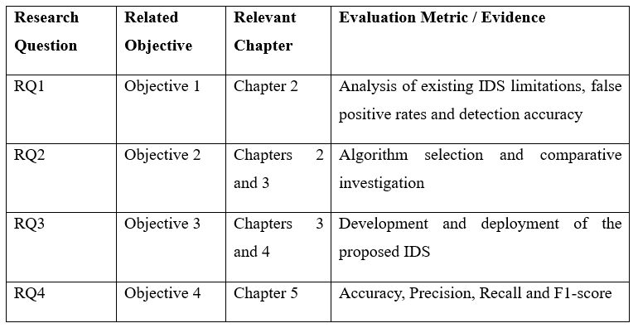

1.8 Structure of the Dissertation
Table 2 Structure of the Dissertation


Chapter 2: Literature Review

2.1 Introduction
Digital communications, cloud computing and the interconnection of information systems have expanded the opportunities for cyber attackers. The importance of sensitive personally identifiable, financial and organisational information being communicated through computer networks at all times means effective cybersecurity is critical to ensure the confidentiality, integrity and availability of information. Intrusion Detection Systems (IDS) are also crucial, as they continuously monitor network traffic and alert to any suspicious or unusual activity that could indicate intrusion before it causes damage [1]. As cyberattacks become more sophisticated and diverse, however, it is challenging traditional intrusion detection techniques. Signature-based and anomaly-based techniques could be restricted by new attacks, alterations in network activity and false positive alerts. These challenges have spurred interest in machine learning techniques that enable the identification of complex patterns in the network traffic and identify legitimate traffic from malicious traffic [2].
In this research, the behaviour of three machine learning techniques, namely Random Forest (RF), Support Vector Machine (SVM) and Artificial Neural Network (ANN) for network intrusion detection, is compared. In this investigation, the significance of selecting an appropriate network intrusion data set with a representative set of normal and malicious traffic is explored for training and testing the proposed models [3]. Selected approaches will be evaluated by means of accuracy, precision, recall and F1-score, especially in terms of minimising false positives. Hence, a critical review of the IDS development, traditional detection limitations, machine learning algorithms, datasets, evaluation metrics and studies was carried out in this chapter to identify the research gaps and provide justification for the proposed comparative study [4].

2.2 Evolution of Network Intrusion Detection Systems
As cyber threats continue to grow in complexity and the digital network becomes larger and larger, network intrusion detection systems have undergone tremendous development. Most early intrusion detection solutions were narrowly based around the prior creation of a set of rules and signatures of known attacks [3]. The systems tackled known attacks remarkably well but failed to identify new attack types or changed variations of known attacks because relying on signature databases to be continually updated was a key to the system's success [5]. With the increasing diversity of network traffic and the emergence of more sophisticated cyberattacks, traditional intrusion detection approaches have become increasingly difficult to maintain as effective cybersecurity solutions. These approaches often depend on predefined rules and known attack patterns, limiting their ability to respond effectively to rapidly evolving threats and previously unseen attack techniques [6]. To resolve these problems, an anomaly-based intrusion detection system (IDS) was developed that sets up the normal behaviour patterns and detects abnormal behaviour that could be a security breach. These systems raised the effectiveness of identifying unknown attacks but tended to also rate a higher number of false positive alarm rates, as anything deemed as unusual or not expected was labelled an attack [7]. The capabilities of monitoring were further enhanced by the development of Host-Based Intrusion Detection Systems (HIDS), Network-Based Intrusion Detection Systems (NIDS) and hybrid detection systems that cover both the single host and the whole network infrastructure [4]. As intrusion detection systems grow, so does the need for more intelligent, adaptive, and scalable systems that can detect current and new attacks while still delivering real-time efficiency.
Table 3 Evolution of Intrusion Detection Systems
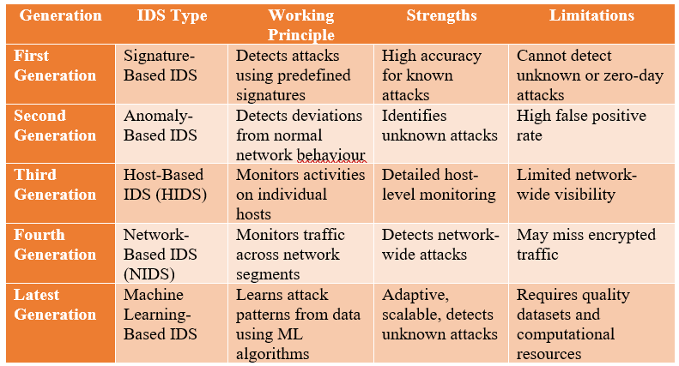

2.3 Traditional Intrusion Detection Approaches and Their Limitations
IDSs have been the backbone of network security for years, and they are still in use today, having been designed to detect suspicious usage or activities in a network by correlating them with prior detection events through a set of pre-defined detection methods. Signature Based Intrusion Detection: It is a network intrusion detection technology that is similar to that of antivirus software, which compares network events to a database of known attack patterns [8]. With signatures being updated frequently, this means that a relatively small number of false alarms are generated, and above all, high accuracy results in the detection of previously identified threats [2]. While effective, however, it is limited in its effectiveness because if it sees a new, modified or zero-day attack that isn't in the signature database, it can't detect it. Anywhere, frequent updates are also needed to provide good detection performance.
To address this, anomaly-based intrusion detection systems (IDS) were developed which learn normal network operations and detect any deviations from them that could signify an attack is taking place. This helps identify an attack when it is unknown but often results in high false positive rates, as the legitimate network behaviours might be misidentified as attacks [9]. Like rule-based and statistical methods, these need some conditions and previous observations, which can reduce the effectiveness in dynamic network environments. These restrictions decrease the overall reliability of traditional IDS, especially in real-time applications of cybersecurity [5]. These threats are increasingly evolving, and more adaptive detection methods need to be developed that can learn from network data and be more accurate whilst reducing the number of false alarms with lower levels of human involvement.

2.4 Machine Learning in Intrusion Detection Systems
The use of machine learning is an important method for enhancing intrusion detection because it allows for the identification of patterns in the network traffic without needing to rely solely on manually written rules [10]. By detecting relationships between the features of network traffic, machine learning models can classify network activities as normal or malicious. In today's networks, attack behaviours can shift quickly, and signatures might not be complete. But there are several details that influence the effectiveness of the model, such as the quality of the dataset, the representation of the features, the algorithm and the preprocessing [1].
Random Forest (RF), Support Vector Machine (SVM) and Artificial Neural Network (ANN) are three machine learning methods that are of particular relevance to this research. An ensemble of decision trees is used to detect complex relations in RF, and SVM is used to detect the boundary of classification between different traffic classes [11]. ANN can learn the nonlinear relationships by using interconnected computational layers and can recognise more complex traffic patterns. These different approaches under fixed experimental conditions can give a more solid foundation for choosing an IDS model [6]. Hence, the research has been built on the foundation of machine learning, and the comparative study of RF, SVM and ANN has been done to find out the most effective method in order to get the accurate and reliable network intrusion detection [12].
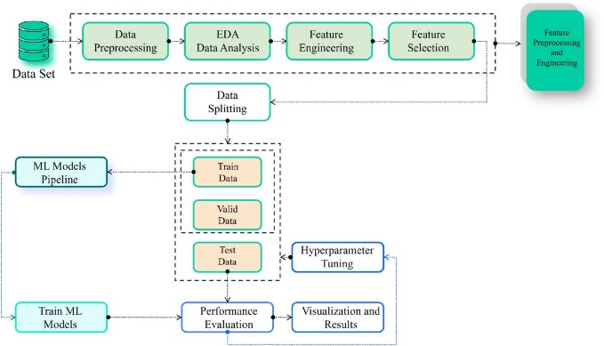
Figure 1 Machine Learning Architecture for Network Intrusion Detection
Source: [4]

2.5 Machine Learning Algorithms Used in Intrusion Detection Systems
Random Forest, Support Vector Machine and Artificial Neural Network are chosen as the core algorithms in the study, as they are different machine learning techniques for network traffic classification. Random Forest is an ensemble method of learning which uses multiple decision trees to get the final classification. It can be used for network intrusion datasets due to its capacity to manage many features and to minimise overfitting [13]. It can also give information regarding the importance of features, which helps to interpret the classification decisions. Support Vector Machine: It is a classification method which finds an optimum separating curve among classes. It is capable of working well if the data in the network has complex class boundaries and high-dimensional features. But when a data set becomes large, the computational needs can grow and so might affect practical deployment [7].
Artificial Neural Network: A network of interconnected computational nodes organised in layers that are used to identify patterns in data. It may have the potential of detecting complex intrusion behaviours due to its capacity for modelling nonlinear patterns, but it may also require more training and be more complex [14]. Various other algorithms like Decision Tree, K-Nearest Neighbour, Naïve Bayes and Logistic Regression have also been used for IDS. This research, however, focuses only on RF, SVM and ANN, thus providing a focused and consistent comparative benchmark [4].
Table 4 Comparison of Machine Learning Algorithms Used in Intrusion Detection Systems
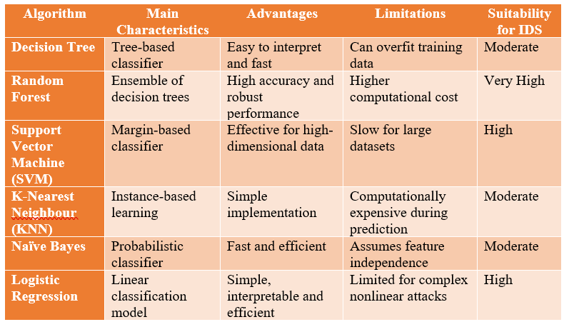

2.6 Network Intrusion Detection Datasets
A proper dataset is very important to build and test a robust IDS based on machine learning. This research chooses the UNSW-NB15 dataset, as it had been designed to provide network traffic with normal activities and various categories of malicious behaviour. UNSW-NB15 presents a more modern view of network traffic than its predecessors and additionally contains several attack classes and network-level features that can be used to help with machine learning classification [15].
Previous datasets like KDD Cup 99 have contributed significantly to the research of IDS, but the traffic characteristics have changed over time, and they lack avoiding repetition. As an improvement, NSL-KDD was proposed to overcome some of the limitations of KDD Cup 99 but is still a primitive set of network activities [8]. CICIDS2017 is another alternative and has realistic traffic as well as some modern attack scenarios. The use of more than one dataset in a single experiment may introduce extra variability and thus complicate controlled comparison [16].
For the final dataset, UNSW-NB15 is chosen for being a single consistent dataset for the three classifiers, RF, SVM, and ANN. Given that the same dataset, preprocessing procedure and evaluation metrics are used for all three models, it allows a fairer comparison and directly caters to the tutor's need for a focused benchmark [5].

2.7 Performance Evaluation Metrics for Intrusion Detection Systems
Intrusion detection system performance is achieved by using intrusion detection system evaluation metrics which evaluate how well the intrusion detection system can classify network traffic and minimise classification errors [17]. They are derived from a confusion matrix by breaking down predictions into true positives, true negatives, false positives and false negatives. Accuracy, likewise, is the overall ratio of correctly labelled network instances – but misleading when datasets are imbalanced because a model might perform well when the majority of instances are in its favour and have bad accuracy with minority attack classes [9].
Precision is the percentage of correctly predicted attack traffic that is true malicious traffic – how successful the intrusion alerts are. Recall measures its ability to detect a real attack and is very significant because when an attack is not detected, it can cause serious security problems. The F1 score is used to comprehensively evaluate the classification performance, which merges both precision and recall into a unified measure [18]. Another factor that shouldn't be overlooked is the false-positive rate, which corresponds to the percentage of alarms produced by the IDS that are incorrect, adding unnecessary effort and a loss of confidence in the IDS device [8]. Hence, using multiple performance measures to gauge the performance of a model is more comprehensive than using only accuracy and helps in designing reliable machine learning-based intrusion detection systems.
Table 5 Common Performance Evaluation Metrics for IDS
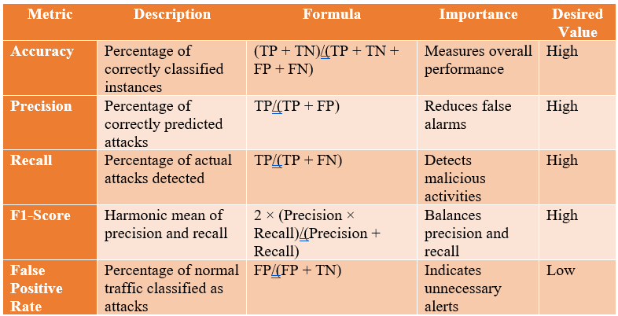

2.8 Critical Review of Existing Studies
Several studies have been conducted that have shown machine learning can enhance intrusion detection, but there are significant variations in algorithms, datasets and evaluation methods. Conventional machine learning models have been used in comparative research for classification, showing that models like Decision Tree, Random Forest, SVM and Logistic Regression can perform a useful classification on the network traffic [19]. Further research into UNSW-NB15 has shown that preparing the data and optimising models are crucial in the design of a machine learning-based IDS.
There have been other studies that have examined deep learning and hybrid approaches to enhance detection capability. Such methods may be able to capture complex patterns without any difficulties, but adding more complexity to the model can pose computational challenges for real-time or practical applications [6]. For imbalanced network traffic, other studies have shown that the class distribution and feature processing can significantly impact IDS results.
Table 6 Comparative Analysis of Existing Studies
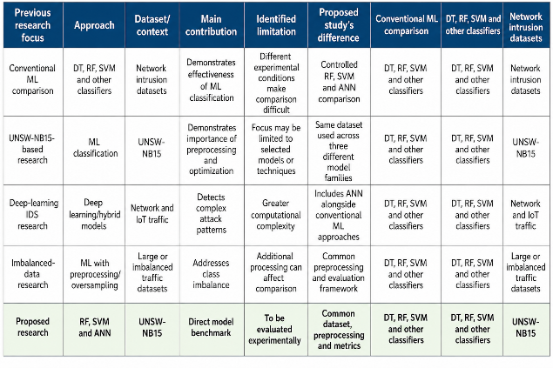
One of the problems in the existing literature is that the results are not easily comparable, as different datasets have been used, different preprocessing techniques have been applied, and different algorithms and evaluation criteria have been used. Some studies highlight accuracy, others precision, recall or F1-score [20]. Thus, the model that seems to be very effective in one study may not be the same model that is superior without a controlled comparison. In this work, the problem is tackled by comparing the performance of different classifiers on one chosen dataset, with the same evaluation measures.
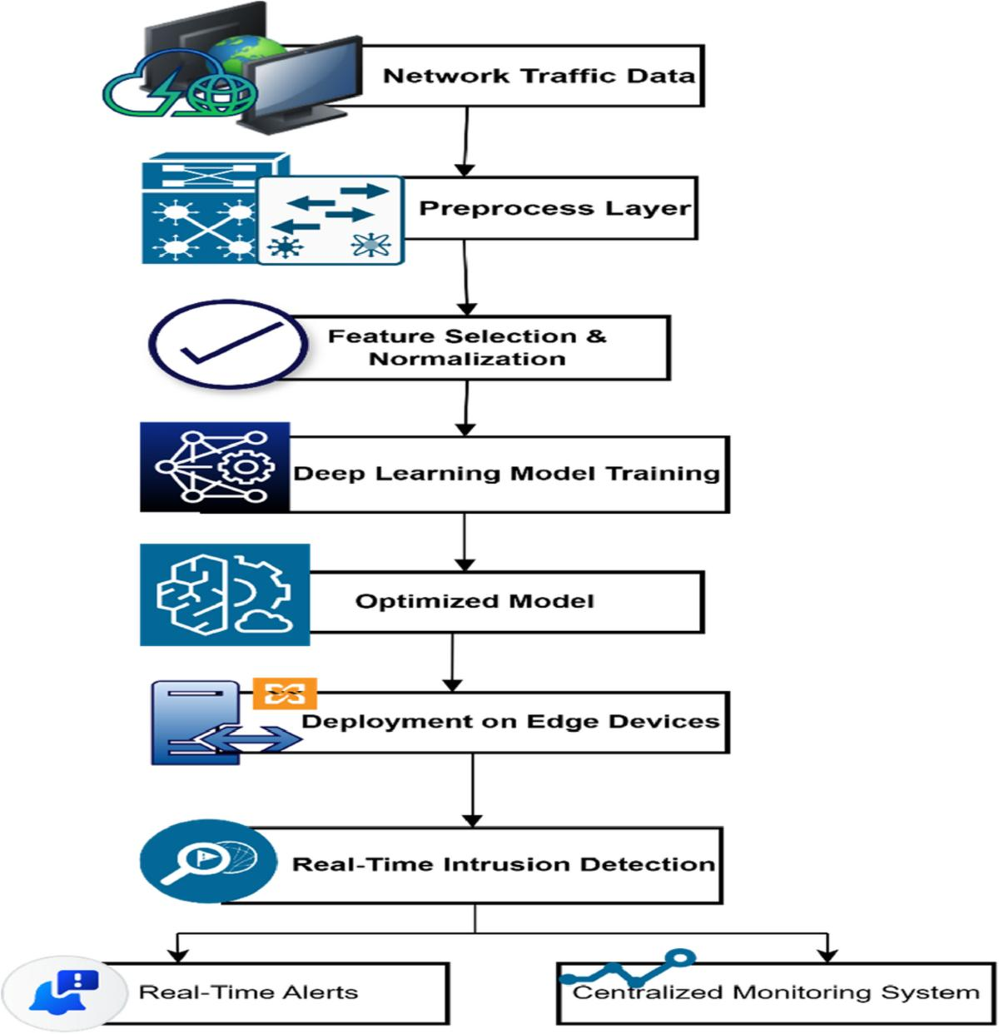
Figure 2 Multi-Model Intrusion Detection System Architecture
Source: [21]

2.9 Research Gap
The reviewed literature suggests that machine-learning approaches are highly promising for network intrusions detection but there are several methodologic restrictions. A number of previous studies have shown high classification accuracy with various data sets, preprocessing methods, feature representations and evaluation metrics [21]. Thus, some discrepancies between models reported cannot be solely blamed on the learning algorithm itself. But a controlled comparison is required to ensure that the design and implementation of the experiments do not produce confounds that compromise the distinction between the differences in algorithmic performance and the differences in design and implementation that occur between experiments.
Another area of difference relates to interpretation of the performance of IDS. Usually, accuracy is highlighted, but it doesn't sufficiently represent the impact of false alarms or missed attacks on operations [7]. The change-over between precision and false-positive rate is especially critical since too many false alarms may overload analysts with tasks, and recall and false-negative rate are critical because alerts of malicious activity may go unreported, which could create security risks. There are also ways to localize accuracy data to F1-score and ROC-AUC to collect more information about the balance and capability of discriminating that appear in [22]. Thus, the use of multiple measures of performance is needed, not a single measure.
Also, there are signs of the clash between complexity of the model and actual deployment from the literature. More sophisticated methods can be suitable to break down the traffic pattern into nonlinear relationships well, but might involve additional computational load that has impact on scalability and real time applicability [6]. This is one reason why one requires to evaluate models on the basis of their practical importance clearly, in addition to their forecasting capability.
To remedy these deficiencies, this dissertation conducts a controlled comparison of the three classifiers (Random Forest, Support Vector Machine, and Artificial Neural Network) on the same UNSW-NB15 dataset, case normalization, and a common set of evaluation criteria throughout the experimental process. This is helpful for making comparisons and making interpretations easier. The method offers a much more concrete foundation for the understanding of discrepancies between the models used and possible regions of strength and limitation.

2.10 Practical and Operational Considerations in Machine Learning-Based IDS
There are indications in the literature that predictive performance isn't always enough to decide if a machine learning based IDS is suitable for situations involving realistic cyber security. An IDS runs in an environment that can both cause problems with the incorrect alerts and fail to detect an attack. False positives could cause security analysts to be overwhelmed by an avalanche of alerts and cause alert fatigue, while false negatives could leave it with malicious activity that goes undetected. Therefore, make the operational interpretation of classification errors a consideration in model evaluation, not all classification errors are the same [8].
Another factor to take into account is the evolution of network traffic. The varied activities or applications/services of an organisation, as well as the individual use of its users, may result in the varied behaviour of its networks. Methods of attack are not static and can change. A model that has been trained on a specific set of data can thus produce different results for traffic of which it was not a part [22]. This makes an important difference between memory in a benchmark environment, and memory in a dynamically changing operational environment.
Suitability for computation is also appropriate. The differences between the characteristics of the trained system, model structure and demanded processing requirements are known between RF and SVM and ANN [7]. A model with a good predictive ability could still need some more realism testing in terms of latency, scalability and resource use before it's considered for monitoring in real-time. In particular, where network traffic needs to be analysed seemingly constantly.
These are important considerations for the interpretation of the results of the experiments for this dissertation. The models chosen for comparison are based on predicting metrics and are discussed in some consideration of false positives, false negatives and considerations of practice. This would ensure that the performance of the models is analysed in the context of the overall operational goal of intrusion detection rather than being seen as a mere rank/ordering exercise.

2.11 Synthesis of Literature and Research Direction
From the literature analysis, it can be concluded that the path leading from traditional IDS (signature and anomaly) to machine learning based learning patterns from network traffic is clearly a natural progression. Practical techniques work well for known attacks enough but are not effective in case the inherent characteristics of attacks change or new attacks are used that the system does not know beforehand [5]. Another method, machine learning, can learn associations between network characteristics and traffic types, but the efficiency of this method relies on the quality of the data set, its pre-processing, the algorithms used and how to evaluate them, among other factors [1].
Random Forest, Support Vector Machine and Artificial Neural Network both provide alternate insights into the classification challenge. RF algorithms can model complex relationships in an ensemble-based method, SVM can model a margin-based classification for high dimensional data, and ANN can model nonlinear relationships by interconnected layers of computation [13, 14]. It is possible to compare their methodology, given the same experimental conditions.
Moreover, the literature also shows that there are no evaluation measures that give an evaluation of an IDS. Overall accuracy may be used to measure accuracy, and other measures such as precision, recall and F1 score offer deeper insights into the performance of each class. RR is especially important for false Positive and false Negative measures, and ROC-AUC offers supplementary evidence for the discriminatory capability [17][18]. Thus, a combination of the measures promotes a more balanced interpretation of the behaviour of the model.
This synthesis then shapes a dissertation, which will take a controlled experimental pathway, with the controlled experimental run of UNSW-NB15 as a benchmark and also using the same preprocessing and evaluation framework for all three runaway models selected. The outcome of this method is to detect the differences in performance under the same conditions and investigate whether acceptable false positive behaviour is acquired to obtain strong classification performance. This direction aids to achieving the research objective and forms the basis of the methodology shown in Chapter 3.

2.12 Chapter Summary
In this chapter, the evolution of IDs and the growing use of machine learning for detecting malicious network activity have been explored. Some of the drawbacks of traditional methods were taken into account, including reliance on predefined signatures and the challenge of detecting new or evolving attacks. Next, machine learning was explored as an adaptive solution that can learn patterns from network traffic.
The review led to the selection of three main algorithms for the scientific investigation proposed: Random Forest, Support Vector Machine, and Artificial Neural Network. They have various learning features that support their comparative evaluation. UNSW-NB15 was chosen as the only dataset for the consistent experimental framework and representative normal and malicious network traffic.
The main findings from the critical review were that existing research had some limitations, including discrepancies in datasets, preprocessing methods, algorithms and evaluation methods. The research gap thus is about the need for a benchmark, that is, a controlled study, of RF, SVM and ANN with consistent conditions and multiple performance measures. This identified gap will be translated into a methodological framework in the next chapter, including the preparation and preprocessing of the datasets and the development and evaluation of the models.

Chapter 3: Research Methodology

3.1 Introduction
The methodology that was used to develop the proposed Network Intrusion Detection System (IDS) using machine learning is presented in this chapter. Sutherland's study sets out to boost detection accuracy, steer clear of false positives, and uncover malicious network traffic.
The research onion guides the research philosophy, approach, strategy and methods [25]. The use of objective and measurable evidence makes positivism and deduction adopted. Experiment and quantitative analysis to test performance and design science research to develop an artefact.
CRISP-DM is an individual machine learning process, guidance from a practical perspective. UNSW-NB15 is the network traffic data that is used to train and test the random forest, the support vector machine and the artificial neural network. The chosen methodology and research procedure are explained in the following sections [26].
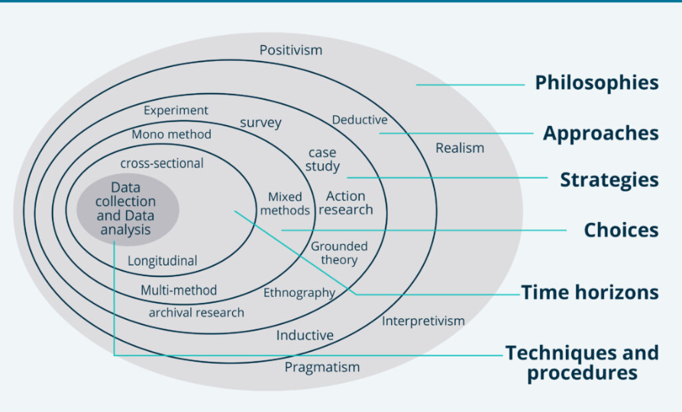
Figure 3 Research Onion Model Showing the Selected Research Philosophy and Methodological Approach Source: [24]

3.2 Research Philosophy
Research philosophy relates to the premises behind research for the collection and interpretation of data. Positivism, interpretivism and pragmatism were considered for this research.
Analysis of interweaved subjective experiences and perceptions of humans is emphasised in interpretivism, and methods can be chosen depending on their utility in practice in pragmatism [27]. This research, however, doesn't need opinions, interviews or kinds of other subjective evidence to meet its goals.
So positivism is taken because the research requires objective and measurable results. Evaluation of the machine learning models is complemented by network traffic data, in addition to numerical evaluation metrics, such as accuracy, precision, recall and F1 score. This helps to make comparisons and draw conclusions from what can be seen [28].

3.3 Research Approach
The research is carried out using both the inductive method and the deductive method. Induction: Builds general ideas or theories from observations/evidence.
This research doesn't seek to produce a new theory, however. Instead, it starts from a discussion about the previous knowledge about the limitations of IDSs and machine learning approaches obtained from the literature [29].
Thus there is used an approach of deduction. Existing knowledge is used to select the three methods (Random Forest, Support Vector Machine and Artificial Neural Network) and test them on the UNSW-NB15 dataset. Evaluation of their performance is done according to pre-defined criteria, which connect the research problem, research aims and the experiment – what measurable results are expected [30].

3.4 Research Strategy and Design Science Research
The various approaches were surveyed, studied, developed and experimented with for several research strategies, which included surveys, case studies, development and experimentation. Surveys and case studies tend to concentrate on opinion or specific context and are not appropriate.
It is important to develop it because it leads to the creation of a machine learning-based IDS. But development efforts do not necessarily prove the proposed artefact is effective or solves the cybersecurity problem identified.
Thus, with respect to the broader context, design science research acts as the umbrella concept, and experimentation is the most predominant strategy [31]. The training and testing of the algorithms (random forest, SVM & ANN) are carried out with the same test set. The same data set, the same preprocessing procedure and the same evaluation measures allow for a fair comparison and provide more trustworthiness of the results.

3.5 Research Method
The study generates quantitative evidence, and so a quantitative research method is used. Measurable values can be used to represent the performance of the developed machine learning models, and they can be compared in an objective manner [32].
A qualitative approach could help create valuable information regarding user experiences or cybersecurity practitioners' experiences with IDS technologies. The number of Casio e-trees used for each, however, would not give the necessary evidence of classification success produced by examples drawn from an interview or observations or from open-ended questions. Hence, qualitative methods are not used as the main approach [33].
The quantitative method will get measurable data results of each machine learning model. Accuracy, precision, recall and F1-score are all good metrics of performance. Accuracy is the percentage of all predictions that are correct; precision is the percentage of correct positive predictions; recall is the percentage of correct positive predictions that are made; and the F1 score balances precision and recall.
This approach is suitable since all the models would be judged on the same criteria [34]. The numbers derived can then be compared, and conclusions can be made based on measurable performance and not on subjectiveness.

3.6 Data Collection
Secondary quantitative data from the UNSW-NB15 dataset were used for the study. Data is available in the kaggle repository, with labelled network flow data with normal and malicious network flow records available. It has also training and testing partitions, which constitute the standardized foundation for training, testing and validation of machine-learning models. Previous studies also show that the use of a dataset facilitates the process of reproducing other studies that make use of the same traffic data.
Primary data collection instruments such as questionnaires, interviews, observations, and experiments with human subjects are not used. This research is technical, based on network traffic data, for which the responses and opinions of the participants are not necessary. The data set contains evidence to study how to classify normal and malicious network activity.
The data collected is then analysed to gain insights into the structure, quality and characteristics before modelling [35]. This involves looking for the quantity and type of variables and for missing data, duplicate records, improbable entries and class distribution of target classes. The data set is then divided to identify predictive variables, remove the variable of interest, and ensure categorical variables are represented correctly for the machine-learning analysis. The numerical variables are preprocessed and standardised by the defined preprocessing pipeline to make features appropriate for the algorithms.
Random Forest, Support Vector Machine and Artificial Neural Network models are fed into the same prepared dataset and use the same approach in preprocessing. This consistency creates an experimental environment in which the predictive performance difference may be discussed specifically with the algorithms selected and not with the difference of the data sources and preparation methods [36]. This leads to a more robust approach in terms of consistency, assessability and a research base for the research questions.

3.7 Data Analysis and Evaluation
Machine learning experimentation of prepared data is made. The models chosen are then trained with the training data and tested with the testing data. The classes predicted by the model are compared against the set of known classes in the dataset.
The extent to which records are classified correctly in general is measured by accuracy. "Precision" refers to the percentage of records marked "malicious" that actually are malicious. Recall is used to look at how well the model performs w.r.t. its ability to detect actual malicious traffic [37]. The F1 score is a balanced measure of performance due to being a mixture of precision and recall.
Consideration is also given to false positive behaviour, as false alarms by an IDS are a huge problem and will ultimately decrease its trustworthiness. Selection of a model should not be based on accuracy alone, however, but also on other factors.
The performance of the RFID, SVM and ANN models obtained is compared based on the same assessment criteria. The most appropriate model that shows the optimal accuracy level, not only in terms of precision and recall but also in terms of the F1 measure, is determined as the desired model of the proposed IDS [38].

3.8 Research Design
The research design is a process from the marked problem of research to the final evaluation. The literature review explores existing limitations of IDS and the related machine learning methods. This helps to identify the chosen algorithms and evaluation criteria.
Second, the information is gathered and analysed in the UNSW dataset, the UNSW-NB15. Preparation of the data is then done in order to make this data applicable to machine learning. Clean, transform and prepare the data for modelling [29].
Third, with the prepared training data (population domain), the following models are developed and trained: Random Forest, Support Vector Machine and artificial neural network. Each algorithm is tailored for use with the appropriate configuration.
Fourth, testing data is not used for training the models. The accuracy, precision, recall and F1-score are applied to analyse the prediction results given by each model [34].
Finally, the results are compared with the performance of the other models to decide the performance model best. The selected model is then used in the proposed machine learning-based IDS. It has a structured design which ensures that the process of investigation is consistent with the research aim and objectives.

3.9 CRISP-DM Process Model
CRISP-DM is used as the data-science process model for the practical development of the machine learning solution. It is not used as overall methodology or a project management framework.
Business understanding involves recognising the intrusion detection problem and its technical requirements. 'Data understanding' consists of analysing the UNSW-NB15 data and extracting useful data features and labels. Data preparation includes cleaning, transforming and preparing the data for machine learning [27].
The modelling stage is a training stage for Random Forest, Support Vector Machine and Artificial Neural Network. In evaluation, accuracy, precision, recall and F1-score are considered strategies to measure model performance. The last deployment stage aims to integrate the best-accomplished model into the proposed IDS.
CRISP-DM is also "iterative", providing a potential for revisiting the steps that have already been performed. In cases where a poor performance is found during the evaluation, for instance, the data preparation or configuration of the model may be enhanced prior to the choice of the final solution [38].

3.10 Validity, Reliability and Verification
Validity is upheld by making sure research methods and evaluation measures relate directly to the aims of the research. The same data set and commonly used performance measures are used to examine all the models.
The experiment is repeatable for reliability. The data preparation process, model development process and evaluation process are documented for repeatability. It is verified by checking the predictions of a model with the known classifications of the testing data set [36].
Multiple evaluation metrics are used to prevent using accuracy as only one of them. This will give more stable feedback on performance and help to support robust conclusions. The results are, however, only applicable to the selected data set/s and experimental setup.

3.11 Chapter Summary
This chapter details the methodology that was utilised to develop and evaluate the proposed machine learning-based intrusion detection system (IDS). It was based on a positivist philosophy, a deductive approach, the research strategy Design Science Research (DSR), and the framework of systematic model development and evaluation, which was experimental. A quantitative methodology was chosen, which is based on measurable and objective performance evidence, due to the problem this research was aimed at solving that is quantifiable and based on objective evidence of intrusion detection effectiveness.
The dataset UNSW-NB15 was chosen as the secondary quantitative data source since it offers labelled network traffic with normal and malicious activities. The three machine-learning classifiers - Random Forest (RF), Support Vector Machine (SVM), and Artificial Neural Network (ANN) - were chosen and tested by following a uniform procedure. They have the same data preparation and evaluation, which makes a controlled comparison of their predictive power possible.
This CRISP-DM framework was integrated to organise the working process of data science in practice into problem understanding, data preparation, modelling, evaluation and deployment. The methodology also gave rise to a series of procedures for the quality assessment, the preprocessing, the model development, the model validation, the model testing and the calculation of the model performance. These methodological choices offer a framework to deal with the goals and questions of the research. The design of the proposed IDS, in detail, like the dataset preparation and preprocessing, model configurations, and development of the prototype, is present in the following chapter.

Chapter 4: Design and Implementation

4.1 Introduction
The proposed design of the NIDS using machine learning is presented in this chapter, along with how it has been put into practice. The implementation mirrors the methodological framework presented in Chapter 3 and is meant to form a system which can be reproduced in an experiment. The development is based on the CRISP-DM process, which consists of data understanding, data preparation, modelling and deployment of the IDS prototype [39]. The aim is to create a setup where the same set of network traffic is fed to the three algorithms of Random Forest (RF), Support Vector Machine (SVM) and Artificial Neural Network (ANN), and the same experimental setup is simulated. This directly addresses the goal of research to develop IDS with machine learning which can discriminate between normal activities and the malicious activities in the network [40].
Implementing it has been done in Python with all the NumPy, Pandas, Scikit-learn, and TensorFlow/Keras libraries. To increase the level of reproducibility, a fixed random seed 42 was used. The environment that was recorded was Python 3.11.15, NumPy 2.4.4, Pandas 3.0.2, Scikit-learn 1.8.0 and TensorFlow 2.21.0.

4.3 Dataset Loading and Initial Inspection
Two CSV files were loaded: the first file containing a set of training data, UNSW_NB15_training-set.csv, and the second a set of test data, UNSW_NB15_testing-set. csv. The number of rows and columns on the training partition were 175,341 and 45, respectively, and 82,332 and 45 on the testing partition. First looked at the predefined local and Colab folders for the files, then searched for the files via an automated download, and then offered the file uploading if the files weren't found.
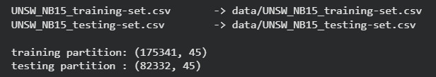
Figure 4 Data Inspection
The values of the target variable were determined to be binary, where 0 and 1 are possible values. The number of normal records in the training partition was 56,000, while the number of normal records in the testing partition was 37,000. In the testing partition, the number of malicious records was 45,332, while the number of malicious records in the training partition was 119,341. So, the malicious proportion in the training partition was 68.06%, while in the testing partition, it was 55.06%. The training partition also contained ten attack categories: Normal (56,000), Generic (40,000), Exploits (33,393), Fuzzers (18,184), DoS (12,264), Reconnaissance (10,491), Analysis (2,000), Backdoor (1,746), Shellcode (1,133) and Worms (130).
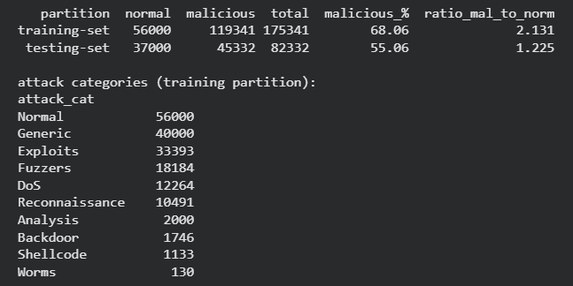
Figure 5 Records Count
Two variables (the combo of 'id' and 'attack_cat') were not included in the feature set used for prediction. The id variable was deleted as it aims at identifying the record instead of the network's behaviour, and the attack_cat variable was omitted as the purpose/case of the research is a binary classification between normal and malicious behaviour. It found that after these exclusions, there remain 42 features—in 39 numerical and 3 categorical: proto, service, and state—which is able to implement [41].

4.4 Data Quality and Preprocessing
Data quality was checked prior to developing the model. There were no missing data in the training and testing partitions. All numerical features had no infinity values, no negative values were detected and no constant feature columns. They were able to find 74,072 duplicate training data in the original training partition (42.2%) and 28,380 duplicate testing data in the original testing partition (34.5%). Aside from that, there were 8,541 testing record images that had feature vectors matching those from the training partition, and there were 229 feature-identical testing record images, but with inconsistent labels in the training partition.
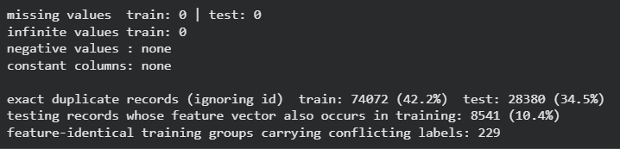
Figure 6 Data Quality Check
To avoid the bias of repeated training observations overwhelming model learning, duplicate training records were removed from the data with respect to the 42 predictive features and the target label [42]. This happened to reduce the training data from 175,341 to 101,269, thus eliminating 74,072 records. The train set consisted of 51,890 normal and 49,379 malicious records after deduplication with a malicious-to-normal ratio of 0.952.
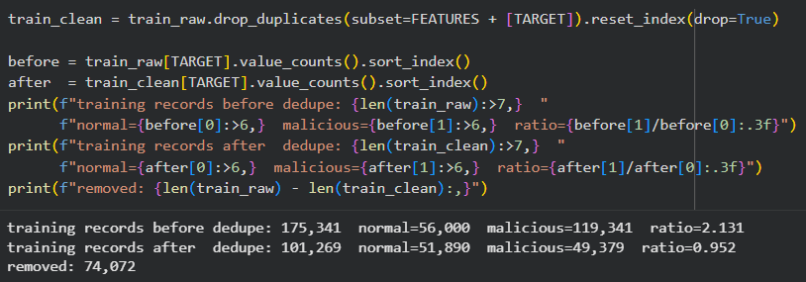
Figure 7 Duplicate Removal
The training data was subsequently split in an 80%-20% train/validate split with random_state set to 42. This resulted in 81,015 training records and 20,254 validation records. In both subsets, the percentage of the malicious share was the same: 48.8%. The 82,332-record testing partition was still locked out. The resulting training subset had 41,512 normal and 39,503 malicious records—that is, the class imbalance in the original data set was greatly reduced by the deduplication. No oversampling or undersampling was done [43]. Rather, the class weighting approach was explored during the modelling process.
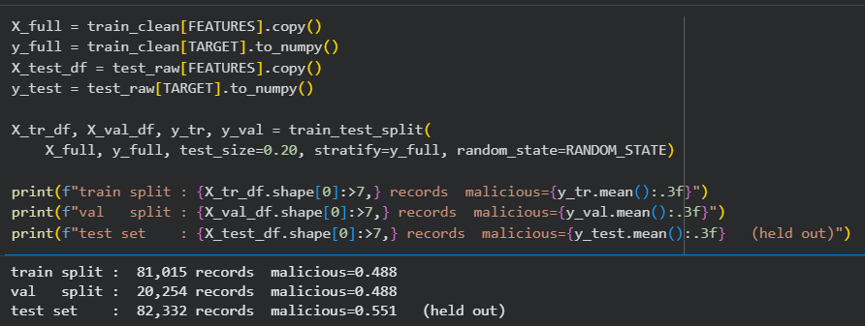
Figure 8 Training Split
The data was pre-processed separately for numerical and categorical variables in the preprocessing pipeline. The min-max scaler was applied to numerical variables after they were log1p and thus standardised. Logarithmic transformations are applied to decrease the effect of very skewed measurements of network flow in numerical data; standardisation puts all the numerical variables on the same scale [44]. One-hot encoding was used for the three categorical variables, with the option of handling unknown categories, "ignore", so that the system can handle and process new categories that will occur during inference but were not seen during training. The service value was also kept as a valid service layer level since it is a true absence of an identified application layer service as opposed to a value being null or missing [45].
The preprocessor was only applied to the 81,015-record training subset, then to the validation and testing subsets. It took a transformation to create 192 encoded features. Consequently, the resulting matrices were 81,015 × 192 for training, 20,254 × 192 for validation and 82,332 × 192 for testing. Leakage verification showed that the scaler was applied to the exact number of 81,015 records, no target variables were present in the feature matrix after applying the variables of the transformed data set, and there were no NaN or infinite values in the transformed data set.
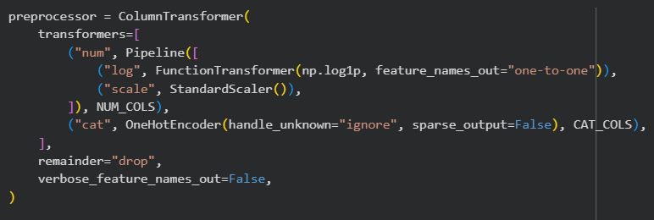
Figure 9 Preprocessor application

4.5 Random Forest Implementation
Random Forest was used as the first supervised classifer due to its ensemble structure and also its ability to extract feature importance information to be used in the supervised classifiers and its ability to model nonlinear relationships. The implementation was based on a set of 300 final DTs and using parallel processing with n_jobs -1, random state 42 and a controlled hyperparameter search [46].
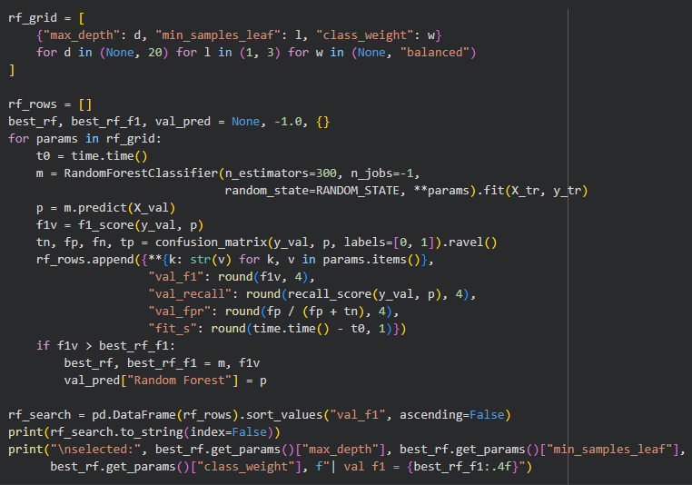
Figure 10 Random Forest
The eight configurations were compared using various levels of maximum tree depth (no limit and 20), minimum samples per leaf (1 and 3), and class weighting (unweighted and balanced). The training was done on the training matrix, and the validation was performed on the validation matrix for both configurations. The choice selected for implementation went ahead with no restrictions on the leaf size, with a minimum leaf size of 3, and with class weighting equal to the minimum. The final RF was then realised with these settings and 300 estimators used [47].

4.6 Support Vector Machine Implementation
The second classifier was an SVM with the radial basis function (RBF) kernel. The RBF kernel was found to be most suitable for the transformed network-flow feature space because it implements non-linear decision boundaries for the feature space. The standardised numerical representation produced by the common preprocessing pipeline to standardise the features is used for the implementation of SVM, since it is highly influenceable by the size of features [48].

Figure 11 Support Vector
Due to the higher computational complexity of the training process of an RBF-based SVM, a deliberately smaller search was conducted. Two different class weighting schemes, unweighted and weighted, were tested, and the search specified the value of C varied between 1.0 and 10.0, giving a sensitivity to scale. This configuration selected was C = 10.0 and a balanced class weighting. The trained SVM was then repeated with the same prepared training matrix with the same selected configuration for all classifiers [49].

4.7 Artificial Neural Network Implementation
The third classifier was a feedforward ANN (FF_ANN) using TensorFlow/Keras. The 192 modified features are fed into the network. The hidden layers are based on the Dense units with ReLU activation and batch normalisation followed by dropout. The first hidden layer has a dropout of 30%, and the remaining hidden layers have a dropout of 20%. Malicious traffic probability is taken by a single sigmoid output neurone.

Figure 12 Artificial Neural Network
The ANN is trained with binary cross-entropy loss and the Adam optimiser with a learning rate of 0.001. As other additional training metrics, accuracy and AUC were supervised. Two architectures (64, 32) and (128, 64, 32) were experimentally explored. The maximum number of epochs in the training cycle was 150, the batch size was 256, and the validation subset was used to monitor during the training. For early stopping, the patience was set to 10 epochs, and the weights with the best validation loss were restored; for ReduceLROnPlateau, the learning rate is reduced by 0.5 after 4 epochs, which have no validation-loss reduction (lower) bound of 1e-5. The (64, 32) architecture is the one finalised by the validation-based approach used for architecture selection during the implementation.

4.8 Evaluation and IDS Prototype Implementation
To be able to process all three models in the same way, a common evaluation tool was developed. The corresponding prediction scores were fed into the function, which generated predictions and calculated accuracy, precision, recall, F1-score, true positive rate, false positive rate, false negative rate, specificity and ROC-AUC. This allowed the same evaluation logic to be applied to all classifiers instead of developing model-specific evaluation procedures [50].
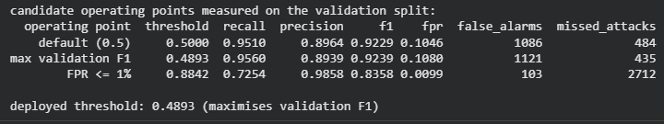
Figure 13 Classifiers
The last step was then to carry out the modelling process as an IDS prototype. The prototype is a wrapper that encapsulates the preprocessing transformation (used in classification training) with the selected classifier for parallelisation such that an individual raw UNSW-NB15 data flow will go through the same transformations as those performed in the training process [51]. The operating threshold chosen was not considered to be a value which could have been set at any possible reference value by the manufacturer. The default false-positive threshold (0.5), the threshold with the highest F1 value and the threshold that falls under a one per cent false-positive constraint were used for comparison by validation prediction scores. Implementing the operating point has been determined to cost a balance between missed attacks and false alarms, and so the F1-based operating point has been adopted for deployment. Importantly, this threshold was not determined using the testing partition [52].
The prototype that they have created requires 42 raw UNSW-NB15 feature columns and preprocesses prior to predicting intrusion. When presented with an individual testing record, an alert decision and a malicious probability were generated, establishing that the created pipeline can make use of an individual flow instead of a full set of data. The prototype is not designed as a production enterprise IDS: It categorises already captured network-flow records only and isn't designed to store traffic blocking, flow reconstruction or packet capture [53].

Figure 14 Prototype
The implementation is thus the embodiment of the practical design described in Chapter 3, yielding a replicable data stream, iterative processing of data, three implementations of supervised machine learning approximators, and a deployable IDS prototype. It is deliberate that the quantitative model-performance results, the confusion matrix results and ROC analysis are presented separately, with the comparative assessment, in Chapter 5.

Chapter 5: Evaluation of Results

5.1 Introduction
In this chapter, the performance of the three elaborated models, namely Random Forest (RF), Support Vector Machine (SVM), and Artificial Neural Network (ANN), is evaluated. The independent test is focused on the evaluation based on the following measures: accuracy, precision, recall, F1-score, false-positive rate (FPR), false-negative rate (FNR), ROC-AUC and confusion-matrix outcomes [54]. Additionally, to evaluate generalisation, validation and testing performance are compared. A special focus is placed on the detection of "recall" behaviour and "false-positives", as an IDS should detect malicious information while sending as few alerts as possible to the security administrator.

5.2 Overall Model Performance
The results of the tests show that all three models were able to detect malicious network traffic; however, they are different in various evaluation criteria.
Table 7 Model Comparison
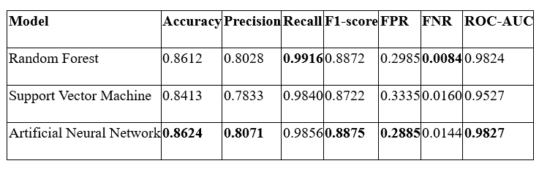

The overall accuracy of the ANN performed highest at 86.24%, followed by the RF at 86.12%, and the SVM performed the lowest overall accuracy at 84.13%. More important, ANN yielded the best malicious-class F1-score of 0.8875 that was just slightly higher than RF's score of 0.8872. There is an only difference of 0.0003, showing a very close performance of the two top models in precision and recall. SVM had an F1 score of 0.8722, which was about 1.5 percentage points lower than that of ANN.
This recall is remarkable, with a particular strength of detection apparent in the recall results. RF obtained maximum recall with 99.16%, indicating that it was able to detect nearly all the malicious cases. ANN followed at 98.56%, while SVM achieved 98.40%. As a result of this, RF achieved a lower FNR (0.84%) than ANN (1.44%) and SVM (1.60%). If it's just the attack that means nothing, then RF is the best.
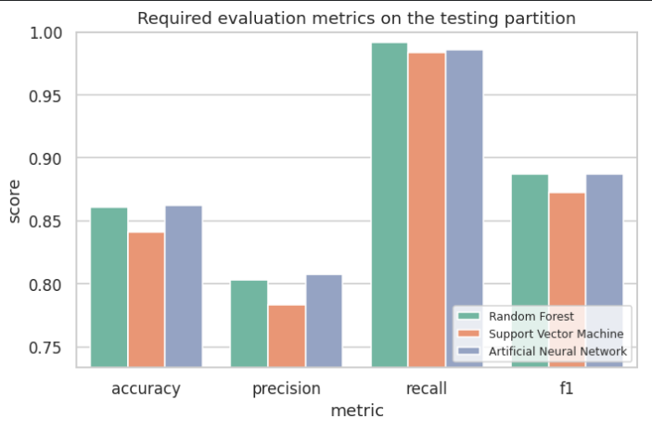
Figure 15 Performance Graph
But false alarms can't be separated from recall. ANN achieved the lowest FPR at 28.85%, compared with 29.85% for RF and 33.35% for SVM. This provides an important operational benefit for ANN as fewer normal network records were misclassified as malicious. The findings align with the slightly better F1 score of ANN and give credence to the marginally better performance of ANN compared to RF, albeit with a different objective: detection and false alarm control [55].
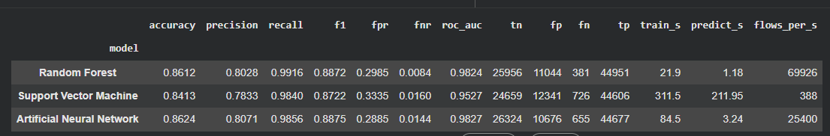
Figure 16 Model Comparison

5.3 Random Forest Evaluation
RF produced an accuracy of 0.8612, a precision of 0.8028, a recall of 0.9916 and an F1-score of 0.8872. It discriminates between normal and malicious well with an ROC-AUC = 0.9824. The model's most notable characteristic is its extremely high malicious recall. There were only 381 records that were missing as malicious, resulting in an FNR of 0.0084.
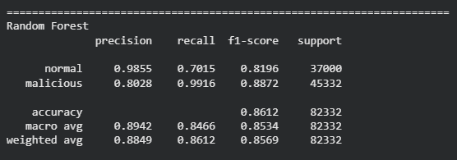
Figure 17 RF Result
The confusion matrix was comprised of 25,956 true negatives, 11,044 false positives, 381 false negatives and 44,951 true positives. Thus, the model was able to identify 44,951 malicious flows as correctly detected, but 11,044 false alarms were created. This is an important critical difference: while the attack-detection rate is highest for RF, almost one-third of the normal traffic was marked as malicious. A security-monitoring environment in which the false-positive rate is high can add to the analyst workload and make automated alerts less meaningful [56].
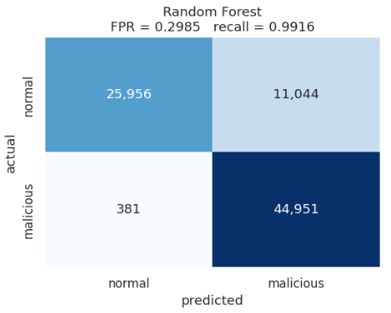
Figure 18 RF Confusion Matrix
This trade-off is also reflected in the class-level results. The malicious traffic resulted in an F1 score of 0.8872, while the normal traffic had an F1 score of 0.8196. The model was also much more aggressive in assigning traffic to the malicious class, as evidenced by the normal-class recall of 70.15%. So, RF compromised on the specificity of normal traffic and opted for attack detection [57].

5.4 Support Vector Machine Evaluation
The SVM model had the poorest overall testing result among the three models. Its accuracy was 84.13%, precision was 78.33%, recall was 98.40%, and F1-score was 87.22%. It also had a significantly lower ROC-AUC score of 0.9527 compared to RF and ANN of 0.9824 and 0.9827, respectively.
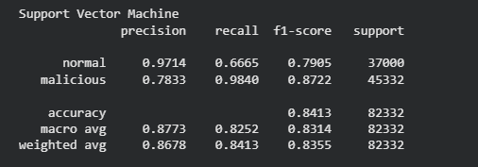
Figure 19 SVM Results
The confusion matrix consisted of 24,659 TNs, 12,341 FPs, 726 FNs and 44,606 TPs. A total of 44,606 attacks were successfully detected, but the maximum number of false alerts were generated by the model when compared with the other two approaches. It showed the FPR for this script at 33.35%, which means that roughly 1/3 of the normal records were mistagged as attacks.
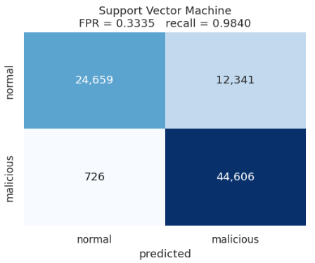
Figure 20 SVM Confusion Matrix
The SVM result is indicative of why accuracy alone would not give a complete picture. Being highly recalled at 98.40%, it performs well; however, the negative impact of its low precision with the high FPR detracts. The model thus has high attack sensitivity and low alert reliability. Although SVM identified 71 fewer attacks than ANN, the cost of providing an operational IDS is the additional 1,297 false alarms.

5.5 Artificial Neural Network Evaluation
The best overall test scores were from ANN. It recorded 86.24% accuracy, 80.71% precision, 98.56% recall and 88.75% F1-score, together with the highest ROC-AUC of 0.9827. The model had a slightly lower recall rate (RF) but also produced lower false positive rates and a slightly higher overall classification balance.
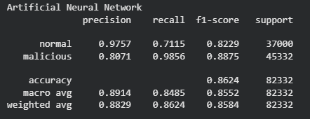
Figure 21 ANN
The “confusion matrix” had 26324 “true negatives” and 10676 “false positives”, plus 655 “false negatives” and 44,677 “true positives”. ANN then successfully identified 44,677 instances of malware and generated 10,676 false alarms along the way! Although ANN also missed 274 attacks as RF did, it triggered 368 fewer false alarms as compared to other approaches. This is a good compromise between the misses and false alarms.
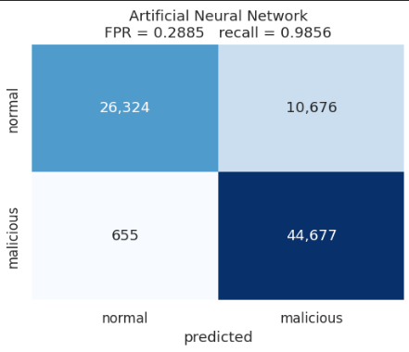
Figure 22 ANN Confusion Matrix
The class of malicious traffic had an F1 score of 0.8875, and for normal traffic it was 0.8229 at the class level. The normal-class recall was 71.15 per cent (better than both RF and SVM). Based on the principal evaluation criteria, ANN is the most well-balanced model, combining the highest accuracy, highest precision, highest F1-score, lowest FPR and highest ROC-AUC.

5.6 ROC-AUC and Discriminative Performance
The models are also evaluated by ROC analysis that supplies an extra evaluation of the models at various classification thresholds. The AUCs of ANN, RF and LDA followed each other closely, with ANN having the highest AUC at 0.9827, followed almost by a knot by RF with an AUC of 0.9824. SVM recorded 0.9527. The closer they are to the AUC, the closer they are to the separation capability of respective malicious and normal traffic, and the comparatively small separation capability of SVM is confirmed when compared to their minimal close connection with the AUC [58].
It can also be noted in the ROC results that a difference/discrimination-based comparison of ANN and RF is not perfectly justifiable. Rather, it's the balance of cost/benefit of operation between false alarms and lost attacks. ANN is more advantageous in the given objective of high detection reliability but at the same time less number of false alerts due to the lower FPR [59].
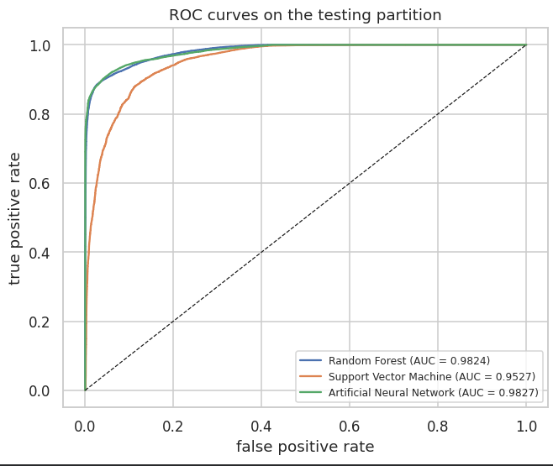
Figure 23 ROC Curves Comparison

5.7 Validation-to-Test Generalisation
A comparison of the validation results with the testing results indicates that all the models had a decrease in the F1-score. RF declined from 0.9296 to 0.8872, a reduction of 0.0423. SVM's biggest move up or down was 0.0489 down to 0.8722. ANN declined from 0.9229 to 0.8875, a reduction of only 0.0354.
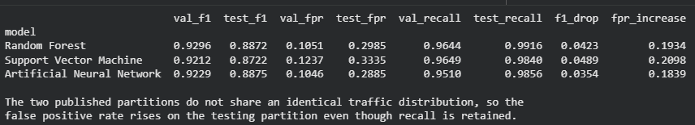
Figure 24 Validation Test Performance
The results of testing partition were the other way round, showing that the false-positive rate rose significantly for models RF (from 10.51% to 29.85%), SVM (from 12.37% to 33.35%) and ANN (from 10.46% to 28.85%). This shows that there are distributional differences between the validation traffic and the testing traffic, but that malicious recall was very high in all three cases. The compared approaches were evaluated with respect to the FPR increase and F1 reduction; ANN had the smallest FPR increases and F1 reductions, indicating the best generalisation performances [60].

5.8 Comparative Critical Evaluation
There is no single model that is better in any specific aspect of the score. Attacks were successfully detected by RF, with a success rate of 99.16%, and it missed 381 malicious records. ANN is the best in terms of accuracy, precision, F1-score, FPR and ROC-AUC. On no main metrics of testing is SVM leading, and it has the highest number of false positives [61].
The difference between the ANN and RF F1-scores is only 0.03 per cent, and overall their detection effectiveness is essentially the same. However, it is able to produce 368 fewer false alarms than RF (false alarms) but only an additional 274 attack deceptions (false detections). In the case of a trade-off between alert volume and detection balance, ANN benefits. The statistically significant increase of the 12,341 false positives also tarnishes its suitability. However, SVM is further called into question by its much higher false positive figure of 12,341.
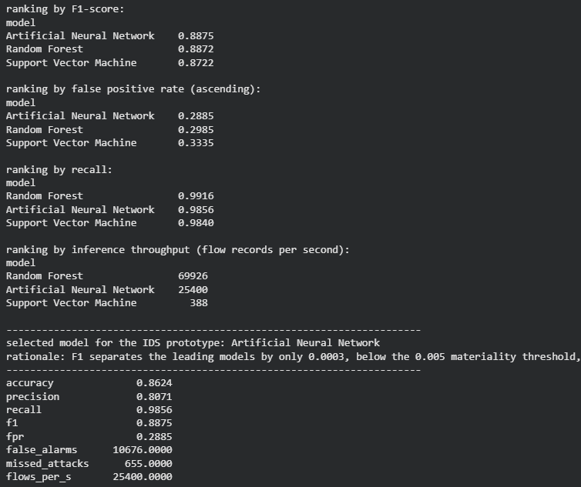
Figure 25 Overall Model Performance
Based on the results, therefore, it can be concluded that ANN will be the best balanced model for the proposed IDS. This final decision doesn't depend fully on just one of the metrics but derives from the amalgamation of F1-Score, Precision, Recall, False Positive Behaviour and ROC-AUC [62]. The evaluation also shows that regardless of the high level of recall, very few attacks are actually detected by the best IDS: RF was able to detect slightly more attacks than ANN, but ANN managed to achieve a superior overall attack-to-false-alarm ratio.

5.9 Chapter Summary
The testing evaluation clearly shows differences in performance between the three models. RF achieved the highest recall at 99.16%, while ANN achieved the highest accuracy (86.24%), precision (80.71%), F1-score (88.75%), lowest FPR (28.85%) and ROC-AUC (98.27%). SVM resulted in the poorest overall performance and the biggest false-positive rate. Then, the validation-to-test analysis revealed that ANN had the minimum degradation of the F1. Drawing on these results, ANN emerges as the best-rotation solution to the problem of the proposed machine learning IDS, with a highlighted RF where decreasing missed attacks is most important [63].

Chapter 6: Conclusion and Recommendations

6.1 Introduction
This dissertation attempts to study the use of machine learning technologies to enhance the optimisation of Network Intrusion Detection Systems (NIDS) to better detect malicious network traffic. The research focused on IDS challenges such as missed intrusions, high false alarms and difficulty of maintaining sure detection in the event of network behaviour variations [64]. The experimental base was the UNSW-NB15 dataset, and classifiers were built and tested under a binary classification setting, using three classifiers: Random Forest (RF), Support Vector Machine (SVM) and Artificial Neural Network (ANN). Results illustrate that machine learning can be the basis for a fruitful approach in malicious-traffic detection; however, high performance is not necessarily correlated to operational efficiency, as shown in the results of the IDS [65].

6.2 Overall Conclusion
The objective of the research was to write an IDS with machine learning that could increase the accuracy of the detection and decrease the false alerts issue. The objective was achieved to a significant extent in the following ways: systematic preprocessing, comparative model development, validation, independent testing, and prototype implementation. On the independent test-set, all three models successfully identified a very high percentage of malicious traffic in their malicious-class recall (TR), which is confirmation that they work very well in recognising a large proportion of malicious traffic. The results do reveal, however, that there were important drawbacks: Some significant error rates at high recall values. Thus, those findings are not conducive to the idea that the efficacy of intrusion detection can be reduced to the detection of attacks [66].
Overall, ANN had the best results in the chosen evaluation measures. It achieved 86.24% accuracy, 80.71% precision, 98.56% recall, an F1-score of 0.8875, a false-positive rate of 28.85%, and an ROC-AUC of 0.9827. The results show good separation between the two classes, especially with malicious traffic, and the lowest false-positive rate of the three models. However, 10,676 normal records were mislabelled as malicious, showing that the false-alert issue is significant.
Similarly, for malicious recall, RF produced a very similar F1 score of 0.8872 and reached the highest malicious recall rate of 99.16% with a false negative rate of 0.84%. This indicates RF was successful in minimising the number of malicious records "missed" compared with ANN. But it yielded a relatively high false positive rate – 29.85% – and 11,044 false positives. SVM produced the weakest overall results, with 84.13% accuracy, 78.33% precision, 98.40% recall, an F1-score of 0.8722, a false-positive rate of 33.35%, and an ROC-AUC of 0.9527. The key difference between ANN and RF is not only about which model is more successful but also about the practical reality of having to detect more attacks but at the same time try to limit the number of unnecessary alerts [67].
The results also highlight the need not to rely exclusively on accuracy as a measure of the effectiveness of IDS. Accuracy refers to the percentage of correct classifications, but not the distribution of errors of normal, malicious or both. Precision – the proportion of the alerts that were positively identified, Recall – the percentage of all malicious traffic that was detected, and F1-Score – the harmonic mean of precision and recall. The other operating characteristics (false positive rate, false negative rate) offer further operating insight, and ROC-AUC assesses discrimination over thresholds. The joint evidence then starts to give a more critical view of the IDS behaviour that none of these metrics individually can do.

6.3 Achievement of Objectives and Research Questions
The false positive and detection challenges were carefully analysed and addressed as the first objective, limitations with the existing IDS approaches. The second one of the goals was accomplished by choosing and comparing RF, SVM and ANN based on its hierarchical classification for intrusion detection of binary classification. The third goal was achieved by the development of an IDS prototype which can extract the network-flow records and classify them as normal or malicious. The evaluation was carried out for the fourth objective and utilised accuracy, precision, recall, F1 score, false-positive rate, false-negative rate, and ROC-AUC as metrics.
The conclusions and outcomes of the experiment then answered the research questions. This study confirmed that there was a need to consider attack misses and false alarms to get a reliable sense of intrusion detection. The performance profile of the three classifiers—RF, SVM and ANN—was not the same, but they all achieved good classification results to differentiate normal and malicious traffic. Overall, ANN had the highest balance, and RF had the highest malicious recall. The results therefore address the research questions posed within the scope of the experiment without assuming that the results would be the same in other network configurations [69][70].

6.4 Research Contribution
The primary contribution to the work is the controlled empirical comparisons of the different methods (RF, SVM and ANN) under consistent preprocessing, validation, testing and multi-metric evaluation on a binary NIDS setting. The research findings show the importance of not only accuracy but also the connection between misclassification costs, false negatives, and false positives in the choice of a model [71].
Another contribution is the development of a research prototype that integrates the preprocessing pipeline with the integrated machine-learning classifiers and serves as the foundation for the classification of network-flow records. It is not a production packet-monitoring system, but the prototype illustrates the integration of the experimental production models into an IDS security panorama and offers a basis for further development in real time [72].

6.5 Limitations
Care needs to be taken when interpreting the findings because of certain limitations. The first one of these is using the UNSW-NB15 benchmark dataset. The dataset includes heuristic data for both normal and malicious network activity and provides the possibility to conduct controlled experimentation; however, there is no benchmark traffic that can accurately cover the diversity, volume, activity, and changing attack patterns of today's enterprise networks [73]. Reported results should therefore be taken as ‘proof' from the experimental situation chosen and not as universal results.
Secondly, unlike continuous recording of live network packets, the prototype is operated with the existing network-flow records. Is not able to work with packet capture, flow reconstruction, enterprise scale monitoring and traffic blocking cognitive function. Therefore, the research is limited to the classification aspect of an IDS and not an overall operational security platform.
Thirdly, the test results indicate that there is a continued significant limitation of false positives. Although the false positive result rate was the lowest at 28.85%, MALICIOUS records that were wrongly identified as normal are still 10,676. During a real security operation, these false alerts might make analysts' jobs harder and can lead to alert fatigue. The study shows "improvement" in the behaviour of the compared model but not complete resolution of the problem with the false positive [74].

6.6 Recommendations
Models should first be tested in future research on a wider variety of data sets and more recent data sets, if possible, with real network traffic. The cross-dataset testing would give better support to the generalisation statements and would show that performances stay the same if traffic characteristics and attack patterns vary from the ones used in the UNSW-NB15 [75].
Developing as a means of minimising false positives is a key concern. Adaptive thresholds and cost-sensitive learning, ensemble techniques and other optimisation methods could be explored in future experiments. The F1-score of both the ANN and RF models were very close, but their respective recall and FP behaviours were different so a careful evaluation of integrating complementary models using a hybrid or ensemble approach could be studied. However, such methods must be supported by independent testing, instead of the simple subadditivity principle that the involvement of a combination of models will automatically increase the performance [76].
The prototype should be further developed for real-time application too. Potential enhancement may include the integration with the Security Information and Event Management (SIEM) platform, network packet/flow capture, continuous classification, alerting, logging, etc. It would be appropriate to then look at automated response mechanisms, but of course, precautions would need to be in place, as unwanted responses would result if classification was wrong [77].
Last, but most significantly, future assessment shall take into account concept drift, computational load and/or processing delay, scalability and resource use. In a network environment, the dynamics of the network can change over time, and the behaviour of attacks may also evolve; thus, a model that works well under the downloaded static benchmark may have to be monitored and retrained in real use. To make this a more thorough and useful intelligent IDS [78], these factors need to be assessed.

6.7 Final Conclusion
On a broader level the dissertation shows that machine learning is able to give good binary network intrusion detection in the chosen experimental environment. The performance of various classifiers, namely RF, SVM and ANN, was satisfactory in terms of malicious-class recall, and ANN overall gave the best performance in terms of accuracy, precision, F1 score, ROC-AUC and false-positive rate. While SVM obtained relatively poor performance for main measures, its higher malicious recall and lower false negative rate were found to be beneficial for the RF. All the findings do not show that machine learning is out of the battle with the operational issues of IDS. The problem is that the false-positive rate of the ANN is still high (28.85%) and that it is not possible to directly generalise to live networks [79] since all the flow records in the benchmark are processed by the ANN.
Further development is on the horizon, and the research therefore does not claim to ready a product for production. The issues for future research are large-scale validation, false-positive reduction, real-time integration, concept-drift management and operational testing. However, these limits suggest that properly assessed machine learning techniques can aid in creating smarter intrusion detection systems and point out technical and practical issues that need to be taken care of prior to implementation in challenging cyberspace settings [80].
The methodological controls provided during this study also need to be taken into consideration when making these conclusions. This was achieved by separating training and validation data from the test data, preprocessing this data consistently, and also using the test data that has never been seen before. Meanwhile, there is an absence of any controls that will eliminate dataset-specific bias or ensure performance under unforeseen operating conditions. The need for further validation into the future therefore exists prior to adoption in complex environments.

Chapter 7: Reflection

7.1 Introduction
This dissertation was a great and challenging learning experience that further equipped my knowledge of machine learning, cybersecurity, and how to conduct research. The project brief was to research an issue in the field of cyber security, learn about what constituted the UNSW-NB15 dataset, preprocess network data, create machine learning models, test the model performance, and build a simple prototype of an IDS. While traversing all four stages, I gained a notion that a successful technical project does not only rely on using an appropriate algorithm but also on careful consideration and decisions around data, data parameters, experimental evaluation and interpretation. I'm sure my technical knowledge has been reinforced through this experience.

7.2 Knowledge and Skills Developed
The main learning was about the role that machine learning can play in an Intrusion Detection System (IDS). Initially, it may be tempting to consider accuracy the trivial measure of success in the modelling process. The evaluation process showed, however, that it is not possible to describe IDS behaviour purely by the accuracy criterion. Precision and Recall, F1-score, false positive rate and false negative rate all offer different insights concerning the detection performance, as do the ROC-AUC. The ability to compare different model performances, in terms of various metrics, namely Random Forest, Support Vector Machine, and Artificial Neural Network, gave me a better understanding of various interpretations that the difference in metrics gives.
At the same time, my data preparation skills were enhanced with the UNSW-NB15 dataset. I learned that it's not in the nature of a model to start building the function as soon as I import the dataset. Before considering further analysis of these data, they must be examined for distribution by class, feature type, duplication, and quality. As 74,072 duplicate records existed in training, there was an issue that needed to be considered before modelling. Another thing I learned is that if the labels of entities from the same feature type differ, it causes me concerns.
The other key skill was the appropriate handling of the various feature types. There were two different approaches for processing numerical variables, and 42 predictive variables were transformed into 192 features. I got a good understanding of the rationale of using training data to fit and then always applying the same input to validation and test data.

7.3 Challenges and Problem-Solving
The dissertation was plagued with a number of problems. The biggest first problem was that the data was duplicated a LOT. I did not want to simply drop records just because there were duplications. I needed to find out how much of that was happening and the implications of using duplicate and conflicting labels for model training. After deduplicating, a total of 101,269 records were the training data available.
Another significant challenge was posed by the models: this was especially so when comparing models. The RF, SVM and ANN showed different levels of performance, and choosing the model was not simply based on computing the greatest performance value for any single measure. ANN achieved 86.24% accuracy, 80.71% precision, a 0.8875 F1-score, a 28.85% false-positive rate, and a 0.9827 ROC-AUC. The best MFI was obtained by RF with a malicious recall of 99.16% and the lowest rate of false negative – 0.84%.
There were also false positives which posed another challenge. While each of the three models performed with a very high malicious-class recall, there were still significant false positives in the independent test results. ANN made 10,676 false positives, whereas both RF and SVM made 11,044. The number of false positives made by ANN was 10,676, whereas the number of false positives made by RF was 11,044, while the number of false positives made by SVM was 12,341. This emphasised the fact that a model can be highly effective in detecting malicious activity but can also be causing high levels of alerts. Therefore, my knowledge expanded, and I learned that it is not always assumed that good classifications mean good candidates for production.

7.4 Research Development
The dissertation helped me build up my research and analytical skills. Linking the technical findings directly to the research aim, objectives and research questions was a big development. With regard to presenting numerical results, rather than reporting numbers, I was thinking more about interpreting the significance of the results to a problem at hand.
I was able to get a better grasp of experimental design after the division of training and validation data from testing. I was educated that the configuration of the model can be based on its performance in validation, and the remaining data is set aside for testing.
The project also further enhanced my approach to systematic problem-solving. Then if there was a technical problem, I was more aware of getting to the root of the problem rather than implementing changes on the code or the parameters. Criteria related to preprocessing, model setting and simulator validation performance and the final test results needed to be taken into account simultaneously.
Another lesson was there needed to be a distinct connection between implementation and evaluation. Each step of the data preparation phase might need careful consideration and should be documented in preparation for the results of later models that may be affected by it. This helped them adopt a more structured working practice and minimised the chance of drawing conclusions on their results without being aware of its context. Then I became more mindful of the acuteness for benchmark performance. A model may work well within the experimental environment, but not so well when facing varying traffic, attacks or restrictions under real conditions. It helped me to understand the difference and enhanced both my interpretation and reflection.

7.5 Overall Reflection
Overall in conclusion, the dissertation enabled me to build and reinforce my cyber security and machine learning knowledge. This was the key point: that choices along the entire research process are crucial for an effective machine learning project. Choosing a technologically advanced algorithm is just half the solution. An IDS network's usefulness highly depends on data quality, its data preprocessing, how it manages intruding data, its choice of model, its performance measurement, false positives and false negatives, generalisation and operational requirements.
The challenges faced during the project were extremely beneficial for me. Solving data issues, understanding differences in a model, the trade-offs, and the different decisions involved with implementing solutions enhanced my patience, analytical thinking, technical problem-solving, and interpretation of data skills.
This project too consisted of hands-on experience in prototype development and testing of an IDS. I felt that the prototype helped me to appreciate how research models could be linked to a real detection workflow, albeit using records of flow information extracted from passive recordings, instead of capturing live flow data. Having to separate these two aspects of a concept demonstration was bringing into my focus a difference between an experimental research demonstration and a production system that can be deployed in the field.
Lastly, the dissertation had a positive impact upon my confidence in doing my own technical research. Gained an enhanced ability to make decisions based on critical thinking, record keeping and conclusions. It would be valuable to these efforts to have found a more diverse variety of network traffic, develop techniques for minimising false positives, and evaluate performance in real time. In summary, the dissertation has resulted in an excellent basis for ongoing improvement and innovation in cyber security and machine learning and has shown that good, useful technical research is an ongoing process of learning, reflecting and adapting decisions when evidence comes in that they are limiting.

References

[1] M. L. Ali, K. Thakur, S. Schmeelk, J. Debello, and D. Dragos, “Deep learning vs. machine learning for intrusion detection in computer networks: A comparative study,” Applied Sciences, vol. 15, no. 4, p. 1903, 2025. Available: https://www.mdpi.com/2076-3417/15/4/1903
[2] T. S. Ustun, S. S. Hussain, A. Ulutas, A. Onen, M. M. Roomi, and D. Mashima, “Machine learning-based intrusion detection for achieving cybersecurity in smart grids using IEC 61850 GOOSE messages,” Symmetry, vol. 13, no. 5, p. 826, 2021. Available: https://www.mdpi.com/2073-8994/13/5/826
[3] N. Sahani, R. Zhu, J. H. Cho, and C. C. Liu, “Machine learning-based intrusion detection for smart grid computing: A survey,” ACM Transactions on Cyber-Physical Systems, vol. 7, no. 2, 2023. Available: https://www.osti.gov/servlets/purl/3015737
[4] M. M. I. Munna, M. M. Rahman, J. Frnda, M. S. Anwar, and A. Kutlimuratov, “Elevating intrusion detection and security fortification in intelligent networks through cutting-edge machine learning paradigms,” Scientific Reports, vol. 15, no. 1, p. 39989, 2025. Available: https://www.nature.com/articles/s41598-025-23754-w
[5] S. Moualla, K. Khorzom, and A. Jafar, “Improving the performance of machine learning-based network intrusion detection systems on the UNSW-NB15 dataset,” Computational Intelligence and Neuroscience, vol. 2021, no. 1, p. 5557577, 2021. Available: https://onlinelibrary.wiley.com/doi/full/10.1155/2021/5557577
[6] A. Fenjan, M. T. M. Almashhadany, S. R. Ahmed, H. A. Fadel, R. Sekhar, P. Shah, and B. S. Veena, “Adaptive intrusion detection system using deep learning for network security,” in Proc. Cognitive Models and Artificial Intelligence Conference, pp. 279–284, May 2024. Available: https://dl.acm.org/doi/abs/10.1145/3660853.3660928
[7] A. Alharbi, A. H. Seh, W. Alosaimi, H. Alyami, A. Agrawal, R. Kumar, and R. A. Khan, “Analyzing the impact of cyber security related attributes for intrusion detection systems,” Sustainability, vol. 13, no. 22, p. 12337, 2021. Available: https://www.mdpi.com/2071-1050/13/22/12337
[8] M. A. Talukder, M. M. Islam, M. A. Uddin, K. F. Hasan, S. Sharmin, S. A. Alyami, and M. A. Moni, “Machine learning-based network intrusion detection for big and imbalanced data using oversampling, stacking feature embedding and feature extraction,” Journal of Big Data, vol. 11, no. 1, p. 33, 2024. Available: https://link.springer.com/article/10.1186/s40537-024-00886-w
[9] E. U. H. Qazi, M. H. Faheem, and T. Zia, “HDLNIDS: Hybrid deep-learning-based network intrusion detection system,” Applied Sciences, vol. 13, no. 8, p. 4921, 2023. Available: https://www.mdpi.com/2076-3417/13/8/4921
[10] A. Hozouri, A. Mirzaei, and M. Effatparvar, “A comprehensive survey on intrusion detection systems with advances in machine learning, deep learning and emerging cybersecurity challenges,” Discover Artificial Intelligence, vol. 5, no. 1, p. 314, 2025. Available: https://link.springer.com/article/10.1007/s44163-025-00578-1
[11] F. Zhao, H. Li, K. Niu, J. Shi, and R. Song, “Application of deep learning-based intrusion detection system (IDS) in network anomaly traffic detection,” Preprints, 2024. Available: https://www.preprints.org/frontend/manuscript/bdd851b018f264a49f3a1d873d950e6f/download_pub
[12] S. Soliman, W. Oudah, and A. Aljuhani, “Deep learning-based intrusion detection approach for securing industrial Internet of Things,” Alexandria Engineering Journal, vol. 81, pp. 371–383, 2023. Available: https://www.sciencedirect.com/science/article/pii/S1110016823008104
[13] A. Awajan, “A novel deep learning-based intrusion detection system for IoT networks,” Computers, vol. 12, no. 2, p. 34, 2023. Available: https://www.mdpi.com/2073-431X/12/2/34
[14] M. Y. Ayub, U. Haider, A. Haider, M. T. A. Tashfeen, H. Shoukat, and A. Basit, “An intelligent machine learning based intrusion detection system (IDS) for smart cities networks,” EAI Endorsed Transactions on Smart Cities, vol. 7, no. 1, p. e4, 2023. Available: https://distantreader.org/stacks/journals/sc/sc-2825.pdf
[15] E. Alshahrani, D. Alghazzawi, R. Alotaibi, and O. Rabie, “Adversarial attacks against supervised machine learning based network intrusion detection systems,” PLoS ONE, vol. 17, no. 10, p. e0275971, 2022. Available: https://journals.plos.org/plosone/article?id=10.1371/journal.pone.0275971
[16] A. Singh, J. Prakash, G. Kumar, P. K. Jain, and L. S. Ambati, “Intrusion detection system: A comparative study of machine learning-based IDS,” Journal of Database Management, vol. 35, no. 1, pp. 1–25, 2024. Available: https://www.igi-global.com/gateway/article/full-text-pdf/338276&riu=true
[17] M. Samantaray, R. C. Barik, and A. K. Biswal, “A comparative assessment of machine learning algorithms in the IoT-based network intrusion detection systems,” Decision Analytics Journal, vol. 11, p. 100478, 2024. Available: https://www.sciencedirect.com/science/article/pii/S2772662224000821
[18] M. Umer, S. Sadiq, H. Karamti, R. M. Alhebshi, K. Alnowaiser, A. A. Eshmawi, H. Song, and I. Ashraf, “Deep learning-based intrusion detection methods in cyber-physical systems: Challenges and future trends,” Electronics, vol. 11, no. 20, p. 3326, 2022. Available: https://www.mdpi.com/2079-9292/11/20/3326
[19] I. Hidayat, M. Z. Ali, and A. Arshad, “Machine learning-based intrusion detection system: An experimental comparison,” Journal of Computational and Cognitive Engineering, vol. 2, no. 2, pp. 88–97, 2023. Available: https://ojs.bonviewpress.com/index.php/JCCE/article/view/270
[20] S. V. N. Santhosh Kumar, M. Selvi, and A. Kannan, “A comprehensive survey on machine learning-based intrusion detection systems for secure communication in Internet of Things,” Computational Intelligence and Neuroscience, vol. 2023, no. 1, p. 8981988, 2023. Available: https://onlinelibrary.wiley.com/doi/full/10.1155/2023/8981988
[21] H. G. A. Umar, I. Yasmeen, M. Aoun, T. Mazhar, M. A. Khan, I. H. Jaghdam, and H. Hamam, “Energy-efficient deep learning-based intrusion detection system for edge computing: A novel DNN-KDQ model,” Journal of Cloud Computing, vol. 14, no. 1, p. 32, 2025. Available: https://link.springer.com/article/10.1186/s13677-025-00762-9
[22] A. Khatib, M. Hamlich, and D. Hamad, “Machine learning based intrusion detection for cyber-security in IoT networks,” in E3S Web of Conferences, vol. 297, p. 01057, 2021. Available: https://www.e3s-conferences.org/articles/e3sconf/pdf/2021/73/e3sconf_iccsre21_01057.pdf
[23] M. N. Chohan, U. Haider, M. Y. Ayub, H. Shoukat, T. K. Bhatia, and M. F. U. Hassan, “Detection of cyber attacks using machine learning based intrusion detection system for IoT based smart cities,” EAI Endorsed Transactions on Smart Cities, vol. 7, no. 2, pp. e4–e4, 2023. Available: https://distantreader.org/stacks/journals/sc/sc-3222.pdf
[24] M. Saunders, “Writing your research paper methodology,” Jean Monnet Centre of Excellence, 2023. [Online]. Available: https://jmce.ukma.edu.ua/laboratory/teaching/methodology. [Accessed: Aug. 24, 2026].
[25] S. S. Tripathy and B. Behera, “Hyperparameter tuning-based optimized performance analysis of machine learning algorithms for network intrusion detection,” arXiv preprint arXiv:2512.15779, 2025. [Online]. Available: https://arxiv.org/pdf/2512.15779
[26] M. Verkerken, L. D’hooge, T. Wauters, B. Volckaert, and F. De Turck, “Towards model generalization for intrusion detection: Unsupervised machine learning techniques,” Journal of Network and Systems Management, vol. 30, no. 1, p. 12, 2022. [Online]. Available: https://pmc.ncbi.nlm.nih.gov/articles/PMC8520582/pdf/10922_2021_Article_9615.pdf
[27] S. Saidane, F. Telch, K. Shahin, and F. Granelli, “Optimizing intrusion detection system performance through synergistic hyperparameter tuning and advanced data processing,” arXiv preprint arXiv:2408.01792, 2024. [Online]. Available: https://arxiv.org/pdf/2408.01792
[28] H. Bakır and Ö. Ceviz, “Empirical enhancement of intrusion detection systems: A comprehensive approach with genetic algorithm-based hyperparameter tuning and hybrid feature selection,” Arabian Journal for Science and Engineering, vol. 49, no. 9, pp. 13025–13043, 2024. [Online]. Available: https://link.springer.com/content/pdf/10.1007/s13369-024-08949-z.pdf
[29] S. Alkadi, S. Al-Ahmadi, and M. M. Ben Ismail, “Toward improved machine learning-based intrusion detection for internet of things traffic,” Computers, vol. 12, no. 8, p. 148, 2023. [Online]. Available: https://doi.org/10.3390/computers12080148
[30] A. Boulaiche, S. Haddad, and A. Lemouari, “A convolutional neural network with hyperparameter tuning for packet payload-based network intrusion detection,” Symmetry, vol. 16, no. 9, p. 1151, 2024. [Online]. Available: https://doi.org/10.3390/sym16091151
[31] I. C. Salisteanu, I. Udroiu, A. C. Gheorghe, I. A. Tudoroiu, and E. M. Diaconu, “Cost-sensitive stacking ensemble with hybrid feature selection for rare attack detection in network intrusion detection systems,” Electronics, vol. 15, no. 14, p. 3094, 2026. [Online]. Available: https://doi.org/10.3390/electronics15143094
[32] W. Du, D. Liang, Y. Lv, X. Liang, G. Wu, Q. Wang, and Z. Xie, “Group & reweight: A novel cost-sensitive approach to mitigating class imbalance in network traffic classification,” International Journal of Machine Learning and Cybernetics, vol. 16, no. 10, pp. 7707–7728, 2025. [Online]. Available: https://arxiv.org/pdf/2409.19214
[33] F. Hassan, Z. S. Syed, A. A. Memon, S. S. Alqahtany, N. Ahmed, M. S. A. Reshan, Y. Asiri, and A. Shaikh, “A hybrid approach for intrusion detection in vehicular networks using feature selection and dimensionality reduction with optimized deep learning,” PLOS ONE, vol. 20, no. 2, p. e0312752, 2025. [Online]. Available: https://journals.plos.org/plosone/article?id=10.1371/journal.pone.0312752
[34] A. Shiravani, M. H. Sadreddini, and H. N. Nahook, “Network intrusion detection using data dimensions reduction techniques,” Journal of Big Data, vol. 10, no. 1, p. 27, 2023. [Online]. Available: https://link.springer.com/content/pdf/10.1186/s40537-023-00697-5.pdf
[35] H. Ghani, S. Salekzamankhani, and B. Virdee, “A hybrid dimensionality reduction for network intrusion detection,” Journal of Cybersecurity and Privacy, vol. 3, no. 4, pp. 830–843, 2023. [Online]. Available: https://doi.org/10.3390/jcp3040037
[36] J. Li, M. S. Othman, H. Chen, and L. M. Yusuf, “Optimizing IoT intrusion detection system: Feature selection versus feature extraction in machine learning,” Journal of Big Data, vol. 11, no. 1, p. 36, 2024. [Online]. Available: https://link.springer.com/content/pdf/10.1186/s40537-024-00892-y.pdf
[37] D. N. Mhawi, A. Aldallal, and S. Hassan, “Advanced feature-selection-based hybrid ensemble learning algorithms for network intrusion detection systems,” Symmetry, vol. 14, no. 7, p. 1461, 2022. [Online]. Available: https://doi.org/10.3390/sym14071461
[38] S. Mishra, N. S. Alshammari, H. Hussain, and R. A. Alfahidah, “A cross-dataset harmonized intrusion detection framework with statistically validated multi-model learning,” PLOS ONE, vol. 21, no. 4, p. e0346982, 2026. [Online]. Available: https://journals.plos.org/plosone/article?id=10.1371/journal.pone.0346982
[39] P. M. Leutle and O. S. Ogunleye, “A machine learning model for classification in cybersecurity networks,” in Proc. 2025 5th Int. Multidisciplinary Information Technology and Engineering Conf. (IMITEC), Nov. 2025, pp. 1–9. [Online]. Available: https://www.researchgate.net/profile/Olalekan-Ogunleye/publication/399734737_A_Machine_Learning_Model_for_Classification_in_Cybersecurity_Networks/links/6966c1f4ee048155cffb5517/A-Machine-Learning-Model-for-Classification-in-Cybersecurity-Networks.pdf
[40] S. Shikonde and M. W. Nkongolo, “A proactive insider threat management framework using explainable machine learning,” arXiv preprint arXiv:2510.19883, 2025. [Online]. Available: https://arxiv.org/pdf/2510.19883
[41] B. W. O. Bayas, S. M. P. Panezo, J. H. Guanin-Fajardo, and S. D. C. Sandoya, “Comparative analysis of machine learning algorithms for malicious network traffic classification,” 2026. [Online]. Available: https://www.preprints.org/frontend/manuscript/07fc3361432211e51f8b66659fc2bedc/download_pub
[42] D. Hill, B. A. Antunes, A. Bertrand, E. M. Nguifo, L. Yon, J. Nautré-Domanski, and V. Antoine, “Machine learning and reproducibility impact of random numbers,” in Proc. 38th Eur. Simulation and Modelling Conf. (ESM), Oct. 2024, pp. 65–70. [Online]. Available: https://hal.science/hal-04642175v1/file/2024%20ESM%20Draft%20AI%20ML%20RRR%20PRNG%20Repro.pdf
[43] N. Williams and A. Schuler, “Improving reproducibility by controlling random seed stability in machine learning based estimation via bagging,” arXiv preprint arXiv:2604.17694, 2026. [Online]. Available: https://arxiv.org/pdf/2604.17694
[44] H. Ahmed and J. Lofstead, “Managing randomness to enable reproducible machine learning,” in Proc. 5th Int. Workshop Practical Reproducible Evaluation of Computer Systems, Jun. 2022, pp. 15–20. [Online]. Available: https://dl.acm.org/doi/pdf/10.1145/3526062.3536353
[45] A. Desai, M. Abdelhamid, and N. R. Padalkar, “What is reproducibility in artificial intelligence and machine learning research?,” AI Magazine, vol. 46, no. 2, p. e70004, 2025. [Online]. Available: https://onlinelibrary.wiley.com/doi/pdf/10.1002/aaai.70004
[46] A. Lemay, K. Hoebel, C. P. Bridge, B. Befano, S. De Sanjosé, D. Egemen, A. C. Rodriguez, M. Schiffman, J. P. Campbell, and J. Kalpathy-Cramer, “Improving the repeatability of deep learning models with Monte Carlo dropout,” npj Digital Medicine, vol. 5, no. 1, p. 174, 2022. [Online]. Available: https://www.nature.com/articles/s41746-022-00709-3.pdf
[47] A. Pinto, L. C. Herrera, Y. Donoso, and J. A. Gutierrez, “Survey on intrusion detection systems based on machine learning techniques for the protection of critical infrastructure,” Sensors, vol. 23, no. 5, p. 2415, 2023. [Online]. Available: https://doi.org/10.3390/s23052415
[48] T. Wang, T. Tang, Z. Cai, K. Fang, J. Tian, J. Li, W. Wang, and F. Xia, “Federated learning-based information leakage risk detection for secure medical internet of things,” ACM Trans. Internet Technol., 2024. [Online]. Available: https://dl.acm.org/doi/pdf/10.1145/3639466
[49] O. A. Alzubi, J. A. Alzubi, M. Alazab, A. Alrabea, A. Awajan, and I. Qiqieh, “Optimized machine learning-based intrusion detection system for fog and edge computing environment,” Electronics, vol. 11, no. 19, p. 3007, 2022. [Online]. Available: https://doi.org/10.3390/electronics11193007
[50] S. A. Mahmud, N. Islam, Z. Islam, Z. Rahman, and S. T. Mehedi, “Privacy-preserving federated learning-based intrusion detection technique for cyber-physical systems,” Mathematics, vol. 12, no. 20, p. 3194, 2024. [Online]. Available: https://doi.org/10.3390/math12203194
[51] A. Kumar and J. A. Gutierrez, “Impact of machine learning on intrusion detection systems for the protection of critical infrastructure,” Information, vol. 16, no. 7, p. 515, 2025. [Online]. Available: https://doi.org/10.3390/info16070515
[52] M. Chevallier, N. Rogovschi, F. Boufarès, N. Grozavu, and C. Clairmont, “Detecting near duplicate dataset with machine learning,” Int. J. Computer Information Systems and Industrial Management Applications, vol. 14, pp. 374–385, 2022. [Online]. Available: https://hal.science/hal-03722301v1/file/Detecting_near_duplicate_dataset_with_machine_learning_IJCISIM3%20%281%29.pdf
[53] L. Budach, M. Feuerpfeil, N. Ihde, A. Nathansen, N. Noack, H. Patzlaff, F. Naumann, and H. Harmouch, “The effects of data quality on machine learning performance,” arXiv preprint arXiv:2207.14529, 2022. [Online]. Available: https://arxiv.org/pdf/2207.14529
[54] K. Rahmani, R. Thapa, P. Tsou, S. C. Chetty, G. Barnes, C. Lam, and C. F. Tso, “Assessing the effects of data drift on the performance of machine learning models used in clinical sepsis prediction,” Int. J. Medical Informatics, vol. 173, p. 104930, 2023. [Online]. Available: https://pmc.ncbi.nlm.nih.gov/articles/PMC9196120/pdf/nihpp-2022.06.06.22276062v1.pdf
[55] M. Rosenblatt, L. Tejavibulya, R. Jiang, S. Noble, and D. Scheinost, “Data leakage inflates prediction performance in connectome-based machine learning models,” Nature Communications, vol. 15, no. 1, p. 1829, 2024. [Online]. Available: https://www.nature.com/articles/s41467-024-46150-w.pdf
[56] X. Zhang, “Machine learning insights into digital payment behaviors and fraud prediction,” 2024. [Online]. Available: https://www.preprints.org/frontend/manuscript/5644588012208cf825c922e54c7b93fb/download_pub
[57] R. Zhao, J. Ding, Q. Dong, and H. Cheng, “Mitigating label noise in network intrusion detection via graph-based sample selection and purification,” Scientific Reports, 2026. [Online]. Available: https://www.nature.com/articles/s41598-026-45988-y_reference.pdf
[58] J. M. Johnson and T. M. Khoshgoftaar, “A survey on classifying big data with label noise,” ACM Journal of Data and Information Quality, vol. 14, no. 4, pp. 1–43, 2022. [Online]. Available: https://dl.acm.org/doi/pdf/10.1145/3492546
[59] Y. N. Rao and K. Suresh Babu, “An imbalanced generative adversarial network-based approach for network intrusion detection in an imbalanced dataset,” Sensors, vol. 23, no. 1, p. 550, 2023. [Online]. Available: https://doi.org/10.3390/s23010550
[60] S. V. Easwaramoorthy, M. Bouakkaz, and R. Somula, “DMThreatNet: A hybrid data mining framework for early cybersecurity threat detection using ensemble intelligence,” Journal of King Saud University Computer and Information Sciences, vol. 38, no. 6, p. 509, 2026. [Online]. Available: https://link.springer.com/content/pdf/10.1007/s44443-026-00916-y.pdf
[61] T. J. Alhindi, “Severity-regularized deep support vector data description with application to intrusion detection in cybersecurity,” Mathematics, vol. 13, no. 23, p. 3741, 2025. [Online]. Available: https://doi.org/10.3390/math13233741
[62] M. Arcos-Argudo, R. Bojorque, and M. Ortiz, “Numerically stabilized regularized learning for intrusion detection: Conditioning, scaling, and cross-dataset transfer analysis,” Mathematics, vol. 14, no. 15, p. 2687, 2026. [Online]. Available: https://doi.org/10.3390/math14152687
[63] S. Debnath and R. Das, “A hybrid CNN-LSTM intrusion detection framework for cybersecurity in smart renewable energy grids,” arXiv preprint arXiv:2606.25200, 2026. [Online]. Available: https://arxiv.org/pdf/2606.25200
[64] A. Singh, J. Amutha, J. Nagar, S. Sharma, and C. C. Lee, “Lt-fs-id: Log-transformed feature learning and feature-scaling-based machine learning algorithms to predict the k-barriers for intrusion detection using wireless sensor network,” Sensors, vol. 22, no. 3, p. 1070, 2022. [Online]. Available: https://doi.org/10.3390/s22031070
[65] D. Protić, M. Stanković, R. Prodanović, I. Vulić, G. M. Stojanović, M. Simić, G. Ostojić, and S. Stankovski, “Numerical feature selection and hyperbolic tangent feature scaling in machine learning-based detection of anomalies in the computer network behavior,” Electronics, vol. 12, no. 19, p. 4158, 2023. [Online]. Available: https://doi.org/10.3390/electronics12194158
[66] S. Ullah, J. Wu, Z. Lin, M. M. Kamal, H. Mostafa, M. Sheraz, and T. C. Chuah, “Comparative analysis of deep learning and traditional methods for IoT botnet detection using a multi-model framework across diverse datasets,” Scientific Reports, vol. 15, no. 1, p. 31072, 2025. [Online]. Available: https://www.nature.com/articles/s41598-025-16553-w.pdf
[67] S. Wang, R. Jiang, Z. Wang, and Y. Zhou, “Deep learning-based anomaly detection and log analysis for computer networks,” arXiv preprint arXiv:2407.05639, 2024. [Online]. Available: https://arxiv.org/pdf/2407.05639
[68] Y. Zhang and Z. Wang, “Feature engineering and model optimization based classification method for network intrusion detection,” Applied Sciences, vol. 13, no. 16, p. 9363, 2023. [Online]. Available: https://doi.org/10.3390/app13169363
[69] M. Shokri and R. Hasibi, “A pipeline of augmentation and sequence embedding for classification of imbalanced network traffic,” arXiv preprint arXiv:2502.18909, 2025. [Online]. Available: https://arxiv.org/pdf/2502.18909
[70] E. Poslavskaya and A. Korolev, “Encoding categorical data: Is there yet anything ‘hotter’ than one-hot encoding?,” arXiv preprint arXiv:2312.16930, 2023. [Online]. Available: https://arxiv.org/pdf/2312.16930
[71] S. I. Kampezidou, A. Tikayat Ray, A. P. Bhat, O. J. Pinon Fischer, and D. N. Mavris, “Fundamental components and principles of supervised machine learning workflows with numerical and categorical data,” Eng., vol. 5, no. 1, pp. 384–416, 2024. [Online]. Available: https://doi.org/10.3390/eng5010021
[72] T. Baumhauer, P. Schöttle, and M. Zeppelzauer, “Machine unlearning: Linear filtration for logit-based classifiers,” Machine Learning, vol. 111, no. 9, pp. 3203–3226, 2022. [Online]. Available: https://link.springer.com/content/pdf/10.1007/s10994-022-06178-9.pdf
[73] M. Benjamin, “Handling categorical variables in ensemble algorithms,” Ensemble Algorithms, 2025. [Online]. Available: https://www.researchgate.net/profile/Matthew-Benjamin-5/publication/388687185_Handling_Categorical_Variables_in_Ensemble_Algorithms/links/67a2e332207c0c20fa78aedc/Handling_Categorical_Variables_in-Ensemble-Algorithms.pdf
[74] J. Roider, W. Wang, D. Zanca, M. Matzner, and B. M. Eskofier, “Predictions in predictive process monitoring with previously unseen categorical values,” in Proc. Int. Conf. Process Mining, Oct. 2024, pp. 227–239. Cham, Switzerland: Springer Nature Switzerland. [Online]. Available: https://link.springer.com/content/pdf/10.1007/978-3-031-82225-4_17.pdf
[75] D. Teney, M. Peyrard, and E. Abbasnejad, “Predicting is not understanding: Recognizing and addressing underspecification in machine learning,” in Proc. Eur. Conf. Computer Vision, Oct. 2022, pp. 458–476. Cham, Switzerland: Springer. [Online]. Available: https://arxiv.org/pdf/2207.02598
[76] Z. Liang, “Efficient representations for high-cardinality categorical variables in machine learning,” in Proc. 2025 Int. Conf. Advanced Machine Learning and Data Science (AMLDS), Jul. 2025, pp. 1–11. [Online]. Available: https://arxiv.org/pdf/2501.05646
[77] T. Talaei Khoei and N. Kaabouch, “Machine learning: Models, challenges, and research directions,” Future Internet, vol. 15, no. 10, p. 332, 2023. [Online]. Available: https://doi.org/10.3390/fi15100332
[78] Z. Dai, L. Y. Por, Y. L. Chen, J. Yang, C. S. Ku, R. Alizadehsani, and P. Pławiak, “An intrusion detection model to detect zero-day attacks in unseen data using machine learning,” PLOS ONE, vol. 19, no. 9, p. e0308469, 2024. [Online]. Available: https://journals.plos.org/plosone/article?id=10.1371/journal.pone.0308469
[79] V. Kandasamy and A. A. Roseline, “Harnessing advanced hybrid deep learning model for real-time detection and prevention of man-in-the-middle cyber attacks,” Scientific Reports, vol. 15, no. 1, p. 1697, 2025. [Online]. Available: https://www.nature.com/articles/s41598-025-85547-5.pdf
[80] N. D. Hoang, “Machine learning approaches for geospatial modeling of urban land surface temperature: Assessing geographical compactness, interpretability, and causal inference,” Sensors, vol. 25, no. 17, p. 5380, 2025. [Online]. Available: https://doi.org/10.3390/s25175380

Appendix
Please Double Click on this attached file for open it.

