How to Use the Albert Displays Website

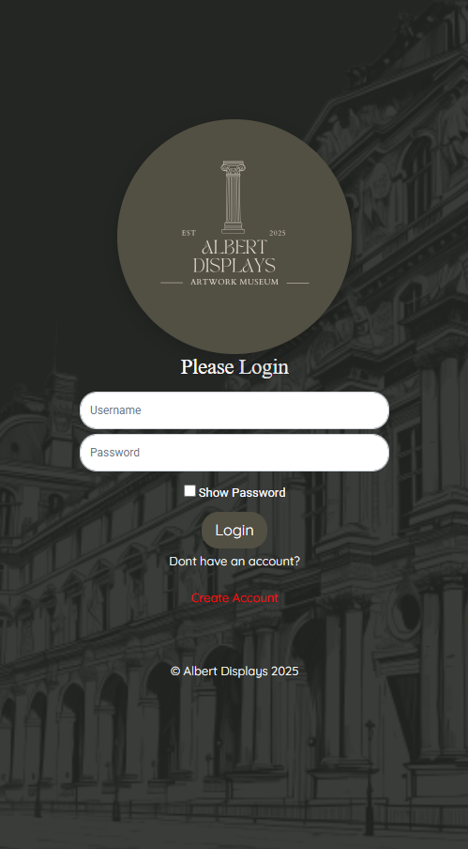
Figure 1 – login screen for users with an account or create one with the create account link

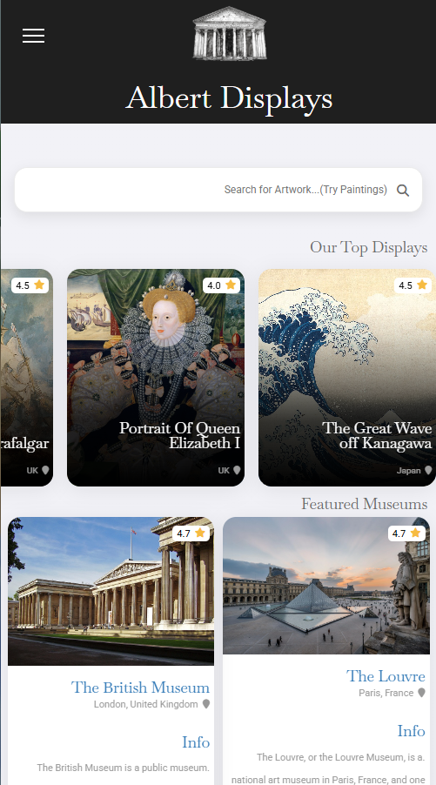
Figure 2 – Homepage with relevant images and information with the addition of a search bar
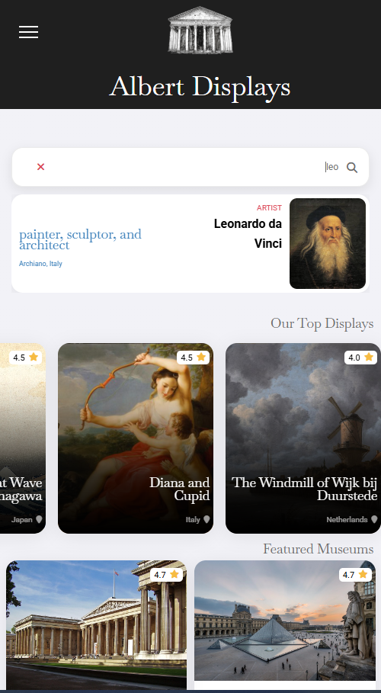
Figure 3 – Search any museums, artists, and artworks based on the presented and relevant material
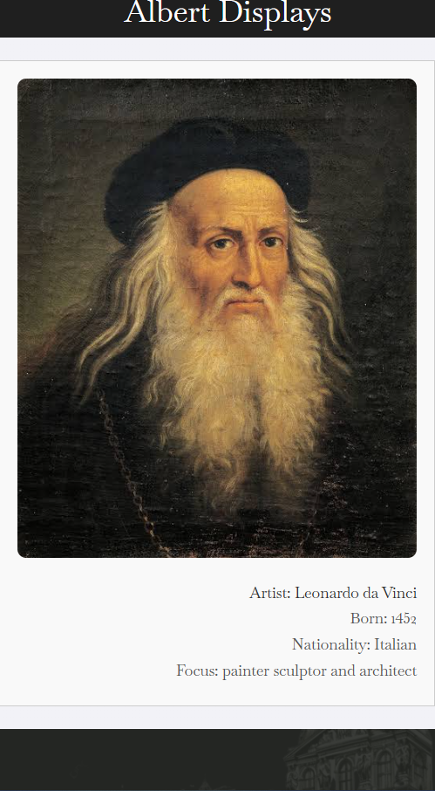
Figure 4 – When clicked on the searched item the user is sent to the relevant page with information
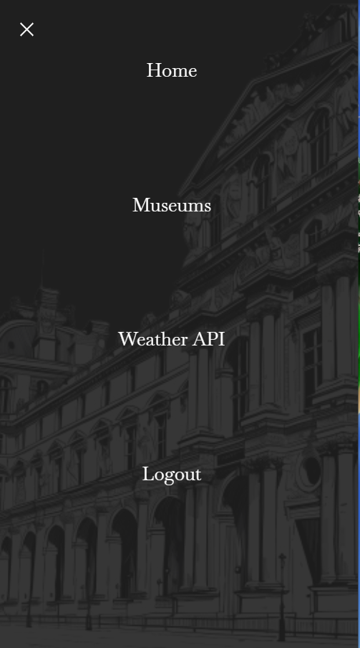
Figure 5 – On all pages there is a burger menu that the user can interact with to navigate the pages on the website
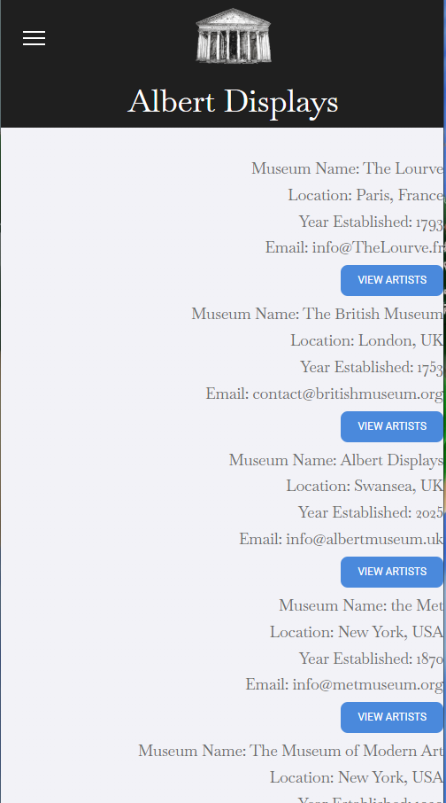
Figure 6 – This is what’s displayed in the museums page with a list of all the museums and the relevant artists
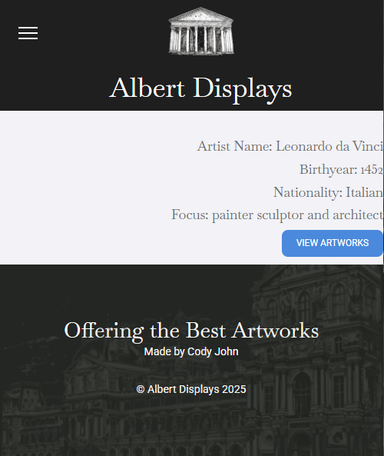
Figure 7 – Details of when an artist is viewed and button to view their artwork
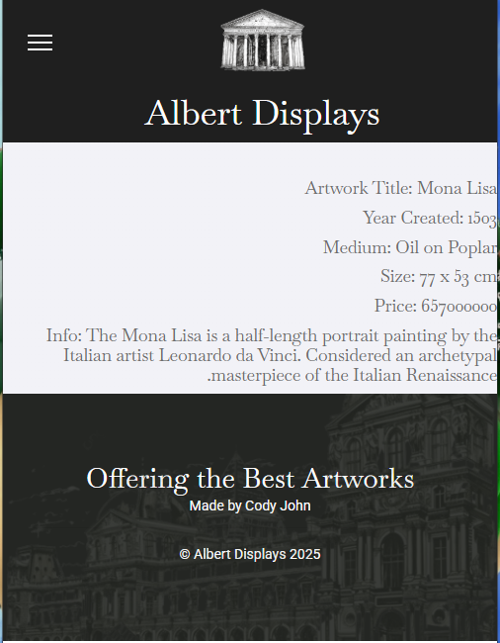
Figure 8 - Details of the artist artwork
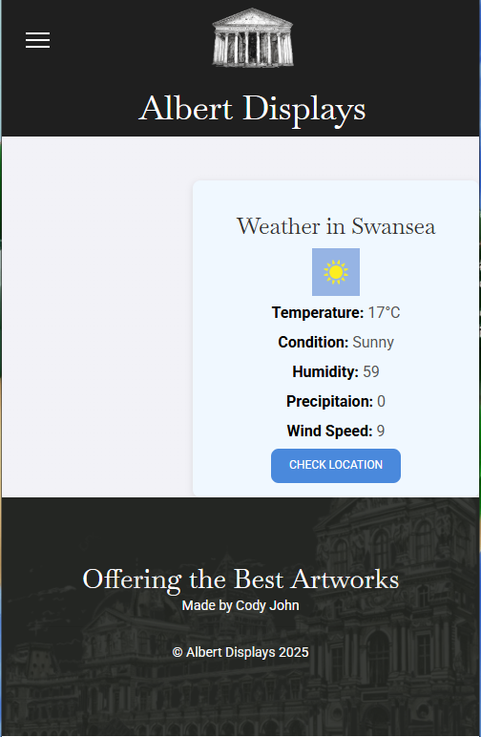
Figure 9 – Also, in the burger menu there is a weather API that reads the current weather

