Ben Brown – 2419961 – Cyber Security and Computing - L4 - Introduction to Web and Database Concepts (FT + PT students) (ACCA4023) – 14/11/25

Contents
Introduction 2
Requirements 2
Implementation 2
Evaluation 4
Website Usability and Its Role in Web Development 4
Usability's Role in Web Development 4
E-commerce Website 5
Usability of Mobile Web Pages 5
Website Accessibility and its role in web development 5
Study on web accessibility 6
Search engine optimisation and its role in web development 6
My Website Evaluation 7
Usefulness 7
Search Engine Optimisation (SEO) 7
Accessibility 7
Summary 7
Compare two websites (argos.co.uk, halfords.co.uk) 8
1. Usability 8
2. Accessibility 8
3. SEO (Search Engine Optimization) 9
4. Mobile Responsiveness 9
Conclusion: 10
References 11
Appendices 12

Introduction
For my website, I created a sportswear brand called “BB Sportswear”, selling clothing specifically aimed for the target audience of the health and fitness industry.

Requirements
A red and black theme for the website was introduced. Red and black portrays a light and dark contrast. This allows a sporty, yet professional theme, complimenting the aesthetic tailored to the brand. The website is specifically designed for sportswear only, with a niche target audience, that is invested in health and fitness. Having said this, the website still caters for all ages, as there are many different types of exercise, e.g bodybuilding, football, combat sports, rugby, that people can start at any age. This creates a widely varied target audience.

Implementation
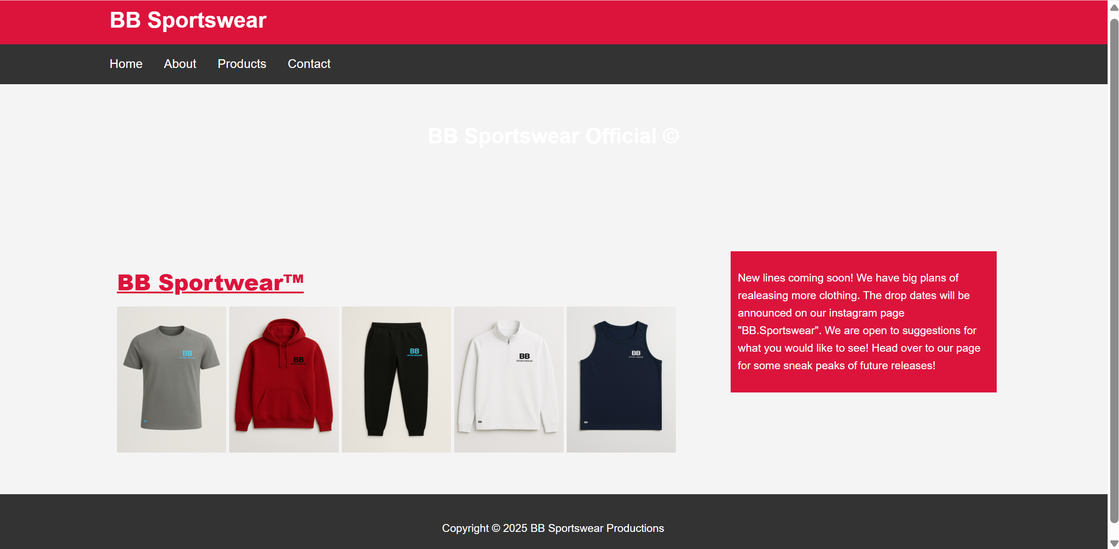
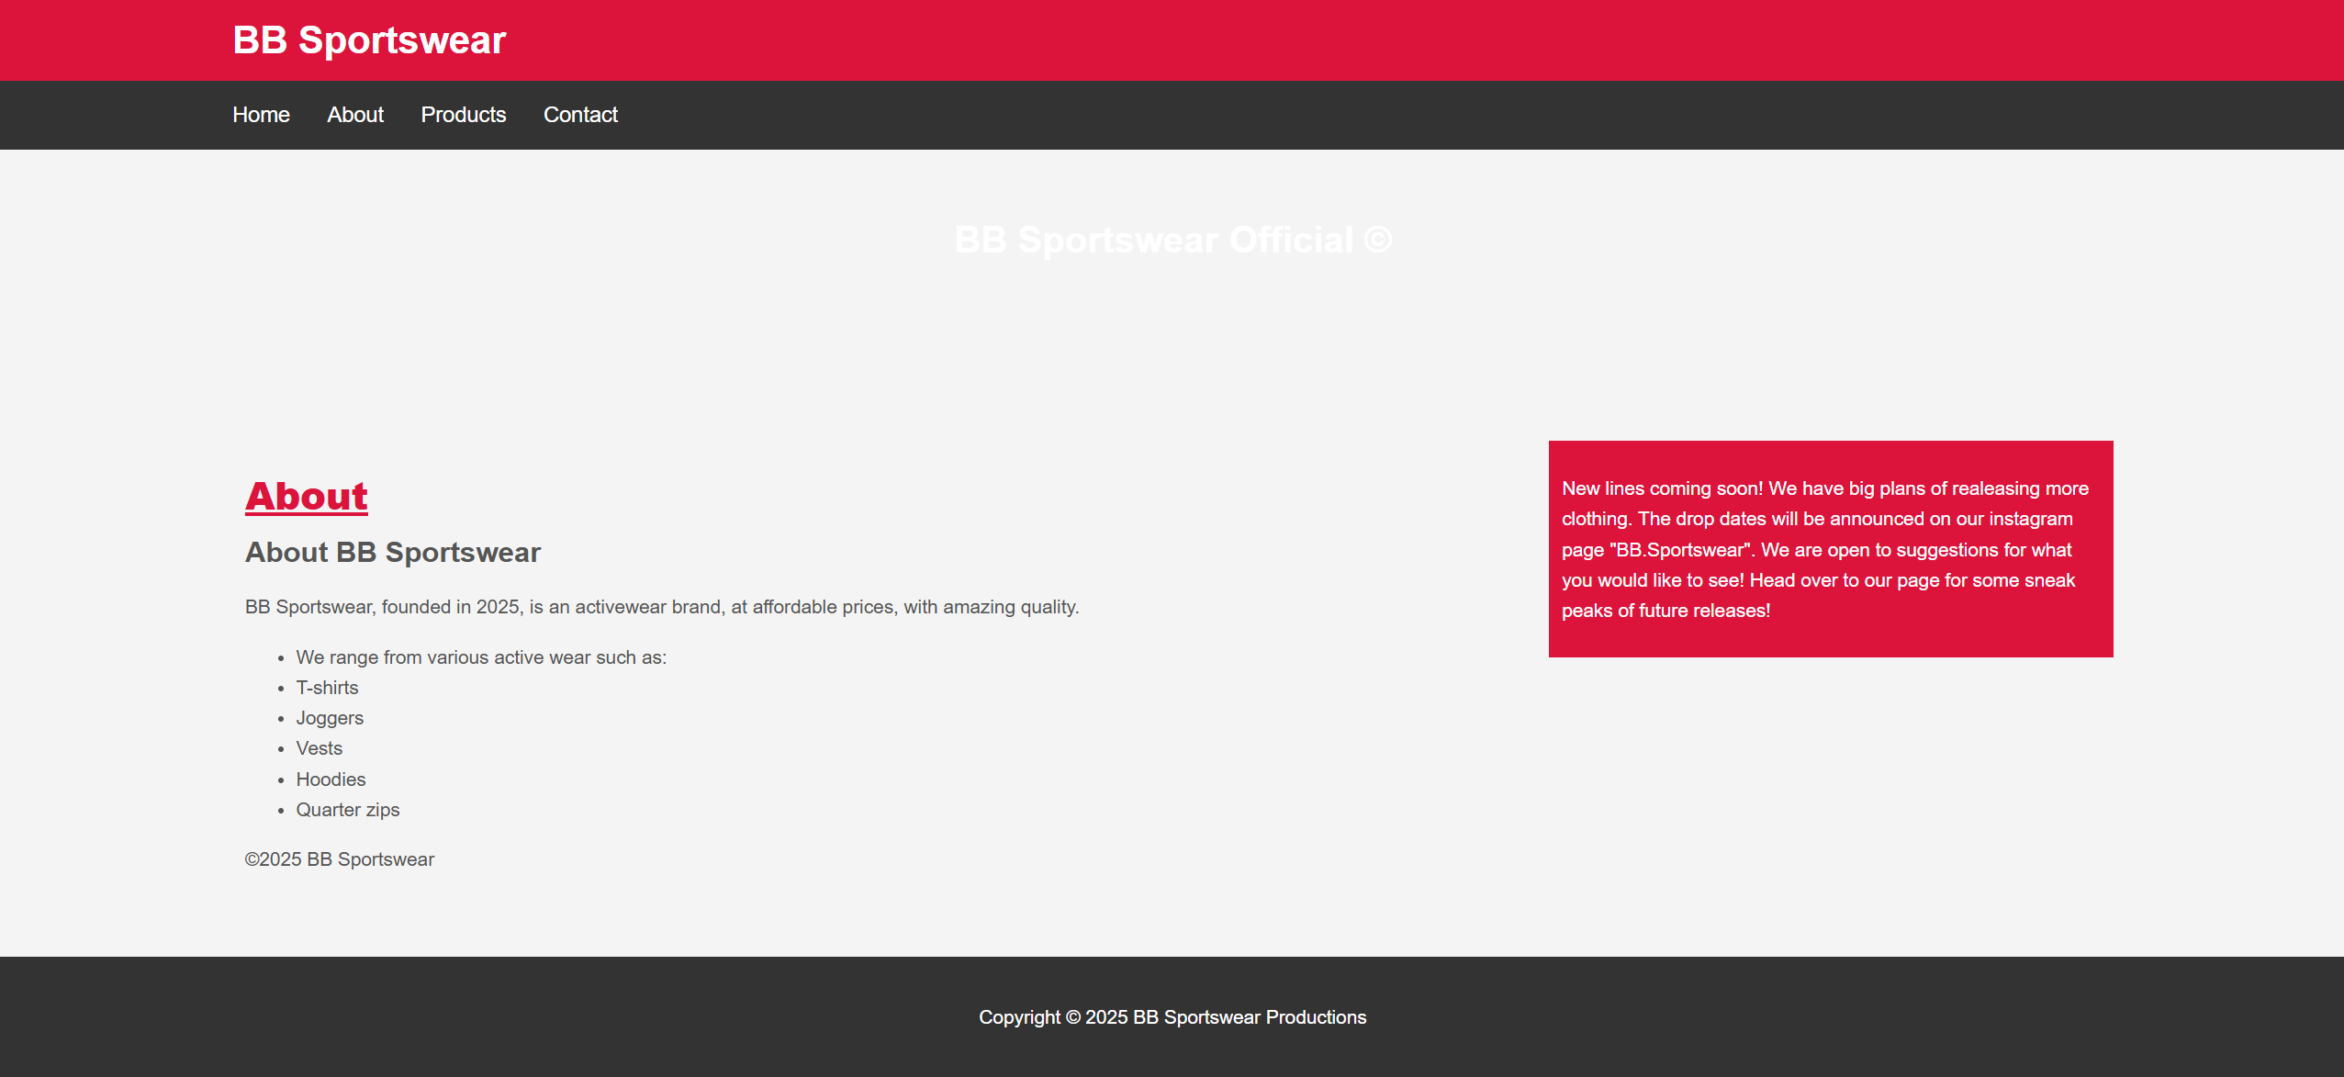
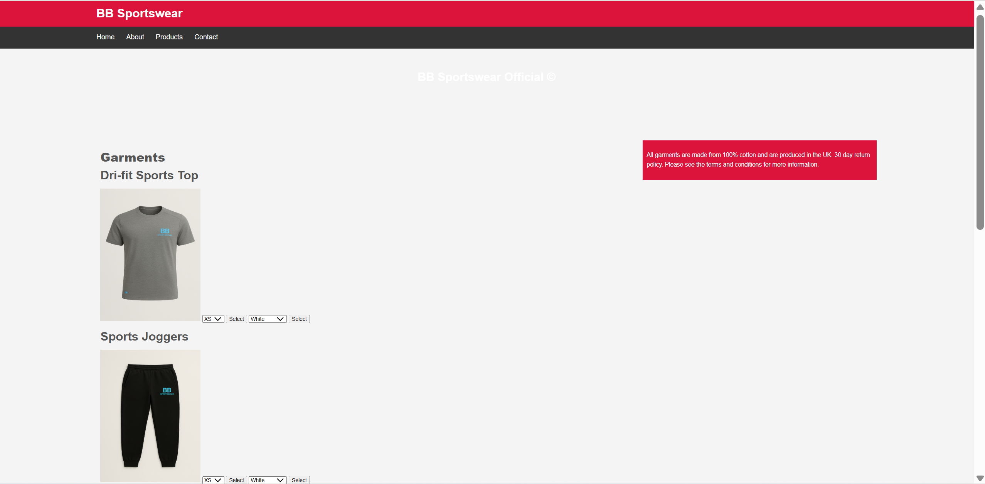
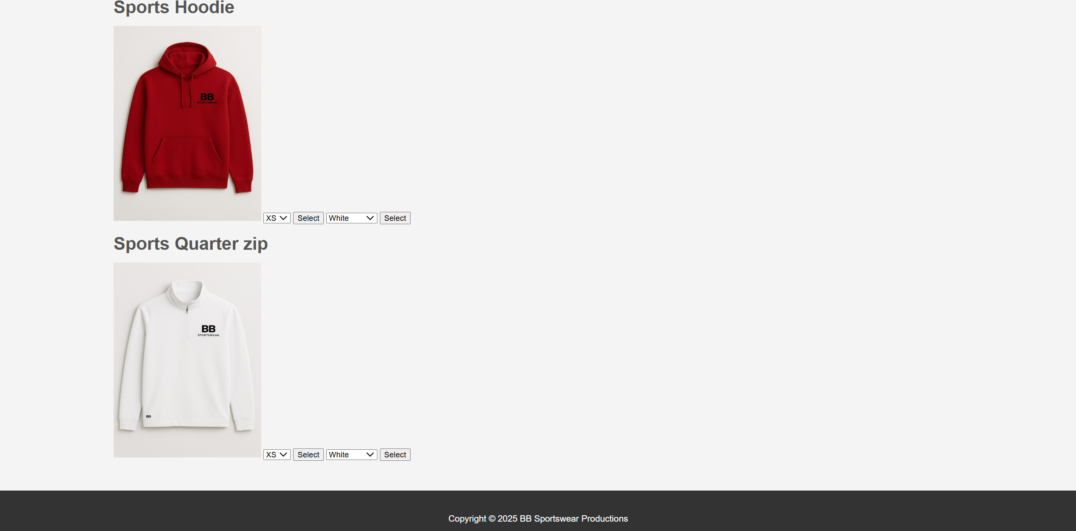
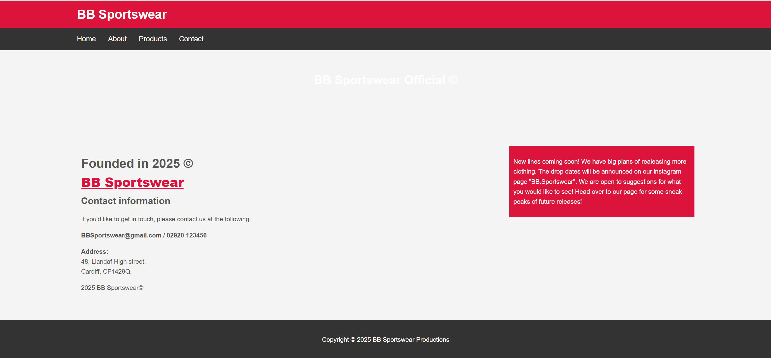

Evaluation

Website Usability and its Role in Web Development
“Website usability, often synonymous with web usability, refers to the ease with which a user can navigate and interact with a website.” [1] Among the important usability points are the following: Effectiveness: The level which users accomplish the required goals. “Efficiency: Efficiency focuses on the speed and ease with which users can achieve their goals after they’ve learned the system.” [2] Learnability: “Learnability measures how quickly a user can pick up on the interface and complete fundamental tasks when using it for the first time.” [2] All of these elements have an impact on user satisfaction, retention, and engagement - all of which are essential for a website to succeed. From design to functionality, usability is critical to the success of web development. A successful business will rely on a striking design to entice its intended audience in the first place. In turn, to retain this audience, successful functionality of the website is key. Improved SEO and better user experiences are made possible by usable websites. Making a website that is effective, accessible, and compatible requires incorporating usability testing into the development process.

Usability's Role in Web Development
Usability is very important throughout web development: User-centred design: “Human-centred design (HCD) aims to develop products, services and systems that are easy to use, meaningful and provide pleasure for people.” [3] Responsive and Accessible Design: Makes sure the website is usable by everyone, including those with disabilities, and functions properly on all devices. SEO Impact: Usability affects how easily users find information, which impacts search engine ratings. Cost Efficiency: Testing usability during development can prevent costly issues post development.

E-commerce Website
The study, "An Empirical Study on the Contribution of Usability to the Success of E-Commerce Websites" demonstrates how user satisfaction is impacted by usability, which includes design and navigation. It is stated that, "Without great design, comes no success." [4] Not having proper design and navigation can cause user frustration, due to not catering for all user abilities.

Usability of Mobile Web Pages
In the journal, "Usability Evaluation of Mobile Web Interfaces: A Systematic Review", mobile web interfaces are discussed. This review provides detailed usability evaluation techniques for mobile web interfaces, emphasising accessibility, speed, and responsiveness. It is mentioned that “formatting is essential towards mobile web usability” [5]. This shows the importance of formatting, as without this, web usability would not be compatible with mobile phones without issues.

Website Accessibility and its role in web development

Designing and creating websites that are accessible to individuals with disabilities such as those with visual, auditory, cognitive, neurological or motor impairments, allows those individuals to view, comprehend, navigate and engage with online content. By adhering to established standards such as the Web Content Accessibility Guidelines (WCAG), it is guaranteed that websites function well with assistive technologies (such as screen readers, voice navigation, and alternative input devices.)
Accessibility is important in web development for a number of reasons:
- Adherence to the law and ethics: According to laws like the EU Web Accessibility Directive, the ADA (US), and the Equality Act (UK), “many regions mandate WCAG-aligned accessibility.” [6]
- Inclusive user experience: This lessens confusion and frustration by guaranteeing that all users can finish tasks regardless of device or ability.
- Improved usability for users: Features that improve overall usability, such as keyboard navigation, appropriate contrast, captions, and clear format, benefit a larger audience.
- Business purpose: Accessible sites reach more customers/clients to improve the brands reputation.
- Better technical quality: Accessibility allows consistent navigation and semantic HTML with cleaner code, overall improving SEO, performance and maintainability throughout the website.

Study on web accessibility
A study on web accessibility, “Benchmarking Web Accessibility Evaluation Tools” by Vigo et al. (2013), concludes the effectiveness of automated accessibility metrics. It is stated that “Automated metrics alone are insufficient to capture the full extent of accessibility barriers encountered by users with disabilities.” [7] This study makes clear that although there are automated tool support developers, human-centred evaluation is still vital. Together, these imply that accessibility is a fundamental part of producing high-quality web development.

Search engine optimisation and its role in web development
This is the process of updating or maintaining a website in order to raise its ranking in search engine results pages is known as search engine optimisation, or SEO. The frequency of website interactions, user engagement and visibility are all increased by effective search engine optimisation. It entails alignment with search engine ranking algorithms, technical optimisation and high-quality content. Among the essential elements are: Technical SEO, which guarantees functional code, responsiveness on mobile devices, quick loading speeds, secure HTTPS, and organised data. Off-page SEO: Establishes credibility via backlinks, social signals, and reliable outside sources. On-page SEO: Enhances content with pertinent keywords, headings, metadata, and internal links to increase semantic HTML, relevance. Lastly, usability and user experience signals: this is where search engines are giving more weight to engagement, mobile usability, dwell time, and content clarity.

SEO influences development from the earliest stages. Developers structure HTML semantically, maintain logical navigation, optimise performance and ensure accessibility. These all contribute to a better search ranking. SEO also encourages continuous improvement: refining content, monitoring analytics and adapting to algorithm updates. A site built without SEO considerations can experience low visibility regardless of its functionality or design quality.
An SEO-related study is “In Google We Trust: Users’ Decisions on Search Results” by B. Pan et al., which describes and illustrates how to look at user behaviour and trust in relation to search result rankings. This demonstrates the importance of SEO-driven visibility. According to the study, "Users overwhelmingly trusted and selected higher-ranked results, even when lower-ranked results were objectively more relevant." [8] This emphasises the significance of SEO once more.
Overall, this study demonstrates that higher rankings significantly affect user behaviour, highlighting SEO’s key role in ensuring that websites are both competitive and discoverable.

My Website Evaluation

Usefulness
The website efficiently conveys the brand's offerings thanks to its user-friendly navigation and attractive product photos. However, there are no interactive product links visible and the large blank space beneath the header detracts from focus. The product photos could be more ‘clickable,’ include a banner or introduction and have obvious call-to-action buttons.
The design promotes usability with a straightforward layout and a consistent colour scheme. The layout could have slightly less whitespace, and some of the text (like "BB Sportswear Official") could have more contrast, though the navigation bar is clear. Readability could be improved by standardising the appearance more, reducing blank space and enhancing text contrast.

Search Engine Optimisation (SEO)
SEO, such as title tags and meta descriptions concise with keywords were included. An appropriate heading structure was utilised, using <h1>and <h2>. Images with descriptive alt text and internal linking through the navigation menu were also included.

Accessibility
Throughout the website, it is apparent that some text could have stronger contrast, though in terms of the navigation, it is correct. The dense text could be easier to read if it were to be broken up slightly. The labels were clear, but the dense text did obscure them somewhat. Standard HTML and CSS were used, but including ARIA (Accessible Rich Internet Application) labels for assistive technologies, alt text, and semantic structure would highly improve the professional look/feel of the website. Consistent contrast and spacing throughout all pages would also help the look.

Summary
The website has a solid foundation in branding, navigation and basic SEO. Enhancements in content clarity, usability (contrast and spacing), accessibility compliance and clearer calls-to-action will improve the overall user experience and professionalism.

Compare two websites (argos.co.uk, halfords.co.uk)
Both Argos.co.uk and Halfords.co.uk are popular UK brands with similarities in the product that they sell, being heavily DIY based. While both have similarities in the core functionality of their websites, they differ in areas such as usability, accessibility, SEO and mobile responsiveness.

1. Usability
Argos.co.uk:
Argos is renowned for its user-friendly, straightforward design. With a large search bar and clear call-to-actions, the homepage arranges categories ‘up front.’ Its click-and-collect service is the integral component of the shopping experience. According to M. Chaffey, "clear product categorisation and intuitive site architecture are essential for effective usability in e-commerce." [9] Websites like Argos and Halfords focus heavily on simplifying the purchasing flow, often using categories and filtering to guide users. However, because there are so many options and filters, some users may feel that the product pages are cluttered.
There is, however, clear navigation, a prominent search bar and a quick checkout, which are Argos’ strong points.

Halfords.co.uk:
Although it serves a more specialised market (cycling and automotive,) Halfords provides a comparable structure. Although the site does a good job of sorting products by type, the promotional content can make it seem visually overwhelming. "Too few promotions can impede engagement, while too many can overwhelm a site," continues Chaffey. [9] Halfords excels in its robust search capabilities in spite of this and there is good use of product filtering, also a useful search bar. However, the homepage, again, might appear overloaded with advertisements.

2. Accessibility
Argos.co.uk:
With WCAG compliance, alternative text for images and keyboard navigation, Argos offers a good accessible experience. According to L. Bateman, "Websites like Argos and Halfords need to ensure compliance with WCAG to provide inclusive experiences for all users."[10] Its mobile version, however, occasionally has text scaling problems that make it difficult to read on certain devices. Argos’ main strengths are the support for screen readers and WCAG compliance. Their main weakness would be the mobile text scaling problems.

Halfords.co.uk:
Some accessibility features on Halfords are not fully optimised, even though it supports keyboard navigation and basic screen reader compatibility. "E-commerce sites frequently struggle with accessibility due to varying quality of content provided by third-party suppliers," [10] Bateman continues. Inconsistent alt text and image descriptions make this apparent. Halfords’ strength overall is the basic accessibility support, whilst its weaknesses include inconsistent alt text and image descriptions.

3. SEO (Search Engine Optimization)
Argos.co.uk:
Argos’ SEO is excellent thanks to its schema markup, meta descriptions and keyword-rich product pages, which allow it to stand out in terms of search results. According to J. Patel, "Websites like Argos and Halfords leverage technical SEO and content marketing, but further implementation of structured data can be beneficial." [11] Its internal linking structure could be strengthened. The strengths overall are the quick load times, optimised content and schema markup, whilst its weaknesses include the deeper internal linking.
Halfords.co.uk:
Halfords also employs SEO best practices, emphasising blog posts and product descriptions. Patel points out that "SEO elements like structured data and internal links need more refinement." [11] For increased search visibility, Halfords could profit from better internal link development and schema markup usage. Its strengths overall are the useful blog posts and well-optimised content, with the overall weakness being that more well-structured data is required.

4. Mobile Responsiveness
Argos.co.uk:
Argos has a responsive layout, quick load times and a mobile-first design. Harris, K. and D. Li explain, "The success of e-commerce depends on mobile optimisation.” [12] Mobile-first design has been successfully prioritised by websites such as Argos. Although the site works well on smaller screens, users occasionally complain of ‘lag’ on mobile networks. Its overall strengths include a seamless experience and a mobile-friendly design. There is a weakness in that its mobile networks can occasionally ‘lag.’

Halfords.co.uk:
Halfords is mobile-responsive, though its performance could be smoother. On mobile devices, the filtering options that are convenient on desktop computers may feel clumsy. Although Halfords' mobile checkout process is optimised, Harris and Li add that "slow page load times and inefficient mobile navigation can reduce conversion rates on e-commerce sites." [12] Its strength is the simplified mobile checkout. There is a weakness in the slow load times and some problems with mobile navigation.

Conclusion:
Strong usability, accessibility, SEO and mobile responsiveness are features shared by Argos.co.uk and Halfords.co.uk. Halfords is notable for its extensive product filtering, whilst Argos is excellent at accessibility and user-friendly design. Both websites could use some work, especially in the areas of mobile navigation, SEO and internal linking, as supported by Harris and Li, who said, “Effective mobile optimization and continuous improvement of user experience are vital for remaining competitive in the growing e-commerce market.” [12]

References
[1] “Website Usability: The Ultimate Guide for 2024,” survicate.com. https://survicate.com/blog/website-usability/

[2] Izzath Isharah, “The Five Usability Components by Jakob Nielsen: Detailed Insights and Examples,” Medium, Nov. 20, 2024. https://medium.com/@iizzathisharah/the-five-usability-components-by-jakob-nielsen-detailed-insights-and-examples-90695af5ffb6

[3] K. Savolainen, “User-Centred Design without Involving Users: A Longitudinal Case Study in a Human-Centred-Design-Mature Company,” The Design journal, vol. 24, no. 6, pp. 887–905, 2021, doi: 10.1080/14606925.2021.1980267.

[4] Peralta, M. I., Garcia, J. F., & Garcia, J. A. The Role of Usability in E-commerce Websites' Success: An Empirical Study. Int. J. Hum.-Comput. Interact (pp. 34) 2018.

[5] Ghoneim, M. A., Khalil, A. T., & Ali, L. A. (2017). Usability Evaluation of Mobile Web Interfaces: A Systematic Review. In Proceedings of MDM (pp. 32-41) 2017.

[6] Government Digital Service, “Understanding WCAG 2.1,” GOV.UK, Oct. 10, 2018. https://www.gov.uk/service-manual/helping-people-to-use-your-service/understanding-wcag

[7] M. Vigo, J. Brown and V. Conway, “Benchmarking Web Accessibility Evaluation Tools: Measuring the Harm of Sole Reliance on Automated Tests,” Proceedings of the 10th International Cross-Disciplinary Conference on Web Accessibility (W4A), (pp. 1–10) 2013.

[8] B. Pan, H. A. Hembrooke, G. Gay, L. A. Granka, M. Feusner and J. K. Newman, “In Google We Trust: Users’ Decisions on Search Results,” Proceedings of the SIGCHI Conference on Human Factors in Computing Systems, (pp. 1027–1036) 2007.

[9] M. Chaffey, Digital Marketing: Strategy, Implementation, and Practice, 6th ed., Pearson Education, 2019.
[10] L. Bateman, Web Accessibility: Web Standards and Best Practices, 3rd ed., Wiley, 2020.
[11] J. Patel, SEO 2021: Learn Search Engine Optimization with Smart Internet Marketing Strategies, 10th ed., CreateSpace, 2021.
[12] K. Harris and D. Li, "Mobile Responsiveness in E-Commerce: Enhancing User Experience," Journal of Digital Commerce, vol. 22, no. 4, (pp. 45-50) 2022.

Appendices

<!DOCTYPE html>
<html>
<head>
<meta charset="utf-8" />
<title> BB Sportswear </title>
<link rel="stylesheet" type="text/css" href="home.css">
</head>

<body>
<header id="main-header">
<div class="container">
<h1> BB Sportswear</h1>
</div>
</header>
<nav id="navbar">
<div class="container">
<ul>
<li><a href="HOME PAGE TEST.html">Home</a></li>
<li><a href="ABOUT TEST.html">About</a></li>
<li><a href="OUR PRODUCTS TEST.html">Products</a></li>
<li><a href="CONTACT TEST.html">Contact</a></li>
</ul>
</div>
</nav>
<section id="showcase">
<div class="container">
<h1> BB Sportswear Official &copy; </h1>
</div>
</section>

<div class="container">
<section id="main">
<!DOCTYPE html>
<html lang="en">
<head>
<meta charset="UTF-8">
<meta name="viewport" content="width=device-width,initial-scale=1.0">
<title> Simple website</title>
<link rel="stylesheet" href="styles.css">
</head>
<body>
<header>
<h1 style="color:crimson"> <strong> <u> BB Sportwear&trade;</strong></u></h1>
<nav>

</nav>
</header>

<img src="images/Tshirt image.png" width="150" height="200"> <img src="images/hoodie bb.jpg" width="150" height="200"> <img src="images/joggers bb.png" width="150" height="200"> <img src="images/quarter zip bb.jpg" width="150" height="200"> <img src="images/vest bb.jpg" width="150" height="200">
</section>
<aside id="sidebar">
<p>New lines coming soon! We have big plans of realeasing more clothing. The drop dates will be announced on our instagram page "BB.Sportswear". We are open to suggestions for what you would like to see! Head over to our page for some sneak peaks of future releases! <p>
</aside>
</div>

<footer id="main-footer">
<p> Copyright &copy; 2025 BB Sportswear Productions </p>
</footer>
</body>
</html>

<!DOCTYPE html>
<html>
<head>
<meta charset="utf-8" />
<title> BB Sportswear </title>
<link rel="stylesheet" type="text/css" href="home.css">
</head>

<body>
<header id="main-header">
<div class="container">
<h1> BB Sportswear</h1>
</div>
</header>
<nav id="navbar">
<div class="container">
<ul>
<li><a href="HOME PAGE TEST.html">Home</a></li>
<li><a href="ABOUT TEST.html">About</a></li>
<li><a href="OUR PRODUCTS TEST.html">Products</a></li>
<li><a href="CONTACT TEST.html">Contact</a></li>
</ul>
</div>
</nav>
<section id="showcase">
<div class="container">
<h1> BB Sportswear Official &copy; </h1>
</div>
</section>

<div class="container">
<section id="main">
<h1><strong>Garments</strong></h1>
<h1> Dri-fit Sports Top</h1>
<img src="images/Tshirt image.png" alt="BB Sportswear tshirt" width="250" height="330">
<body>
<select id ="Size" >
<option value="XS">XS</option>
<option value="S">S</option>
<option value="M">M</option>
<option value="L">L</option>
<option value="XL">XL</option>

</select>
<button onclick="getValue();">Select</button>

<script type="text/javascript">
function getValue() {
var value = document.getElementById('Size').value;
alert(value);
}
</script>

<body>
<select id ="Colour" >
<option value="White">White</option>
<option value="Grey">Grey</option>
<option value="Black">Black</option>
<option value="Light blue">Light blue</option>
<option value="Red">Red</option>

</select>
<button onclick="getValue();">Select</button>

<script type="text/javascript">
function getValue() {
var value = document.getElementById('Colour').value;
alert(value);
}
</script>

<h1>Sports Joggers</h1>
<img src="images/joggers bb.png" alt="BB Sportswear joggers" width="250" height="330">

</body>
</html>

<body>
<select id ="Size" >
<option value="XS">XS</option>
<option value="S">S</option>
<option value="M">M</option>
<option value="L">L</option>
<option value="XL">XL</option>

</select>
<button onclick="getValue();">Select</button>

<script type="text/javascript">
function getValue() {
var value = document.getElementById('Size').value;
alert(value);
}
</script>

<body>
<select id ="Colour" >
<option value="White">White</option>
<option value="Grey">Grey</option>
<option value="Black">Black</option>
<option value="Light blue">Light blue</option>
<option value="Red">Red</option>

</select>
<button onclick="getValue();">Select</button>

<script type="text/javascript">
function getValue() {
var value = document.getElementById('Colour').value;
alert(value);
}
</script>

</head>
<body>

<h1>Sports Vest</h1>
<img src="images/vest bb.jpg" alt="BB Sportswear vest" width="250" height="330">

</body>
</html>

<body>
<select id ="Size" >
<option value="XS">XS</option>
<option value="S">S</option>
<option value="M">M</option>
<option value="L">L</option>
<option value="XL">XL</option>

</select>
<button onclick="getValue();">Select</button>

<script type="text/javascript">
function getValue() {
var value = document.getElementById('Size').value;
alert(value);
}
</script>

<body>
<select id ="Colour" >
<option value="White">White</option>
<option value="Grey">Grey</option>
<option value="Black">Black</option>
<option value="Light blue">Light blue</option>
<option value="Red">Red</option>

</select>
<button onclick="getValue();">Select</button>

<script type="text/javascript">
function getValue() {
var value = document.getElementById('Colour').value;
alert(value);
}
</script>

</head>
<body>

<h1>Sports Hoodie</h1>
<img src="images/hoodie bb.jpg" alt="BB Sportswear hoodie" width="250" height="330">

</body>
</html>

<body>
<select id ="Size" >
<option value="XS">XS</option>
<option value="S">S</option>
<option value="M">M</option>
<option value="L">L</option>
<option value="XL">XL</option>

</select>
<button onclick="getValue();">Select</button>

<script type="text/javascript">
function getValue() {
var value = document.getElementById('Size').value;
alert(value);
}
</script>

<body>
<select id ="Colour" >
<option value="White">White</option>
<option value="Grey">Grey</option>
<option value="Black">Black</option>
<option value="Light blue">Light blue</option>
<option value="Red">Red</option>

</select>
<button onclick="getValue();">Select</button>

<script type="text/javascript">
function getValue() {
var value = document.getElementById('Colour').value;
alert(value);
}
</script>

</head>
<body>

<h1>Sports Quarter zip</h1>
<img src="images/quarter zip bb.jpg" alt="BB Sportswear quarter zip" width="250" height="330">

</body>
</html>

<body>
<select id ="Size" >
<option value="XS">XS</option>
<option value="S">S</option>
<option value="M">M</option>
<option value="L">L</option>
<option value="XL">XL</option>

</select>
<button onclick="getValue();">Select</button>

<script type="text/javascript">
function getValue() {
var value = document.getElementById('Size').value;
alert(value);
}
</script>

<body>
<select id ="Colour" >
<option value="White">White</option>
<option value="Grey">Grey</option>
<option value="Black">Black</option>
<option value="Light blue">Light blue</option>
<option value="Red">Red</option>

</select>
<button onclick="getValue();">Select</button>

<script type="text/javascript">
function getValue() {
var value = document.getElementById('Colour').value;
alert(value);
}
</script>

</head>
<body>

</head>
<body>
</section>
<aside id="sidebar">
<p>All garments are made from 100% cotton and are produced in the UK. 30 day return policy. Please see the terms and conditions for more information. <p>
</aside>
</div>

<footer id="main-footer">
<p> Copyright &copy; 2025 BB Sportswear Productions </p>
</footer>
</body>
</html>

<!DOCTYPE html>
<html>
<head>
<meta charset="utf-8" />
<title> BB Sportswear </title>
<link rel="stylesheet" type="text/css" href="home.css">
</head>

<body>
<header id="main-header">
<div class="container">
<h1> BB Sportswear</h1>
</div>
</header>
<nav id="navbar">
<div class="container">
<ul>
<li><a href="HOME PAGE TEST.html">Home</a></li>
<li><a href="ABOUT TEST.html">About</a></li>
<li><a href="OUR PRODUCTS TEST.html">Products</a></li>
<li><a href="CONTACT TEST.html">Contact</a></li>
</ul>
</div>
</nav>
<section id="showcase">
<div class="container">
<h1> BB Sportswear Official &copy; </h1>
</div>
</section>

<div class="container">
<section id="main">

<!DOCTYPE html>
<html lang="en">
<head>
<meta charset="UTF-8">
<meta name="viewport" content="width=device-width,initial-scale=1.0">
<title> Simple website</title>
<link rel="stylesheet" href="styles.css">
</head>
<body>
<header>
<h1 style="color:crimson"><strong><u>About</strong></u></h1>
<nav>

</nav>
</header>
<main>
<h2> About BB Sportswear </h2>
<p> BB Sportswear, founded in 2025, is an activewear brand, at affordable prices, with amazing quality.</p>
<ul>
<li>We range from various active wear such as:</li>
<li>T-shirts</li>
<li>Joggers</li>
<li>Vests</li>
<li>Hoodies</li>
<li>Quarter zips</li>
</ul>
</main>
<footer>
<p>&copy;2025 BB Sportswear </p>
</footer>
</body>
</html>
</section>
<aside id="sidebar">
<p>New lines coming soon! We have big plans of realeasing more clothing. The drop dates will be announced on our instagram page "BB.Sportswear". We are open to suggestions for what you would like to see! Head over to our page for some sneak peaks of future releases! <p>
</aside>
</div>

<footer id="main-footer">
<p> Copyright &copy; 2025 BB Sportswear Productions </p>
</footer>
</body>
</html>

<!DOCTYPE html>
<html>
<head>
<meta charset="utf-8" />
<title> BB Sportswear </title>
<link rel="stylesheet" type="text/css" href="home.css">
</head>

<body>
<header id="main-header">
<div class="container">
<h1> BB Sportswear</h1>
</div>
</header>
<nav id="navbar">
<div class="container">
<ul>
<li><a href="HOME PAGE TEST.html">Home</a></li>
<li><a href="ABOUT TEST.html">About</a></li>
<li><a href="OUR PRODUCTS TEST.html">Products</a></li>
<li><a href="CONTACT TEST.html">Contact</a></li>
</ul>
</div>
</nav>
<section id="showcase">
<div class="container">
<h1> BB Sportswear Official &copy; </h1>
</div>
</section>

<div class="container">
<section id="main">
<h1>Founded in 2025 &copy;</h1>
<!DOCTYPE html>
<html lang="en">
<head>
<meta charset="UTF-8">
<meta name="viewport" content="width=device-width,initial-scale=1.0">
<title> Simple HTML</title>
<link rel="stylesheet" href="styles.css">
</head>
<body>

<main>
<h1 style="color:crimson"><strong><u>BB Sportswear</strong> </u>
<nav>

</nav>
</header>

<h2> Contact information </h2>
<p>If you'd like to get in touch, please contact us at the following:</p>
<p><strong>BBSportswear@gmail.com / 02920 123456</strong></p>
<p><strong> Address:</strong><br>
48, Llandaf High street, <br>
Cardiff, CF1429Q,<br>
</p>
</main>
<footer>
<p>2025 BB Sportswear&copy; </p>
</footer>
</body>
</html>
</section>
<aside id="sidebar">
<p>New lines coming soon! We have big plans of realeasing more clothing. The drop dates will be announced on our instagram page "BB.Sportswear". We are open to suggestions for what you would like to see! Head over to our page for some sneak peaks of future releases! <p>
</aside>
</div>

<footer id="main-footer">
<p> Copyright &copy; 2025 BB Sportswear Productions </p>
</footer>
</body>
</html>

body{
background-color:#f4f4f4;
color:#555;
font-family:Arial, Helvetica, san-serif;
font-size:15px;
line-height:1.6em;
margin:0;
}

.container{
width:80%;
margin:auto;
overflow:hidden;
}
#main-header{
background-color:crimson;
color:#fff;
}

#navbar{
background-color:#333;
color:#fff;
}

#navbar ul{
padding:0;
list-style:none;
}
#navbar li{
display:inline;
}
#navbar a{
font-size:17px;
padding-right:25px;
}
a{
color:white;
text-decoration:none;
}
a:hover{
color:crimson;
}

#main-footer{
background-color:#333;
color:#fff;
text-align:center;
padding:20px;
margin-top:40px;
}
#main{
float:left;
width:70%;
padding:10px;
box-sizing:border-box;
}
#sidebar{
float:right;
width:30%;
background-color:crimson;
color:#fff;
padding:10px;
box-sizing:border-box;
}
#showcase{
background-image:url("splash_cr.jpg");
background-size:1280px;
opacity:1.0;
background-position:center right;
min-height:200px;
margin-bottom:29px;
text-align:center;
}
#showcase h1{
color:white;
font-size:29px;
line-height:1.6;
padding:29px;
}
@media (max-width:600px) {
#main{
width:100%;
float:none;
}

#sidebar{
width:100%;
float:none;
}

#navbar li{
display:block;
}
}

