Bartosz Galantowicz
Studen number : 1700994
Computer Systems
“Creating a Network of Virtual Machines using Oracle VirtualBox and Windows Networking”
PROF JOHN REES

The Report
- I started to set up my first Virtual Machine by choosing the name and selecting the type of operating system. The operating systems I choose for the virtual servers were Windows 2008(64-bit) and for the virtual clients Windows 7(64-bit).
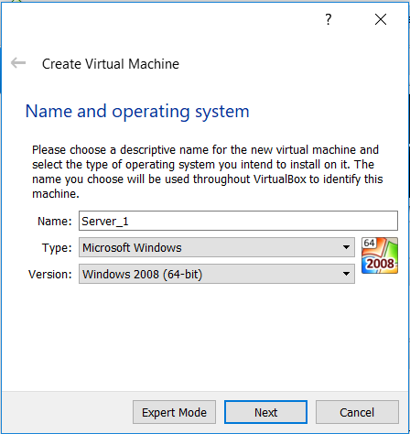
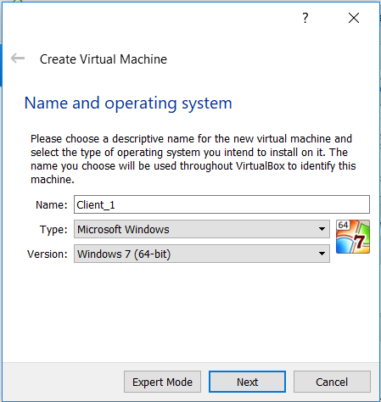
- To creating the Virtual Machine, it is required to allocate some memory (RAM) and space for the virtual hard disk, so I did it for each server and client – 4096 MB of RAM and 20GB of hard disk space.
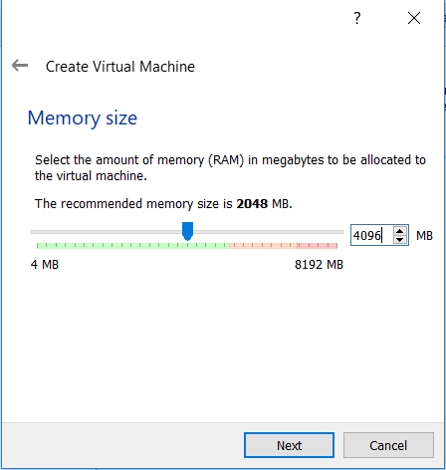
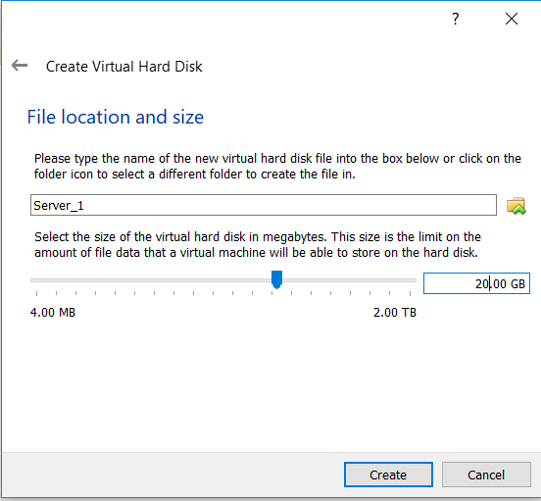

- After creating the virtual machines, I have set up the settings for them. Firstly, I have created two network adapters for Server 1, naming them PublicNet and PrivateNet1.
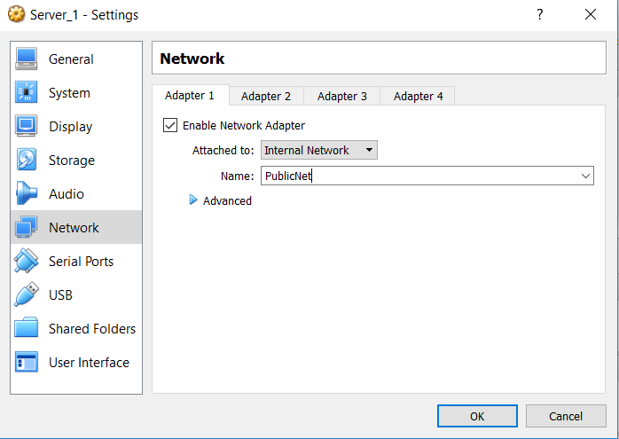
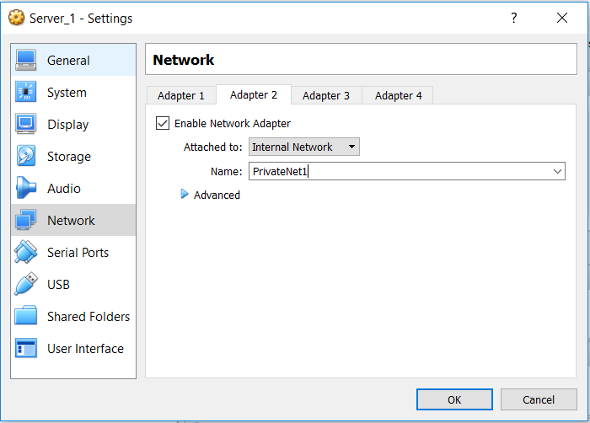
- The system settings which I provided for the virtual machines are the same for each.
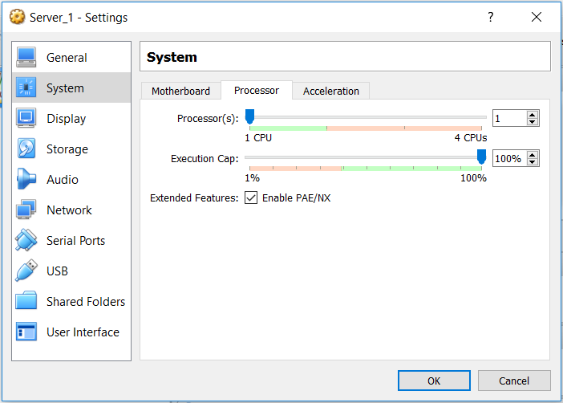
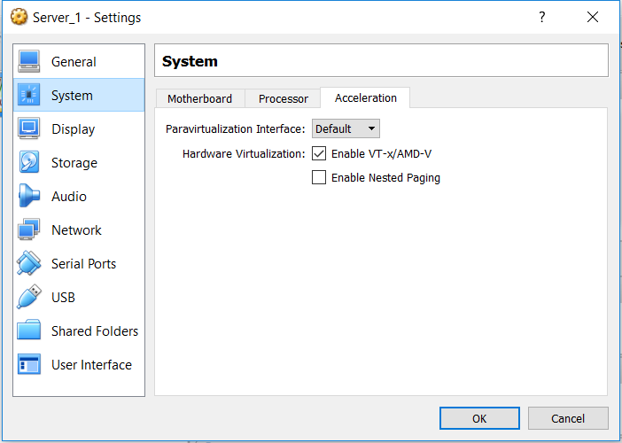

- Using the storage setting, I have managed to install the operating system for servers and clients from pre-downloaded disk images of the operating systems.
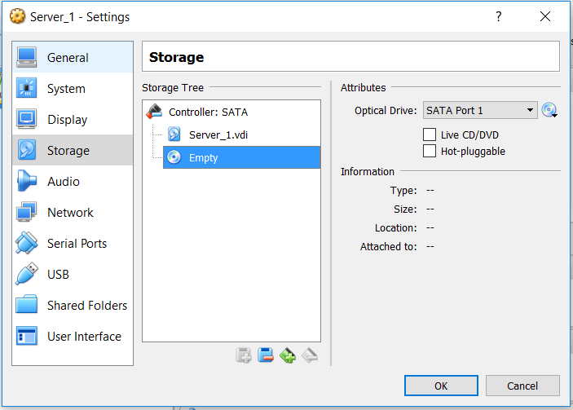

- For servers, I have installed Windows 2008 as the operating system.
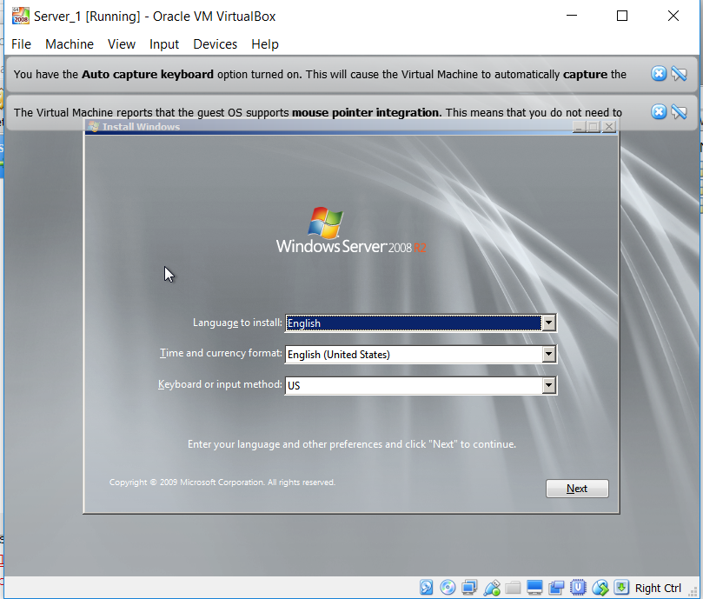
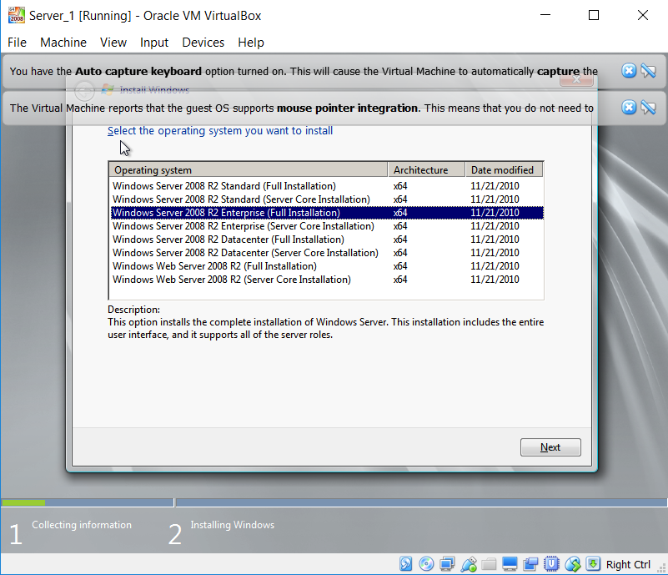

- When installation had ended, I have created the Administrator password for each server.
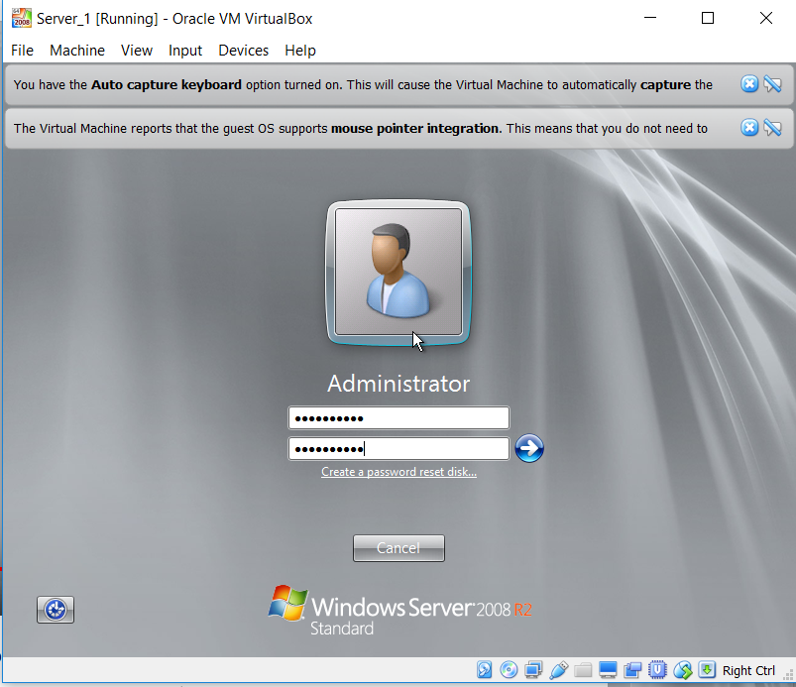

- The process of creating virtual machines for clients is very similar to the process of creating servers. The only exceptions were to give a name Client_1 for my virtual machines and choose the proper version of Windows 7.
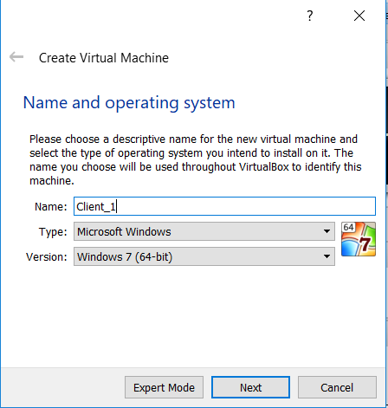
- For virtual clients, I defined network adapters, one for each client.
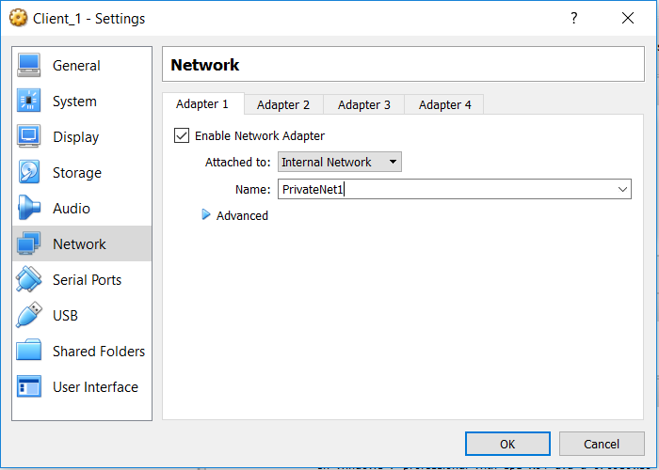

- I have set up the system settings for virtual clients the same as I had done it for the virtual server and then I mounted Windows 7 disk image which was needed to install the operating system for the clients.
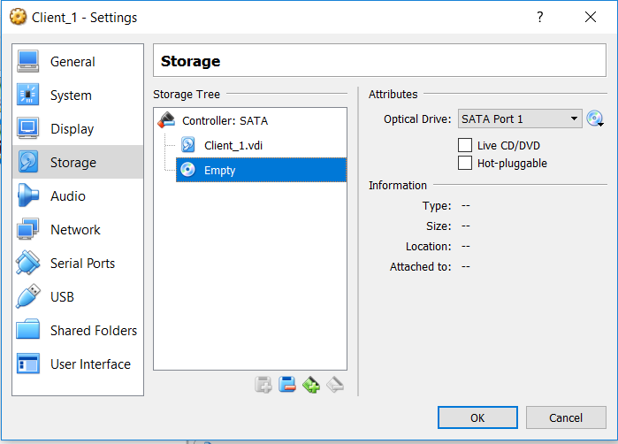
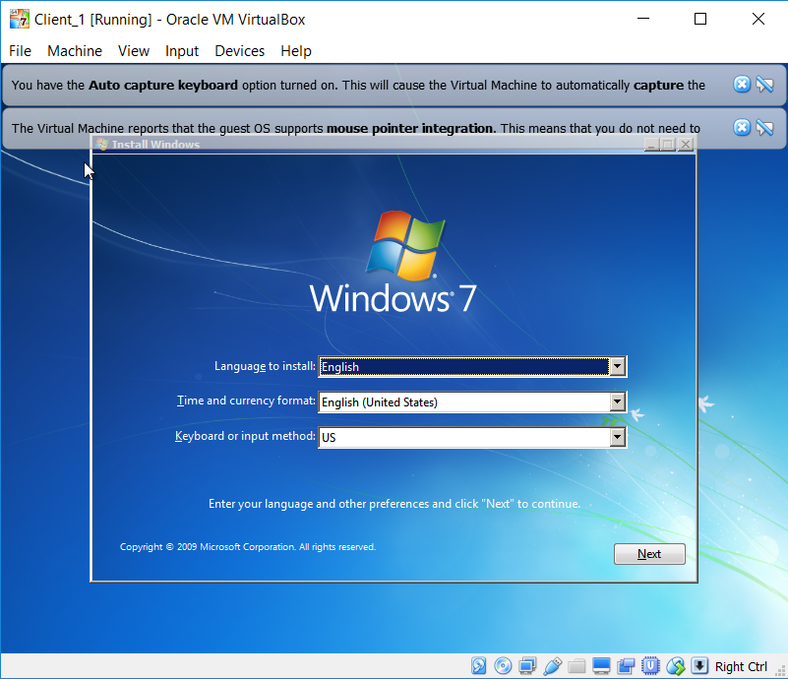

- After installation of the operating system on Server 1 I configured the networking settings. Firstly, I renamed my first adapter “Publicnetwork”, then I was able to assign the IP address by setting IPv4 properties.
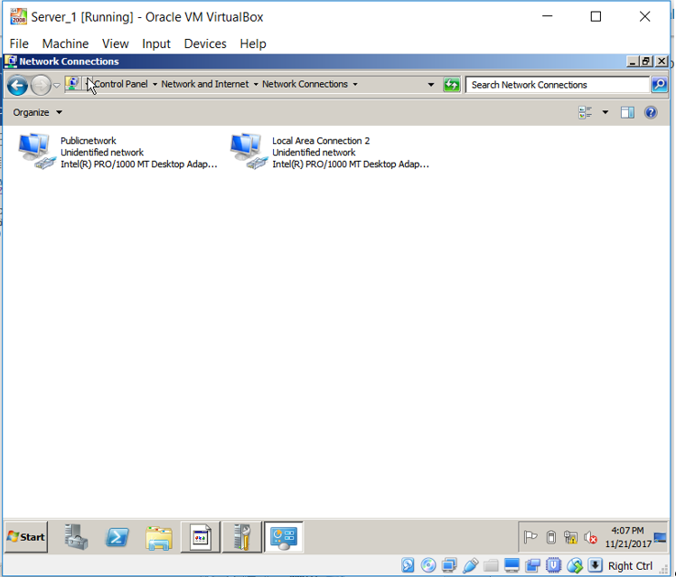
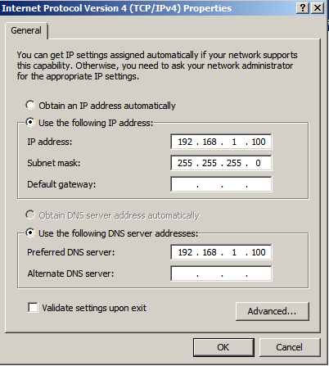
- To allow Server 1 to work correctly, I turned off the firewall.
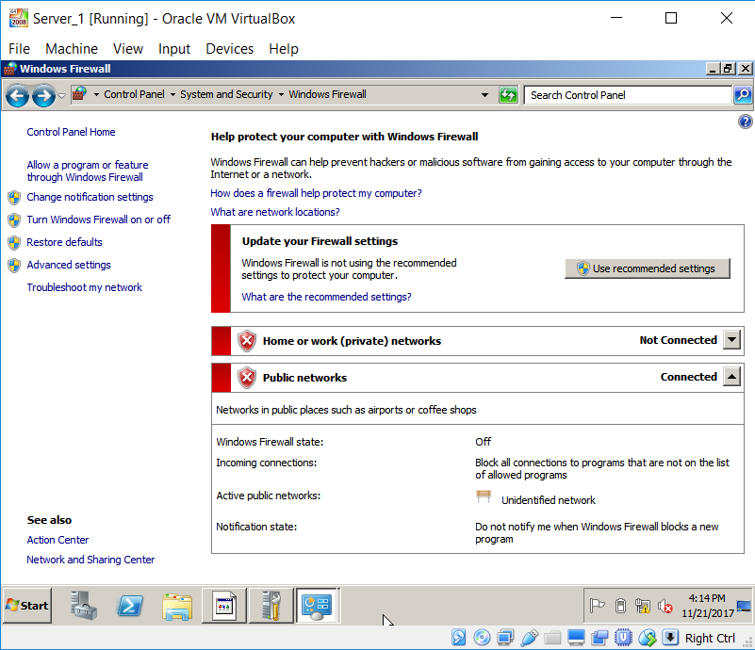
- In VirtualBox, I have used the virtual switch name “privatenetswitch1” to rename the name of the Adapter 2.
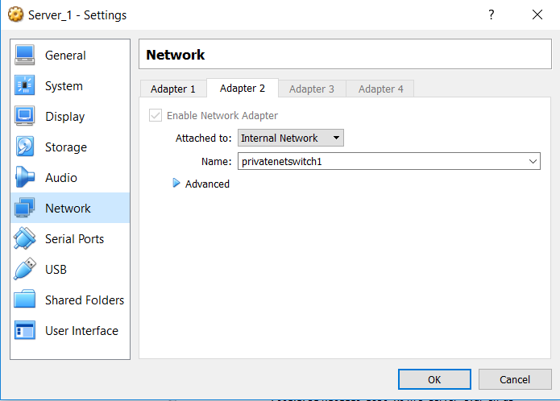
- I changed the name of the second adapter to “privatenet1” in the Server 1 virtual machine, and I configured the IP for this adapter.
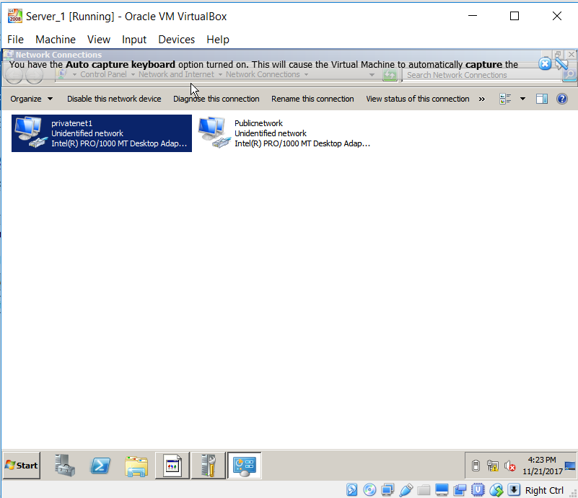
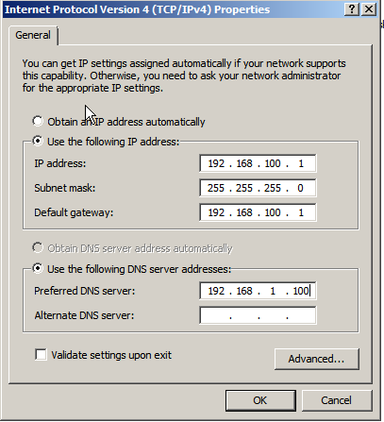
- For Client 1, I connected the renamed adapter “privatenet1” to "Publicnetwork" by configuring IPv4 Properties.
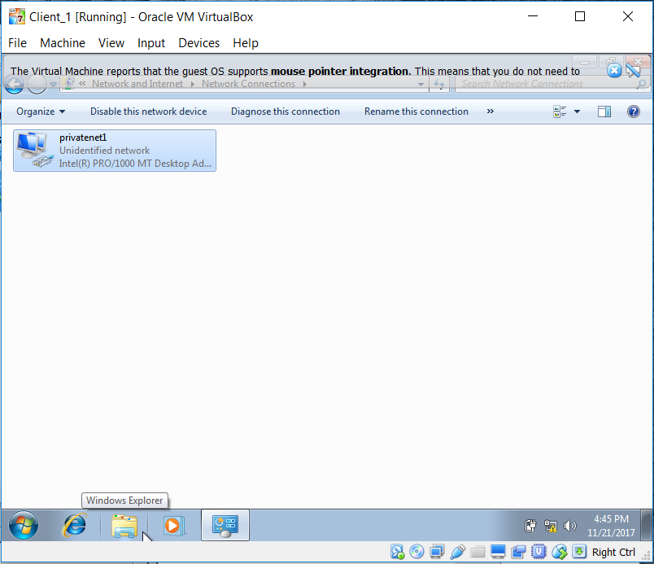
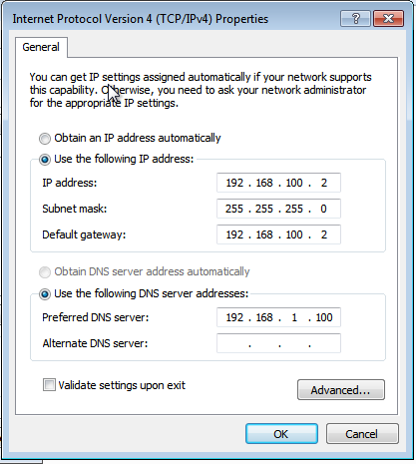
- I have turned off the firewall of Client 1.
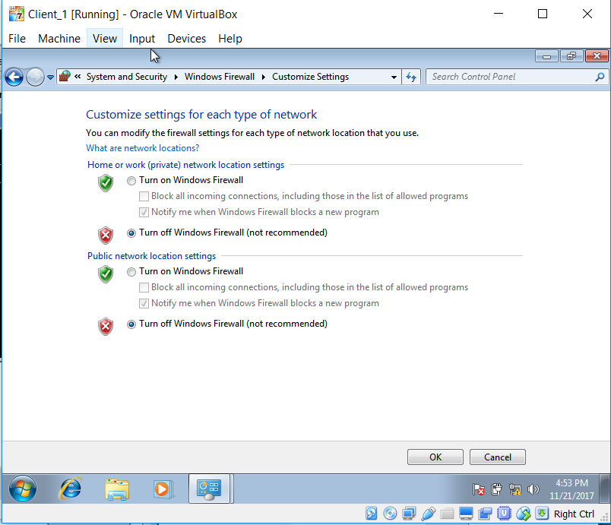
- In VirtualBox, I put the switch name “privatenetswitch1” as a name of the Adapter 1 of Client 1.
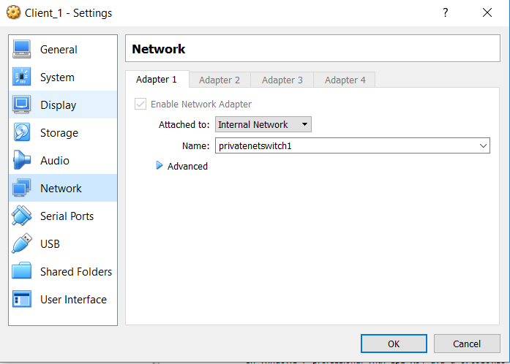
- By using the ping command, I was able to verify that Client 1 is connected to Server 1.
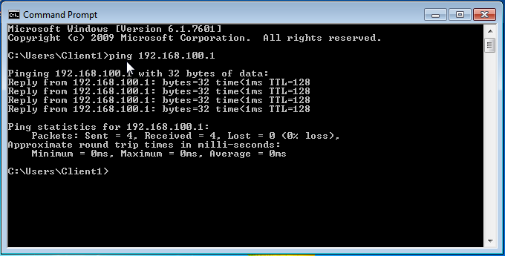

- The network connection between Server 1 and Client 1 was obtained. Therefore I managed to create a domain. I started by adding the Active Directory Domain Service Role.
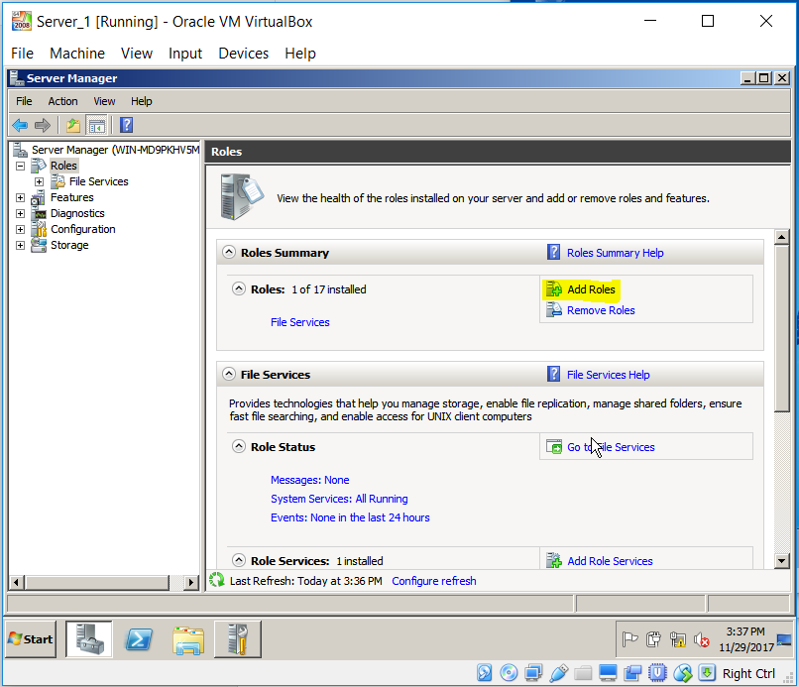
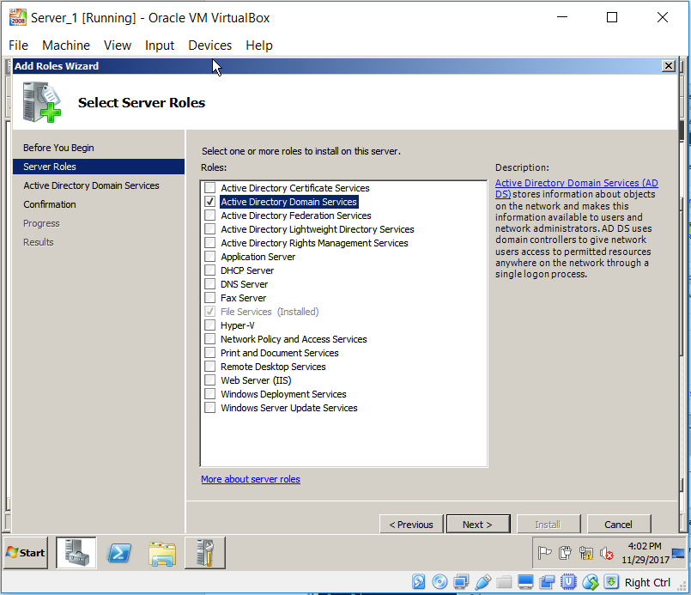
- Another step was to run the dcpromo and installation an Active Directory Domain. I called my domain “uwtsd.com” and assigned the administrator password.
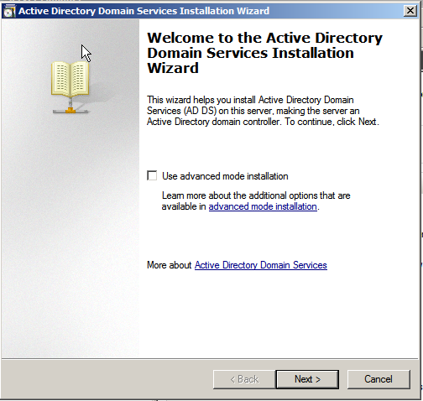
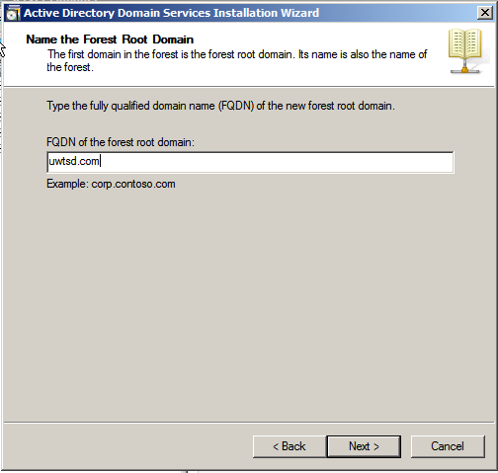
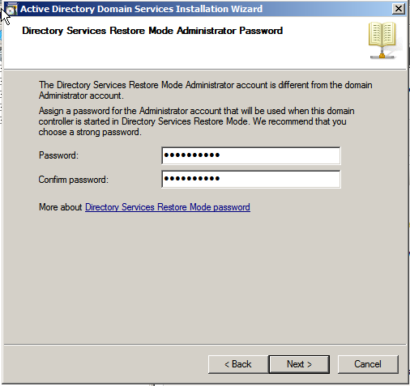
- When the installation had finished, and I rebooted the system and logged into the domain controller, the domain was visible and could be found in Server Manager.
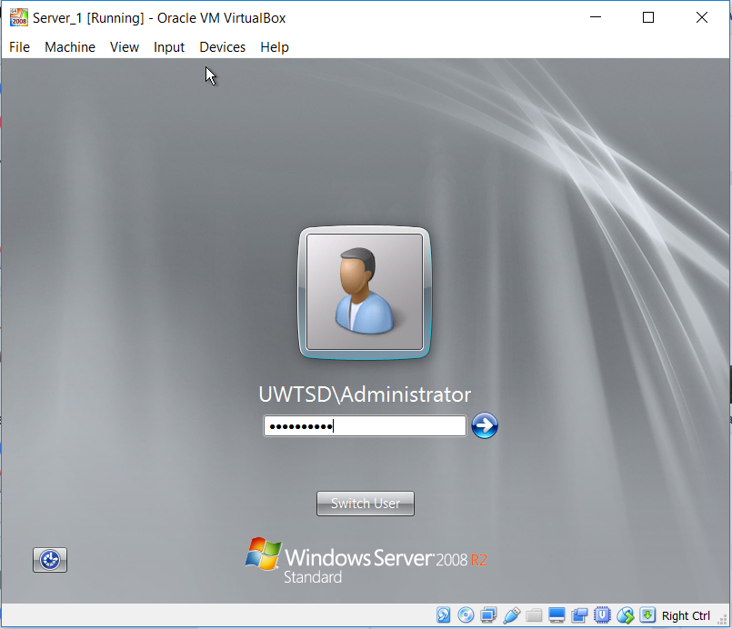
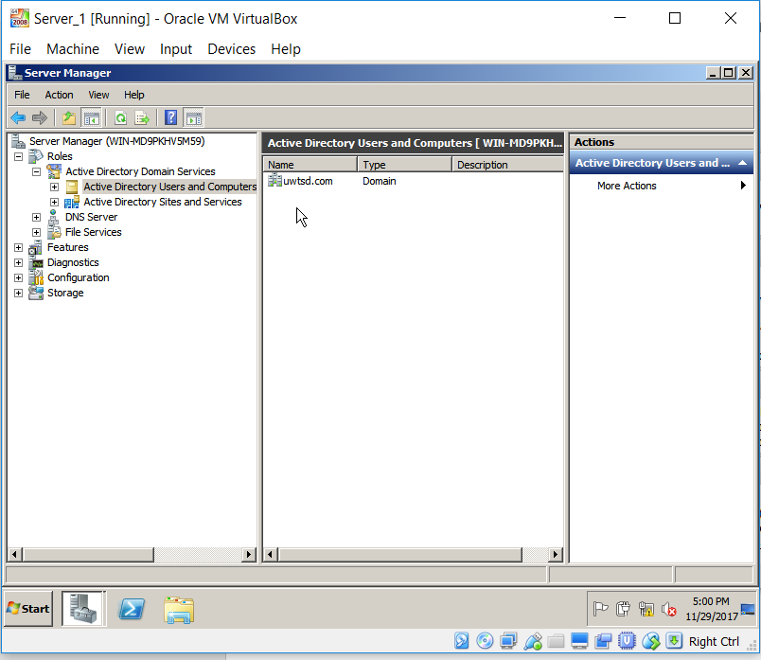

- Next, I have added the client computer to the domain.
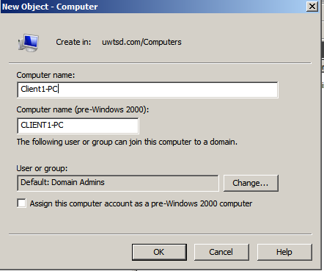
- To connect Client 1 to the domain, I had had to type the name of my domain in advanced system settings of Client 1, and after that, I authenticated the operation using the details of my Administrator account.
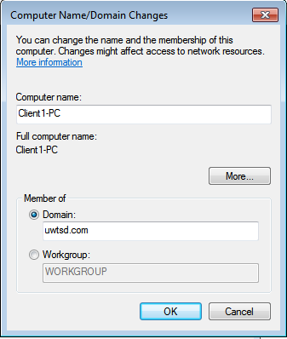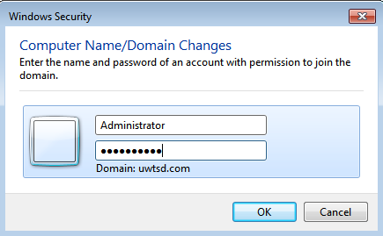
- Client 1 has been connected to the domain.
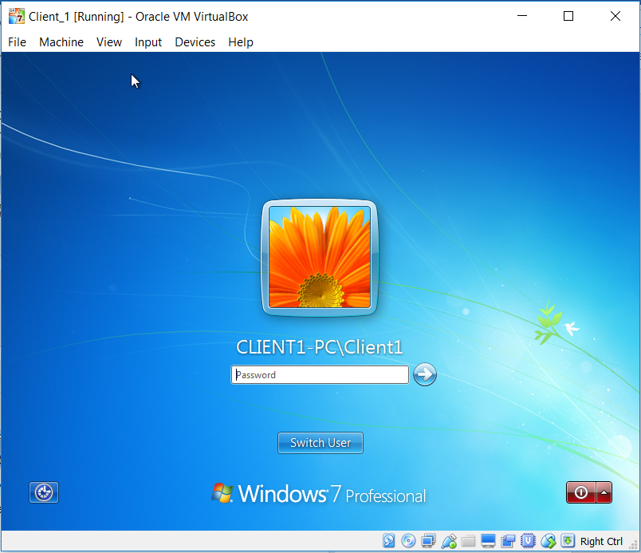
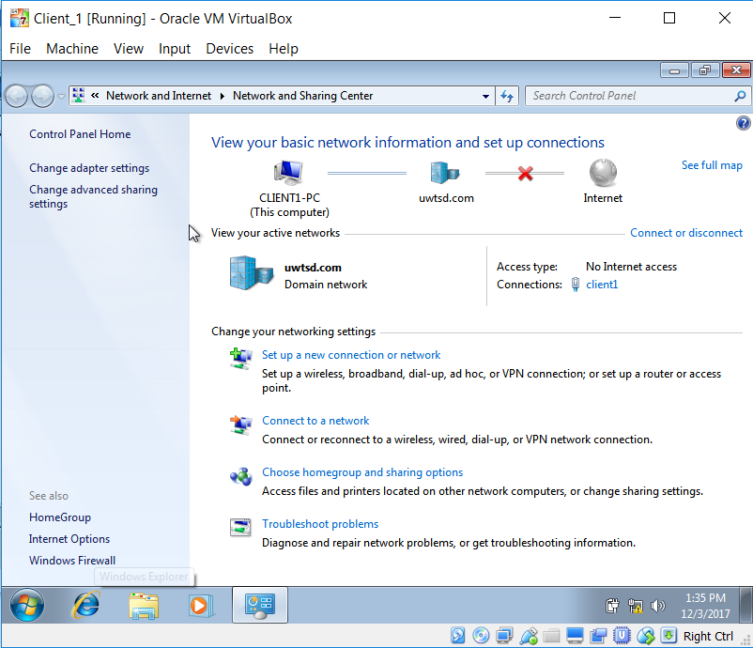
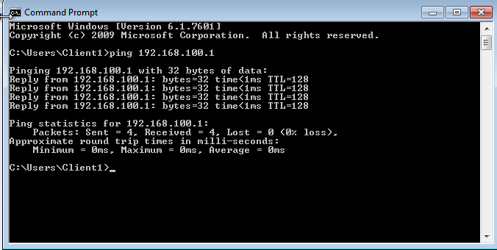
- To authorise the DHCP Service I had to add the specific role of the server, the DHCP server role. Choosing and configuring the appropriate network was required in the next steps of installation.
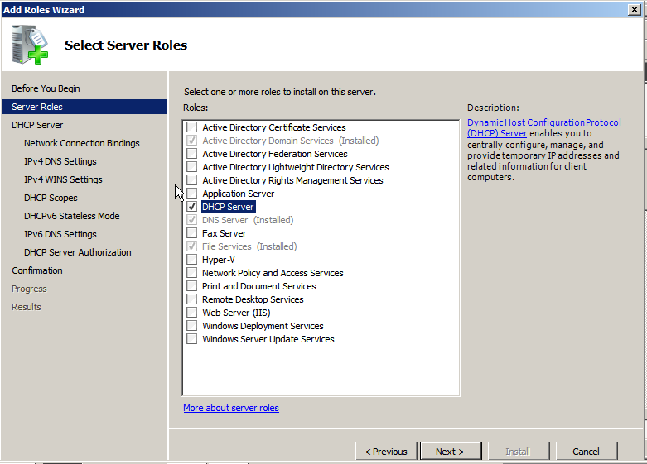
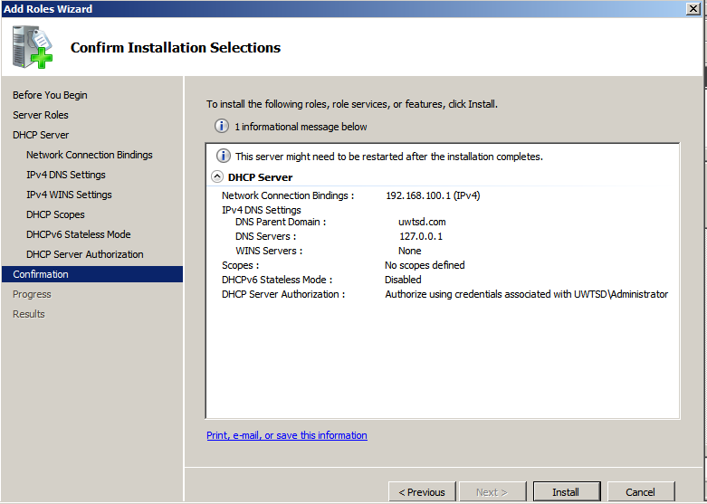

- Next task was arranging the scope of the network, and at this stage, I obtained the client adapter network addresses automatically.
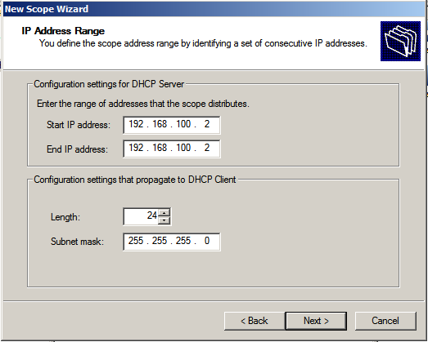
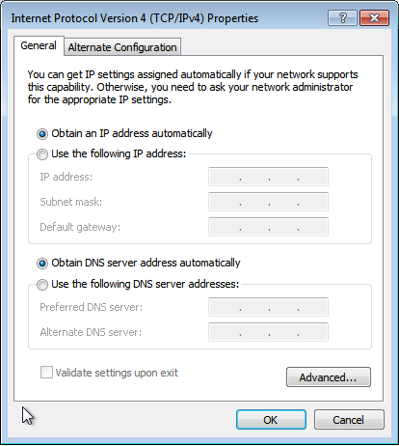

- In Client 1 I have used Command Prompt to obtain the connection with DHCP Server. Next, I checked that the Client 1 is connected to DHCP Server in Address Leases of the server.
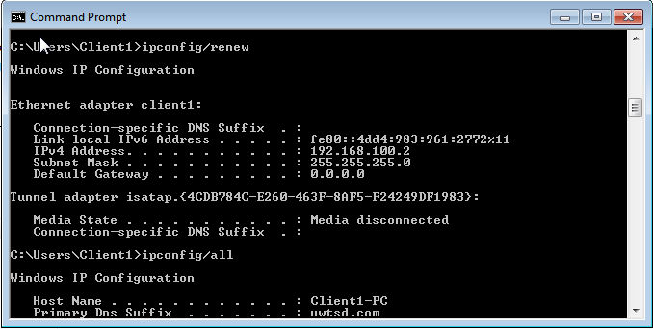
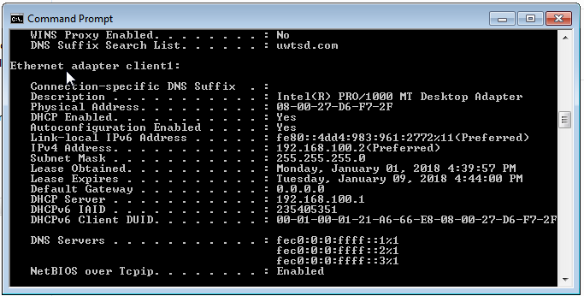
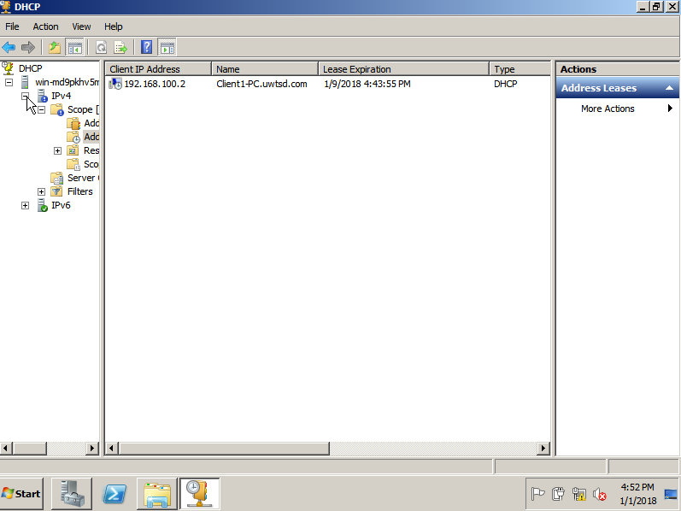
Observational Tasks
A). State the benefits of using Type 2 Hypervisor virtualisation software in your design. Comment on the strengths and weaknesses of the VirtualBox platform used in your network.
A Type 2 hypervisor, also called a hosted hypervisor, is a virtual machine manager which can be installed as a software application on an operating system. Hosted hypervisors support and allow to make virtual machines by coordinating settings for CPU, memory, capacity, network and other similar elements of the physical computer’s operating system. [1]
The main advantage of using Type 2 Hypervisor is the possibility of keeping various operating systems on one physical computer. It could be helpful if we would like to, for example, open a specific file or an application which can be opened or installed only in particular operating system such as Linux, but we just have Windows machine disposal. In my design, I have created two different virtual machines with two various operating systems on them. Moreover, after installation a virtual server and virtual client I was able to set up the network between them. Furthermore, the hosted hypervisor is an excellent instrument for network and system engineers because the hypervisor allows them to get an essential experience and try new concepts and ideas without the risk of breaking down an operating system and hardware. My project is an excellent example of experimenting with a virtual network, which sometimes was a trial and errors method, but thanks to, Type 2 Hypervisor this exercise did not get brought catastrophic results.
The VirtualBox platform is a type of hypervisor which was very logic and intuitive during the work with it. It is straightforward to create virtual machines and set up all settings and parameters using this platform. The weakest point of the VirtualBox is its limited number of virtual machines which can work on the one piece of hardware and the fact that performance on a virtual machine is not as well as the performance of the real device with these same features.

B). Explain, with use of diagrams, the significance of the following terms: Active Directory Forests, Trees, Parent and Child Domains.
Active Directory hierarchy overview

Forest
Tree
Tree

Active Directory – The tool which provides the managing, controlling and organising network resources. Network administrators can use Active Directory to arrange elements of a network by adding or creating user accounts, computers or other devices such as printers into a hierarchical logical system. [2]
Forests – The highest level of the hierarchical logical system of Active Directory which contains trees and domains. A forest can be built with one or more trees, and information in Active Directory is shared only within it. [2]
Trees – A tree is a set of hierarchically organised domains where one domain is the root domain that could have child domains connected to itself. All domains within the tree share a contiguous namespace. [2]
Parent – The first domain created into a tree also called the root domain. Child domains are connected to the parent domain.
Child Domains – The domains connected to their parent domain which shares a common directory database, security settings and have the common domain name with the parent.

C). Investigate and document the main roles and responsibilities of an Active Directory Domain Controller.
A domain controller is a server and the centrum of administration of a domain, which allows configuration permissions, administer and manage computers, users and other devices across the domain. [3]
The main roles and responsibilities of an Active Directory Domain Controller:
- Containing active directory and group policy
- Responding to security authentication request
- Adding users to the domain
- Storing user account information
D). What actions could we take in the event of a Domain Controller becoming unavailable?
In the situation when a Domain Controller is unavailable, e.g. crashing DNS server, we can reconnect the network by creating a new prime DNS Server. The other solution could be checking the security settings, which may cause the problems with authentications of the connected domains.
In the situation when a Domain Controller is unavailable, e.g. crashing DNS server, we can reconnect the network by creating a new prime DNS Server. The other solution could be checking the security settings, which may cause the problems with authentications of the connected domains.

References

[1] | "Type 2 hypervisor (hosted hypervisor)," 12 2014. [Online]. Available: http://searchservervirtualization.techtarget.com/definition/hosted-hypervisor-Type-2-hypervisor.
[2] | Microsoft, "What Are Domains and Forests?," Microsoft, 19 11 2014. [Online]. Available: https://technet.microsoft.com/en-us/library/cc759073(v=ws.10).aspx.
[3] | Techopedia, "Domain Controller (DC)," [Online]. Available: https://www.techopedia.com/definition/4193/domain-controller-dc.

