Network Operating Systems & Services
Author: Cameron Brown (2004688)
ACCA5023
School of Applied Computing
Wales Institute of Science and Art

Name of the Team: GCEA
Team Members
Student Name | Student ID
Gio Aguilar | 2001127
Cameron Brown | 2004688
Jack Kennedy | (Unsure)
Ethan Matthews | 2117013

Team Evaluation
 | Cameron
Gio | 4
Cameron | 4
Jack | 1
Ethan | 4

Comments on Team Evaluation

Gio: I think Gio helped the group quite a bit. He assisted Jack a lot when he was present and provided screenshots and annotations for the group tasks.

Cameron: I think that I had assisted the group a lot whenever they were stuck or confused on certain parts. I had also provided screenshots and annotations for the group task. I had missed a lecture at the end of it all but we had completed the group work before that so thankfully I didn’t impact the team negatively.

Jack: I was not present for 1 lecture but in the rest of the lectures, Jack only showed up once and didn't provide any screenshots or annotations for the group tasks.

Ethan: Ethan had helped me a bit and had helped Gio quite a bit too from what I had noticed. He had also provided screenshots and annotations for the group work, including sections where me and Gio didn't have any screenshots.

Introduction 5
Part 1: Group Task 5
Part 2: Observational Task 22
Conclusion 25
Reflection on collaborative work 26
References 26

Introduction
This essay contains the results of collaborative work on building, deploying, configuring and managing a Type 2 Hypervisor platform-based Virtualized network. As well as an individual observational task showcasing knowledge in the collaborative work completed prior, which includes topics such as Type 1 and Type 2 Hypervisors, DHCP, Active Directory, and other terminologies like Ping, Firewall and OOBE.

Part 1: Group Task

TASK 1 - 1.1 (VM Creation and Operating System Installation)

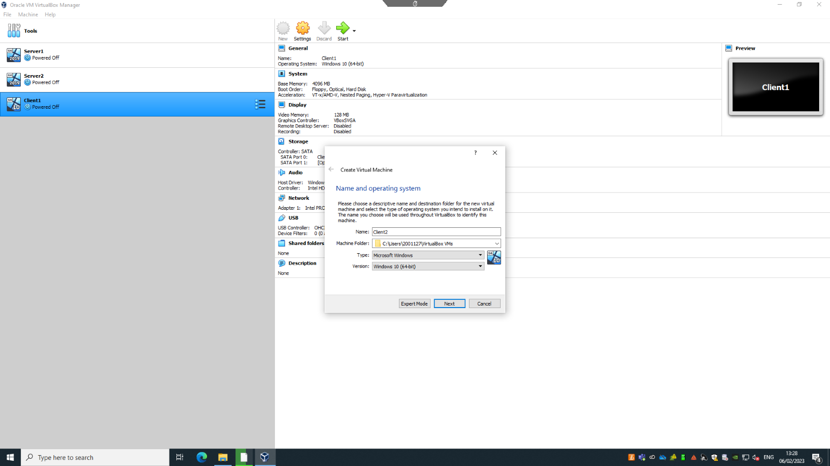

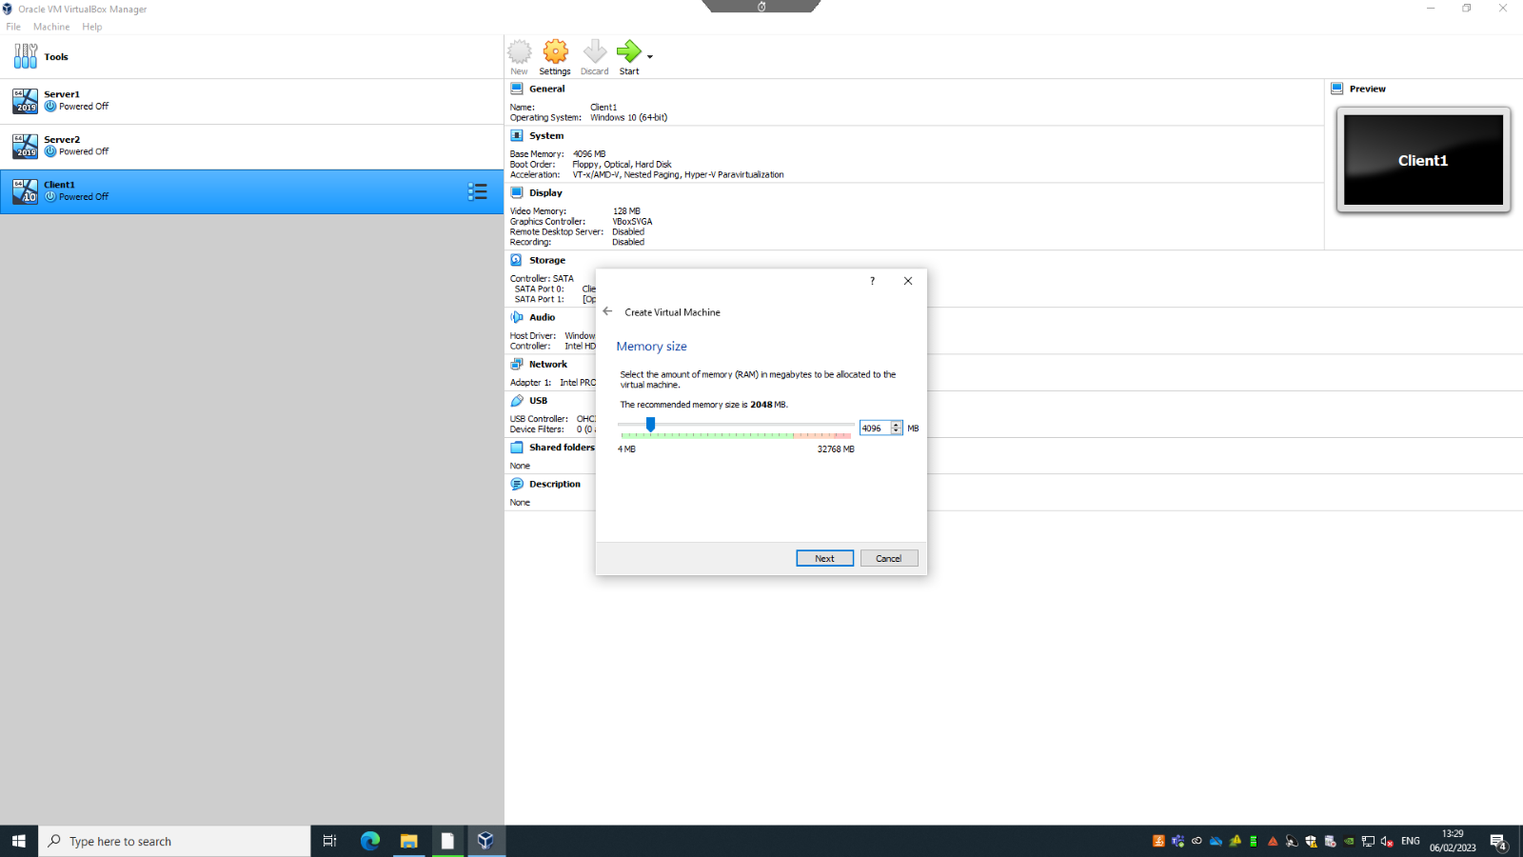
This is the creation of the Client 2 virtual machine that the user made out of the 4 that were/are going to be created. In the above photos the only difference that would be made would be the name of them as the memory size between all four of the virtual machines is the same.
As a side note, the storage for both servers would be different compared to the storage of the client virtual machines (25gb for server and 20gb for client). Also the operating systems installed on them are different as shown in the first photo. For client two we have selected the Windows 10 operating system but for the servers it would be Windows Server 2019.
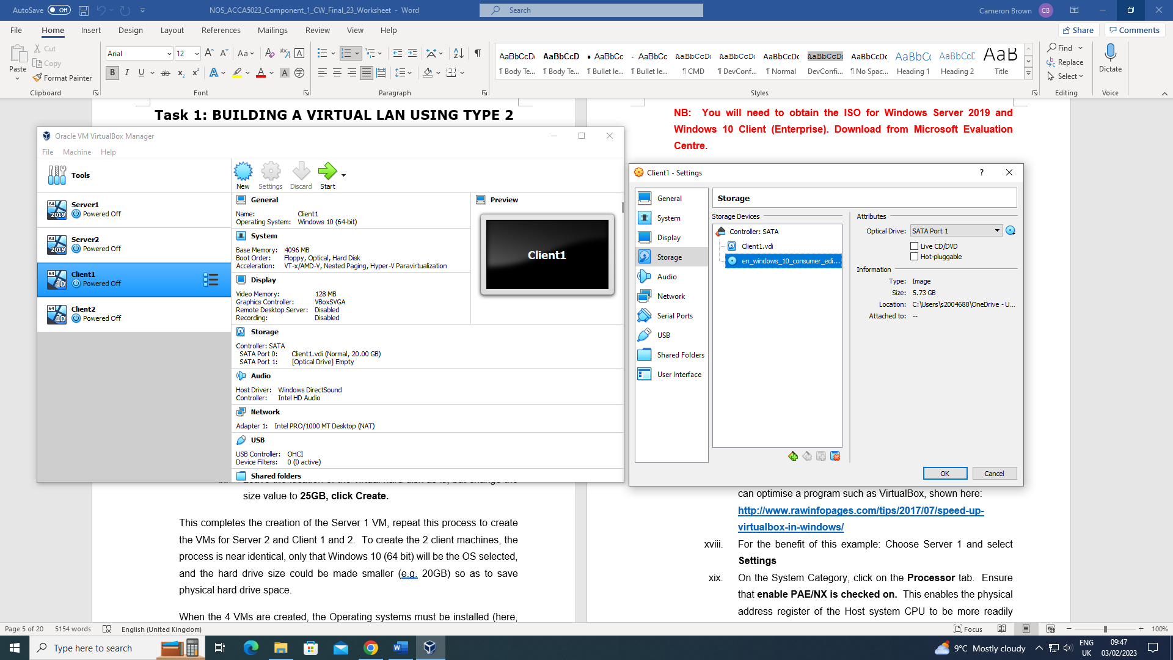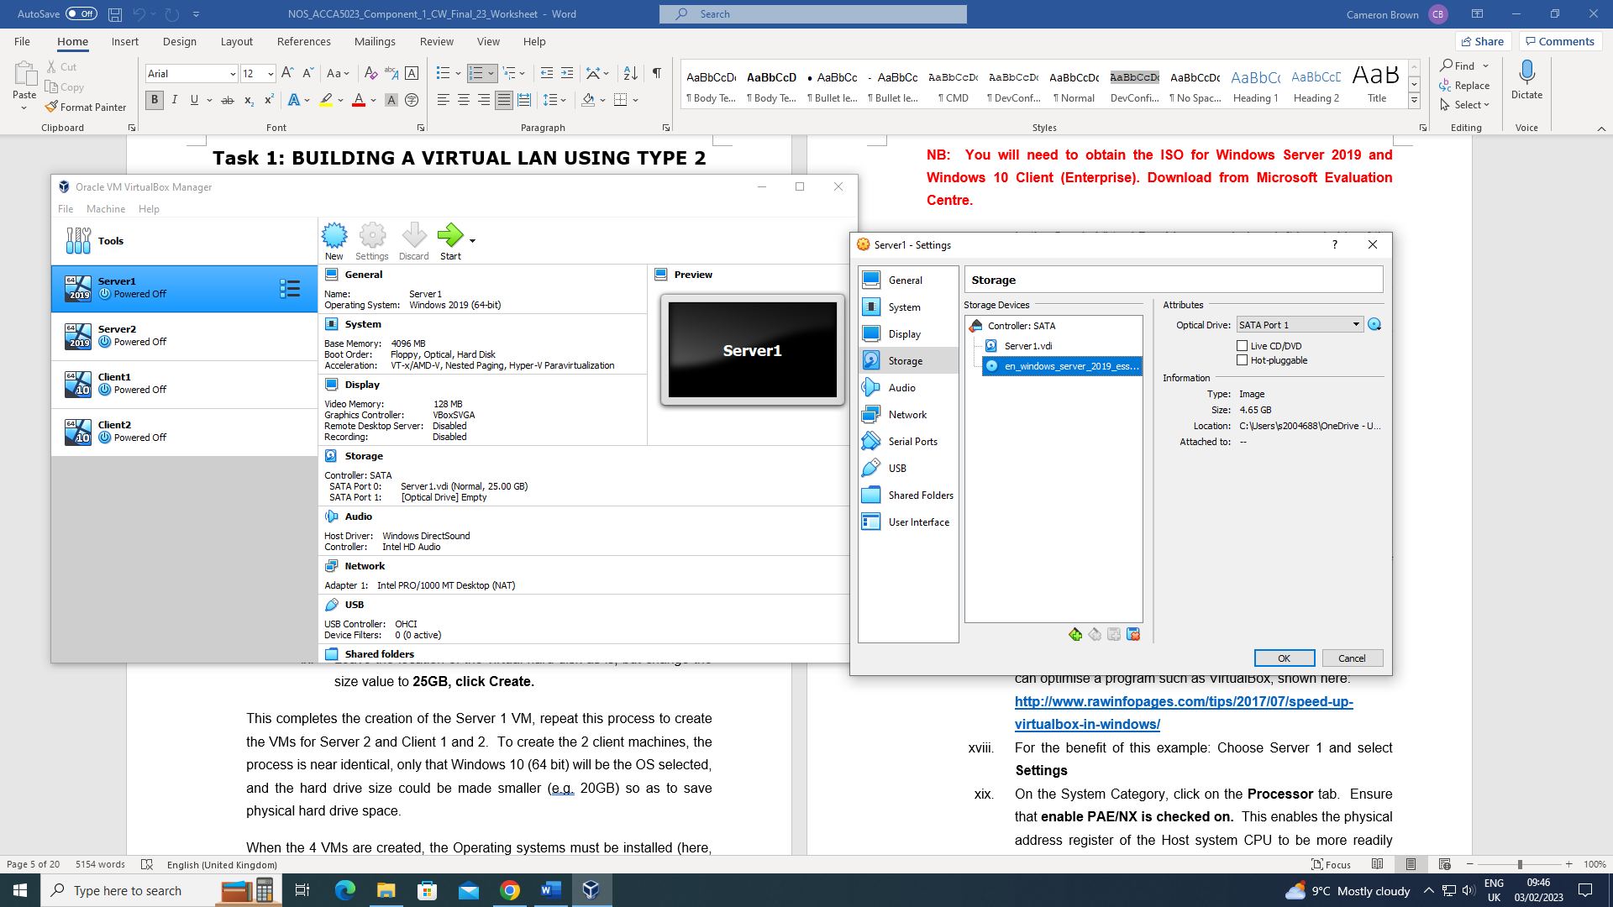
Here are the installations of the ISOs to the selected servers and clients, as you can see between both photos one has the Windows 10 ISO and the other has a Windows Server 2019 ISO, this allows the user to properly install the required operating systems and run the software.
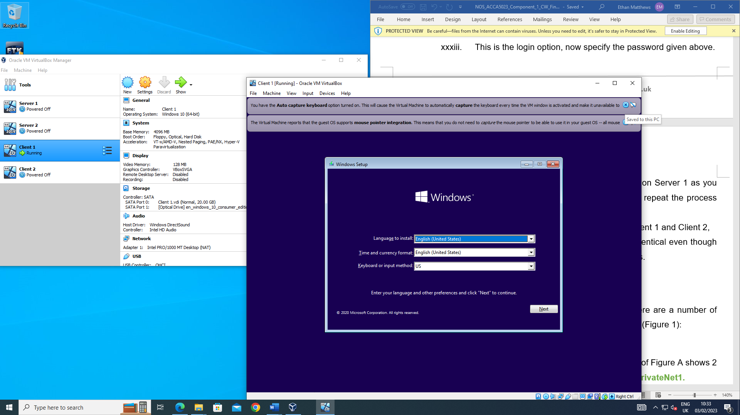
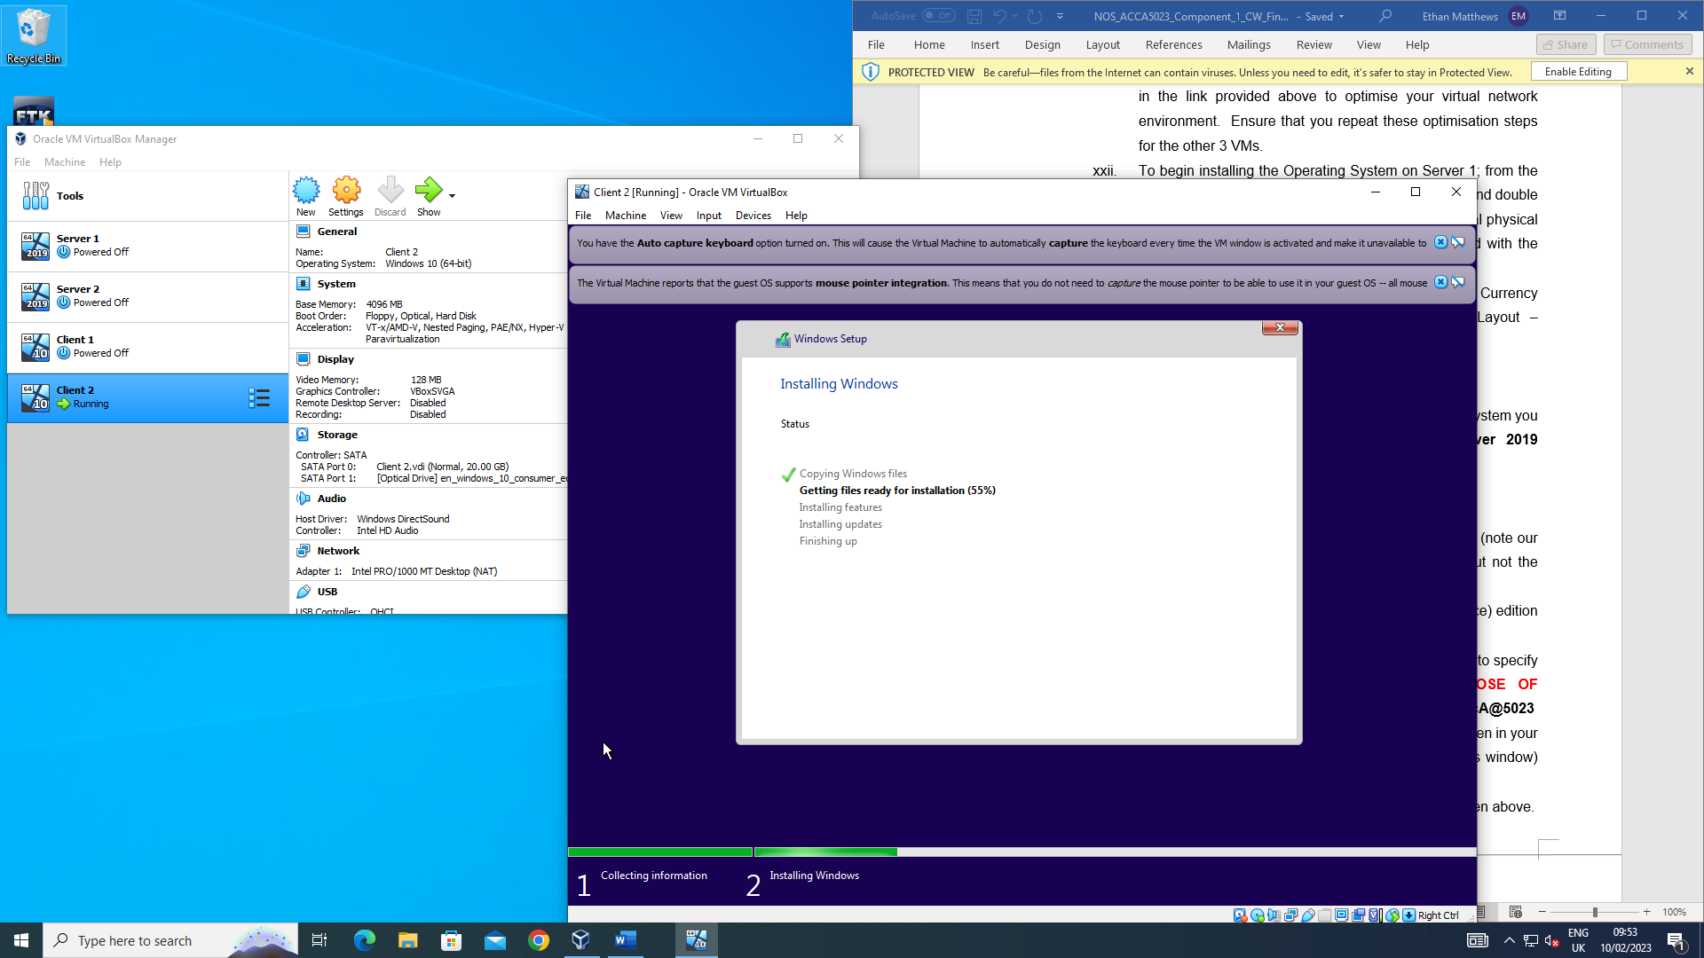
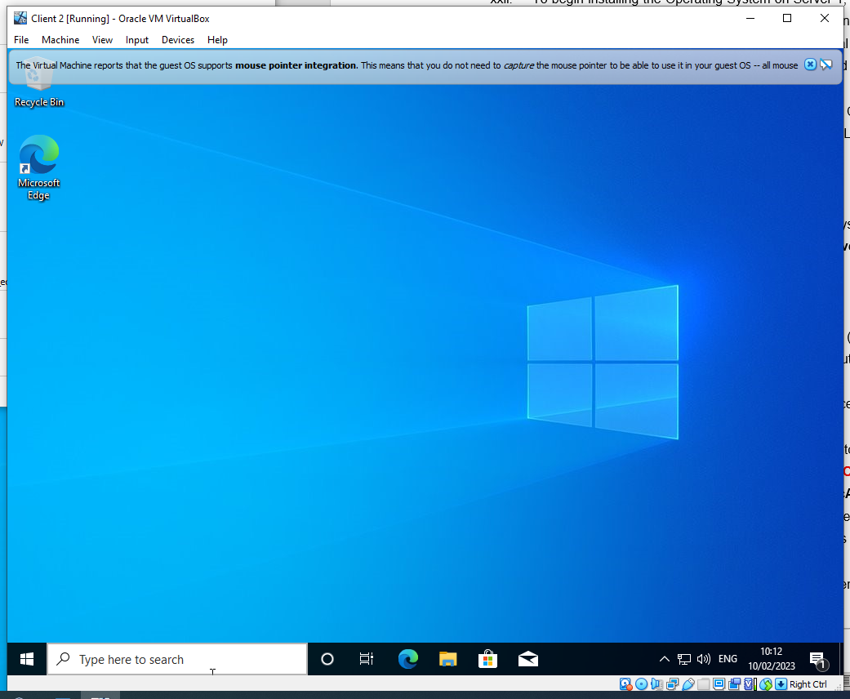
Here in the above three photos would be the installation for the Windows 10 operating system that appears on client two. Client two is the only one included here as the procedure to install the operating system on the servers is exactly the same process as the clients, the only difference in selecting the right operating system (Windows Server 2019 & Windows 10 (Client) Enterprise).

TASK 1 - 1.2 (Virtual Network Configuration)

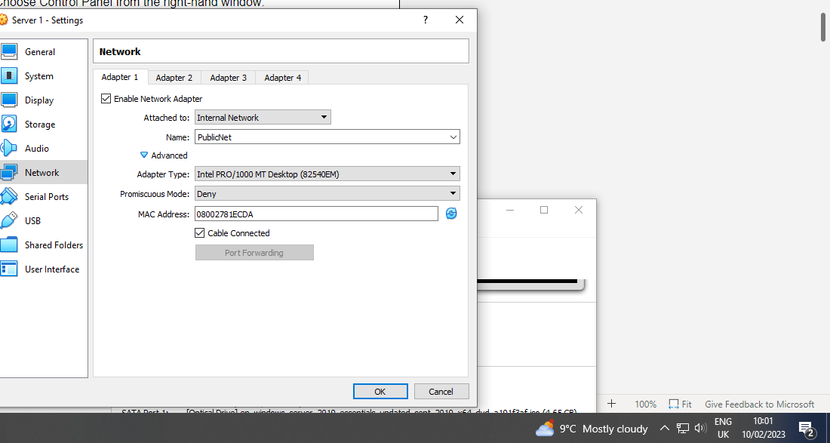
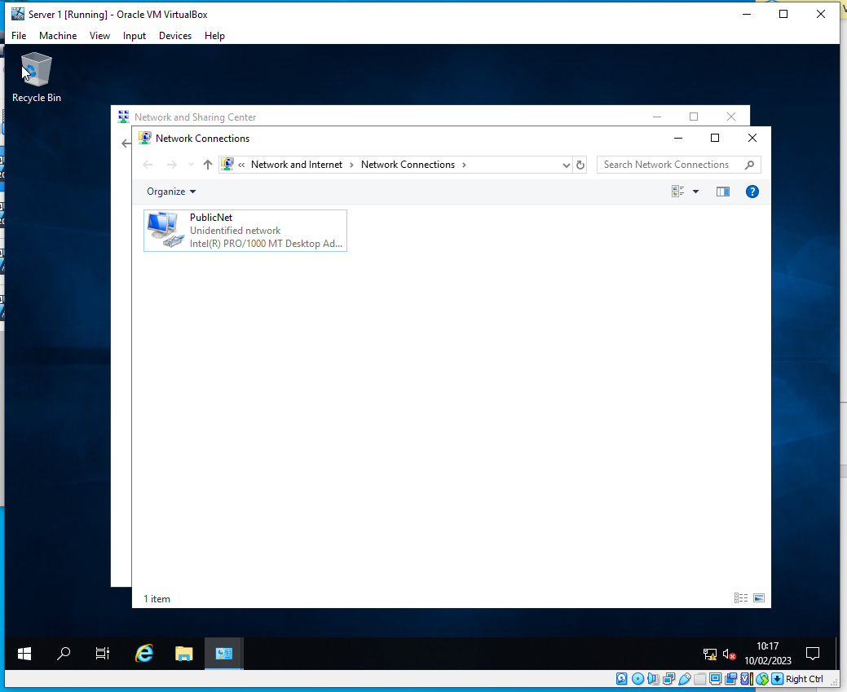
For task 1.2 (Virtual Network Configuration), the internal network for all VM’s were updated. Client 1 and Server 1 were on the same network, and Client 2 and Sever 2 were on the same network. Both servers belong to the same network called PublicNet, they both also have their own network, Server 1 has one called PrivateNet1 and Server 2 has one called PrivateNet2. Client 1 and Client 2 are each connected to one PrivateNet respectively.
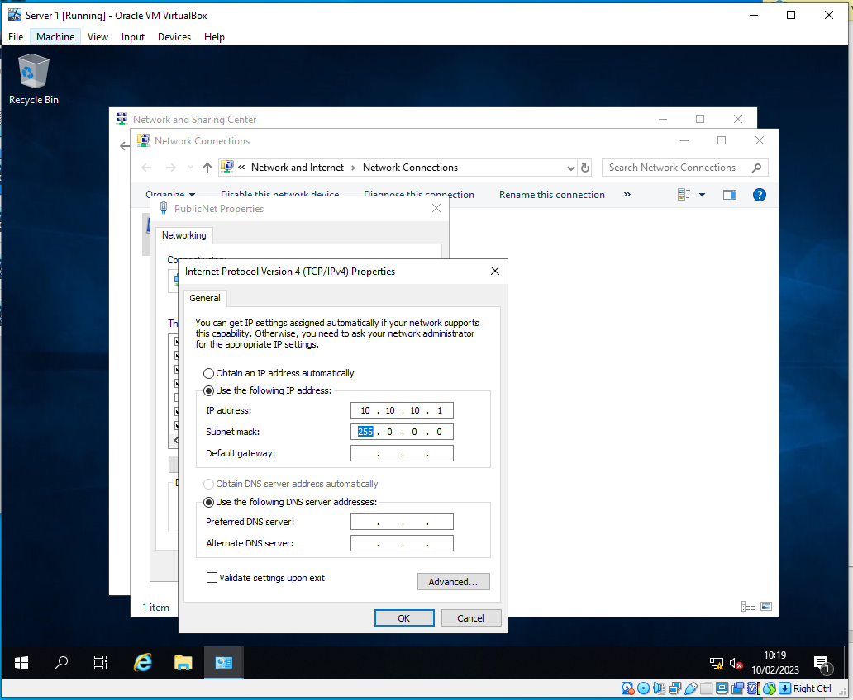
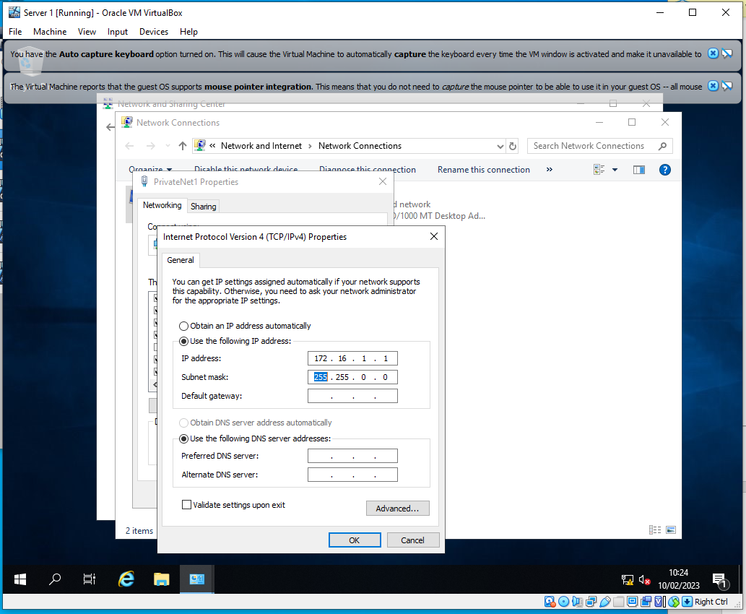
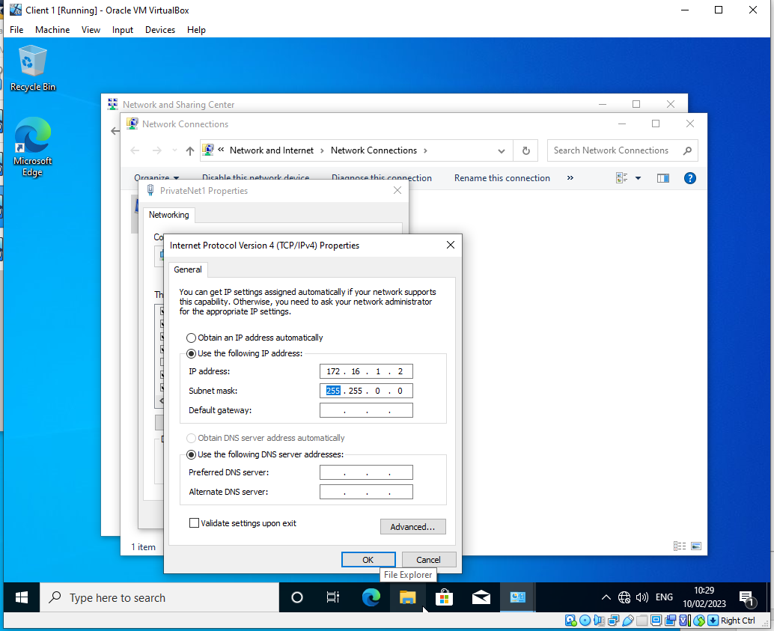

The IP addresses have been configured for Client 1 and Server 2 according to the specifications stated in the worksheet - Client 1 (172.16.1.2) - Server 1 (172.16.1.1) and Client 2 (172.16.2.2) - Server 2 (172.16.2.1). The PublicNet for the servers were also configured as shown on the diagrams above. Server 1’s PublicNet network was configured to 10.10.10.1 and Server 2 was configured to 10.10.10.2.
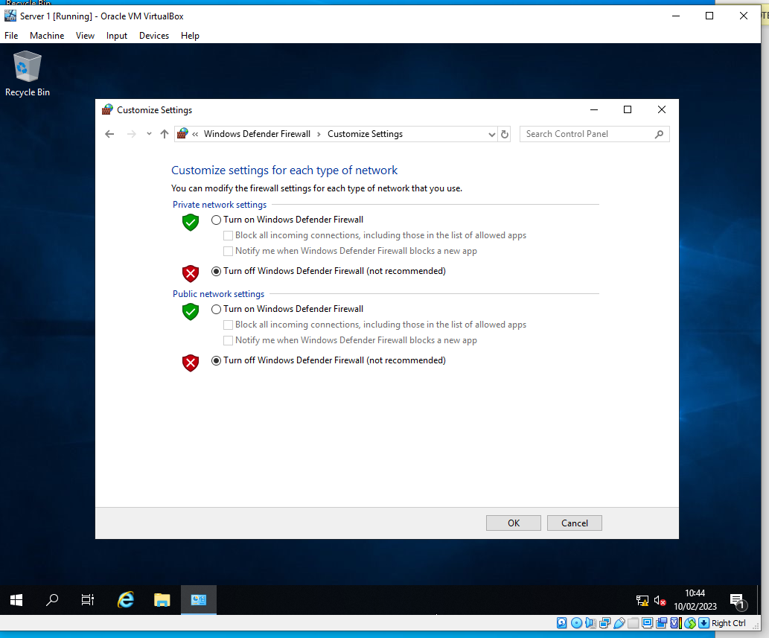
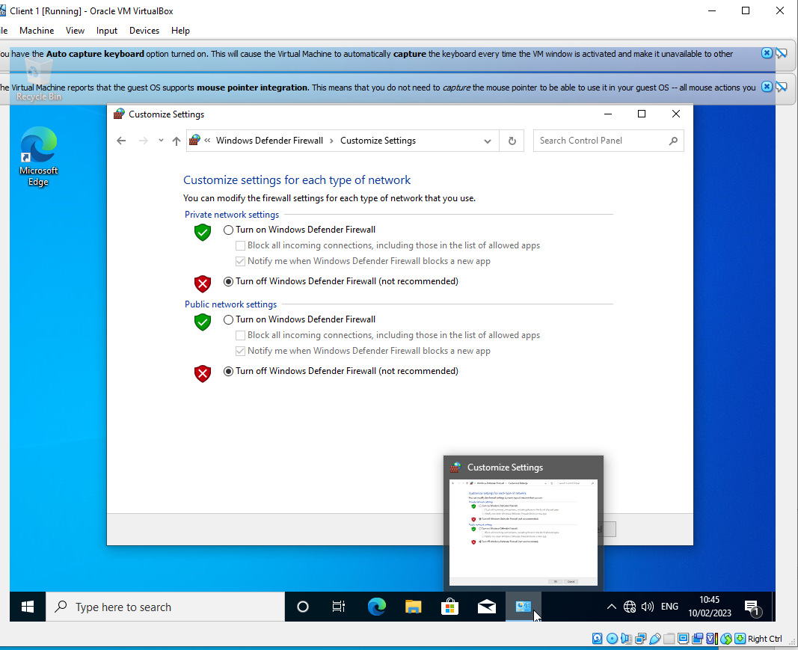

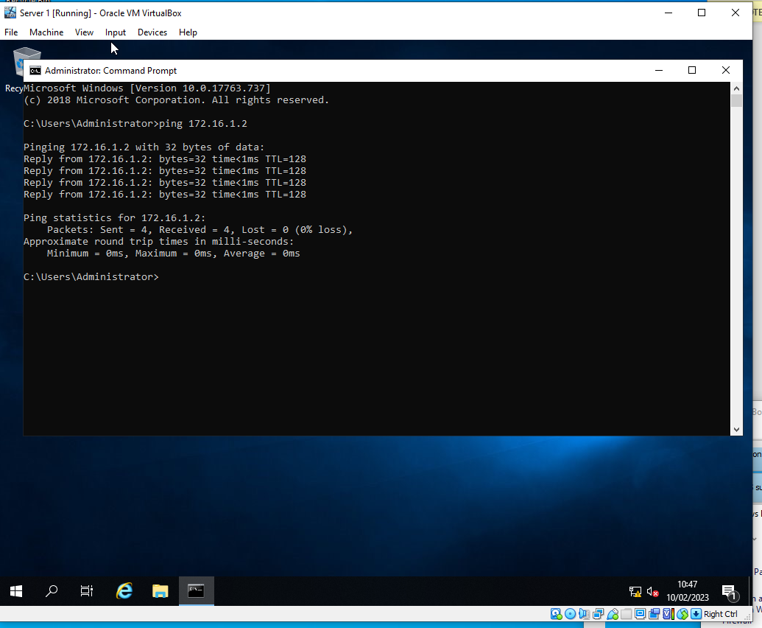
Due to the OOBE for the VMs rejecting ICMP requests, the firewalls had to be disabled on both clients and both servers. Then in order to test that the networks were set up correctly, a ping request between the different networks was done. In which a successful attempt can be seen above.
Task 2 - 2.1 (Prerequisite)

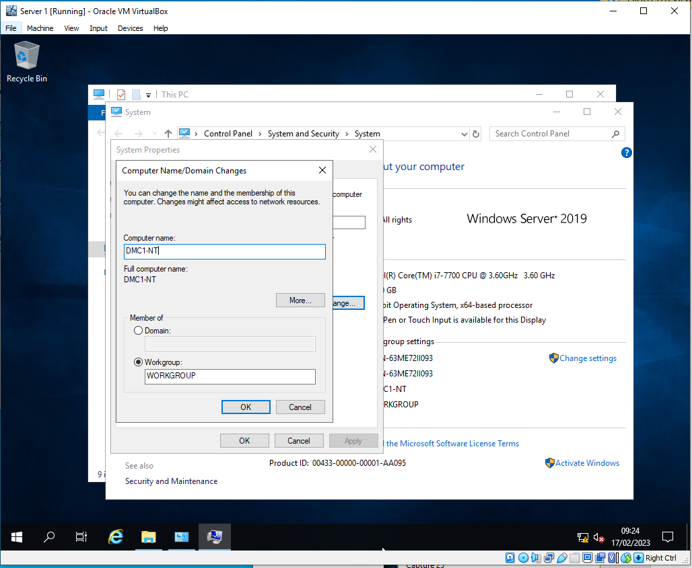
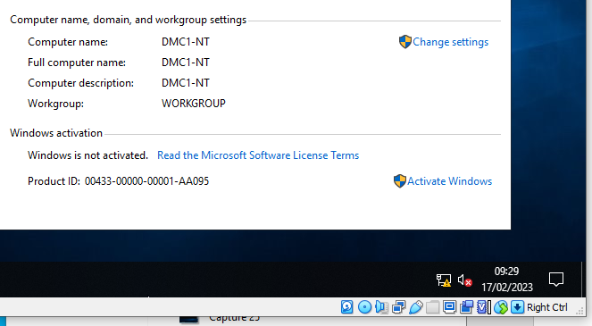

2.2 - Deploying Active Directory

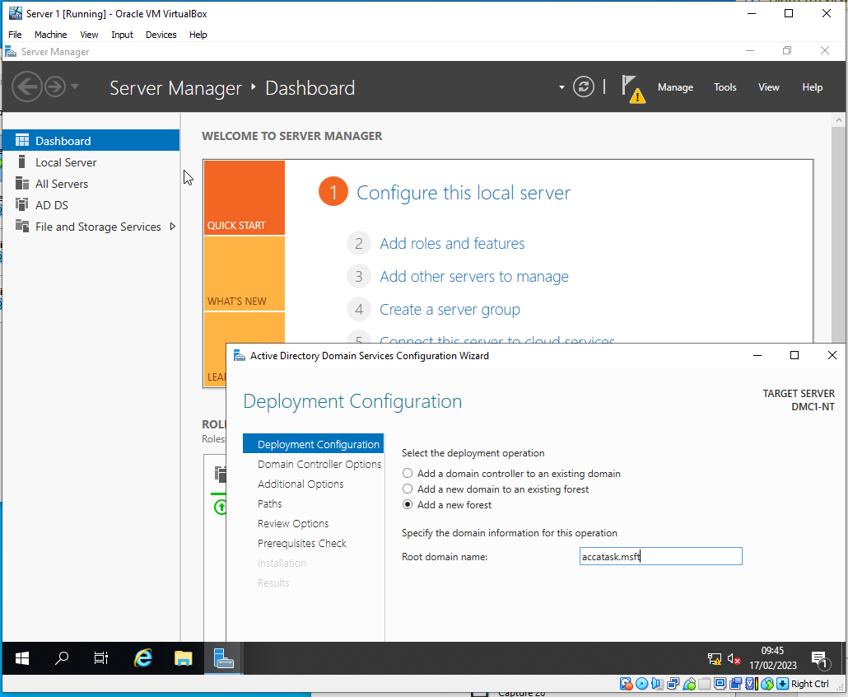
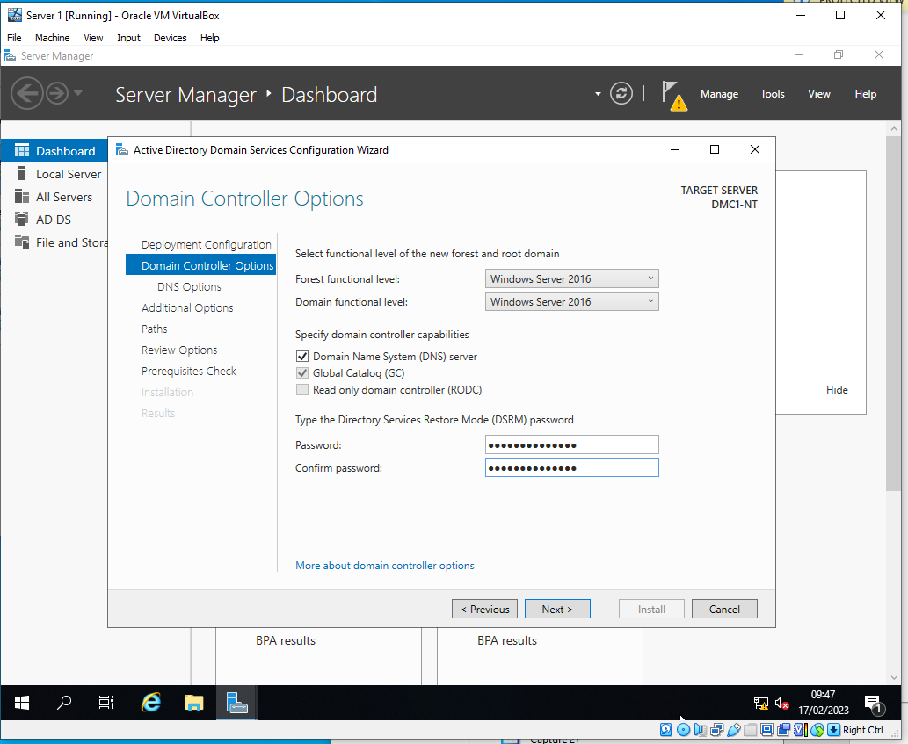
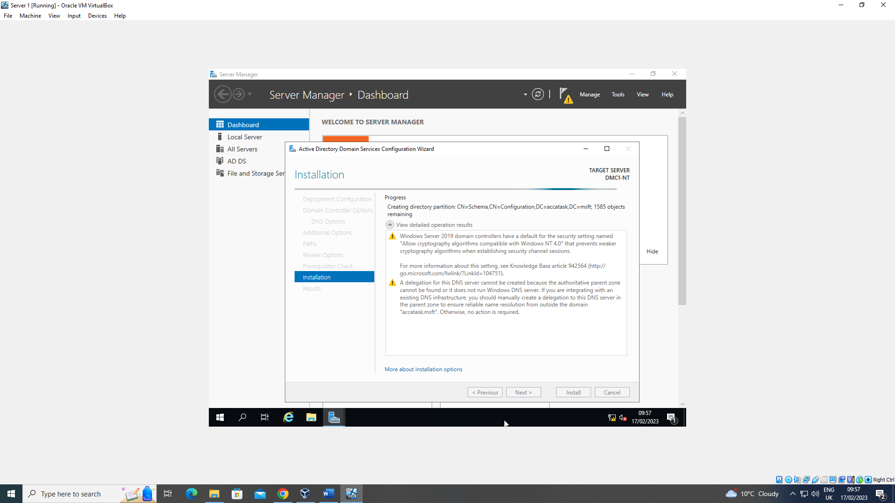

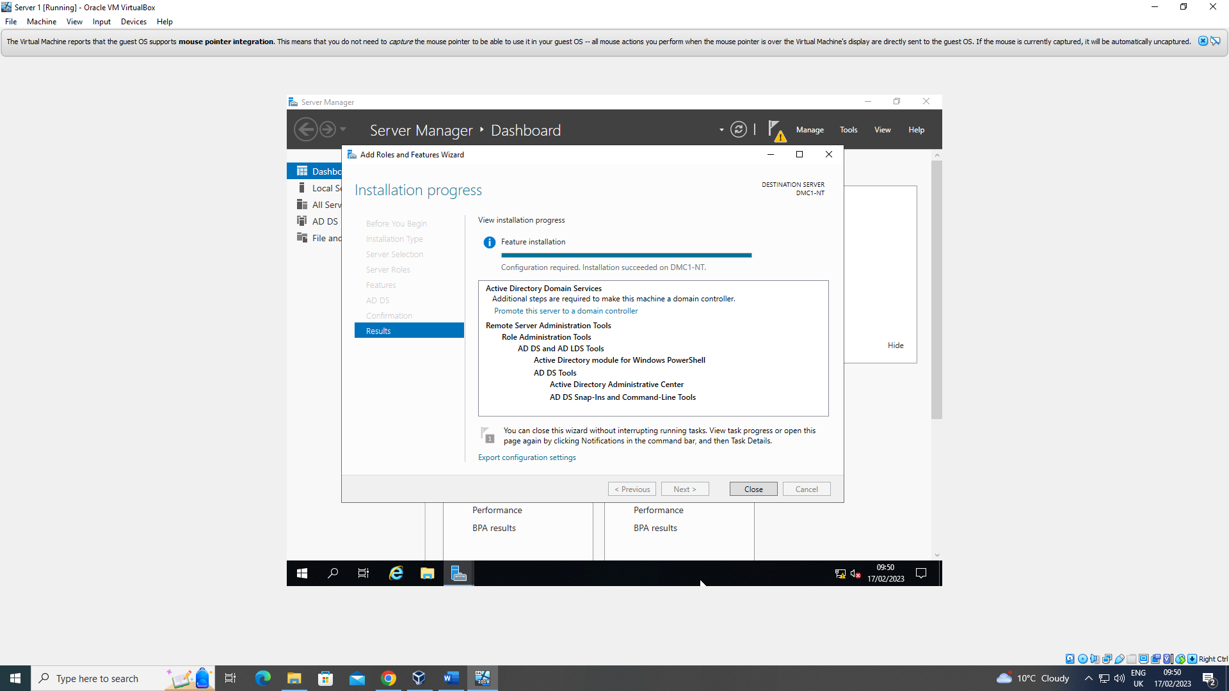

2.3 - Creating user account objects using Active Directory Users and Computers snap-in console.
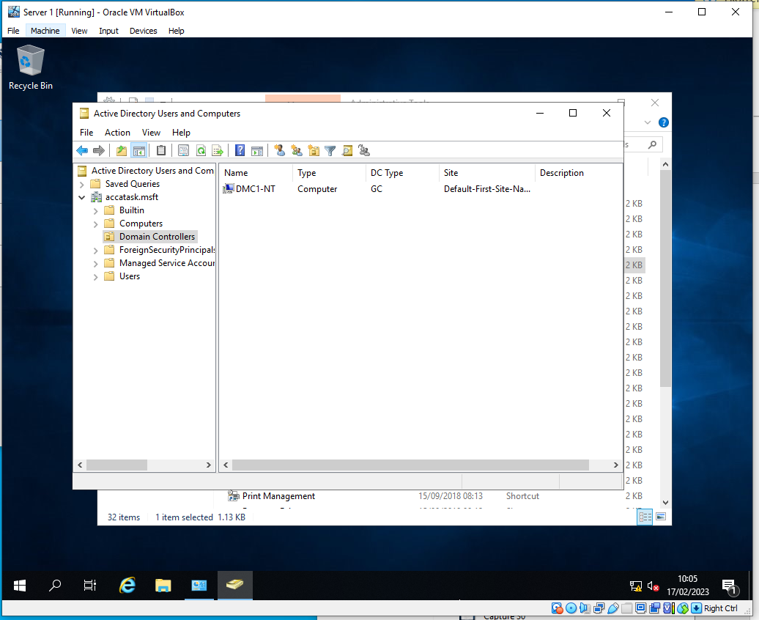
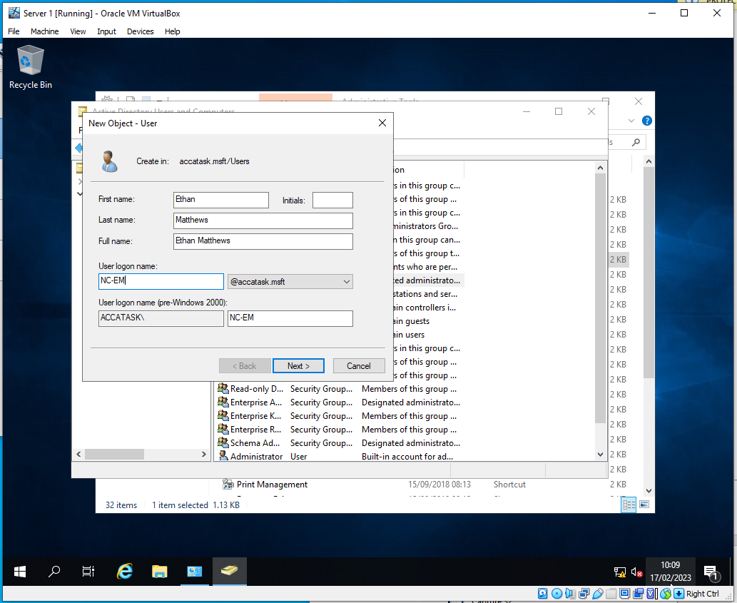
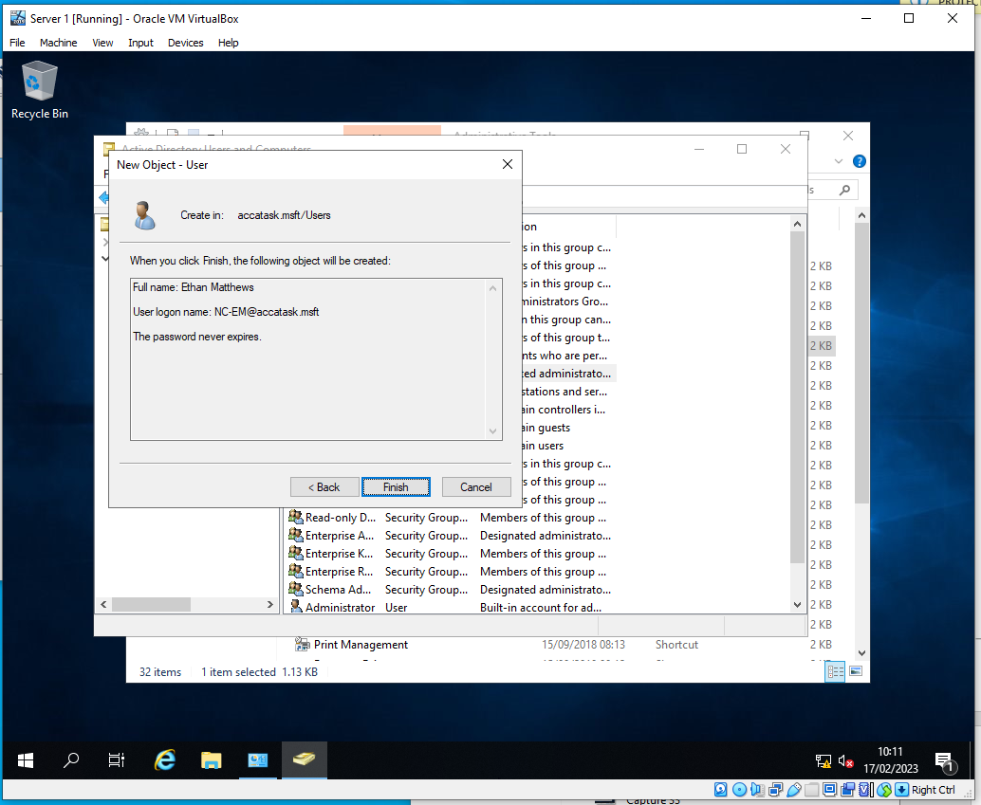
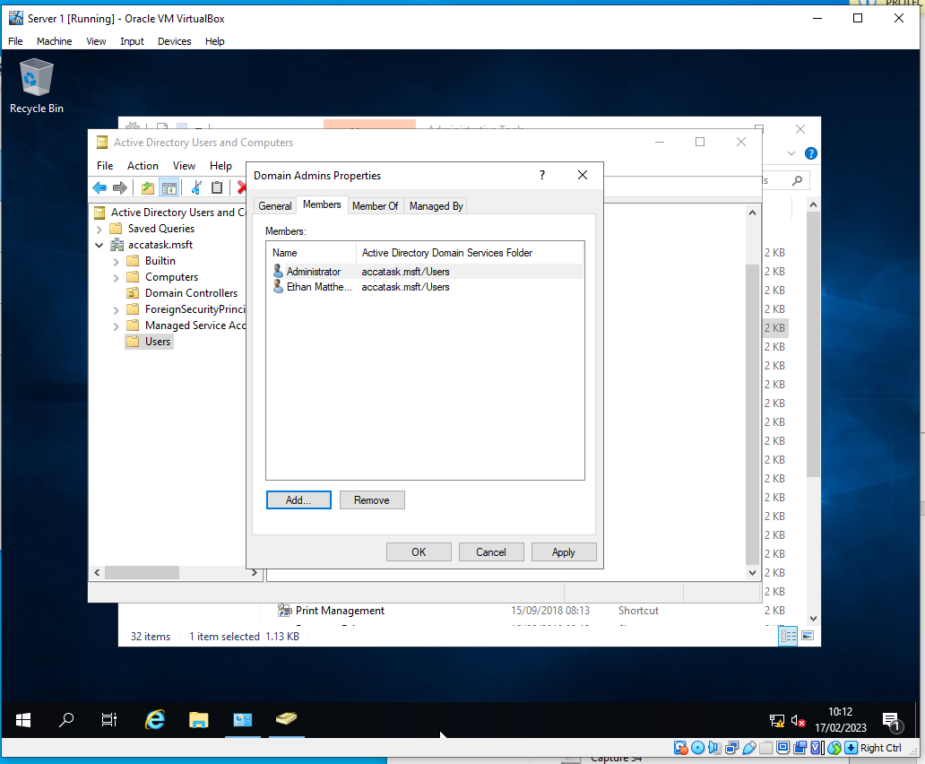

2.4 - Object attributes of interest.

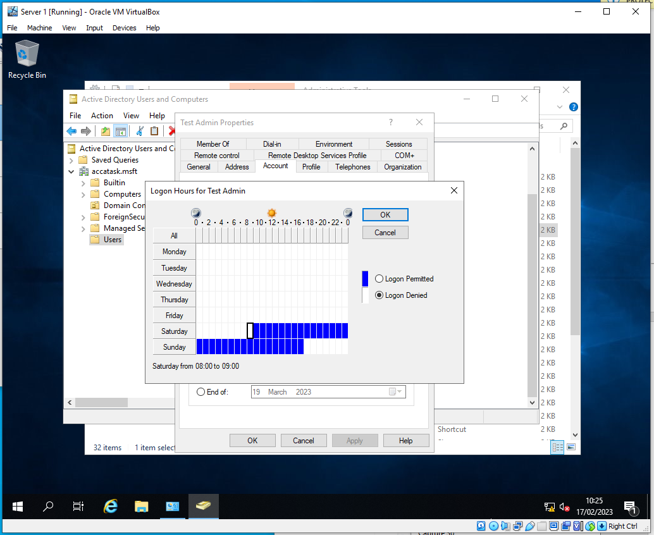
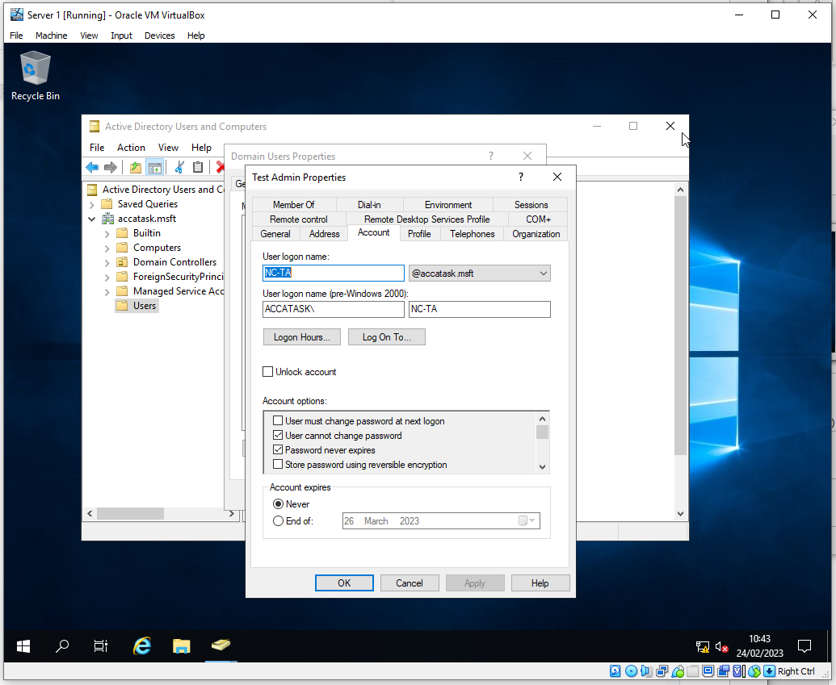

2.5 -Adjoining the domain and testing user logins.

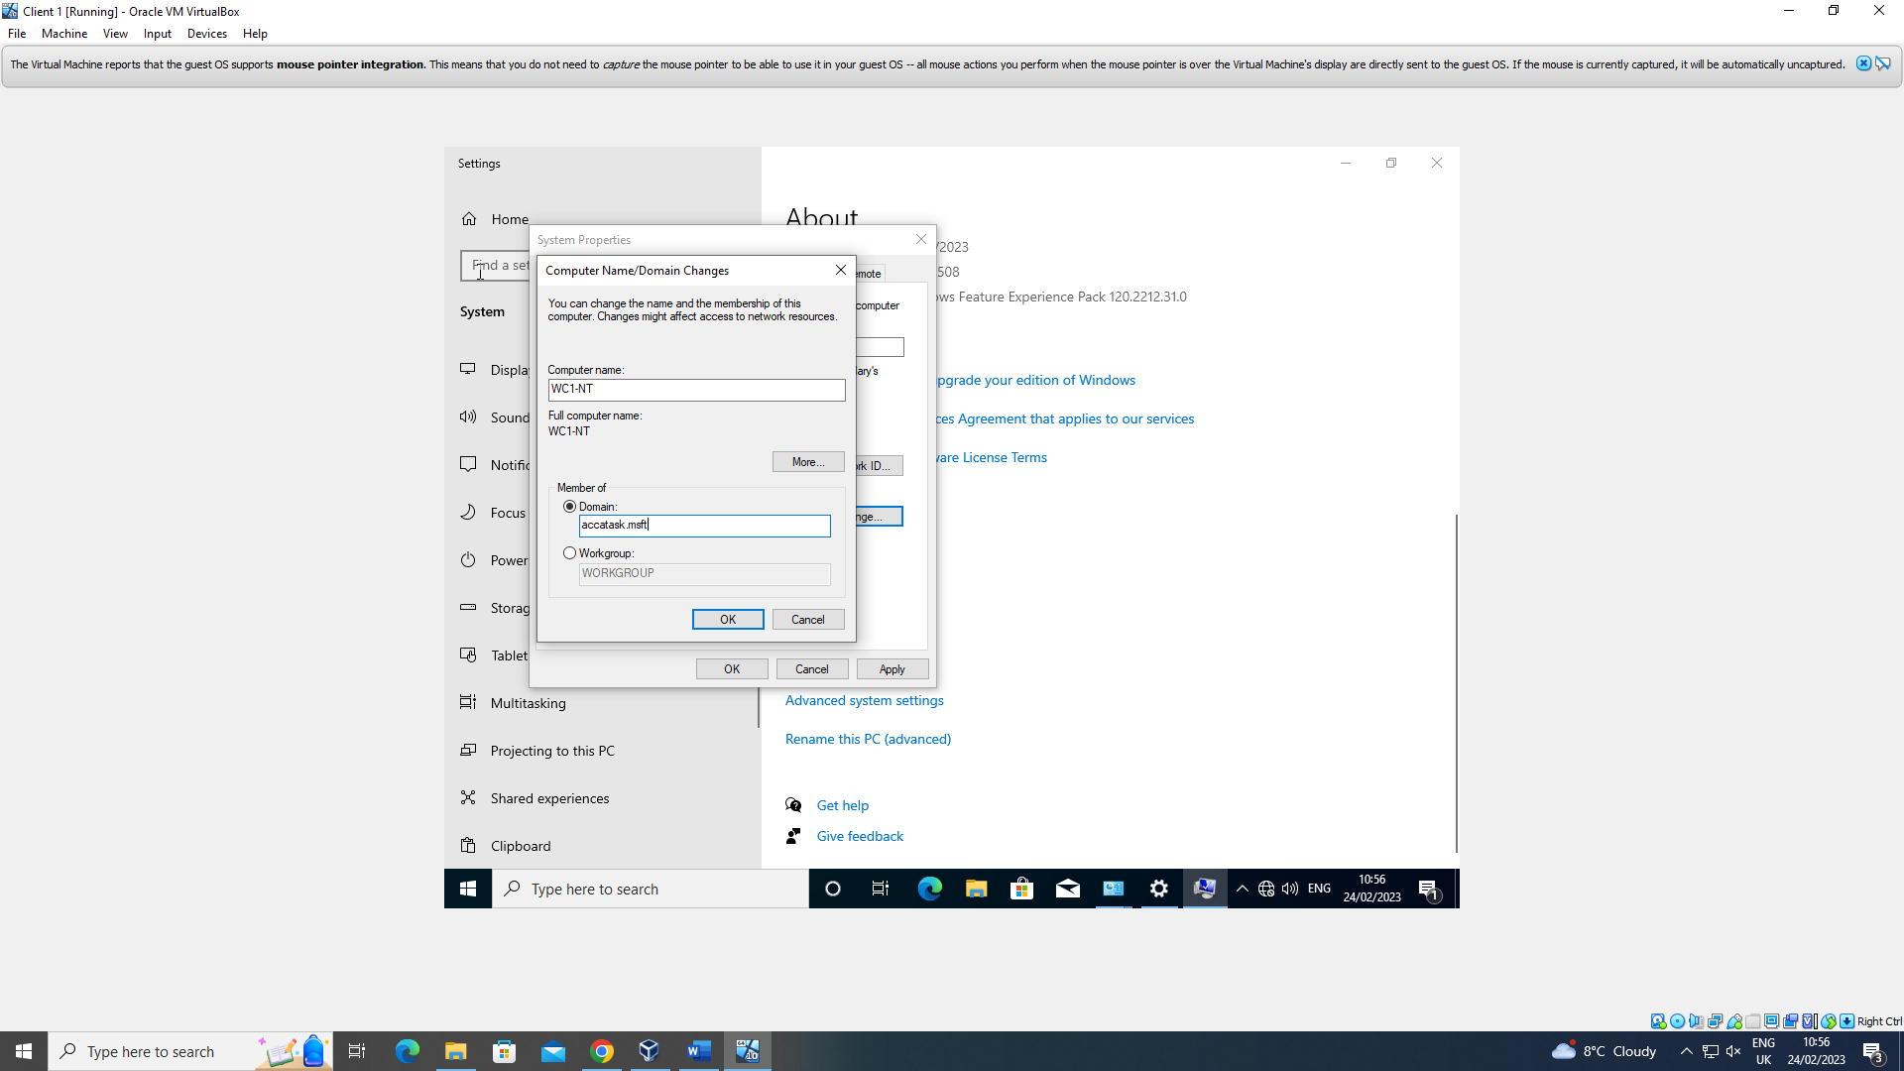
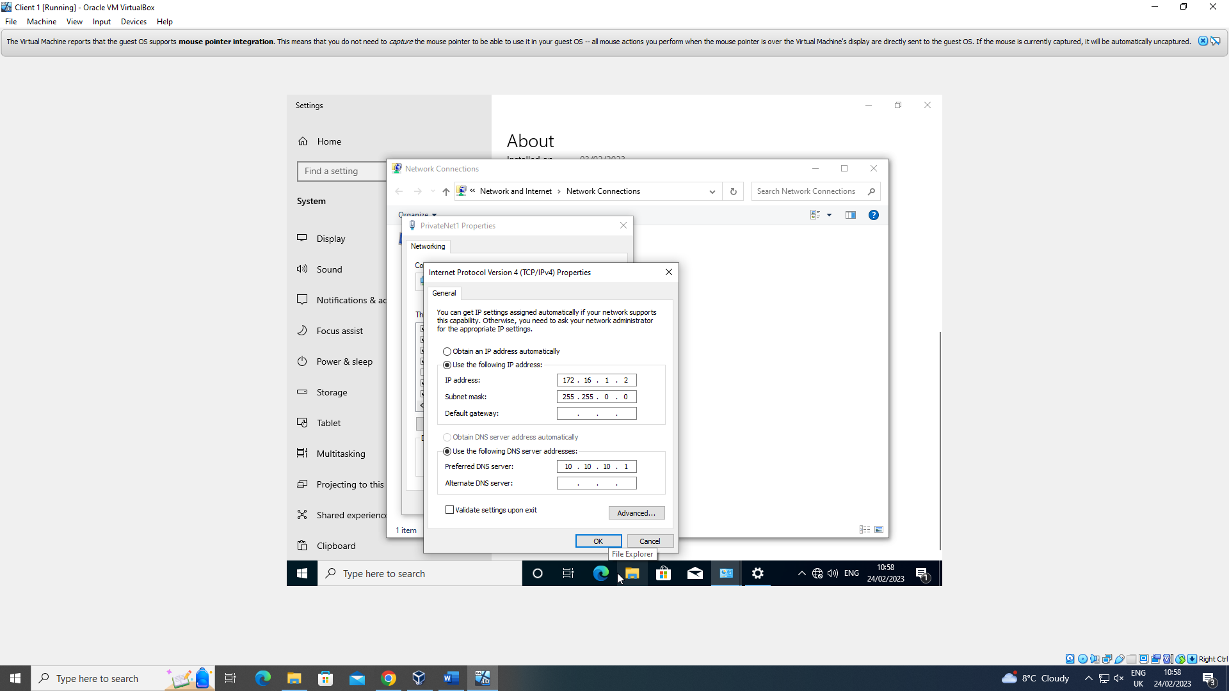

Part 2: Observational Task
A Type 2 Hypervisor was used in the practical task because it’s faster and easier to set up compared to a Type 1 Hypervisor. Type 2 Hypervisors are easier to manage and can also be used on a wider range of operating systems and hardware. A Type 1 Hypervisor wouldn’t be as convenient to use in the practical task as it would be harder to install and manage, which makes it worse for this specific practical task as the extra efficiency is also more than likely negligible for what the task wanted.

Since “a type-1 hypervisor is in direct control of all resources of the physical computer” [1], they would be more fitting for more enterprise use. This includes data centres and cloud computing. These both benefit highly from having the hypervisor have direct control of all resources, while a Type 2 Hypervisor would make the data centres a lot less efficient due to the machines themselves needing to allocate some resources to itself.

Type 1 Hypervisors are useful because it’s very efficient due to having direct access to the hardwares resources. “Aside from having better performance characteristics, Type 1 hypervisors are also considered to be more secure than Type 2 hypervisors.” [2] This is because a user cannot affect the hypervisor that they’re using. In the case where a virtual machine is damaged, only the singular user is affected while the rest are untouched. Type 1 Hypervisors are also harder to install and manage compared to Type 2 Hypervisors. If you pair that with the information that Type 2 Hypervisors also have less hardware compatibility due to needing direct access to the hardware, it becomes very apparent that someone may choose a Type 2 Hypervisor instead, especially for tasks that don’t necessarily need the efficiency given from a Type 1 Hypervisor.

Type 2 Hypervisors are easier to install and manage compared to a Type 1 Hypervisor. Since it doesn’t need direct access to hardware resources, Type 2 Hypervisors are more compatible with hardware, which makes them a lot more accessible. Due to the above though, it makes the Type 2 Hypervisors less efficient and slower. This makes them better for lighter tasks but noticeably worse for enterprise use such as use in data centres.

DHCP (Dynamic Host Configuration Protocol) is a networking protocol that allows devices on a network to be automatically assigned IP addresses. This is useful as it allows every device to be automatically configured to the network instead of needing an administrator to do it manually for every device. It does this by allowing a DHCP server to assign IP addresses to devices as they join the network.

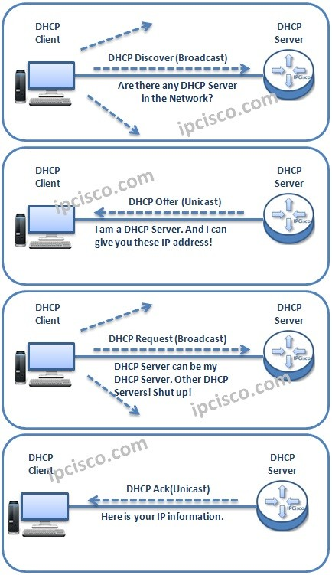
(Image from https://ipcisco.com/lesson/dhcp-ip-allocation-operation/)
As seen in the image above, when a device connects to a network via DHCP, it requests an IP address from the DHCP server. “DHCP assigns an IP address to a client for a limited period of time (or until the client explicitly relinquishes the address).” [3] The device then sends a request to the server to say that the lease has been accepted and starts using the assigned IP address. The lease is then recorded in the DHCP server's database, along with the lease time.

DHCP is important because it greatly simplifies the process of giving IP addresses to client machines. Without DHCP, network administrators would have to manually assign IP addresses to each machine. “If there are a large number of computers in the enterprise network, manual configuration by the network administrator is a massive workload and repetitive work”. [4] DHCP makes it easier to add or remove machines from the network and can then reuse their IP address automatically as needed.

Active Directory is a tool created by Microsoft that simplifies the network administrators job in a similar fashion that DHCP does. While DHCP focuses on IP address assignment, Active Directory focuses on user accounts and managing the devices that the user would use. It does this using a hierarchical structure.
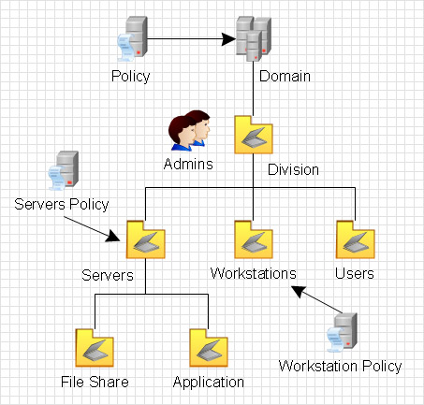
(Image from https://www.conceptdraw.com/How-To-Guide/active-directory-diagram)
The hierarchical structure of Active directory allows administrators to organise the network and its resources into groups based on location and/or department. Active Directory is highly secure and possible to have layered security, which is having policies and permissions for security at different levels.” [5] This allows the administrator to create policies for the users in each department that limit their privileges to exactly what they need. Without Active Directory, any new user would need their privileges manually changed each. Due to humans not being perfect, this can eventually lead to some users potentially having more privileges than needed, which can then cause a security issue. With Active Directory, new users are assigned into the departments group where they are automatically assigned privileges that are assigned to that group as a whole.
Due to the importance and power of Active Directory, it has a lot of tools in place to help the network keep secure. “Domain admins are targeted due to their ability to access nearly any resource in the organization.” [6] Because of this, it’s important to enforce multi factor authentication on all users, especially users that have higher privileges compared to others. On top of this, Active Directory supports auditing and logging. This allows admins to monitor user activity in order to detect security issues, this includes failed login attempts.

While resolving the worksheet, there were different terminologies that a lot of people may not have come across before, an example of this would be Ping. The Ping command is available on most operating systems, including Windows, Linux and Mac. The user types “Ping” and then an IP address or the URL of a website and then the command prompt then sends a small packet of data to the machine that hosts the address and waits for a response. If the Ping is successful, then the 2 devices are connected and can communicate.

Server Management may also be another term that others may not be familiar with. Server Management is the administration and maintenance of a server, which can include the software, hardware, the users and the security of it all. Managing a server means that the administrator needs to monitor the machines and the users to protect the network from any threats. The administrator can also roll out software updates all at once so that all the machines are up to date. Server Management is generally the same among different operating systems. Although Windows has its own built-in server management tool via Windows Server 2019, while Linux would have to either depend on third party tools or use command prompt tools such as SSH or Bash scripts to get the job done.

Another term that others may not be too familiar with is Firewall. Firewalls are vital for security because “a firewall such as CA Personal Firewall acts as a gate between your PC and the Internet. All information passing through the gate must be authorized”. [7] This allows unwanted traffic to enter into the network. Incoming and outgoing traffic is also monitored to further increase security. Firewalls can be hardware or software that runs on the server or the end devices themselves.

OOBE is another term that users are likely to not have a lot of knowledge about. OOBE stands for “Out of Box Experience” and is the initial setup process in operating systems. It guides the users through the setup process in order to minimise the likelihood of errors occurring. Windows, Linux and Mac operating systems each have their own OOBE equivalent to make the setup process easy for users.

Conclusion
In conclusion, this essay has discussed the importance of operating systems and the networks surrounding them. In current society, the demand for server technicians and network administrators continues to be in high demand and will continue to grow. In order to be successful in server management and network administration, a comprehensive understanding of all the different hardwares, softwares and terminologies used is needed. Server management and network administration plays a role in any successful business and organisation around the world.

Reflection on collaborative work
While initially hesitant about collaborative work, it ended up benefiting me more than expected. Working with some other like minded individuals has helped me develop my social and teamworking skills over the course of the practical task. While I prefer to work individually and get the job done on my own time without relying on others, I cannot deny that working in a group can also yield great results assuming all the members of the group are capable of finishing their tasks.

References
[1] E. Bugnion, D. Tsafrir, and J. Nieh, Hardware and software support for virtualization. San Rafael, California: Morgan & Claypool Publishers, 2017. doi: 10.2200/S00754ED1V01Y201701CAC038.

[2] M. Portnoy, Virtualization essentials, 1st edition. Indianapolis, IN: John Wiley & Sons, Inc., 2012. Available: https://www-vlebooks-com.ezproxy.uwtsd.ac.uk/Product/Index/43978?page=0

[3] A. Butterfield, G. E. Ngondi, A. Kerr. “DHCP." In A Dictionary of Computer Science. Oxford University Press, 2016. https://www-oxfordreference-com.ezproxy.uwtsd.ac.uk/view/10.1093/acref/9780199688975.001.0001/acref-9780199688975-e-6335.

[4] L. Huawei Technologies Co., “DHCP,” in Data Communications and Network Technologies, Singapore: Springer, 2022. Available: https://library.oapen.org/handle/20.500.12657/59330

[5] J. Arumugam and R. Balasubramani, "Working Architecture of Active Directory Applications in Libraries," Library Philosophy and Practice, pp. 1-7, 2019. Available: https://www.proquest.com/scholarly-journals/working-architecture-active-directory/docview/2216863549/se-2.

[6] B. A. Hallberg, Networking : a beginner’s guide, Sixth edition. New York, New York State: McGraw-Hill Education, 2014. Available: DOI: https://doi.org/10.3390/electronics11162629.

[7] E. Geier and J. T. Geier, Simple computer security disinfect your PC. Indianapolis, IN: Wiley Pub., 2007. Available: https://www-vlebooks-com.ezproxy.uwtsd.ac.uk/Product/Index/2955?page=0

