BMIH4003
Hospitality & Guest Services
Diana Adraiana Les-2222995

Assessment 2: Report

Hotel standards, Reputation management and Service Culture

Lecturers: Charlotte Joyner

Table of Contents
Introduction 3
Hotel standards 4
What is the purpose of brand consistency standards? 4
Do all hotels have the same standards? 4
Reputation management 5
How can hotels manage their reputation effectively? 5
What is the importance of effective guest reviews management? 5
What is the impact of negative reviews? 6
Service culture 7
What is service culture? 7
How does this differ from corporate culture? 7
Why is this important in the hotel industry? 8
Recommendations 9
Conclusion 10
References 11

Introduction
The tours and traveling sector is very booming now. Though this potential sector got a huge bump due to Covid-19, it is raising its head again. Hospitality and guest service management is a responsive service that is used by the hotel management to handle their customers and also other hotel operations. Marriott Int. is one of the biggest hotels in the United Nations of America. Marriott Int. is known for its biggest number of available rooms as it has the biggest hotel chain in the world. In this report, the hotel standard, reputation management, and service culture will be discussed and some recommendations will be provided (Baek et al, 2020).

Figure: Logo of the organisation (Phung et al, 2019).

Hotel standards

What is the purpose of brand consistency standards?
Brand value is very much a critical and important resource for every business. Based on the brand name, customer repetition will be dependent. Maintaining the brand name, value, and brand consistency is very much important. Brand consistency is helpful to lead to brand recognition by the customers. That means customers will have a positive affection for buying the product or service. Whenever any bad evaluations come alongside, the employer could lose many capacity customers. When Marriott Int. would have this kind of brand recognition, customers would be more likely to take its service and would commit to Marriott Int. for a long time. And to have brand recognition, Marriott Int. should use brand consistency strategies (Szabo et al, 2019).

Do all hotels have the same standards?
No, all the hotels do not have the same standards. The standards of the hotels change on some criteria. The type of hotel and its offering class of rooms are two of the criteria to differ from the hotel standard. Again, the vision or future goal is also another driver to have different standards. Well, Marriott Int. is an international hotel service reputed for peasant rooms and service. As in the case of chain hotels, like Marriott Int., standardization plays an important role in having a good position in the market. The standard means both the operational standards and physical standards (Phung et al, 2019).
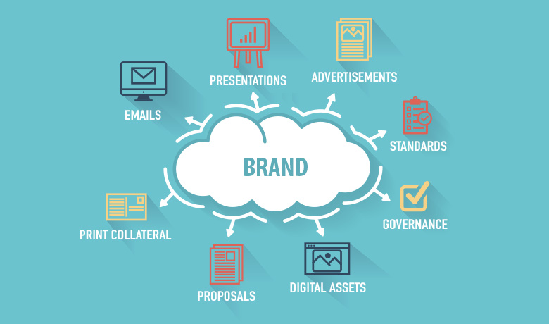
Figure: Brand consistency (Tian et al, 2019)

Reputation management

How can hotels manage their reputation effectively?
The brand value or name much more depends on how much reputation the organization has. Marriott Int. needs to monitor the influencing information about the service that is given both online and offline. In this digital era, all the customers check the online rating (service comment/ reviews given by previous customers) before taking the service and also compare it with other organization that gives similar service. Hospitality and visitor carrier management is a responsive carrier that is used by the resort management to handle their clients and additionally different lodge operations. Logo cost could be very a good deal a essential and important useful resource for each business. There are some steps that Marriott Int. would follow to manage its reputation. Marriott Int. could monitor its online reputation, build a reputation management plan, handle negative comments follow other successful brand reputations, and measure its result, etc. (Christensen et al, 2020).

What is the importance of effective guest reviews management?
Before the online burst, information gathering was so difficult and people rarely know the reviews that are given by the previous service taker. But after the online revolution, all the customers check out the reviews before taking the service and also compare with similar organizations that provide the same service. The excursions and touring zone is very booming now. This capacity area were given a massive bump because of covid-19, it's far elevating its head again. Well, positive reviews are always good and helpful for companies like Marriott because it would help Marriott Int. to increase the traffic and bookings to its hotels. Hence, the potential customers would feel confident about their staying and make their staying (Tian et al, 2019).
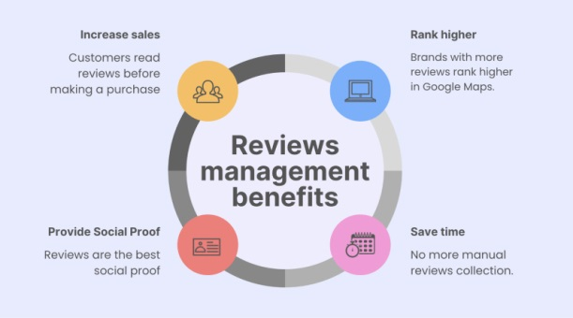
Figure: reviews management (Dangermond et al, 2022)

What is the impact of negative reviews?
The impact of negative reviews is severe for every business as it affects the potential customers' decisions. Meaning, whenever any negative reviews come along, Marriott Int. would lose many potential customers. According to the study, 86% of customers feel uncomfortable buying services or products from an organization that has negative reviews. There are some steps that the agency would observe to manage its recognition. The impact of poor evaluations is severe for every business because it affects the ability customers' selections. Primarily based on the emblem name, consumer repetition might be based. Retaining the logo name, value, and logo consistency may be very much important (Christensen et al, 2020).
Logo consistency is helpful to lead to emblem reputation by the clients. Which means customers may have a fantastic affection for buying the products or services. So, Marriott Int. need to deal with the negative reviews very seriously and carefully as it would cost the hotel in traffic and revenue. Marriott Int. needs to be careful about negative reviews because they can damage the factors to its prestige, credibility, and also the trustworthiness of customers to the business. The negative value also impacts diminishing the brand value of the business (Hao et al, 2020).

Service culture

What is service culture?
Service culture is important in several ways to a business organization. Marriott Int. would have better operation service from the employees, and customers would have a better experience with the hotel if Marriott Int. would be able to have better service culture. To make the Marriott Int. stronger organization, it should focus on customer satisfaction. The standards of the lodges alternate on some criteria. Better service culture would help Marriott Int. to have a good reputation and also repeat customers. The service culture also works in maintaining effective communication. The communication is between the customers, employees, and hotel management. Hence, to compete with competitors in the market, providing better service, good service culture, could be a good strategy (Dangermond et al, 2022).

How does this differ from corporate culture?
Organizational culture plays an important role in having effective operations in business. Well, the corporate culture is like a part of the service culture. Corporate culture refers to the way how an organization’s employee would think, act, and react to the world around them. The service culture refers to a collective way. The brand cost or name much more depends on how lots popularity the agency has. The agency desires to reveal the influencing facts approximately the carrier that is given each on line and offline. In the service culture, employees use collective ways to think about business operations to give outstanding service to the customers or clients. So, corporate culture is practiced inside the organization, and service culture has its impact outside of the organization (Haque et al, 2021).
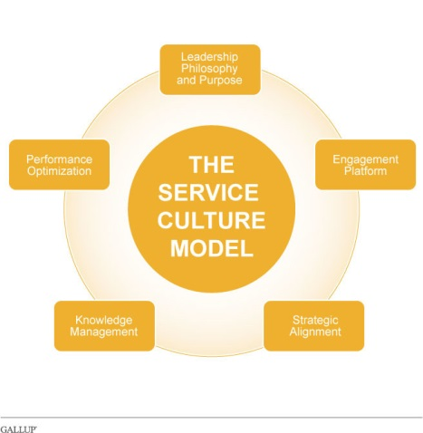
Figure: service culture and development (Akbar et al, 2020)

Why is this important in the hotel industry?
Every business organization should try to have an effective service culture. An effective service culture would have the right tone for the employee to have the right calls, pick appropriate wording and provide the best action for the operation. The importance of an effective service culture is several. The sort of lodge and its supplying class of rooms are two of the criteria to differ from the motel fashionable. Nicely, the organisation is an international motel carrier reputed for peasant rooms and carrier. Once more, the imaginative and prescient or destiny intention is also every other motive force to have special standards. Marriott Int. would treat unique than others. Along with that, Marriott Int. would get values, traditions, beliefs, behaviors, and good attitudes which are so precious for a business. Again, an effective hotel culture would attract talent, engage the employees in the work and affect the whole performance (Choi et al, 2021).

Recommendations
- The organisation should develop its health and security system to bring development in its performance in crucial situations. Though Covid-19 had a serious effect on the business, as well as on the US economy, Marriott Int. is doing well so far.
- Marriott Int. should identify the right partners as the hotel is doing well with its franchise companies but should bring some upgrade in their conditions to expand business in new areas (Choi et al, 2021).
- Marriott Int. should imply a new rule to its franchise to upgrade the rule about 8 year’s old kids. Again, the interior design could be changed or updated for some of the hotels.
- Well, as Marriott Int. is making $12 billion (average) per year, it should be continued providing better service to the customers (Akbar et al, 2020).

Conclusion
In the hotel business, the reputation is much more dependent on how the hotel management provides their service, cultural tradition, and also behaves. So, the employer want to deal with the negative reviews very critically and punctiliously as it might cost the resort in traffic and sales. These affect much to get the customers in future. Marriott Int. is doing well and if they succeeded to provide the same service tradition, the reputation and revenue making would not be stopped but rather continued from generation to generation (Car et al, 2019).

References
Akbar, F.H., Pasiga, B.D., Samad, R., Rivai, F., Abdullah, A.Z., Pasinringi, S.A., Saleh, L.M. and Pratiwi, D., (2020). The relationship between service quality, culture similarity to satisfaction and loyalty of medical (dental) tourism. Systematic reviews in pharmacy, 11(12), pp.19-30.
Baek, J., Choe, Y. and Ok, C.M., (2020). Determinants of hotel guests’ service experiences: an examination of differences between lifestyle and traditional hotels. Journal of Hospitality Marketing & Management, 29(1), pp.88-105.
Car, T., Stifanich, L.P. and Šimunić, M., (2019). Internet of things (iot) in tourism and hospitality: Opportunities and challenges. Tourism in South East Europe, 5, pp.163-175.
Choi, Y., Oh, M., Choi, M. and Kim, S., (2021). Exploring the influence of culture on tourist experiences with robots in service delivery environment. Current Issues in Tourism, 24(5), pp.717-733.
Christensen, T. and Lægreid, P., (2020). The coronavirus crisis—crisis communication, meaning- making, and reputation management. International Public Management Journal, 23(5), pp.713-729.Raihan
Dangermond, K., Weewer, R., Duyndam, J. and Machielse, A., (2022). “If it stops, then I’ll start worrying.” Humor as part of the fire service culture, specifically as part of coping with critical incidents. Humor, 35(1), pp.31-50.
Hao, F., Xiao, Q. and Chon, K., (2020). COVID-19 and China’s hotel industry: Impacts, a disaster management framework, and post-pandemic agenda. International journal of hospitality management, 90, p.102636.
Haque, I., Rashid, A., Rasheed, R. and Amirah, N.A., (2021). Differentiated services quality and service culture: customers’ preference in air travel. Journal of Tianjin University Science and Technology, 54(07), pp.19-46.
Phung, M.T., Ly, P.T.M. and Nguyen, T.T., (2019). The effect of authenticity perceptions and brand equity on brand choice intention. Journal of Business Research, 101, pp.726-736.
Szabo de Edelenyi, F., Egnell, M., Galan, P., Druesne-Pecollo, N., Hercberg, S. and Julia, C., (2019). Ability of the Nutri-Score front-of-pack nutrition label to discriminate the nutritional quality of foods in the German food market and consistency with nutritional recommendations. Archives of public health, 77(1), pp.1-9.
Tian, Z., Gao, X., Su, S., Qiu, J., Du, X. and Guizani, M., (2019). Evaluating reputation management schemes of internet of vehicles based on evolutionary game theory. IEEE Transactions on Vehicular Technology, 68(6), pp.5971-5980.

