INTERCULTURAL COMPETENCE REPORT

Module Code: BMIH5003
Lecturer Name: Heidi Prosser
Student Name: Anaida Adamache
Student Id:2026381

Executive Summary
The report compares English and Indian cultural behaviours in the hospitality industry, with a focus on intercultural leadership. Some of the key cultural features and leadership styles that the GLOBE Project examines include communication, hierarchy, and decision-making among others. A visit at the 5-star Inclusivity Hotel & Spa in London, England brought home the recognition of the need to acknowledge cultural differences to serve guests well or manage them effectively. Suggestions on what can be done to address cross-cultural challenges include cross-cultural training, transparent lines of communication and sharing ideas while making decisions together.

Table of Contents
Introduction 3
Main Body 3
Culture Overview 3
GLOBE Project/Country Analysis 4
Critically discuss the challenges of intercultural leadership in the hospitality industry 5
Conclusion 6
Recommendations 6
References 8

Introduction
The hospitality industry has become prosperous in diffusing cultures across the world. The purpose of the report is to show why hotel manager of the 5-star Inclusivity Hotel & Spa in London in England and at the 5-star Inclusivity Hotel & Spa in New Delhi, India need to be aware of the cultural distances between them. Therefore, hotel manager at the 5-star Inclusivity Hotel & Spa in London, England needs to appreciate these distinctions so that they can create remarkable visitor experiences as well as be effective leaders. This paper will discuss significant discrepancies, analyse results from GLOBE’s cultural dimensions and leadership practices, and propose ways of dealing with cross-cultural challenges by hotel management.

Main Body

Culture Overview
India and England are made up of different cultures, each having its unique customs, traditions, means of communicating and societal expectations. English culture is typically characterised by politeness, punctuality in timekeeping and strict adherence to protocols in social interactions (Assets.publishing.service.gov.uk, 2024). Communication tends to be straightforward and short with a focus on individuality as well as the need for personal space (Irwin, 2020). In contrast, in India, where communication tends to be more indirect and hierarchical, Hotel & Spa staff could focus on building relationships and maintaining harmony with guests (Acemoglu and Robinson, 2021). Communication is often indirect depending on the context for instance while maintaining harmony it also preserves relationships (Shaari, 2020). The country has a wide range of languages spoken; numerous cuisines and religious practices are making India’s culture dynamic.
Customs related to hierarchy, time perception and social behaviour prove the greatest disparities between English and Indian cultures (Kainthola, 2021). Besides, England is oriented towards individualism and justice while India still relies on traditional social structure (Kainthola, 2021). Equally, in England, timekeeping and efficacy are very important as opposed to the Indian situation where “Indian Standard Time” (Vattikonda et al. 2020) prevails. This can be evidenced through home entertainment practices and the organisation’s teamwork tactics like how they treat their customers in Inclusivity Hotel & Spa . This will therefore necessitate good cross-cultural understanding as well as better guest experiences by taking due note of these differences.

GLOBE Project/Country Analysis
The GLOBE Project provides valuable insights into cultural dimensions and leadership practices across different countries. Analysing the GLOBE scores for India and England reveals notable differences in cultural values and leadership styles that are pertinent to the hospitality industry.
England | India
Culture Visualisation
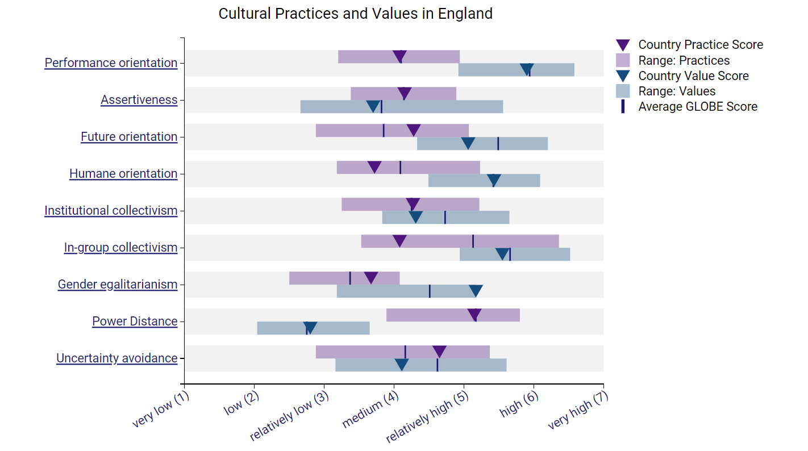 | 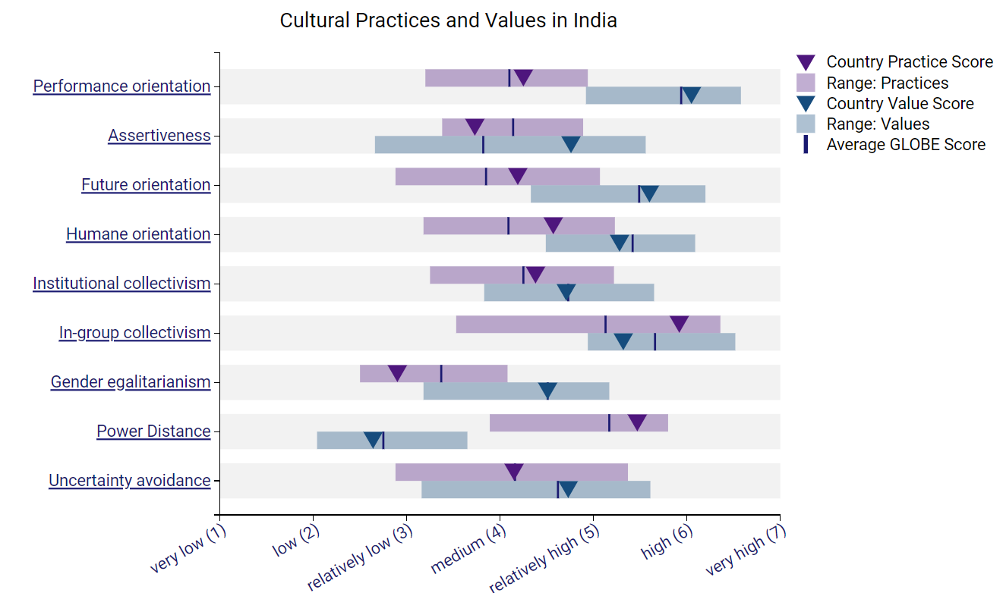
Leadership Visualisation
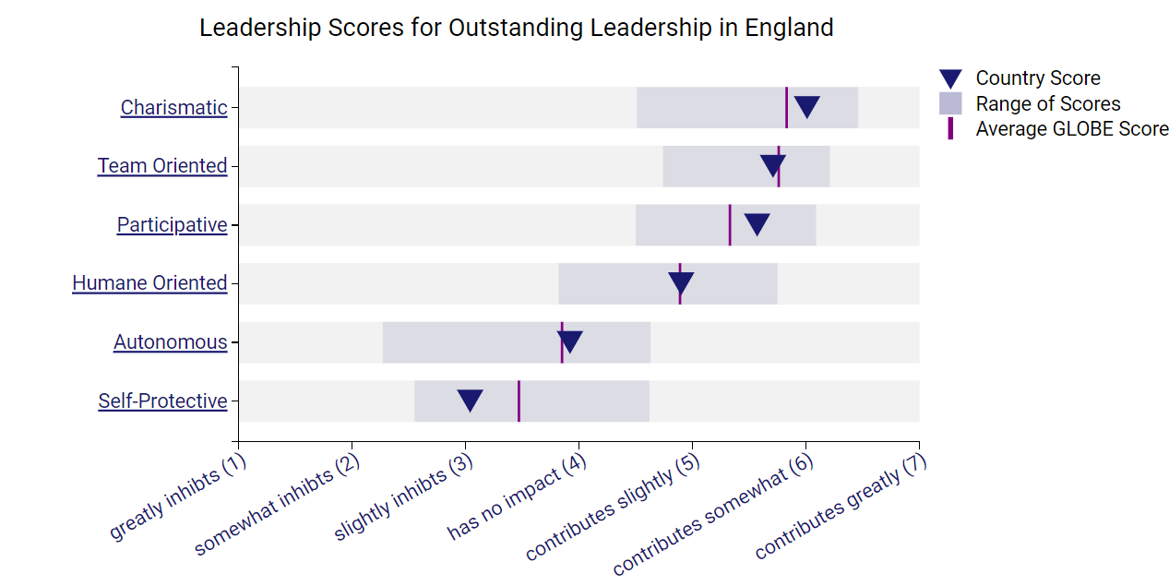 | 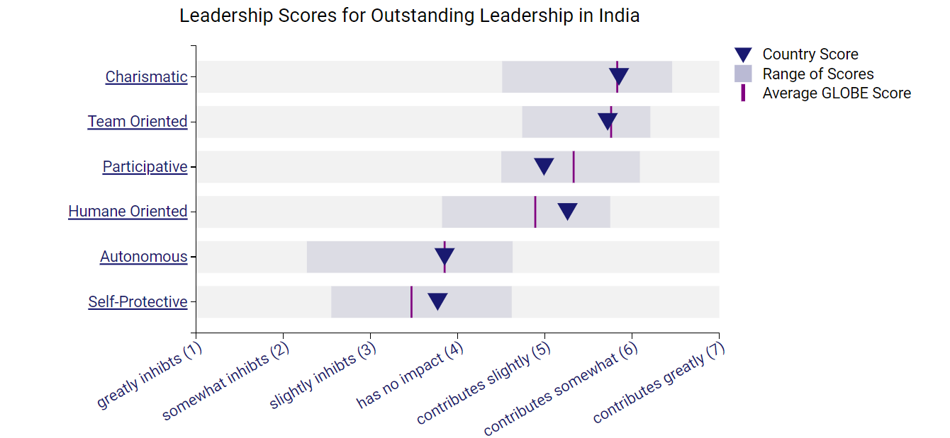
Table 1: Country Scores
(Source: Globeproject.com, 2024)
India is well-known for its cultural aspects such as power disparity, collectivism and apprehensiveness (Globeproject.com, 2024). In India, there is a lot of respect given to hierarchies while trying to avoid ambiguity and maintain team harmony. Indian-style leaders often tend towards mentoring, networking and consensual decision-making (Globeproject.com, 2024). On the other hand, England has attributes like individualism, low power distance and medium uncertainty avoidance index (Globeproject.com, 2024). Thus, individual’s freedom comes first followed by egalitarianism and adaptability. In English leadership practices, autonomy is emphasised alongside meritocracy and assertive decision-making.
In Inclusivity Hotel & Spa hospitality industry, it is important that one is able to comprehend these cultural differences. To offer good service to their customers and manage their multi-cultured teams, leaders in Hotel Inclusivity need to modify their leadership styles and communication strategies to fit into the staff’s cultural tastes suitably. By using GLOBE Project data, hotel management can create a culturally responsive environment which enhances teamwork, innovation as well as guest contentment.

Critically discuss the challenges of intercultural leadership in the hospitality industry
In the Hotel Inclusivity hospitality industry, intercultural leadership is always a challenge due to cultural differences between team members. One of the most likely places for disagreement may be in communication where different levels of directness and assertiveness may cause misunderstanding or misinterpretations. If, for instance, a Hotel Inclusivity manager communicates indirectly with his subordinates, he might not understand anything; instead, his subordinates will feel that their boss’ approach is too harsh. In India, where over 19,500 languages and dialects are spoken, ensuring effective communication among team members and guests can be daunting (Indianexpress.com, 2024).
Furthermore, different opinions about gradation and governing could lead to tensions among multicultural group members. Take India for example as one of the growing Southern Asian economies. The authority and seniority are highly respected in this country, team associates might hesitate to raise their voices or question management’s decisions thereby stifling invention and enterprise spirit. Hotel Inclusivity should integrate cultural considerations into its operational processes, particularly when planning events or menus. One of these problems that was noticed was being sensitive to religious and cultural affiliations when planning events or menus (Christiansen et al. 2020). However, this also provided an opportunity to show variety and meet the special requirements of visitors from diverse backgrounds. In summary, a prosperous global hotel leader must apprehend and recognise cultural subtleties, be forward in communication and adapt to managerial styles that promote inclusiveness and teamwork where team members are from different environments.

Conclusion
In summary, the success of Hotel Inclusivity operations in England and India hinges on its ability to navigate cultural distances effectively. Knowing these differences is essential in the hospitality industry for effective leading, guest satisfaction and team cohesion. From the assessment, it can be understood that it is necessary to evolve from simple acknowledgement of cultural differences into actively accommodating them. Consequently, the following suggestions will address intercultural problems and leverage guest service delivery improvement chances as well as enhance team effectiveness in the ever-changing world of the hospitality business.

Recommendations
Challenges | Recommendations
Implement Cross-Cultural Training: | - Provide all employees with thorough Cross-cultural training programmes to improve their sensitivity and understanding of their cultures.  - Incorporate courses on cultural norms resolution techniques and communication styles specific to the hospitality sector (Rabiul et al. 2023).  - Promote interactive learning by stimulating real-world settings using case studies and role-playing activities.
Foster Open Communication Channels: | - Organise frequent team meetings and feedback sessions to help cross-cultural team members communicate honestly and understand one another.  - Encourage team members to openly share their opinions and concerns to promote a collaborative and inclusive atmosphere.  - Establish a multicultural mentorship programme so that team members may benefit from one another's viewpoints and experiences.
Adapt Leadership Styles | - Take a flexible leadership stance that honours and acknowledges the team's cultural diversity.  - Regardless of cultural background, promote inclusive decision-making procedures that welcome participation from all team members.  - Continually offer leadership development opportunities so that managers may acquire the competence required to successfully handle cross-cultural issues.
The all-inclusiveness of Hotel Inclusivity may enhance the standard of silence service to customers in multicultural settings. Achieve a supportive work environment that overcomes cross-cultural leadership challenges by putting this trial into practice.

References
Acemoglu, D. and Robinson, J.A., 2021. Culture, institutions and social equilibria: A framework (No. w28832). National Bureau of Economic Research.
Assets.publishing.service.gov.uk (2024), “Creating a Culture” Available at: https://assets.publishing.service.gov.uk/media/5a7506e4ed915d3c7d529cec/Tom_Bennett_Independent_Review_of_Behaviour_in_Schools.pdf [Accessed on: 15.02.2024]
Christiansen, B., Branch, J.D. and Karmowska, J. (2020) Cultural Factors and Performance in 21st Century Businesses. Hershey: IGI Global.
Globeproject.com (2024), “England” Available at: https://globeproject.com/results/countries/GBR%3Fmenu=list.html#list [Accessed on: 15.02.2024]
Globeproject.com (2024), “India” Available at: https://globeproject.com/results/countries/IND%3Fmenu=list.html#list [Accessed on: 15.02.2024]
Indianexpress.com (2024), “More than 19,500 mother tongues spoken in India: Census” Available at: https://indianexpress.com/article/india/more-than-19500-mother-tongues-spoken-in-india-census-5241056/ [Accessed on: 15.02.2024]
Irwin, H., 2020. Communicating with Asia: Understanding people and customs. Routledge.
Kainthola, V.P., 2021. Principles of hotel management.
Rabiul, M.K., Shamsudin, F.M., Yean, T.F. and Patwary, A.K., 2023. Linking leadership styles to communication competency and work engagement: evidence from the hotel industry. Journal of Hospitality and Tourism Insights, 6(2), pp.425-446.
Shaari, A.H., 2020. Accentuating illocutionary forces: Emoticons as speech act realization strategies in a multicultural online communication environment. 3L, Language, Linguistics, Literature, 26(1).
Vattikonda, B., Das, M., Bhardwaj, T., Panja, S., Arora, P., Gupta, A. and Aswal, D.K., 2020. Time and Frequency Metrology. Metrology for Inclusive Growth of India, p.197.

